SUPERMAN: A Novel System for Storing and Retrieving Scientific-Simulation Provenance for Efficient Job Executions on Computing Clusters
Jin Ma and Young-Kyoon Suh
Convergence Research Platform Development Laboratory,
Center of Computational Science and Engineering,
National Institute of Supercomputing and Networking
Korea Institute of Science and Technology Information (KISTI)
Daejeon, Korea 34141
{majin, yksuh}@kisti.re.kr

Abstract— Compute-intensive simulations typically charge substantial workloads an online simulation platform backed by large-scale computing clusters. Such heavy simulations are given with no de-duplication and thus easily deteriorate the performance of the platform shared by a number of users. To more efficiently perform compute-heavy workloads, we present a novel system, called SUPERMAN (SimUlation ProvEnance Recycling MANager), to seamlessly record and retrieve provenances and of previously-executed simulations for preventing users from initiating duplicate and/or similar simulations on the limited computing resources. This system offers a great opportunity to do easy validation on parameters of simulations by third-party users and perform a variety of analytics helpful for those who are not familiar with the platform. In addition, the system enables interoperability across other systems by collecting simulation provenance in a de-facto standard form, W3C PROV. We firmly believe that the SUPERMAN system contributes to boosting the performance of the online simulation platform by enabling efficient utilization of limited computing resources.
Keywords—Computing Clusters; Simulation; Provenance; PROV;

Introduction
EDISON [1] is a well-known online scientific-computing simulation platform developed by KISTI. This platform has been designed and developed to educate students and assist researchers to conduct their research online with a variety of large-scale computing software tools from diverse computational science and engineering fields. The platform has been quite mature enough to support about cumulative 40K users over the past five years in Korea. Due to this success, a copy version of this platform, dedicated to serve users engaged in Computational Fluid Dynamtics (CFD) has been already deployed at National Center for High-performance Center [2] in Taiwan.
Typically, an EDISON user selects one of those tools on the platform and makes a great number of computational jobs initiated from the chosen tool on our computing clusters. One challenge we encountered was how to efficiently handle a huge number of user requests with the same input parameters and files on the same simulation tool. Up to now, the platform served those requests without checking any duplicates in a first-come, first-served fashion. Thus, significant pressure has been charged on our limited computing clusters.
To address this concern, we present a novel system for storing and processing scientific simulation provenance with which a duplicate simulation request can be promply inspected and answered if it exists in the system. This system is termed SUPERMAN (SimUlation ProvEnance Recycling MANager), since it recycles previously-executed simulation provenances to handle future simulation requests from a number of users to save limited computing resources we have. SUPERMAN records simulation provenance along with a de-facto standard, PROV specification [3], of which the use enables interoperability for further verification of that provenance across other systems understanding the PROV specification.
This paper is organized in the folllowing. Section II discusses design priciples of our system. Section IV provides an example of W3C PROV Section III presents an overall architecture of our system.

Design Principles
SUPERMAN holds the SINGLE properties meeting the six goals in its design.

Design Goals
- Scalability: tolerable to a flooding of simulations from numerous users
- Interoperability: understandable in any system following a standard form
- Nonintrusive: not interrupting the operation of the main platform while collecting provenance without notice
- Generality: support for any domain in computational science and engineering
- Lightweightness: nonintrusive with a main system
- Effectiveness: not only reproducibility but also many other tasks, mainly for enabling system efficienty in simulation

Provenance Modeling

Collected Provenance
Table I summarizes what information regarding our HPC simulation is collected from the portal system. There are four categories: (1) user, (2) science app (simulation software), (3) simulation, and (4) (computing) job. Concerning the user, we want to keep what affiliation a user belongs to as well as a user-specific information like user ID and name. With respect to the science app, we should know which computational science and engineering field a science app launching a user’s simulation comes from, let alone the name and version of the app. In the simulation category, we collect the ID, title, and creation date of that simulation, as well as how many jobs were created. When it comes to the job category, we collect a different kind of information about a job created by the simulation: sequence number, status (success or fail), submit date (in job queue), start date (out of job queue), end date, execution path, and input data with specific parametric values provided for that job. This kind of simulation information forms a provenance instance for further processing.
- Collected Information for Pprovenance on EDISON
Item |  | Description
Category | - | Description
User | user ID | ID, name, and affiliation of a simulation user registered on platform
User | user name
User | affiliation
Science App | domain ID | a specific domain in computational science and engineering (e.g. CFD, Nano, ...)
Science App | science app name | Name and version of  a science app of interest  on provenance
Science App | science app version
Simulation | simulation ID | simulation ID
Simulation | title | simulation title
Simulation | creation date | when this simulation was created
Simulation | job count | how many jobs were produced from this simulation
Job | job seq no | sequence number of this job
Job | job status | status of this job: success or fail
Job | job submit date | job submission date (in queuing)
Job | job start date | job start date (out of queue)
Job | job end date | job end date
Job | job exec path | where input files are located, and output files are generated
Job | job data | specific parametric values provided to a science app

Each simulation provenance instance is standardized in PROV [4] as mentioned earlier. The subsequent sections discuss how we map the collected information to different elements in PROV and later give an example of how to physically represent the instance in JSON format.

W3C PROV
In the SUPERMAN framework any simulation provenance generated by the EDISON platform is captured along with PROV-DM[3] and physically serialized to JSON format [3]. Thus, this is called PROV-JSON [5]. Stored provenances are utilized to determined whether a given simulation is a duplicate of any instances managed and stored by the SUPERMAN framework.

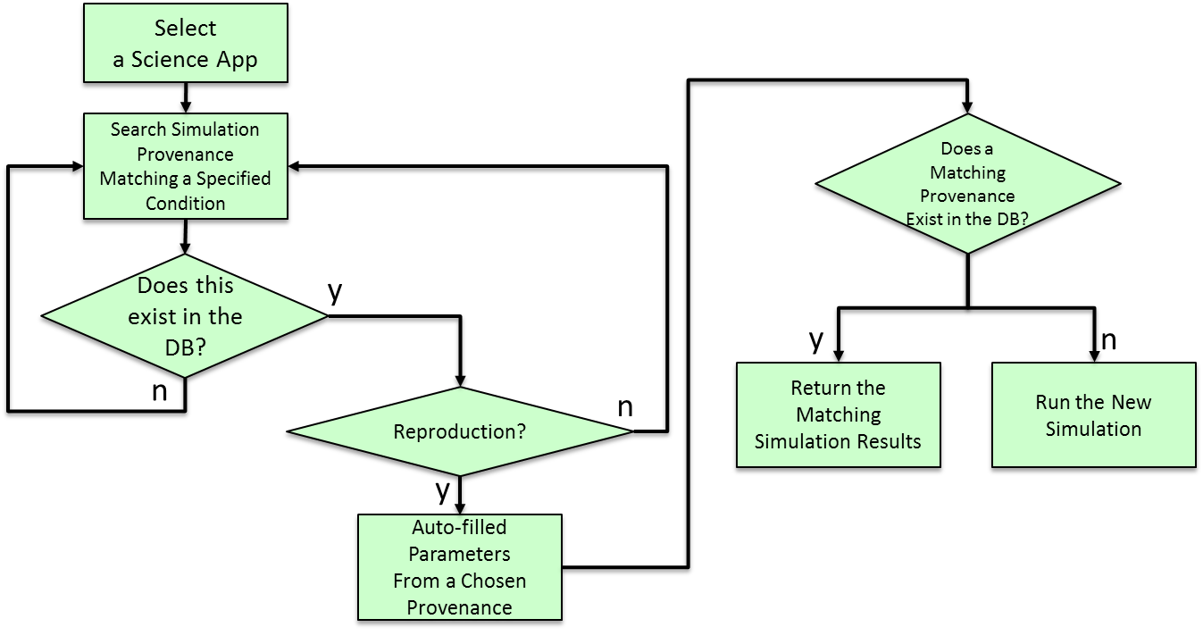
- Flow diagram of simulation provenance
- W3C PROV-DM Elements
Element | Description
Agent | An agent can be understood as an agent concept that can act on behalf of an entity, Agent is responsible for the Entity
Activity | An activity is an action, a function, an attribute and a relation that an agent and an entity can perform
Entity | Physical, digital, and conceptual types are called entities

Table 2 shows according to constraints of the PROV-DM Rationale (Informative) element and description. In short, an entity contains all the concepts that actually exist the agent is the delegator of the entity and the activity is related to the functions and attributes of the agent and the entity. And Fig. 2 shows the modeling based on the elements of Table 2 and the relationship between the elements.
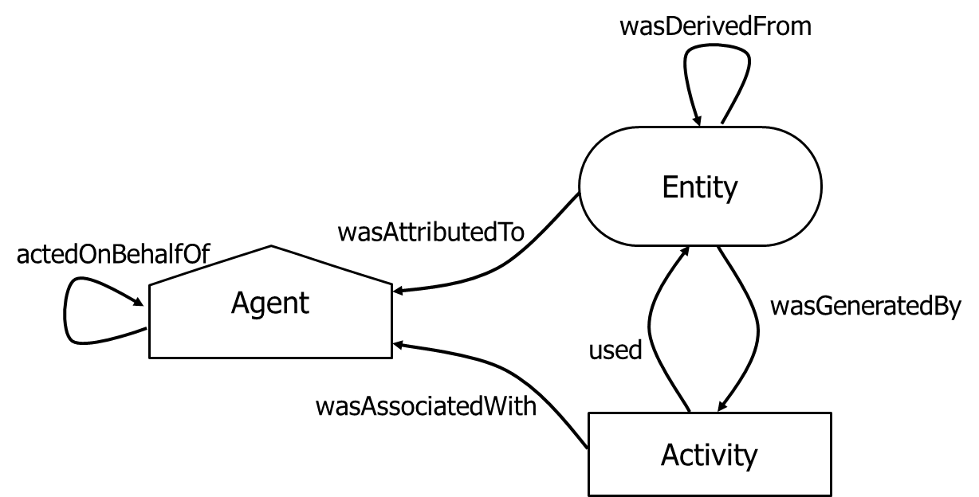
- Relationship between elements in PROV-DM

PROV-JSON Creation
PROV-JSON [8, 9] generates a file with a lightweight PROV model in JSON format. And then, PROV-JSON can be converted to other type (such as PROV-N, PROV-O, PROV-XML). Therefore, generated the PROV-JSON file supports interoperability and lightweightness for any simulation provenance data of EDISON platform. Fig. 3 shows the relation between model and attributes by applying the W3C standard PROV-DM model shown in Fig. 2 to Simulation Provenance of the EDISON platform. And each element and relation is as follows:
- Agent: User, Simulation SW
- Entity: Jobs, Input, output
- Activity: Simulation
- Relation: actedOnBehalfOf, wasAssociatedWith, wasAttributeTo, wasDerivedFrom, wasGeneratedBy, used
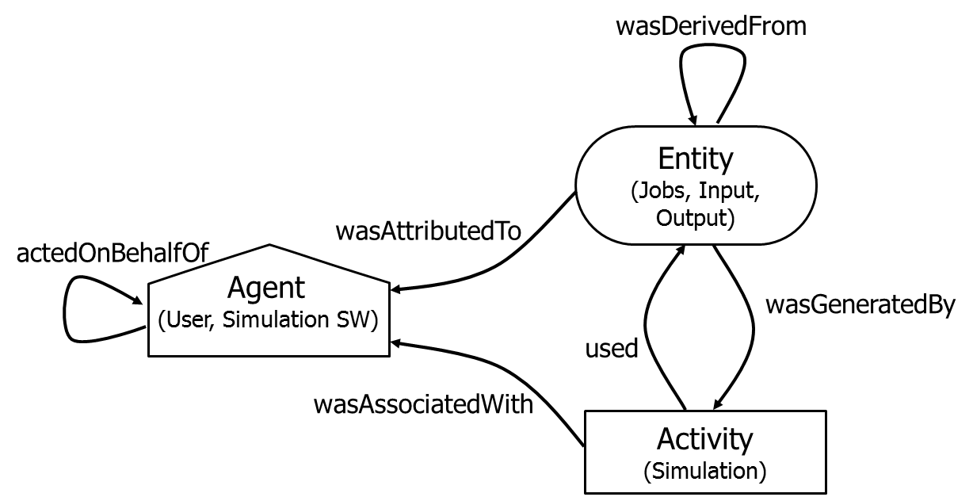
- Reconstruction of PROV Model based on EDISON platform simulation provenance

Sss

- PROV-JSON Creation Scenario
No. | PROV Scenario
1 | Simulation (394197c0-1134-41df-9a6b-2b49460aaec1) wasAssociatedWith a Simulation SW (2D_Comp_P/EDISON/SOLVERS/2D_Comp_P/2.5.0/bin/2D_Comp_P)
2 | Simulation (394197c0-1134-41df-9a6b-2b49460aaec1) wasAssocicationWith a User (zacwhee)
3 | Simulation SW (2D_Comp_P) ActedOnBehalfOfUser (zacwhee)
4 | Job1 (677eb1d5-14c8-437a-a270-acb7aa8885c5) was AttributedTo a Simulation SW (2D_Comp_P)
5 | Job1 (677eb1d5-14c8-437a-a270-acb7aa8885c5) was GeneratedBy Simulation (394197c0-1134-41df-9a6b-  2b49460aaec1)
6 | Simulation (394197c0-1134-41df-9a6b-2b49460aaec1) used input (NASAsc2-0714(2).msh)
7 | Output (/EDISON/LDAP/zacwhee/394197c0-1134-41df-9a6b-2b49460aaec1/result) wasGeneratedBy Simulation (394197c0-1134-41df-9a6b-2b49460aaec1)
8 | Job2 (585a7cd7-0919-4824-af8e-fdf024b2d174) WasDerivedFrom Job1 (a4729361-1379-4c4d-aedc-838ed9ca9829)
9 | Solver (2D_Comp_P_2.5) WasDerivedFrom Solver (2D_Comp_P_2.0)

System Architecture
This section presents an overall architecture of SUPERMAN.

Overall Architecture
Fig. 2 shows what components constitute SUPERMAN and how the system interacts with the EDISON platform [1].
Conventionally, HPC simulations are conducted on EDISON in the following. A user logs in Application Portal Framework, based on Liferay Portal [8], which provides a list of a variety of simulation tools provided by specialized disciplines in computational science and engineering. The user selects one of the tools and creates and submits to Job Execution Framework a computing job. Then the job is put in queue and sequentially taken out of the queue for execution on Infrastructure. By embracing the SUPERMAN system into EDISON, this running scenario is somewhat altered.
SUPERMAN provides eight main functionalities to enable simulation provenance service. (i) Simulation provenance collection indicates that all the actions on an HPC simulation executed on EDISON are captured as provenance record. A detailed piece of information for provenance is shown in Table 1. When a provenance record is created, SUPERMAN does a check if it already exists in a repository, called Simulation Data Repository, to be discussed shortly. (ii) Simulation provenance validation means that a recorded provenance record is validated against existing provenance records. For instance, with the past records we can determine whether a wrong value in a parameter of a chosen tool is given. (iii) Simulation provenance modelling supports standardizing the collected simulation provenance. As mentioned earlier, each provenance record is modelled along with PROV and physically stored as a file in PROV-JSON. (iv) Querying on stored provenance records is also supported via a search engine, which will be discussed in the subsequent section. (v) Provenance-based parameter assistance and visualization service means that a user will be provided with a possible recommendation for what parametric values are typed when being ready to run a simulation. (vi) Data-driven simulation services is enabled based on provenance records as discussed in our prior article [3]. (vii) Provenance-based analytics can be provided to get users more informed about their simulations, specifically with estimated completion time, resource busy time, and top-k processing on provenances with regard to popularity. Finally, (viii) provenance records with actual simulation results are preserved in the separate for future access. From this repository we’ll be able to filter out any duplicate simulations given from the portal.
In the following section we elaborate on each component of SUPERMAN along with a control flow.

Detailed Components
In this section, we walk through each component of SUPERMAN along with a control flow.
If a user requests an HPC simulation on the platform, that request is forwarded to SUPERMAN to see if any duplicate request with the same input parameters/files is recorded as provenance. If not, the requested simulation is normally conducted and completed simulation results are returned to the user. Otherwise, the simulation results are immediately returned to the user without executing the requested simulation.

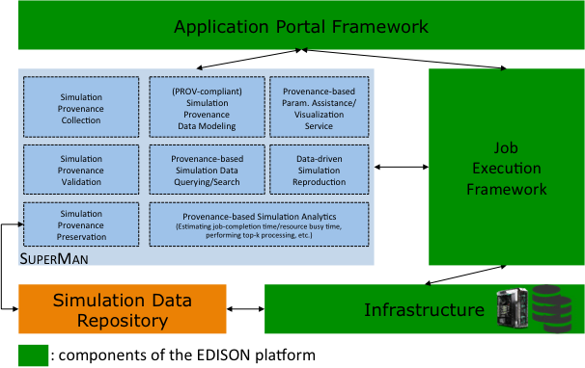
- SUPERMAN Architecture

Simulation Provenance Extractor

This component extracts the provenance of a completed simulation from the result database. For instance, the provenance covers Table 1’s information and some additional information such as input file size and simulation result paths obtained via Job Execution Framework. We also collect whether a simulation was success or fail for future analytics.

Simulation Provenance Validator

A collected provenance record is validated by another component, called Simulation Provenance Validator. Even if that record is correctly constructed, it may have an out-of-range or wrong value for a parameter of a chosen simulation tool, compared with what values were provided for that parameter in the past. In this case we do not execute the requested simulation and cause a run-time error to the platform, in turn notifying the user with that error. Once a provenance record is validated, then we send it to the next component.

Simulation Provenance Loader

Simulation Provenance Loader takes an approved record and converts it to the PROV-JSON file. It then stores the json file into Simulation Data Repository for future access.

Simulation Provenance Matcher

This component compares a new provenance record with existing records, returned from Simulation Provenance Retriever, to be discussed shortly, performing provenance retrieval along with matching conditions. The Matcher generates a hash key of the new provenance and matches whether it is identical to that of any of the retrieved provenances. If so, then SUPERMAN returns existing simulation results back to the user.
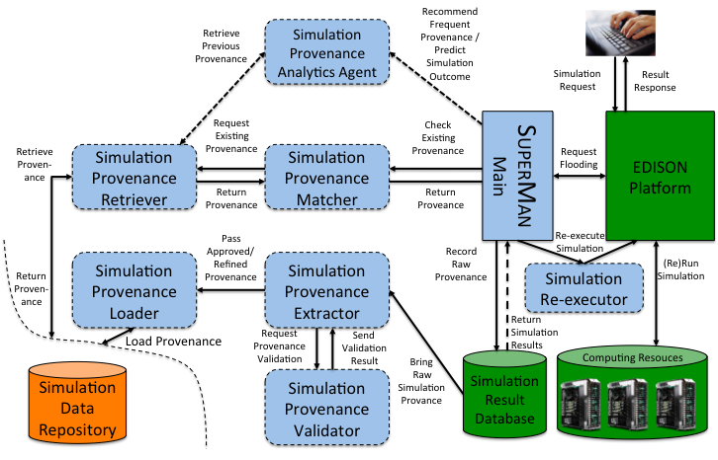
- Functional flow of the SUPERMAN framework, interacting the EDISON platform

Simulation Provenance Retriever

This component is responsible for retrieving the user-requested simulation provenance (parameter value) from the EDISON platform through the simulation repository. Fig. 6 shows the retrieval process of the Simulation Provenance Retriever connected with the existing EDISON platform.
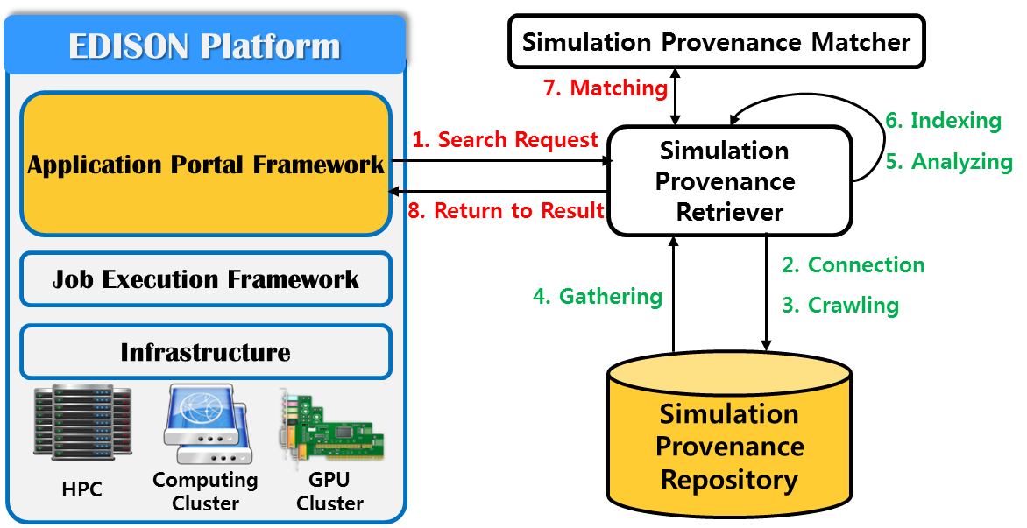
- Simulation Provenance Retriever process with the EDISON Platform

Simulation Provenance Analytics Agenet

We design Simulation Provenance Analytics Agent to perform a variety of analytics based on accumulated provenances. For instance, we can recommend the most frequently accessed provenance records via top-k processing or estimate the completion time of a requested simulation based on past provenance records. These analytics will be provided with users for assistance in carrying out simulation.

Simulation Re-executor

The last component is Simulation Re-executor, which allows the platform to recycle existing simulation results or re-run the simulations with altered parametric values. The Re-executor passes a selected provenance record to the platform, which in turns automatically loads into simulation parameters previously-entered values extracted from the record. The user can run the simulation with the loaded values on the platform as they are, or change the values. Once the simulation is initiated, then SUPERMAN figures out whether a provenance of the requested simulation exists in the previous provenances. If so, then the results matching the provenance are immediately returned back to the user. Otherwise, the requested simulation is normally executed on computing resources via the platform. Certainly, its provenance is stored as a new record.

The following section discusses how we record provenances and achieves searching for provenances in the SUPERMAN.

Provenance Loading
We designed a Hash table structure to eliminate duplication of the PROV-JSON stored in the simulation provenance repository Hash table is expected to improve the efficiency of management of provenance.
- Hashtable Creattion Process for deduplication
Step. | Description
1 | If the input file is used in the simulation, generate the hash value using the file name.
2 | If the simulation does not use an input file, generate a hash value for the input parameter using JobData.
3 | Concatenation of the hash values generated through 'Step 1 and 2' is used as a parameter of the Hash () method to generate a final hash value.
4 | Key of the HashTable is hash value generated in step1 or step2, and the Value is the hash value finally generated by step 3.

Related Work

Online simulation service systems

Several HPC service platforms have been proposed to provide online simulation services in many diverse fields in computational science and engineering. WebMo focuses on running simulations in chemistry. NEESHub is a simulation service platform on which simulations regarding earth science are performed. NanoHUB is a well-known platform to allow users to run nano-electronics simulations. However, none of these platforms are general-purpose as opposed to our platform for which SUPERMAN is enabled. In addition, those platforms do not consider collecting simulation provenance to handle later simulation requests and save resources.
There is a general-purpose platform, called HUBZero, working similarly
Currently, there are a number of simulation service systems that provide the ability to store and share simulation results, whose goal is similar to ours. For example, DataSpaces [3] provides a shared-space abstraction for simulation data staging. BIGNASim [4] is a NoSQL database portal for nucleic acids simulation data. SciDrive [5] is a free open-source scientific data publishing platform with the simplicity of Dropbox. DCMS [6] stores molecular simulation data in a relational database system so that researchers can query and search the simulation results. iBIOMES [7] is a management system for large biomolecular simulation and computational chemistry datasets. Scibox [8] is a cloud-based simulation data sharing and storage system providing a Dropbox-like interface. However, these systems do not provide the ability to reuse the existing simulation results automatically without user involvement, and more importantly, do not provide the ability to predict the result of a requested simulation based on the previous simulation results.

e-Science frameworks
In this section, we compare SUPERMAN with other simulation service frameworks. Compare with HUBZero and nanoHUB an online simulation service similar to EDISON platform. Compared with SUPERMAN applied to the EDISON platform, overseas simulation service defines the requirements as follows. The support is expressed as O, X, △.
The main requirements of the comparison between the online simulation service and the SUPERMAN with EDISON Platform service are as follows:
- Simulation Re-run: Whether to support re-execution of previously executed simulations.
- Input & Output Data share: Means the sharing support for the input data used for executing the simulation or the data outputted as the result, nanoHUB can share the user name, user ID and e-mail to be shared, HUBZero is an incomplete data sharing system because it must be uploaded directly to the project page of the simulation. But SUPERMAN can use the input and output files stored in the simulation provenance repository for other users.
- Simulation Provenance Retriever: Supports retrieval of simulation provenance executed by another user, and displays the retrieval result.

- Hashtable Creattion Process for deduplication
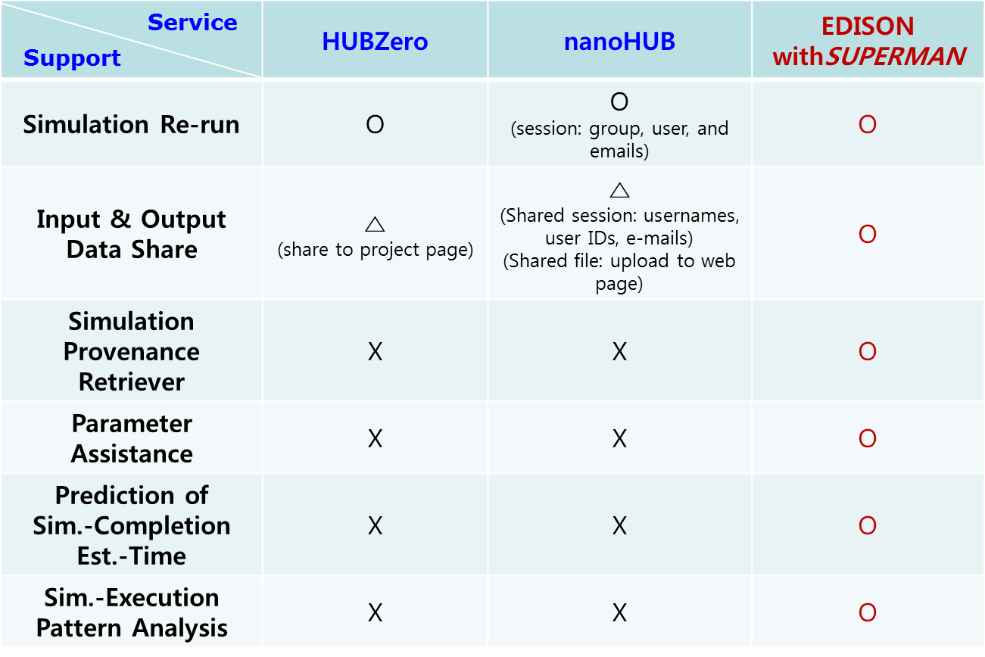

Conclusion and Future Work
Several HPC service platforms have been proposed to provide online simulation services in many diverse fields in computational science and engineering. WebMo focuses on running simulations in chemistry. NEESHub is a simulation service platform on which simulations regarding earth science are performed. NanoHUB is a well-known platform to allow users to run nano-electronics simulations. However, none of these platforms are general-purpose as opposed to our platform for which SUPERMAN is enabled. In addition, those platforms do not consider collecting simulation provenance to handle later simulation requests and save resources.

Acknowledgements
This research was supported by the EDISON Program through the National Research Foundation of Korea(NRF) funded by the Ministry of Science, ICT & Future Planning (No. NRF-2011-0020576). Young-K Suh is the corresponding author.

References
- Young-Kyoon Suh, Hoon Ryu, Hanki Kim, and Kum Won Cho, "EDISON: A Web-based HPC Simulation Execution Framework for Large-scale Scientific Computing Software," in Proceeding of IEEE/ACM 16th International Symposium on Cluster, Cloud and Grid Computing (CCGrid 2016), May 2016, pp. 608–612. (references)
- A. B. Shiflet, and Shiflet, G. W. 2014. Introduction to Computational Science: Modeling and Simulation for the Sciences. 2nd edition. Princeton University Press.
- Ki Yong Lee, YoonJae Shin, YoonJae Shin, YeonJeong Choe, SeonJeong Kim, Young-Kyoon Suh, Jeong Hwan Sa, and Kum Won Cho, "Design and Implementation of a Data-driven Simulation Service System,'' in Proceedings of the Sixth International Conference on Emerging Databases: Technologies, Applications, and Theory (EDB 2016), October 2016, pp. 77–80. (references)
- W3C, "PROV-Overview," https://www.w3.org/TR/2013/NOTE-prov-overview-20130430/, viewed on April 28, 2017.
- W3C, "The PROV-JSON Serialization," https://www.w3.org/ Submission/2013/SUBM-prov-json-20130424/, viewed on April 28, 2017.
- W3C, "PROV-DM," https://www.w3.org/TR/prov-dm/," viewed on April 28, 2017.
- Liferay Portal 6.2, “https://web.liferay.com/products/liferay-portal/liferay-portal-6.2,” viewed on June 1, 2017.
- JSON, "Introducing JSON", http://json.org/, viewed on May 14, 2017.
- ECMA, “Standard ECMA-404: The JSON Data Interchange Format”, https://www.ecma-international.org/publications/standards/Ecma-404.htm , viewed on May 14, 2017.

