SUPERMAN: A Novel System for Storing and Retrieving Scientific-Simulation Provenance for Efficient Job Executions on Computing Clusters
Young-Kyoon Suh and Jin Ma
Convergence Research Platform Development Laboratory,
Center of Computational Science and Engineering,
National Institute of Supercomputing and Networking
Korea Institute of Science and Technology Information (KISTI)
Daejeon, Korea 34141
{yksuh, majin}@kisti.re.kr

Abstract— Compute-intensive simulations typically charge substantial workloads an online simulation platform backed by large-scale computing clusters. Such heavy simulations are given with no de-duplication and thus easily deteriorate the performance of the platform shared by a number of users. To more efficiently handle compute-heavy simulations, we present a novel system, called SUPERMAN (SimUlation ProvEnance Recycling MANager), to seamlessly record and retrieve provenances of previously-executed simulations for preventing users from initiating duplicate and/or similar simulations on the limited computing resources. This system offers a great opportunity to do easy validation on parameters of simulations by third-party users and perform a variety of analytics helpful for those who are not familiar with the platform. In addition, the system enables interoperability across other systems by collecting simulation provenance in a de-facto standard form, W3C PROV. We firmly believe that the proposed system contributes to boosting the performance of the online simulation platform by enabling efficient utilization of limited computing resources with little overhead.
Keywords—EDISON; Simulation; HPC; Computing Clusters; Provenance; PROV;

Introduction
EDISON [1, 2] is a well-known online scientific-computing simulation platform developed by KISTI. This platform has been designed and developed to educate students and assist researchers to conduct their research online with a variety of large-scale computing software tools from diverse computational science and engineering fields. The platform has been quite mature enough to support about cumulative 40K users over the past five years in Korea.
Challenge: An EDISON user selects a software tool on the platform and initiates a great number of computational jobs on the chosen running on our infrastructure. One challenge we are faced with is to have to serve a flooding of simulation requests with no change of input parameters. For instance, a number of students in a class utilizing EDISON simultaneously run simulations with “identical” input data along with its TA’s guidance, resulting in writing the same output files and thus quickly consuming our limited computing/storage resources.
To address this concern, we propose a novel system for storing and processing scientific simulation provenance with which a duplicate simulation request that has been seen before can be noticed and then quickly answered based on existing results matching that request. This system is termed SUPERMAN (SimUlation ProvEnance Recycling MANager), since it recycles previously-executed simulations through provenances to handle future requests from a number of users, in order to save limited computing resource. SUPERMAN records simulation provenance in accordance with a de-facto standard, PROV specification [3], of which the use enables interoperability for further processing or verification of that provenance across other systems understanding the PROV specification.
This paper is organized in the following. Section II discusses design principles of our system. Section III provides what information is collected for and how to model provenances using an example of W3C PROV. We then present an overall architecture of our system. Section V performs a literature survey and then finally we conclude this paper in Section VI.

Design Principles
SUPERMAN holds the SINGLE properties satisfying the six goals in its design.
- Scalability: support for a flooding of simulations from numerous users
- Interoperability: understandable by any system following a standard form
- Nonintrusive: not interrupting the operation of the main platform while collecting provenance without notice
- Generality: support for an arbitrary tool in a computational science and engineering field
- Lightweightness: using minimal information for provenance modeling
- Effectiveness: support for not only reproducibility but several analytics tasks, mainly for enabling system efficiently in simulation
Specifically, SUPERMAN should be scalable to manage provenances on simulation requests flooding from the EDISON platform. In turn, the produced provenances should be interoperable [4] via a standardized form by another system wishing to request our provenances and perhaps perform further processing on them. Our system shouldn’t hurt the normal simulation execution conducted by the EDISON platform. SUPERMAN should also be able to manage provenances from an arbitrary tool from a computational science and engineering discipline. In addition, the provenance modeling should avoid conveying superfluous information while preserving minimality in describing an executed simulation. Finally, the utilization of produced provenances should be effective so that the platform gets more efficient.
We now discuss what and how to model provenance for our simulations on EDISON.

Simulation Provenance Modeling

Collected Simulation Information
Table I summarizes what information regarding our HPC simulation is collected from the EDISON platform. There are four categories: (1) user, (2) science app (or simulation SW), (3) simulation, and (4) (computing) job. Concerning the user, we want to keep what affiliation a user belongs to as well as a user-specific information like user ID and name. With respect to the science app, we should know which computational science and engineering field a science app launching a user’s simulation comes from, let alone the name and version of the app. In the simulation category, we collect the ID, title, and creation date of that simulation, as well as how many jobs were created. When it comes to the job category, we collect a different kind of information about a job created by the simulation: sequence number, status (success or fail), submit date (in job queue), start date (out of job queue), end date, execution path, and input data with specific parametric values provided for that job. This kind of simulation information forms a provenance instance for further processing.
- Collected Information for Provenance on EDISON
Item |  | Description
Category | - | Description
User | user ID | ID, name, and affiliation of a simulation user registered on platform
User | user name
User | affiliation
Science App | domain ID | a specific domain in computational science and engineering (e.g. CFD, Nano, and other areas.)
Science App | science app name | Name and version of a science app of interest on provenance
Science App | science app version | Name and version of a science app of interest on provenance
Simulation | simulation ID | simulation ID
Simulation | title | simulation title
Simulation | creation date | when this simulation was created
Simulation | job count | how many jobs were produced from this simulation
Job | job seq no | sequence number of this job
Job | job status | status of this job: success or fail
Job | job submit date | job submission date (in queuing)
Job | job start date | job start date (out of queue)
Job | job end date | job end date
Job | job exec path | where input files are located, and output files are generated
Job | job data | specific parametric values provided to a science app

Each simulation provenance instance is standardized in PROV [5] as mentioned in the introduction. The following section discusses how to associate the collected information with what elements in PROV and later gives an example of how to physically represent the instance in JSON format.

Detailed Provenance Modeling Using PROV
In the SUPERMAN system any simulation provenance generated by the EDISON platform is captured along with PROV-DM [5] and physically serialized to JSON format [6].
Table II describes core structures of PROV-DM. An entity indicates all the concepts that actually exist; an agent means the delegator of the entity; the activity concerns the functions and attributes of the agent and the entity.
- Core structures of PROV-DM [4]
Element | Description
Agent | An agent can be understood as an agent concept that can act on behalf of an entity. Agent is responsible for the entity.
Activity | An activity is an action, a function, an attribute, and a relation that an agent and an entity can perform.
Entity | Physical, digital, and conceptual types are called entities.

PROV-JSON [7] physically generates a file with a lightweight PROV model in the JSON format. PROV-JSON can be converted to other types (such as PROV-N, PROV-O, and PROV-XML). Therefore, a generated PROV-JSON file supports interoperability that can be shared by and disseminated to other platforms understanding PROV.
Fig. 1 depicts how a simulation performed on the EDISON platform can be represented by the elements in PROV-DM and their relations. The following is the mapping of a specific item to a corresponding element:
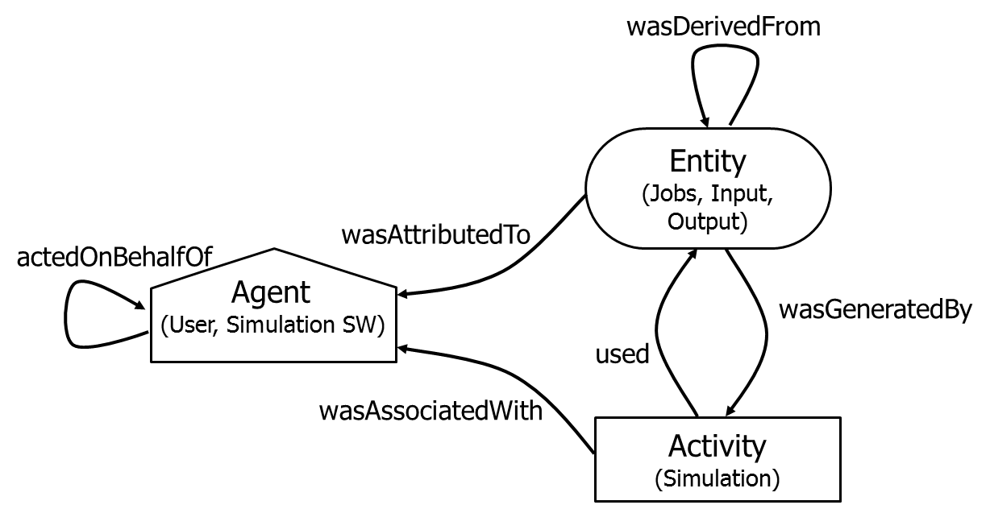
- Reconstruction of the PROV Model on the EDISON simulation.
- Agent: User and Simulation SW
- Entity: Jobs, Input (file or parameter sets), and Output (file or path), and
- Activity: Simulation.
We also use the following relations to make an association with the elements:

- Relation: actedOnBehalfOf, wasAssociatedWith, wasAttributeTo, wasDerivedFrom, wasGeneratedBy, and used.
The following is an description of each relation type:
- actedOnBehalfOf, being used to delegate authority and responsibility between Agents,
- wasAssociatedWith, meaning that Activity was associated with Agent,
- wasAttributeTo, meaning that Entity was attributed to Agent,
- wasDerivedFrom, meaning that (one) Entity was derived from (another) Entity,
- wasGeneratedBy, meaning that Entity was generated by Activity, and
- Used, meaning that Activity used Entity.
Let’s consider a specific simulation provenance in the following. A simulation (id: 394197c0-1134-41df-9a6b-2b49460aaec1) was run by a software tool (2D_Comp_P), chosen by a user (id: zacwhee). The simulation concerned two computing jobs (id: 677eb1d5-14c8-437a-a270-acb7aa8885c5 and id: 585a7cd7-0919-4824-af8e-fdf024b2d174) with an input file, named NASAsc2-0714(2).msh.
- An Example of PROV-JSON Representation on a Simulation Provenance
PROV-JSON with a namespace prefix (ex. prov:) omitted
// Element definitions
"agent": {"simulation SW": {"(prov:)label": "2D_Comp_P"}},
"entity": { "Input": {"fileName":"NASAsc20714(2).msh"},
"job1":{"677eb1d5-14c8-437a-a270acb7aa8885c5"},
"job2":{"585a7cd7-0919-4824-af8efdf024b2d174"},
"Output": {"/EDISON/LDAP/zacwhee/394197c0-1134-41df-9a6b-2b49460aaec1/result"}},
"activity": {"simulation ID": { "label": "394197c0-1134-41df-9a6b2b49460aaec1"},
// Relation definitions
"actedOnBehalfOf": {
"zacwhee": {"delegate":"2D_Comp_P", "responsible": "zacwhee"}},
"wasAssociatedWith": {"2D_Comp": {"activity":"2D_Comp_P","agent":"zacwhee"}},
"wasAttributedTo": {"677eb1d5-14c8-437a-a270-acb7aa8885c5 ": {"agent":2D_Comp_P","entity": "Job1"},
{" 585a7cd7-0919-4824-af8e-fdf024b2d174": {"agent": "2D_Comp_P","entity": "Job2"},
" NASAsc20714(2).msh": {" agent": " zacwhee ","entity": "Input"}},
"wasGeneratedBy": {
"activity": "394197c0-1134-41df-9a6b-2b49460aaec1",
"role": {"WasGeneratedBy"},"entity": "Output",
"activity": "394197c0-1134-41df-9a6b-2b49460aaec1",
"role": {"WasGeneratedBy"}, "entity": "job1",
"activity": "394197c0-1134-41df-9a6b-2b49460aaec1",
"role": {"WasGeneratedBy"}, "entity": "job2",
"activity": "394197c0-1134-41df-9a6b-2b49460aaec1"},
"used": {{"activity": "394197c0-1134-41df9a6b2b49460aaec1", "entity":"input"}}
In the end, the simulation produced the output directory (/EDISON/LDAP/zacwhee/394197c0-1134-41df-9a6b-2b49460aaec1/result). This provenance can be represented using the elements and the relations in the PROV model, as shown in Table III.

System Architecture
In this section we present the system architecture of SUPERMAN along with an altered simulation-running scenario via provenance utilization.

Overall Architecture
Conventionally, HPC simulations on the EDISON platform are conducted in the following. A user logs into Application Portal Framework, based on Liferay Portal [8], which allows that user to access various simulation SWs from several specialized disciplines. The user selects one of the SWs and creates and submits to Job Execution Framework a computing job. Then the job is put in queue and sequentially taken out of the queue for execution on Infrastructure. By getting the SUPERMAN system to interact with EDISON, however, this simulation-running scenario is somewhat altered as follows.
If a user requests an HPC simulation on the platform, that request is forwarded to SUPERMAN to see if any duplicate request with the same input parameters/files has been recorded as provenance. If not, the requested simulation is normally conducted, and completed simulation results are provided to the user. If that exists, the simulation results are immediately returned to the user without executing the requested simulation that would otherwise be long-running and repeated.
Fig. 2 shows what components constitute SUPERMAN and how the system interacts with the EDISON platform. SUPERMAN provides eight main functionalities to enable simulation provenance service. (i) Simulation Provenance Collection indicates that all the actions on an HPC simulation executed on EDISON are captured as provenance record. A detailed piece of information for provenance is shown in Table I. When a provenance record is created, SUPERMAN sees if it already exists in a repository, called Simulation Data Repository, to be discussed shortly. (ii) Simulation Provenance Validation validates a recorded provenance record compared with existing provenance records. For instance, with the past records we can determine whether a wrong value into an input parameter of a chosen SW is entered. (iii) Simulation Provenance Modeling supports standardizing the collected simulation provenance. As mentioned earlier, each provenance record is modelled along with PROV and physically stored as
a file in PROV-JSON. (iv) Provenance-based Simulation Data Querying/Search performs a search on stored provenance via a search engine, which will be discussed in the subsequent section. (v) Provenance-based Parameter Assistance and Visualization Service means that a user will be provided with a possible recommendation for what parametric values are typed when being ready to run a simulation. (vi) Data-driven Simulation Reproduction performs simulation-rerunning based on provenance records in a somewhat different fashion from what was discussed in a prior article [9].
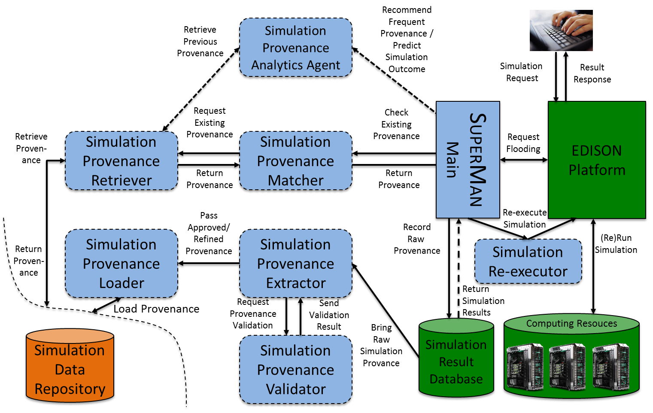
- Functional flow of the SUPERMAN framework, interacting the EDISON platform
(vii) Provenance-based Simulation Analytics provides a service for users to get more informed about their ready-to-run simulations, specifically with estimated job completion time, resource busy time, top-k processing with regard to popularity, job fail rate, and error detection based on provenances. Finally, (viii) Simulation Provenance Preservation provides a service of permanently storing provenances with actual simulation results in a separate repository for future access.
Fig. 3 shows an overall architecture of the SUPERMAN system. It consists of seven components to perform their respective tasks to collect and manage provenances from the EDISON platform.

Simulation Provenance Extractor
This component extracts the provenance of a completed simulation from the result database. For instance, the provenance covers Table 1’s information and some additional information such as input file size and simulation result paths obtained via Job Execution Framework of the EDISON platform. We also collect whether a simulation was success or fail for future analytics.

Simulation Provenance Validator
A collected provenance record is validated by another component, called Simulation Provenance Validator. Even if that record is correctly constructed, it may have an out-of-range or wrong value for an input parameter of a chosen simulation SW, compared with what values were provided for that parameter in the past. In this case we do not execute the requested simulation and cause a run-time error to the platform, subsequently notifying the user with that error. Once a provenance record is validated, then we send it to the next component to be described below.

Simulation Provenance Loader
Simulation Provenance Loader takes an approved record and converts it to the PROV-JSON file. It then stores the JSON file into Simulation Data Repository for future access.
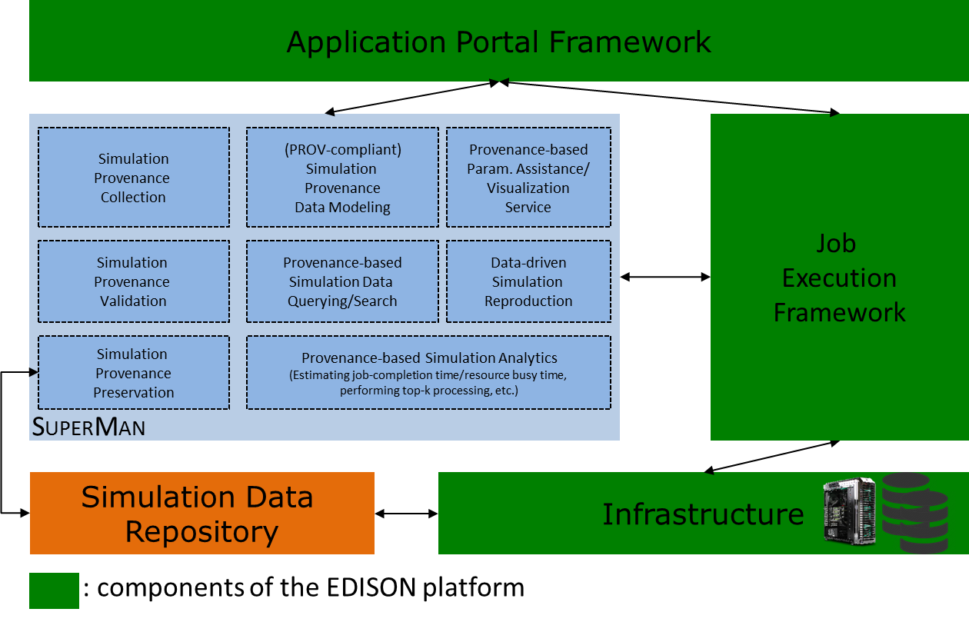
- SUPERMAN Architecture
To make the loading more efficient, we designed a Provenance Hash Table, termed PHT to eliminate duplicates of the PROV-JSON files stored in the simulation provenance repository. PHT is expected to improve the efficiency of management of provenance. Table IV details the steps taken to build PHT.
- Hash Table Construction Process for deduplication
Step. | Description
1 | If an input file is used in a given simulation, generate the hash value based on the file contents.
2 | If the simulation does not use an input file, generate a hash value based on the input parameter and values entered into a computing job.
3 | A combination of the hash values generated through Steps 1–2 is used as a parameter of a hash function to generate the final hash value to be used for a key for PHT.
4 | Once the given simulation is completed, the value of PHT is the output path and gets associated with the generated key in PHT.

Simulation Provenance Matcher
This component compares a new provenance record with existing records, returned from Simulation Provenance Retriever, to be discussed shortly, performing provenance retrieval along with matching conditions. The Matcher generates a hash key of the new simulation as described in Table IV. It then matches whether it is identical to that of any of the retrieved provenances. If so, then SUPERMAN returns existing simulation results back to the user.

Simulation Provenance Retriever
This component is responsible for retrieving the user-requested simulation provenance (parameter value) from the EDISON platform through Simulation Data Repository. Fig. 4 shows the retrieval process of the Simulation Provenance Retriever connected with the existing EDISON platform.

Simulation Provenance Analytics Agent
Simulation Provenance Analytics Agent can provide a variety of analytics service based on accumulated provenances.
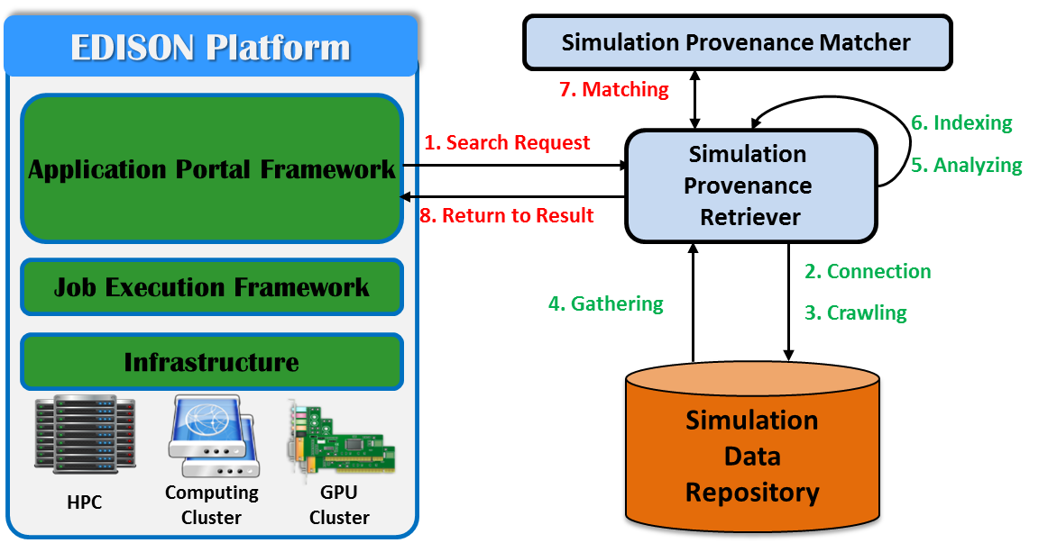
- Simulation Provenance Retriever’s process with EDISON
For instance, the Agent can recommend the most frequently accessed provenance records via top-k processing or estimate the completion time of a requested simulation based on past provenance records. We’re also considering detecting a potential error on specified parameters. These analytics will be provided with users for assistance when they carry out their simulations.

Simulation Re-executor
The last component is Simulation Re-executor, which allows the platform to recycle existing simulation results or re-run the simulations with altered parametric values. The Re-executor passes a selected provenance record to the platform, which in turns automatically loads into simulation parameters previously entered values extracted from the record. The user can run the simulation with the loaded values on the platform as they are, or change the values. Once the simulation is initiated, then SUPERMAN figures out whether a provenance of the requested simulation exists in the previous provenances. If so, then the results matching the provenance are immediately returned back to the user. Otherwise, the requested simulation is normally executed on computing resources via the platform. Certainly, its provenance is stored as a new record.
Simulation re-execution (reproduction) can be triggered from provenance search. Fig. 5 illustrates a flow diagram of how a user’s provenance search can reach simulation reproduction. A user selects a science app (simulation SW) on EDISON. The user queries the app’s simulation provenances matching a given condition. Subsequently, SUPERMAN checks if there’s any matching existing provenance(s) on the search. If no existing record is found then the user can keep making further inquiries on different conditions.
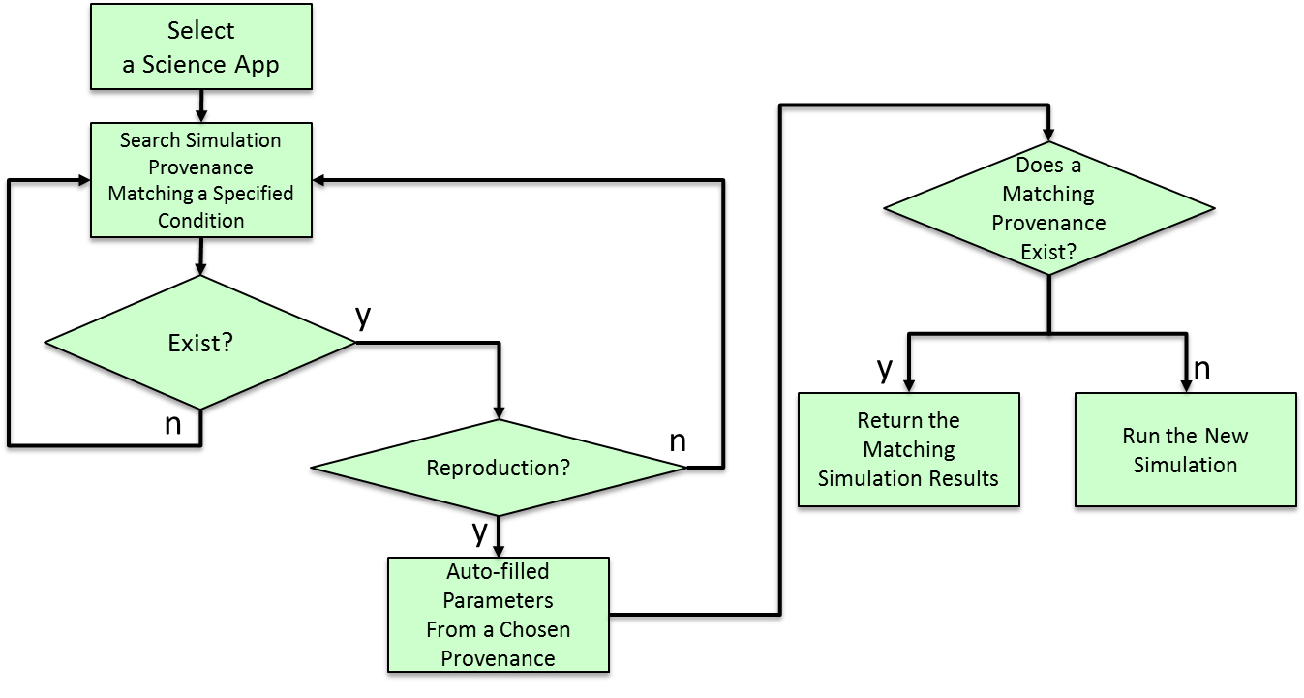
- A flow diagram of simulation-running with the aid of past proveances
But if any matching provenance(s) exists, a user can reproduce the same simulation from that provenance. That is, SUPERMAN passes the matching provenance, and then the EDISON portal automatically fills up parametric values extracted from the passed provenance for that user. It is totally acceptable for the user to run simulations with different input parameter values than the auto-filled values. In any case, once the user re-executes the simulation, then SUPERMAN snatches the request and determines if a provenance record associated with that request exists in the Simulation Data Repository. If so then, the associated simulation results are immediately reported back to that user. Otherwise, the new simulation is initiated and gets normally executed on the EDISON infrastructure. Again, upon the completion of the simulation, its provenance is captured for future use.

Related Work
Several HPC service platforms have been proposed to provide online simulation services in many diverse fields in computational science and engineering. WebMo [10] focuses on running simulations in chemistry. NEESHub [11] is a simulation service platform on which simulations regarding earth science are performed. NanoHUB [12] is a well-known platform to allow users to run nano-electronics simulations. None of these platforms is general-purpose. Also, they do not have any capability of storing completed results.
There is also a general-purpose platform, called HUBZero [13], working similarly to EDISON. This platform supports running simulation tools from a variety of computational science and engineering disciplines online. However, that platform does not consider utilizing provenances as opposed to our work. Table V shows how our work is distinguished from the two popular existing platforms such as HUBZero and nanoHUB. The support is expressed as O, X, and △. We specially chose these two because they function quite similarly compared to the EDISON platform on which SUPERMAN is applied. The EDISON equipped with SUPERMAN is expected to support (i) rerunning simulations on the same parameters with no actual execution on computing resources, (ii) sharing input/output files, (iii) retrieving existing simulation data matching a given condition on input parameters of a selected
- Comparison of SuperMan with HUBZero and nanoHUB
 | HUBZero | nanoHUB | SUPERMAN
Simulation Re-run | O | O | O
Input & Output Data Share | △ | △ | O
Simulation Provenance Retrieval | X | X | O
Parameter Assistance | X | X | O
Prediction of Sim.- Completion Est.- time | X | X | O
Sim. –Execution Pattern Analysis | X | X | O
tool, (v) estimating when to complete given simulations based on past provenances, and finally, (v) grouping input parameters on a given output for a researcher to quickly grasp what conditions to be provided.
A description of the function in table as item is as follows:
- Simulation Re-run: indicates whether to support re-execution of previously executed simulations. HUBZero and nanoHUB share simulation sessions using user, group, and email.
- Input & Output Data share: indicates the sharing support for the input data provided for executing the simulation or the output data produced as the result. nanoHUB can share the user name, user ID and e-mail, and HUBZero is an incomplete data sharing system because it must be uploaded directly to the project page of the simulation. But SUPERMAN can use the input and output files stored in the simulation provenance repository for other users.
- Simulation Provenance Retrieval: indicates a support for retrieving simulation provenances executed by another user and displaying retrieval result.
- Parameter Assistance: indicates a support for recommendation of appropriate parameters before running the simulation. Simulation Provenance Analytics Agent can recommend the most used parameters.
- Prediction of Simulation Completion Estimation time: indicates a support for estimating completion time based on provenances.
- Simulation Execution Pattern Analysis: indicates a support for analyzing what group of input parameters is frequently given on a chosen simulation tool. In this way, a user can be assisted when connecting to a platform. SUPERMAN can conduct this pattern analysis via provenance analytics.

Also, there are some simulation service systems providing capability to record simulation results. DataSpaces [14] exposes an abstraction for sharing simulation data. SciDrive [15] provides an interface to publish data like DropBox. Scibox [16] also uses an interface similar to DropBox to support sharing and storing simulation data in the cloud. An earlier research [8] supports reusing existing simulation results with its own format. As far as we know, these systems cannot or does not treat future requests using standardized provenances unlike the proposed system.

Conclusion and Future Work
In this paper we presented a new architecture, called SUPERMAN, to collect simulation provenances to make an online simulation platform more efficient and data-centric. The SUPERMAN system supports recording and searching simulation provenances. By doing the recording, the same simulation requests that have been captured before can be quickly served with existing results already executed before. Last but not least, this system is designed to independently work with the EDISON platform, so that the platform’s operation does not get interrupted by the proposed system, and vice versa. We plan to get the proposed SUPERMAN system to fully function with the EDISON platform and report how efficiently the system filters out duplicate simulation requests while the platform being in service.

Acknowledgements
This research was supported by the EDISON Program through the National Research Foundation of Korea(NRF) (No. NRF-2011-0020576).

References

- Young-Kyoon Suh, Hoon Ryu, Hanki Kim, and Kum Won Cho, "EDISON: A Web-based HPC Simulation Execution Framework for Large-scale Scientific Computing Software," in Proceeding of IEEE/ACM 16th International Symposium on Cluster, Cloud and Grid Computing (CCGrid 2016), May 2016, pp. 608–612.
- Jin Ma, Jongsuk Ruth Lee, Kumwon Cho, and Minjae Park, "Design and Implementation of Information Management Tools for the EDISON Open Platform," KSII Transactions on Internet and Information Systems, vol. 11, no. 2, pp. 1089–1104, 2017.
- W3C, "PROV-Overview," https://www.w3.org/TR/2013/NOTE-prov-overview-20130430/, viewed on April 28, 2017.
- Luc Moreau, Paul Groth, Jame Cheney, Timothy Lebo, and Simon Miles, “The Rationale of PROV,” Journal Web Semantics, vol. 35, no. 4, pp. 235–257, 2015.
- W3C, "PROV-DM," https://www.w3.org/TR/prov-dm/," viewed on April 28, 2017.
- ECMA, “Standard ECMA-404: The JSON Data Interchange Format”, https://www.ecma-international.org/publications/standards/Ecma-404.htm , viewed on May 8, 2017.
- W3C, "The PROV-JSON Serialization," https://www.w3.org/ Submission/2013/SUBM-prov-json-20130424/, viewed on May 8, 2017.
- Liferay, "Liferay Portal 6.2," https://web.liferay.com/products/liferay-portal/liferay-portal-6.2, viewed on June 1, 2017.
- Ki Yong Lee, YoonJae Shin, YoonJae Shin, YeonJeong Choe, SeonJeong Kim, Young-Kyoon Suh, Jeong Hwan Sa, and Kum Won Cho, "Design and Implementation of a Data-driven Simulation Service System,'' in Proceedings of the Sixth International Conference on Emerging Databases: Technologies, Applications, and Theory (EDB 2016), October 2016, pp. 77–80.
- J. Schmidt and W. Polik, “WebMO Portal (Chemistry),” http://www.webmo.net, viewed on June 3, 2017.
- T. J. Hacker et al., "The NEEShub Cyberinfrastructure for Earthquake Engineering,” Computing in Science & Engineering, vol. 13, no. 4, pp. 67–78, 2011.
- G. Klimeck et al., "nanoHUB.org: Advancing Education and Research in Nanotechnology," Computing in Science & Engineering, vol. 10, no. 5, pp. 17– 23, 2008.
- M. McLennan and R. Kennell, "HUBzero: a Platform for Dissemination and Collaboration in Computational Science and Engineering," Computing in Science & Engineering, vol. 12, no. 2, pp. 48–53, 2010.
- Docan, C., Parashar, M., and Klasky, S., "DataSpaces: an interaction and coordination framework for coupled simulation workflows," Cluster Computing, Vol. 15, No. 2, pp.163-181.
- Mishin, D., Medvedev, D., Szalay, A. S., Plante, R., and Graham, M., "Data Sharing and Publication Using the SciDrive Service," in Proceedings of Astronomical Data Analysis Software and Systems XXIII, 465, 2014.
- Huang, J., Zhang, X., Eisenhauer, G., Schwan, K., Wolf, M., Ethier, S., Klasky, S. "Scibox: Online Sharing of Scientific Data via the Cloud," in Proceedings of the 28th IEEE International Parallel & Distributed Processing Symposium, pp. 145-154, 2014.

