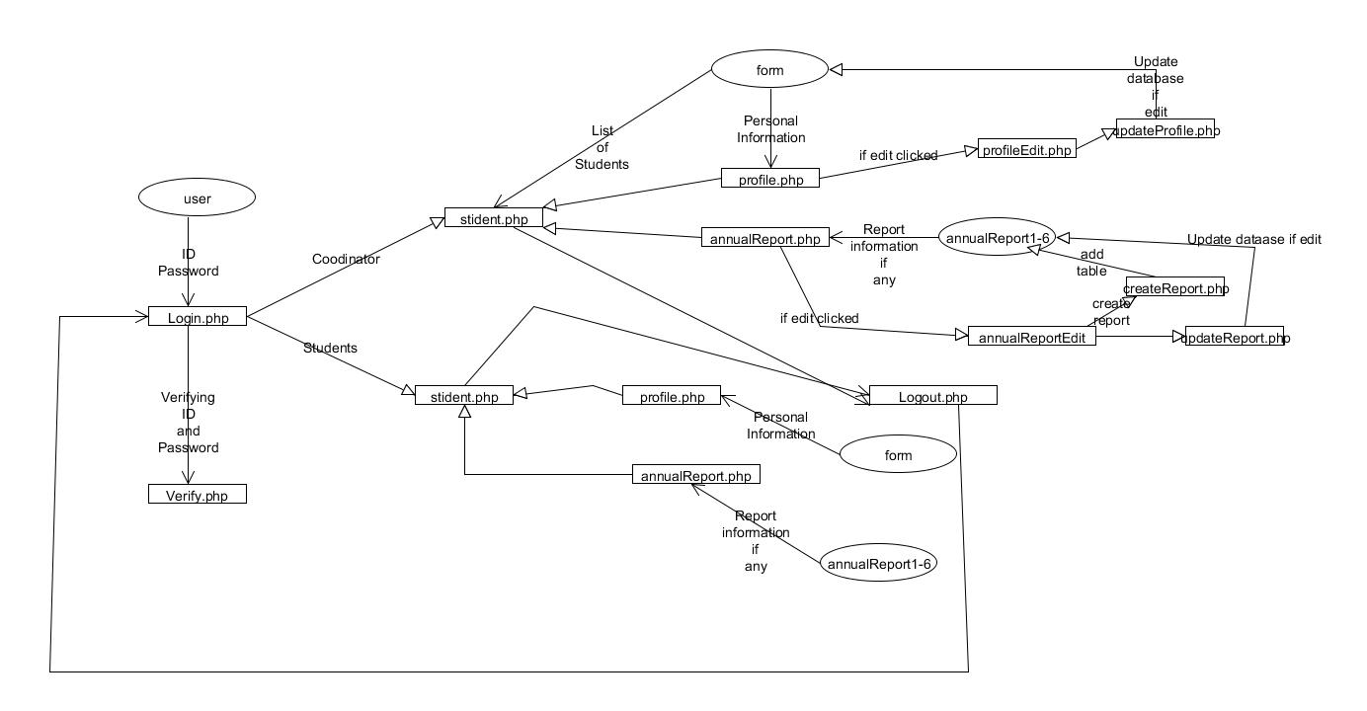

**Description**

Before logging in the user is asked to enter their Novell account information. The user is then sent to *login.php* which is the login page. The webpage will then ask for access to the user's webcam and geolocation. Once a username and password are inputted, *verify.php* will verify the information by comparing it to the *user* table in the database. Incorrect information will display the appropriate message whereas proper login information will send the user to *students.php,* as well as checking if the login is a student or a coordinator.

The login page also has a link to create an account for users who do not yet have one. This is a simple account creation page which adds the user information into the *user* table in the database. New accounts are set to student accounts by deafult. Only the website administrator can create coordinators. This is done by editing the database manually.

The *students.php* page provides all the necessary information. Those designated as "students" only have READ access to their own information. Users designated as "coordinators" have full READ/WRITE access to all student information, as well as the ability to view the information of all students in the database.

For coordinators, the *students.php* page will have a list of students on the left-hand side. Clicking a name will bring up that student's information. An AJAX request is sent and embeds *profile.*php of the appropriate student into the page. *Profile.php* contains a submenu with buttons linking to profile (which is selected by default) and annual reports 1 through 6 as well as a container. The “profile” submenu option sends an AJAX request which embeds *profileInfo.php* of the student into the container of *profile.php*; the data is taken from the *form* table of the database. Each of the annual report buttons link to their respective annual reports (which trigger a similar AJAX request which embeds *annualReport.php* into the container). If the selected annual report does not exist, the coordinator is given the option to create one. This is determined by checking the *form* table which has either a "1" or a "0" denoting that the form exists or does not. The annual report information is all found in the *annualReport* table of the database. If no annual report exists and the coordinator chooses to create one, they are sent to *createReport.php* which simply creates a new empty report and redirects to *students.php*.

Both the student profile and the annual reports have an "Edit" button which redirect to *profileEdit.php* or *annualReportEdit.php*. These allow a coordinator to update or add any relevant information to the profile or report. Once submitted, the user is sent to *updateProfile.php* or *updateReport.php* which update the information into the database and redirect back to *students.php*.

All users have the ability to log out by pressing the "Logout" button on the menu bar. This destroys the session, logging the user out, and redirects them back to *login.php*.