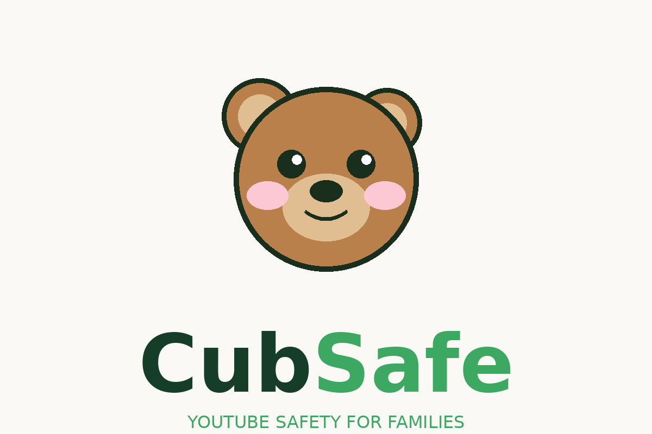
Founding Vision
Jerry Becker · April 2026

Your parents couldn’t prepare you for this one. But other parents can.

The Problem

Something happened around 2010 that no generation of parents before us has ever faced. Our kids were handed a screen — and on that screen was the entire internet, algorithmically curated to keep them watching as long as possible.

We became the first generation of parents raising kids in the digital age. And nobody gave us a manual.

Our own parents can’t help. They didn’t have to navigate this. There’s no generational wisdom to draw from, no cultural playbook, no grandparent who’s been there. When it comes to what our kids are watching online, we’re all figuring it out in real time — alone.

“I feel like raising my kids in the digital age is HARD...there’s no manual for this...there aren’t even ratings on YouTube to help me out.”
— Parent of a 12-year-old, in user research
YouTube is the television of this generation. 85% of parents say their child watches it. 50% say it’s every single day. Kids average 21 hours of screen time per week — more than double what parents consider ideal. And yet YouTube has zero content ratings for creators. Zero. A platform that a billion children use every day, and parents have no information to make decisions.

The existing parental control tools — Bark, Qustodio, Circle — manage devices. None of them reach inside YouTube and give parents the information they actually need: is this channel appropriate for my child?

Parents are frustrated. They feel like they’re losing a battle against an algorithm that’s designed to keep their kids watching, whether the content is good for them or not.

The Insight

When we sat down with parents and listened — really listened — something emerged that wasn’t in any competitor’s product.

Parents aren’t just trying to block bad content. They’re trying to raise good kids. And they’re already doing something remarkable without any tools to help them: they’re talking to each other.

“Do you let your kids watch MrBeast?” “What channels do you allow for a 12-year-old?” “My son keeps asking about this Clix guy — is he appropriate?”

These conversations are happening in school pickup lines, Facebook parent groups, and iMessage threads. Parents are crowdsourcing wisdom about digital parenting because there’s nowhere else to turn.

The village it takes to raise a child has always existed. It just hasn’t been built for the digital age yet.
That’s the insight at the heart of CubSafe. We’re not building a content blocker. We’re building the infrastructure for a generation of parents who need each other — and don’t have a place to find each other yet.

The Vision

CubSafe is the platform that helps families navigate YouTube together — from YouTube Kids all the way to independence.

Think of the gap that exists today:

- YouTube Kids serves children up to age 10 — heavily curated, age-appropriate, training wheels on.
- YouTube proper is the wild west — no ratings, no curation, the algorithm optimized for engagement not wellbeing.
- The gap between them — ages 10 to 15 — is completely unserved. Kids have outgrown Cocomelon but aren’t ready for the algorithm. Nobody is helping families navigate this transition.

CubSafe is that bridge.

The Graduated Experience

Rather than a static parental control, CubSafe grows with the child. As kids demonstrate responsibility and maturity, they earn more freedom — and parents have the data to make that decision confidently.

- Curated mode. Parent-approved channels only. Full control. Ages 10–11:
- Green-rated channels auto-unlocked. Parent sees everything. Child earns some autonomy. Ages 12–13:
- Amber channels unlocked. Parent gets a weekly digest instead of real-time alerts. Ages 14–15:
- Training wheels off. CubSafe becomes an optional advisory layer. Age 16+:

This isn’t a surveillance tool. It’s a trust-building tool. Kids aren’t locked out — they’re working toward earning more freedom. That’s a fundamentally different and more respectful relationship with the product.

The Community Layer

The real moat isn’t the rating engine. It’s the network.

When Parent A has spent six months curating an approved channel list for her 13-year-old, that work shouldn’t disappear. It should be available to Parent B, whose kid just turned 13 and is starting from scratch.

CubSafe makes that sharing structural — not accidental. Parents can browse approved lists from parents of similar-aged kids, import lists that match their values, and contribute back to the community over time.

The more parents join, the better it gets. That’s a network effect. And network effects are what turn useful apps into generational platforms.

“Your parents couldn’t prepare you for this one. But other parents can.”

The North Star Moment

Every great product has a moment it’s building toward. A scene so clear and specific that it motivates every decision along the way.

Ours is this:

A family sits down together on a Sunday evening. They open CubSafe on the TV. Mom, dad, and their 13-year-old are building their approved channel list together — the kid advocating for the channels he loves, the parents reviewing the ratings, negotiating, deciding together. It’s not a battle. It’s a conversation. And at the end of it, everyone feels good about what was decided.

That moment — a family navigating the digital world together, with trust instead of conflict — is what we’re building toward.

When we get there, we’ll pop the bubbly. 🍾

The Roadmap

Phase 1 — Know (Now)
- AI-powered content ratings for any YouTube channel
- Free for all parents, always
- Web-based, mobile-optimized
- Email waitlist for iOS app

Phase 2 — Control (Next)
- Native iOS app
- Curated channel feed — parent-approved content only
- Universal Links — YouTube links open in CubSafe
- Multi-child profiles with graduated access by age
- Instant channel blocking from the app

Phase 3 — Connect (Platform)
- Shared approved lists between parents
- Community curation — crowdsourced parenting wisdom
- School partnerships — institutional licensing
- Creator verification badges

Phase 4 — Monitor (Intelligence)
- Real-time alerts when new channels appear
- Weekly family content digest
- Smart TV and Roku apps
- Android support

What This Is Not

CubSafe is not a parental control app. Parental control apps are about restriction. They’re built on fear. They treat kids as problems to be managed.

CubSafe is not a surveillance tool. We’re not building something kids will resent and parents will feel guilty about.

CubSafe is not competing with Bark, Qustodio, or Circle. Those products solve device management. We solve something they can’t: the information gap, the trust gap, and the community gap that every parent of a 10–15 year old is living with right now.

CubSafe is a digital growing-up companion. For families. Built by a parent who lives this problem every day.

YouTube grows up with your kids. So does CubSafe.

Jerry Becker · CubSafe Founder · April 2026

