Close Enough — results tables from the powered run
Run ce_run_2026-09-05_v2. Target Qwen2.5-7B-Instruct, bf16 reference, τ = 0.7 with no top-p/top-k, 220 prompts (prose 40, code 60, arithmetic 40, Chinese 40, hard-verifiable 40), 8 generations per prompt on one RTX 5090. Judge claude-sonnet-5 (second family claude-opus-5 on 10%), judged 2026-09-05/06, 2,288 calls. Baseline for every measured arm is the mean of the two unmodified draws (reference, resample) on the same prompt; the resample row is the exchangeability test against the reference alone. Equivalence at the pre-stated bound of ±0.3 rating points is declared when the 90% confidence interval lies inside the bound (TOST, α = 0.05).

Table 1. Pooled quality deltas (n = 220 per arm)
Arm | Δ | 95% CI | Verdict at ±0.3 | s.d. | Derailed | Mean EAR
resample (bf16, null) | -0.05 | [-0.18, +0.08] | equivalent | 0.94 | 0.0% | —
speculative λ=1.0 (null) | +0.05 | [-0.06, +0.16] | equivalent | 0.84 | 0.9% | 0.950
speculative λ=0.2 | -0.02 | [-0.14, +0.10] | equivalent | 0.92 | 0.9% | 0.952
NF4 4-bit | +0.01 | [-0.10, +0.12] | equivalent | 0.84 | 1.8% | —
HQQ 3-bit | -0.70 | [-0.85, -0.55] | worse | 1.14 | 4.1% | —
exit d15, refill 16 | -1.07 | [-1.26, -0.87] | worse | 1.49 | 10.9% | —
exit d15, no refill | -1.67 | [-1.90, -1.43] | worse | 1.76 | 18.6% | —
EAR (expected acceptance rate, 1 − TV between draft and target next-token distributions, averaged over drafted positions) is recorded only in the speculative arms. Derailed is the judge's flag; the reference and resample arms had 0.0%.

Table 2. Quality deltas by domain (n = 40 per cell, 60 for code)
Arm | prose | code | arith | zh | hard
resample (bf16, null) | +0.07 [-0.21, +0.36] | +0.08 [-0.20, +0.36] | -0.03 [-0.08, +0.03] ≡ | -0.12 [-0.40, +0.15] | -0.33 [-0.72, +0.07]
speculative λ=1.0 (null) | +0.16 [-0.05, +0.37] | +0.06 [-0.10, +0.22] ≡ | +0.01 [-0.01, +0.04] ≡ | -0.14 [-0.42, +0.14] | +0.16 [-0.30, +0.63]
speculative λ=0.2 | -0.09 [-0.27, +0.09] ≡ | +0.04 [-0.17, +0.25] ≡ | +0.01 [-0.01, +0.04] ≡ | -0.31 [-0.58, -0.04] ↓ | +0.21 [-0.30, +0.73]
NF4 4-bit | +0.09 [-0.12, +0.30] ≡ | -0.06 [-0.31, +0.19] ≡ | -0.04 [-0.14, +0.07] ≡ | -0.16 [-0.42, +0.10] | +0.24 [-0.12, +0.59]
HQQ 3-bit | -0.46 [-0.78, -0.15] ↓ | -0.84 [-1.17, -0.52] ↓ | -0.09 [-0.29, +0.12] ≡ | -0.91 [-1.24, -0.58] ↓ | -1.11 [-1.54, -0.69] ↓
exit d15, refill 16 | -0.69 [-1.01, -0.36] ↓ | -1.02 [-1.45, -0.60] ↓ | -0.44 [-0.79, -0.08] ↓ | -0.66 [-0.95, -0.38] ↓ | -2.54 [-3.04, -2.04] ↓
exit d15, no refill | -1.16 [-1.47, -0.85] ↓ | -1.62 [-2.10, -1.15] ↓ | -1.24 [-1.88, -0.60] ↓ | -1.04 [-1.34, -0.74] ↓ | -3.29 [-3.84, -2.74] ↓
≡ equivalent at ±0.3; ↓ significantly worse; no mark = interval too wide to decide at this n. Arithmetic is at ceiling (every reference rated 7), so its judged cells carry little information; see Table 3.
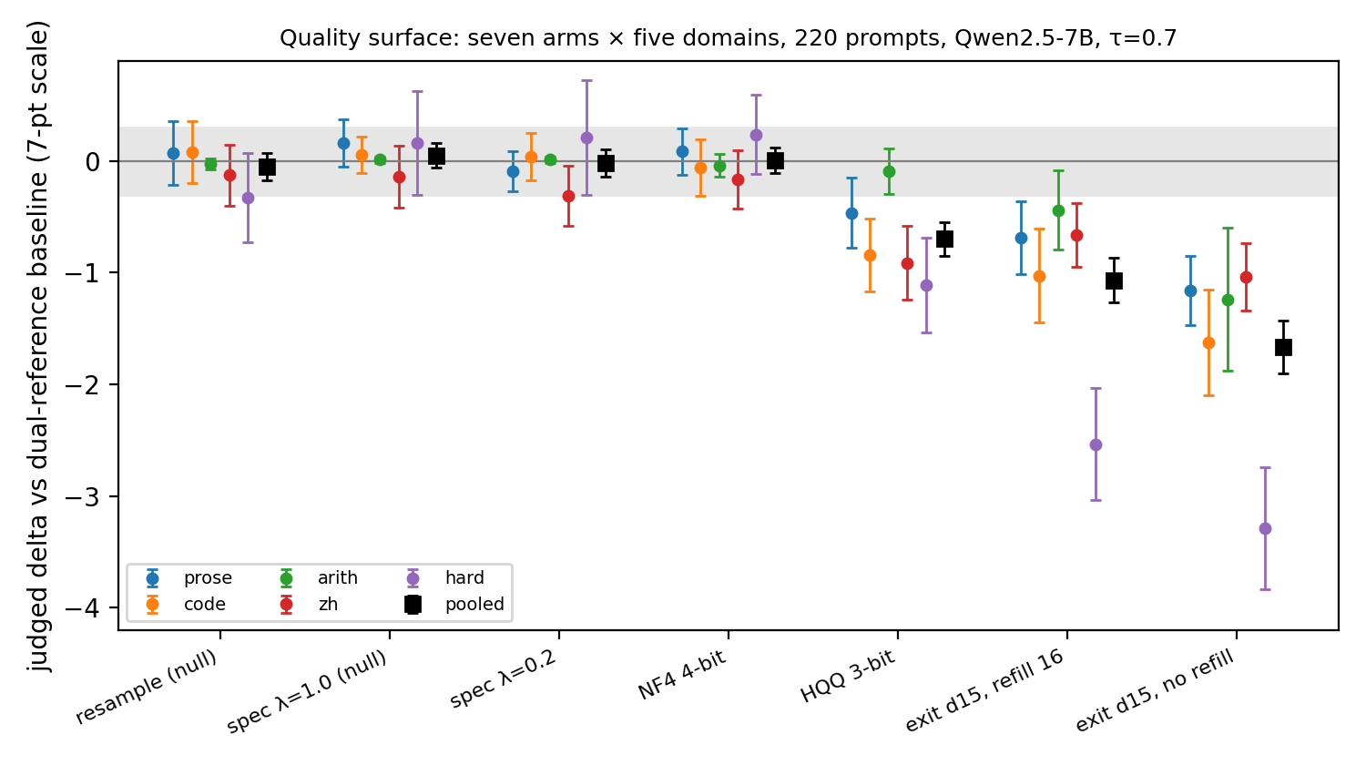
Figure 1. The quality surface: judged delta with 95% CI for each arm, by domain and pooled. Grey band is the ±0.3 equivalence bound.

Table 3. Execution-grounded correctness (hard-verifiable and arithmetic domains)
Arm | Math correct | Code items passing all tests | Code tests passed | Arith: same outcome as reference | Hard: same outcome as reference
reference (bf16) | 19/27 | 8/13 | 30/48 | — | —
resample (bf16, null) | 15/27 | 7/13 | 30/48 | 40/40 | 31/40
speculative λ=1.0 (null) | 18/27 | 8/13 | 29/48 | 40/40 | 31/40
speculative λ=0.2 | 18/27 | 9/13 | 37/48 | 40/40 | 30/40
NF4 4-bit | 18/27 | 6/13 | 27/48 | 40/40 | 35/40
HQQ 3-bit | 12/27 | 2/13 | 16/48 | 39/40 | 27/40
exit d15, refill 16 | 6/27 | 0/13 | 15/48 | 40/40 | 19/40
exit d15, no refill | 4/27 | 0/13 | 7/48 | 32/40 | 15/40
Math: 27 problems with a computed ground truth, checked against the "Final answer" line. Code: 13 functions run against 48 hidden assert tests in an isolated subprocess, after stripping the model's own asserts. "Same outcome" counts items whose correctness matches the reference's on the same prompt (the resample row is the same-model floor for that agreement).

Table 4. The instrument
Quantity | Value
Same text judged twice (n=352) | exact agreement 86%; within one point 100%; s.d. of difference 0.37
Judge-only s.d. per rating | 0.26 (variance 0.068)
Residual variance per paired delta | 1.66; judge share ≈ 8%
Prompt-effect ICC of deltas across arms | 0.12 (dual-reference baseline; 0.49 with a single reference in the August ladder)
Reference at ceiling (rated 7) | 68% pooled; prose 65%, code 78%, arith 100%, zh 50%, hard 40%
Paired-delta s.d. by domain | prose 0.95, code 1.41, arith 1.07, zh 0.96, hard 2.03
Second judge family (claude-opus-5, n=176) | mean |diff| 0.45; means 5.73 vs 5.37 (offset −0.36); Spearman ρ = 0.88
Judge rating vs execution check (hard, n=320) | 6.07 when correct (n=150), 2.45 when wrong (n=170); items wrong by checker yet rated ≥ 6: 0
Judge rating vs arithmetic outcome (n=320) | 6.89 when agreeing with reference (n=311), 2.33 on the 9 real errors

Table 5. Registered predictions and outcomes
Arm / claim | Registered | Basis | Measured | Verdict
resample (bf16, null) | 0.00 | exchangeability | -0.05 [-0.18, +0.08] | inside
speculative λ=1.0 (null) | 0.00 (|δ| < 0.05) | rejection-sampling proof | +0.05 [-0.06, +0.16] | inside
speculative λ=0.2 | −0.05 [−0.2, +0.1] | ladder pilot | -0.02 [-0.14, +0.10] | inside
NF4 4-bit | −0.10; zh −0.45 | noise/ladder pilots | +0.01 [-0.10, +0.12] | inside
HQQ 3-bit | −0.8 [−1.5, −0.4] | EAR ≈ 0.80 | -0.70 [-0.85, -0.55] | inside
exit d15, refill 16 | −0.55 | greedy anchor −0.59 | -1.07 [-1.26, -0.87] | OUTSIDE
exit d15, no refill | −1.00 | greedy anchor −1.05 | -1.67 [-1.90, -1.43] | OUTSIDE
Reference correctness, hard math | 20–23 / 27 | known bf16 errors | 19/27 | OUTSIDE
Reference correctness, hard code | 8–10 / 13 | — | 8/13 | inside
Quant./spec. arms within ±3 items of reference | yes | — | NF4 18/6, λ=1.0 18/8, λ=0.2 18/9 (math/code) | inside
Depth arms < 10/27 math, < 4/13 code | yes | — | 6/0 and 4/0 | inside
Judge under-reads depth-arm collapse on hard | −0.8 to −1.5 | proxy-failure hypothesis | −2.54 and −3.29 | OUTSIDE
Predictions were recorded in the analysis script before the run, with the anchors from the August pilots. The two early-exit misses share a cause: the pilots used greedy decoding and no verifiable domain; under sampling with the hard domain included the damage is roughly twice the anchor. The judge-under-reads miss is the informative one: the rating judge fully registered the correctness collapse, so the proxy-failure argument in the paper rests on the automatic measures, not on the judge.

