CYBORG MUTANT ZOMBIE CIRCUS
RULES v3.6
Welcome in interplanetary reality show Cyborg Mutant Zombie Circus! As an artifical being called Animatron your task is simple: survive in crazy doctor Morbid Bolíto’s labyrinth full of dangerous traps and savage monsters. Goal of the game is to successfully solve the Quests you will face in the labyrinth and get the fame and popularity among the millions of fans of the Cyborg Mutant Zombie Circus arena. To achieve this you can leverage the plenty of upgrades also occuring in the labyrinth: biological implants, huge arsenal of lethal weapons and crazy Voodoo rituals. The first player with sufficient popularity will be freed from the labyrinth and will be proclamated as a human able to vote and obligated to pay the taxes. And everybody wants that!

GAME CONTENT
- this rules
- 6 special CMZC dice (not included in print & play bundle)
- 6 Animatron cards
- 45 Quest cards
- 72 and 72 Voodoo cards
- 36 basic limb cards (18 Arms and 18 Legs)

SETTING UP THE GAME
Shuffle the decks with Upgrades, Voodoo cards and Quests. Reveal the first 3 Quests. Each player starts with an Animatron card, 2 Arms and 2 Legs. Also deal 2 Upgrades and 2 Voodoo cards to each player. Voodoo cards can be played anytime (including the opponents’ turns). On the other hand the Upgrades can be played only during your turn. Some cards require bone, hand or leg - if you don’t have free slots you may discard any cards from play to make them available. Animatron card provides 4 bone slots used for Hands (each providing a hand slot) and Legs (each providing foot slot).
Determine by your favorite way which player will start the game.

PLAYer turn
First you can play up to two Upgrades during your turn. If you play no Upgrades, you can discard any number of cards from your hand into the discard pile (so called recyclation).

After playing Upgrades you have to try to complete a Quest. You can choose any of Quests revelealed in play or you can try a random Quest from the top of the deck. After revealing new Quest from the deck this way, you cannot choose other one. When the last revealed Quest is completed, reveal three new Quests from the top of the deck.

After evaluating the Quest your turn ends by drawing Upgrades or Voodoo cards up to the card limit (which is 4 cards at the start of the game, however completing some Quests can increase it). You can draw any combination of Upgrades or Voodoo cards and there is no maximum limit of cards in the hand.

EVAluating the Quest
Each Quest requires passing the test of one of three Animatron’s attributes to be completed. These attributes are power, speed and intelligence. Value of the attribute is determined by amount of specific symbols on the cards in play. On the start of the game, each Animatron has power 2 (provided by Arms), speed 2 (provided by Legs) and intelligence 1 (provided by Animatron card).
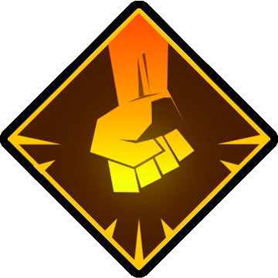 | power | 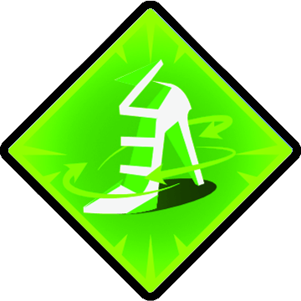 | speed |  | intelligence
If your attribute has zero value, you cannot try to complete revealed Quest requiring testing it.
When testing the attribute, roll with so many CMZC dice according to the value of the attribute. After rolling, any player can reroll or modify the result using their Upgrades or Voodoo cards. Cards used for modifying the result can be used again for only after the beginning of it’s owner’s next turn.
If any player already unsuccessfully tried to complete the test and therefore there is a popularity token on it (see Fail result below), it can be removed to reroll one die.
The time interval when the result can be modified is determined according the difficulty of the game: for beginners – 10 seconds, for advanced players – 5 seconds, for experts – 3 seconds after last modification (depends on common agreement of your game settings).
Each die rolls one of these results:


- Epic success – mutually eliminated with one tragic fail, otherwise it
beats over all fails
- Double success – counts as
2 standard success results

- Success – mutually eliminated by
one standard fail
- Boring – neutral result

- Fail - mutually eliminated by one
standard success

- Tragic fail – mutually eliminated with one epic success, otherwise it beats over all success results (including the double success)
In case when no player can or want to modify the result, determine the final result:

Success
Congratulationz! You have passed the test and completed the Quest! Move the Quest card next to your animatron card. You will get popularity points or your card limit is increased or both in some cases according to the symbols on Quest card.

FAIL
Ow sh*t! I have a bad feeling about this… The Quest remains available for other players and reward is increased: put a popularity +1 token on it. Now you must discard your Upgrades (or basic limbs) from play with an amount of lives on them according to the penalty for failing on the Quest card. Attention! If you have no lives, you die! (See Death of an Animatron.)
 |  |  | live
BORING
If all results are eliminated or boring, nothing happens. You have not completed the test, but you will not lose any part of your body, which is not so bad, after all. Also reveal one more quest from the top of the deck to keep audience engaged. Boring result is automatic when your attribute is zero (when trying to complete the random quest from the top of the deck).
Death of an animatron
If you lose all your lives, do not despair! Dr. Morbid Bolíto will turn you into the Zombie by his evil Voodoo magic. Discard all cards from your hand and your turn ends without drawing any. Turn your Animatron card on the other side. Zombie gets penalty of -2 popularity and has no intelligence! Instead of playing and Upgrade, you can regenerate one Arm or one Leg. If Zombie player should lose more lives than they can discard from play, they lose all lives, discards all cards from their hand and the turn ends without drawing any. In case of 2 player game, Zombie draws the cards normally.




Card symbols



requires available provides bone,
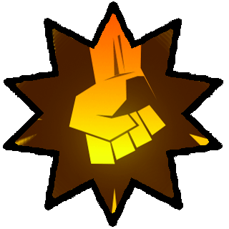
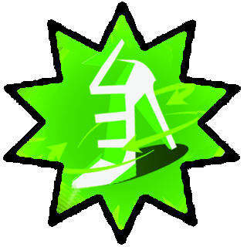

bone, arm or leg slot arm or leg slot

can be used only during power,
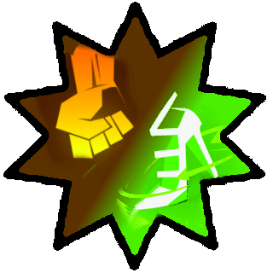
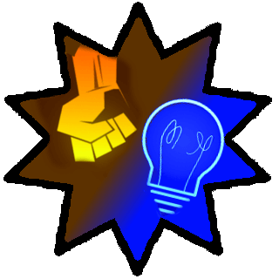
speed or intelligence test



can be used only in only for power or
power or speed test intelligence test
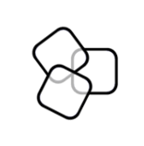

once per game round you may reroll one, up to two or up to three dice in your test
(according to the number of dice inside)

in case of red arrows, you can reroll a
die even in opponent’s test

set manually specific
result on the die
remove one die

any result
increasing power, speed or intelligence
(adding die to test roll)


Card effects differentiates between general symbols and dice results (with borders).
adds an epic success to the result – cannot be
reset or rerolled, but can be eliminated by:

GOAL OF THE GAME
The game ends immediately when any player gets 10 popularity points. In case of 4 or more players game, it is enough to get 7 point to win. In that case accept our warmest congratulationz!!! You will be released from the labyrinth and in next episodes of our reality show we will inform about your attempts of integration to „normal“ human society.
GAME VARIANTS
Can be combined (use at your own risk):
- TACTIC: you can play only one Upgrade during your turn
- CHAOTIC: shuffle the Upgrades and Voodoo deck together
- HARDCORE: you cannot reroll die by removing extra popularity token
- TEAM PLAY: recommended for 4 and required for 6 or 8 players game, the pairs sitting in opposite are playing together as teams and final common score for winning is 13 popularity points

