ECE6845 Assignment 2
Zeyu liu

- Generate a 256x256 2-D complex white Gaussian random field.
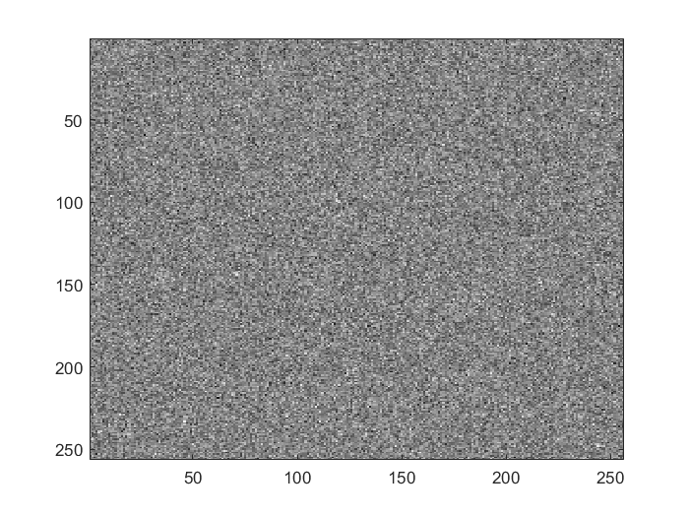
1.1 complex white G real
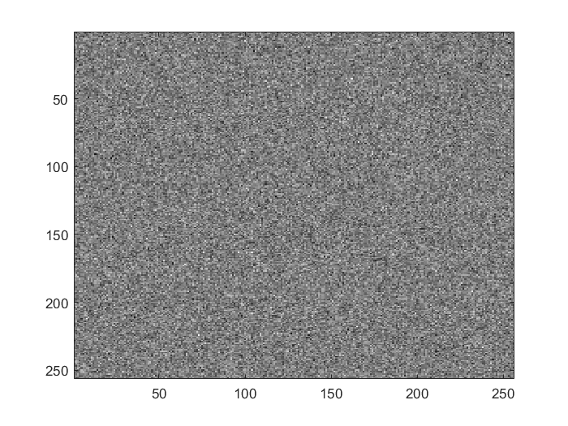
1.2 complex white G imaginary
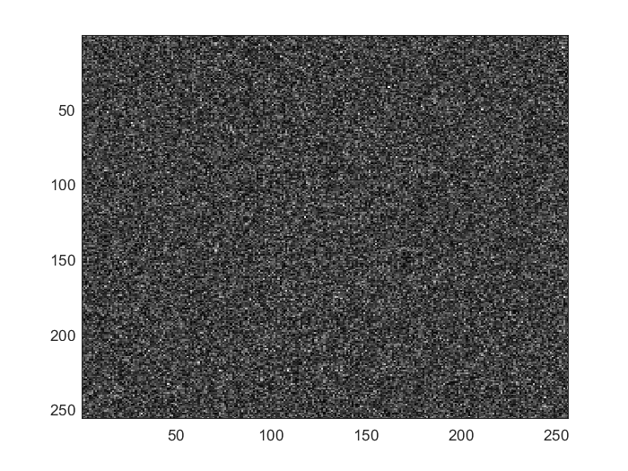
1.3 complex white G magnitude
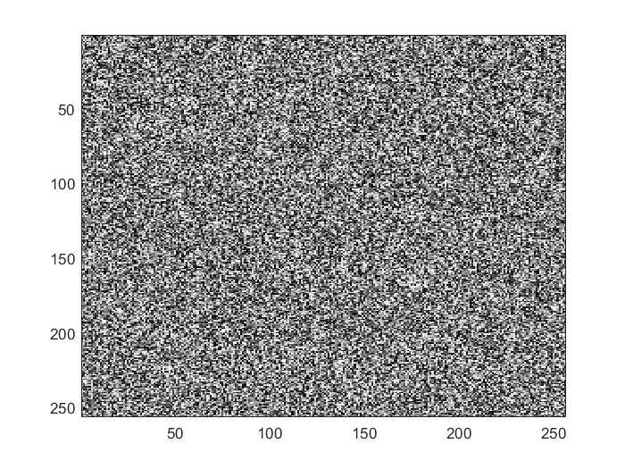
1.4 complex white G phase angle

- Apply 2-D FFT to the complex Gaussian random field you generated in the above. Is the image (real part) you obtained after FFT different to the one you generated in Part 1? Why?

Solution: The image real part after FFT is different to the one I generated. Although the two images look like similar, the real part of complex Gaussian random field after FFT has changed by FFT. After the FFT, it create a new complex Gaussian white noise image.
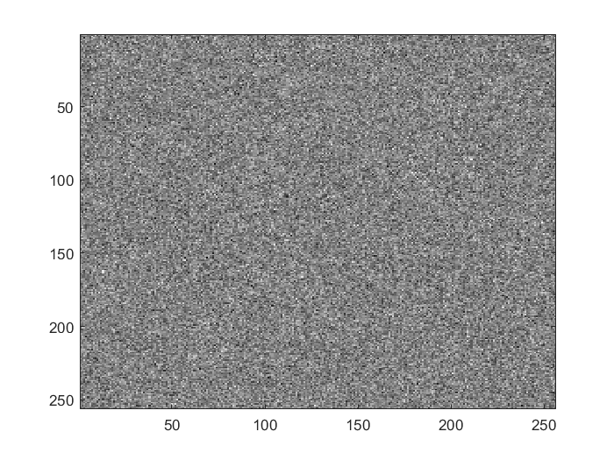
2.1 Apply 2-D FFT complex white G real
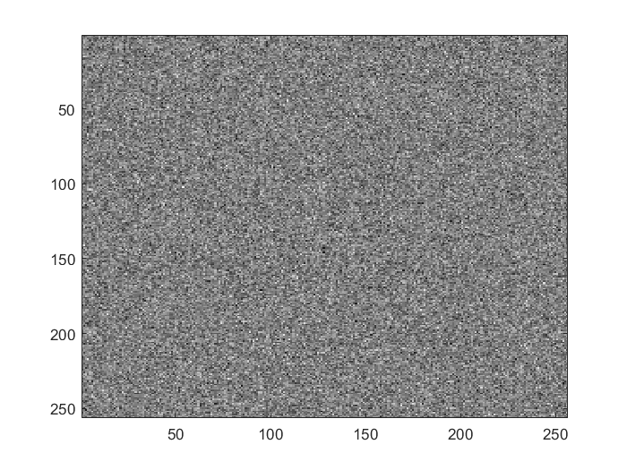
2.2 Apply 2-D FFT complex white G imaginary

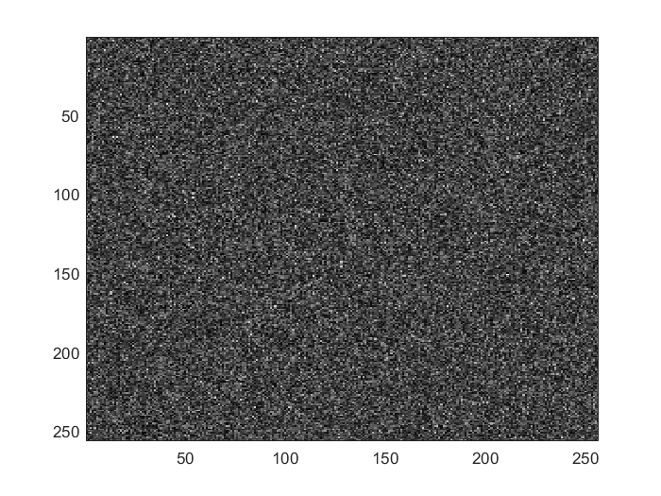
2.3 Apply 2-D FFT complex white G magnitude

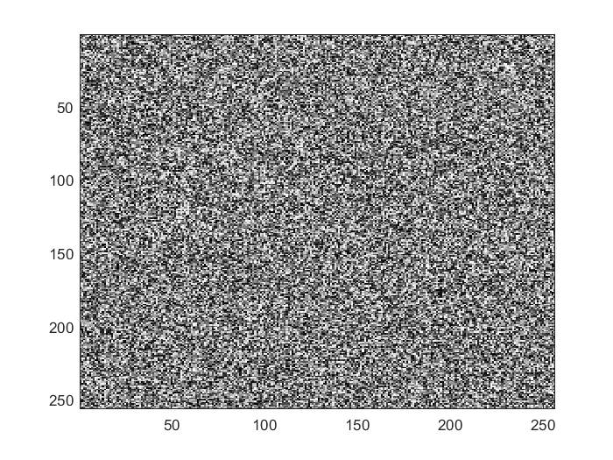
2.4 Apply 2-D FFT complex white G phase angle

- Repeat the experiment in Part 3 with real white Gaussian random field. Is there any difference in the appearance to the FFT of complex white Gaussian? Why?

Solution: Although the two picture looks same. There is difference in the appearance to the FFT of complex white Gaussian. Their original signals are different. The complex white Gaussian has two Guassian noise signals and the real white Gaussian random field only use the real part to do FFT.

3.1 real white G

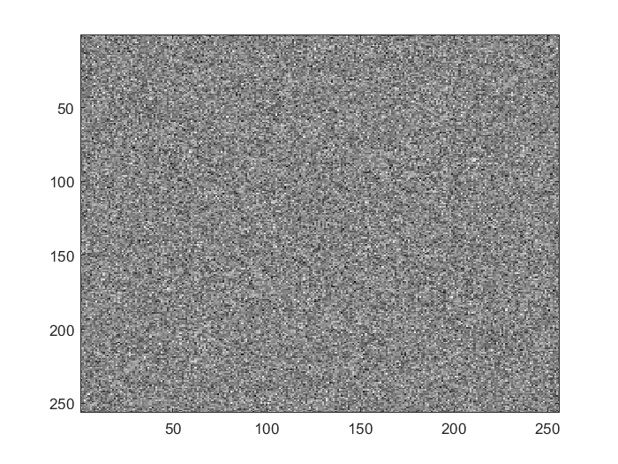
3.2 Apply 2-D FFT real white G real

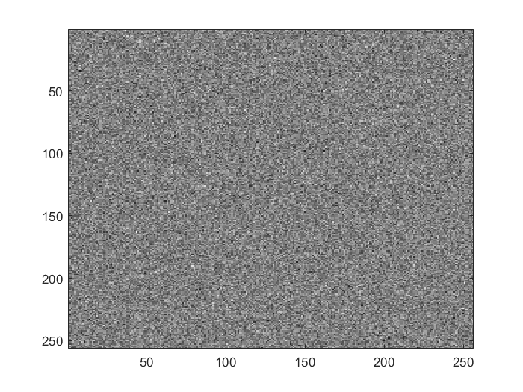
3.3 Apply 2-D FFT real white G imaginary

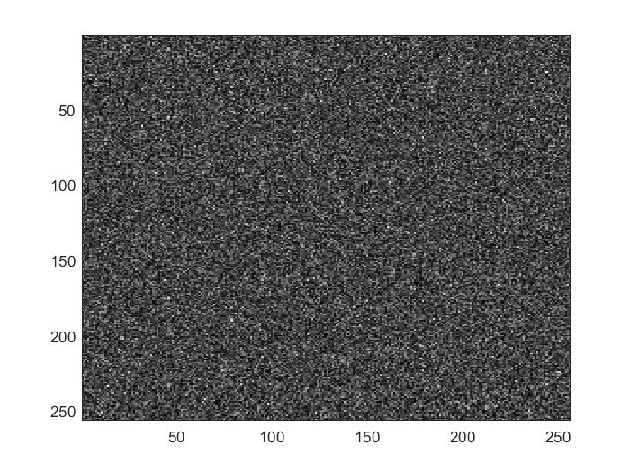
3.4 Apply 2-D FFT real white G magnitude

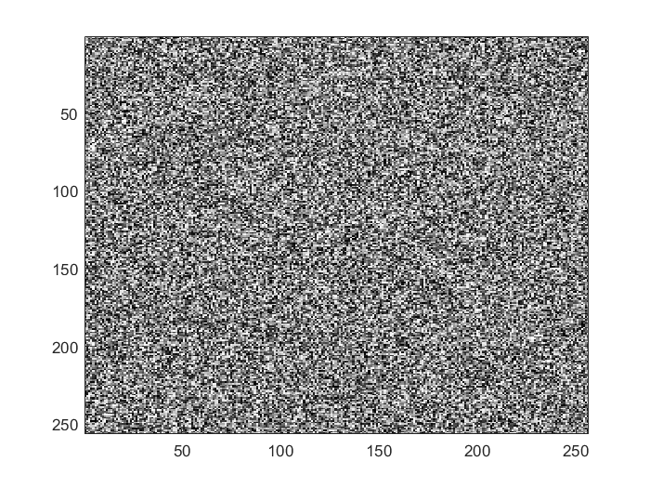
3.5 Apply 2-D FFT real white G phase angle

- Apply the FFT of the images you generated in Assignment 1. Are the images you obtained after FFT real? Why?

Solution: the images obtain after FFT is not real, because it has imaginary part in picture 4.2, it has phase angle in picture 4.4.

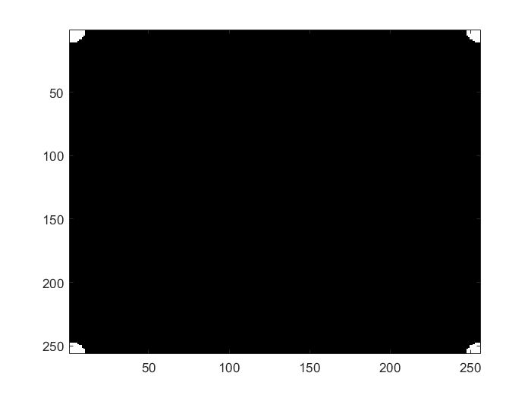
a

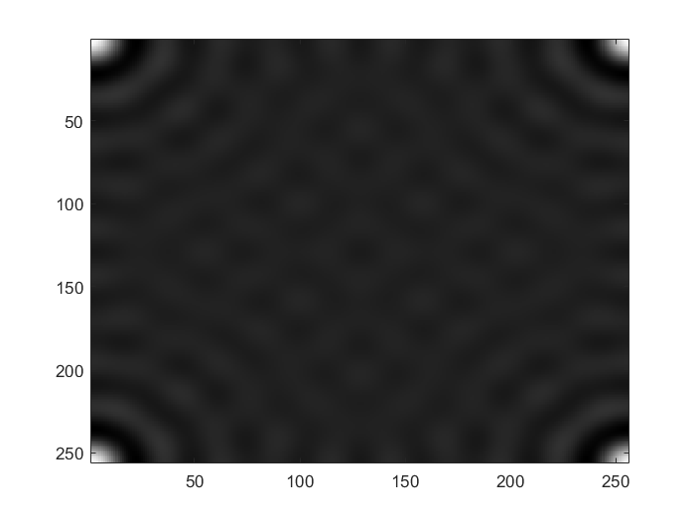
4.1 real

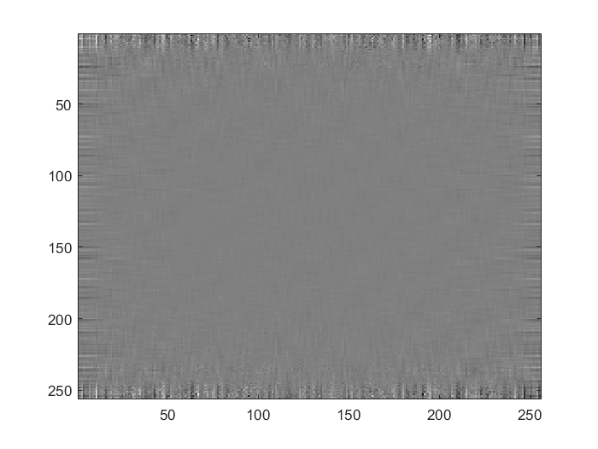
4.2 imaginary

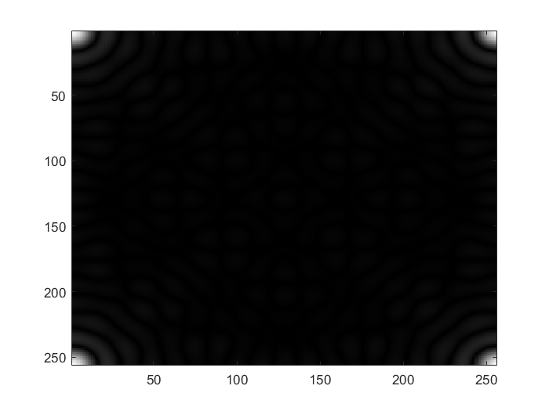
4.3 magnitude

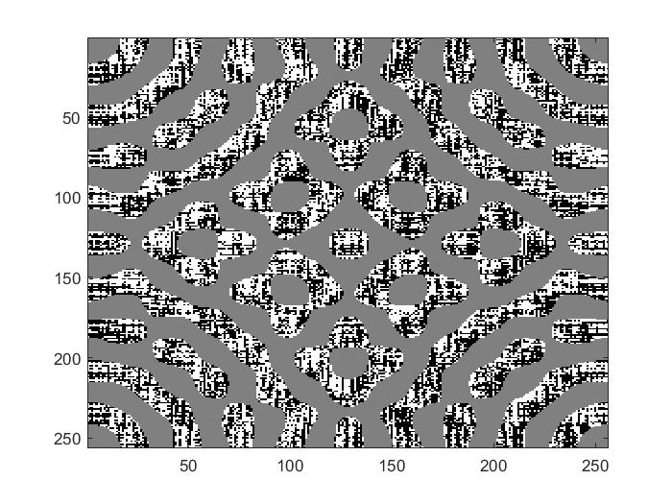
4.4 phase angle

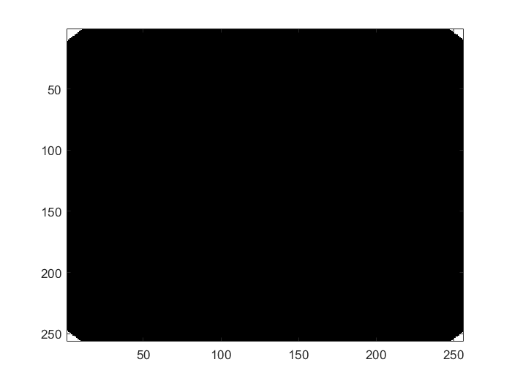
b
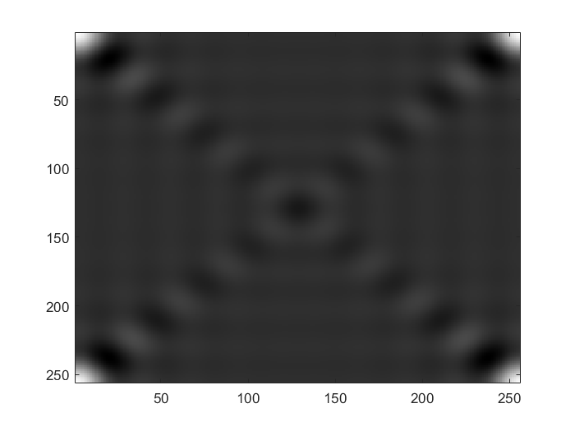
4.1 real

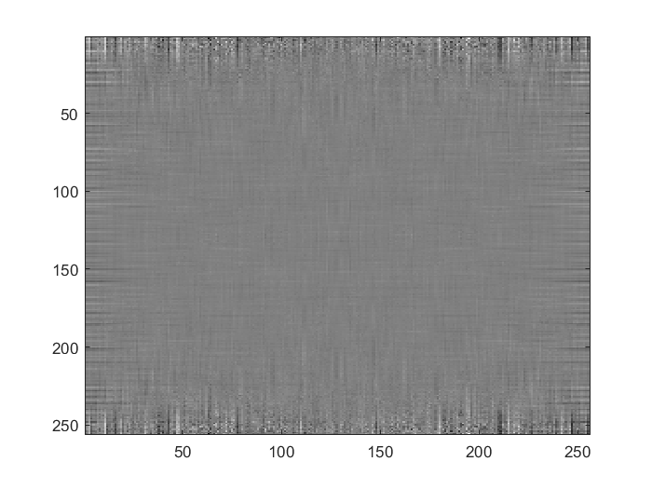
4.2 imaginary

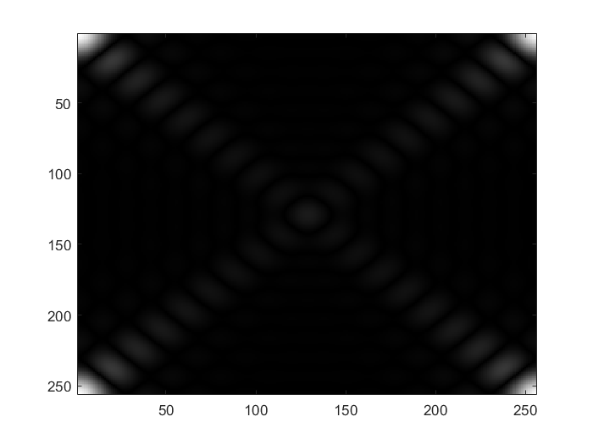
4.3 magnitude

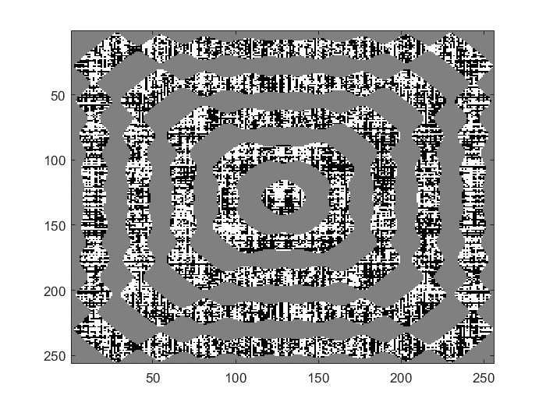
4.4 phase angle

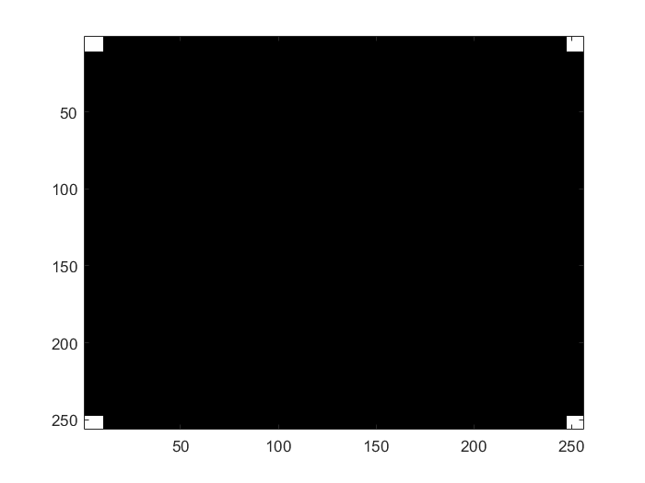
c
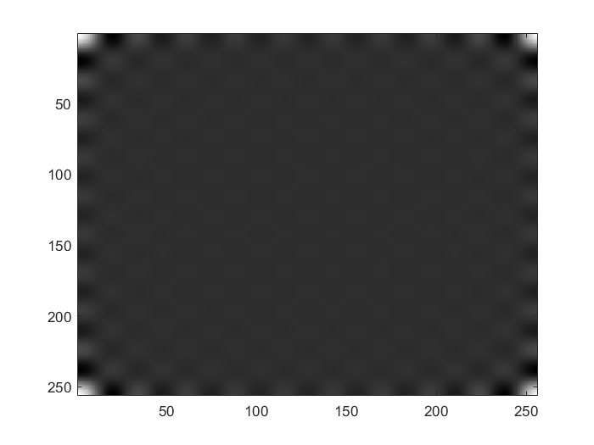
4.1 real

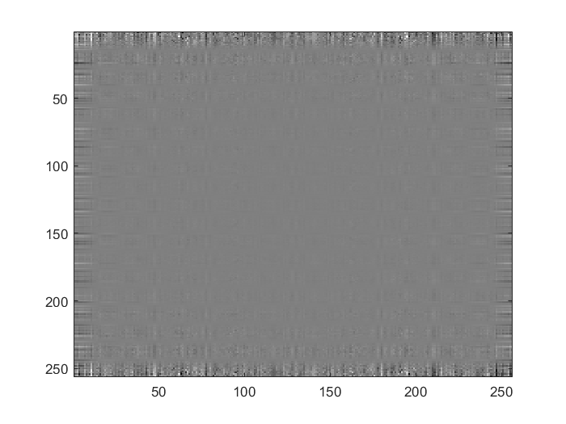
4.2 imaginary

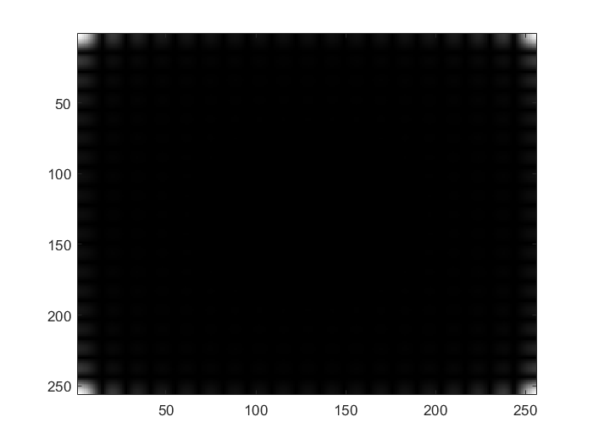
4.3 magnitude

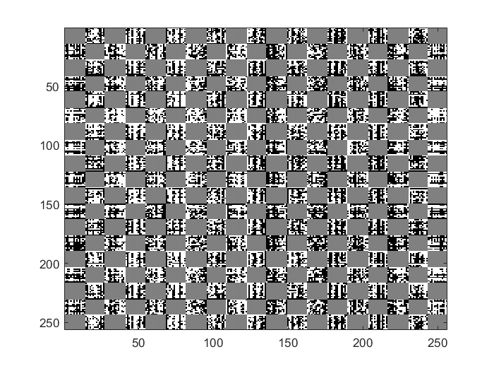
4.4 phase angle

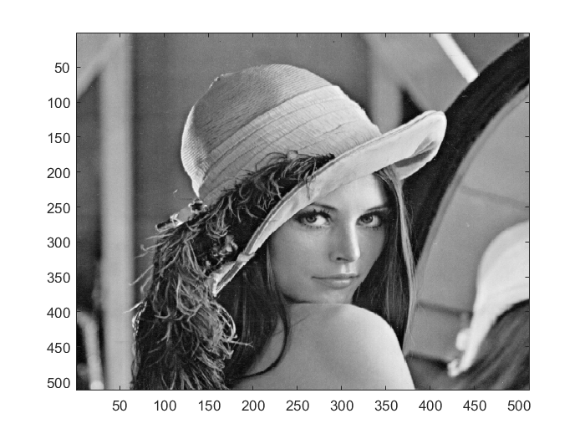
d FFT for lena
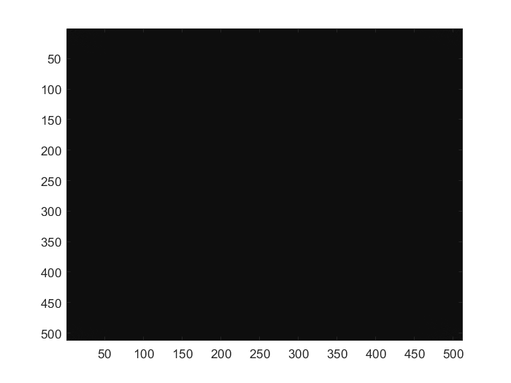
real

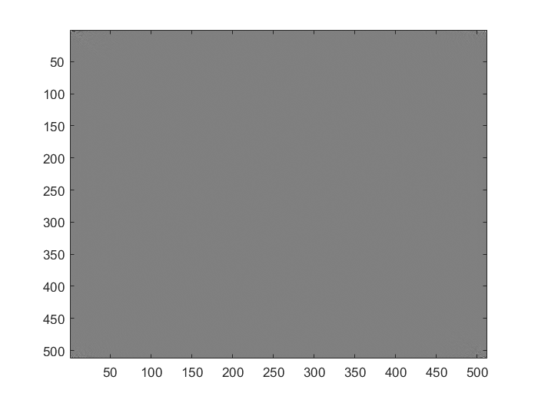
imaginary
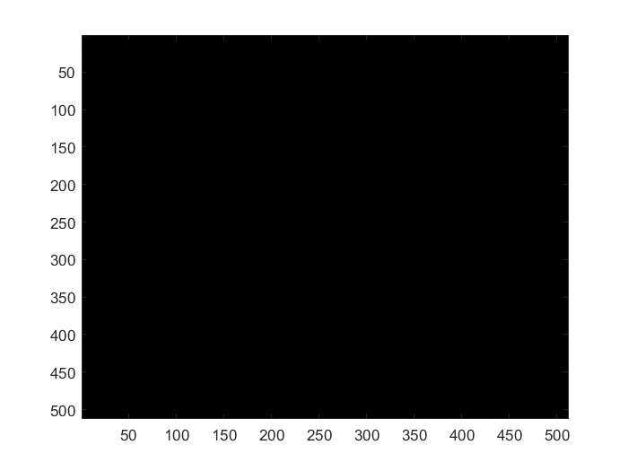
magnitude
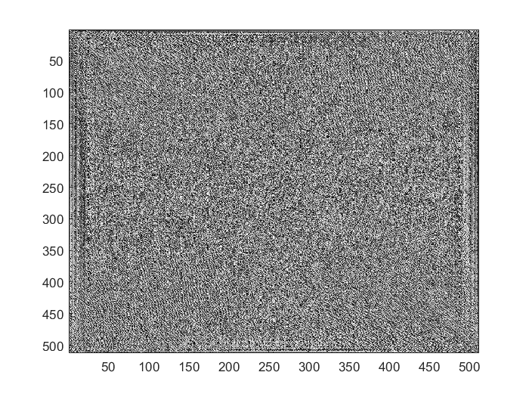
Phase angle

