ECE 6845 Assignment 1

Zeyu Liu

- Download ‘Lena’ image (Lena.bmp) from Blackboard



- Write a Matlab program that reads, displays and write image, and test it with ‘Lena’ image.

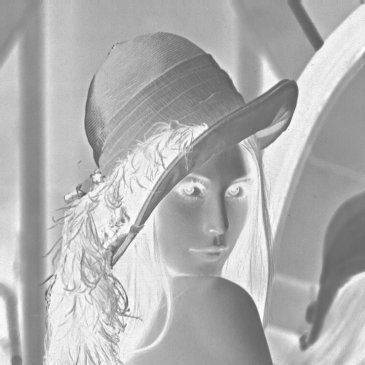

% Homework1: Exercises in reading and writing images
% Zeyu Liu
% 1/29/2019
function homework1

% Read an image
f = imread('lena.dib');

%Use gray(256) colormap
colormap(gray(256));

% Display image f to screen
imagesc(f);
pause;

% Find number of rows and numbers of columns
[M,N] = size(f);

% Create a blank (all-zero) image
g = zeros(M,N);

% Copy image f and invert then write to g
for m=1:M,
for n=1:N,
g(m,n) = 255 - f(m,n);
end;
end;

% Display inverted image
imagesc(g);

% Write inverted image to a file
imwrite(g,gray(256),'lena inverted.bmp');

- Generate a 256x256 image having the following intensity (gray) pattern:

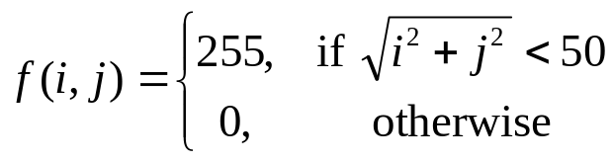

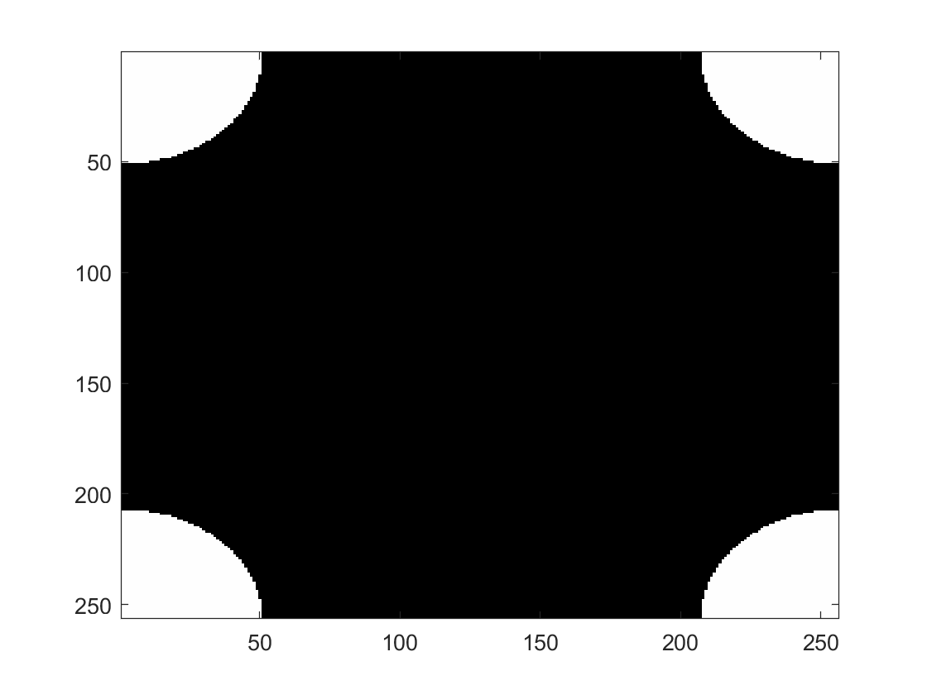
% Generate a 256x256 image with a disk of Euclidian distance
% measures
function disk_gen

N = 256;
R = 50;

fE = zeros(N);

for m=1:N,
% m1 is a variable having positive and negative values
if (m>N/2) m1 = m-1-N;
else m1 = m-1;
end;
for n=1:N,
% n1 is a variable having positive and negative values
if (n>N/2) n1 = n-1-N;
else n1 = n-1;
end;
% compute Euclidian distance from the origin
distE = sqrt(m1^2+n1^2);

% if pixel is within a disk of radius 50, then color it white
if (distE<R)
fE(m,n) = 255;
end;
end;
end;

colormap(gray(256));

image(fE);

- Repeat for the following pattern:

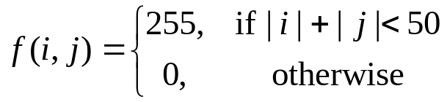
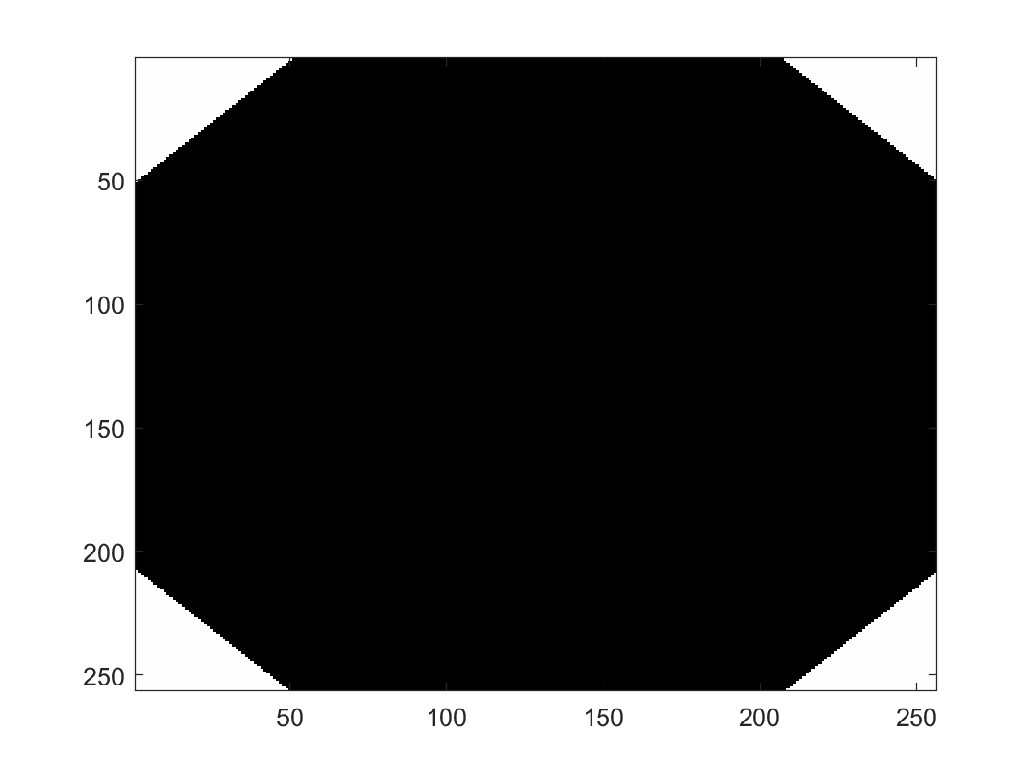
% Generate a 256x256 image with a disk of City-block distance
% measures
function disk_gen

N = 256;
R = 50;

f4 = zeros(N);

for m=1:N,
% m1 is a variable having positive and negative values
if (m>N/2) m1 = m-1-N;
else m1 = m-1;
end;
for n=1:N,
% n1 is a variable having positive and negative values
if (n>N/2) n1 = n-1-N;
else n1 = n-1;
end;

% compute City-block distance from the origin
dist4 = abs(m1)+abs(n1);

% if pixel is within a disk of radius 50, then color it white
if (dist4<R)
f4(m,n) = 255;
end;
end;
end;

colormap(gray(256));

image(f4);

- Repeat for the following pattern:

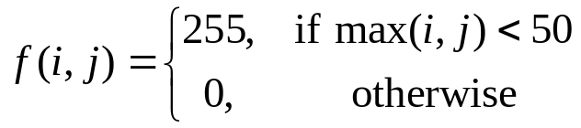
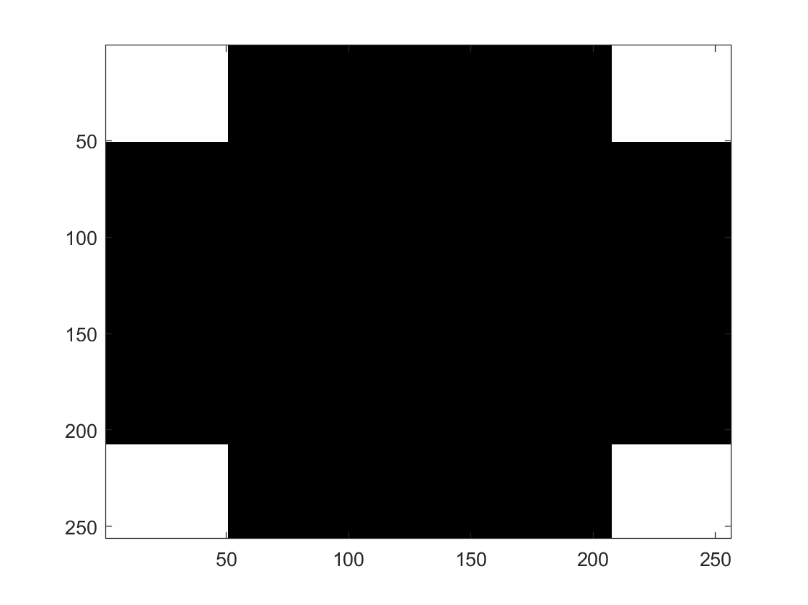
% Generate a 256x256 image with a disk of Checkboard distance
% measures
function disk_gen

N = 256;
R = 50;

f8 = zeros(N);

for m=1:N,
% m1 is a variable having positive and negative values
if (m>N/2) m1 = m-1-N;
else m1 = m-1;
end;
for n=1:N,
% n1 is a variable having positive and negative values
if (n>N/2) n1 = n-1-N;
else n1 = n-1;
end;

% compute Checkboard distance from the origin
dist8 = max(abs(m1),abs(n1));
% if pixel is within a disk of radius 50, then color it white
if (dist8<R)
f8(m,n) = 255;
end;
end;
end;

colormap(gray(256));

image(f8);

*I use one function “disk_gen” to solve the 3,4,5 problems, I separate it in three here.

