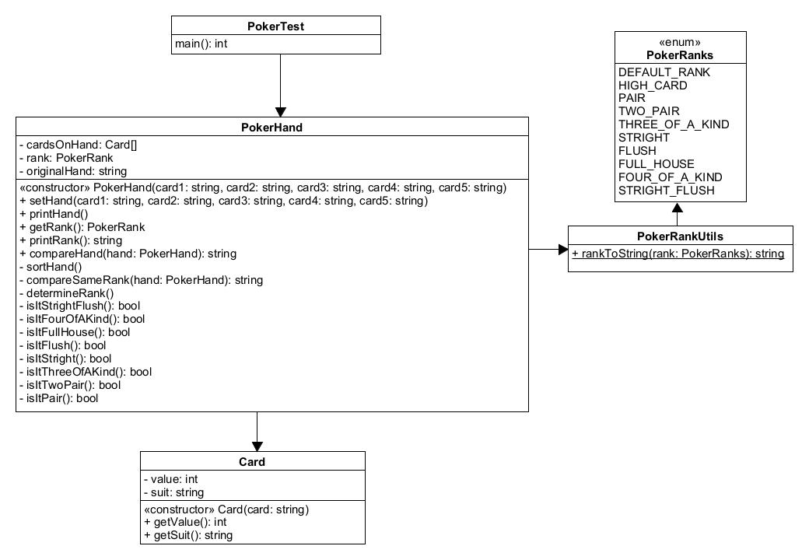Jerry Wang

Assignment 3 Poker Hand

OOP with C++, JHU

2/18/2024

**Section 1 Design:**

**Overview:**

**Attributes:**

**Behavior:**

**Section 2 Code:**

**Section 3 Test Results:**

Test Cases:

Test set 1: Valid test of each hand rank. 9 test

Test set 2: Valid test of comparing hand of the same rank. For every possible variation. 11 test

Test set 3: Valid test of comparing every rank. 36 test

Test set 4: invalid input test: too many input. too little input. Outside of the range of card value. Outside of range of card suit. 5 test