# Executive Summary

Supply Chain Operating Networks (SCONs), driven by financial transactions, are beginning to overlap on the capabilities offered and the industries served creating an environment where end-users are required to adopt multiple systems based on the segment of the supply chain they are in and the industry they serve (or hope to serve). As leading adopters of supply chain visibility systems expand beyond the transactional systems offered in SCON solutions and move to a digital world powered by sensors and connected products, assets and shipments (Internet of Things) a robust network with the ability to link transactional data to event based data will be required to increase the visibility of these assets and shipments in the SCON’ at the individual part level.

Achieving the future state for end-to-end supply chain visibility through a Supply Chain Network of Networks (SCNoN) requires developing and improving capabilities in three broad areas addressed in this proposal: (1) digitally interfacing systems of different parties across supply chain networks, (2) integrating sensor based supply chain events with existing transactional data capabilities of ERP systems and, (3) developing integrated supply chain (SC) modeling and simulation tools for demonstration of the impacts on the proposed SCNoN architecture design.

The mission of the proposed digital SCNoN is to provide a seamless, standardized digital integration across the different parties of the supply chain network with corresponding process and data models. The SCNoN will drastically increase the efficiency in data exchange, improve the utilization of SC Visibility Systems across large and small organizations by reducing the time and complexity to implement, improve computational capabilities and reduce data load, and increase the level and velocity of visibility across the network with granularity at the product and shipment levels. The proposed data exchange standard will enable collaboration between the different stakeholders at all stages of the supply chain network at every individual product level (item, case, pallet, shipment).

The goal of the project as proposed by the multidisciplinary University/Industry collaborative team is to:

1. Develop and publish an end-to-end solution architecture with supporting analytics for Supply Chain Visibility (SCV) that is scalable to support multiple industries, all supply chain stakeholders regardless of size, and enable future technology capabilities.
2. Identify the current supply chain standards for SCV, the existing solutions in the market, and document the technical/functional gaps between standards, solutions and needs.
3. Show a working software solution where supply chain events from either a Value Added Network (VAN) or a Heterogeneous Distributed Network are utilized to trigger business transactions in a traditional ERP.
4. Demonstrate the use of real-time information for visibility across the supply, demand and internal operations to provide users with the ability to make trade-off decisions to maximize profit.

Project deliverables will provide DMDII and its members, including the DoD supply chain, ***interoperable SCON systems that will enable seamless data exchange across multi-tier supply chains to provide greater visibility*** and, therefore, better responsiveness to improve not only individual corporate performance but also overall supply chain performance.

# Technical Approach

## Problem Statement and DMDII Relevance

The global supply chain is a complex and dynamic set of interactions and trade-offs between suppliers, manufacturing, warehousing, carriers, and customers to deliver the right product, at the right time, in the right condition. The data to support trade-off decisions to maximize profit, not just minimize costs, are spread across the global supply chain with ownership of the systems and underlying data varying based on the type of decision being made. The maturation of Electronic Data Interchange (EDI) has enabled automated transactional messaging between trading partners Enterprise Resource Planning (ERP) systems. The emergence of Supply Chain Operating Networks (SCON) has extended the availability of transactional data across members of the SC network based on the movement of goods. However, the value derived and success of SCON systems is directly proportional to the level of participation by a given industry sector or trading group. As companies, both big and small, venture in to new industries and sectors the ability to support multiple networks for supply chain visibility is both inefficient and costly (Heaney, 2014)***. The Internet of Things (IoT) will transform traditional supply chains to digital supply chains driven by sensors indicating events in the network, not transactions; this transformation change will require a new set of solutions to marry transactional and event based data.*** The creation of a framework and set of standards for a “Network of Networks” to support integration of best of class supply chain visibility solutions, at the sensor level, is critical in connecting the underlying data sources for not only transactional but also event data.

**Business case for this problem:**

* Improve Work Process Efficiencies and Reduce SG&A
* Reduce Transportation and Accessorial Spend
* Provide visibility of where the product is located within the SC network
* Reduce Inventory across all trading partners
* Improved Customer Service
* Provide the framework for a Multi-Enterprise Orchestration Technology Platform

The development of such a framework extends beyond a single supplier or network of suppliers. As such the adoption and involvement of DMDII will be crucial for promoting the proposed framework making it the standard and technology of choice for next generation supply chain management (SCM). This proposal aims to develop the framework and demonstrate its efficiency and feasibility in the specific scenario of physical distribution. A concerted effort between the DMDII and the team would be needed to build a community of early and key adopters around the proposed framework and the underlying standard in the physical distribution area as well as upstream in areas such as supply and production.

The aim of the proposed project is in direct alignment with the vision of DMDII of addressing gaps in digital manufacturing with innovative and sustainable solutions. The proposed project will also not be possible without the technical and financial support from DMDII allowing for a broader scope engagement from all the academic and industrial partners involved in the project. This partnership will afford a practical, industrial strength solution to a critical problem in SCM that utilizes the latest research and technological trends. Furthermore, the partnership will also enable the development of an educational component that will facilitate market penetration of the proposed technology through the necessary research and educational content development (seminars, publications, project based courses, and related online content). This educational effort will help extend the impact of the proposed project beyond its funding cycle and lead to further enhancement and improvement phases.

## Methodology

We propose to develop a SC Network of Networks (SCNoN) that will improve supply chain visibility at the physical distribution level. Figure A illustrates some of the complexities of the steps involved in the physical distribution in a simple scenario from The Dow Chemical Company; these become several magnitudes higher when the exchanges involve several participants, multiple transactions and multi-mode shipments.

### *Figure A: Physical Distribution Complexities*

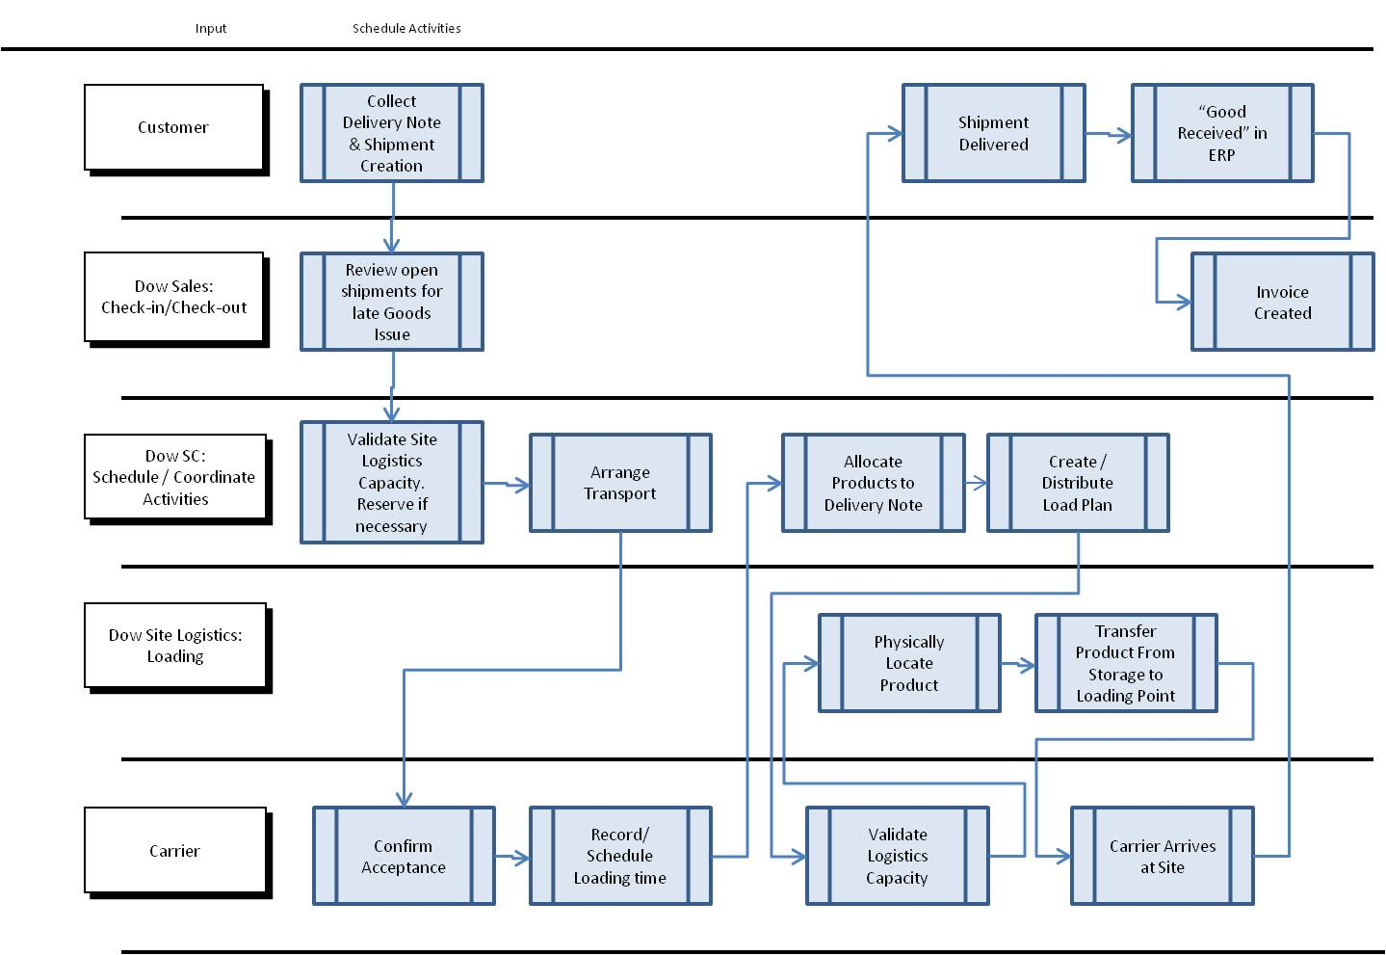

The current best practice for physical distribution is to rely on SCON - or traditionally a Value Added Network (VAN) - for the exchange of documents, using EDI, in order to digitize the document thread required by the accounting and warehousing transactions involved in the distribution chain.

Furthermore, the consensus is that the current transactional layer is not sufficient to support the recurrent requirements for supply chain visibility and that a real-time information layer is needed to overcome these limitations [Kinaxis, 2014]. However, there is no clear consensus around the best approach to address the community need for supply chain visibility [EFT, 2015].

### *Figure B: Document Exchange Cycle*

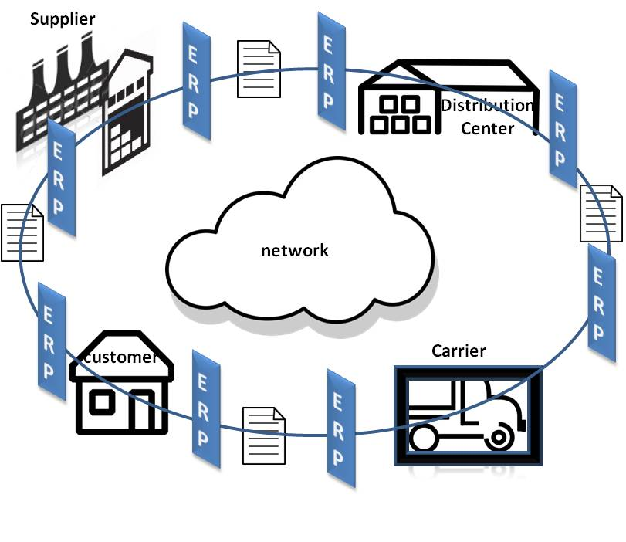

The scope of this project is to deliver the pseudo-real time status of the shipment and provide a better visibility of the physical distribution of goods. This granularity level and the fact that the aforementioned shipment status can be updated repeatedly while in transit makes the above architecture, data model, exchange format and framework limited in handling the volume and velocity of the exchanged data.

The required SC visibility will be delivered through a versatile stack of layers (Figure C). The proposed SCNoN will use a JSON-based light weight data exchange format to explore two network architecture options:

* a heterogeneous distributed network.
* a value added network design around SaaS (Software as a Service) cloud computing model.

The proposed network architecture options will have to accommodate the volume and velocity expected when the real-time status of the shipment (and the products in the shipment) are tracked. Furthermore, the architecture of the SCNoN will need to be scalable and promote interoperability. These features are essential in order to close the gap in SCM that is being addressed.

Each of the SCNoN layers, functionality and contribution to delivering supply chain end-to-end visibility is discussed in the next section.

#### Common Data Model Layer

As previously mentioned, while EDI may be efficient for document exchange, it is not suitable for the traffic volume and velocity anticipated in the delivery of the real-time status of goods in today’s physical distribution environments and global economy.

***Data Exchange Format***

When selecting the data exchange format we evaluated XML and JSON. Both have advantages and disadvantages. JSON is the emerging standard in data exchange format. XML has been in use for more than a decade and was a major enabler of web services applications [Ben-Miled, 2004]. Both data exchange formats can be compared from various aspects. Both XML and JSON are simple, open, and support a high level of interoperability and self-describing data. While XML is good for document exchange, JSON is better at supporting the exchange of data objects. Indeed, XML is a document markup language while JSON is a data exchange language.

JSON is lighter weight, more scalable and would be better suited for this project due to the anticipated large volume of traffic between the participating suppliers, carriers, and customers. This is particularly important when the granularity of the data exchanged moves from the container or pallet level to the individual product level.

### *Figure C: Framework Architecture*

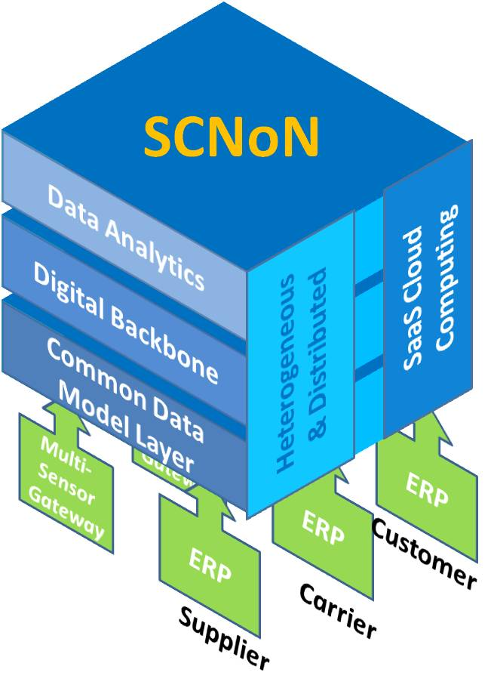

***Data Exchange Standard***

The proposed digital thread solution is the creation and use of cross-domain, common digital surrogates of various stages of a product’s journey in a SCN, contemporaneous assessment of the product’s current location status and future possibilities to inform all stakeholders of the current state of the shipment. This increased visibility resulting from connecting the underlying data sources for not only transactional but also event data will ensure the sharing of critical milestones, external events and traditional transactional data sources at the sensor level. Such data needs to be transformed into meta-object data representation to support both in-bound and out-bound movements under different conditions and scenarios between multiple SCN ERP systems, in other words the need is for interoperability.

***A key component of the proposed research is to establish the standard for data exchange*** that would promote interoperability between the various the supply chain participants. This standard will be developed in three phases with each phase engaging a wider audience and leading to more community buy-in. The DMDII members will play a major role in building sector wide consensus around the defined standard.

#### Digital Backbone

Several SCON (supply chain operating networks) facilitate the exchange of transactional documents between different members of the SC. The SCON model is suitable for transactional document exchange. The key question is scalability for large volumes of data, collected from a large number of sensors, being exchanged in real-time among various supply chain participants. One of the ***contributions of this project is to investigate the practical advantages and disadvantages of a centralized SaaS cloud model of SCONs versus a heterogeneous distributed network***. These two options are shown across the three layers of SCNoN in Figure C.

#### The Heterogeneous Distributed Backbone

While the majority of EDI still occurs via dedicated EDI Networks, or Value-Added Networks (VANs), the recent flexibility and affordability of public networks such as TCP/IP may be changing this trend. Currently, and until convergence, some companies may still implement a hybrid strategy, where two or more networks are used for different purposes. However, in the near future, the public networks and their various underlying access technologies (e.g., WIFI, GPRS, GMS, LTE, and VANET: Vehicular Ad-hoc Network) may become the message delivery technology of choice due to the economies of scale.

The emerging trend of the public network as a replacement for Value-Added Networks will require the development of matching services and functionalities provided by the VANs, including secure communications, authentication of all messages, identification of a counterpart, tracking of messages and many other auxiliary services. The development of these functionalities for public networks is being driven by the explosive volume of data in emergent P2P services and business models such as A2A (Application), B2B (Business), D2D (Device) and M2M (Machine). It is expected that this explosive data behavior associated with the increasing response time constraints will render legacy VANs unable to respond to these demands and would lead to a migration or a convergence of VANs towards public networks.

Given the above trend, the potential for implementing SCNoN using current public networks under a distributed heterogeneous model of networks will be prototyped. These public networks already include a variety of services and protocols fitting the demands of data exchange necessary for the proposed framework, including Secure Socket Layer, IPSec and Virtual Private Networks. The proposed open source framework will use TCP/IP and JSON to send real time messages relating shipment status to various stakeholders. The network logic can be compared to the RSS feed where different customers receive frequent updates from various sources. Except in this case the feed is originating from the various sensors via the participants’ gateways.

Figure D shows the architecture of the SCNoN and its interaction with the ERP of a supplier. A similar configuration will be used for the other supply chain participants including carriers and customers. A sample transport process (Figure A) would begin with the product in the supplier’s loading area. This is normally reflected by a set of transactions that adjust the warehouse inventory and generate necessary shipping documents (e.g., packing list, copy of PO, etc.). For the purpose of SC visibility, an event should also be generated and forwarded to the outgoing queue in the SCNoN.

Event handling and event queues are well supported in most of today’s ERPs (e.g. SAP, Oracle, IFS , etc.) and their configuration for this purpose would require minimal effort. The event in the outgoing queue will then be picked up by the wrapper shown in Figure D. The wrapper will need to fetch and extract the needed information and generate a single message in the JSON data exchange format. The resulting message will be forwarded to the parties involved in the shipment including the end-customer.

As the carrier picks up the order and loads it on the transportation vehicle, a second event is generated by the relevant sensor (location in the example outlined below but could be other environmental statuses or events), formatted in the proposed data exchange format and also forwarded to all parties involved including both the supplier and the customer. This data exchange would have to be augmented by the current status of the shipment (e.g., onboard in this case) in addition to the initial data provided by the supplier.

### *Figure D: Heterogeneous Distributed Backbone*

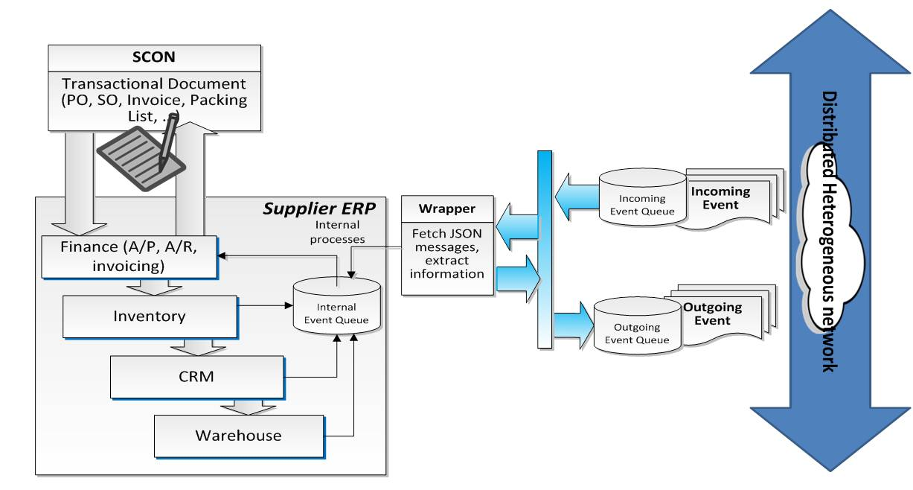

The sensor management gateway would format the incoming GPS signal in the proposed common data exchange format and forward the associated message, representing the event, to all the parties involved. While this approach requires more collaboration and more transparency from all parties, preliminary investigation indicates that it is the option of choice because it would eliminate duplicate processing at the recipient levels and it would maintain the integrity of the message. It will also improve the security of the data exchange network.

The on-board message is not only processed internally by the carrier but also sent to the supplier and the customer enabling both to start having complete visibility on the shipment of the order. The sensor will continue to send status updates while the shipment is en-route. So far, we have assumed a push technology for data exchange. With real-life scenarios we will also explore the potential efficiency of a pull technology where the recipient (e.g., customer or supplier) would request the status update from the carrier’s sensor management gateway.

The onboard message from the carrier will be received by the supplier, processed by the wrapper and placed in the internal ERP event queue. The supplier can then use this event to trigger the necessary transactions according to the processes in place within the organization.

The interfaces shown in Figure D will be developed using Java. The choice of this language is based on its wide base community and its support from most of the vendors which facilitates interoperability and promotes the open paradigm being proposed in this project. In addition, JSON and Java are highly compatible and are both backed by several open source libraries, utilities, parsers, and translators that can be reused for this project.

#### The SaaS Cloud Computing Model

The SaaS Cloud Computing Model is also an emerging trend where software is managed centrally and is delivered under a one-to-many model. The purpose of this activity in the project is to investigate the potential for SaaS to deliver scalable supply chain visibility at the product level. The proposed digital thread, under a SaaS Cloud Computing model, will also seamlessly integrate information throughout the entire SCNoN from suppliers’ ERP systems through Carriers’ sensor data. All these capabilities will enable sharing the contextualized information in a bi-directional flow of digital information.

Under this model, Siemens’Teamcenter will be used as the digital back-bone for managing the communication between the sensor and transactional event data coming from both internal and external ERP systems and multiple partners on different SCN’s, for executing the SC models developed to make decisions on actions and forwarding the associated message, representing the action, to all the parties involved.

Siemens’Teamcenter will be configured to store information obtained from the different stages of a SCN and to handle the communication of such data between various stages and the models for selected objective computation and subsequent decision support. Furthermore, as in the distributed heterogeneous model, the data coming from both local ERP systems and sensors needs to be transformed into the proposed common data exchange format.

Although Teamcenter is proprietary software, it will use the data exchange standard and model derived in this project and therefore will demonstrate the potential adoption of the open data exchange standard by software vendors for the purpose of developing a commercial end-to-end visibility solution for SCM, thus enabling cross-vendors/cross open-source interoperability. Furthermore, this model will also help evaluate the practicality of the SaaS cloud computing model for the delivery of pseudo-real-time supply chain visibility.

#### Data Analytics

A key benefit of the proposed SCNoN and resulting supply chain visibility is the potential for an effective and real-time analytics layer with value added diagnostic and descriptive view of supply chain processes [Titze, 2015]. Currently, supply chain strategists and decision makers are struggling with the widening gap between volume and velocity of the data and tools available to analyze this data [Tohame, 2015].

The design and implementation of the Analytics layer for this project will use the common data model and tie together supply chain information into a format that can be used with KPIs and analytics to improve the responsiveness of the business.

### *Figure E: One View Cloud Architecture*

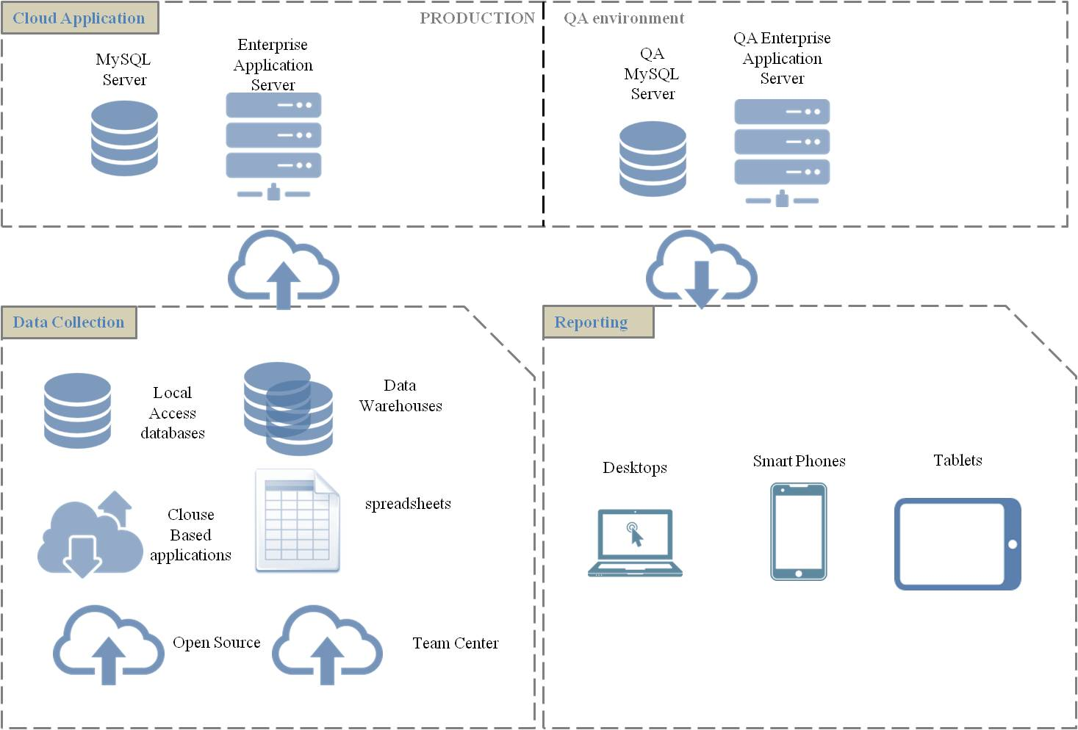

Under the SaaS cloud computing digital backbone model, the Analytics layer, and the primary business user-interface will be based on Sage Clarity’s One View Real Time Analytical Framework (Figure E). One View provides an integration layer, analytics, pre-configured Key Performance Indicators, Root Cause Analysis, Goal Attainment Simulation and Score carding. One View is also delivered via a cloud-based architecture and utilizes a consistent experience across multiple devices – Smartphone, Tablet, Desktop/Laptop.

Incoming data is aggregated into the One View Data repository and the cloud-based analytics system performs summary analytics, roll-ups, etc. Other supply chain visibility algorithms occur in this layer, such as Root Cause Analysis and Goal Attainment modeling.

The combined SaaS cloud computing solution will utilize the standard data exchange model developed in the project, Team Center as the digital backbone and One View for Data Analytics. The heterogeneous distributed backbone model will also use the same data exchange model and will implement the key functionalities of the Data Analytics layer using open source tools and libraries, thus completing the proposed open software stack.

### *Figure F: SC Simulation Modeling and KPI Analysis to Validate SCNoN Capability*

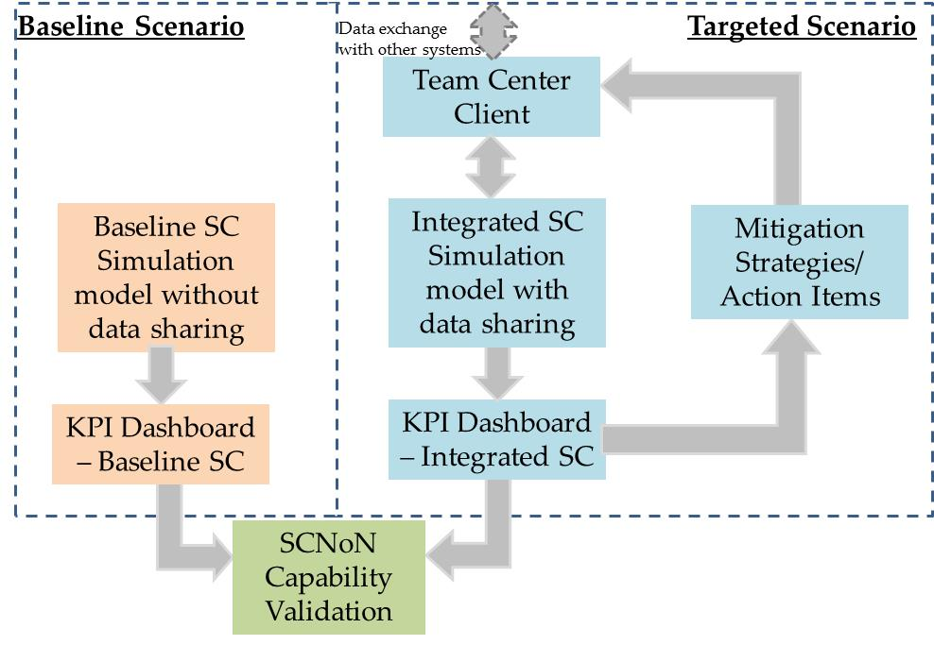

#### SC Modeling and KPIs

In order to facilitate the development of the proposed common data exchange standard for supply chain visibility and for testing and validation of the applications discussed above, the supply chain processes will be modeled. The activity of SC modeling and KPIs development in support of the proposed SCNoN framework is discussed next.

The data collected from industrial partners for real-life scenarios will be used to demonstrate the business benefits of the increased supply chain visibility via the use of SC modeling and simulation tools (Figure F), and how these tools can support the trade-off decisions that are based on the data spread across the global supply chain network to maximize profit and improve other KPI’s identified.

In order to demonstrate the improved decision support capability enabled by the developed SCNoN, the most important KPI’s at the supplier, customer and carrier levels must be identified. Therefore, a deliverable from the SC modeling task will include a repository of KPIs/performance metrics for each supply chain entity as well as for different functions and activities within each entity. A dashboard of such KPI’s will be incorporated into SC simulation models to demonstrate impact of increased supply chain visibility for the multiple constituencies. The analysis will compare performance of a ‘baseline’ supply chain and one with a SCNoN (Figure F).

The integrated SC simulation models will be used to identify actionable events [through the capability offered by the SCNoN]. For example, Badurdeen et al., (2014) propose a taxonomy of ‘risk’ events that could influence various KPI’s in multi-tier supply chains. Such risk events could be caused to occur randomly in both the baseline and integrated SC simulation models to identify the relative impact on performance as well as what mitigation strategies/action items could potentially influence the KPIs adversely. Such capability can help increase proactive response management and better resiliency in the supply chain.

The SC simulation models can also be used to better understand the lag times and their impact on SC performance. For example, the time between event occurrence and notification, or prediction accuracy – i.e., the extent to which data from the system accurately predicts an adverse event before it occurs, could also be studied to improve the system architecture/standards in the form of data capture needs and data exchange frequencies addressed in other tasks of this project.

In addition to the process-level validation of the applications developed in this project, the proposed simulation will allow the identification of KPIs across the supply chain and the generation of test cases that will be used to evaluate the scalability and correct functionality of the proposed SCNoN framework under the SaaS cloud computing model as well as the heterogeneous distributed model.

## Innovation

EDI is the workhorse of the supply chain, automating Business-to-Business transaction for over 40 years. However, there is a significant gap in the performance and value derived from EDI causing an adoption gap across supply chain partners. The advent of financial transaction driven Supply Chain Operating Networks are taking hold and seeing strong adoption by leading SC companies. The current market is made up of best of class solution providers that have emerged based on their legacy solution offerings in a target market or supply chain modal segment. If interoperable solutions are not built, the industry risks fragmentation and multiple sources of the truth. Strong integration is required across the tools used to drive performance across the modes and in the functions that manage the supply chain; these include the systems and tools used for Purchasing, Finance, Planning, Manufacturing, Transportation Management, Risk Management, Supply Chain Sustainability, and Customer Service. This will be further complicated by the move from intermittent system based transactional data to real-time sensor based data triggering financial transactions.

The industry is at a tipping point, where the next network highway to facilitate low cost, efficient network connections between systems and tools that are creating step changes in efficiency and operability of SC’s across industries [Plambeck, 2012]. Best of class solutions in the systems and tools outlined above are beginning to overlap on the capabilities and industries served; thus creating an environment where end-users are required to adopt multiple systems based on the segment of the supply chain they are in and the industry they serve (or hope to serve). Furthermore, as leaders in supply chain visibility expand beyond the transactional systems offered in SCON solutions today and move to a digital world powered by sensors and connected products, assets and shipments (Internet of Things) a robust network of linking transactional data to event based data will be required.

**Why is solution of this problem transformative rather than incremental?**

SCONs are rapidly growing and their adoption rates and penetration will be governed by the markets they serve as with any transformative technology. As end-to-end supply chains span many geographies, modes and industries, the opportunity to provide a framework to connect the various best of class players and systems will be transformational for all supply chain participants. If left to the markets, the adoption and cost of implementing supply chain visibility will be extremely high and inefficient, the final outcome limiting bandwidth and capability of the supply chain of the future.

Deliberate design with a systems approach versus a patchwork approach will facilitate innovations we cannot yet envision by providing an environment which removes interconnectivity and data sharing as a primary challenge. Instead innovators can focus on functionality such as:

* + Interoperability- A communication framework to share data (event and transactional) between and among all supply chain parties.
  + Speed – Ability to rapidly implement carriers and trading partners on and across platforms will reduce overall time to execution.
  + Harmonization of Systems – An underlying canonical data exchange standard for SC Visibility that allows systems providers and SC users to harmonize on terms and definitions
  + Demonstrate able Supply Chain Visibility – A Supply Chain control tower with visibility across the supply, demand and internal operations will provide users with the ability to make trade-off decisions to maximize profit.

### *Performance Improvement Metrics*

|  |  |  |  |  |
| --- | --- | --- | --- | --- |
|  | **Metric** | **Present State (Baseline)** | **Future State (Project Goal)** | **Usefulness of future state** |
| **Project Performance Metrics** | Development of end-to-end linked SC Network of Networks (SCNoN) | Manual/time lagged data exchange | Automatic data exchange | High success rate in data exchange and increased visibility |
| Number of SC nodes (customers, suppliers, carriers/3PLs, others) connected | None/very few SC nodes connected | All nodes for selected SC connected | Number of SC nodes connected through the SCNoN reflects extent of system interoperability |
| SC performance KPI reporting frequency | Weekly (or delayed) reporting manually | Daily or, as needed, automatic reporting | Ability to quickly determine SC risk events for better management/mitigation |
| Number of IT systems connected (e.g.: ERP, quality, sensors, 3PL, customer, etc.) | Most systems disparate & not interfaced | All systems integrated for seamless data exchange | Better interfacing and system interoperability for increase SC visibility |

|  |  |  |  |
| --- | --- | --- | --- |
| **Responsive SC (Static to Real-Time) Performance Evaluation** | **KPI Group** | **Supporting KPIs for SC Performance Evaluation** | |
| Customer Service | * On time deliveries * Customer order cycle time * Supply quality | * Late shipment breakdown * OTIF * In transit delivery |
| Perfect Order | * Order to cash * Order accuracy * Schedule Adherence | * Fill rate * Supply chain cycle time * Supply chain velocity |
| Shipping | * Transit time * Truckload capacity utilization | * Customer on time delivery * Supplier on time delivery |
| Inventory | * Days supply * Inventory turns | * Supply in transit * Inventory aging * Inventory movement |

## Project Deliverables

The deliverables from the project include

1. **Governance document & Lessons Learned**: A report of the challenges and experiences gained through this multi-partner, industry-university collaborative effort.
2. **Data Exchange Standard Document including as an Appendix Data Exchange SC processes Templates**: Documentation of the SC community consensus on an efficient data exchange format that will enable end-to-end supply chain visibility. Templates for implementing the underlying exchanges based on Dow’s current supply chain and a to-be event based supply chain.
3. **SC Simulation Model, KPI & Event repositories**: SC simulation models for baseline and SCNoN scenarios for validation of capability developed, repositories of KPIs to evaluate SC performance and event repositories for what-if scenario analysis.
4. **Software application**: Prototype software application with a software stack consisting of 1) an analytics layer, 2) a digital backbone and 3) a common data model demonstrating end-to-end supply chain visibility. The application will be supported by complete user documentation and developer documentation enabling the wide distribution to the community and adaptation of the application to third party software other than the ones used in this project.
5. **Workforce Development and Education**: Four seminars will be held to disseminate the results of the proposed project in addition to publication of research papers and the development of an online course at the University of Kentucky and a multi-disciplinary project-based course at IUPUI.