Hybrid Peer-to-Peer Architecture in Support of Supply Chain Visibility

Zhijie Li 1, Haowan Wu1, Alvaro Esperanca1,

Jeffrey Tazelaar2, John Wassick2, Zina Ben Miled1

1 Electrical and Computer Engineering Department, Purdue School of Engineering and Technology, IUPUI

2The Dow Chemical Company

Abstract

???? 2 to 3 paragraphs that you can add once you finish the paper

1. Introduction

Whythis is needed – what challenges are you trying to address …..

The project we are doing is to build a system that can increase visibility of current supply chain system.

Current supply chain operating network is a transaction driven network. Based on current business environment end-users are required to adopt multiple systems based on the segment of the supply chain they are in and the industry they serve (or hope to serve). Now we are living in a world that is powered by sensors, connected products. A robust network is needed to link transactional data to event based data in order to increase the visibility of current supply chain operating network.

Current supply chain system used in all industries is relying on value added network (VAN) and electronic data interchange. Value added network (VAN) is a private network provider hired by company to facilitate electronic data interchange. VAN is a network that is expensive to set up and does not offer a scalable structure. Electronic data interchange is the transfer of data from one computer system to another with standardized format. Nowadays, the scale of business is increasing dramatically. Value added network and electronic data interchange cannot accommodate the business demand any more. Comparing with old method used in document transfer in business EDI has certain advantages such as faster data transfer less human intervention. The method we use in this project is more efficient. First EDI is a transaction based data transfer method. In a supply chain management system one party does not send the shipment status update to another until certain transaction is been done. It is hard for one particular company to follow multiple EDI format. VAN is great method when public internet was not wildly available in the world, but now compare with public internet VAN has certain disadvantages. Firstly it has higher cost to set up. A large business company might afford the cost, but lots of small business are not able to set their own VAN for themselves. A better idea is that to use public internet to communicate with each other. Our system uses a network that is called supply chain network of network which means that we can build a network over an existing network only for certain communication.

Move from transactional system to event based system

What is value added network what is electronic data interchange

a real-time information layer is needed to overcome these limitations

xml vs json

xml good for document exchange not suitable for the amount of traffic involved in this project

json lightweight more scalable. Object oriented .This is particularly important when the granularity of the data exchanged moves from the container or pallet level to the individual product level.

EDI may be efficient for document exchange, it is not suitable for the traffic volume and velocity anticipated in the delivery of the real-time status of goods in today’s physical distribution environments and global economy.

(1 page)

1. Related work

2 pages – related work – other systems that are similar (what is the same and what is better)

Part 1 – exiting SC systems and why is your approach better

Example: Ariba Business Network from SAP, GT Nexus, Elemica, E2Open, etc. – You need to be familiar with these

Part 2 - Sensor Aggregation & IOT (ThingWorx, Siemens – Team Center - Google Cloud Platform , ….

Part 3 – Peer to Peer systems (e.g. Napster, and others – Eric we covered these in class ) how does your approach outperform others and how is it similar

### *Figure 1: Physical Distribution Complexities*

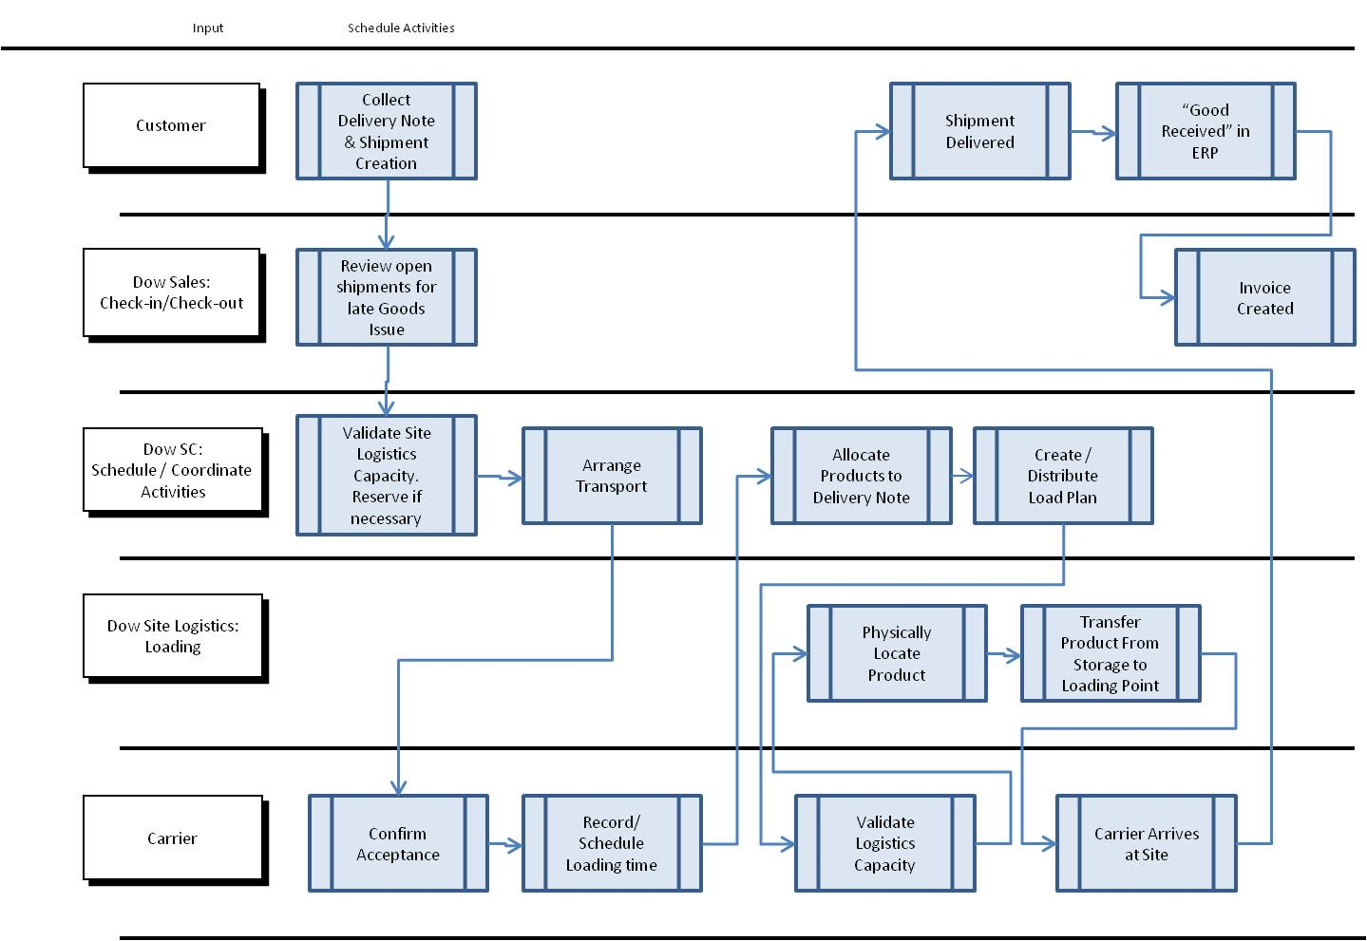

Part 4 – dynamic user centric P2P network or hybrid P2P networks (e.g. paper that I gave you Fortes – Figuiredo and others)

1. Physical Distribution

What is physical distribution

1. Solution Overview

### 

**Figure 1.** this figure is too simple and does not add any information – start with the one that you drew on the board in SL 113

The proposed physical distribution system is based a hybrid peer-to-peer architecture that is customized dynamically for each stakeholder. The SCV (give a name – so we do not called the proposed system throughout) is based on a collection of purpose-centric customized networks that can be configured dynamically on the fly. This is a departure from the traditional transaction based EDI exchange systems. SCV allows stakeholders to share information related to a given shipment in real time.

4.1 Roles and Configurations

There are three main stakeholders for a given shipment. These roles consists of Customer, Carrier, Supplier. Obviously a given entity may assume more than one role over several shipments. For instance, a carrier in one shipment can also be a customer in other shipment. However, for a given shipment these roles are in general distinct.

4.2 Modules

Describe each module in your system and its functionality – also include a detailed diagram that shows all the modules –

The overview of the model is shown in Figure ????. The main modules include the Index Server, …., …..

1. Index Server

Index server acts as a yellow page. It holds all clients’ information such as IP address, clients’ names. When a client wants to communication with others, it will first query index server for the information of the target client. How ? what is the process flow ? why do you have to maintain an index server ? Client will update their IP address regularly. How and why can’t you maintain static IP – mobile client – etc…

Each client will act as customer or carrier or supplier. The communication procedure is shown on the following picture.

### 

**Figure 2.** same comment as for Figure 1

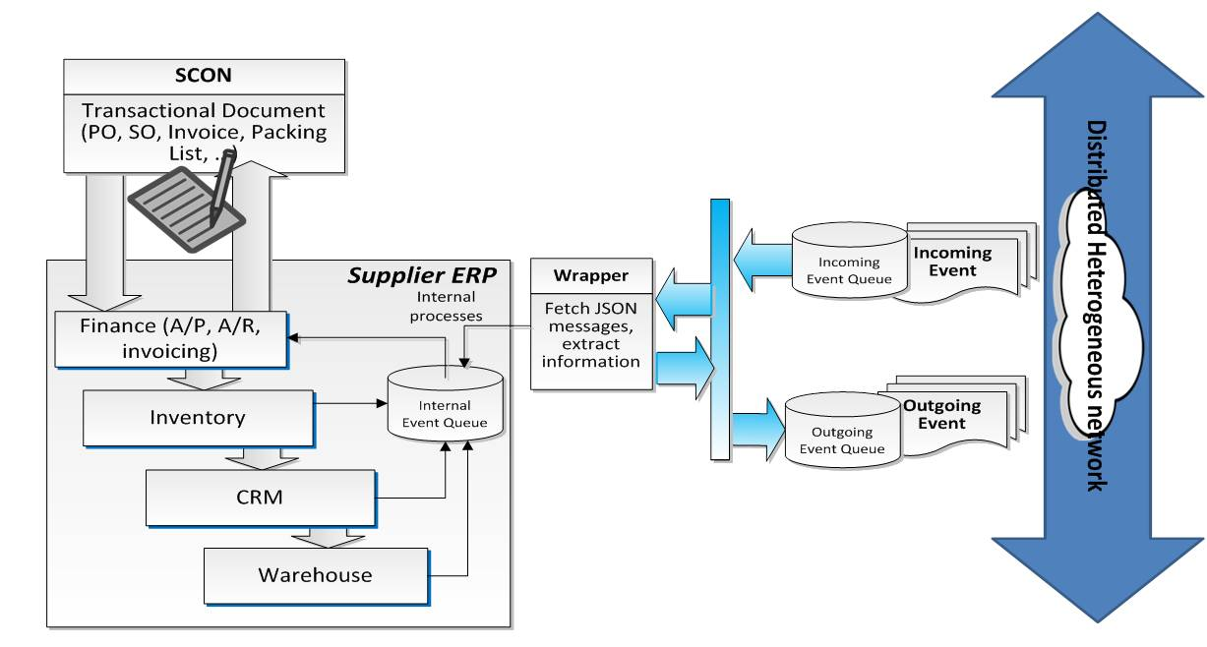

This model is based on the assumption that the order information has already been initialized by each company’s ERP (enterprise resource planning) and the order information is already in our MongoDB. The order information is shown in appendix. The communication is initialized by the supplier. The supplier will establish a TCP connection with customer and carrier. It will update the shipment information to carrier and customer when a new signal ???? arrives. The signal is sent by some integrated sensor network such as bar code scanner. Our software will broadcast to all parties that involved in the shipment, once it receives the signal. It will keep update the status until carrier picks up. The carrier will receive GPS signal from the track and it will use the same mechanism to broadcast to other parties. The customer will be required to verify the status of the shipment and manually submit the final acceptance of the shipment once the order is delivered.

Client queries index server about others’ IP address according to the information contained in Order struct which will be explained later in this paper. There are few advantage of adding one index server in to the system. Firstly it can reduce the amount of network traffic. one client has to send IP address update message to all clients’ in the network if every client stores each other’s IP address in its own database, instead of doing this, we have index server to handle all the client information related communication, so client only have to send one message to index server to update its’ information. Secondly this structure can help protect the privacy of each company’s information. Company’s information will only be accessible by index server and the parties that are involved in one transaction. Other parties can only access the information while a shipment is taking place. The information will not be stored in any place other than index server.

Peer to peer

This system uses peer to peer architecture for the communication between clients. Peer to peer architecture can reduce network traffic , since communication are between clients, there is no server interfere in between the communication. Using peer to peer architecture can avoid single point failure, even one client goes down the communication will continue. Once the client resumes online it will receive the newest information from other clients. In addition it can reduce data storage cost. Since the data is stored locally in every client. There is no need to establish a centralized server storage. I

1. Client Application

Client side software uses a 3 tier architecture. The first layer is presentation layer. This layer is generally known as user interface which displays the information user need to know. Second layer is application layer. It is the layer that connects presentation layer and data layer. User can use presentation layer to send commands to application layer, application layer will handle all kinds of requests such as confirming the delivery of a shipment. The third layer is the data layer. It holds all information of the client such as order/shipment information. Using this three layer design can first separate each individual part clearly and makes it easy to modify each part. The change of one layer does not affect the others. Security is enhanced by this model as well. The only way to access data layer is through application layer. This can ensure the safety of the data.

You need to add a detailed diagram – and explain each layer in details – block diagram and description

When I am done reading the paper I should have a blue print of the system that you are proposing

**4.3 Data exchange template**

How is data exchanged and what is its format – content

**4.4 Example Scenario**

1. Conclusion

The proposed platfo …..

References