PROJECT ASSIGNMENT 2

Group10-PA2 Project Proposal
  - Two bounded modules, six alternatives, weighted recommendation, and PA3 test plans
FIFA.com and Chess.com
Course | CSC13112 - UI/UX Design, FIT-HCMUS
Group | Group10
Team | Le Minh (21127645); Nguyen Vu Bach (21127224); Pham Nguyen Gia Bao (20127119); Trang Minh Nhut (22127318)
Evidence date | Local evidence audited through 30 July 2026
Document type | Evidence-based redesign report
Status | FINAL - simulated-study evidence explicitly labeled

Contents
[[TOC]]

1. Proposal scope and traceability
FIFA Ticket Confidence Module: Users need to compare current ticket state, freshness and official destination before leaving FIFA.com.

Chess Guided Beginner Review Module: Beginners need one interpretable mistake and one next practice action before advanced analysis.

Screen evidence: F2-E03/E04/E09 and C2-E05/E07-E10 bound the visible interface claims.
Simulated study: Scenario records inform hypothesis coverage only; no expected benefit is an observed outcome.
Design inference: The modules preserve current products and introduce bounded decision/learning layers.

2. FIFA Ticket Confidence Module alternatives

2.1 F-A1 Status Dashboard
Field | Record
Concept | Status Dashboard within FIFA Ticket Confidence Module
Target user | Trust-sensitive ticket planners
Task flow | Choose context -> compare states -> inspect freshness -> preview official destination -> act or stay
Main screen | Status comparison dashboard
Interaction | Filter, expand provenance, preview handoff, save/alert
Problem coverage | Directly covers status, freshness, and destination confidence
Accessibility | Text labels, table semantics, keyboard order, color-independent states
Privacy | Minimize saved preferences; explicit alert consent
Data dependency | Governed ticket-state feed, timestamps, partner metadata
Failure recovery | Keep last timestamped state, distinguish missing/stale, retry without losing context
Risk | Feed inconsistency or false confidence
Tradeoff | Highest clarity; requires reliable governed data
PA3 test plan | Test state interpretation, destination recognition, stay/continue choice, and recovery
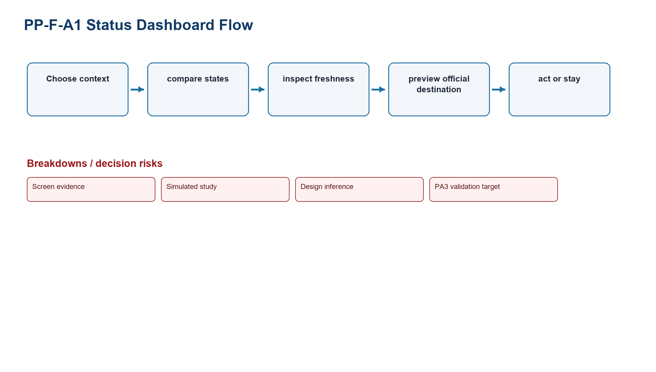
Figure PP-F-A1. Status Dashboard task-flow model
Source: Design inference based on TP-FIFA
Related: Test state interpretation, destination recognition, stay/continue choice, and recovery

2.2 F-A2 Guided Concierge
Field | Record
Concept | Guided Concierge within FIFA Ticket Confidence Module
Target user | Infrequent and first-time planners
Task flow | State intent -> answer questions -> receive route -> preview destination -> confirm
Main screen | Step-by-step concierge
Interaction | Single-choice questions, back/edit, recommendation rationale
Problem coverage | Covers complex choice and handoff confidence
Accessibility | Progress, plain labels, keyboard/radio semantics
Privacy | Avoid sensitive profiling; delete draft answers
Data dependency | Eligibility rules, ticket channels, partner metadata
Failure recovery | Explain unsupported markets, preserve answers, offer dashboard
Risk | Long flow and rule maintenance
Tradeoff | More guidance; slower comparison
PA3 test plan | Test completion, backtracking, recommendation comprehension, and unsupported-state recovery
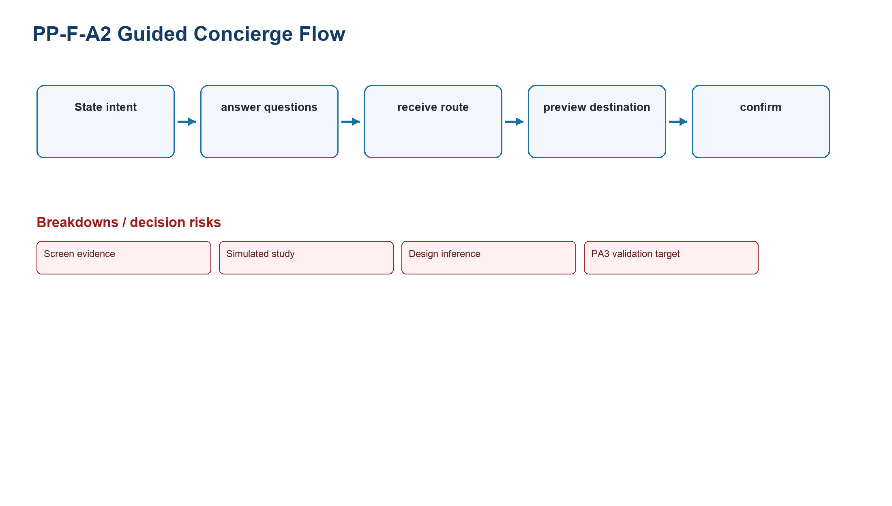
Figure PP-F-A2. Guided Concierge task-flow model
Source: Design inference based on TP-FIFA
Related: Test completion, backtracking, recommendation comprehension, and unsupported-state recovery

2.3 F-A3 Alert-First Planner
Field | Record
Concept | Alert-First Planner within FIFA Ticket Confidence Module
Target user | Followers waiting for sale changes
Task flow | Follow context -> set preference -> wait -> receive verified change -> open destination
Main screen | Saved-plan and alert center
Interaction | Follow, consent, edit, snooze, stop, open alert
Problem coverage | Covers freshness and return; weaker immediate comparison
Accessibility | Channel alternatives, readable timestamps, no color-only urgency
Privacy | Explicit permission, minimal contact data, retention limit
Data dependency | Change events, notification channel, partner metadata
Failure recovery | Retain local plan if permission denied; retry irrelevant or failed alerts
Risk | Notification fatigue and delayed data
Tradeoff | Strong return support; depends on alert quality
PA3 test plan | Test permission denial, alert relevance, freshness comprehension, and return context
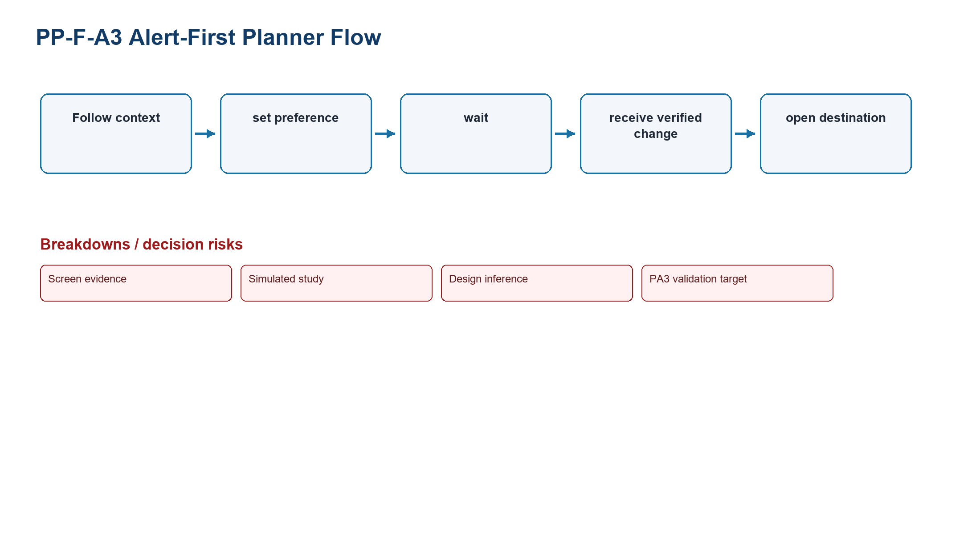
Figure PP-F-A3. Alert-First Planner task-flow model
Source: Design inference based on TP-FIFA
Related: Test permission denial, alert relevance, freshness comprehension, and return context

3. Chess Guided Beginner Review Module alternatives

3.1 C-A1 Beginner Review Preset
Field | Record
Concept | Beginner Review Preset within Chess Guided Beginner Review Module
Target user | First-time and returning low-analysis learners
Task flow | Open game -> select preset -> identify one mistake -> try move -> read explanation -> practice or depth
Main screen | Primary mistake card beside board
Interaction | Try move, reveal why, continue practice, reveal advanced detail
Problem coverage | Directly covers one interpretable mistake and next practice action
Accessibility | Keyboard board alternative, focus order, plain language, color-independent evaluation
Privacy | Use only selected game; explain retention and sharing
Data dependency | Game artifact, analysis service, explanation rules, learning catalog
Failure recovery | Handle no game, invalid PGN, engine unavailable, no major mistake, restriction
Risk | Oversimplification or incorrect explanation
Tradeoff | Strongest beginner interpretation; constrains initial depth
PA3 test plan | Test mistake comprehension, move trial, practice selection, and depth disclosure
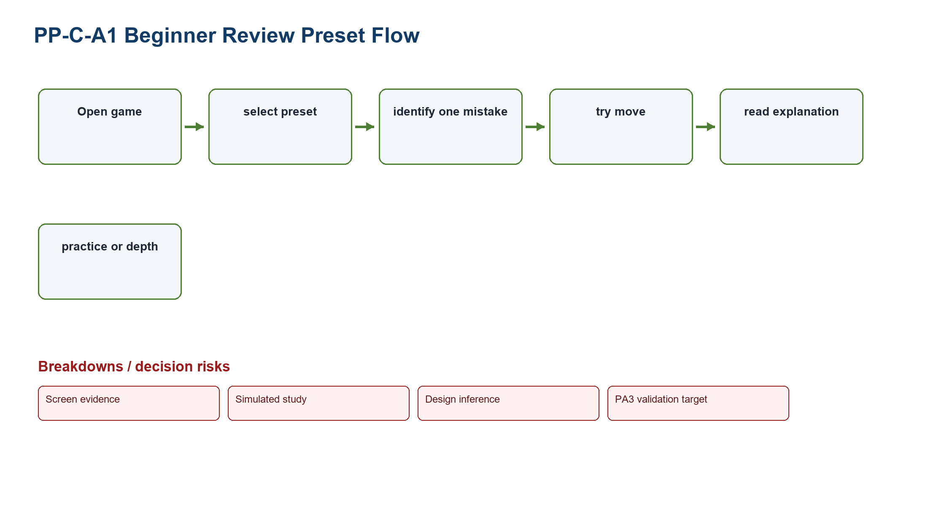
Figure PP-C-A1. Beginner Review Preset task-flow model
Source: Design inference based on TP-CHESS
Related: Test mistake comprehension, move trial, practice selection, and depth disclosure

3.2 C-A2 Conversational Coach
Field | Record
Concept | Conversational Coach within Chess Guided Beginner Review Module
Target user | Beginners who prefer question-led guidance
Task flow | Open review -> state intent -> coach clarifies -> explain position -> try move -> practice
Main screen | Conversation plus board
Interaction | Choose intent, ask why, try move, request another explanation
Problem coverage | Covers interpretation and vocabulary
Accessibility | Structured choices, transcript headings, keyboard board alternative
Privacy | Do not collect unrelated personal data; clear conversation retention
Data dependency | Game artifact, explanation service, learning catalog
Failure recovery | Offer fixed explanation cards if the coach service fails
Risk | Inconsistent wording and longer interaction
Tradeoff | Flexible explanation; harder to validate
PA3 test plan | Test response consistency, vocabulary comprehension, and service fallback
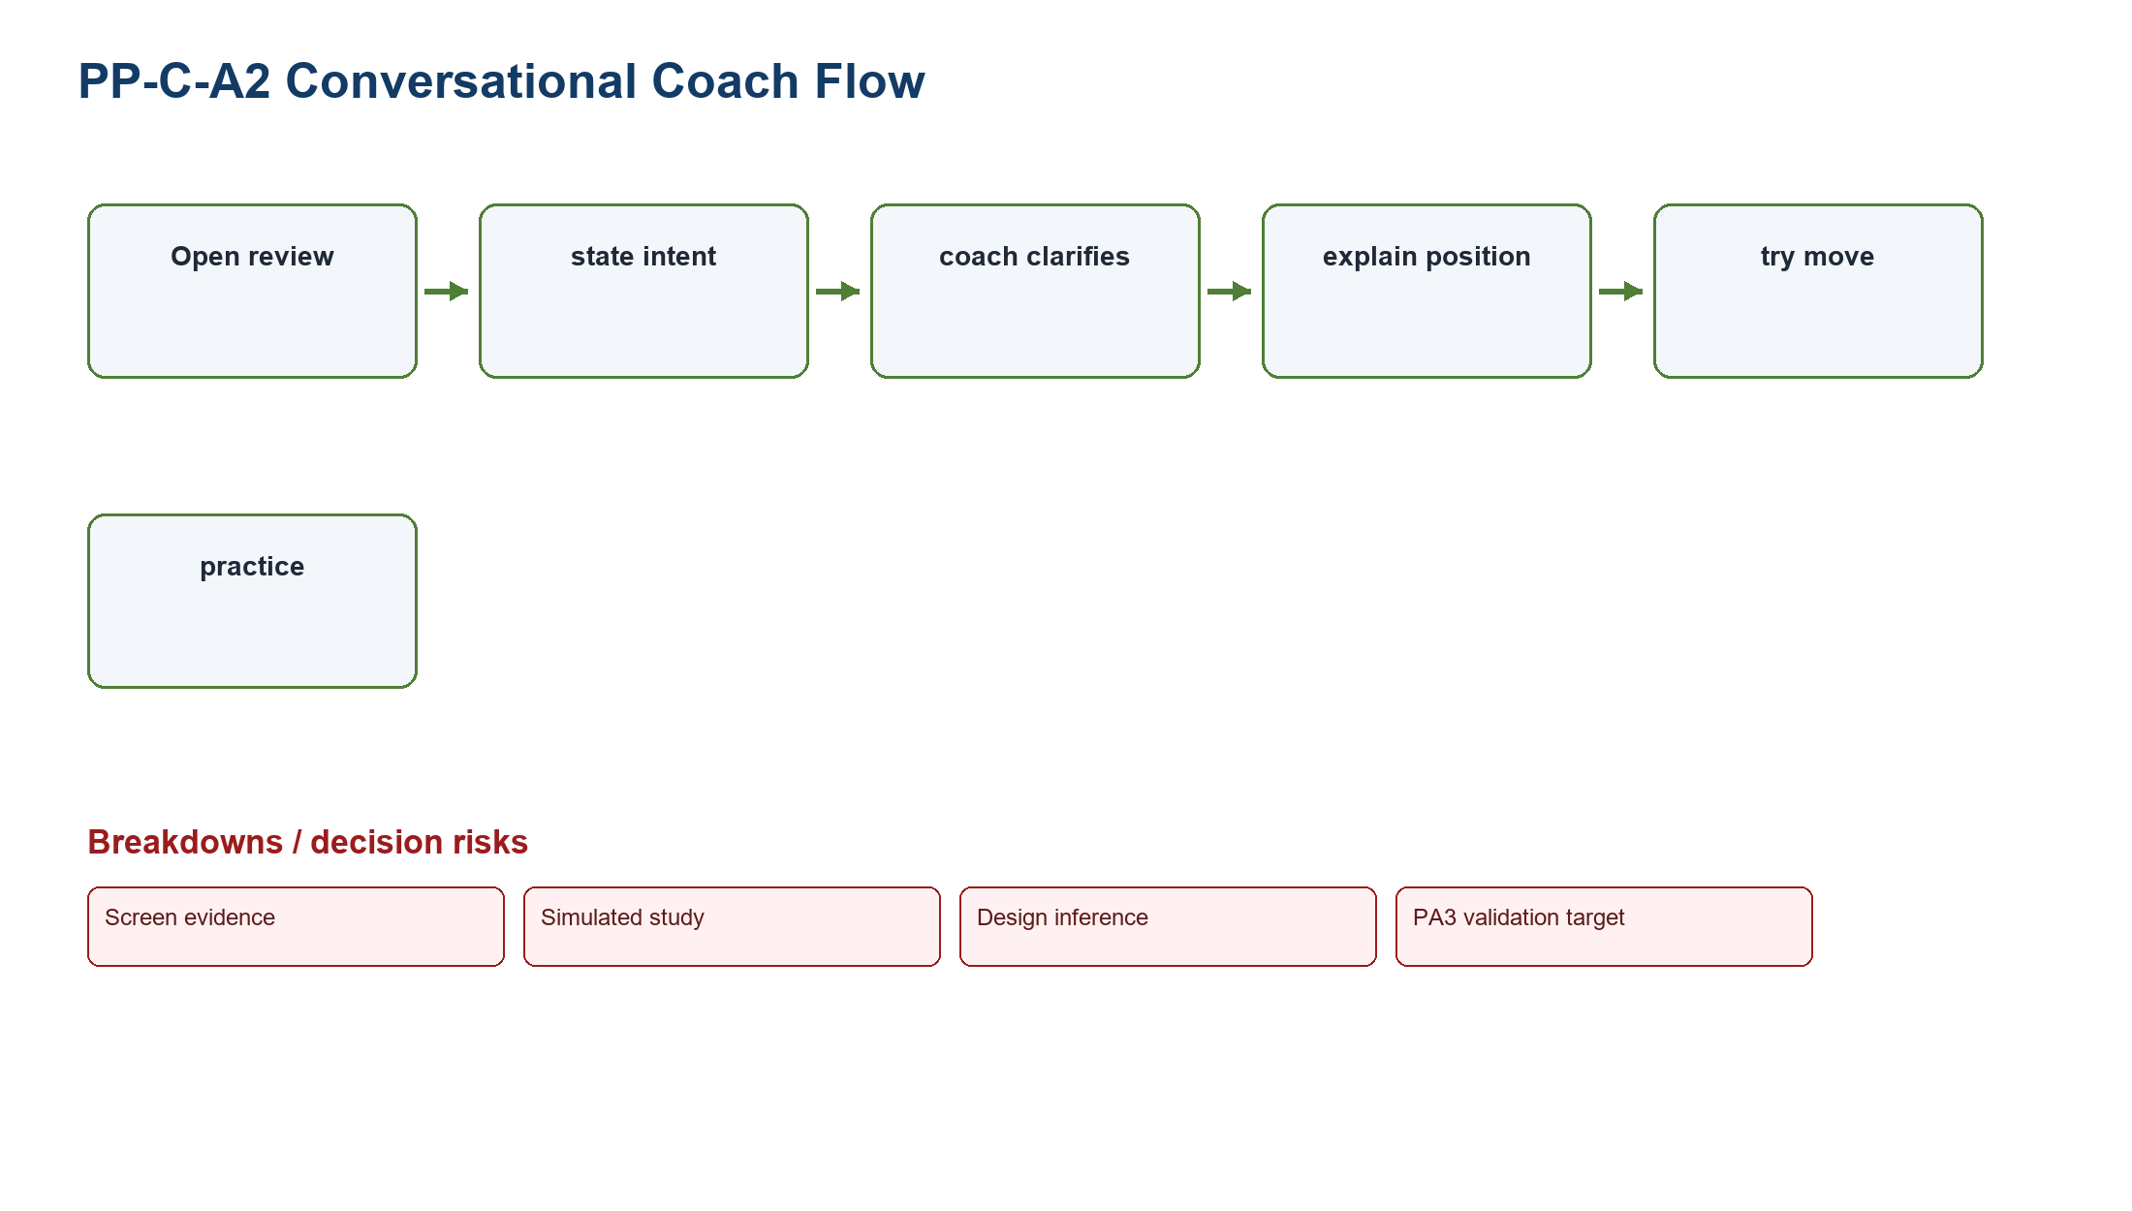
Figure PP-C-A2. Conversational Coach task-flow model
Source: Design inference based on TP-CHESS
Related: Test response consistency, vocabulary comprehension, and service fallback

3.3 C-A3 Visual Game Story
Field | Record
Concept | Visual Game Story within Chess Guided Beginner Review Module
Target user | Returning learners who scan game turning points
Task flow | Open review -> view chapters -> inspect turning point -> replay chance -> choose next action
Main screen | Chapter timeline with board snapshots
Interaction | Scrub chapters, select turning point, replay, continue
Problem coverage | Covers prioritization and narrative continuation
Accessibility | Text chapter list, reduced motion, keyboard timeline
Privacy | Use game data only; respect game visibility
Data dependency | Game segmentation, analysis service, learning catalog
Failure recovery | Fall back to a single mistake card if segmentation fails
Risk | Long games and multiple comparable mistakes
Tradeoff | Strong overview; less direct for first-time beginners
PA3 test plan | Test turning-point recognition, replay accuracy, and continuation choice
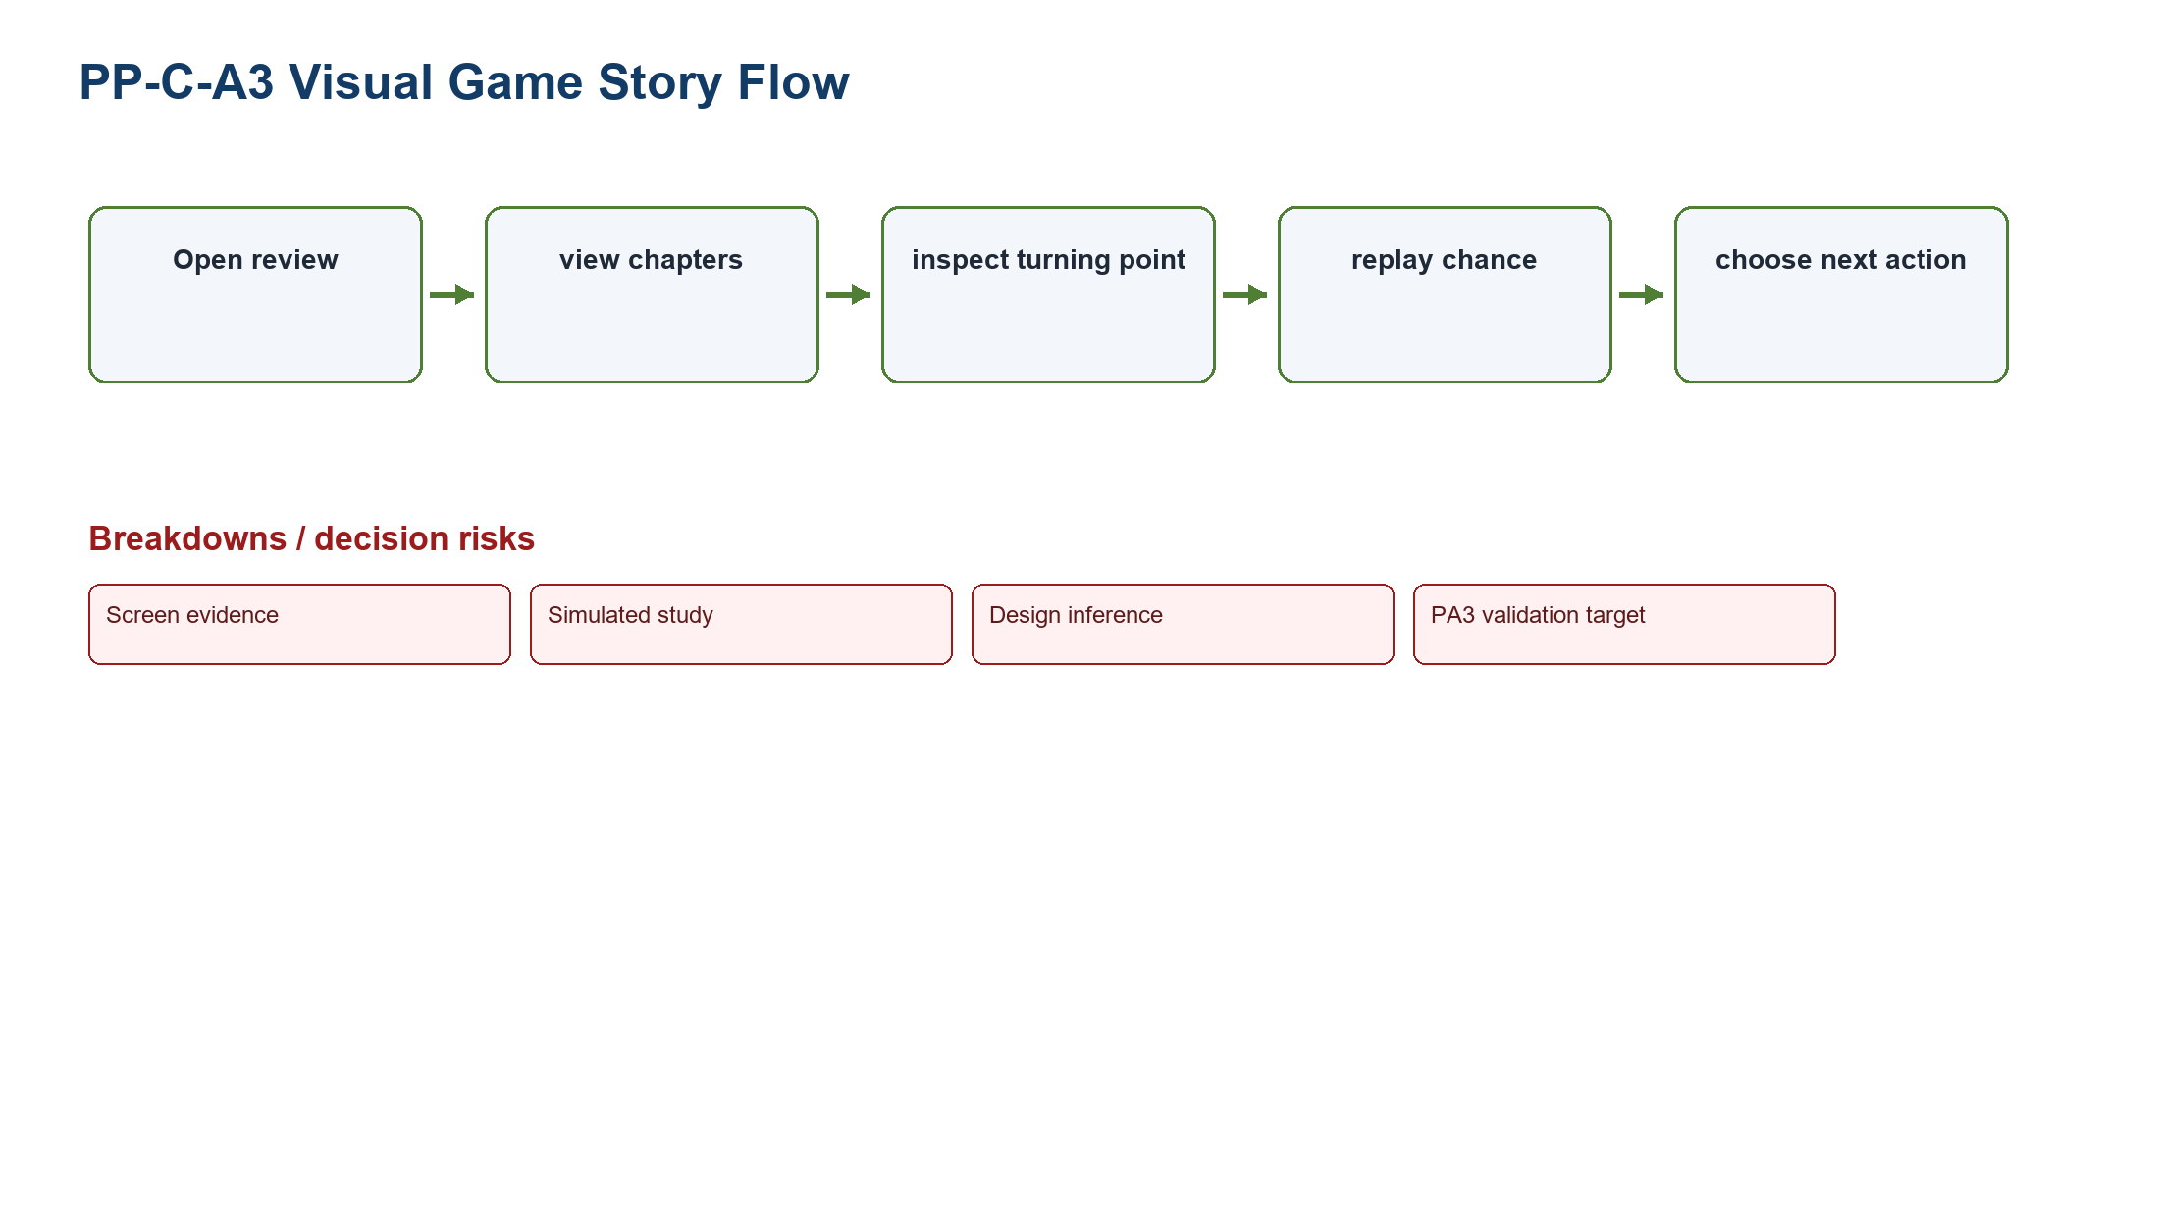
Figure PP-C-A3. Visual Game Story task-flow model
Source: Design inference based on TP-CHESS
Related: Test turning-point recognition, replay accuracy, and continuation choice

4. Weighted comparison method
Formula: Weighted score = Problem coverage x 30% + Learnability x 20% + Accessibility x 15% + Recovery x 15% + Data feasibility x 10% + PA3 testability x 10%. Factors use 1-5; maximum is 5.00.

Alternative | Coverage 30% | Learnability 20% | Accessibility 15% | Recovery 15% | Data 10% | PA3 10% | Weighted | Reason
F-A1 Status Dashboard | 5 | 4 | 5 | 5 | 3 | 5 | 4.55 | Direct comparison and recovery; reliable feed is the main dependency.
F-A2 Guided Concierge | 4 | 5 | 4 | 4 | 3 | 4 | 4.05 | High guidance but a longer flow and heavier rule maintenance.
F-A3 Alert-First Planner | 3 | 4 | 4 | 4 | 3 | 4 | 3.65 | Strong freshness/return support but weaker immediate comparison.
C-A1 Beginner Review Preset | 5 | 5 | 5 | 5 | 4 | 5 | 4.90 | Best alignment to one mistake, move trial, explanation, and practice.
C-A2 Conversational Coach | 4 | 5 | 4 | 3 | 2 | 3 | 3.75 | Flexible but consistency, service fallback, and validation are harder.
C-A3 Visual Game Story | 4 | 4 | 4 | 4 | 3 | 4 | 3.90 | Good overview but less direct for a first-time beginner.

5. Recommendations and retained alternatives
Recommendation - FIFA: Select Status Dashboard because it most directly combines ticket state, freshness, official destination preview, user control, and recovery. Guided Concierge and Alert-First Planner remain PA3 parallel prototypes.

Recommendation - Chess: Select Beginner Review Preset because it establishes one interpretable mistake and one next practice action before advanced depth. Conversational Coach and Visual Game Story remain PA3 parallel prototypes.

Recommendation | Reason | Principal risk | PA3 validation target
F-A1 Status Dashboard | Highest weighted FIFA score and strongest tough-problem coverage | Stale or conflicting governed data | Accurate state/freshness interpretation and calibrated handoff confidence
C-A1 Beginner Review Preset | Highest weighted Chess score and clearest learning priority | Oversimplification or explanation error | Mistake comprehension, better-move trial, and relevant practice choice

6. PA3 parallel-prototyping plan
Product | Parallel concepts | Common scenario | Measures | Stop/iterate rule
FIFA | Status Dashboard; Guided Concierge; Alert-First Planner | Compare a missing/stale ticket state and decide whether to leave FIFA.com | State accuracy; destination recognition; confidence calibration; recovery | Reject a concept that causes state misinterpretation or implies partner completion
Chess | Beginner Review Preset; Conversational Coach; Visual Game Story | Open a completed game, identify one mistake, try a better move, continue practice | Explanation accuracy; wrong path; continuation relevance; depth control | Reject a concept that hides correction, blocks keyboard use, or overstates certainty
PA3 validation target: Expected benefits remain hypotheses until prototype sessions produce observed evidence.

7. Course-source application
Course basis: LN01 - Introduction - v2.pdf, pp. 20, 22, 24; LN02 - Fundamental Concepts - Usability Dimensions_2.pdf, pp. 62-67, 74-76, 83-84, 101-115; LN03 - UI Design Process.pdf, pp. 16-19, 23-24, 28-30, 34-36; LN04 - Task Analysis.pdf, pp. 3, 6-15, 39-49.

