PROJECT ASSIGNMENT 2

Group10-PA2 User Analysis
  - Clearly labeled simulated brainstorming, affinity analysis, voting, and prioritization
FIFA.com and Chess.com
Course | CSC13112 - UI/UX Design, FIT-HCMUS
Group | Group10
Team | Le Minh (21127645); Nguyen Vu Bach (21127224); Pham Nguyen Gia Bao (20127119); Trang Minh Nhut (22127318)
Evidence date | Local evidence audited through 30 July 2026
Document type | Evidence-based redesign report
Status | FINAL - simulated-study evidence explicitly labeled

Contents
[[TOC]]

1. Analysis boundary and source discipline
Simulated brainstorming record: The workshop, raw-note generation, votes, discussion, attendance, and consensus below are scenario-based synthetic evidence prepared for course reporting. They are not contemporaneous meeting evidence.

Screen evidence: Visible interface states seed observable notes only.
Simulated study: Participant-behavior notes and votes are synthetic scenario records.
Design inference: Clusters and priorities are interpretations that require PA3 testing.

2. Simulated brainstorming session
Field | Record
Record type | Simulated brainstorming record
Date and duration | 22 Jul 2026, 19:30-20:45 (75 minutes)
Participants | Le Minh; Nguyen Vu Bach; Pham Nguyen Gia Bao; Trang Minh Nhut
Objective | Transform PA1 continuity, screen evidence, and simulated-study patterns into prioritized PA2 problems.
Silent note generation | 12 minutes; each member drafts atomic notes independently.
Round-robin sharing | 16 minutes; one note per turn, no evaluation during sharing.
Clustering | 18 minutes; group by user task and breakdown rather than feature.
Duplicate merging | 8 minutes; retain the clearest atomic wording and all source tags.
Cluster naming | 6 minutes; name clusters with user-facing task language.
Prioritization | 8 minutes; six simulated votes per member per product.
Consensus | 5 minutes; review weighted scores and resolve the selected problem statement.
Owner assignment | 2 minutes; Bach owns FIFA synthesis, Bao owns Chess synthesis, Nhut owns diagrams/HCI mapping, Le owns integration/traceability.

3. Raw notes: 36 FIFA and 36 Chess

Note ID | Product | Cluster | Atomic note | Source type
F-RN-01 | FIFA | Ticket status clarity | Current sale state needs one label | screen evidence
F-RN-02 | FIFA | Ticket status clarity | Missing state differs from sold out | simulated participant behavior
F-RN-03 | FIFA | Ticket status clarity | Resale must not look like primary sale | PA1 inherited finding
F-RN-04 | FIFA | Ticket status clarity | Waiting room is a temporary state | design inference
F-RN-05 | FIFA | Ticket status clarity | Hospitality is a distinct option | screen evidence
F-RN-06 | FIFA | Ticket status clarity | State comparison belongs in one view | simulated participant behavior
F-RN-07 | FIFA | Handoff trust | Preview the destination domain | PA1 inherited finding
F-RN-08 | FIFA | Handoff trust | Explain why departure is needed | design inference
F-RN-09 | FIFA | Handoff trust | Offer stay on FIFA.com | screen evidence
F-RN-10 | FIFA | Handoff trust | Preserve a safe return route | simulated participant behavior
F-RN-11 | FIFA | Handoff trust | Do not imply partner transaction status | PA1 inherited finding
F-RN-12 | FIFA | Handoff trust | Keep tournament context through handoff | design inference
F-RN-13 | FIFA | Mobile overview | Keep selected tournament first | screen evidence
F-RN-14 | FIFA | Mobile overview | Avoid a long undifferentiated card stack | simulated participant behavior
F-RN-15 | FIFA | Mobile overview | Restore filters on return | PA1 inherited finding
F-RN-16 | FIFA | Mobile overview | Use labels that survive small screens | design inference
F-RN-17 | FIFA | Mobile overview | Make status scannable without color | screen evidence
F-RN-18 | FIFA | Mobile overview | Resume with one recognition step | simulated participant behavior
F-RN-19 | FIFA | Browse load | Ticket entry competes with content | PA1 inherited finding
F-RN-20 | FIFA | Browse load | Repeated cards increase scanning | design inference
F-RN-21 | FIFA | Browse load | Tournament identity should anchor actions | screen evidence
F-RN-22 | FIFA | Browse load | Reduce cross-page comparison | simulated participant behavior
F-RN-23 | FIFA | Browse load | Keep action wording consistent | PA1 inherited finding
F-RN-24 | FIFA | Browse load | Separate browse from purchase intent | design inference
F-RN-25 | FIFA | Freshness and alerts | Show last-updated time | screen evidence
F-RN-26 | FIFA | Freshness and alerts | Name the governed source | simulated participant behavior
F-RN-27 | FIFA | Freshness and alerts | Label stale data explicitly | PA1 inherited finding
F-RN-28 | FIFA | Freshness and alerts | Allow relevant change alerts | design inference
F-RN-29 | FIFA | Freshness and alerts | Explain notification permission | screen evidence
F-RN-30 | FIFA | Freshness and alerts | Let users edit or stop alerts | simulated participant behavior
F-RN-31 | FIFA | Recovery and return | Retry missing state without losing context | PA1 inherited finding
F-RN-32 | FIFA | Recovery and return | Network loss should retain the last snapshot | design inference
F-RN-33 | FIFA | Recovery and return | Login mismatch needs safe recovery | screen evidence
F-RN-34 | FIFA | Recovery and return | Expired return links need explanation | simulated participant behavior
F-RN-35 | FIFA | Recovery and return | Partner failure must offer stay | PA1 inherited finding
F-RN-36 | FIFA | Recovery and return | Never infer purchase completion | design inference
C-RN-01 | Chess | Entry choice overload | Beginner review needs one named entry | screen evidence
C-RN-02 | Chess | Entry choice overload | Analysis setup paths compete | simulated participant behavior
C-RN-03 | Chess | Entry choice overload | Feature names require recall | PA1 inherited finding
C-RN-04 | Chess | Entry choice overload | Completed game should expose review | design inference
C-RN-05 | Chess | Entry choice overload | Expert view opens too early | screen evidence
C-RN-06 | Chess | Entry choice overload | Outcome labels are easier to recognize | simulated participant behavior
C-RN-07 | Chess | Learning priority | Show one important mistake first | PA1 inherited finding
C-RN-08 | Chess | Learning priority | Explain why before numeric depth | design inference
C-RN-09 | Chess | Learning priority | Make the next action explicit | screen evidence
C-RN-10 | Chess | Learning priority | Keep the lesson goal visible | simulated participant behavior
C-RN-11 | Chess | Learning priority | Do not present every candidate equally | PA1 inherited finding
C-RN-12 | Chess | Review setup | No game needs a clear setup route | design inference
C-RN-13 | Chess | Review setup | Invalid PGN must preserve input | screen evidence
C-RN-14 | Chess | Review setup | Board orientation needs confirmation | simulated participant behavior
C-RN-15 | Chess | Review setup | Engine failure needs a safe fallback | PA1 inherited finding
C-RN-16 | Chess | Review setup | Premium restriction needs honest scope | design inference
C-RN-17 | Chess | Vocabulary load | Evaluation terms need inline help | screen evidence
C-RN-18 | Chess | Vocabulary load | Plain language should lead | simulated participant behavior
C-RN-19 | Chess | Vocabulary load | Terminology help should not interrupt | PA1 inherited finding
C-RN-20 | Chess | Vocabulary load | Returning learners forget feature names | design inference
C-RN-21 | Chess | Vocabulary load | Recognition should replace recall | screen evidence
C-RN-22 | Chess | Mobile scanning | Keep the board and main mistake together | simulated participant behavior
C-RN-23 | Chess | Mobile scanning | Collapse secondary panels | PA1 inherited finding
C-RN-24 | Chess | Mobile scanning | Use color-independent indicators | design inference
C-RN-25 | Chess | Mobile scanning | Preserve state after interruption | screen evidence
C-RN-26 | Chess | Mobile scanning | Maintain readable tap targets | simulated participant behavior
C-RN-27 | Chess | Practice continuation | Link the mistake to one lesson | PA1 inherited finding
C-RN-28 | Chess | Practice continuation | Offer one relevant puzzle | design inference
C-RN-29 | Chess | Practice continuation | Preserve the reviewed position | screen evidence
C-RN-30 | Chess | Practice continuation | Let users continue later | simulated participant behavior
C-RN-31 | Chess | Practice continuation | Explain why the practice is relevant | PA1 inherited finding
C-RN-32 | Chess | Advanced depth disclosure | Reveal engine detail on demand | design inference
C-RN-33 | Chess | Advanced depth disclosure | Do not remove expert access | screen evidence
C-RN-34 | Chess | Advanced depth disclosure | Remember the disclosure choice | simulated participant behavior
C-RN-35 | Chess | Advanced depth disclosure | Keep beginner explanation stable | PA1 inherited finding
C-RN-36 | Chess | Advanced depth disclosure | Separate learning priority from depth | design inference
Scenario-based synthetic evidence: All 72 notes are one-idea records; simulated participant behavior notes are not real observation claims.

4. Affinity diagrams and cluster synthesis
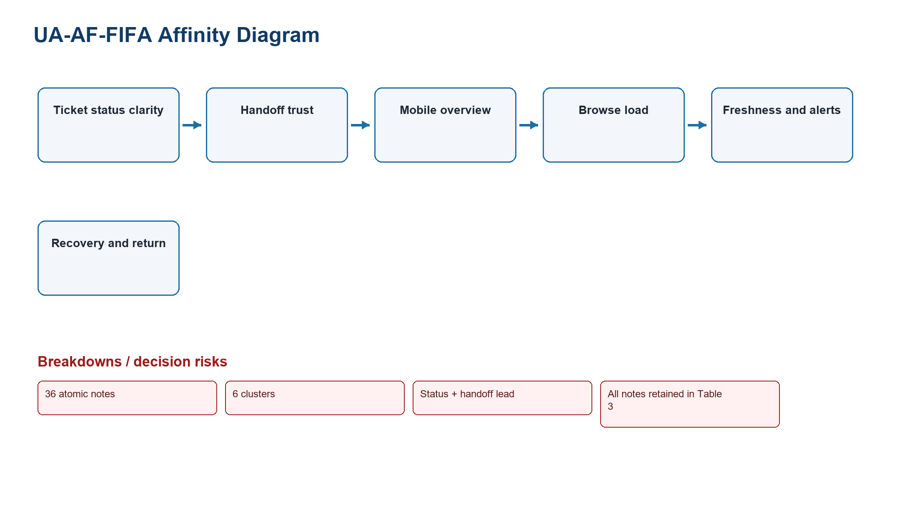
Figure UA-AF-01. FIFA affinity clusters
Source: Screen evidence + simulated participant behavior + PA1 inherited finding + design inference
Related: 36 FIFA raw notes
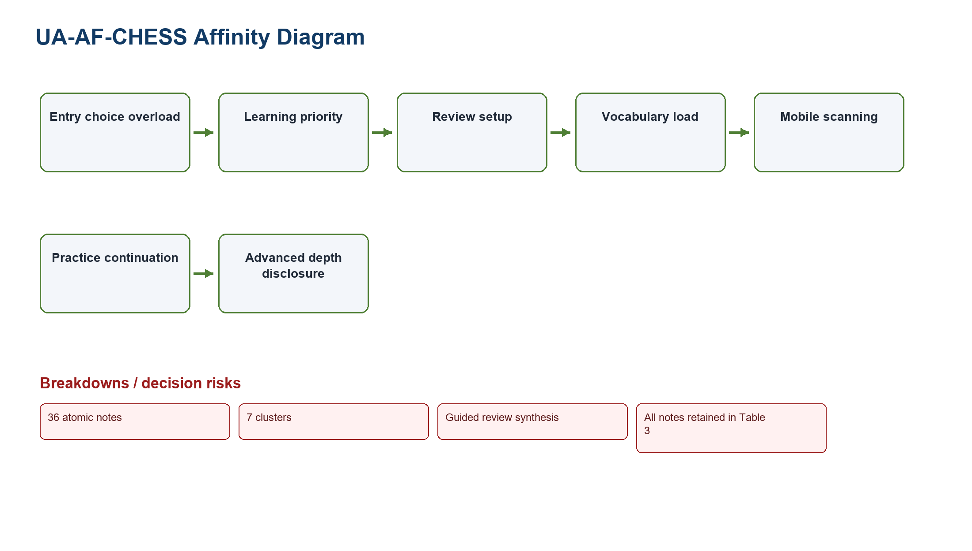
Figure UA-AF-02. Chess affinity clusters
Source: Screen evidence + simulated participant behavior + PA1 inherited finding + design inference
Related: 36 Chess raw notes

Product | Cluster | Count | Representative notes | Pattern | Affected task | Severity | Design direction
FIFA | Ticket status clarity | 6 | Current sale state needs one label; Missing state differs from sold out | Repeated task-state or orientation breakdown | Compare ticket states | Critical | One comparison dashboard
FIFA | Handoff trust | 6 | Preview the destination domain; Explain why departure is needed | Repeated task-state or orientation breakdown | Preview destination | High | Destination preview + stay/return
FIFA | Mobile overview | 6 | Keep selected tournament first; Avoid a long undifferentiated card stack | Repeated task-state or orientation breakdown | Resume on mobile | Medium | Persist tournament context
FIFA | Browse load | 6 | Ticket entry competes with content; Repeated cards increase scanning | Repeated task-state or orientation breakdown | Find ticket entry | Medium | Task-led entry
FIFA | Freshness and alerts | 6 | Show last-updated time; Name the governed source | Repeated task-state or orientation breakdown | Inspect freshness / subscribe | Medium | Timestamp + controlled alerts
FIFA | Recovery and return | 6 | Retry missing state without losing context; Network loss should retain the last snapshot | Repeated task-state or orientation breakdown | Recover and return | Medium | State-specific recovery
Chess | Entry choice overload | 6 | Beginner review needs one named entry; Analysis setup paths compete | Repeated task-state or orientation breakdown | Open review | Critical | Beginner review preset
Chess | Learning priority | 5 | Show one important mistake first; Explain why before numeric depth | Repeated task-state or orientation breakdown | Identify mistake | High | One mistake first
Chess | Review setup | 5 | No game needs a clear setup route; Invalid PGN must preserve input | Repeated task-state or orientation breakdown | Open game | Medium | Validated setup states
Chess | Vocabulary load | 5 | Evaluation terms need inline help; Plain language should lead | Repeated task-state or orientation breakdown | Read explanation | High | Inline plain-language help
Chess | Mobile scanning | 5 | Keep the board and main mistake together; Collapse secondary panels | Repeated task-state or orientation breakdown | Review on mobile | Medium | Primary-card hierarchy
Chess | Practice continuation | 5 | Link the mistake to one lesson; Offer one relevant puzzle | Repeated task-state or orientation breakdown | Continue practice | High | One relevant next exercise
Chess | Advanced depth disclosure | 5 | Reveal engine detail on demand; Do not remove expert access | Repeated task-state or orientation breakdown | Reveal detail | Medium | Progressive disclosure

5. Simulated dot voting
Simulated brainstorming record: Each member receives six votes for FIFA and six for Chess; totals equal 24 votes per product.

Member | Status | Handoff | Mobile | Browse | Freshness | Recovery | Total
Le Minh | 3 | 2 | 0 | 0 | 1 | 0 | 6
Nguyen Vu Bach | 3 | 2 | 0 | 0 | 0 | 1 | 6
Pham Nguyen Gia Bao | 2 | 2 | 0 | 1 | 1 | 0 | 6
Trang Minh Nhut | 2 | 2 | 1 | 0 | 1 | 0 | 6
FIFA cluster | Total votes
Ticket status clarity | 10
Handoff trust | 8
Freshness and alerts | 3
Mobile overview | 1
Browse load | 1
Recovery and return | 1
Member | Entry | Priority | Setup | Vocabulary | Mobile | Practice | Depth | Total
Le Minh | 1 | 0 | 0 | 2 | 0 | 2 | 1 | 6
Nguyen Vu Bach | 1 | 1 | 1 | 1 | 0 | 1 | 1 | 6
Pham Nguyen Gia Bao | 1 | 1 | 1 | 1 | 0 | 2 | 0 | 6
Trang Minh Nhut | 1 | 1 | 1 | 1 | 1 | 0 | 1 | 6
Chess cluster | Total votes
Vocabulary load | 5
Practice continuation | 5
Entry choice overload | 4
Learning priority | 3
Review setup | 3
Advanced depth disclosure | 3
Mobile scanning | 1
Field | Record
Discussion notes | FIFA votes concentrate on status and handoff confidence. Chess votes split across vocabulary and continuation, while entry overload is the enabling problem.
Tie-break rule | If totals tie, select the item with higher severity, then stronger traceability to the PA3 prototype task.
Consensus statement | Prioritize FIFA ticket status plus handoff confidence, and treat Chess entry, explanation, and continuation as one guided beginner review problem.
Selected problems | FIFA: ticket status clarity and handoff trust. Chess: guided beginner review.

6. Weighted prioritization
Formula: Weighted score = Severity x 25% + Task frequency x 15% + Risk x 20% + Reach x 10% + Evidence strength x 15% + PA3 relevance x 15%. Each factor is scored 1-5; maximum is 5.00.

Candidate | Severity | Frequency | Risk | Reach | Evidence | PA3 | Weighted | Score rationale
FIFA status + freshness | 5 | 4 | 5 | 4 | 4 | 5 | 4.60 | Critical ambiguity; frequent planning; trust risk; broad reach; strong screen/synthetic trace; direct PA3 module.
FIFA handoff confidence | 5 | 3 | 5 | 4 | 4 | 5 | 4.45 | Critical departure risk; lower frequency; broad consequence; direct PA3 decision.
FIFA mobile overview | 3 | 4 | 3 | 4 | 4 | 3 | 3.50 | Frequent but lower consequence; evidence supports orientation rather than transaction risk.
Chess guided beginner review | 5 | 5 | 4 | 5 | 4 | 5 | 4.65 | High learning severity/frequency/reach; strong PA3 relevance; synthetic outcomes require validation.
Chess mobile scanning | 3 | 4 | 3 | 4 | 3 | 3 | 3.35 | Broad but secondary to entry and learning-priority breakdown.
Chess advanced depth | 3 | 2 | 3 | 3 | 3 | 4 | 3.00 | Important control but lower beginner frequency; retained as a disclosure requirement.

7. Tough problems

7.1 TP-FIFA
TP-FIFA: Users need to compare current ticket state, freshness and official destination before leaving FIFA.com.

Field | Record
Affected users | Trust-sensitive planners and tournament followers
Context | Ticket planning before an outbound handoff
Screen evidence | F2-E03/E04/E09
Simulated study result | F-SIM-02/04/05/06 show status or handoff hesitation and 2-3/5 confidence
Root cause | State, freshness, and destination are separated
Consequence | Delayed action, unsafe assumption, or abandonment
Market gap | Official sports sites rarely combine governed state, freshness, and destination preview in one decision view
Scope | Comparison, preview, alerts, and recovery inside FIFA.com
Out of scope | Transaction, inventory creation, pricing, or partner redesign
PA3 test question | Can users accurately choose buy, wait, register interest, resale, hospitality, or stay?

7.2 TP-CHESS
TP-CHESS: Beginners need one interpretable mistake and one next practice action before advanced analysis.

Field | Record
Affected users | First-time beginners and returning low-analysis learners
Context | After-game review and practice continuation
Screen evidence | C2-E05/E07-E10
Simulated study result | C-SIM-01/02/04/05/06 show wrong paths, vocabulary hesitation, and continuation need
Root cause | Feature/setup organization precedes the learning outcome
Consequence | Expert view without an actionable learning priority
Market gap | Many analysis tools optimize depth before beginner interpretation and continuation
Scope | Beginner preset, one mistake, try move, explanation, practice, optional depth
Out of scope | Engine redesign, coaching guarantees, or removal of expert controls
PA3 test question | Can users explain one mistake and select one relevant practice action?

8. Course-source application
Course basis: LN01 - Introduction - v2.pdf, pp. 20, 22, 24; LN02 - Fundamental Concepts - Usability Dimensions_2.pdf, pp. 62-67, 74-76, 83-84, 101-115; LN03 - UI Design Process.pdf, pp. 16-19, 23-24, 28-30, 34-36; LN04 - Task Analysis.pdf, pp. 3, 6-15, 39-49.
Design inference: The selection balances effectiveness, efficiency, learnability, memorability, errors, satisfaction, status visibility, recognition, progressive disclosure, user control, and error prevention.

