PROJECT ASSIGNMENT 2

Group10-PA2 User Research
  - Source analysis, try-it-yourself walkthrough, and clearly labeled simulated study
FIFA.com and Chess.com
Course | CSC13112 - UI/UX Design, FIT-HCMUS
Group | Group10
Team | Le Minh (21127645); Nguyen Vu Bach (21127224); Pham Nguyen Gia Bao (20127119); Trang Minh Nhut (22127318)
Evidence date | Local evidence audited through 30 July 2026
Document type | Evidence-based redesign report
Status | FINAL - simulated-study evidence explicitly labeled

Contents
[[TOC]]

1. Research scope, methods, and validity boundary
Simulated-study disclosure: All participant profiles, sessions, quotations, observations, task outcomes, and ratings in this report are scenario-based synthetic evidence created to test design hypotheses; they are not presented as research with real users.

Method | What it supports | Boundary | Source label
Source analysis | Interface inventory, documented states, PA1 continuity | A file or screen does not prove behavior | Screen evidence / PA1 inherited finding
Try-it-yourself walkthrough | Task path, transition, recovery, and handoff inspection | Shows the path available to the evaluator, not population performance | Screen evidence / Design inference
Simulated user sessions | Scenario coverage, test cases, hypotheses, and comparison logic | Does not represent real-user measurement | Simulated study / PA3 validation target
Course source: Course basis: LN01 - Introduction - v2.pdf, pp. 20, 22, 24; LN02 - Fundamental Concepts - Usability Dimensions_2.pdf, pp. 62-67, 74-76, 83-84, 101-115; LN03 - UI Design Process.pdf, pp. 16-19, 23-24, 28-30, 34-36; LN04 - Task Analysis.pdf, pp. 3, 6-15, 39-49.
PA1 inherited finding: FIFA separates useful tournament content from ticket decision confidence; Chess.com provides strong play and learning functions but exposes analysis choices with high recall demand.
Design inference: Visibility of system status, recognition over recall, progressive disclosure, user control, and error prevention organize the PA2 questions.

2. Tasks and protocol

2.1 FIFA task set
- Find ticket entry.
- Compare tournament status.
- Decide buy, wait, register interest, resale, or hospitality.
- Identify destination before leaving FIFA.com.
- Resume on mobile.
- Recover from missing or stale status.

2.2 Chess task set
- Choose a beginner route.
- Continue a lesson.
- Solve a puzzle.
- Open analysis or review.
- Identify one important mistake.
- Try a better move.
- Read a plain-language explanation.
- Continue to practice.
- Reveal advanced detail on demand.
Simulated research session protocol: Each 25-35 minute record uses 5 minutes of introduction, 15-20 minutes of task work, and 5 minutes of follow-up. Notes are structured; no audio or video is recorded.

3. Simulated participants

ID | Role | Age | Device | Domain / application experience | Frequency | Motivation and context | Constraints / accessibility | Tasks
F-SIM-01 | Casual football fan | 18-24 | Android phone | Follows major finals; Occasional FIFA.com visitor | Monthly in season | Find ticket entry without planning expertise; Commute; one-handed use | Limited time and data; Large tap targets | F1-F6
F-SIM-02 | Casual football fan | 25-34 | Windows laptop + phone | Watches selected national-team matches; Uses Match Centre occasionally | Several times per tournament | Compare match and ticket status; Evening planning at home | Avoids creating accounts early; High contrast | F1-F6
F-SIM-03 | Tournament follower | 25-34 | iPhone | Tracks brackets and schedules; Returning FIFA.com visitor | Weekly in tournament periods | Coordinate a group trip; Mobile-first, shared planning | Needs fast resumption; Text zoom | F1-F6
F-SIM-04 | Tournament follower | 35-44 | MacBook + Android phone | Follows multiple competitions; Regular Match Centre user | Weekly | Connect schedule context to ticket action; Desk-to-mobile transition | Many open tabs; Keyboard access on laptop | F1-F6
F-SIM-05 | Trust-sensitive ticket planner | 35-44 | Windows laptop | Has bought event tickets online; Knows FIFA.com but not partner boundaries | At key sale windows | Avoid unofficial or stale destinations; Family purchase planning | Needs provenance before leaving site; Clear status text, not color alone | F1-F6
F-SIM-06 | Trust-sensitive ticket planner | 45-54 | Android phone | Plans international tournament travel; Low-frequency FIFA.com visitor | A few times per year | Know whether to buy, wait, or register interest; Mobile on variable network | Low confidence after handoff; Plain language and persistent focus | F1-F6
C-SIM-01 | First-time beginner | 18-24 | Android phone | Knows piece movement; First Chess.com week | Daily trial week | Choose a safe beginner route; Short study breaks | Unfamiliar analysis terms; Plain language | C1-C9
C-SIM-02 | First-time beginner | 25-34 | Windows laptop | Played fewer than ten games; New account | Twice weekly | Understand one mistake; Home learning session | Fears breaking the position; Keyboard-only path | C1-C9
C-SIM-03 | Returning learner | 18-24 | iPhone | Completed basic lessons; Returns after four months | Weekly when active | Resume without relearning navigation; Mobile evening practice | Forgets feature locations; Text zoom | C1-C9
C-SIM-04 | Returning learner | 35-44 | MacBook | Knows opening principles; Intermittent lesson and puzzle use | Monthly | Reconnect review to practice; Desktop at home | Forgets analysis vocabulary; Reduced motion | C1-C9
C-SIM-05 | Intermediate player with low analysis use | 25-34 | Windows laptop | Club-level casual; Plays games and puzzles | Weekly | Review without engine overload; After-game desktop session | Skips dense panels; Keyboard shortcuts with labels | C1-C9
C-SIM-06 | Intermediate player with low analysis use | 35-44 | Android tablet | Understands tactics; Rarely opens analysis | Several times per month | Find one actionable improvement; Tablet practice session | Terminology slows scanning; Color-independent indicators | C1-C9
Scenario-based synthetic evidence: IDs are fictional study roles; no names identify participants.

4. Three-day simulated session plan
Session ID | Date | Duration | Participant | Device | Tasks | Facilitator | Note taker | Recording method
F-SES-01 | 16 Jul 2026 | 28 min | F-SIM-01 | Android phone | F1, F2, F4, F5 | Nguyen Vu Bach | Trang Minh Nhut | Structured notes only; no audio/video
F-SES-02 | 16 Jul 2026 | 31 min | F-SIM-02 | Windows laptop + phone | F1-F6 | Nguyen Vu Bach | Le Minh | Structured notes only; no audio/video
C-SES-01 | 16 Jul 2026 | 29 min | C-SIM-01 | Android phone | C1-C3, C7-C9 | Pham Nguyen Gia Bao | Trang Minh Nhut | Structured notes only; no audio/video
C-SES-02 | 16 Jul 2026 | 32 min | C-SIM-02 | Windows laptop | C1-C9 | Pham Nguyen Gia Bao | Le Minh | Structured notes only; no audio/video
F-SES-03 | 17 Jul 2026 | 30 min | F-SIM-03 | iPhone | F1-F6 | Nguyen Vu Bach | Trang Minh Nhut | Structured notes only; no audio/video
F-SES-04 | 17 Jul 2026 | 34 min | F-SIM-04 | MacBook + Android phone | F1-F6 | Nguyen Vu Bach | Le Minh | Structured notes only; no audio/video
C-SES-03 | 17 Jul 2026 | 27 min | C-SIM-03 | iPhone | C1-C3, C5-C9 | Pham Nguyen Gia Bao | Trang Minh Nhut | Structured notes only; no audio/video
C-SES-04 | 17 Jul 2026 | 35 min | C-SIM-04 | MacBook | C1-C9 | Pham Nguyen Gia Bao | Le Minh | Structured notes only; no audio/video
F-SES-05 | 18 Jul 2026 | 33 min | F-SIM-05 | Windows laptop | F1-F6 | Nguyen Vu Bach | Trang Minh Nhut | Structured notes only; no audio/video
F-SES-06 | 18 Jul 2026 | 35 min | F-SIM-06 | Android phone | F1-F6 | Nguyen Vu Bach | Le Minh | Structured notes only; no audio/video
C-SES-05 | 18 Jul 2026 | 30 min | C-SIM-05 | Windows laptop | C1-C9 | Pham Nguyen Gia Bao | Trang Minh Nhut | Structured notes only; no audio/video
C-SES-06 | 18 Jul 2026 | 34 min | C-SIM-06 | Android tablet | C1-C9 | Pham Nguyen Gia Bao | Le Minh | Structured notes only; no audio/video
Simulated research session: This is a simulated session record used for scenario coverage and planning, not an attendance or research claim.

5. Twelve simulated note sheets

5.1 Note sheet F-SIM-01
Simulated observation: F-SES-01 - 16 Jul 2026 - 28 min; structured notes only; no audio/video.

Field | Record
Participant profile | Simulated participant F-SIM-01; Casual football fan; 18-24; Android phone; motivation: Find ticket entry without planning expertise; constraint: Limited time and data; accessibility: Large tap targets
Task | F1, F2, F4, F5
Action sequence | Opens menu, scrolls to Tickets & Hospitality, returns to Match Centre, then reopens ticket page.
Hesitation point | Pauses at tournament cards with different CTA wording.
Visible interface trigger | Tickets & Hospitality card and tournament status text.
Inferred mental model | Ticket page should give one current action.
Simulated quote | “I can find tickets, but I still do not know what is open.”
Simulated task result | Partial success
Workaround | Uses Match Centre as a comparison anchor.
Design opportunity | Show state, freshness, and next action together.
Limitation | Scenario-based; no live sale data.
PA3 validation target: Test whether the proposed response reduces the hesitation in F-SES-01 without hiding needed control.

5.2 Note sheet F-SIM-02
Simulated observation: F-SES-02 - 16 Jul 2026 - 31 min; structured notes only; no audio/video.

Field | Record
Participant profile | Simulated participant F-SIM-02; Casual football fan; 25-34; Windows laptop + phone; motivation: Compare match and ticket status; constraint: Avoids creating accounts early; accessibility: High contrast
Task | F1-F6
Action sequence | Finds Match Centre quickly, compares schedule, opens ticket entry, then checks destination preview.
Hesitation point | Hesitates before the external handoff.
Visible interface trigger | Match Centre filters and partner CTA.
Inferred mental model | An official domain preview should precede departure.
Simulated quote | “The schedule is clear; the handoff is the risky part.”
Simulated task result | Success with hesitation
Workaround | Opens destination in a second tab.
Design opportunity | Keep tournament context and return route.
Limitation | Scenario-based; partner response not tested.
PA3 validation target: Test whether the proposed response reduces the hesitation in F-SES-02 without hiding needed control.

5.3 Note sheet F-SIM-03
Simulated observation: F-SES-03 - 17 Jul 2026 - 30 min; structured notes only; no audio/video.

Field | Record
Participant profile | Simulated participant F-SIM-03; Tournament follower; 25-34; iPhone; motivation: Coordinate a group trip; constraint: Needs fast resumption; accessibility: Text zoom
Task | F1-F6
Action sequence | Selects tournament, saves context mentally, moves to phone view, and searches for the same state.
Hesitation point | Loses orientation after the mobile stack changes order.
Visible interface trigger | Long mobile tournament-card stack.
Inferred mental model | Mobile should restore the selected tournament first.
Simulated quote | “I want the same tournament to stay at the top.”
Simulated task result | Partial success
Workaround | Uses page search and browser history.
Design opportunity | Persist context across devices.
Limitation | Scenario-based; account synchronization assumed.
PA3 validation target: Test whether the proposed response reduces the hesitation in F-SES-03 without hiding needed control.

5.4 Note sheet F-SIM-04
Simulated observation: F-SES-04 - 17 Jul 2026 - 34 min; structured notes only; no audio/video.

Field | Record
Participant profile | Simulated participant F-SIM-04; Tournament follower; 35-44; MacBook + Android phone; motivation: Connect schedule context to ticket action; constraint: Many open tabs; accessibility: Keyboard access on laptop
Task | F1-F6
Action sequence | Uses Match Centre filters, opens ticket card, checks freshness, then returns.
Hesitation point | Questions whether the status changed since the last visit.
Visible interface trigger | Status label without a prominent timestamp.
Inferred mental model | Current state requires visible provenance.
Simulated quote | “Is this from today or from the last sale window?”
Simulated task result | Failure on freshness
Workaround | Refreshes and compares wording.
Design opportunity | Display updated time and governed source.
Limitation | Scenario-based; timestamp policy unknown.
PA3 validation target: Test whether the proposed response reduces the hesitation in F-SES-04 without hiding needed control.

5.5 Note sheet F-SIM-05
Simulated observation: F-SES-05 - 18 Jul 2026 - 33 min; structured notes only; no audio/video.

Field | Record
Participant profile | Simulated participant F-SIM-05; Trust-sensitive ticket planner; 35-44; Windows laptop; motivation: Avoid unofficial or stale destinations; constraint: Needs provenance before leaving site; accessibility: Clear status text, not color alone
Task | F1-F6
Action sequence | Compares buy, wait, resale, and hospitality paths before choosing to stay.
Hesitation point | Stops when official destination is not explained.
Visible interface trigger | Multiple commercial paths and outbound CTA.
Inferred mental model | Departure requires trust evidence and safe cancellation.
Simulated quote | “I will not leave until I know where this goes.”
Simulated task result | Success by choosing stay
Workaround | Copies the domain name for separate checking.
Design opportunity | Preview destination, purpose, and return behavior.
Limitation | Scenario-based; no transaction attempted.
PA3 validation target: Test whether the proposed response reduces the hesitation in F-SES-05 without hiding needed control.

5.6 Note sheet F-SIM-06
Simulated observation: F-SES-06 - 18 Jul 2026 - 35 min; structured notes only; no audio/video.

Field | Record
Participant profile | Simulated participant F-SIM-06; Trust-sensitive ticket planner; 45-54; Android phone; motivation: Know whether to buy, wait, or register interest; constraint: Low confidence after handoff; accessibility: Plain language and persistent focus
Task | F1-F6
Action sequence | Finds ticket page, encounters missing state, retries on variable network, then subscribes conceptually.
Hesitation point | Cannot distinguish missing from sold out.
Visible interface trigger | Empty or stale status region.
Inferred mental model | Missing data is not a ticket outcome.
Simulated quote | “No status should not look like no tickets.”
Simulated task result | Recovered after retry
Workaround | Returns to homepage and tries again.
Design opportunity | Differentiate missing, stale, sold out, and waiting room.
Limitation | Scenario-based; notification permission simulated.
PA3 validation target: Test whether the proposed response reduces the hesitation in F-SES-06 without hiding needed control.

5.7 Note sheet C-SIM-01
Simulated observation: C-SES-01 - 16 Jul 2026 - 29 min; structured notes only; no audio/video.

Field | Record
Participant profile | Simulated participant C-SIM-01; First-time beginner; 18-24; Android phone; motivation: Choose a safe beginner route; constraint: Unfamiliar analysis terms; accessibility: Plain language
Task | C1-C3, C7-C9
Action sequence | Chooses Learn, continues a lesson, solves a puzzle, then looks for review.
Hesitation point | Opens several analysis entry choices.
Visible interface trigger | Learn cards, puzzle board, analysis entry menu.
Inferred mental model | Review should start with a beginner preset.
Simulated quote | “Which button tells me what I did wrong?”
Simulated task result | Partial success
Workaround | Returns to the completed game screen.
Design opportunity | Offer one labeled beginner route.
Limitation | Scenario-based; no engine output claimed.
PA3 validation target: Test whether the proposed response reduces the hesitation in C-SES-01 without hiding needed control.

5.8 Note sheet C-SIM-02
Simulated observation: C-SES-02 - 16 Jul 2026 - 32 min; structured notes only; no audio/video.

Field | Record
Participant profile | Simulated participant C-SIM-02; First-time beginner; 25-34; Windows laptop; motivation: Understand one mistake; constraint: Fears breaking the position; accessibility: Keyboard-only path
Task | C1-C9
Action sequence | Uses keyboard to open a game, selects beginner review, tries a move, and reads help.
Hesitation point | Focus order reaches advanced controls before explanation.
Visible interface trigger | Analysis controls and terminology links.
Inferred mental model | The main mistake should precede advanced depth.
Simulated quote | “I found analysis, but not the first thing to learn.”
Simulated task result | Success with wrong path
Workaround | Uses Tab and headings to relocate.
Design opportunity | Order content by learning priority.
Limitation | Scenario-based; keyboard path modeled.
PA3 validation target: Test whether the proposed response reduces the hesitation in C-SES-02 without hiding needed control.

5.9 Note sheet C-SIM-03
Simulated observation: C-SES-03 - 17 Jul 2026 - 27 min; structured notes only; no audio/video.

Field | Record
Participant profile | Simulated participant C-SIM-03; Returning learner; 18-24; iPhone; motivation: Resume without relearning navigation; constraint: Forgets feature locations; accessibility: Text zoom
Task | C1-C3, C5-C9
Action sequence | Recognizes puzzles, resumes a lesson, opens a completed game, then searches for analysis.
Hesitation point | Forgets the name of the review feature.
Visible interface trigger | Navigation labels and game actions.
Inferred mental model | Returning learners recognize outcomes, not feature terms.
Simulated quote | “I remember the result, not the menu name.”
Simulated task result | Recovered
Workaround | Uses recent activity to reopen the game.
Design opportunity | Add review action at the completed game.
Limitation | Scenario-based; recency history assumed.
PA3 validation target: Test whether the proposed response reduces the hesitation in C-SES-03 without hiding needed control.

5.10 Note sheet C-SIM-04
Simulated observation: C-SES-04 - 17 Jul 2026 - 35 min; structured notes only; no audio/video.

Field | Record
Participant profile | Simulated participant C-SIM-04; Returning learner; 35-44; MacBook; motivation: Reconnect review to practice; constraint: Forgets analysis vocabulary; accessibility: Reduced motion
Task | C1-C9
Action sequence | Opens game, selects review, reads one explanation, then continues to a lesson.
Hesitation point | Stops at evaluation and engine terms.
Visible interface trigger | Evaluation label and advanced analysis controls.
Inferred mental model | Terminology help should be available in place.
Simulated quote | “Tell me why before showing the numbers.”
Simulated task result | Success with hesitation
Workaround | Opens help text and ignores depth.
Design opportunity | Plain-language explanation with optional terms.
Limitation | Scenario-based; explanation quality not measured.
PA3 validation target: Test whether the proposed response reduces the hesitation in C-SES-04 without hiding needed control.

5.11 Note sheet C-SIM-05
Simulated observation: C-SES-05 - 18 Jul 2026 - 30 min; structured notes only; no audio/video.

Field | Record
Participant profile | Simulated participant C-SIM-05; Intermediate player with low analysis use; 25-34; Windows laptop; motivation: Review without engine overload; constraint: Skips dense panels; accessibility: Keyboard shortcuts with labels
Task | C1-C9
Action sequence | Finds analysis, follows one candidate line, returns, and selects a puzzle.
Hesitation point | Takes a wrong path into full analysis first.
Visible interface trigger | Multiple setup paths and engine panel.
Inferred mental model | Low-analysis users need a preset at entry.
Simulated quote | “I opened the expert view by accident.”
Simulated task result | Recovered
Workaround | Backs out and uses review link.
Design opportunity | Default to beginner review for the scenario.
Limitation | Scenario-based; recommendation accuracy not claimed.
PA3 validation target: Test whether the proposed response reduces the hesitation in C-SES-05 without hiding needed control.

5.12 Note sheet C-SIM-06
Simulated observation: C-SES-06 - 18 Jul 2026 - 34 min; structured notes only; no audio/video.

Field | Record
Participant profile | Simulated participant C-SIM-06; Intermediate player with low analysis use; 35-44; Android tablet; motivation: Find one actionable improvement; constraint: Terminology slows scanning; accessibility: Color-independent indicators
Task | C1-C9
Action sequence | Opens recent game, identifies one turning point, tries a move, and reveals advanced detail.
Hesitation point | Scans slowly on tablet because labels compete.
Visible interface trigger | Board, move list, explanation, depth disclosure.
Inferred mental model | A single learning card should lead the visual hierarchy.
Simulated quote | “One mistake and one next exercise is enough.”
Simulated task result | Success
Workaround | Collapses side panels.
Design opportunity | Progressive disclosure and continuation action.
Limitation | Scenario-based; engine availability assumed.
PA3 validation target: Test whether the proposed response reduces the hesitation in C-SES-06 without hiding needed control.

6. Simulated task results
Trace | Task completion | Hesitations | Wrong paths | Recoveries | Confidence | Clarity
F-SIM-01 / F-SES-01 | 3/4 | 3 | 1 | 1 | 3/5 | 3/5
F-SIM-02 / F-SES-02 | 5/6 | 2 | 1 | 1 | 3/5 | 4/5
F-SIM-03 / F-SES-03 | 4/6 | 3 | 1 | 1 | 3/5 | 3/5
F-SIM-04 / F-SES-04 | 4/6 | 3 | 0 | 1 | 2/5 | 3/5
F-SIM-05 / F-SES-05 | 4/6 | 4 | 1 | 1 | 2/5 | 3/5
F-SIM-06 / F-SES-06 | 3/6 | 4 | 2 | 2 | 2/5 | 2/5
C-SIM-01 / C-SES-01 | 5/6 | 3 | 2 | 1 | 3/5 | 3/5
C-SIM-02 / C-SES-02 | 7/9 | 4 | 2 | 1 | 3/5 | 3/5
C-SIM-03 / C-SES-03 | 6/8 | 3 | 2 | 2 | 3/5 | 3/5
C-SIM-04 / C-SES-04 | 7/9 | 3 | 1 | 1 | 3/5 | 4/5
C-SIM-05 / C-SES-05 | 7/9 | 3 | 2 | 1 | 3/5 | 3/5
C-SIM-06 / C-SES-06 | 8/9 | 2 | 1 | 1 | 4/5 | 4/5
Simulated task result: The FIFA status/handoff records contain lower confidence and more hesitation than schedule-oriented work. Chess analysis entry has more wrong paths than puzzles; guided lesson work is clearer than analysis entry. No row is perfect, and every number traces to one note sheet.

7. Personas

7.1 FIFA trust-sensitive ticket planner
Field | Record
Persona ID | UR-P-F1
Summary | FIFA trust-sensitive ticket planner
Goals | Compares state and official destination before departure
Behaviors | Checks labels, timestamp, domain, and return route
Context | Family purchase at a sale window
Domain / application experience | High ticket-domain experience; moderate FIFA.com experience
Device pattern | Laptop first; phone resume
Frustrations | Ambiguous status and unexplained handoff
Capabilities | Careful comparison and risk detection
Limitations | Will wait rather than accept uncertainty
Simulated quote | “I need the state and destination before I leave.”
Scenario | Compare sale, resale, hospitality, then choose act or stay.
Evidence basis | F-SIM-05/06; F2-E09; PA1 inherited ticket drawback
Assumptions to validate | Whether destination preview improves calibrated trust

7.2 FIFA returning tournament follower
Field | Record
Persona ID | UR-P-F2
Summary | FIFA returning tournament follower
Goals | Reconnect schedule context to ticket action
Behaviors | Starts in Match Centre and expects tournament continuity
Context | Weekly tournament planning
Domain / application experience | High competition knowledge; regular FIFA.com use
Device pattern | Phone first; laptop comparison
Frustrations | Mobile stack and lost filters
Capabilities | Fast recognition of tournaments and schedules
Limitations | Does not remember ticket channel wording
Simulated quote | “Keep my tournament context when I switch devices.”
Scenario | Follow a tournament, inspect status, resume on mobile.
Evidence basis | F-SIM-03/04; F2-E03/E04; PA1 continuity
Assumptions to validate | Whether persisted context reduces recovery work

7.3 Chess first-time beginner
Field | Record
Persona ID | UR-P-C1
Summary | Chess first-time beginner
Goals | Understand one important mistake and next action
Behaviors | Uses Learn and Puzzles; avoids engine terminology
Context | Short mobile learning session
Domain / application experience | Basic rules; first week on Chess.com
Device pattern | Phone; occasional laptop
Frustrations | Too many entry choices
Capabilities | Willing to try a move and read a short explanation
Limitations | Cannot interpret evaluation vocabulary
Simulated quote | “Show me what to learn first.”
Scenario | Complete a lesson, puzzle, and beginner review.
Evidence basis | C-SIM-01/02; C2-E05-E10; PA1 learning strength
Assumptions to validate | Whether one preset improves entry selection

7.4 Chess returning learner who forgets analysis terms
Field | Record
Persona ID | UR-P-C2
Summary | Chess returning learner who forgets analysis terms
Goals | Resume review and practice after a gap
Behaviors | Recognizes recent game and lesson outcomes over feature names
Context | Intermittent desktop session
Domain / application experience | Moderate chess knowledge; low analysis use
Device pattern | Laptop; tablet backup
Frustrations | Recall-heavy labels and dense advanced panels
Capabilities | Can compare moves with plain explanations
Limitations | Forgets analysis terminology
Simulated quote | “I remember the game, not the analysis label.”
Scenario | Open recent game, identify one mistake, continue practice.
Evidence basis | C-SIM-03/04/05; C2-E07-E10
Assumptions to validate | Whether outcome-oriented labels improve memorability

8. Work models
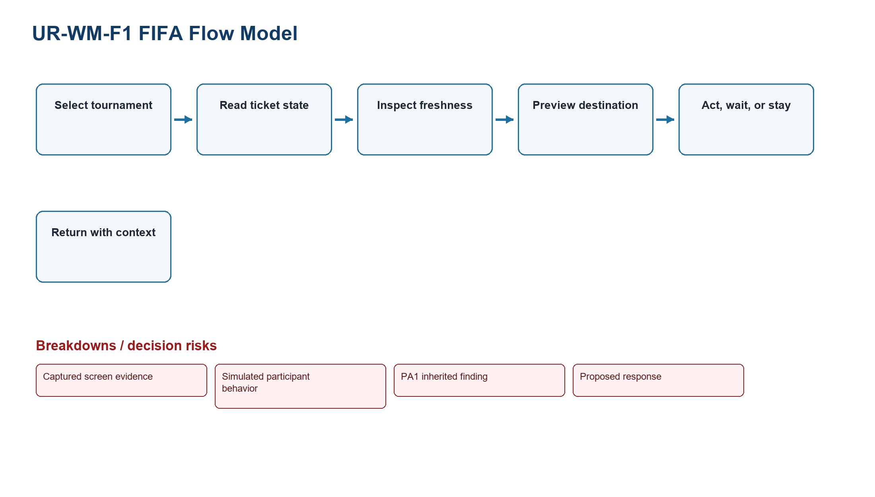
Figure UR-WM-01. Fifa Flow
Source: Captured screen evidence + simulated participant behavior + PA1 inherited finding + proposed response
Related: Task protocol, personas, findings, and PA3 validation
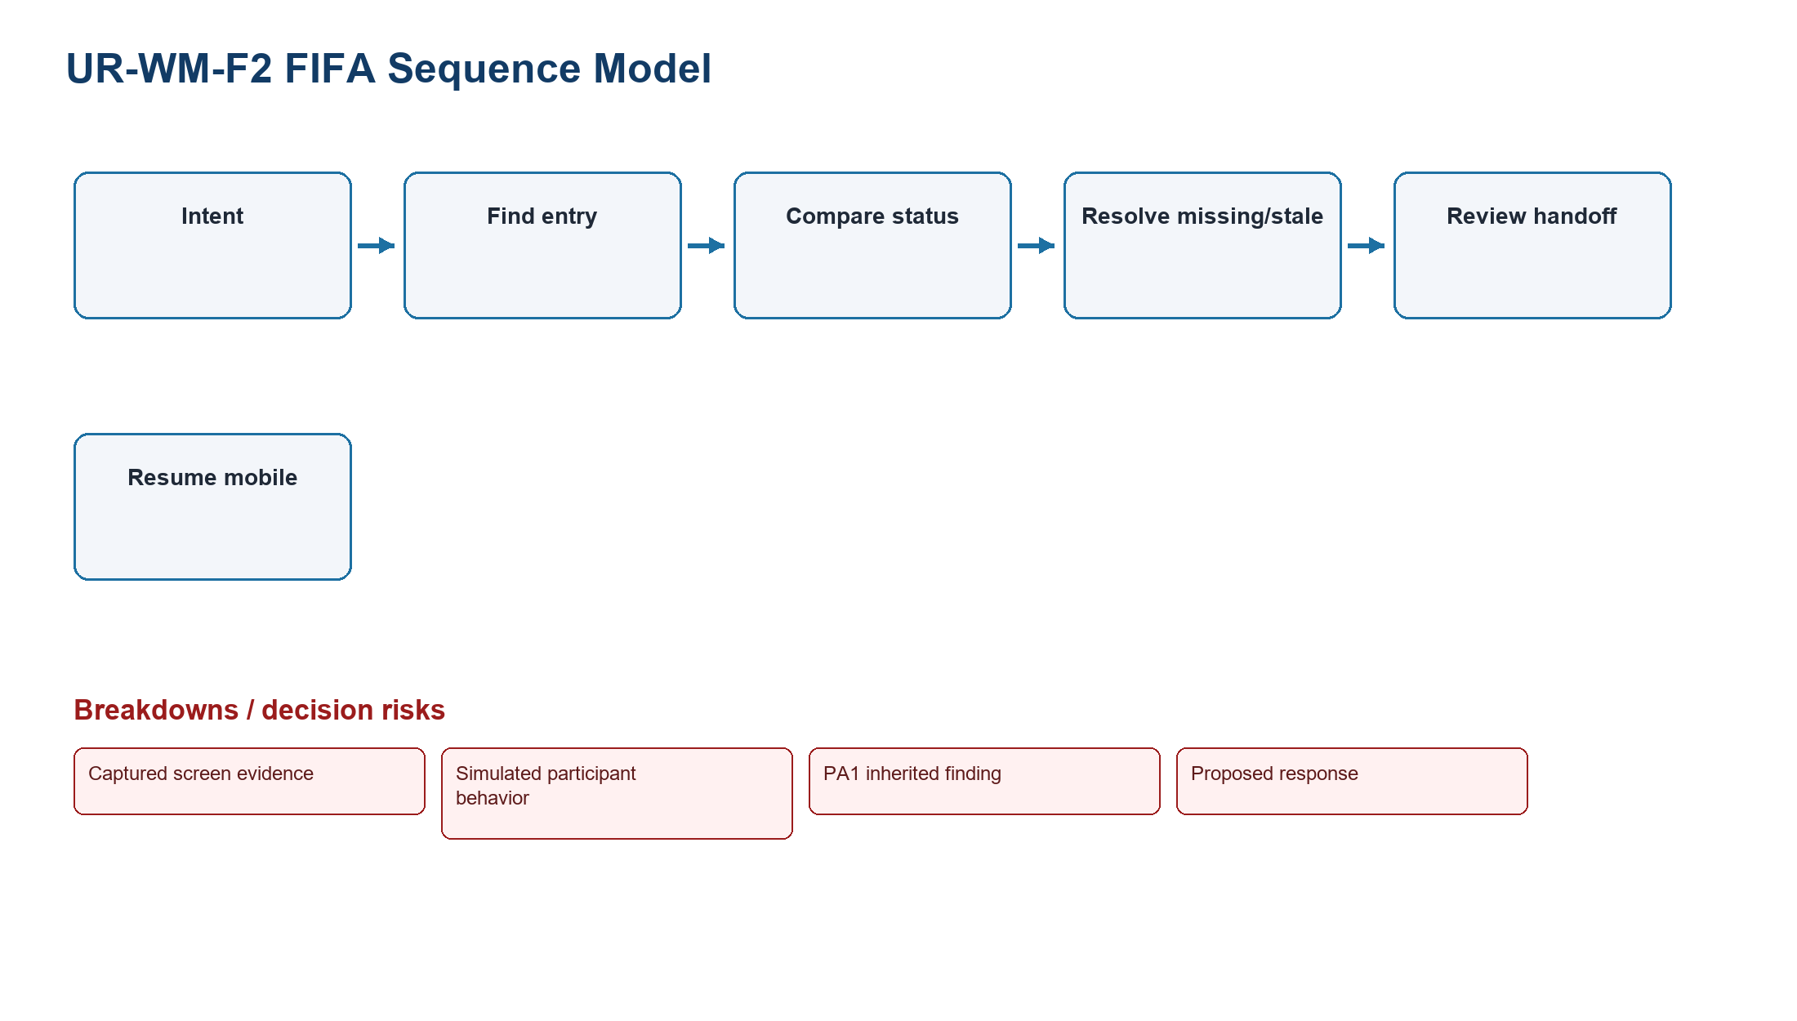
Figure UR-WM-02. Fifa Sequence
Source: Captured screen evidence + simulated participant behavior + PA1 inherited finding + proposed response
Related: Task protocol, personas, findings, and PA3 validation
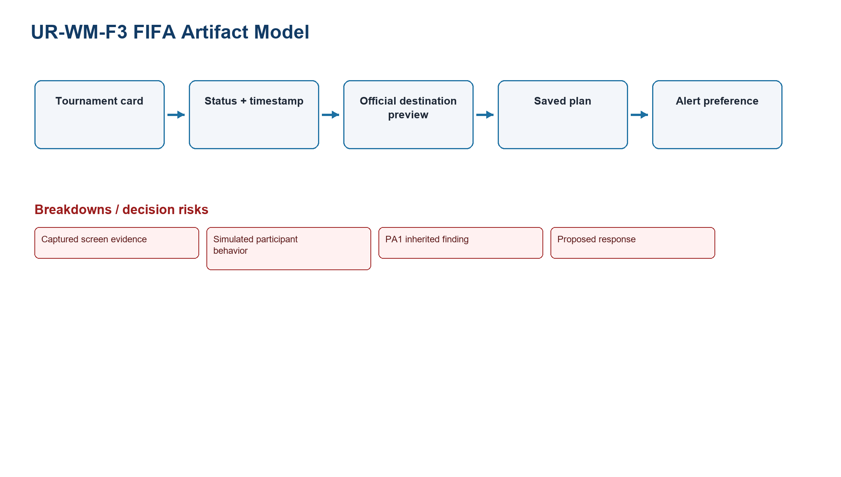
Figure UR-WM-03. Fifa Artifact
Source: Captured screen evidence + simulated participant behavior + PA1 inherited finding + proposed response
Related: Task protocol, personas, findings, and PA3 validation
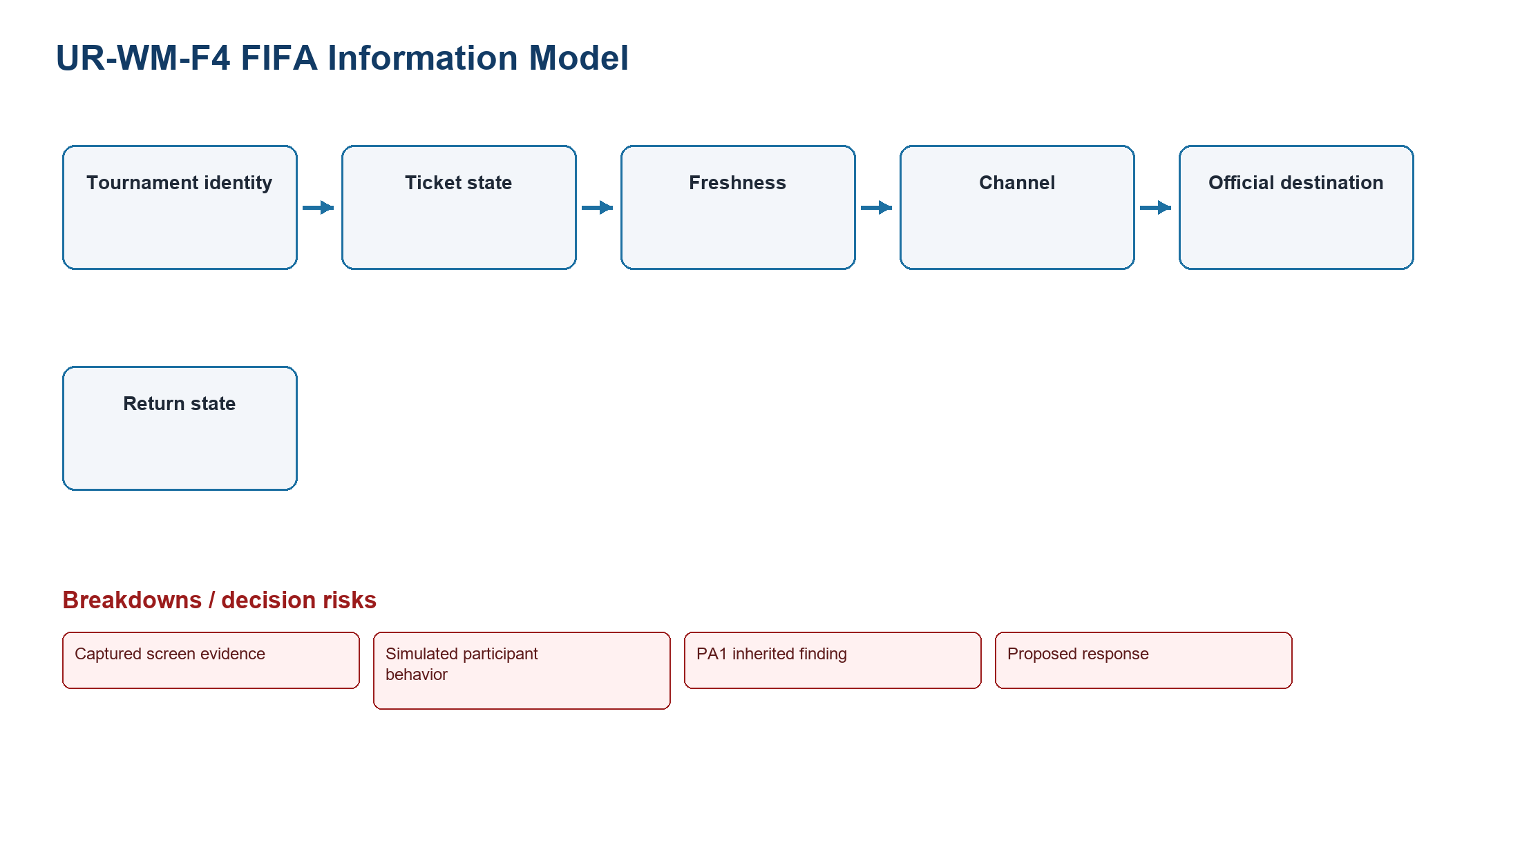
Figure UR-WM-04. Fifa Information
Source: Captured screen evidence + simulated participant behavior + PA1 inherited finding + proposed response
Related: Task protocol, personas, findings, and PA3 validation
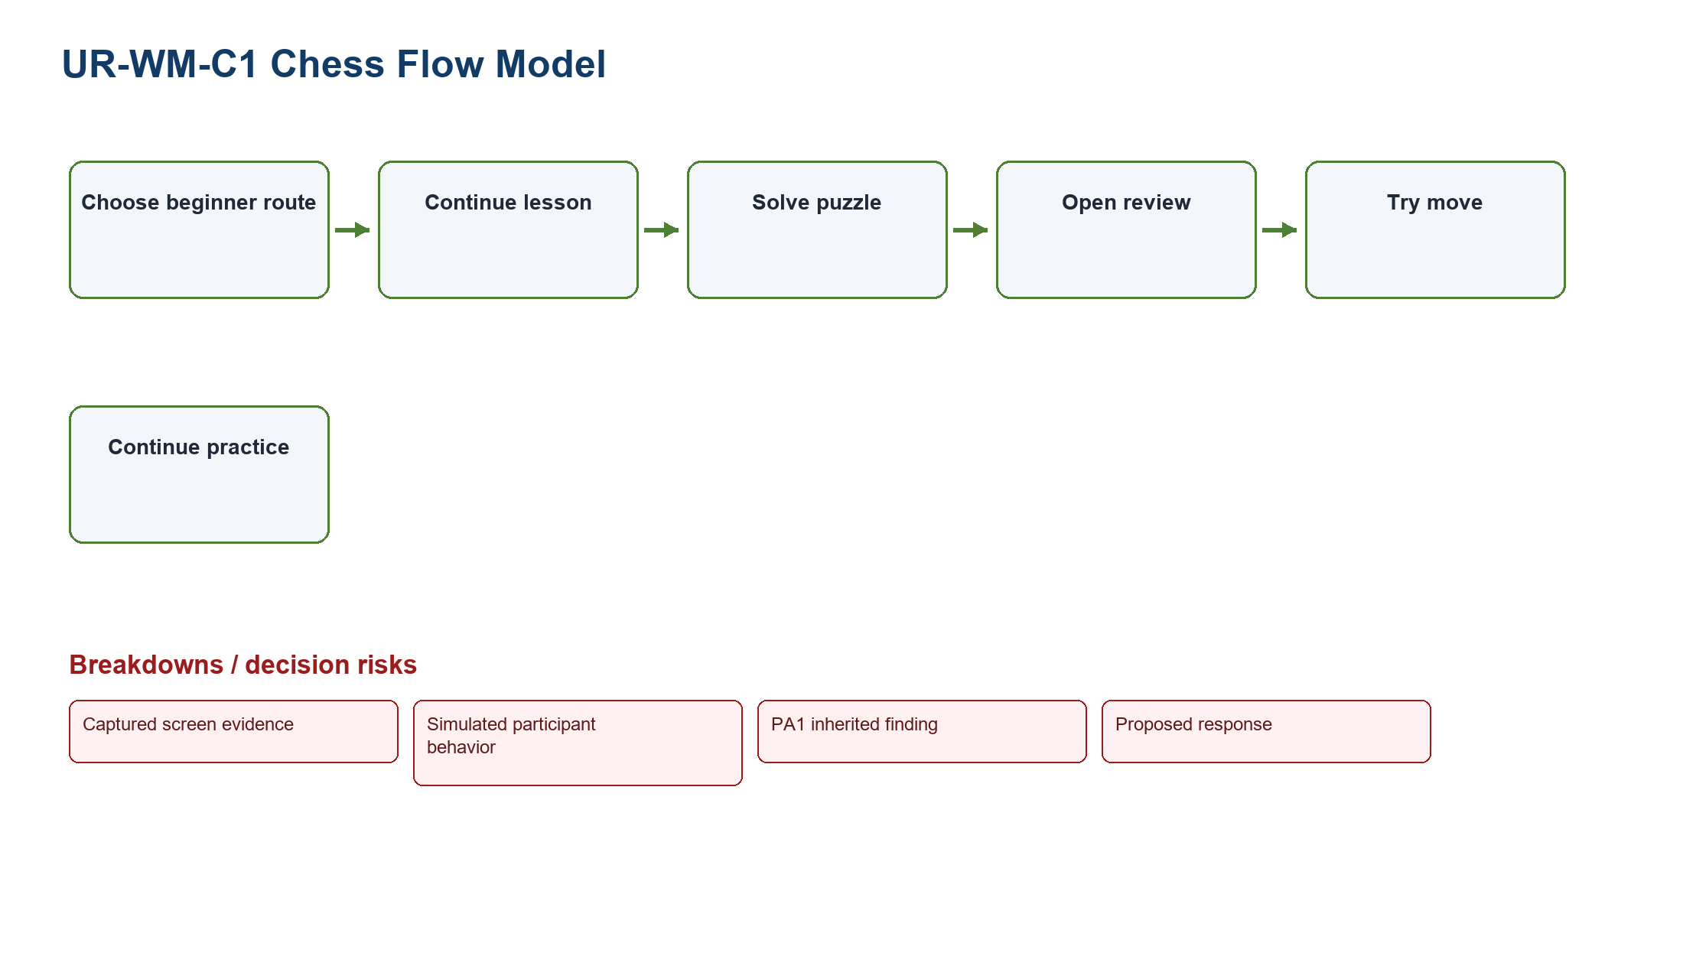
Figure UR-WM-05. Chess Flow
Source: Captured screen evidence + simulated participant behavior + PA1 inherited finding + proposed response
Related: Task protocol, personas, findings, and PA3 validation
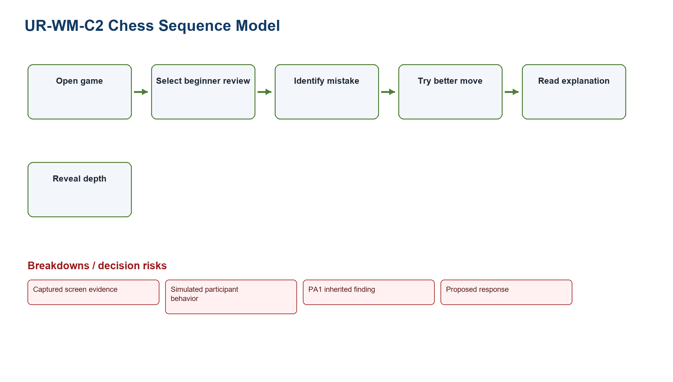
Figure UR-WM-06. Chess Sequence
Source: Captured screen evidence + simulated participant behavior + PA1 inherited finding + proposed response
Related: Task protocol, personas, findings, and PA3 validation
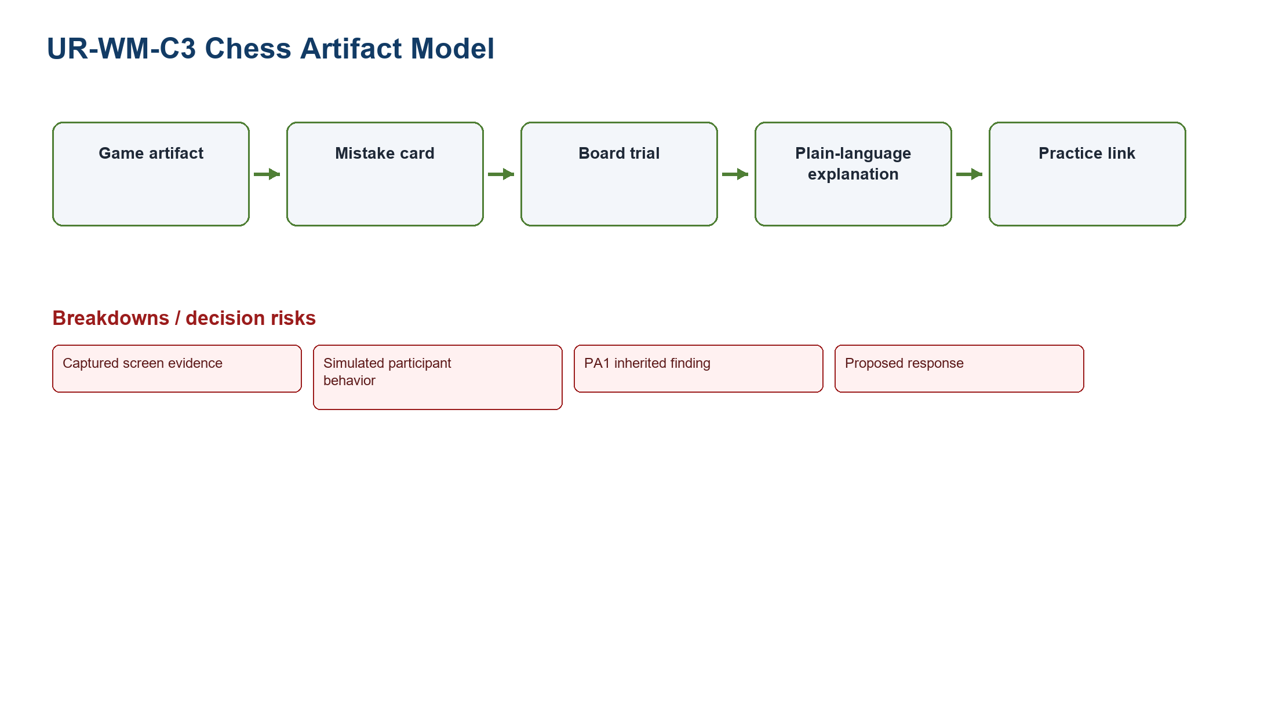
Figure UR-WM-07. Chess Artifact
Source: Captured screen evidence + simulated participant behavior + PA1 inherited finding + proposed response
Related: Task protocol, personas, findings, and PA3 validation
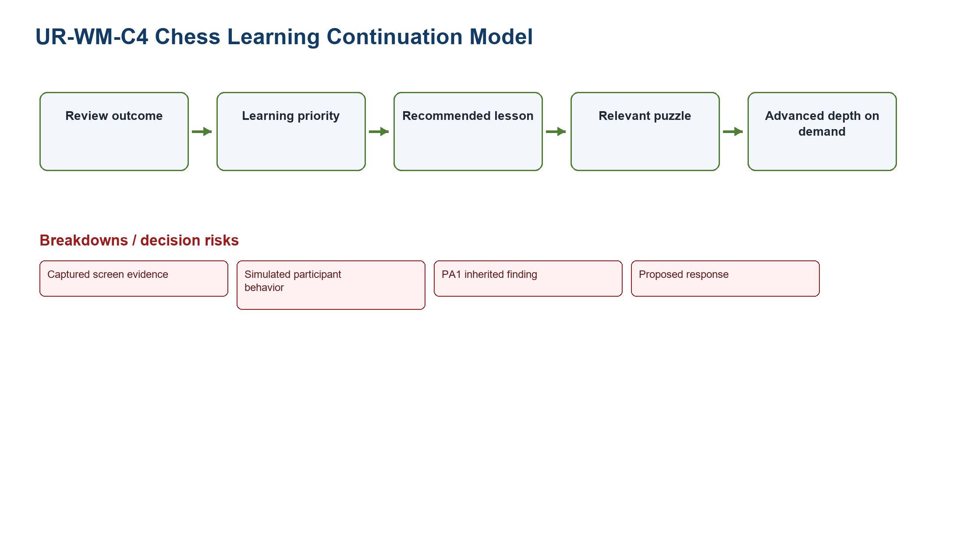
Figure UR-WM-08. Chess Continuation
Source: Captured screen evidence + simulated participant behavior + PA1 inherited finding + proposed response
Related: Task protocol, personas, findings, and PA3 validation

9. Findings
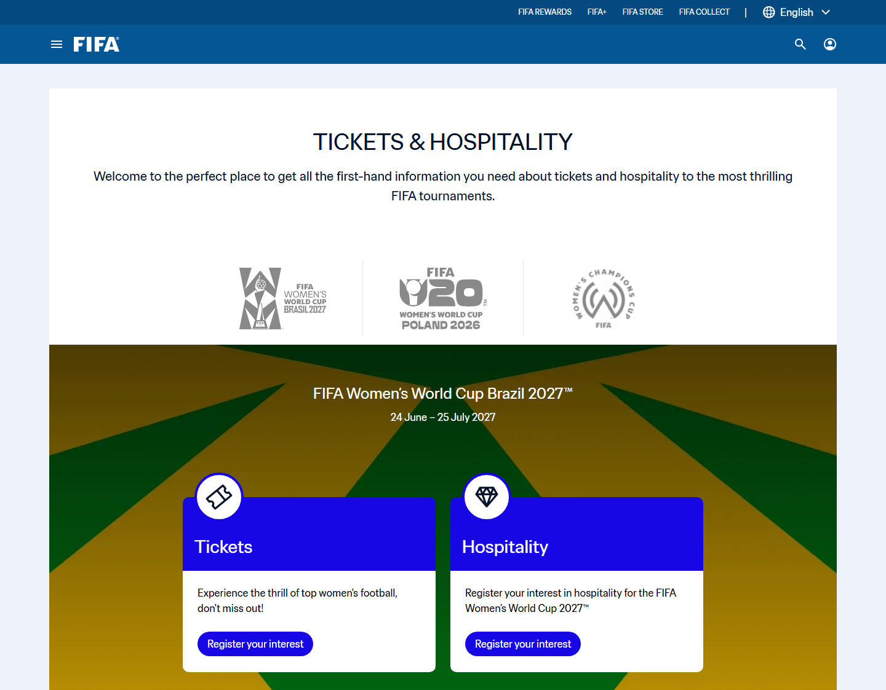
Figure UR-EV-01. FIFA ticket decision surface used by UR-F01 and UR-F02
Source: Screen evidence F2-E09; captured interface state only
Related: Ticket status clarity, freshness, handoff trust, and TP-FIFA
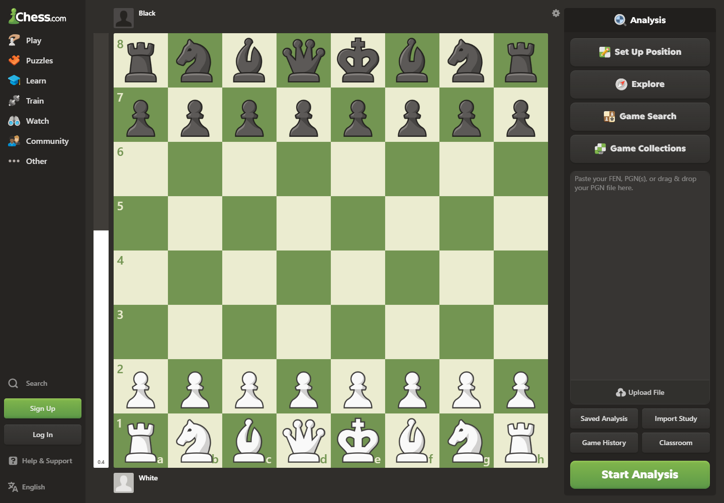
Figure UR-EV-02. Chess analysis-entry decision surface used by UR-C01 and UR-C02
Source: Screen evidence C2-E10; captured interface state only
Related: Entry choice overload, learning priority, vocabulary load, and TP-CHESS

ID | Visible evidence | Simulated study support | Affected user | Context | Task | Usability dimension | Severity | Root cause | Consequence | Design implication | Limitation | PA3 validation question
UR-F01 | F2-E09 ticket entry/card state | F-SIM-04/05/06: status or freshness hesitation | Trust-sensitive planners | Sale-window planning | Compare state and freshness | Visibility; effectiveness; errors | Critical | State, freshness, and action are separated | Waiting or unsafe departure | Status Dashboard with timestamp and missing/stale distinction | Scenario-based; live feed not inspected | Can users distinguish missing, stale, sold out, resale, and waiting room?
UR-F02 | F2-E09 outbound ticket path | F-SIM-02/05: handoff confidence 2-3/5 | Ticket planners | Before leaving FIFA.com | Preview destination | Satisfaction; user control; error prevention | High | Destination purpose and return path are not one decision object | Abandonment or uncalibrated trust | Official destination preview with stay/continue/return | No transaction performed | Does preview improve decision accuracy without overstating safety?
UR-F03 | F2-E02 mobile stack; F2-E03/04 schedule context | F-SIM-03/04: context recovery | Tournament followers | Desk-to-mobile continuation | Resume mobile | Efficiency; memorability | Medium | Context is not visibly persisted | Repeat search and filter work | Restore selected tournament and freshness | Account sync assumed | Can users resume with one recognition step?
UR-C01 | C2-E10 analysis entry choices | C-SIM-01/02/05: 2 wrong paths in several records | First-time and low-analysis players | After-game review | Open analysis | Learnability; recognition over recall; errors | Critical | Entry is organized by feature/setup rather than learning outcome | Expert view opens before a learning priority | Beginner Review Preset | No completed engine review observed | Can beginners choose the review route without terminology help?
UR-C02 | C2-E07/08 learning routes and C2-E10 analysis entry | C-SIM-02/04/06: explanation priority | Beginners and returning learners | Review after game | Identify mistake and read explanation | Effectiveness; satisfaction; progressive disclosure | High | Advanced detail competes with plain explanation | Numbers are seen before meaning | One mistake card, why, try move, then depth | Explanation accuracy unmeasured | Can users explain the mistake in their own words?
UR-C03 | C2-E05/07 practice artifacts | C-SIM-03/04/06: continuation chosen after review | Returning learners | Short practice session | Continue to practice | Efficiency; memorability | Medium | Review and practice are separate destinations | Insight does not become deliberate practice | Relevant lesson/puzzle continuation | Recommendation relevance is hypothetical | Does one next practice action increase correct continuation?

10. Evidence and course-source summary
Screen evidence: F2-E02-E04 and F2-E09 support FIFA navigation/status claims; C2-E05, C2-E07-E10 support Chess learning and analysis-entry claims.
PA1 inherited finding: The product pair, drawbacks, and evidence limits remain continuous with PA1.
Simulated study: Twelve scenario records generate hypotheses and traceable synthetic metrics only.
Design inference: Effectiveness, efficiency, learnability, memorability, errors, satisfaction, visibility, recognition, progressive disclosure, control, and prevention guide the implications.
PA3 validation target: Prototype testing must replace synthetic expectations with observed user evidence.
Course basis: LN01 - Introduction - v2.pdf, pp. 20, 22, 24; LN02 - Fundamental Concepts - Usability Dimensions_2.pdf, pp. 62-67, 74-76, 83-84, 101-115; LN03 - UI Design Process.pdf, pp. 16-19, 23-24, 28-30, 34-36; LN04 - Task Analysis.pdf, pp. 3, 6-15, 39-49.

