PROJECT ASSIGNMENT 2

Group10-PA2 Project Proposal
  - Task-first redesign concepts for ticket confidence and guided beginner review
FIFA.com and Chess.com
Course | CSC13112 - UI/UX Design, FIT-HCMUS
Group | Group10
Team | Le Minh (21127645); Nguyen Vu Bach (21127224); Pham Nguyen Gia Bao (20127119); Trang Minh Nhut (22127318)
Evidence date | Local evidence audited through 30 July 2026
Document type | Evidence-based redesign report

Contents
1. Proposal summary ................................... 3
2. Evidence-based problem selection ................... 3
3. Target users and contexts .......................... 3
4. Concept family A - FIFA ............................ 3
5. Concept family B - Chess.com ....................... 9
6. Weighted comparison ................................ 15
7. Recommended direction .............................. 16
8. Scope and non-scope ................................ 16
9. Design principles, risks, and success criteria ..... 16
10. Traceability and preparation for PA3 .............. 17

1. Proposal summary
Overall concept: A task-first web redesign program with two product-specific modules: Module A, FIFA Ticket Confidence Layer; Module B, Chess Guided Beginner Review.

These are redesign concepts for existing web experiences. They are not implemented or tested products. Benefits are hypotheses for PA3 prototyping and informal testing.

2. Evidence-based problem selection
Module | Tough problem | Evidence | PA1 continuity
A. FIFA Ticket Confidence Layer | Status, availability, resale/waiting, and destination are not consolidated before external action. | F2-E09, E10, E11, E18 | F-D2, F-D4
B. Chess Guided Beginner Review | Learning and analysis entry expose competing choices and advanced controls before a clear beginner next action. | C2-E01, E07, E08, E10, E12, E15 | C-D1, C-D2

3. Target users and contexts
- F-P3 plans tickets across days or devices and needs official status before identity, partner, or payment boundaries.
- C-P1 learns with limited terminology; C-P3 returns after gaps and needs recognition plus a clear continuation.
- Secondary personas remain in scope for compatibility, but the initial prototypes focus on these scenarios.

4. Concept family A - FIFA

F-A1 Status Dashboard
Field | Concept definition
Target proto-persona / scenario | F-P3 (provisional) - Compare ticket states before action.
Problem addressed | TP-FIFA.
Form factor | Responsive web redesign.
Concept summary | Comparison-first dashboard
Interaction model | Tournament, sale phase, ticket type, availability summary, resale, waiting state, milestone, last update, one official action.
Artifacts / data | Comparison table and status cards
Core screens / components | Dashboard; status detail; destination preview
Information hierarchy | State -> evidence timestamp -> official action
HCI principles | Visibility of system status; recognition; error prevention. See LN02 - Fundamental Concepts, pp. 66, 116; LN03 - UI Design Process, p. 36.
Expected benefit | Hypothesis: improves confidence and comparison speed.
Tradeoff | Adds new status, guidance, or planning structure that must not obscure direct official routes.
Implementation dependency | Depends on governed real-time status data.
Privacy / trust | Could appear authoritative when data is stale.
Accessibility | Text/icon status, keyboard comparison, screen-reader timestamps.
Evidence links | F2-E09, F2-E18; F-D4
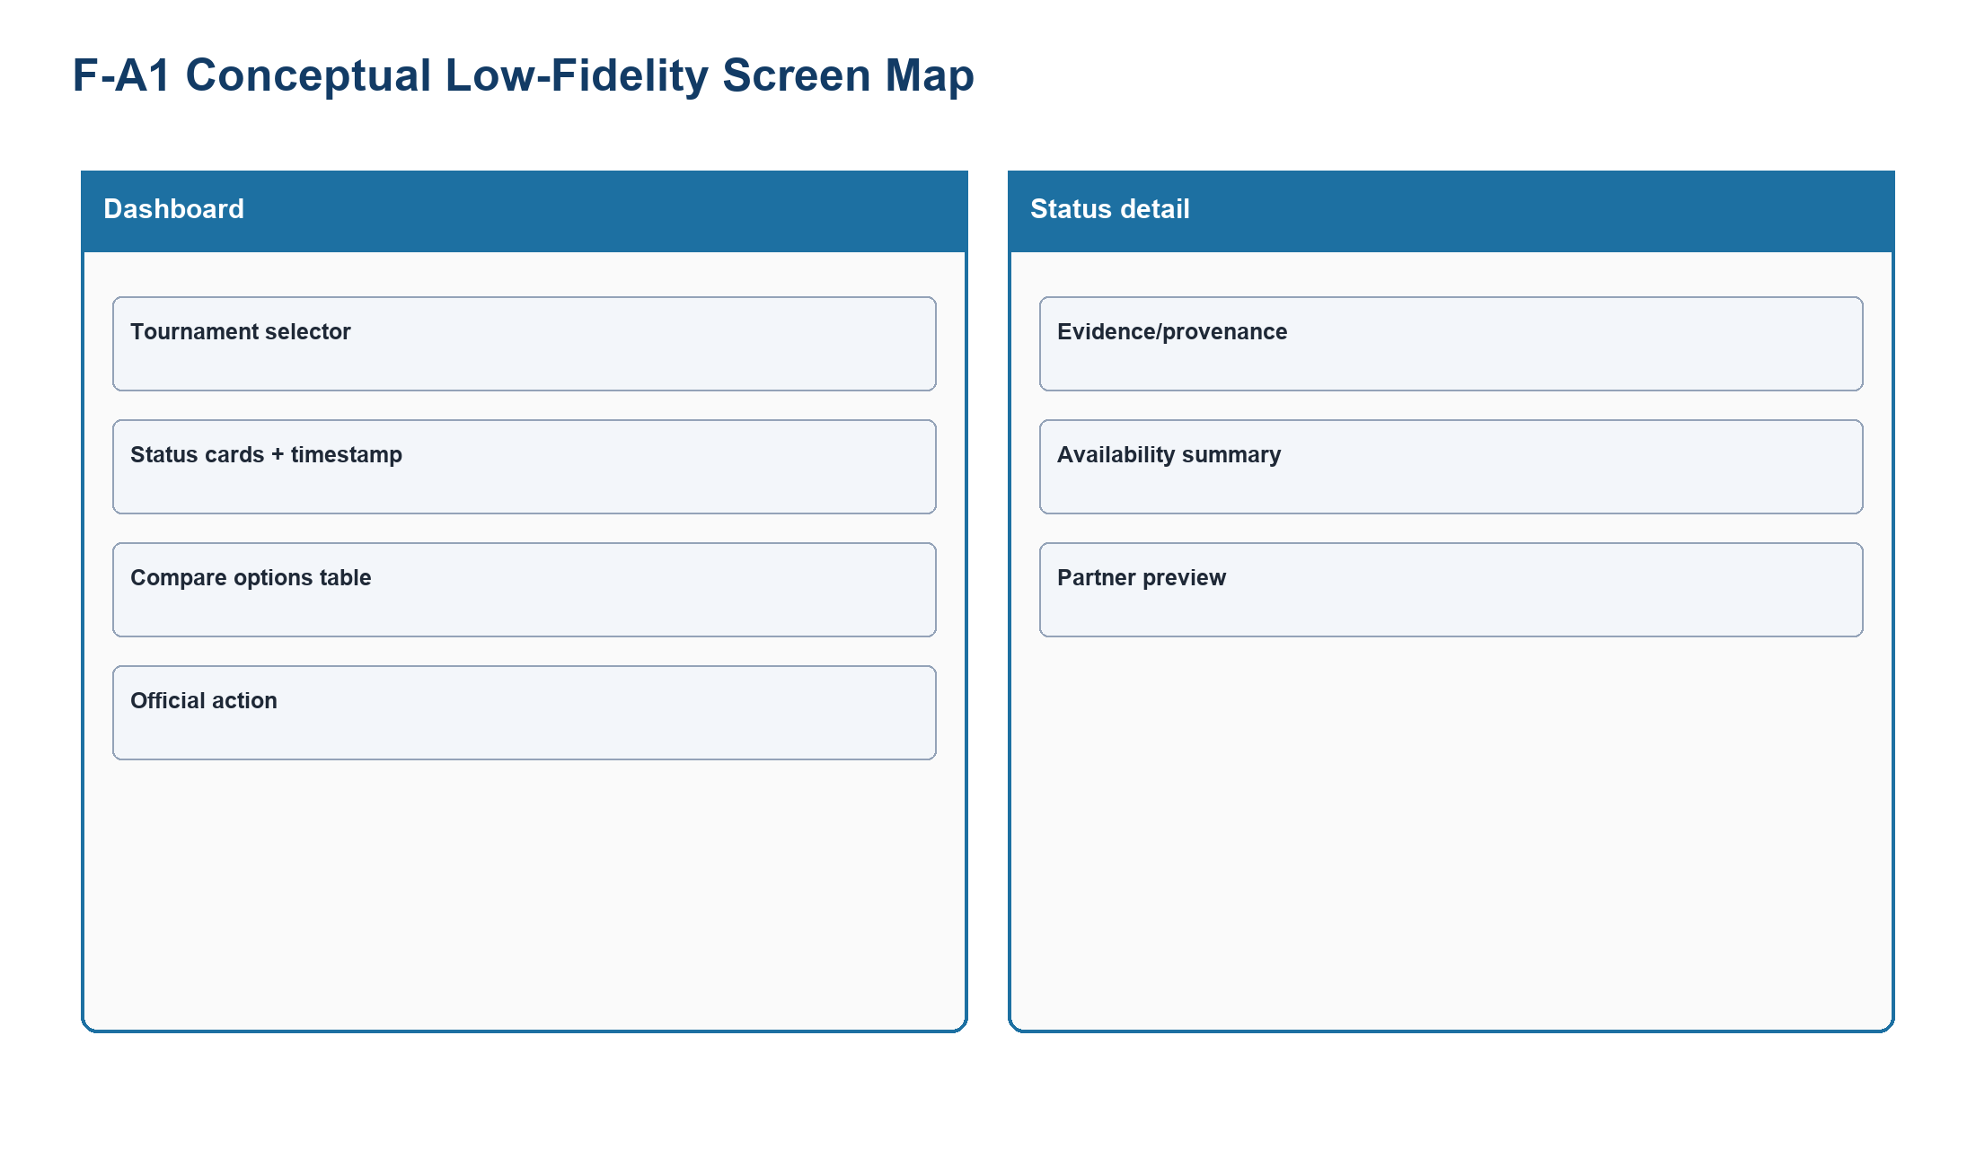
Figure PP-F-A1-L. Status Dashboard conceptual low-fidelity screen map made only from shapes and labels.
Source: generated-diagrams/f-a1-lowfi.png
Related: F-P3; TP-FIFA
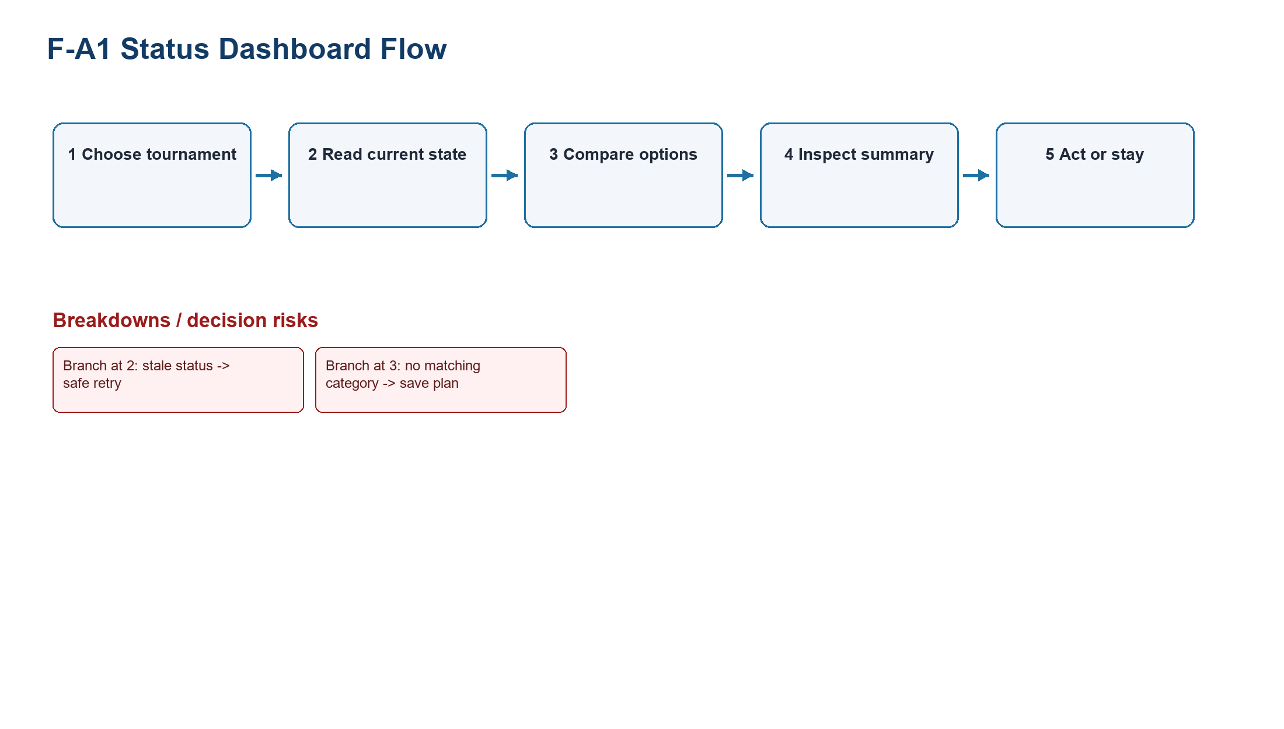
Figure PP-F-A1-F. Status Dashboard flow model. Numbered steps, branches, and breakdowns are proposal hypotheses, not existing or tested behavior.
Source: generated-diagrams/f-a1-flow.png
Related: F-P3; TP-FIFA

F-A2 Guided Ticket Concierge
Field | Concept definition
Target proto-persona / scenario | F-P3 (provisional) - Resolve an individual ticket path.
Problem addressed | TP-FIFA.
Form factor | Responsive web redesign.
Concept summary | Step-by-step wizard
Interaction model | Ask tournament, date/team, ticket type, party size, and eligibility; then explain next official path.
Artifacts / data | Wizard, eligibility summary, handoff confirmation
Core screens / components | Preference steps; result; partner preview
Information hierarchy | One question -> eligibility -> destination
HCI principles | Progressive disclosure; feedforward; error prevention. See LN02 - Fundamental Concepts, pp. 66, 116; LN03 - UI Design Process, p. 36.
Expected benefit | Hypothesis: reduces interpretation burden for complex eligibility.
Tradeoff | Adds new status, guidance, or planning structure that must not obscure direct official routes.
Implementation dependency | Requires eligibility and market rules.
Privacy / trust | Collects preference data and must minimize retention.
Accessibility | Explicit labels, error summary, back navigation, no time limit.
Evidence links | F2-E09-E11; F-D2/F-D4
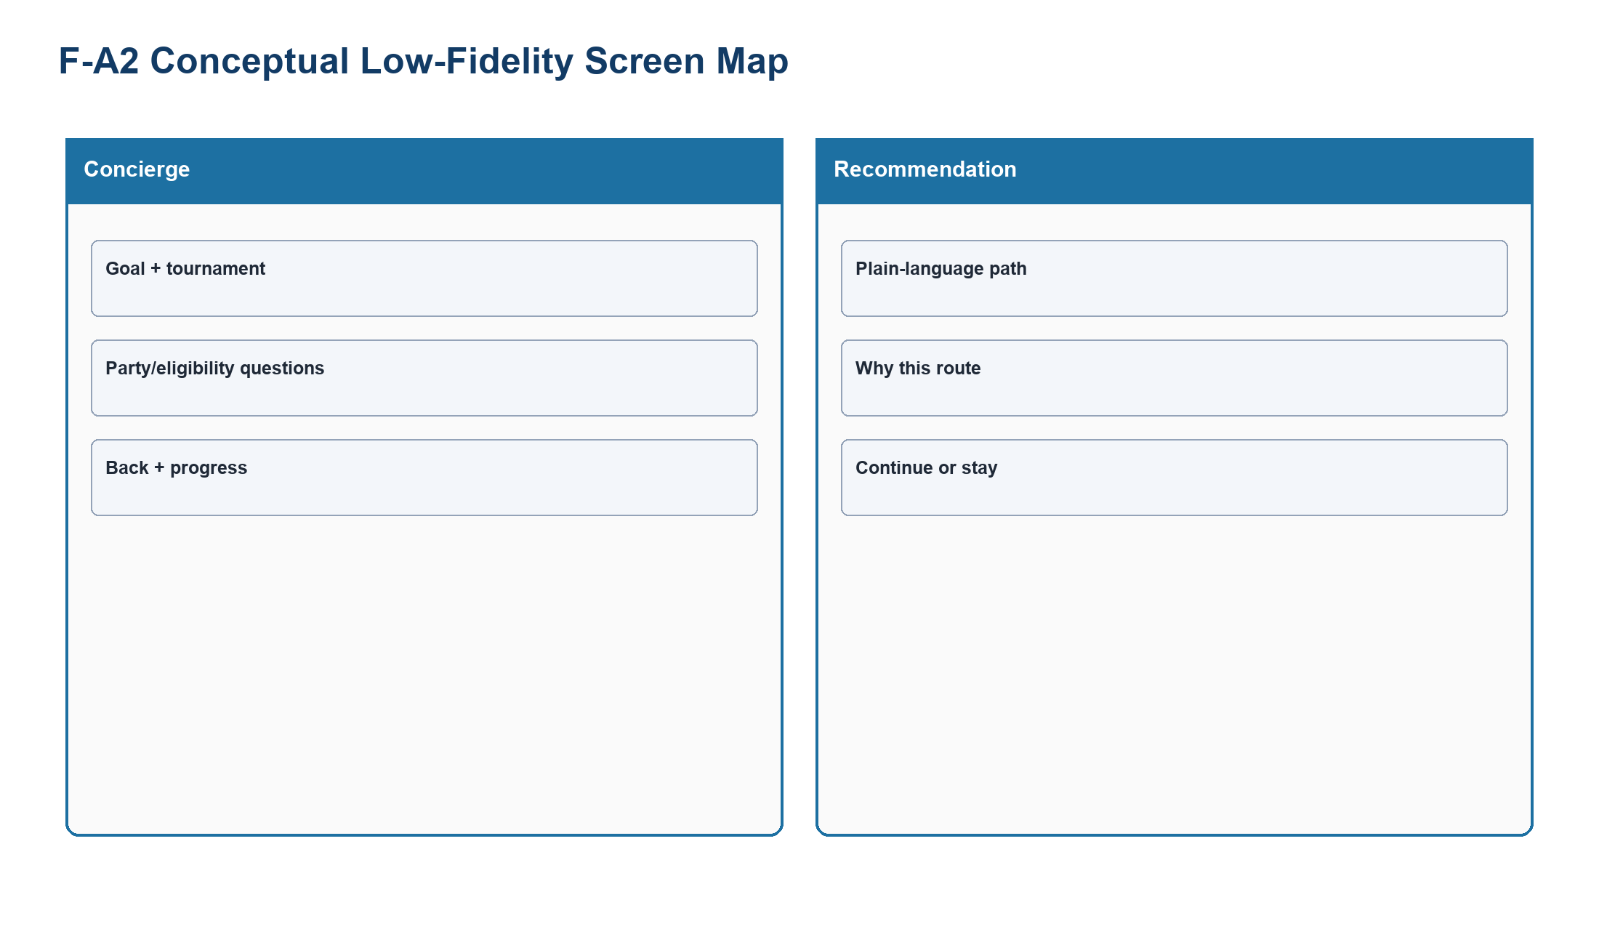
Figure PP-F-A2-L. Guided Ticket Concierge conceptual low-fidelity screen map made only from shapes and labels.
Source: generated-diagrams/f-a2-lowfi.png
Related: F-P3; TP-FIFA
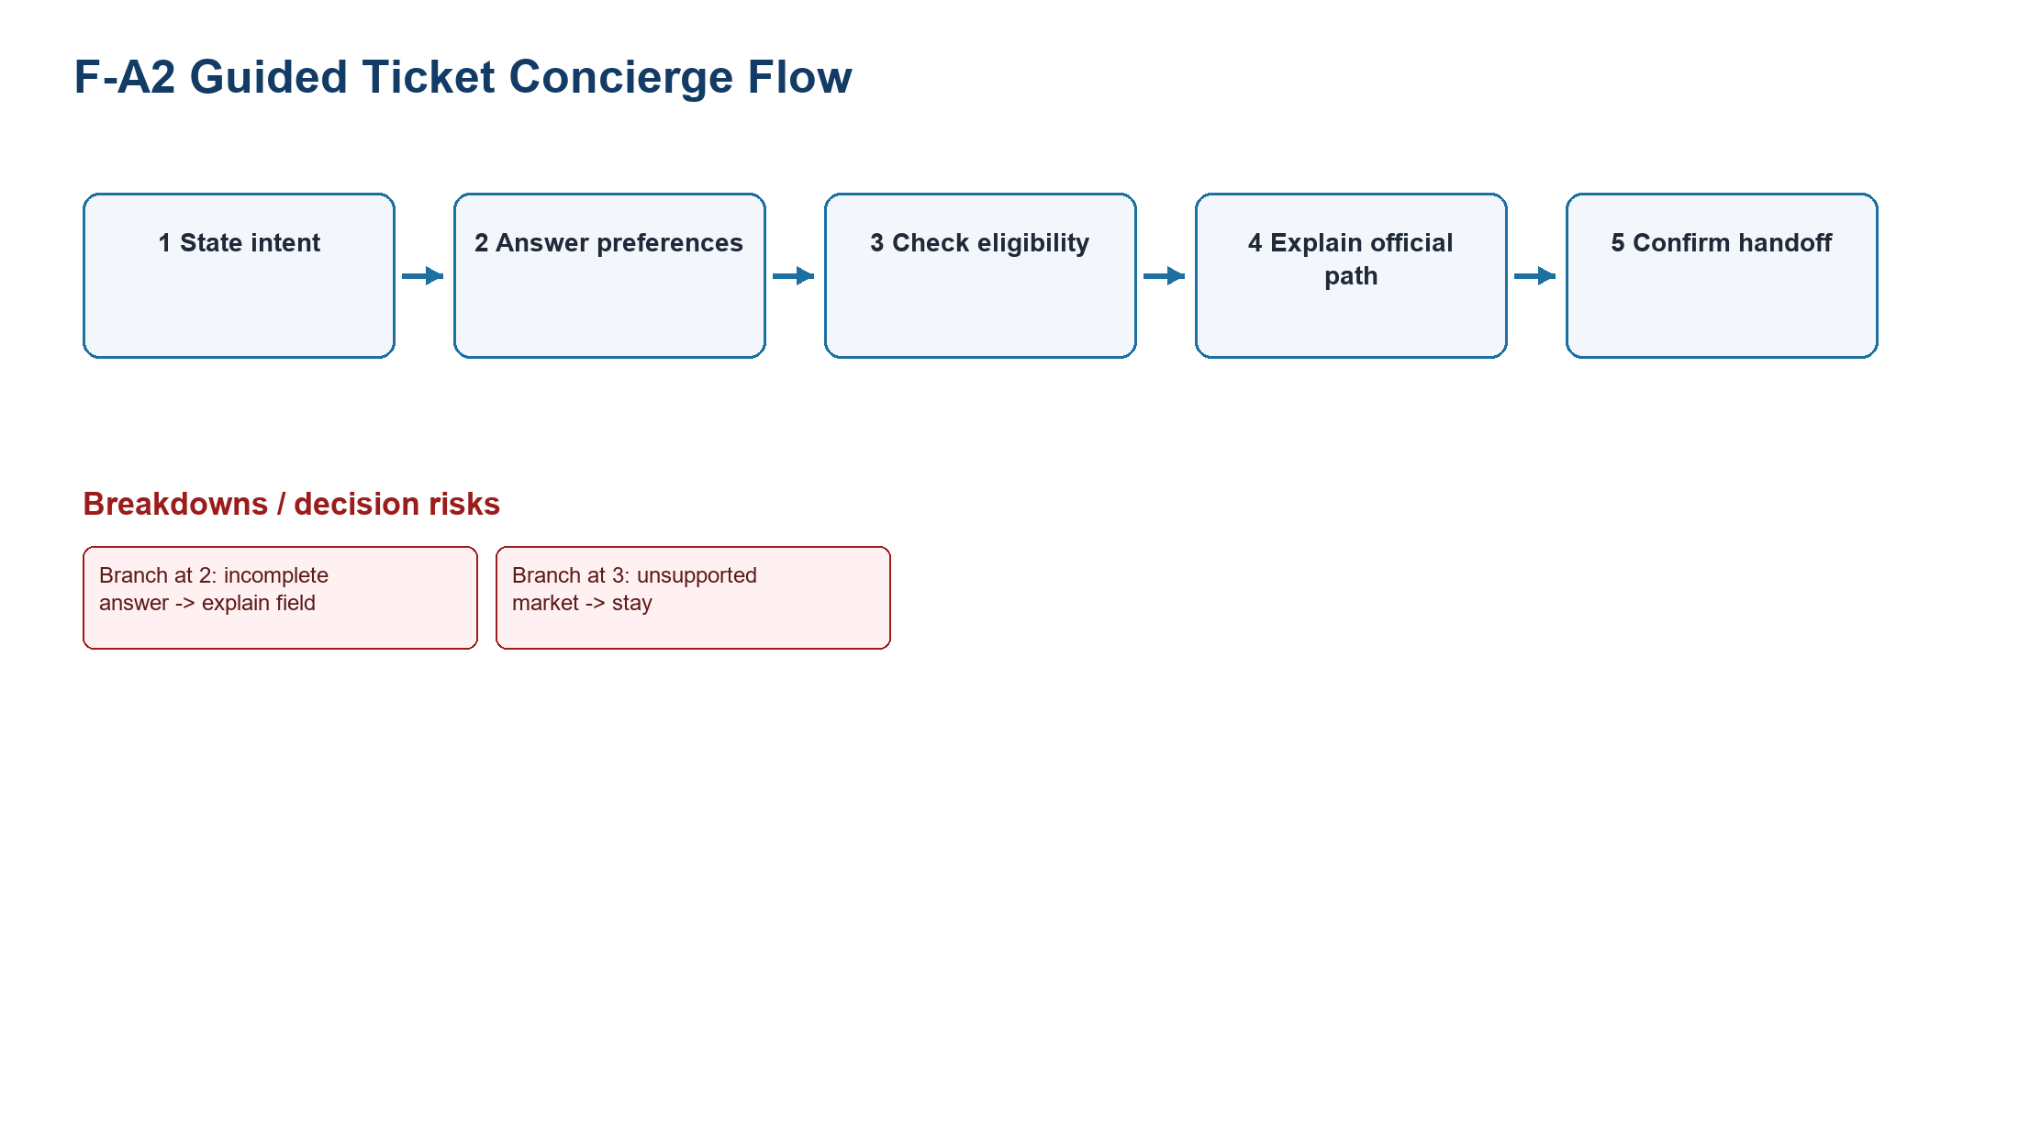
Figure PP-F-A2-F. Guided Ticket Concierge flow model. Numbered steps, branches, and breakdowns are proposal hypotheses, not existing or tested behavior.
Source: generated-diagrams/f-a2-flow.png
Related: F-P3; TP-FIFA

F-A3 Alert-First Ticket Planner
Field | Concept definition
Target proto-persona / scenario | F-P3 (provisional) - Avoid repeated manual checking.
Problem addressed | TP-FIFA.
Form factor | Responsive web redesign.
Concept summary | Planning workspace
Interaction model | Follow tournament/team, save requirements, receive verified state changes, and open partner only when actionable.
Artifacts / data | Watchlist, requirement card, alert receipt
Core screens / components | Planner; consent; verified alert; destination preview
Information hierarchy | Plan -> wait -> verified change -> action
HCI principles | Prospective-memory support; user control; trust. See LN02 - Fundamental Concepts, pp. 66, 116; LN03 - UI Design Process, p. 36.
Expected benefit | Hypothesis: replaces repeated checking with governed alerts.
Tradeoff | Adds new status, guidance, or planning structure that must not obscure direct official routes.
Implementation dependency | Requires notification service and consent state.
Privacy / trust | Notification privacy and fatigue.
Accessibility | Channel choice, quiet hours, accessible alert history.
Evidence links | F2-E09, F2-E18; F-D4
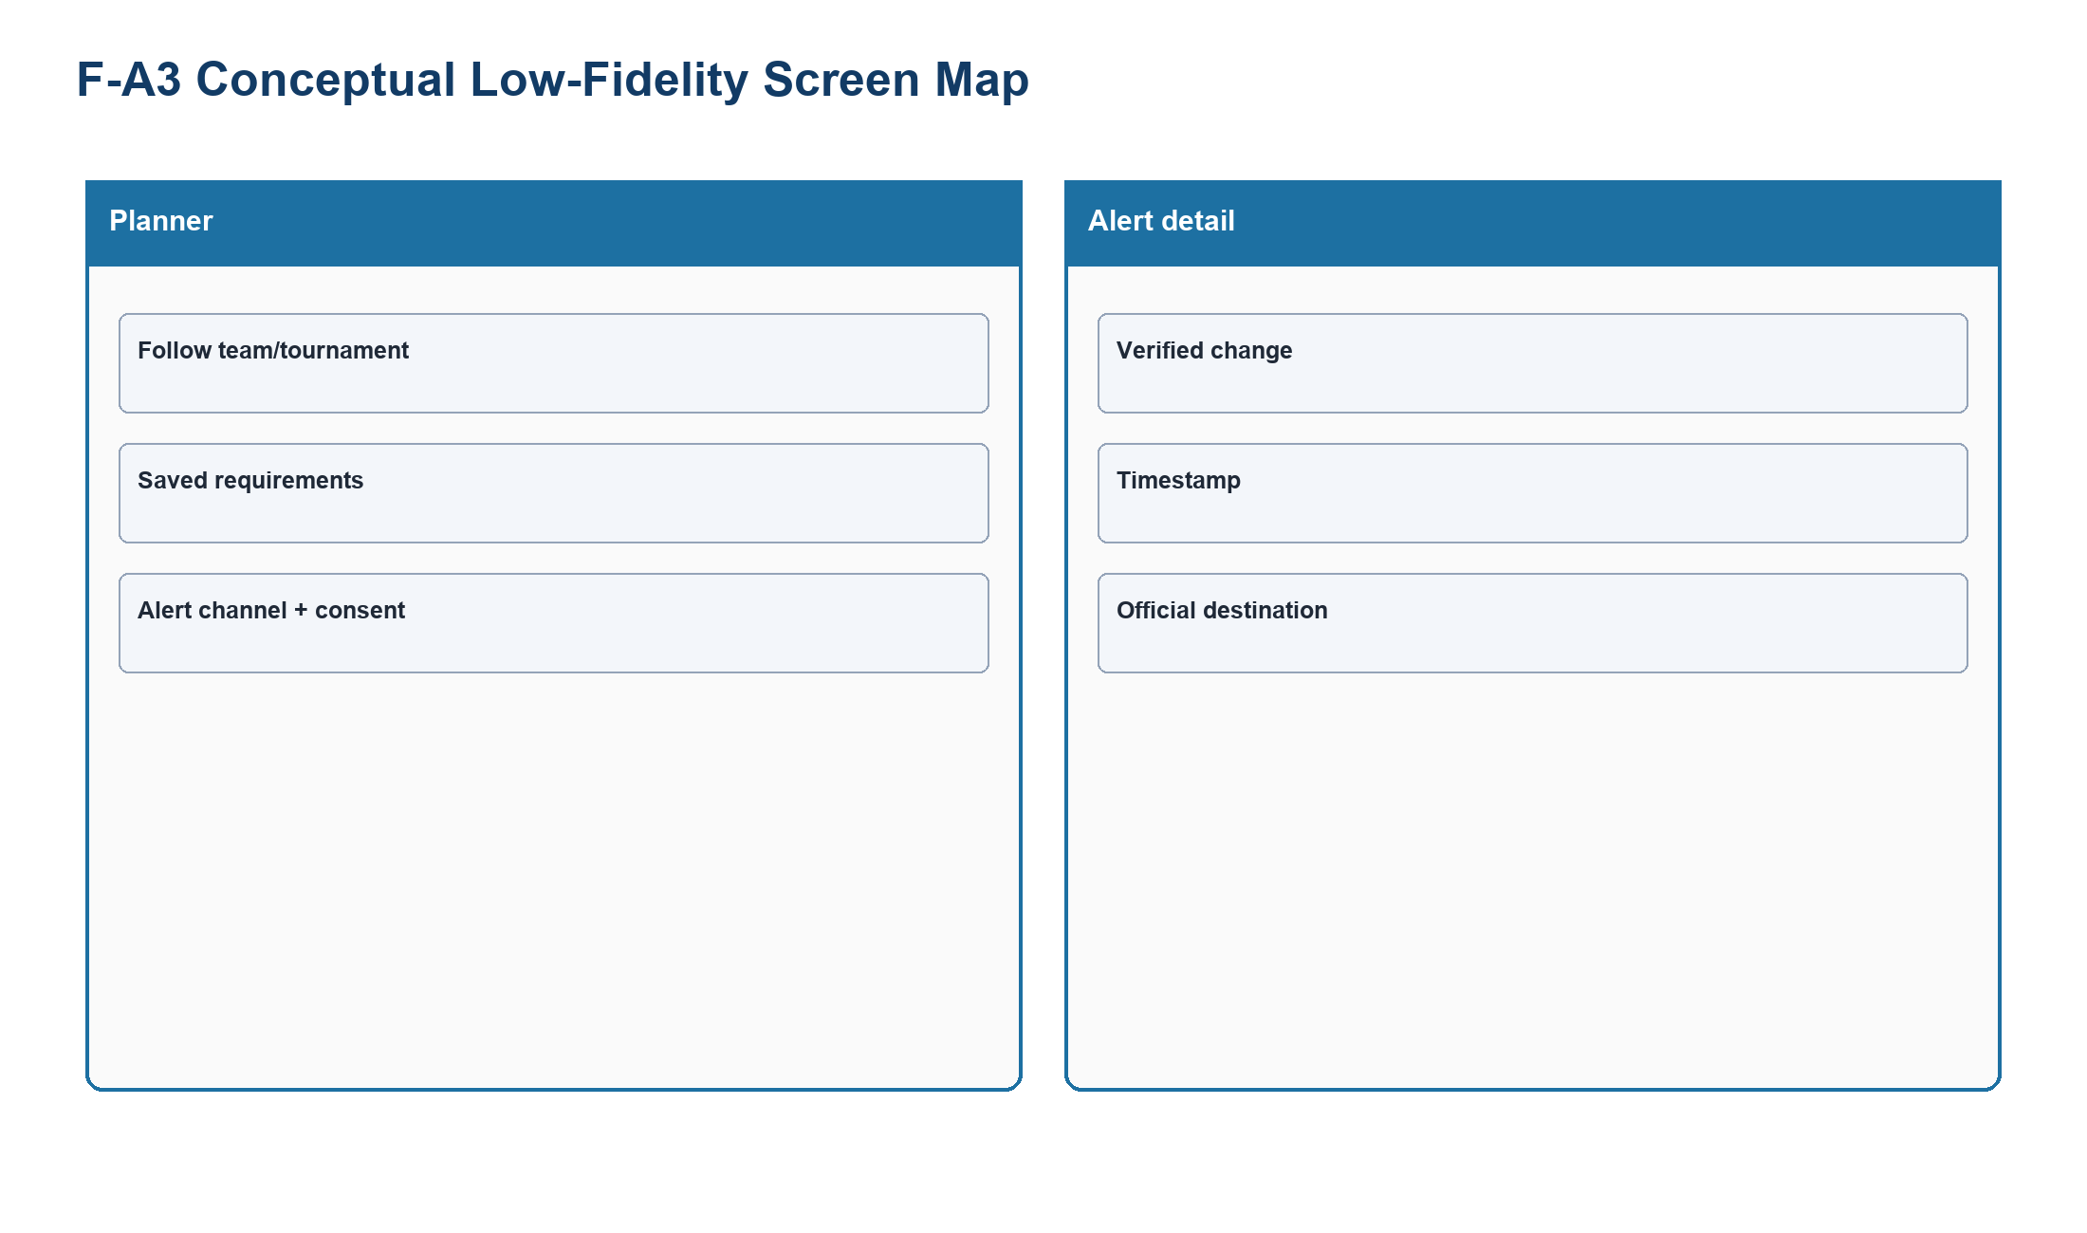
Figure PP-F-A3-L. Alert-First Ticket Planner conceptual low-fidelity screen map made only from shapes and labels.
Source: generated-diagrams/f-a3-lowfi.png
Related: F-P3; TP-FIFA
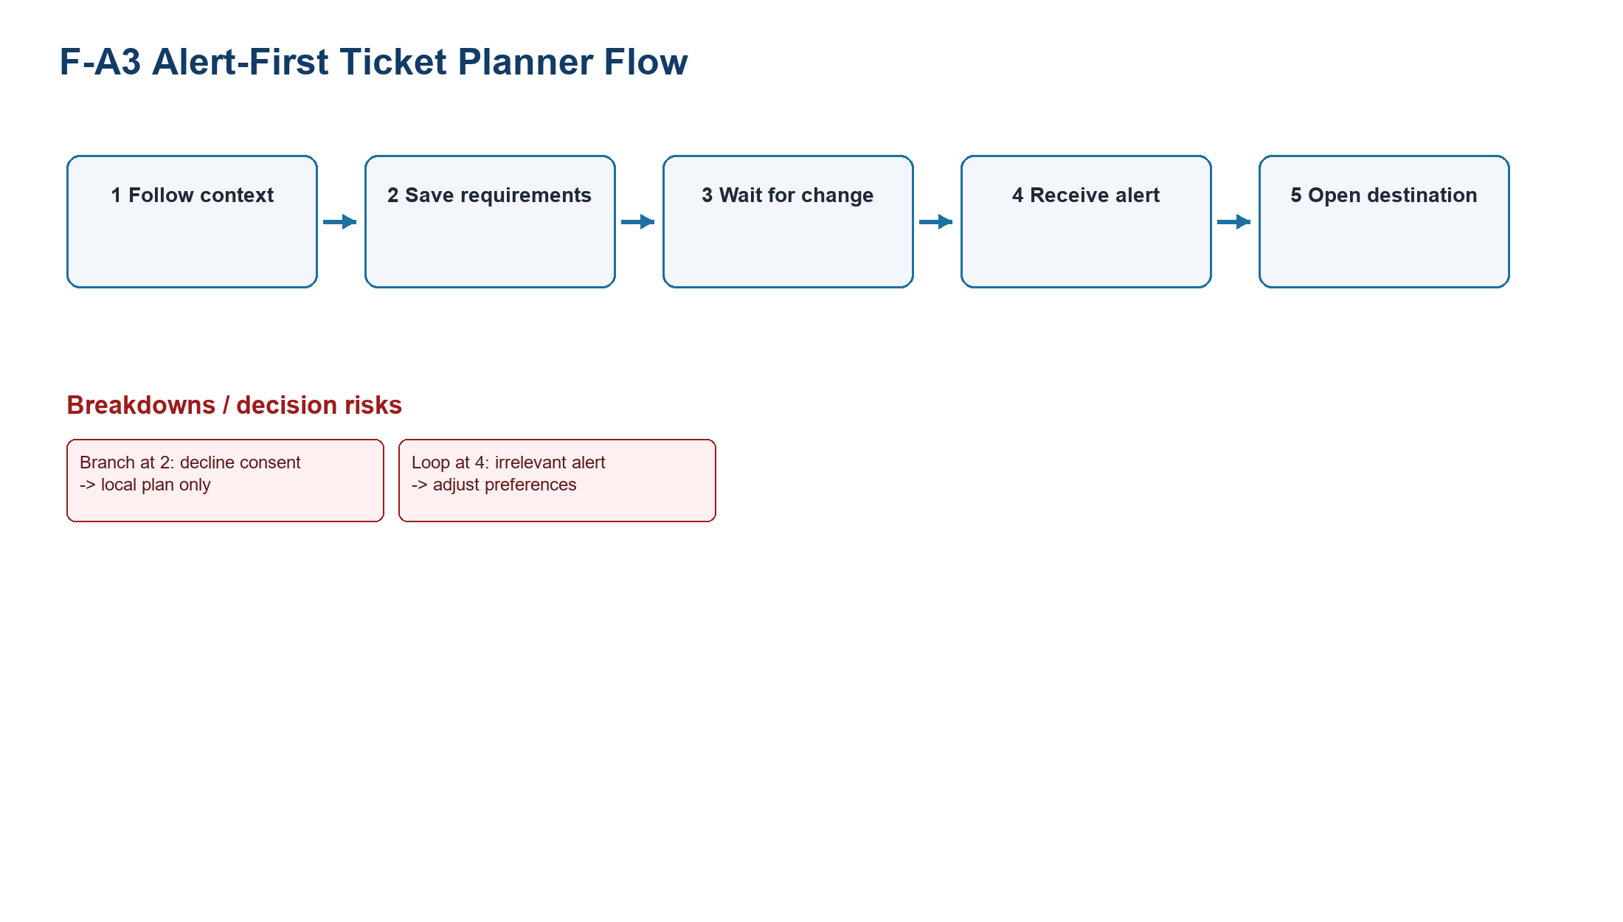
Figure PP-F-A3-F. Alert-First Ticket Planner flow model. Numbered steps, branches, and breakdowns are proposal hypotheses, not existing or tested behavior.
Source: generated-diagrams/f-a3-flow.png
Related: F-P3; TP-FIFA

5. Concept family B - Chess.com

C-A1 Beginner Analysis Preset
Field | Concept definition
Target proto-persona / scenario | C-P1; C-P3 (provisional) - Understand one critical review point.
Problem addressed | TP-CHESS.
Form factor | Responsive web redesign.
Concept summary | Simplified review surface
Interaction model | Show one main mistake, one best move, one plain-language explanation, and one next-learning action; advanced data on demand.
Artifacts / data | Position card, move comparison, explanation, lesson link
Core screens / components | Preset entry; critical position; try move; next action
Information hierarchy | Primary action -> explanation -> practice -> optional advanced
HCI principles | Progressive disclosure; feedback; recognition. See LN02 - Fundamental Concepts, pp. 66, 116; LN03 - UI Design Process, p. 36.
Expected benefit | Hypothesis: makes review interpretable before engine detail.
Tradeoff | Simplification can hide nuance; advanced analysis must remain explicitly available.
Implementation dependency | Requires review engine and explanation rules.
Privacy / trust | Explanations must state uncertainty and avoid false authority.
Accessibility | Keyboard board alternative, text move notation, non-color status.
Evidence links | C2-E08, C2-E10; C-D1/C-D2
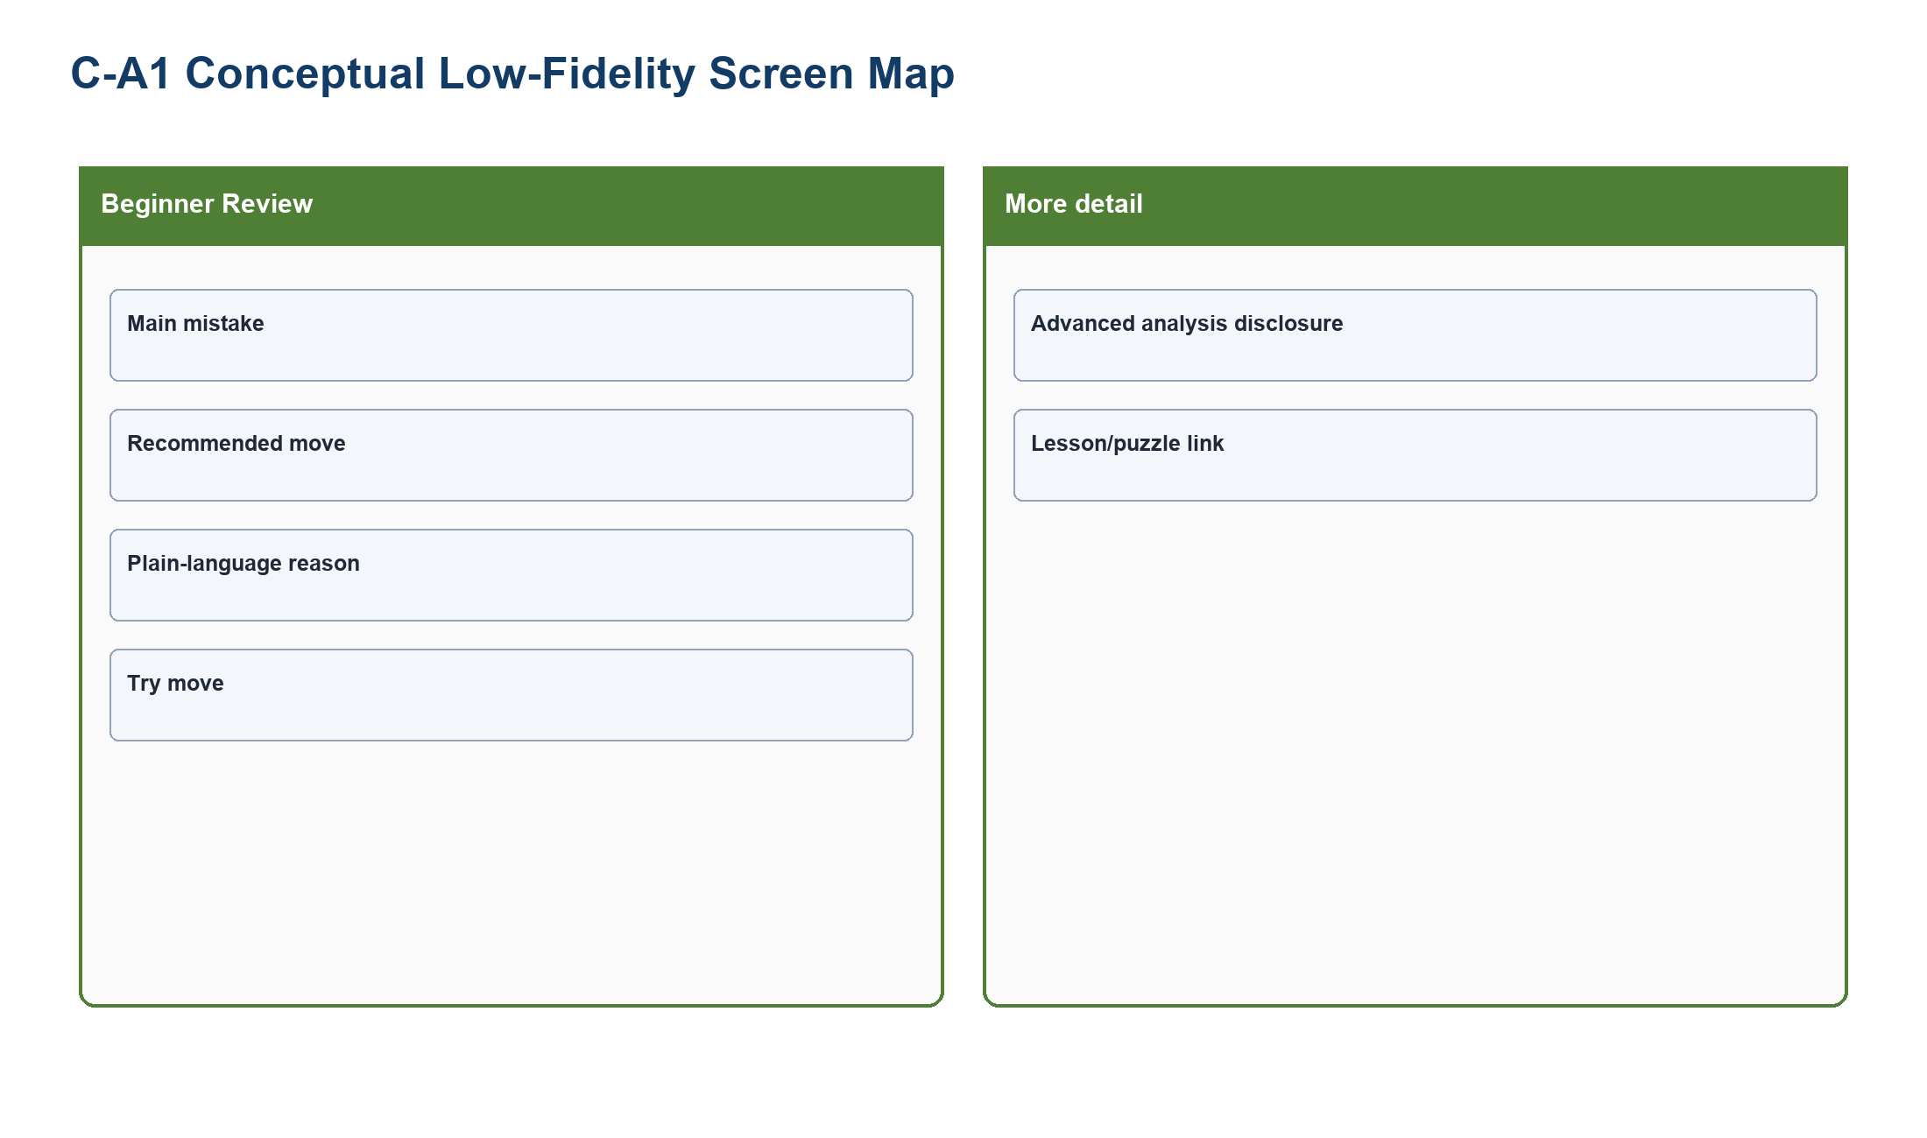
Figure PP-C-A1-L. Beginner Analysis Preset conceptual low-fidelity screen map made only from shapes and labels.
Source: generated-diagrams/c-a1-lowfi.png
Related: C-P1; C-P3; TP-CHESS
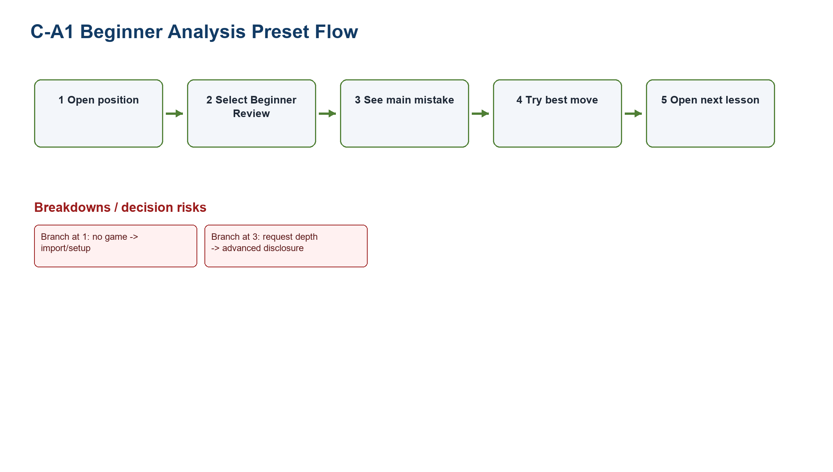
Figure PP-C-A1-F. Beginner Analysis Preset flow model. Numbered steps, branches, and breakdowns are proposal hypotheses, not existing or tested behavior.
Source: generated-diagrams/c-a1-flow.png
Related: C-P1; C-P3; TP-CHESS

C-A2 Conversational Coach
Field | Concept definition
Target proto-persona / scenario | C-P1; C-P3 (provisional) - Connect intention to feedback.
Problem addressed | TP-CHESS.
Form factor | Responsive web redesign.
Concept summary | Guided Q&A
Interaction model | Ask what the player intended, explain the critical position, and link one lesson or puzzle.
Artifacts / data | Question card, response options, coach explanation
Core screens / components | Intent question; critical position; resource link
Information hierarchy | Intent -> clarification -> explanation -> next task
HCI principles | Conversational scaffolding; reflection; contextual help. See LN02 - Fundamental Concepts, pp. 66, 116; LN03 - UI Design Process, p. 36.
Expected benefit | Hypothesis: increases personal relevance of review.
Tradeoff | Simplification can hide nuance; advanced analysis must remain explicitly available.
Implementation dependency | Requires safe prompt/explanation logic.
Privacy / trust | Conversation data and incorrect inference require controls.
Accessibility | Skip option, concise language, screen-reader announcements.
Evidence links | C2-E08, C2-E10; C-D2
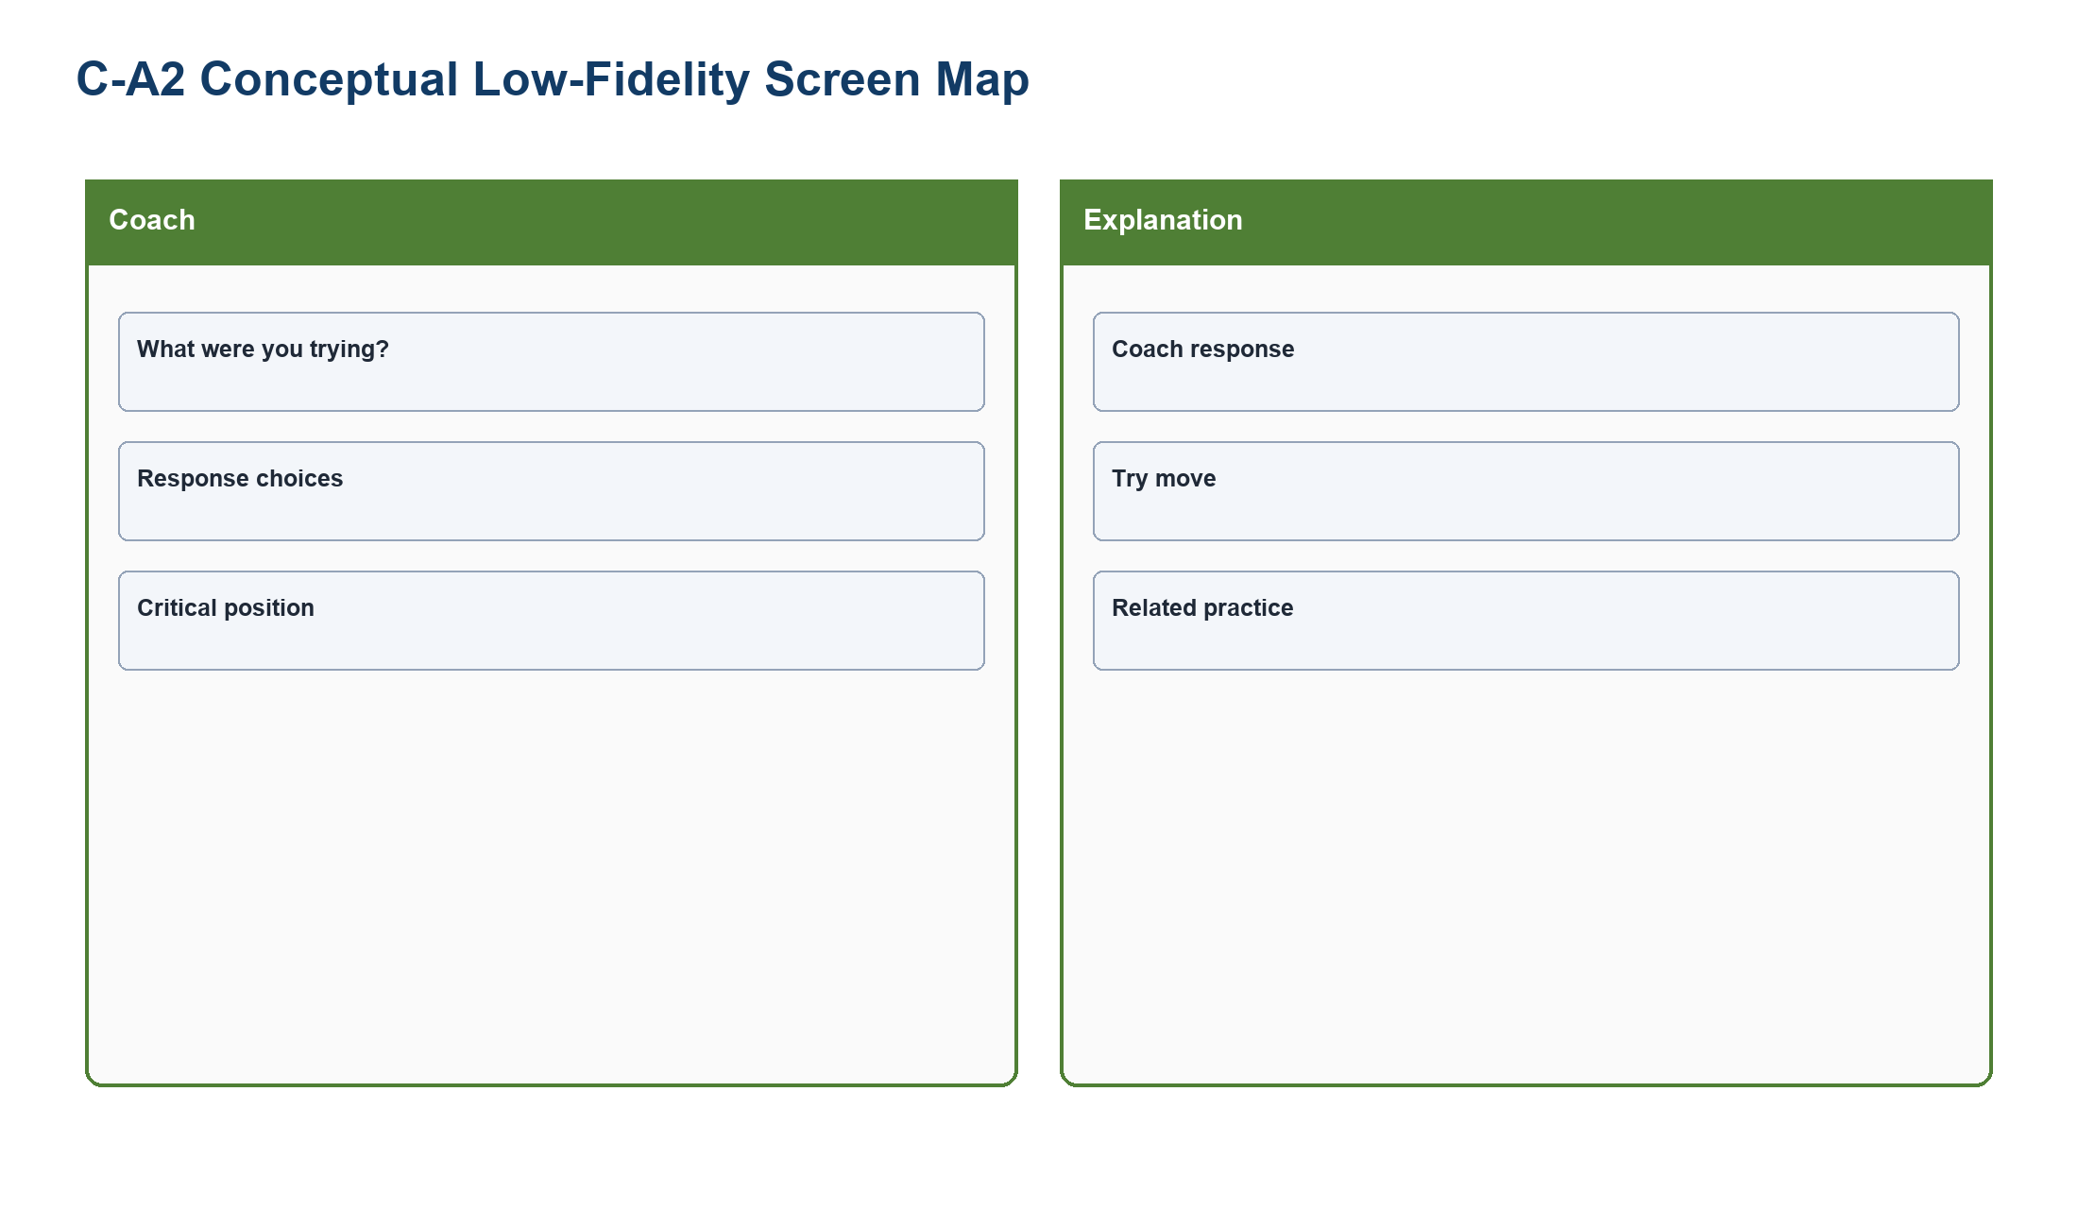
Figure PP-C-A2-L. Conversational Coach conceptual low-fidelity screen map made only from shapes and labels.
Source: generated-diagrams/c-a2-lowfi.png
Related: C-P1; C-P3; TP-CHESS
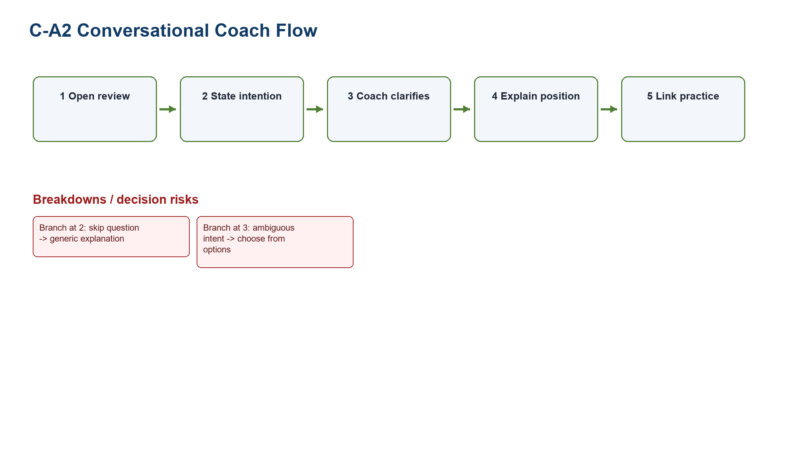
Figure PP-C-A2-F. Conversational Coach flow model. Numbered steps, branches, and breakdowns are proposal hypotheses, not existing or tested behavior.
Source: generated-diagrams/c-a2-flow.png
Related: C-P1; C-P3; TP-CHESS

C-A3 Visual Game Story
Field | Concept definition
Target proto-persona / scenario | C-P1; C-P3 (provisional) - Understand the game as a sequence.
Problem addressed | TP-CHESS.
Form factor | Responsive web redesign.
Concept summary | Chapter/timeline review
Interaction model | Group opening, turning point, main error, recovery chance, and next step; collapse engine detail.
Artifacts / data | Timeline chapters, board snapshot, recovery action
Core screens / components | Story overview; chapter detail; practice
Information hierarchy | Overview -> turning point -> replay -> next step
HCI principles | Chunking; external cognition; progressive disclosure. See LN02 - Fundamental Concepts, pp. 66, 116; LN03 - UI Design Process, p. 36.
Expected benefit | Hypothesis: supports recall through narrative structure.
Tradeoff | Simplification can hide nuance; advanced analysis must remain explicitly available.
Implementation dependency | Requires reliable event segmentation.
Privacy / trust | Story labels can oversimplify complex games.
Accessibility | Linear keyboard order, text chapter summary, scalable board.
Evidence links | C2-E10; C-D2
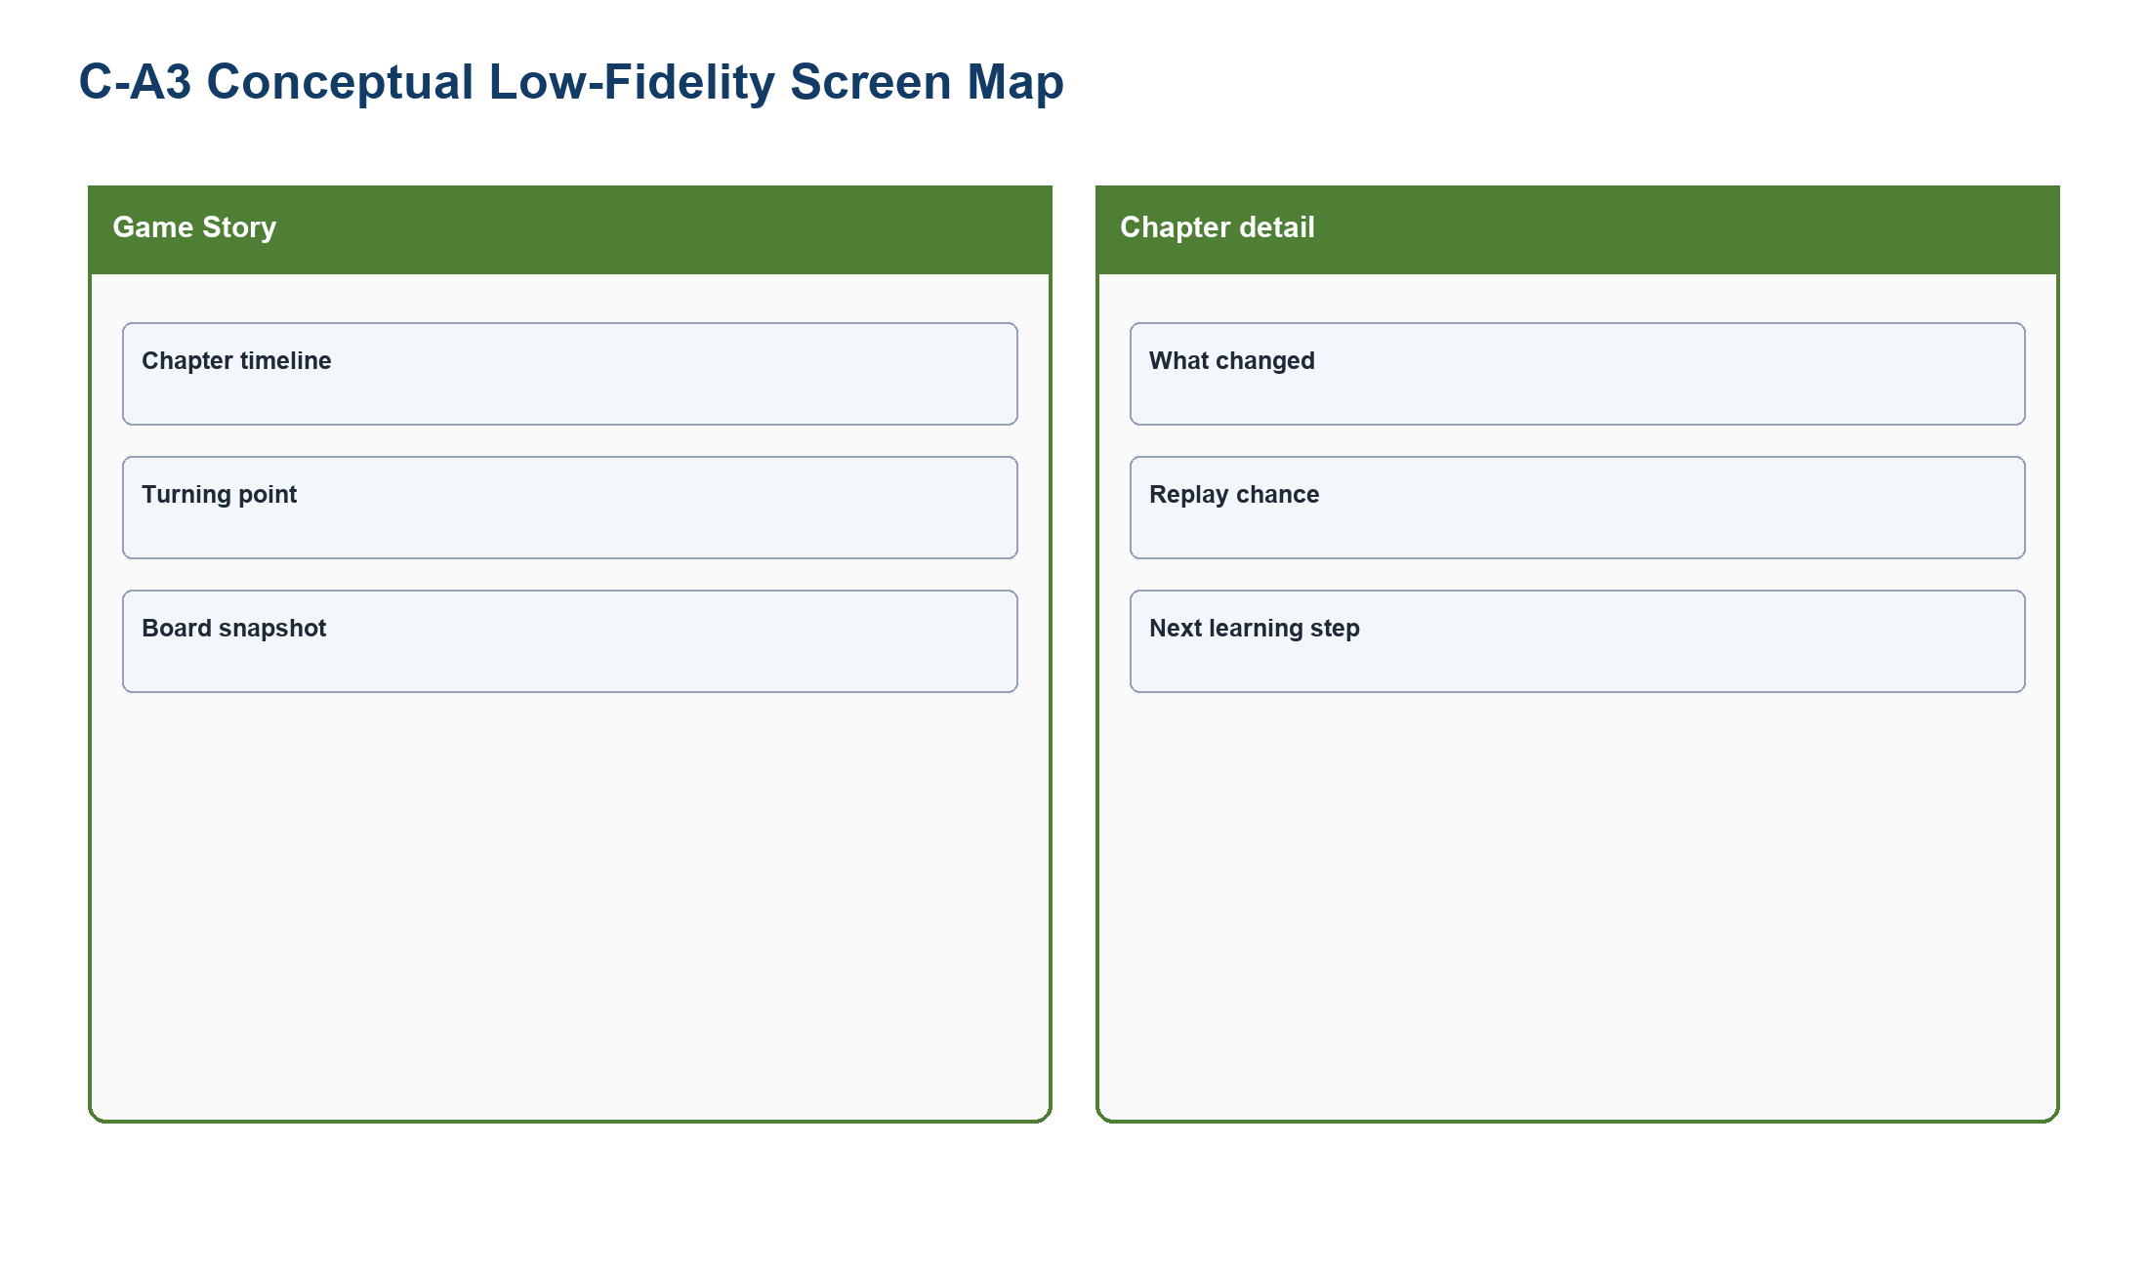
Figure PP-C-A3-L. Visual Game Story conceptual low-fidelity screen map made only from shapes and labels.
Source: generated-diagrams/c-a3-lowfi.png
Related: C-P1; C-P3; TP-CHESS
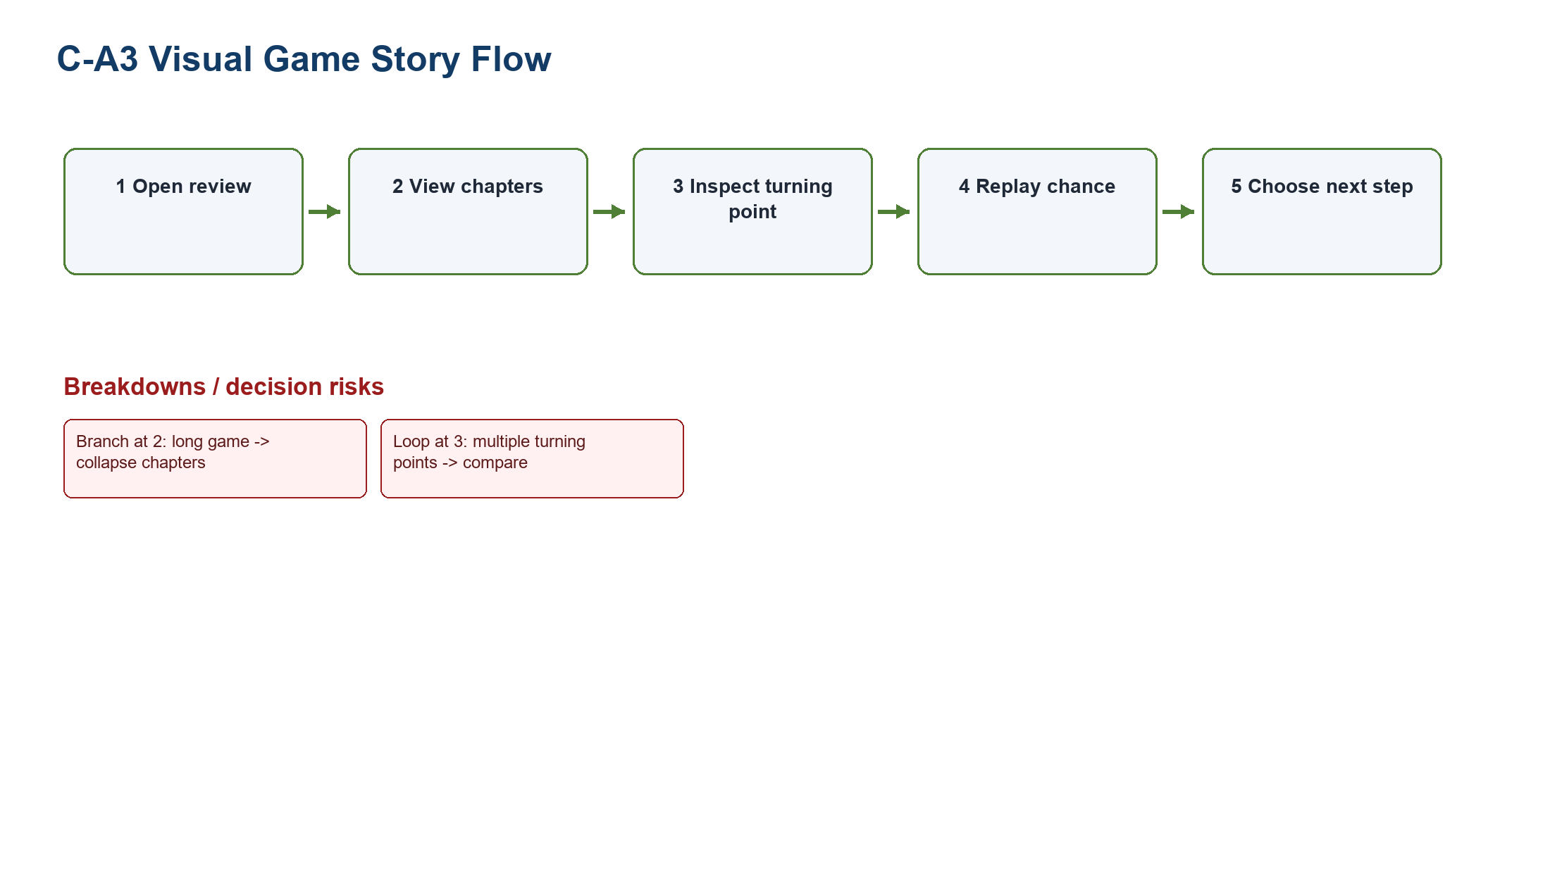
Figure PP-C-A3-F. Visual Game Story flow model. Numbered steps, branches, and breakdowns are proposal hypotheses, not existing or tested behavior.
Source: generated-diagrams/c-a3-flow.png
Related: C-P1; C-P3; TP-CHESS

6. Weighted comparison
Concept | Problem fit | Learnability | Error prevention / trust | Task efficiency | Feasibility | Cross-device fit | Accessibility | Evidence strength | Weighted
F-A1 | 5 | 4 | 5 | 5 | 3 | 4 | 4 | 5 | 89/100
F-A2 | 5 | 5 | 5 | 3 | 3 | 4 | 5 | 4 | 89/100
F-A3 | 4 | 4 | 4 | 5 | 2 | 5 | 4 | 4 | 80/100
C-A1 | 5 | 5 | 4 | 5 | 4 | 4 | 5 | 5 | 93/100
C-A2 | 4 | 5 | 4 | 3 | 2 | 4 | 4 | 4 | 77/100
C-A3 | 4 | 4 | 3 | 4 | 3 | 4 | 5 | 4 | 77/100
Weights total 100%. Scoring uses 1 (weak) to 5 (strong). Weighted total = Σ(score × criterion weight ÷ 5). These are design-team analytical comparison scores, not usability measurements or brainstorming votes.
Concept | Short score rationale
F-A1 | Strongest problem/evidence fit and efficient comparison; feasibility is lower because governed, fresh status data is required.
F-A2 | High learnability, error prevention, and accessibility through guided steps; slower for repeat users and dependent on eligibility rules.
F-A3 | Strong repeated-checking and cross-device fit; feasibility is constrained by notifications, consent, and alert governance.
C-A1 | Strongest entry-orientation, learnability, efficiency, accessibility, and evidence continuity; depends on reliable explanation rules.
C-A2 | High reflective scaffolding; lower feasibility/efficiency because conversation logic may infer intent incorrectly.
C-A3 | Strong accessibility and narrative chunking; segmentation may oversimplify games and has moderate implementation complexity.

7. Recommended direction
FIFA recommendation: Prototype F-A1 Status Dashboard first, while testing F-A2 and F-A3 as meaningfully different wizard and planning alternatives.

Chess recommendation: Prototype C-A1 Beginner Analysis Preset first, while retaining C-A2 conversational and C-A3 narrative alternatives.

8. Scope and non-scope
In scope | Out of scope
Responsive web concept flows; task entry; information hierarchy; partner disclosure; beginner review; accessible interaction. | Implementation, live ticket inventory, payment processing, identity migration, engine accuracy validation, production integration.
Three alternatives per tough problem; PA3 hypothesis and test criteria. | Claimed measured improvement, fabricated participant results, premove or Focus Mode redesign as primary scenario.

9. Design principles, risks, and success criteria
- State before action: disclose current status and destination before commitment.
- One clear next action: present the beginner's primary step before advanced depth.
- Progressive disclosure without removal: advanced and direct routes remain available.
- Trust through provenance: official destination, timestamp, and uncertainty are visible.
- Accessible redundancy: text, icon, structure, and programmatic labels support color.
Design goal for PA3 | Target (not a tested result)
Ticket state recognition | A first-time prototype participant identifies the current state without opening another property.
Destination feedforward | The partner name and destination domain are visible before exit.
Beginner review priority | The main review action appears in the initial viewport and keyboard order.
Advanced access | Advanced analysis remains available through a labeled disclosure control.
Accessibility | All core actions have keyboard and screen-reader definitions; color is never the only status channel.

10. Traceability and preparation for PA3
- TP-FIFA -> F-A1/F-A2/F-A3 -> FIFA use cases F-UC01-F-UC06.
- TP-CHESS -> C-A1/C-A2/C-A3 -> Chess use cases C-UC01-C-UC06.
- Create two PA3 scenarios, each with three parallel paper-prototype alternatives; test comprehension, next-action selection, error recognition, and return orientation.
- Do not interpret expected benefits as measured outcomes.

