PROJECT ASSIGNMENT 2

Group10-PA2 Use Case Document
  - Twelve user-goal use cases, UML system diagrams, and six alternative flow models
FIFA.com and Chess.com
Course | CSC13112 - UI/UX Design, FIT-HCMUS
Group | Group10
Team | Le Minh (21127645); Nguyen Vu Bach (21127224); Pham Nguyen Gia Bao (20127119); Trang Minh Nhut (22127318)
Evidence date | Local evidence audited through 30 July 2026
Document type | Evidence-based redesign report

Contents
1. Scope and notation ................................. 3
2. Actors and external systems ........................ 3
3. Concept-to-use-case mapping ........................ 3
4. FIFA UML use-case diagram .......................... 4
5. FIFA use case specifications ....................... 4
6. Chess UML use-case diagram ......................... 12
7. Chess use case specifications ...................... 12
8. Alternative-concept flow models .................... 20
9. Shared system-level nonfunctional requirements ..... 22
10. Traceability and open issues ...................... 23

1. Scope and notation
This document specifies two proposed responsive web modules. UML use-case diagrams show actors outside named system boundaries and user-goal ellipses inside. The six concept diagrams in Section 8 are flow models, not use-case diagrams. Task specifications follow goal, precondition, subtasks, exceptions, context, and involved-party guidance (LN04 - Task Analysis, pp. 6, 39-40, 48-49).

2. Actors and external systems
Actor/system | Role | Trust boundary
Ticket Buyer | Selects context, interprets governed status, saves a plan, and decides on an external handoff. | May cross partner, identity, and notification boundaries.
Official Ticketing Partner | Provides the external official action. | External domain/account/payment context; purchase success is never inferred.
Notification/Identity Services | Persist optional plan/consent and deliver alerts. | Personal data, consent, authentication, and retention.
Beginner / Returning Player | Loads an artifact, requests review, practices, and chooses learning continuation. | May be anonymous or authenticated.
Analysis/Explanation Services | Validate positions and supply analysis/explanation artifacts. | Uncertainty, entitlement, and explanation quality.
Learning Catalog | Supplies lessons/puzzles and entitlement metadata. | Relevance, availability, progress, and return context.

3. Concept-to-use-case mapping
Concept | Primary use cases
F-A1 | F-UC01, F-UC02, F-UC03, F-UC05, F-UC06
F-A2 | F-UC01, F-UC02, F-UC05, F-UC06
F-A3 | F-UC01, F-UC04, F-UC05, F-UC06
C-A1 | C-UC01-C-UC06
C-A2 | C-UC01-C-UC04, C-UC06
C-A3 | C-UC01-C-UC03, C-UC05-C-UC06

4. FIFA UML use-case diagram
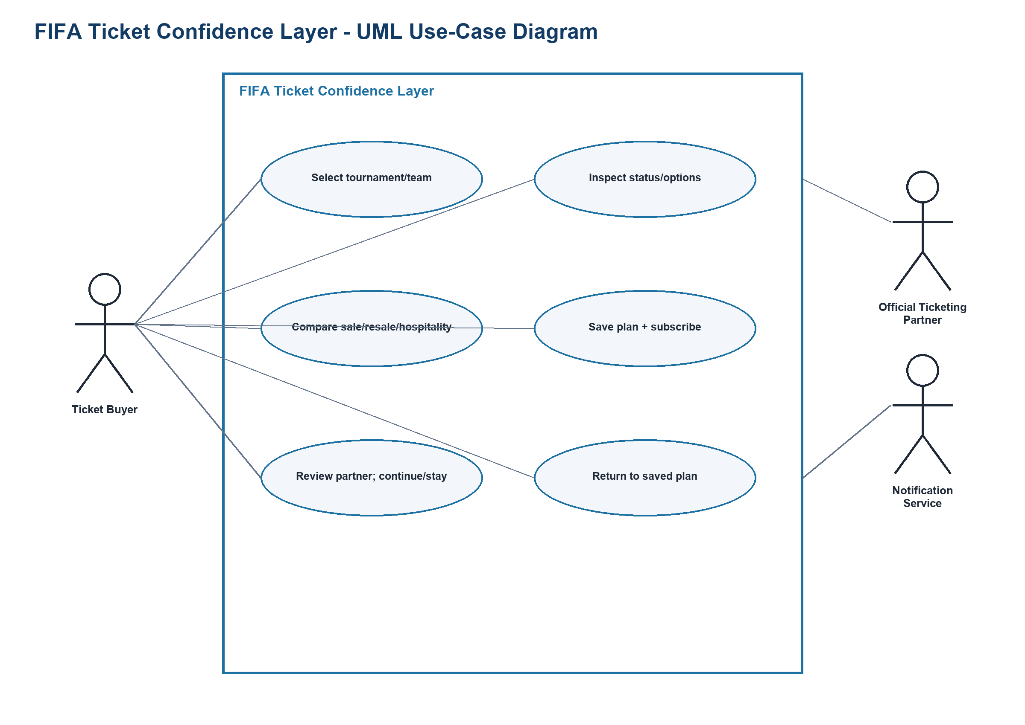
Figure UC-F-SYS. UML use-case diagram: named boundary, Ticket Buyer and external-system actors, use-case ellipses, and associations.
Source: generated-diagrams/fifa-system-use-cases.png
Related: F-P3; TP-FIFA

5. FIFA use case specifications

F-UC01 Select tournament or team
Field | Specification
Scope / level | FIFA Ticket Confidence Layer / user goal
Primary actor | Ticket Buyer
Supporting actors | FIFA tournament catalog
Stakeholders and interests | Buyer wants correct context; FIFA content owner wants canonical tournament/team identity.
Trigger | The buyer opens the ticket-planning module with a tournament or team in mind.
Preconditions | The catalog has a governed identifier and display label; the module can disclose stale/unavailable catalog data.
Minimal guarantee | The originating artifact/context remains recoverable; no unsupported state or external success is invented.
Success guarantee | Selected ticket context and accessible confirmation.
Frequency | At the start of a planning session; assumption to validate.
Priority | High
Links | Proto-persona F-P3; TP-FIFA; concepts F-A1/F-A2/F-A3; evidence F2-E09, F2-E18
Open issue | Who owns catalog freshness across FIFA properties?

Main success scenario
- Open the tournament/team selector.
- Search or browse the governed catalog.
- Inspect the matching label, competition, and season.
- Choose one tournament or team.
- Confirm the selected context shown in the planning header.
- Continue to ticket-status inspection.

Alternative and exception flows
- A1 at step 2: No result matches; show spelling guidance and browse categories without creating a fake item.
- A2 at step 4: Multiple seasons share a label; require an explicit season choice.
- E1 at step 2: Catalog is unavailable; retain the prior context and offer retry.

Use-case-specific data, rules, and special requirements
Category | Requirement
Required data | Tournament/team ID, canonical label, competition, season, locale.
Rules | Only governed catalog entries may be selected; ambiguous names require disambiguation.
Output artifact | Selected ticket context and accessible confirmation.
Special requirement | Search results expose type and season in text, not color alone.

F-UC02 Inspect official ticket status and available options
Field | Specification
Scope / level | FIFA Ticket Confidence Layer / user goal
Primary actor | Ticket Buyer
Supporting actors | Ticket Status Service
Stakeholders and interests | Buyer needs a bounded current state; data owner must avoid false precision.
Trigger | A ticket context is selected and the buyer asks what is currently visible/available.
Preconditions | F-UC01 is complete; each returned field includes provenance and freshness or an unavailable marker.
Minimal guarantee | The originating artifact/context remains recoverable; no unsupported state or external success is invented.
Success guarantee | Readable status summary with provenance and one safe next action.
Frequency | Repeated during planning; frequency is an assumption, not measured.
Priority | Critical
Links | Proto-persona F-P3; TP-FIFA; concepts F-A1/F-A2; evidence F2-E09, F2-E18; F-D4
Open issue | What official system is authoritative for each field?

Main success scenario
- Request status for the selected context.
- Read the plain-language overall state and last-updated time.
- Review which official option categories have governed data.
- Open the provenance explanation for a category.
- Inspect the single next official action associated with that state.
- Choose to compare options, save the plan, or stop.

Alternative and exception flows
- A1 at step 2: Status is stale; label it stale and suppress action language that implies currency.
- A2 at step 3: A category has no governed data; show 'not provided' rather than 'unavailable'.
- E1 at step 1: Status service fails; show no cached value unless its timestamp and source remain visible.

Use-case-specific data, rules, and special requirements
Category | Requirement
Required data | Context ID, state label, option-category presence, source, timestamp, action eligibility.
Rules | Unknown, not provided, closed, and sold out are distinct states.
Output artifact | Readable status summary with provenance and one safe next action.
Special requirement | Timestamp is localized and screen-reader text conveys the same state as icons.

F-UC03 Compare sale, resale, hospitality, and waiting states
Field | Specification
Scope / level | FIFA Ticket Confidence Layer / user goal
Primary actor | Ticket Buyer
Supporting actors | Ticket Status Service; Hospitality Catalog
Stakeholders and interests | Buyer wants comparable definitions; FIFA/partners need categories represented accurately.
Trigger | The buyer chooses Compare from a governed ticket-status summary.
Preconditions | At least one category has a governed value; unavailable fields are explicitly marked.
Minimal guarantee | The originating artifact/context remains recoverable; no unsupported state or external success is invented.
Success guarantee | Persisted comparison/filter state and selected option, if any.
Frequency | Once or more per selected tournament; assumption to validate.
Priority | High
Links | Proto-persona F-P3; TP-FIFA; concepts F-A1; evidence F2-E09; F-D4
Open issue | Which comparison fields are legally/operationally available per market?

Main success scenario
- Open the option comparison for the selected context.
- Read category definitions for sale, resale, hospitality, and waiting.
- Compare state, eligibility, key date, and official destination by row.
- Filter rows to categories relevant to the buyer.
- Inspect why any row lacks data or action.
- Select one row for details or return to the unfiltered comparison.

Alternative and exception flows
- A1 at step 2: A market does not support resale; explain the market rule instead of hiding the row.
- A2 at step 4: Filtering would produce zero rows; keep filters visible and offer Clear filters.
- E1 at step 3: Categories use incompatible freshness times; display each timestamp rather than a misleading shared timestamp.

Use-case-specific data, rules, and special requirements
Category | Requirement
Required data | Category taxonomy, state, eligibility summary, key date, destination, per-row timestamp.
Rules | Rows cannot be ranked as better without an explicit buyer criterion.
Output artifact | Persisted comparison/filter state and selected option, if any.
Special requirement | Table supports keyboard row navigation and a stacked mobile reading order.

F-UC04 Save a ticket plan and subscribe to verified alerts
Field | Specification
Scope / level | FIFA Ticket Confidence Layer / user goal
Primary actor | Ticket Buyer
Supporting actors | Identity Service; Notification Service
Stakeholders and interests | Buyer wants control and low alert noise; services need valid consent and deliverability.
Trigger | The buyer wants to avoid manually repeating the same check.
Preconditions | A context exists; consent and authentication requirements are disclosed before collecting contact data.
Minimal guarantee | The originating artifact/context remains recoverable; no unsupported state or external success is invented.
Success guarantee | Saved plan, subscription state, consent receipt, and controls.
Frequency | Occasional setup followed by event-driven alerts; assumption to validate.
Priority | High
Links | Proto-persona F-P3; TP-FIFA; concepts F-A3; evidence F2-E09, F2-E18; F-D4
Open issue | What retention period and channels are approved?

Main success scenario
- Open Save plan from the selected ticket context.
- Choose tracked categories and optional team/date preferences.
- Review which fields are stored locally or in an account.
- Save the plan with a recognizable label.
- Choose an alert channel and quiet-hours preference.
- Confirm consent and view the verified-alert criteria.
- Receive an accessible plan summary with edit/unsubscribe controls.

Alternative and exception flows
- A1 at step 3: Buyer declines account storage; offer a local-only plan if supported.
- A2 at step 5: Buyer declines notifications; save the plan without a subscription.
- E1 at step 6: Channel verification fails; keep the plan and mark alerts inactive.

Use-case-specific data, rules, and special requirements
Category | Requirement
Required data | Plan ID/label, context, categories, preferences, storage mode, channel, consent, quiet hours.
Rules | No marketing consent is bundled with status alerts; alerts fire only on governed changes.
Output artifact | Saved plan, subscription state, consent receipt, and controls.
Special requirement | Consent is reversible; notification content minimizes sensitive preference data.

F-UC05 Review partner identity and choose Continue or Stay
Field | Specification
Scope / level | FIFA Ticket Confidence Layer / user goal
Primary actor | Ticket Buyer
Supporting actors | Official Ticketing Partner
Stakeholders and interests | Buyer needs informed control; FIFA and partner need a trustworthy boundary.
Trigger | The buyer selects an action that leaves the FIFA-hosted module.
Preconditions | Destination is allow-listed and tied to the chosen option; the current plan/context can be preserved.
Minimal guarantee | The originating artifact/context remains recoverable; no unsupported state or external success is invented.
Success guarantee | Handoff decision, retained context, and optional return token.
Frequency | Before every external ticket/hospitality handoff.
Priority | Critical
Links | Proto-persona F-P3; TP-FIFA; concepts F-A1/F-A2/F-A3; evidence F2-E10, F2-E11; F-D2
Open issue | Which partner/account disclosures are required for each route?

Main success scenario
- Open the destination preview for the selected action.
- Read the official partner name and destination domain.
- Review whether sign-in, identity, or payment context may change.
- Read what context will be preserved for return.
- Choose Continue or Stay on FIFA.com.
- If Continue, open the allow-listed destination and record a return token; if Stay, retain the current decision surface.

Alternative and exception flows
- A1 at step 2: Partner/domain verification is unavailable; disable Continue and offer retry.
- A2 at step 5: Buyer chooses Stay; close the preview without external navigation.
- E1 at step 6: Destination fails to open; keep the saved context and show a safe retry.

Use-case-specific data, rules, and special requirements
Category | Requirement
Required data | Partner ID/name, allow-listed domain, action type, account-boundary notice, return token.
Rules | No open redirect; Continue is unavailable when partner identity cannot be verified.
Output artifact | Handoff decision, retained context, and optional return token.
Special requirement | Focus enters the preview, remains trapped appropriately, then returns to the invoking control.

F-UC06 Return to a saved plan after partner activity
Field | Specification
Scope / level | FIFA Ticket Confidence Layer / user goal
Primary actor | Ticket Buyer
Supporting actors | Official Ticketing Partner; Identity Service
Stakeholders and interests | Buyer wants orientation; FIFA must not misrepresent partner-side completion.
Trigger | The buyer follows a return link or reopens the planner after partner activity.
Preconditions | A valid local/account plan or time-limited return token exists; partner activity is not assumed to be available.
Minimal guarantee | The originating artifact/context remains recoverable; no unsupported state or external success is invented.
Success guarantee | Restored plan with explicit freshness and next actions.
Frequency | After an external handoff or later planning session; assumption to validate.
Priority | High
Links | Proto-persona F-P3; TP-FIFA; concepts F-A1/F-A2/F-A3; evidence F2-E11; F-D2
Open issue | Can any partner return a signed completion state, and for how long?

Main success scenario
- Open the return link or Saved plans list.
- Validate the return token or authenticate for the stored plan.
- Restore tournament/team, comparison filters, and alert state.
- Label the restored data with current freshness/provenance.
- Show that partner-side purchase/activity status is unknown unless explicitly returned by a governed integration.
- Let the buyer refresh, edit the plan, inspect status, or remove it.

Alternative and exception flows
- A1 at step 2: Token expired; offer account lookup or safe plan recreation without exposing token data.
- A2 at step 3: Only a partial plan is available; list omitted fields before continuing.
- E1 at step 4: Refresh fails; keep the restored snapshot labeled with its prior timestamp.

Use-case-specific data, rules, and special requirements
Category | Requirement
Required data | Return token, plan ID, saved context/filter/alerts, current status timestamp, optional governed partner result.
Rules | Never infer purchase success from a return; expired tokens cannot be replayed.
Output artifact | Restored plan with explicit freshness and next actions.
Special requirement | Restoration is announced to assistive technology without moving focus unexpectedly.

6. Chess UML use-case diagram
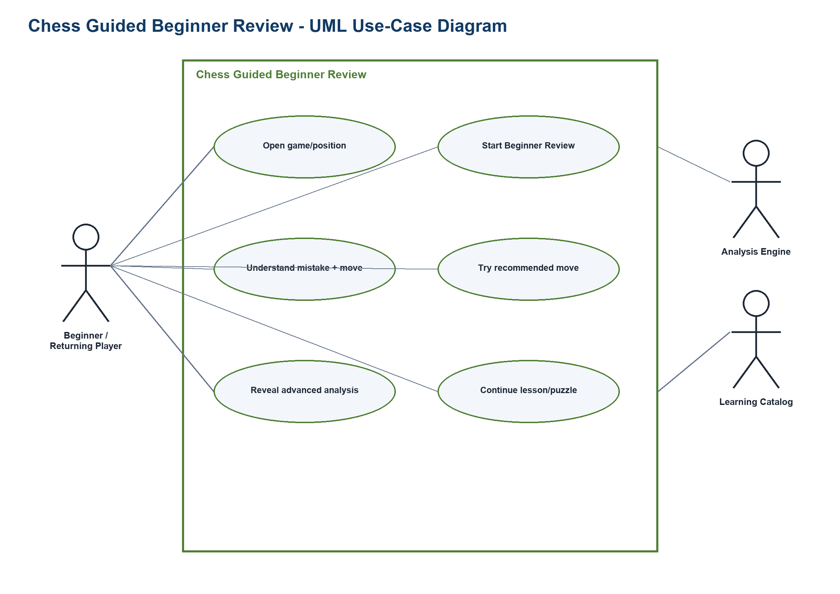
Figure UC-C-SYS. UML use-case diagram: named boundary, player and external-system actors, use-case ellipses, and associations.
Source: generated-diagrams/chess-system-use-cases.png
Related: C-P1/C-P3; TP-CHESS

7. Chess use case specifications

C-UC01 Open a completed game or analysis position
Field | Specification
Scope / level | Chess Guided Beginner Review / user goal
Primary actor | Beginner / Returning Player
Supporting actors | Game Store; Analysis Engine
Stakeholders and interests | Player wants the intended position; platform needs valid, permission-appropriate game data.
Trigger | The player chooses a completed game, paste/import, or setup route for review.
Preconditions | The source artifact is accessible; unsupported/invalid notation can be identified without losing input.
Minimal guarantee | The originating artifact/context remains recoverable; no unsupported state or external success is invented.
Success guarantee | Validated review artifact and entry state.
Frequency | Per review session; assumption to validate.
Priority | High
Links | Proto-persona C-P1; C-P3; TP-CHESS; concepts C-A1/C-A2/C-A3; evidence C2-E10
Open issue | Which anonymous/import formats are supported?

Main success scenario
- Choose Completed game, Paste/import, or Set up position.
- Select the game or enter the position data.
- Review source, side to move, and orientation.
- Correct any detected notation or setup issue.
- Confirm the review artifact.
- Open the review entry with Beginner Review and advanced-analysis choices.

Alternative and exception flows
- A1 at step 1: No completed game exists; keep import and setup routes available.
- A2 at step 3: Orientation is wrong; switch sides before confirmation.
- E1 at step 2: Notation is invalid; identify the first invalid segment and preserve the remaining input.

Use-case-specific data, rules, and special requirements
Category | Requirement
Required data | Game/position ID, notation, source, side to move, orientation, ownership/visibility.
Rules | Private games/positions follow account permissions; invalid data is never silently corrected.
Output artifact | Validated review artifact and entry state.
Special requirement | Board setup has a text-notation alternative and fully labeled pieces/squares.

C-UC02 Start Beginner Review
Field | Specification
Scope / level | Chess Guided Beginner Review / user goal
Primary actor | Beginner / Returning Player
Supporting actors | Analysis Engine
Stakeholders and interests | Player wants a low-vocabulary entry; engine owner must communicate uncertainty and availability.
Trigger | A valid game/position is open and the player chooses Beginner Review.
Preconditions | C-UC01 is complete; the system can disclose analysis availability/entitlement.
Minimal guarantee | The originating artifact/context remains recoverable; no unsupported state or external success is invented.
Success guarantee | Beginner Review overview or actionable unavailable state.
Frequency | Per selected review artifact; assumption to validate.
Priority | Critical
Links | Proto-persona C-P1; C-P3; TP-CHESS; concepts C-A1/C-A2/C-A3; evidence C2-E10; C-D2
Open issue | What entitlement and expected-duration disclosures are accurate?

Main success scenario
- Choose Beginner Review from the review entry.
- Read the mode summary: one critical point first, advanced detail optional.
- Confirm whose perspective and skill-level language to use.
- Start the requested analysis.
- Wait with progress and cancellation controls.
- Receive the Beginner Review overview or a clear unavailable explanation.

Alternative and exception flows
- A1 at step 3: Player skips skill-level choice; use neutral beginner language, not a hidden profile inference.
- A2 at step 5: Player cancels; return to review entry with the artifact intact.
- E1 at step 4: Analysis is unavailable or restricted; explain the condition before suggesting another route.

Use-case-specific data, rules, and special requirements
Category | Requirement
Required data | Artifact ID, perspective, language level, analysis request/status, entitlement disclosure.
Rules | Beginner mode changes presentation, not engine truth; uncertainty is retained.
Output artifact | Beginner Review overview or actionable unavailable state.
Special requirement | Progress is perceivable without relying on animation; cancellation is keyboard accessible.

C-UC03 Understand the main mistake and recommended move
Field | Specification
Scope / level | Chess Guided Beginner Review / user goal
Primary actor | Beginner Player
Supporting actors | Analysis Engine; Explanation Service
Stakeholders and interests | Beginner wants meaning, not just a label; engine/explanation owners need calibrated language.
Trigger | Beginner Review returns at least one explainable critical position.
Preconditions | C-UC02 succeeded; a move recommendation and confidence/uncertainty representation exist.
Minimal guarantee | The originating artifact/context remains recoverable; no unsupported state or external success is invented.
Success guarantee | Comprehended-position view and chosen next action.
Frequency | One primary explanation per beginner overview; assumption to validate.
Priority | Critical
Links | Proto-persona C-P1; TP-CHESS; concepts C-A1/C-A2/C-A3; evidence C2-E08, C2-E10; C-D2
Open issue | Which explanation rules are safe at each language level?

Main success scenario
- Open the primary critical-position card.
- See the played move and recommended move in notation and on the board.
- Read the immediate tactical/positional consequence in plain language.
- Inspect the evidence cue or uncertainty note behind the recommendation.
- Move between before and after board states.
- Choose Try this move, Next critical point, or More analysis.

Alternative and exception flows
- A1 at step 1: No single critical point is reliable; present a neutral summary and explain why.
- A2 at step 3: A term is unfamiliar; open an inline definition without leaving the position.
- E1 at step 4: Explanation cannot be generated reliably; show move comparison without synthetic prose.

Use-case-specific data, rules, and special requirements
Category | Requirement
Required data | Position, played/recommended moves, evaluation change, explanation concepts, uncertainty.
Rules | Do not state one move as universally best without the engine context; avoid invented player intent.
Output artifact | Comprehended-position view and chosen next action.
Special requirement | Every visual arrow/color has text notation and ordered board-state descriptions.

C-UC04 Try the recommended move
Field | Specification
Scope / level | Chess Guided Beginner Review / user goal
Primary actor | Beginner Player
Supporting actors | Move Validator; Analysis Engine
Stakeholders and interests | Player wants immediate practice; validator must distinguish legal, recommended, and alternative moves.
Trigger | The player selects Try this move from a critical-position explanation.
Preconditions | A legal starting position and recommended move are available; practice mode is non-rated.
Minimal guarantee | The originating artifact/context remains recoverable; no unsupported state or external success is invented.
Success guarantee | Practice attempt, feedback, and retry/continue choice.
Frequency | Zero or more times per critical position.
Priority | High
Links | Proto-persona C-P1; TP-CHESS; concepts C-A1/C-A2; evidence C2-E08, C2-E10
Open issue | How many alternatives receive tailored feedback?

Main success scenario
- Open the critical position in practice mode.
- Read the goal and whose turn it is.
- Enter a move by board or notation.
- Receive legal/illegal validation without revealing the answer prematurely.
- If legal, compare the move with the recommendation and see the key consequence.
- Retry, reveal the recommended move, or continue to practice.

Alternative and exception flows
- A1 at step 3: Player requests a hint; reveal one bounded cue and record no failure judgment.
- A2 at step 5: Legal alternative is reasonable; explain the difference instead of marking it simply wrong.
- E1 at step 4: Input method fails; preserve the position and offer notation entry/reset.

Use-case-specific data, rules, and special requirements
Category | Requirement
Required data | Practice position, entered move, legality, recommended/acceptable alternatives, hint state.
Rules | Practice never changes rating/game history; legality and recommendation are separate judgments.
Output artifact | Practice attempt, feedback, and retry/continue choice.
Special requirement | No time limit; keyboard move entry and full board reset are available.

C-UC05 Reveal advanced analysis on demand
Field | Specification
Scope / level | Chess Guided Beginner Review / user goal
Primary actor | Returning Player
Supporting actors | Analysis Engine
Stakeholders and interests | Returning player wants depth; beginner flow must remain stable and recoverable.
Trigger | The player chooses More analysis from a beginner explanation or overview.
Preconditions | A review artifact exists; advanced data availability and terminology level are disclosed.
Minimal guarantee | The originating artifact/context remains recoverable; no unsupported state or external success is invented.
Success guarantee | Advanced view state plus intact return location.
Frequency | Optional per position; assumption to validate.
Priority | Medium
Links | Proto-persona C-P3; TP-CHESS; concepts C-A1/C-A3; evidence C2-E10
Open issue | Which advanced controls belong in the first disclosure tier?

Main success scenario
- Activate the labeled More analysis disclosure.
- Read a short preview of the additional data types.
- Expand engine lines, evaluations, or setup controls intentionally.
- Adjust one advanced setting if needed.
- Inspect the updated advanced result with provenance.
- Collapse advanced analysis and return to the same beginner position.

Alternative and exception flows
- A1 at step 3: Advanced data is unavailable; leave the beginner explanation visible and state why.
- A2 at step 4: A setting changes the evaluated position; require confirmation before replacing the current context.
- E1 at step 5: Engine refresh fails; retain the prior result with its timestamp/status.

Use-case-specific data, rules, and special requirements
Category | Requirement
Required data | Disclosure state, engine lines/evaluations, settings, provenance, refresh status.
Rules | Advanced detail is opt-in and reversible; collapsing never discards the beginner explanation.
Output artifact | Advanced view state plus intact return location.
Special requirement | Disclosure communicates expanded/collapsed state programmatically and restores focus.

C-UC06 Continue with a relevant lesson or puzzle
Field | Specification
Scope / level | Chess Guided Beginner Review / user goal
Primary actor | Beginner / Returning Player
Supporting actors | Learning Catalog
Stakeholders and interests | Player wants relevant continuation; catalog owner needs accurate topic/level/entitlement metadata.
Trigger | The player finishes an explanation/practice attempt and chooses a learning follow-up.
Preconditions | A concept tag can be mapped to governed catalog items; entitlement is known or disclosed.
Minimal guarantee | The originating artifact/context remains recoverable; no unsupported state or external success is invented.
Success guarantee | Opened learning item, saved return context, and optional progress link.
Frequency | Optional at the end of a review segment.
Priority | High
Links | Proto-persona C-P1; C-P3; TP-CHESS; concepts C-A1/C-A2/C-A3; evidence C2-E07, C2-E08, C2-E15
Open issue | How are relevance and duration validated for beginners?

Main success scenario
- Open the Recommended next step panel.
- Read why each lesson or puzzle relates to the reviewed position.
- Compare type, level, duration estimate, and entitlement.
- Choose one lesson or puzzle.
- Confirm whether progress will be saved and where the review return link appears.
- Open the learning item with the review context preserved.
- Complete/exit and return to the review or learning path.

Alternative and exception flows
- A1 at step 2: No strong match exists; say so and offer browse by concept instead of a false recommendation.
- A2 at step 3: Item is restricted; disclose entitlement before selection and keep an accessible alternative.
- E1 at step 6: Catalog item fails to open; retain review context and offer another item.

Use-case-specific data, rules, and special requirements
Category | Requirement
Required data | Concept tags, item ID/type/level/duration, relevance reason, entitlement, return context.
Rules | Recommendation rationale is visible; restricted items are not the only continuation path.
Output artifact | Opened learning item, saved return context, and optional progress link.
Special requirement | Cards have descriptive link names and predictable return navigation.

8. Alternative-concept flow models
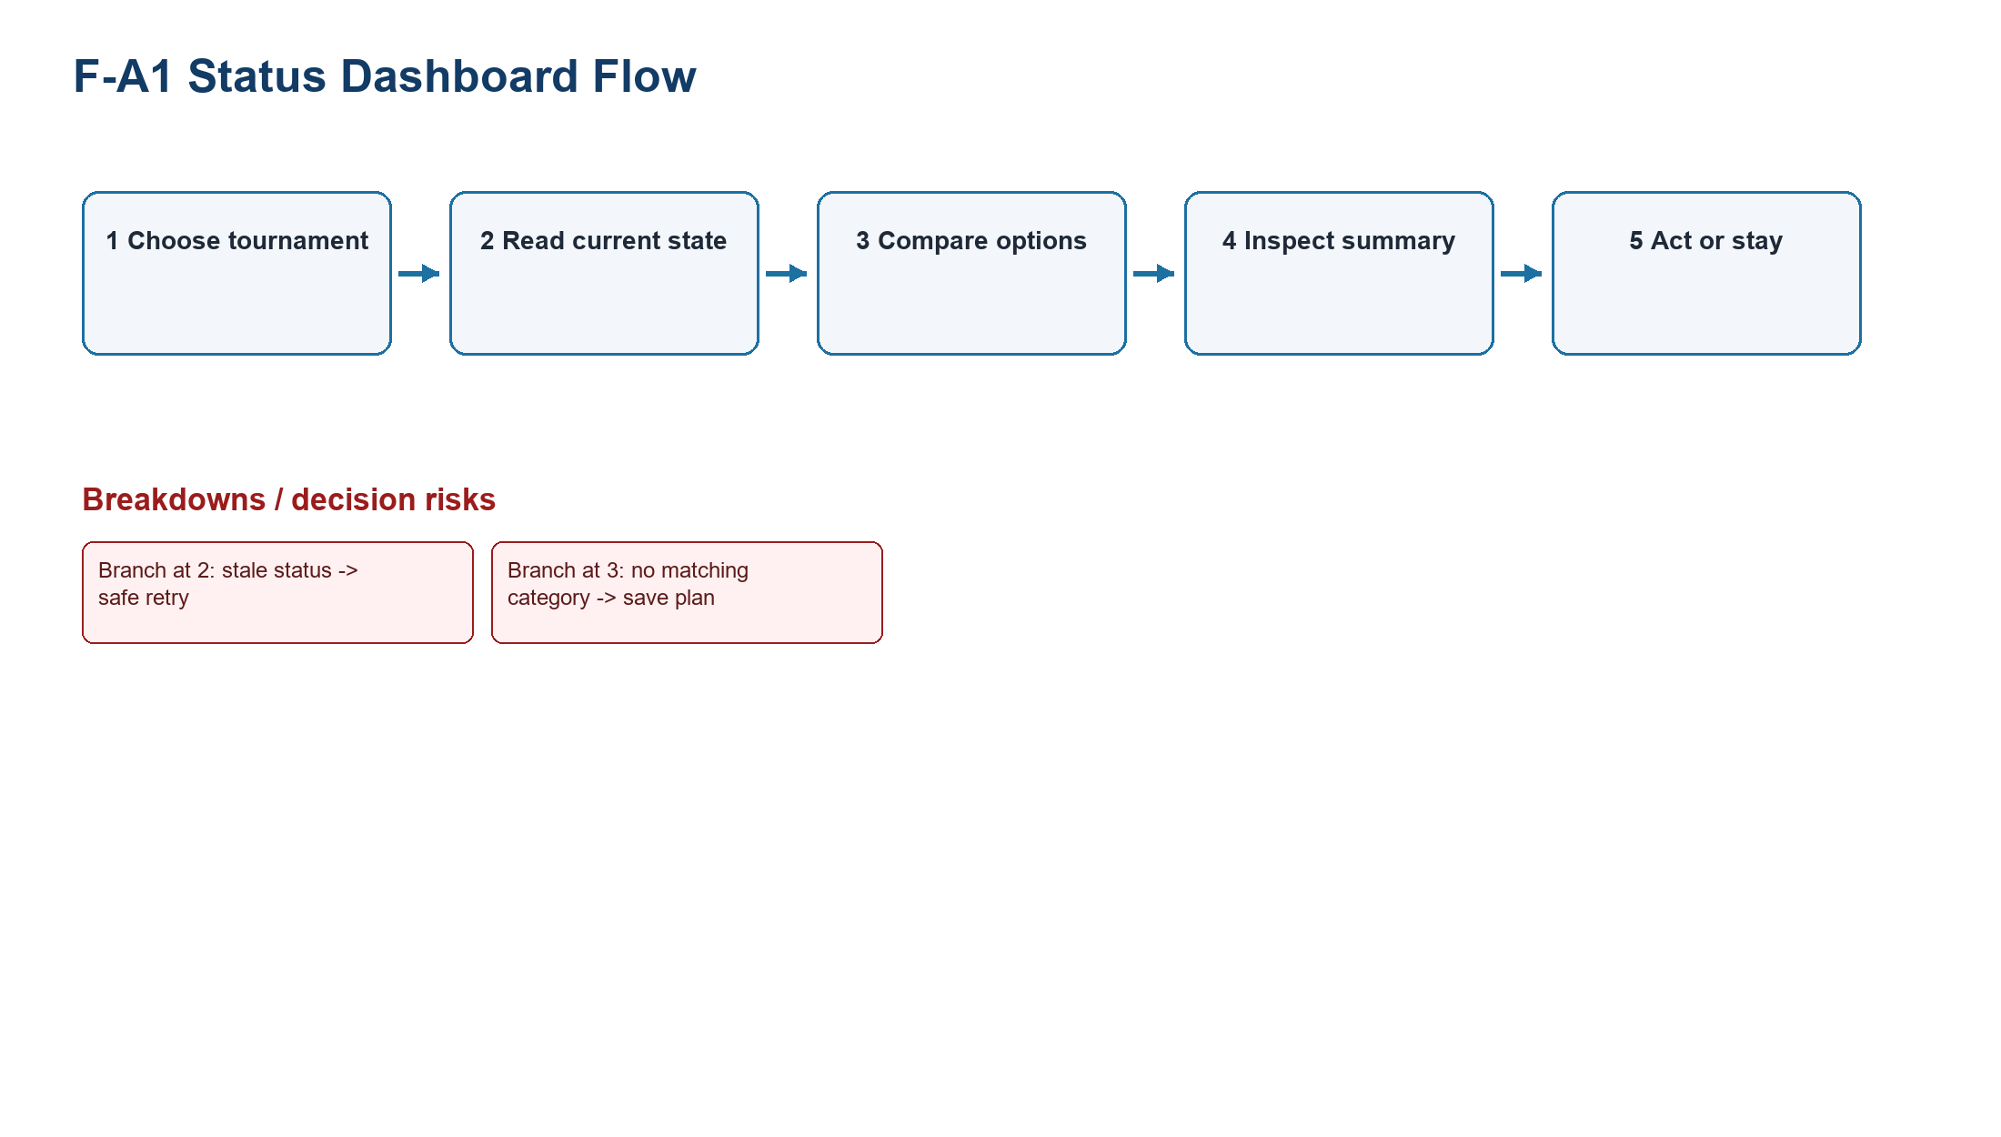
Figure UC-F-A1. Status Dashboard flow model with numbered exact steps and labeled branches/breakdowns; it is not a use-case diagram.
Source: generated-diagrams/f-a1-flow.png
Related: F-P3; TP-FIFA
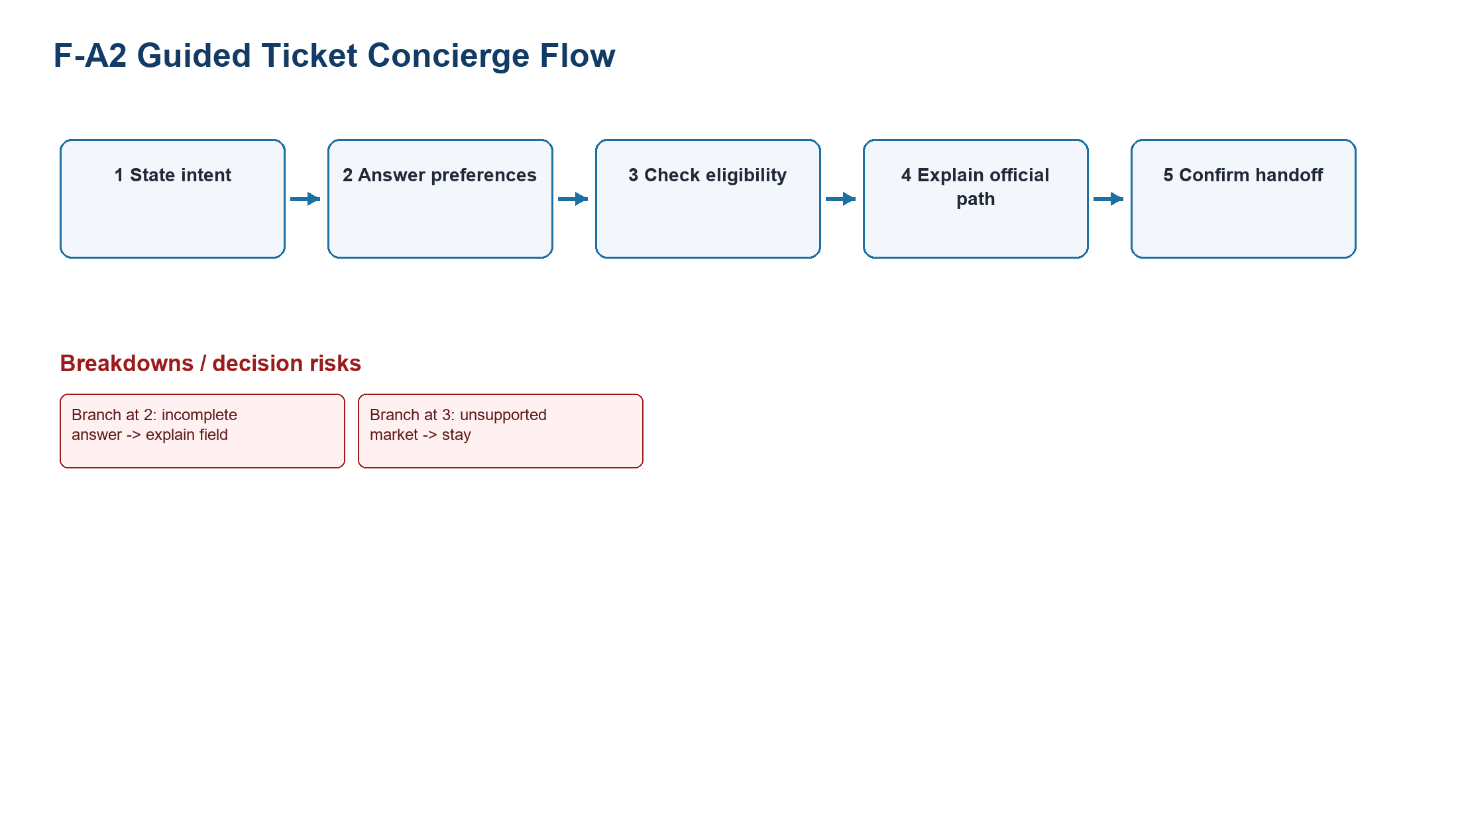
Figure UC-F-A2. Guided Ticket Concierge flow model with numbered exact steps and labeled branches/breakdowns; it is not a use-case diagram.
Source: generated-diagrams/f-a2-flow.png
Related: F-P3; TP-FIFA
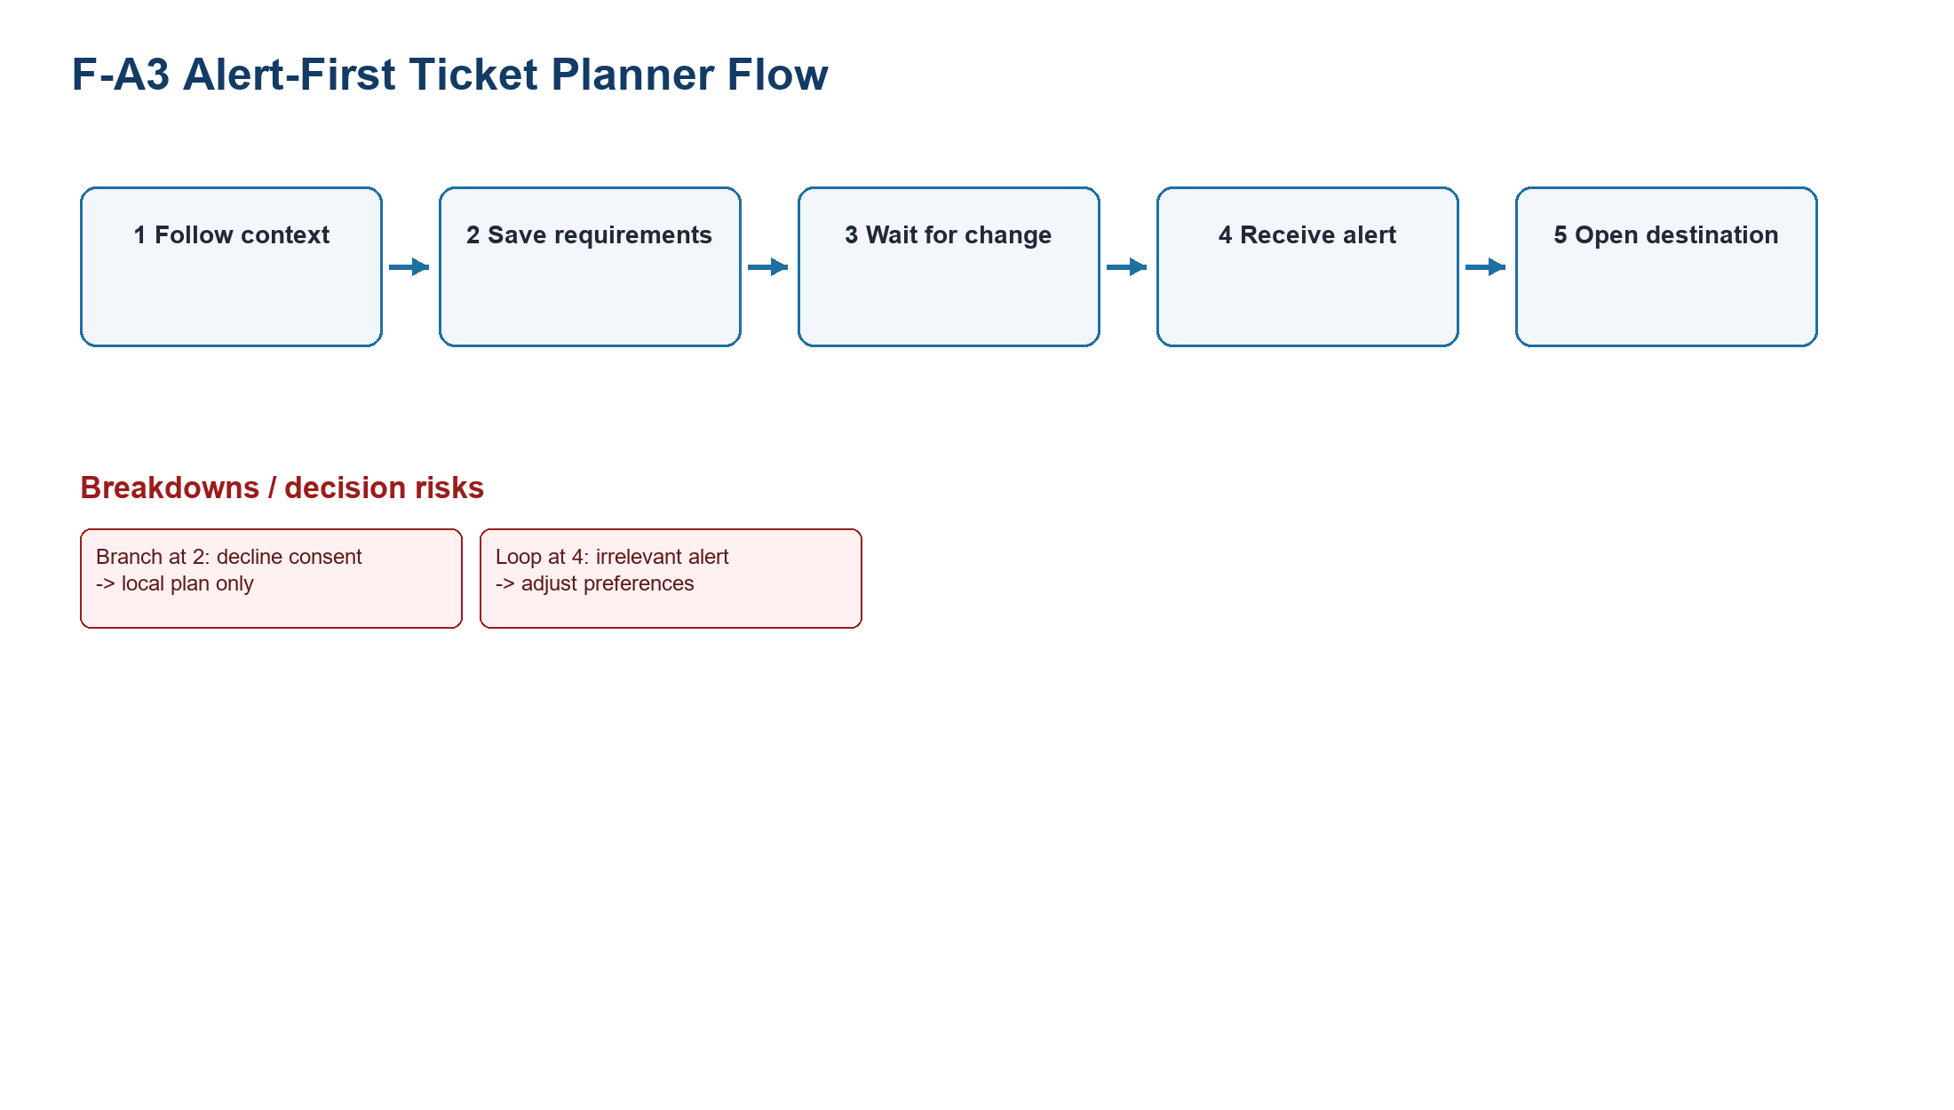
Figure UC-F-A3. Alert-First Ticket Planner flow model with numbered exact steps and labeled branches/breakdowns; it is not a use-case diagram.
Source: generated-diagrams/f-a3-flow.png
Related: F-P3; TP-FIFA
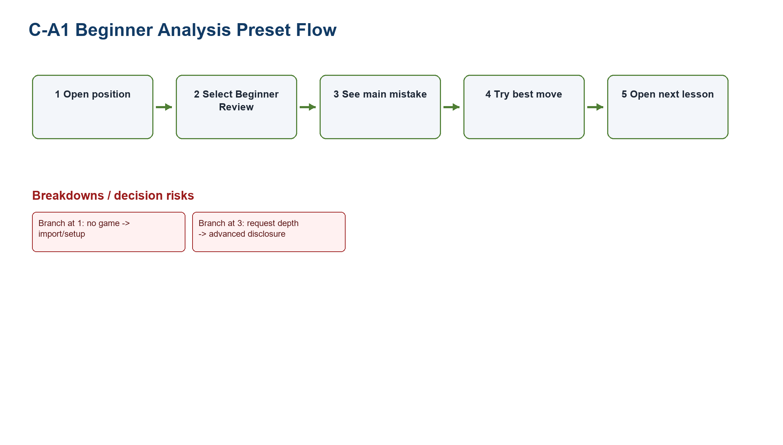
Figure UC-C-A1. Beginner Analysis Preset flow model with numbered exact steps and labeled branches/breakdowns; it is not a use-case diagram.
Source: generated-diagrams/c-a1-flow.png
Related: C-P1/C-P3; TP-CHESS
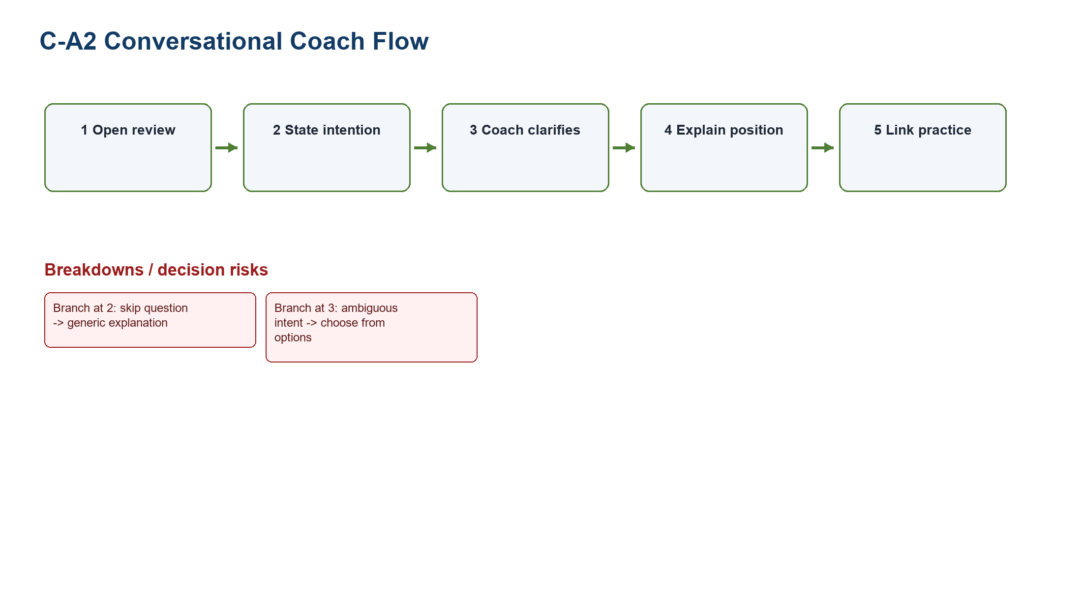
Figure UC-C-A2. Conversational Coach flow model with numbered exact steps and labeled branches/breakdowns; it is not a use-case diagram.
Source: generated-diagrams/c-a2-flow.png
Related: C-P1/C-P3; TP-CHESS
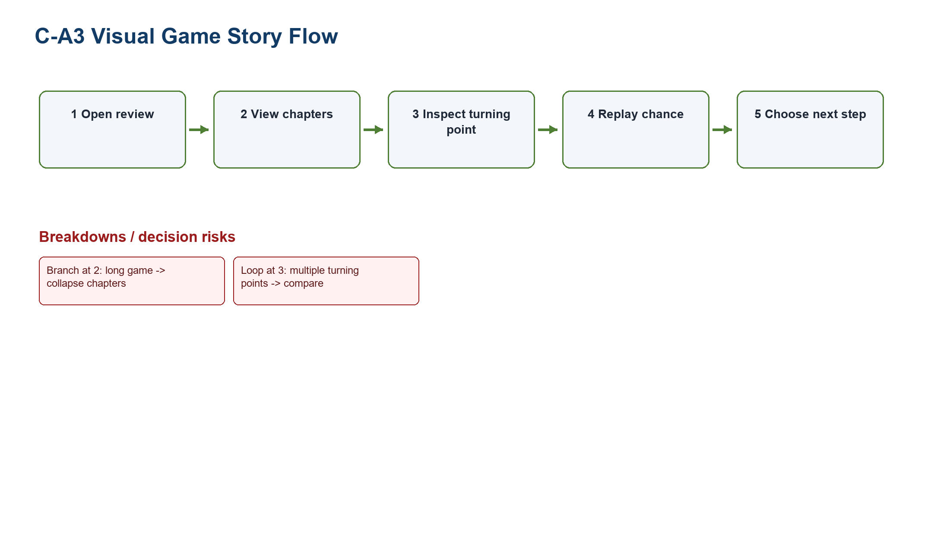
Figure UC-C-A3. Visual Game Story flow model with numbered exact steps and labeled branches/breakdowns; it is not a use-case diagram.
Source: generated-diagrams/c-a3-flow.png
Related: C-P1/C-P3; TP-CHESS

9. Shared system-level nonfunctional requirements
Category | System-level requirement
Usability | Plain task language, visible system status, low-memory choices, explicit closure, and recoverable reversal (LN02 - Fundamental Concepts, p. 116).
Accessibility | Keyboard operation, visible focus, logical reading order, text alternatives, labeled controls/states/errors, no color-only meaning, and scalable layouts.
Security / trust | Allow-listed external destinations, provenance, calibrated uncertainty, protected tokens/preferences, and no inferred external success.
Privacy | Data minimization, purpose-specific consent, retention disclosure, edit/delete controls, and no bundled marketing consent.
Data freshness / provenance | Every governed state exposes source and timestamp; stale, unknown, not provided, closed, and unavailable remain distinct.
Error recovery | Preserve valid input/context, focus the exact error, provide retry/safe exit, and avoid destructive silent correction.
Localization | Localize dates/times/language while preserving canonical identifiers, chess notation, partner domains, and status semantics.

10. Traceability and open issues
Tough problem | Concepts | Use cases | Evidence
TP-FIFA | F-A1/F-A2/F-A3 | F-UC01-F-UC06 | F2-E09-E11/E18; F-D2/F-D4
TP-CHESS | C-A1/C-A2/C-A3 | C-UC01-C-UC06 | C2-E07/E08/E10/E15; C-D1/C-D2 (entry-only PA2 limitation)
- Which official system owns each ticket state and freshness field?
- Which markets and partner disclosures must each FIFA path express?
- Which explanations can be produced reliably with calibrated uncertainty?
- Which entitlement alternatives and return contexts are supported?
- Which PA3 measures will validate the stated hypotheses without treating them as prior results?

