PROJECT ASSIGNMENT 2

Group10-PA2 User Analysis
  - Evidence-derived prework for group brainstorming and prioritization
FIFA.com and Chess.com
Course | CSC13112 - UI/UX Design, FIT-HCMUS
Group | Group10
Team | Le Minh (21127645); Nguyen Vu Bach (21127224); Pham Nguyen Gia Bao (20127119); Trang Minh Nhut (22127318)
Evidence date | Local evidence audited through 30 July 2026
Document type | Evidence-based redesign report
Status | INCOMPLETE - verified group brainstorming evidence is absent

Contents
1. Requirement status and evidence boundary ........... 3
2. Required real-session protocol ..................... 3
3. Analyst prework legend and note inventory .......... 3
4. Readable affinity views ............................ 5
5. Candidate ideas retained for a future group session .... 6
6. Provisional tough problems ......................... 7
7. Scoring formula and missing consensus record ....... 7
8. Dimension-by-dimension rationale and ownership gap .... 8
9. Provisional design requirements .................... 8
10. Traceability, limitations, and completion gate .... 9
Appendix A. Full 55-note analyst prework .............. 9

1. Requirement status and evidence boundary
Requirement 2 blocker: PA2 requires real group brainstorming. No verified date, duration, participant list, tool/export, raw-note generation record, clustering record, votes, scoring sheet, consensus record, or board screenshot/export was found. This report therefore remains incomplete.

The material below is analyst prework derived from validated screenshots, PA1 findings, and the User Research task analysis. It must not be presented as a group meeting or group consensus.

2. Required real-session protocol
Required field | Current status | Completion evidence needed
Date and duration | Missing | Dated session record with start/end or duration.
Participants | Missing | Verified attendee list; do not infer from roster.
Tool and board | Missing | Real board screenshot/export from the session.
Raw note generation | Missing | Unclustered notes with authorship or session provenance.
Clustering | Missing | Record of how notes moved into FIFA and Chess themes.
Voting/scoring | Missing | Raw individual votes or an explicit consensus record.
Decisions and ownership | Missing | Decision log naming owner and affected requirement.
When supplied, the session should diverge before converging, compare alternatives, and document review/evaluation as part of an iterative, user-centered design process (LN03 - UI Design Process, pp. 19, 23-24, 30).

3. Analyst prework legend and note inventory
- [OBS] = visible screenshot state.
- [PA1] = inherited PA1 report finding with report/page reference.
- [IDEA] = design inference or proposal, never observed behavior.
- No note label establishes frequency, severity, vote, or user preference.
Cluster | Representative notes | Evidence basis
FIFA-A1/A2 | Task entry, date/filter scanning, mixed result types, interruption. | F2-E01-E05; PA1 ProductResearch pp. 4-6
FIFA-A3 | Ticket cards show tournament-specific actions but not a consolidated comparison surface in the capture. | F2-E09/E18; F-D4, PA1 PotentialSolutions p. 8
FIFA-A4 | FIFA+ entry, DAZN brand/account context, consent, and sibling-property vocabulary change. | F2-E10-E16; F-D2, PA1 PotentialSolutions p. 6
FIFA-A5 | Long mobile match, ticket, and article surfaces. | F2-E17-E20
CHESS-A1-A4 | Many first-level task/setup routes; puzzle and lesson continuation artifacts. | C2-E01-E09/E12-E16; C-D1, PA1 PotentialSolutions p. 11
CHESS-A5 | Analysis entry shows multiple setup/import paths and Start Analysis; no completed review is visible. | C2-E10; C-D2 continuity only, PA1 PotentialSolutions p. 12
CHESS-A6 | Promotional/long-page content near learning; ambiguous ad capture is restricted. | C2-E07/E11/E15; evidence-validation.md

4. Readable affinity views
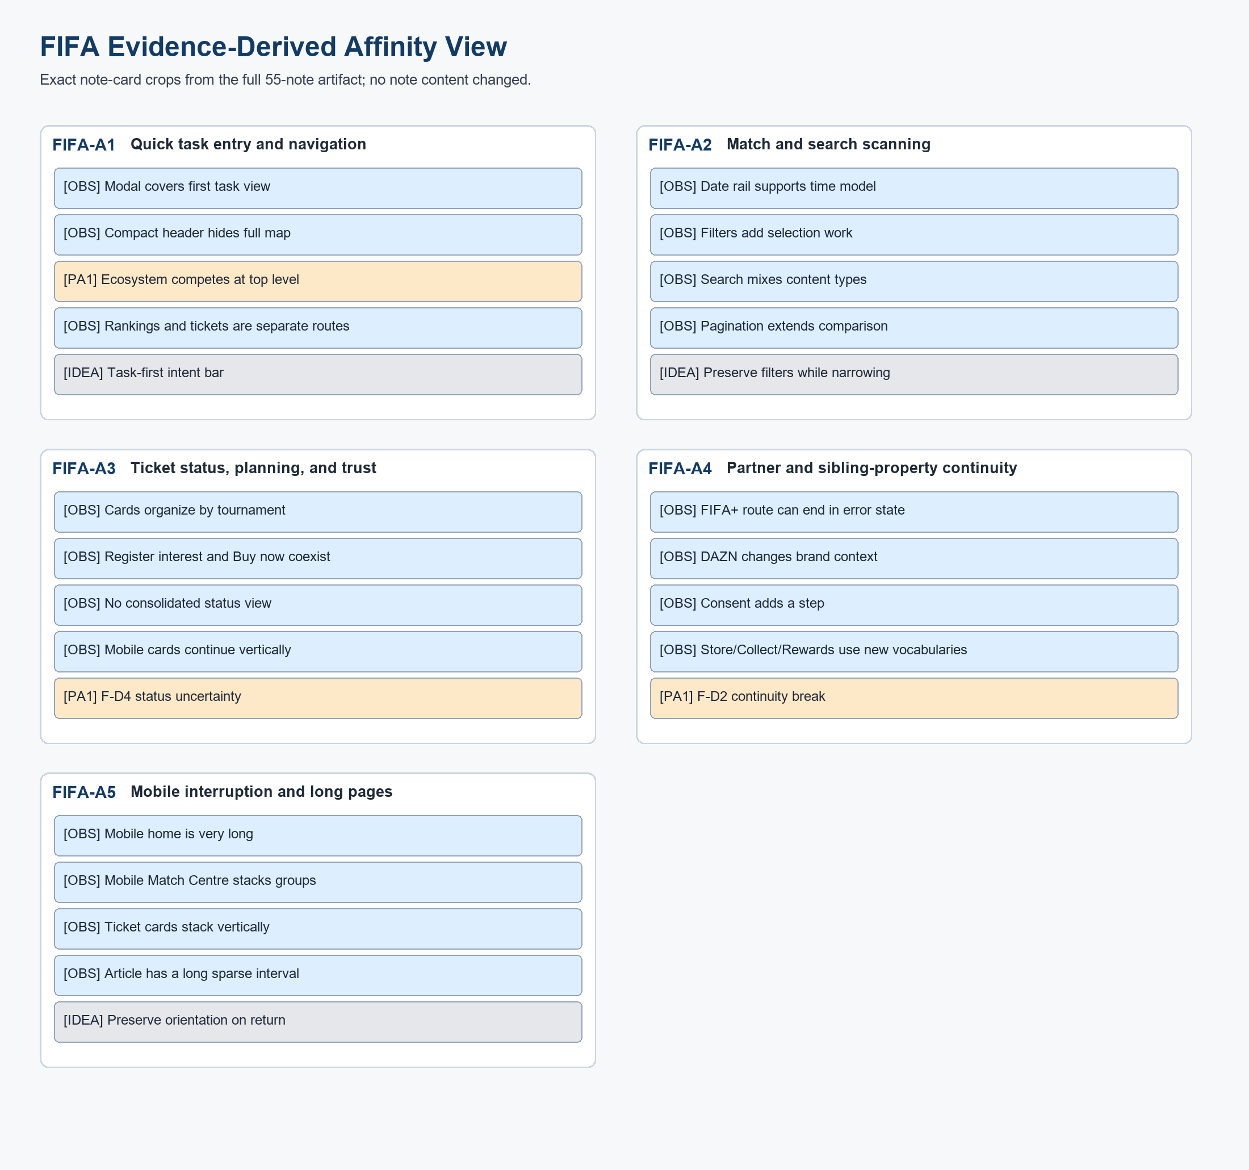
Figure UA-F01. FIFA evidence-derived affinity prework. This is not a real brainstorming-board export and does not satisfy Requirement 2.
Source: generated-diagrams/affinity-fifa.png
Related: FIFA-A1-FIFA-A5; TP-FIFA
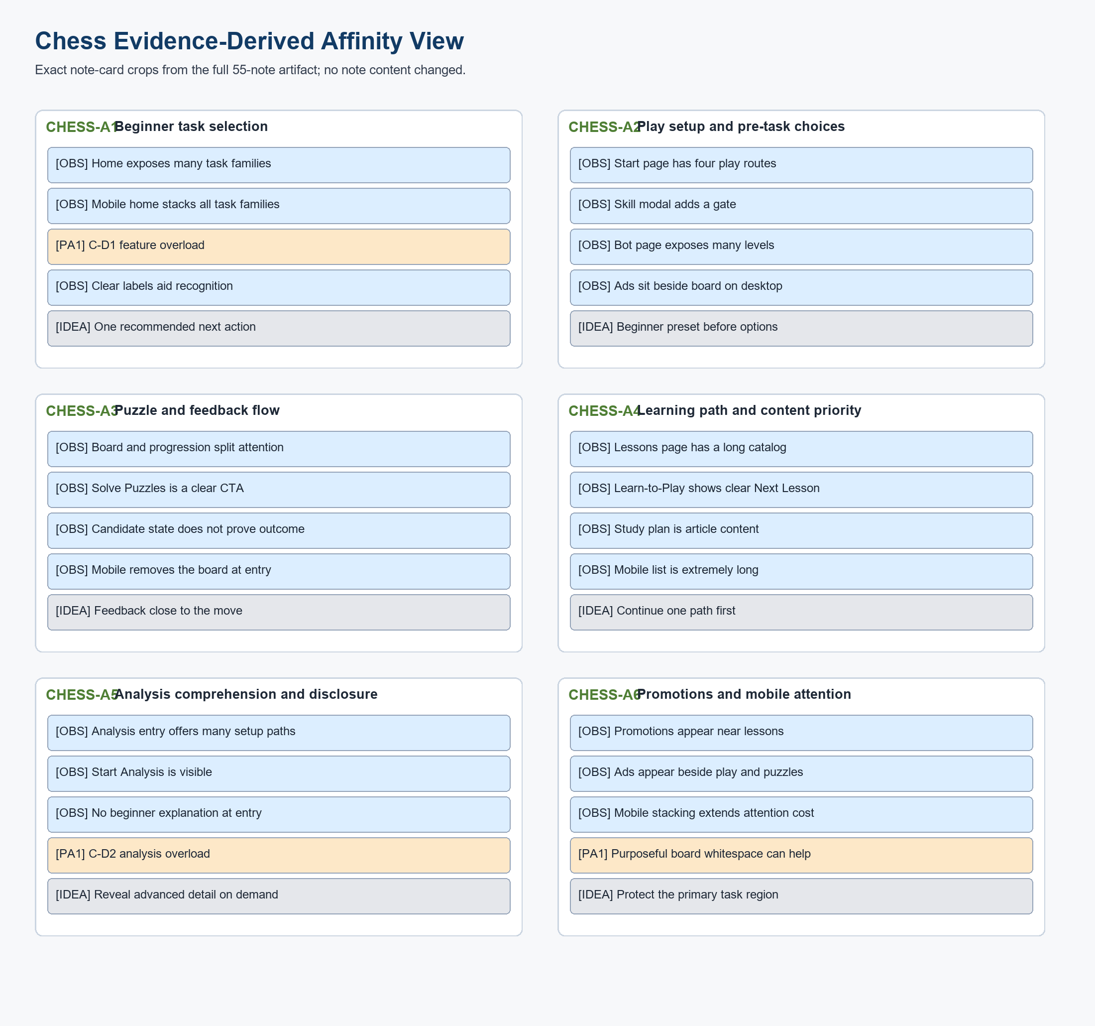
Figure UA-C01. Chess evidence-derived affinity prework. This is not a real brainstorming-board export and does not satisfy Requirement 2.
Source: generated-diagrams/affinity-chess.png
Related: CHESS-A1-CHESS-A6; TP-CHESS

5. Candidate ideas retained for a future group session
Problem family | Concept candidates | Evidence/idea status
Ticket decision surface | F-A1 Status Dashboard; F-A2 Guided Ticket Concierge; F-A3 Alert-First Ticket Planner. | Proposal ideas linked to F2-E09/E18 and F-D4.
Partner handoff | Partner/domain preview; Continue or Stay; return-path preservation. | Proposal ideas linked to F2-E10/E11 and F-D2.
Beginner review entry | C-A1 Beginner Analysis Preset; C-A2 Conversational Coach; C-A3 Visual Game Story. | Proposal ideas linked narrowly to C2-E10 entry state plus C-D2.
Learning continuation | One recommended next action; relevant lesson/puzzle; advanced detail on demand. | Proposal ideas linked to C2-E07/E08/E15 and C-D1.

6. Provisional tough problems
TP-FIFA (provisional): On the captured FIFA ticket landing decision surface, tournament cards expose different visible actions, while a consolidated comparison of sale, resale, hospitality, waiting, availability, freshness, and partner destination is not visible. This is not a universal claim about every FIFA ticket channel.

HMW-F: How might a responsive web redesign help a ticket planner compare governed visible states and review the official destination before choosing act, wait, continue, or stay?

TP-CHESS (provisional): At the captured Chess.com analysis-entry state, a beginner or returning player sees multiple setup/import paths and Start Analysis, but the screenshot does not show a completed review or a plain-language next-learning explanation. The problem is entry orientation, not proven completed-review overload.

HMW-C: How might a responsive web redesign make one beginner review path explicit at entry, then connect a critical position to optional advanced detail and relevant practice?

7. Scoring formula and missing consensus record
Proposed group formula: Total = Severity + Frequency + Risk + Reach + Evidence + PA3 relevance, with each dimension scored 1-5. A valid total requires the raw votes or a documented consensus for every dimension.
Dimension | 1 anchor | 3 anchor | 5 anchor | Required rationale/owner
Severity | Minor inconvenience | Meaningful friction | Blocks confidence/comprehension | Named voter or consensus record
Frequency | Rare assumption | Occasional assumption | Repeated/frequent evidence | Direct evidence or explicit assumption
Risk | Negligible | Moderate | Trust/error critical | Evidence-linked rationale
Reach | Narrow role | One role class | Multiple roles/devices | Scope rationale
Evidence | Single ambiguous item | Multiple aligned items | Direct + PA1 triangulation | Exact evidence IDs/pages
PA3 relevance | Weak | Useful | Two-scenario core | Concept/prototype rationale
Candidate | Severity | Frequency | Risk | Reach | Evidence | PA3 | Total / owner
TP-FIFA | Not voted | Not voted | Not voted | Not voted | F2-E09/E18 + F-D4 | Not voted | Not computed; owner unavailable
TP-CHESS | Not voted | Not voted | Not voted | Not voted | C2-E10 + C-D2; entry-only limitation | Not voted | Not computed; owner unavailable
The two problems are retained provisionally to keep the Proposal and Use Case documents internally traceable. Their selection is an evidence-driven editorial decision, not a fabricated group vote.

8. Dimension-by-dimension rationale and ownership gap
Problem / dimension | Provisional rationale | Verified owner
TP-FIFA severity/risk | Ticket planning may cross identity/payment boundaries; PA1 documents trust sensitivity (PA1 PeerReview pp. 2-3). | None recorded
TP-FIFA frequency/reach | Repeated checking and multi-device scope are PA1/design assumptions, not PA2 measurements. | None recorded
TP-FIFA evidence | F2-E09/E18 show ticket landing/card states; F2-E10/E11 show destination/context changes. | None recorded
TP-FIFA PA3 relevance | Three distinct dashboard, concierge, and alert concepts can test the same decision surface. | None recorded
TP-CHESS severity/risk | C2-E10 supports entry-orientation uncertainty only; no completed-review error outcome is observed. | None recorded
TP-CHESS frequency/reach | Beginner/returning scope is provisional; no PA2 participant frequency exists. | None recorded
TP-CHESS evidence | C2-E10 plus C2-E07/E08/E15 and PA1 C-D1/C-D2 establish continuity, not measured overload. | None recorded
TP-CHESS PA3 relevance | Three preset, conversational, and narrative concepts can be compared as parallel prototypes. | None recorded

9. Provisional design requirements
Req. | Design requirement | Evidence / rationale
F-R1 | Show a plain-language current ticket state before any external exit. | F2-E09, E18; F-D4
F-R2 | Compare only governed sale, resale, hospitality, waiting, and availability fields; label unavailable fields rather than inventing them. | TP-FIFA
F-R3 | Disclose partner name, destination domain, account boundary, and return path before continuation. | F2-E10-E13; F-D2
F-R4 | Encode status with text and icon as well as color; expose last-updated time. | Trust and accessibility
C-R1 | Place one explicit Beginner Review entry action before advanced setup paths. | C2-E10; TP-CHESS
C-R2 | In the proposed review output, explain one critical position, recommended move, and next learning action in plain language. | Design hypothesis from C-D2; not captured current output
C-R3 | Keep engine detail and advanced setup available through explicit progressive disclosure. | C2-E10
C-R4 | Provide keyboard and screen-reader labels for every core action; never rely only on color. | Accessibility

10. Traceability, limitations, and completion gate
- Every provisional tough problem links to approved screenshot evidence and a PA1 drawback page.
- Every Proposal alternative and Use Case ID maps back to one provisional tough problem.
- No measured improvement, group attendance, note ownership, vote, or consensus is claimed.
- Completion requires the real group board export, session metadata, raw notes, clustering record, votes/consensus, decisions, and owners.

Appendix A. Full 55-note analyst prework

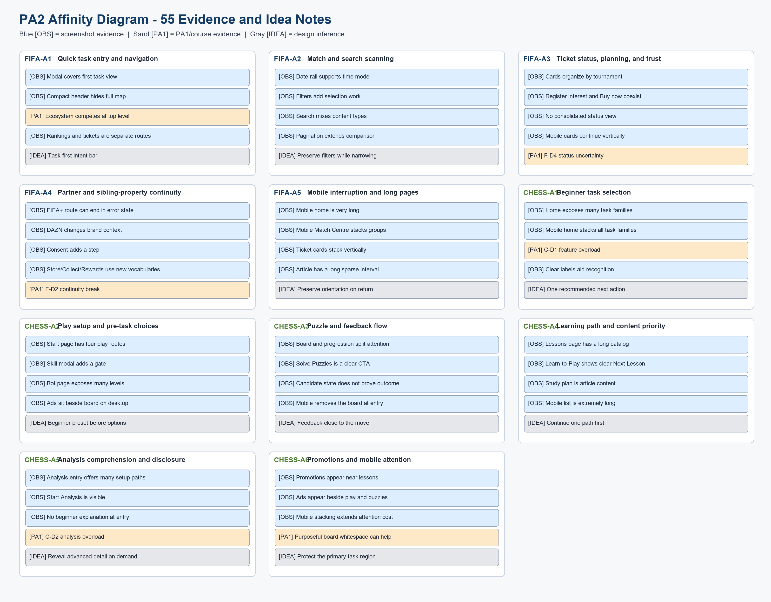
Figure UA-A01. Full 55-note evidence-derived analyst prework. It is not a real group brainstorming-board screenshot/export.
Source: generated-diagrams/affinity-diagram.png
Related: All focal tasks and provisional tough problems

