PROJECT ASSIGNMENT 2

Group10-PA2 User Research
  - Source analysis and structured try-it-yourself artifact walkthrough
FIFA.com and Chess.com
Course | CSC13112 - UI/UX Design, FIT-HCMUS
Group | Group10
Team | Le Minh (21127645); Nguyen Vu Bach (21127224); Pham Nguyen Gia Bao (20127119); Trang Minh Nhut (22127318)
Evidence date | Local evidence audited through 30 July 2026
Document type | Evidence-based redesign report

Contents
1. Scope and evidence boundary ........................ 3
2. Research questions ................................. 3
3. Methods ............................................ 3
4. Walkthrough-session protocol and verified record .... 3
5. User and task characteristics ...................... 4
6. Focal task findings ................................ 6
7. Provisional role-based proto-personas .............. 13
8. Work models ........................................ 16
9. Insights and limitations ........................... 19
10. Traceability ...................................... 20
11. References ........................................ 20
12. Evidence appendix ................................. 20

1. Scope and evidence boundary
Observed evidence: The approved corpus contains 105 local website captures (54 FIFA and 51 Chess.com). Captures prove interface states only. No participant behavior, quotation, preference, completion time, or success rate is inferred.

The study continues the PA1 product pair and uses two permitted methods: source analysis and a structured try-it-yourself artifact walkthrough (PA2-LKDuy-2026-Public.pdf, p. 2). No external participant session is represented. User experience is defined relative to specified users, goals, and context; those contextual fields are therefore stated explicitly and kept provisional where direct research is absent (LN01 - Introduction - v2, pp. 20, 24).

2. Research questions
- RQ-F1/F2: What visible structures support fixture checking and official information lookup?
- RQ-F3/F4/F5: What ticket status, destination boundary, and future-action support is visible before action?
- RQ-C1/C2: What choices precede play, and how is an immediate puzzle action signposted?
- RQ-C3/C4/C5: How is a learning path continued, what is visible at analysis entry, and what evidence could support a comprehensible review narrative?
- Across products: which goals, contexts, capabilities, artifacts, and breakdowns can be documented without behavioral inference?

3. Methods
Method | Material | Procedure | Validity boundary
Source analysis | PA1 ProductResearch, PotentialSolutions, PeerReview, WeeklyReport; PA1/PA2 briefs; LN01-LN04. | Preserve canonical IDs; compare claims with the current approved captures; cite report and page. | Prior PA1 statements remain documentary evidence, not new PA2 participant evidence.
Structured artifact walkthrough | evidence-index.csv, capture-manifest.csv, approved images, evidence-validation.md. | Trace each focal task from a named start state to a visible decision/end state; record controls, branches, missing information, and artifacts. | Researcher inspection of artifacts only; screenshots do not establish what a user did.
Evidence-gap audit | Workspace files and supplied attachments. | Search for session notes, recordings, surveys, brainstorming records, feedback, meetings, and ownership. | Absence is reported as a blocker; it is never filled with synthetic data.
Task analysis documents goals, preconditions, subtasks, exceptions, context, frequency assumptions, and other involved parties (LN04 - Task Analysis, pp. 6, 39-40, 48). Walk-through is an accepted refinement technique (LN04, p. 44).

4. Walkthrough-session protocol and verified record
Member-specific limitation: No verified PA2 record names the researcher/member who performed a walkthrough, its duration, or a contemporaneous recording method. The table below is the reproducible artifact protocol used for this report, not a reconstructed human-session claim.

Protocol field | Verified value or limitation
Researcher/member | Not recorded in a valid PA2 walkthrough log.
Date | Capture-manifest records approved captures on 30 July 2026; this is capture metadata, not a participant-session date.
Duration | Not recorded; no duration is reported.
Device | Manifest viewport labels and pixel dimensions are used only for the associated capture (desktop or mobile).
Task | FR-T1-FR-T4 and CR-T1-CR-T4, defined below.
Start/end state | Named visible page/state from evidence-index.csv; no unobserved transition is asserted.
Success condition | Information/action that must be visible at the decision point; this is a task criterion, not a measured success.
Recording | Approved PNG capture, evidence-index row, manifest metadata, and traceability-matrix row.
Observation wording | Use 'researcher observed in the artifact' for pixels/controls; never 'the user did'.

5. User and task characteristics
Task | Goal | Context | Success condition | Evidence | PA1
FR-T1 | Check today's fixtures/results | Short mobile or desktop check | Today/date anchor; visible match state | F2-E03, E04, E17 | F-D5
FR-T2 | Search official World Cup information | Research or tournament following | Find an official, relevant result | F2-E05, E06, E07, E08 | F-D5
FR-T3 | Verify ticket availability and next official action | Trust-sensitive planning | Understand status before leaving FIFA.com | F2-E09, E18 | F-D4
FR-T4 | Move to FIFA+ or sibling property with orientation | Watch or ecosystem transition | Understand destination and return path | F2-E10-E16, E20 | F-D1, F-D2, F-D3
CR-T1 | Start a game or bot session | Short or focused play | Reach an appropriate start state | C2-E02-E04, E13, E16 | C-D1
CR-T2 | Solve a puzzle | Practice session | Identify the immediate puzzle action | C2-E05, E06, E14 | C-D1
CR-T3 | Find beginner lesson and continue path | Home/school learning | Select and continue one coherent path | C2-E07-E09, E12, E15 | C-D1
CR-T4 | Open analysis and identify next action | Post-game reflection | Know what to do before advanced detail | C2-E10 | C-D2
Persona | Domain experience | Application experience | Capabilities | Constraints / risk
F-P1 Casual football fan | Basic to moderate | Occasional FIFA.com | Recognizes teams, dates, scores | Interrupted attention; mobile scanning
F-P2 Tournament follower | Moderate to high | Repeat tournament browsing | Compares fixtures, rankings, stories | Many parallel information needs
F-P3 Trust-sensitive planner | Moderate | Cross-property research | Checks official source and destination | Ticket risk; identity/payment boundary
C-P1 Beginner learner | Low | New or early-stage | Can follow clear guided steps | Low chess vocabulary; choice overload
C-P2 Competitive player | High | Frequent play | Fast board manipulation | Time pressure; motor accuracy
C-P3 Returning player | Moderate | Intermittent | Recognizes board and common tasks | Forgets feature location and analysis meaning

6. Focal task findings
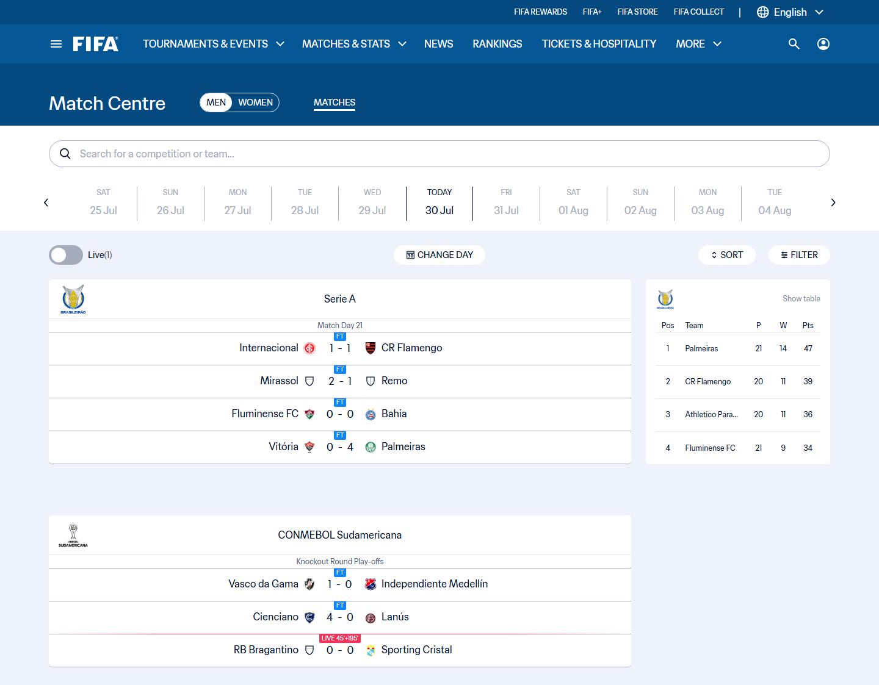
Figure UR-01. Observed state: Match Centre with gender control, date rail, search, live toggle, date, sort and filter controls, match rows, tables, and latest results. Supported claim: Date-based mental model; visible match status; multiple narrowing controls; long scanning surface. Limitation: A measured completion time or participant difficulty.
Source: capture-work/fifa/desktop/fifa-06-match-centre.png; URL: https://www.fifa.com/en/match-centre; captured: 2026-07-30 14:47:35 +07:00
Related: F-P1; F-P2; FR-T1
Researcher observed the listed controls and content hierarchy in this artifact. Any expected redesign benefit remains a PA3 hypothesis.
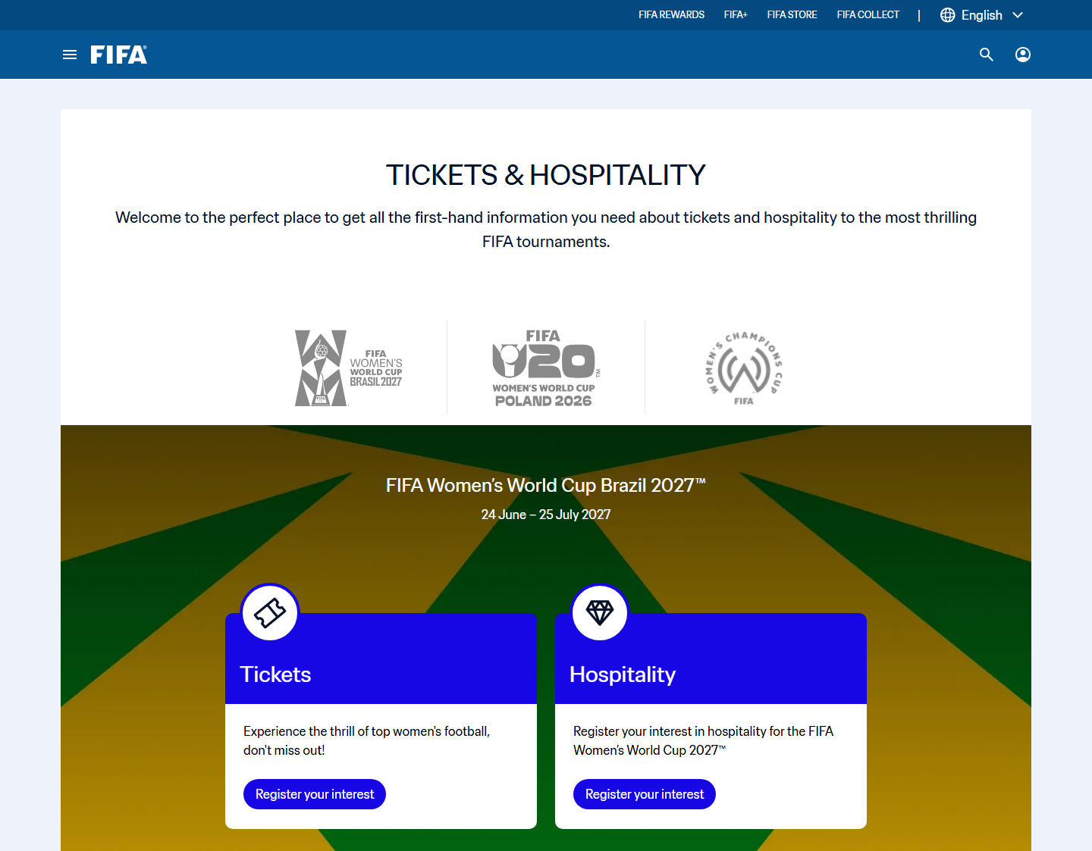
Figure UR-02. Observed state: Tickets and Hospitality landing page with tournament logos, ticket and hospitality cards, mixed register-interest and buy-now labels, other tournaments, news, and footer. Supported claim: Tournament-based ticket entry; card destinations; no consolidated cross-tournament status dashboard. Limitation: Seat map; waiting room; resale dashboard; verified partner redirect.
Source: capture-work/fifa/desktop/fifa-20-tickets-hospitality-landing.png; URL: https://www.fifa.com/en/tickets; captured: 2026-07-30 14:54:42 +07:00
Related: F-P3; FR-T3
Researcher observed a ticket landing decision surface organized by tournament cards. The captured state supports a need to compare visible options; it does not prove universal absence across every FIFA ticket channel.
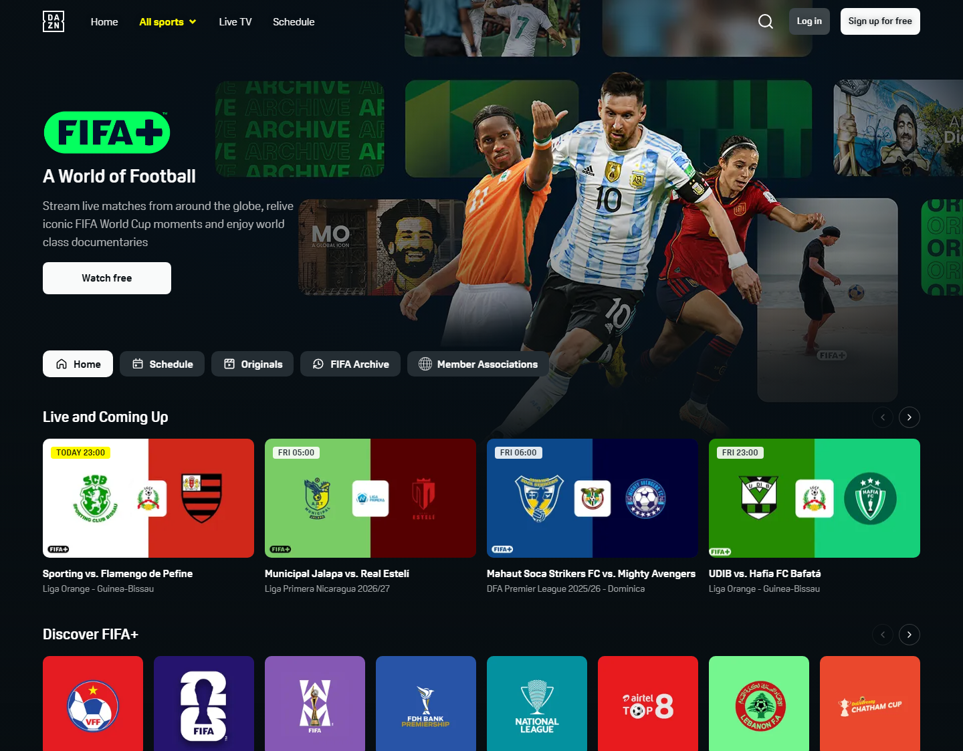
Figure UR-03. Observed state: Dark DAZN-hosted FIFA+ page with FIFA+ hero, sign-in controls, navigation, event cards, and media rails. Supported claim: Brand and account boundary; different IA; dense watch rails; need for handoff feedforward. Limitation: A tested trust failure or universal confusion.
Source: capture-work/fifa/desktop/fifa-35-fifa-plus-dazn-landing.png; URL: https://www.plus.fifa.com/; captured: 2026-07-30 15:03:26 +07:00
Related: F-P3; FR-T4
Researcher observed the listed controls and content hierarchy in this artifact. Any expected redesign benefit remains a PA3 hypothesis.
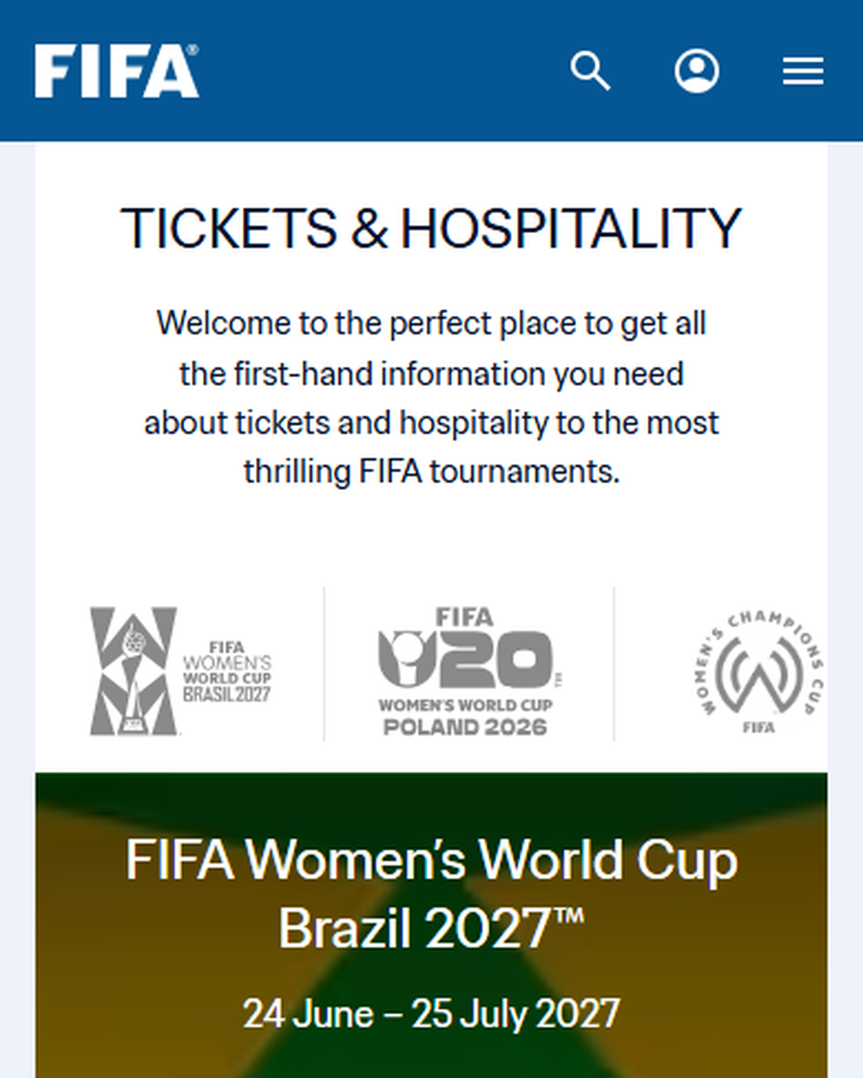
Figure UR-04. Observed state: Mobile Tickets and Hospitality page with stacked cards, horizontal carousels, news, and footer. Supported claim: Narrow-screen ticket discovery; card-based selection and long continuation. Limitation: Unified status dashboard; waiting room; partner redirect.
Source: capture-work/fifa/mobile/fifa-51-tickets-mobile.png; URL: https://www.fifa.com/en/tickets; captured: 2026-07-30 15:13:08 +07:00
Related: F-P3; FR-T3
Researcher observed the listed controls and content hierarchy in this artifact. Any expected redesign benefit remains a PA3 hypothesis.
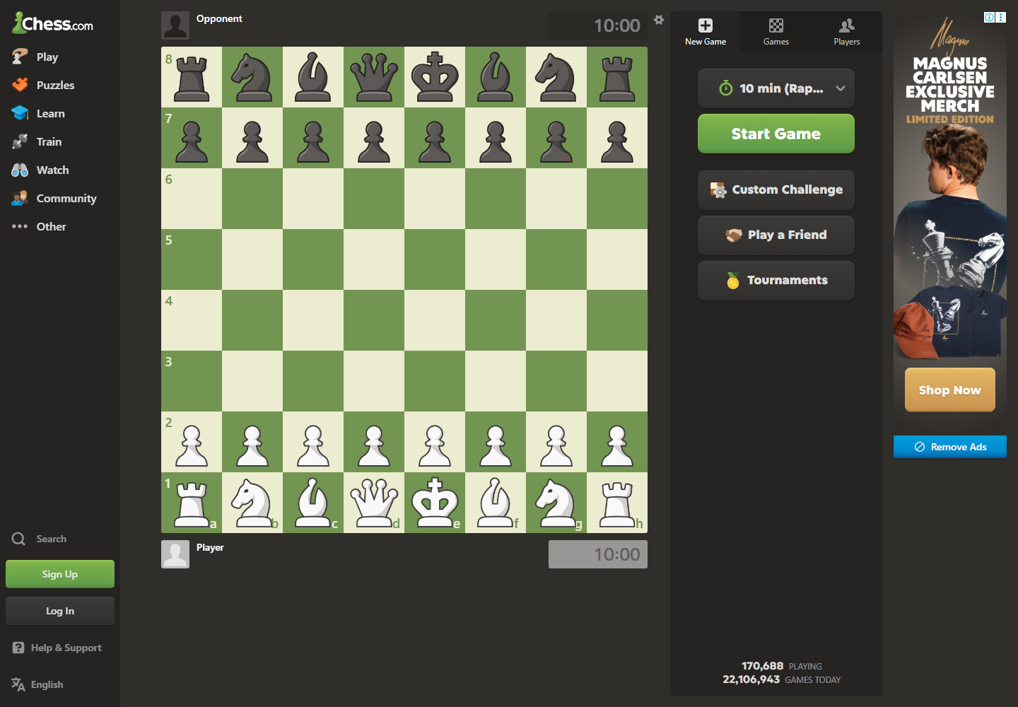
Figure UR-05. Observed state: Play entry with board, clocks, time control, Start Game, Custom Challenge, Play a Friend, Tournaments, navigation, and advertisement. Supported claim: Direct board mental model; fast-play options; competing controls and advertising. Limitation: Active game in progress.
Source: capture-work/chess/desktop/chess-05-play-entry.png; URL: https://www.chess.com/play/online; captured: 2026-07-30 15:15:04 +07:00
Related: C-P1; C-P2; C-P3; CR-T1
Researcher observed the listed controls and content hierarchy in this artifact. Any expected redesign benefit remains a PA3 hypothesis.
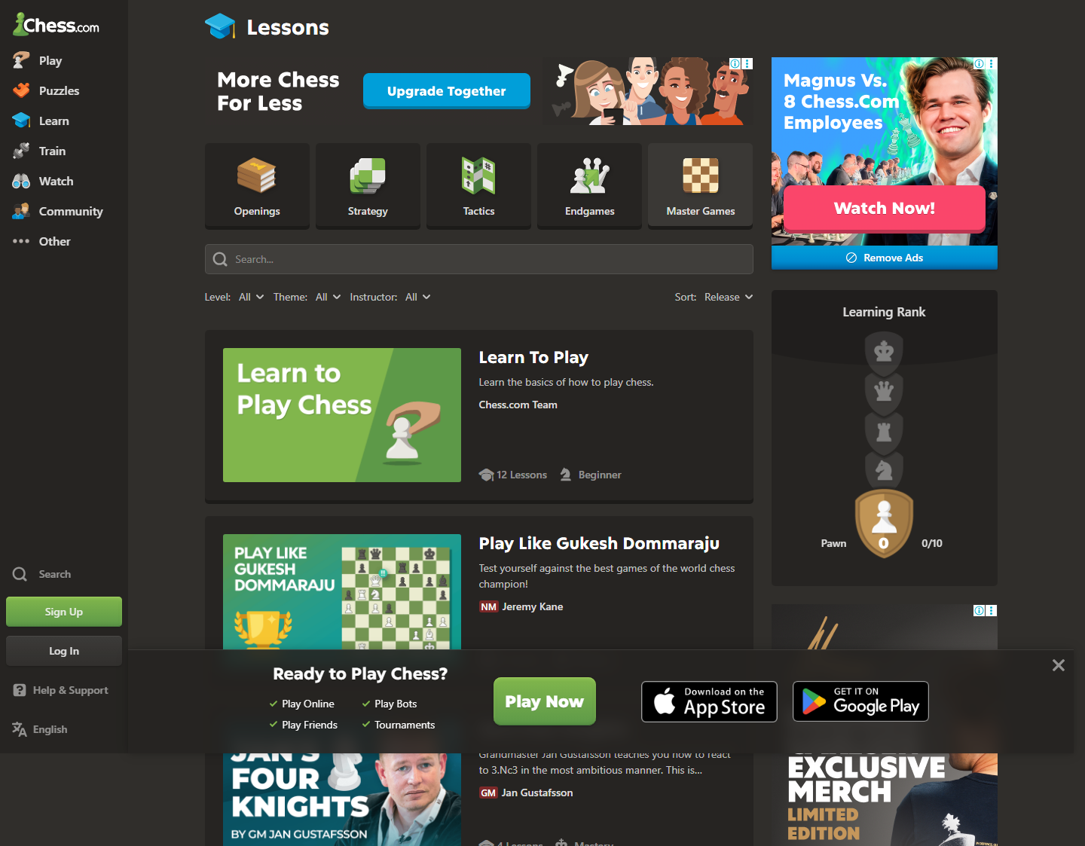
Figure UR-06. Observed state: Lessons page with category tabs, upgrade messaging, learning rank, ads, app promotion, long course list, pagination, and footer. Supported claim: Multiple learning categories; paid messaging and ads near learning content; long course list. Limitation: A specific lesson completed or premium entitlement interruption.
Source: capture-work/chess/desktop/chess-24-lessons-landing-loaded.png; URL: https://www.chess.com/lessons; captured: 2026-07-30 15:25:36 +07:00
Related: C-P1; C-P3; CR-T3
Researcher observed the listed controls and content hierarchy in this artifact. Any expected redesign benefit remains a PA3 hypothesis.
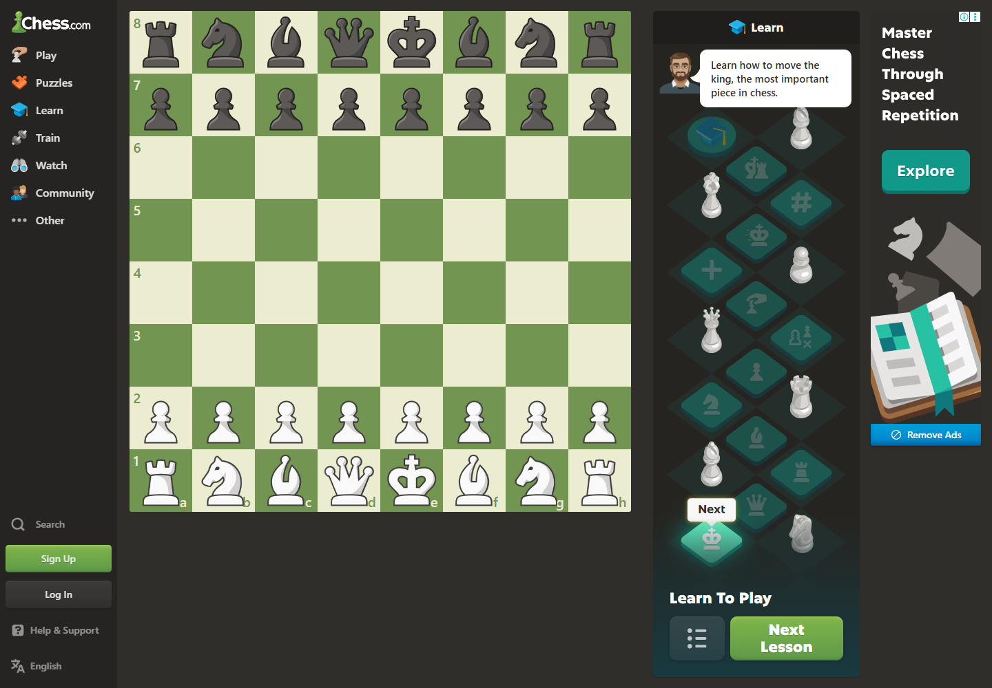
Figure UR-07. Observed state: Learn-to-Play board with progressive lesson path, prompt, and Next Lesson control. Supported claim: Progressive guided-learning pattern; clear next action. Limitation: Measured learning improvement.
Source: capture-work/chess/desktop/chess-26-learn-page.png; URL: https://www.chess.com/learn; captured: 2026-07-30 15:26:44 +07:00
Related: C-P1; CR-T3
Researcher observed the listed controls and content hierarchy in this artifact. Any expected redesign benefit remains a PA3 hypothesis.
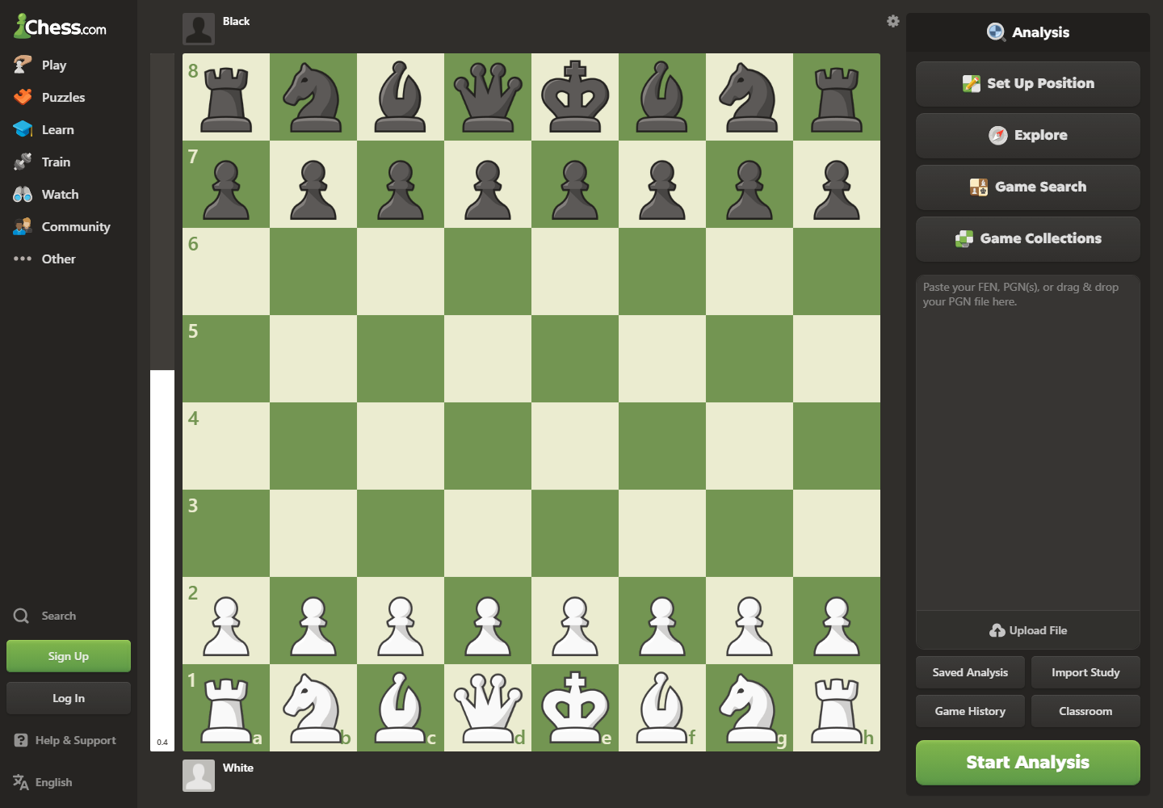
Figure UR-08. Observed state: Analysis entry board with Set Up Position, Explore, Game Search, Game Collections, import/upload options, and Start Analysis. Supported claim: Advanced entry exposes several paths and controls. Limitation: Completed review; engine lines; chart; classifications; beginner explanation.
Source: capture-work/chess/desktop/chess-29-analysis-board.png; URL: https://www.chess.com/analysis; captured: 2026-07-30 15:28:05 +07:00
Related: C-P1; C-P3; CR-T4
Researcher observed multiple analysis-entry and setup paths. The artifact does not show a completed Game Review, engine lines, move classifications, or demonstrated user overload.

7. Provisional role-based proto-personas
Status: These are role-based proto-personas derived from PA1 and artifact analysis. They have no invented names, ages, quotations, or direct-research claims.

F-P1 - Casual fixture checker (provisional)
Attribute | Provisional profile
Role | Casual fixture checker
Environment | Phone during a short, interruptible check
Goals and tasks | Check today's fixtures or results
Capabilities | Recognizes dates, teams, score states, and common navigation labels
Domain/application experience | As stated in Section 5; provisional and not measured.
Constraints | Low attention; long vertical surfaces
Artifacts | Match rows and date/status labels
Distinct scenario | Scenario: opens Match Centre, anchors on the current date, scans a relevant match state, and exits once the result is visible.
Success criteria | Visible date and match state without claiming measured speed.
Evidence basis | F2-E03/E17; Group10-PA1-ProductResearch, pp. 3, 5

F-P2 - Tournament information follower (provisional)
Attribute | Provisional profile
Role | Tournament information follower
Environment | Laptop during a research or follow-up session
Goals and tasks | Compare official tournament, ranking, and article information
Capabilities | Moderate football vocabulary; repeat web browsing
Domain/application experience | As stated in Section 5; provisional and not measured.
Constraints | Mixed result types; modal or article interruption
Artifacts | Search cards, tournament identity, ranking table
Distinct scenario | Scenario: searches an official tournament topic, distinguishes result types, opens one source, then relocates the tournament context.
Success criteria | Official source and context remain identifiable.
Evidence basis | F2-E05-E08; Group10-PA1-ProductResearch, pp. 3, 6-7

F-P3 - Trust-sensitive ticket planner (provisional)
Attribute | Provisional profile
Role | Trust-sensitive ticket planner
Environment | Laptop plus phone across repeated planning checks
Goals and tasks | Determine current visible option and official destination before leaving FIFA.com
Capabilities | Moderate domain knowledge; checks source identity and action labels
Domain/application experience | As stated in Section 5; provisional and not measured.
Constraints | Money/identity boundary; incomplete visible status
Artifacts | Tournament card, status summary, partner preview, saved plan
Distinct scenario | Scenario: selects a tournament, compares sale/hospitality/waiting labels, reviews the named destination, and chooses act, wait, or stay.
Success criteria | Decision can be made without inventing unavailable seat or resale data.
Evidence basis | F2-E09-E13/E18; Group10-PA1-PotentialSolutions, pp. 6, 8

C-P1 - Beginner learner (provisional)
Attribute | Provisional profile
Role | Beginner learner
Environment | Home or school on laptop/phone
Goals and tasks | Choose one comprehensible learning or review action
Capabilities | General web navigation; limited chess/application vocabulary
Domain/application experience | As stated in Section 5; provisional and not measured.
Constraints | Many first-level routes; analysis entry lacks completed review explanation
Artifacts | Board, lesson card, review card, explanation
Distinct scenario | Scenario: opens a completed game or position, selects Beginner Review, reads one critical point, tries the move, and continues to one relevant practice item.
Success criteria | One next action is understandable before advanced depth.
Evidence basis | C2-E01/E07/E08/E10/E12/E15; Group10-PA1-ProductResearch, pp. 3, 10-12

C-P2 - Focused competitive player (provisional)
Attribute | Provisional profile
Role | Focused competitive player
Environment | Desktop during time-sensitive play
Goals and tasks | Start an appropriate game efficiently
Capabilities | High chess and application experience; fast board manipulation
Domain/application experience | As stated in Section 5; provisional and not measured.
Constraints | Time pressure and motor accuracy
Artifacts | Board, clock, time control, start action
Distinct scenario | Scenario: opens Play, confirms time control, starts the intended game route, and retains a stable board focus.
Success criteria | Chosen start state is visible and reversible before play.
Evidence basis | C2-E02/E13; Group10-PA1-ProductResearch, pp. 3, 10-11

C-P3 - Returning learning player (provisional)
Attribute | Provisional profile
Role | Returning learning player
Environment | Intermittent laptop/phone sessions
Goals and tasks | Resume a coherent learning path and regain analysis orientation
Capabilities | Moderate chess knowledge; incomplete memory of feature locations
Domain/application experience | As stated in Section 5; provisional and not measured.
Constraints | Reorientation after gaps; advanced terminology
Artifacts | Lesson path, board position, analysis entry, learning link
Distinct scenario | Scenario: returns after a gap, recognizes a prior learning artifact, opens a review, and selects one relevant lesson or puzzle.
Success criteria | Continuation is identifiable without removing optional expert controls.
Evidence basis | C2-E04/E08-E10/E16; Group10-PA1-ProductResearch, pp. 3, 12

8. Work models
The models separate people/places/artifacts and coordination (flow), intent-trigger-steps-branches-loops-breakdowns (sequence), and artifact-information-action-downstream decision-breakdown (artifact). They are provisional because no direct observation session exists.
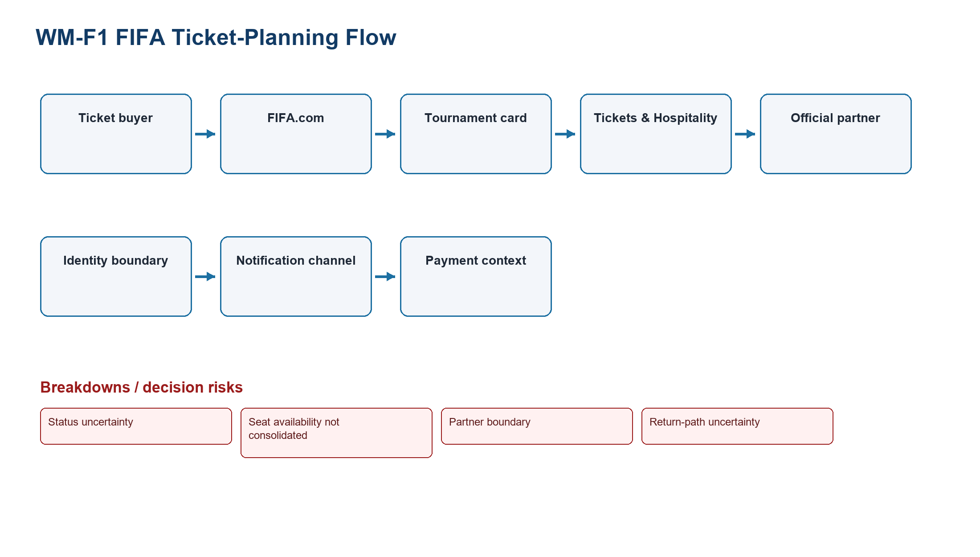
Figure WM-F1. FIFA flow model: people/groups, virtual places, artifacts, directed coordination, and ticket-planning breakdowns.
Source: generated-diagrams/wm-f1-ticket-planning.png
Related: Product-specific provisional roles and focal tasks
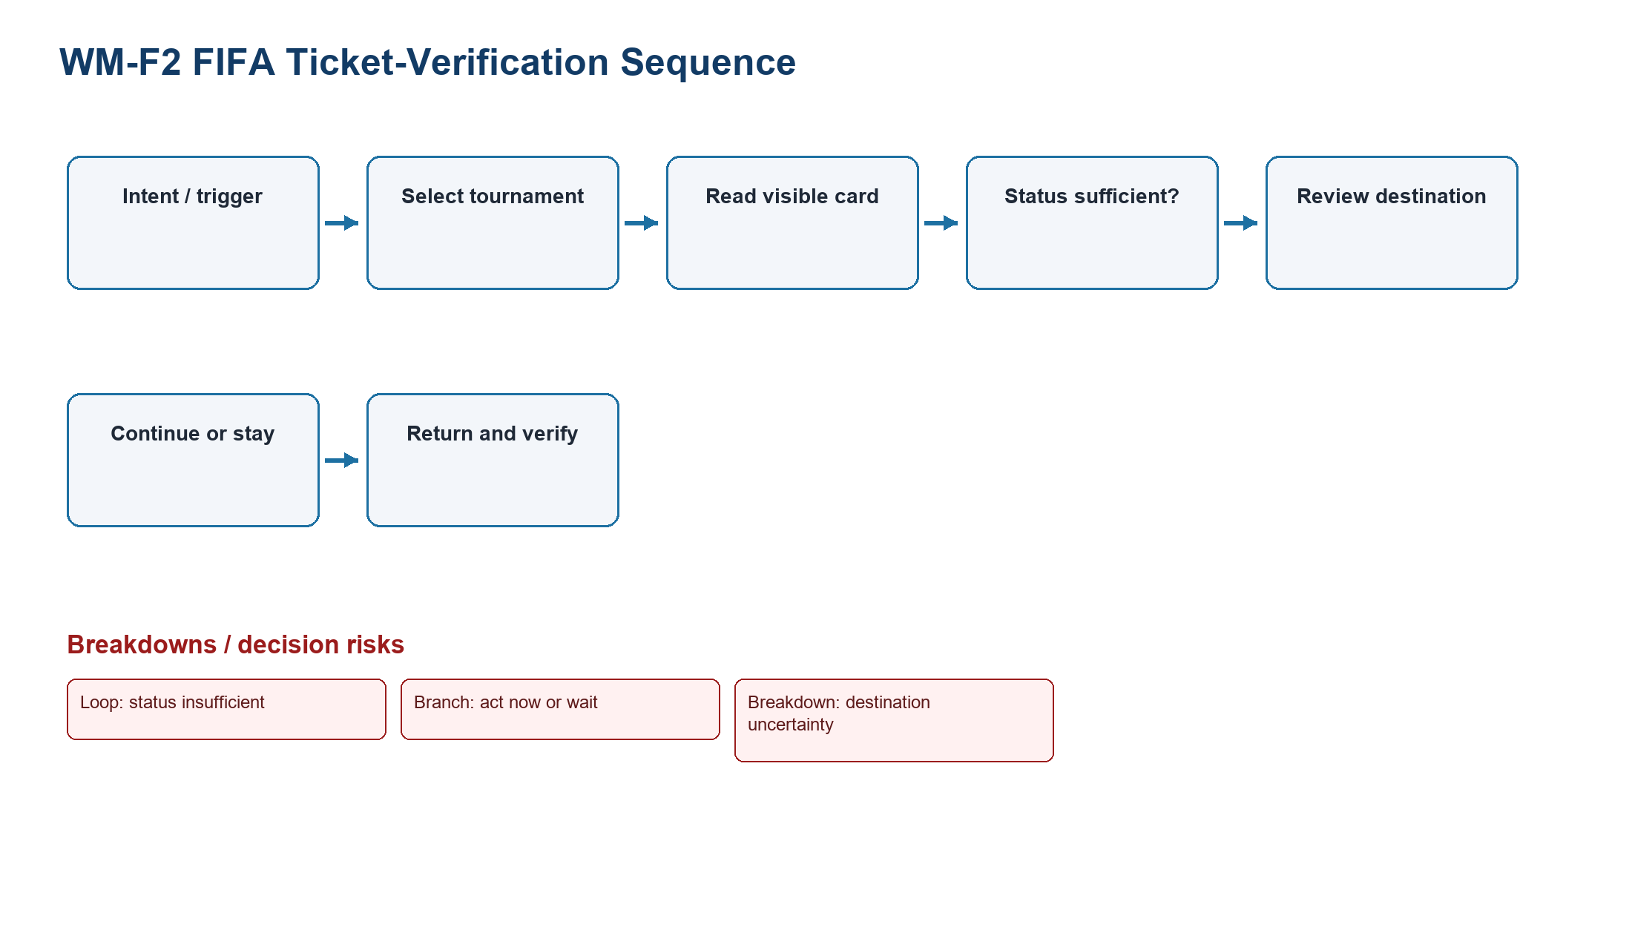
Figure WM-F2. FIFA sequence model: intent, trigger, steps, status-sufficient loop, act/wait branch, hesitation, and destination breakdown.
Source: generated-diagrams/wm-f2-ticket-verification.png
Related: Product-specific provisional roles and focal tasks
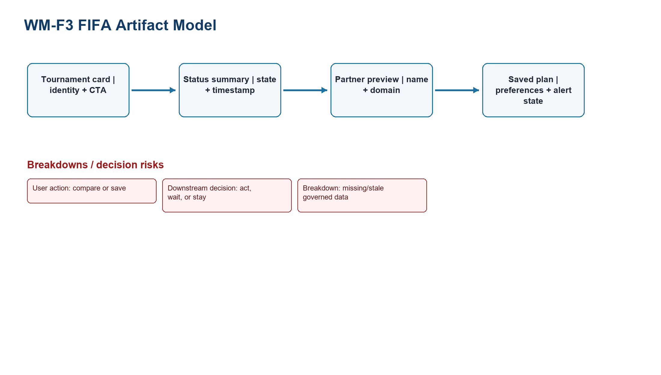
Figure WM-F3. FIFA artifact model: ticket artifacts, information carried, user action, downstream decision, and missing/stale-data breakdown.
Source: generated-diagrams/wm-f-artifacts.png
Related: Product-specific provisional roles and focal tasks
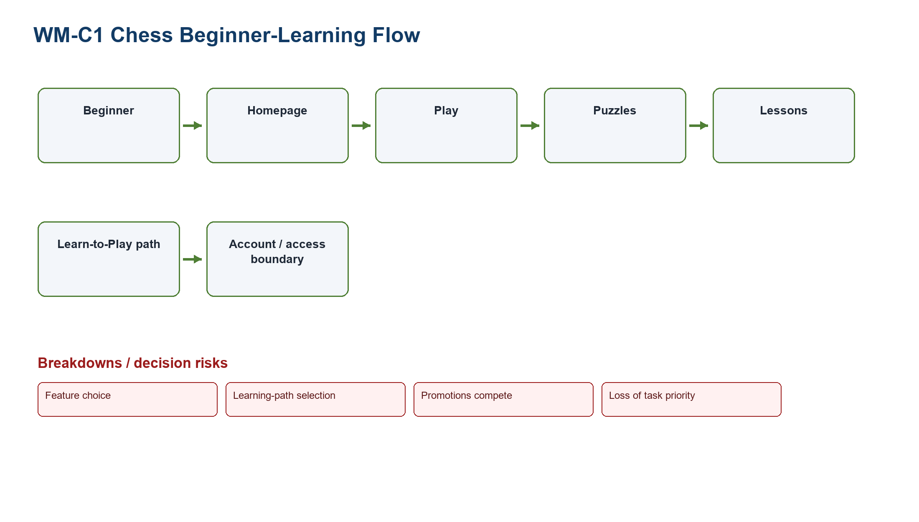
Figure WM-C1. Chess flow model: beginner/returning roles, home/play/puzzles/lessons places, artifacts, coordination, and priority breakdowns.
Source: generated-diagrams/wm-c1-beginner-learning.png
Related: Product-specific provisional roles and focal tasks
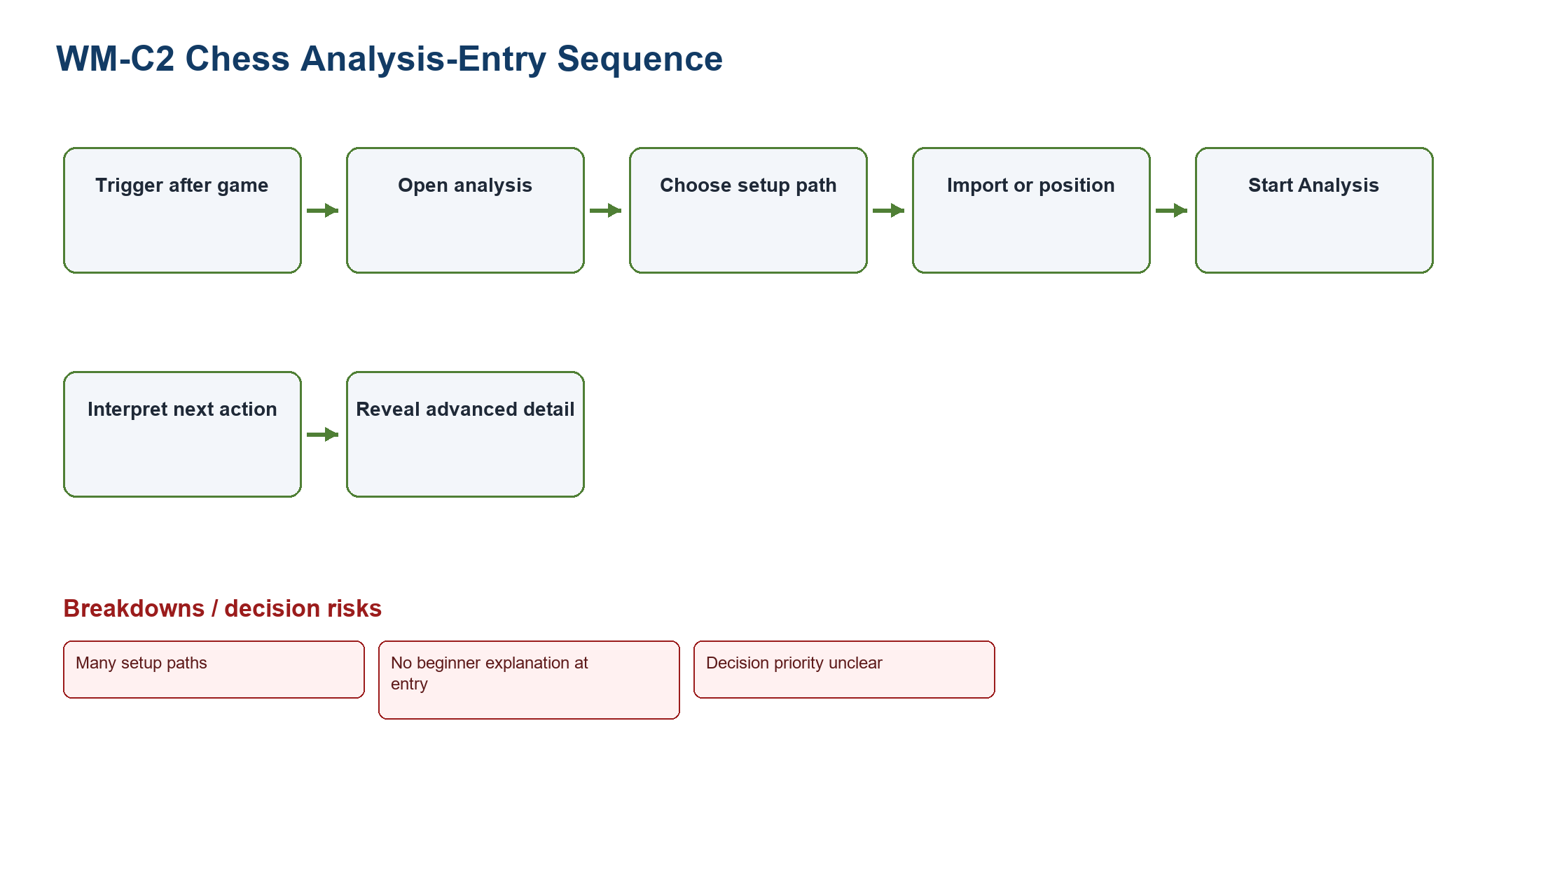
Figure WM-C2. Chess sequence model: post-game trigger, setup branches, interpretation, optional detail, hesitation, and entry-state limitation.
Source: generated-diagrams/wm-c2-analysis-entry.png
Related: Product-specific provisional roles and focal tasks
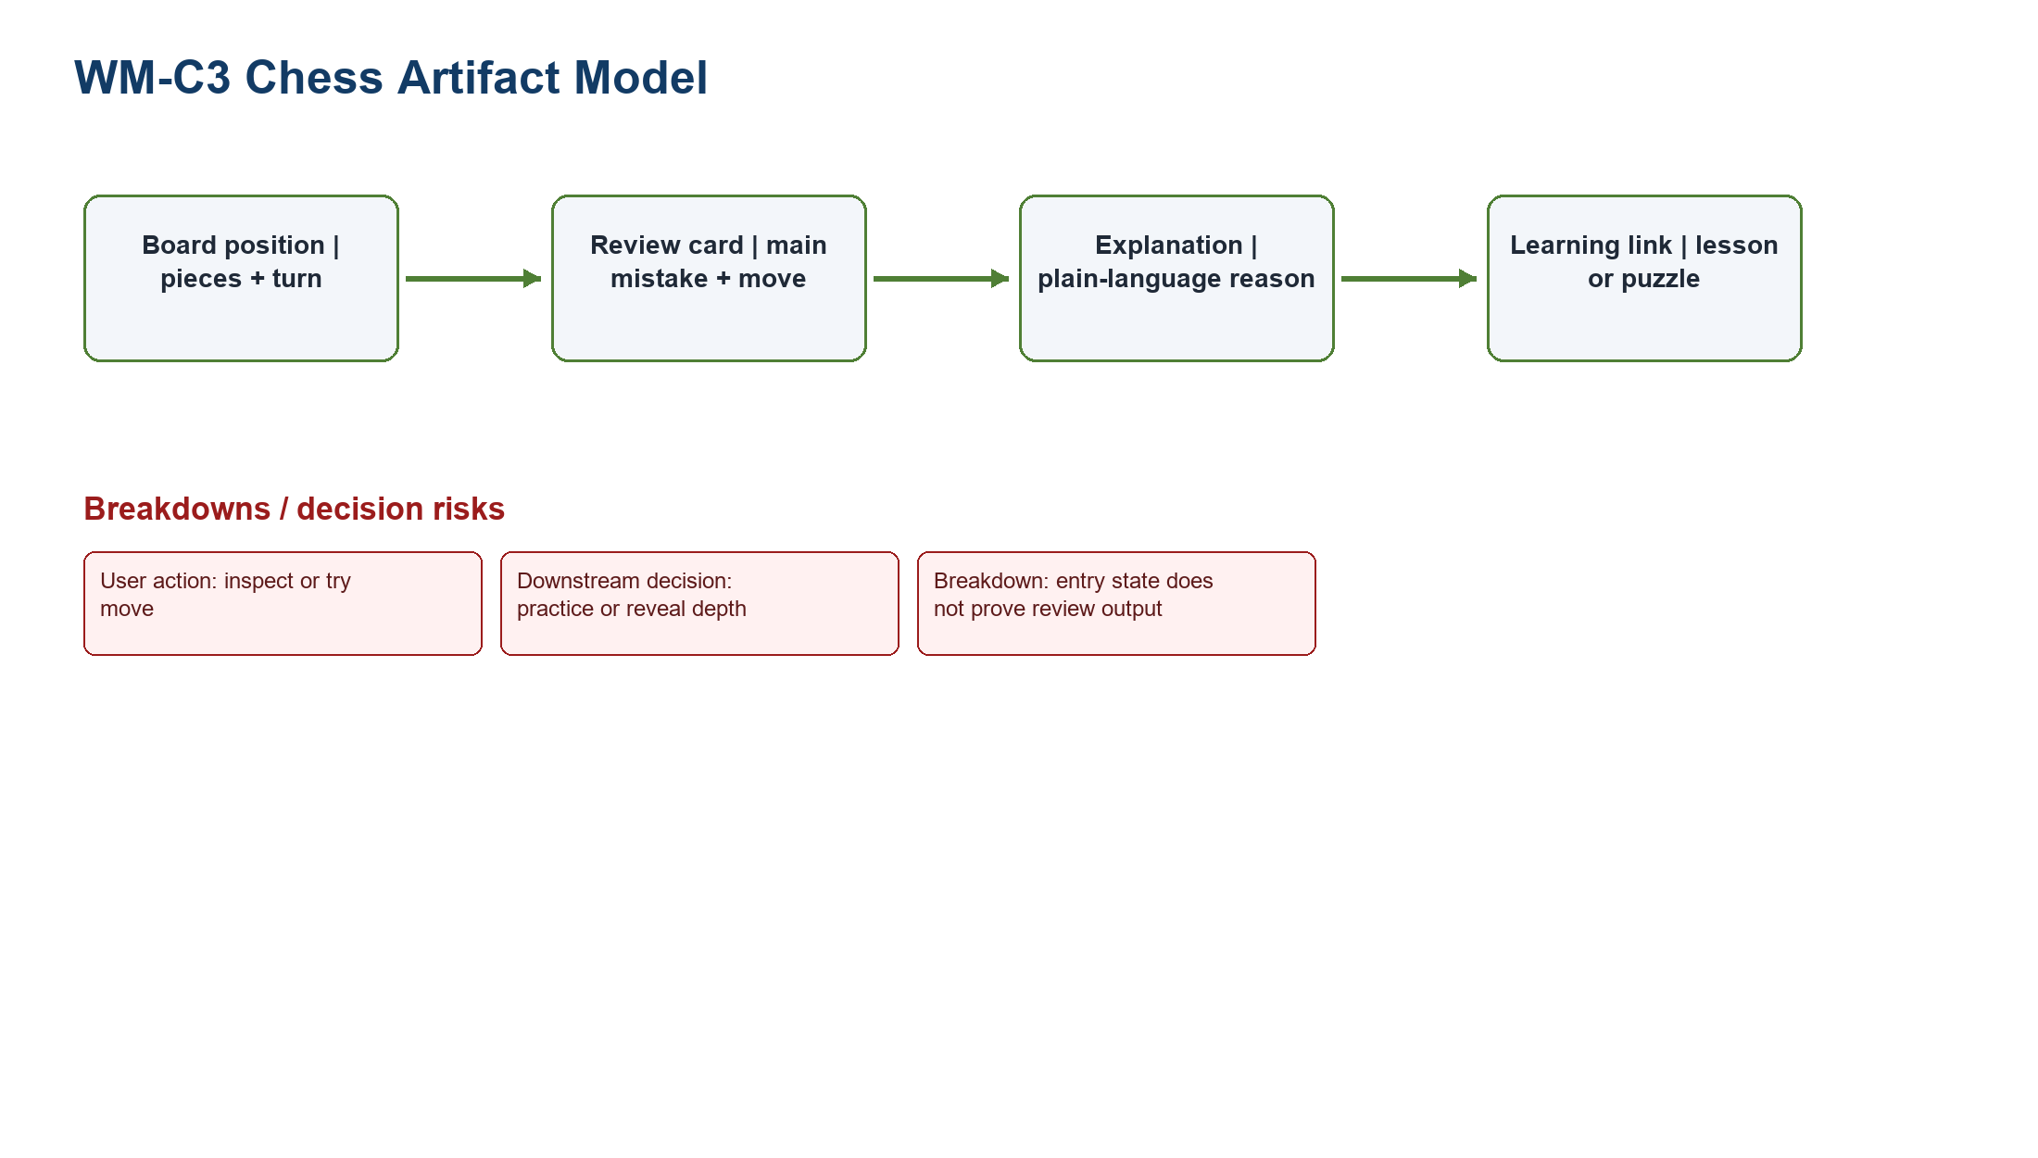
Figure WM-C3. Chess artifact model: board/review/explanation/learning artifacts, information, action, downstream practice decision, and evidence limits.
Source: generated-diagrams/wm-c-artifacts.png
Related: Product-specific provisional roles and focal tasks

9. Insights and limitations
- Both products expose recognizable domain artifacts, but the decision burden differs: FIFA asks users to verify information and boundaries; Chess.com asks users to prioritize actions and interpret depth.
- Mobile layouts preserve major tasks through stacking, while increasing vertical continuation and reducing simultaneous overview.
- A positive baseline exists in Chess.com's Learn-to-Play path: a visible Next Lesson action demonstrates how one clear continuation can coexist with a rich product.
- The selected problems are TP-FIFA ticket confidence and TP-CHESS beginner learning/review priority.
- No external participant behavior, interview, survey, quotation, observation transcript, or measured outcome exists.
- No verified member/date/duration record exists for a human walkthrough.
- Screenshots are time-bound states and cannot establish universal product behavior.
- The Chess analysis capture is entry-only; it does not validate completed Game Review overload.
- Role-based proto-personas and work models require future validation with representative users.

10. Traceability
Problem | Personas | Tasks | Evidence | PA1 continuity | PA3 direction
TP-FIFA | F-P3 | FR-T3, FR-T4 | F2-E09, E10, E11, E18 | F-D2/F-D4; PA1 PotentialSolutions pp. 6, 8 | F-A1/F-A2/F-A3; F-UC01-F-UC06
TP-CHESS | C-P1, C-P3 | CR-T3, CR-T4 | C2-E01, E07, E08, E10, E12, E15 | C-D1/C-D2; PA1 PotentialSolutions pp. 11-12 | C-A1/C-A2/C-A3; C-UC01-C-UC06

11. References
- Group10-PA1-ProductResearch.pdf, pp. 2-12.
- Group10-PA1-PotentialSolutions.pdf, pp. 2, 6, 8, 11-12.
- PA2-LKDuy-2026-Public.pdf, pp. 1-3.
- LN01 - Introduction - v2.pdf, pp. 20, 22, 24.
- LN02 - Fundamental Concepts - Usability Dimensions_2.pdf, pp. 62-66, 116-118.
- LN03 - UI Design Process.pdf, pp. 16, 23-24, 28, 30, 36.
- LN04 - Task Analysis.pdf, pp. 3, 6-7, 39-40, 44, 47-49.

12. Evidence appendix
The exact approved full-height images used for the main focal figures follow. Main-body figures are pixel-preserving crops for legibility; these appendix images retain the complete capture.
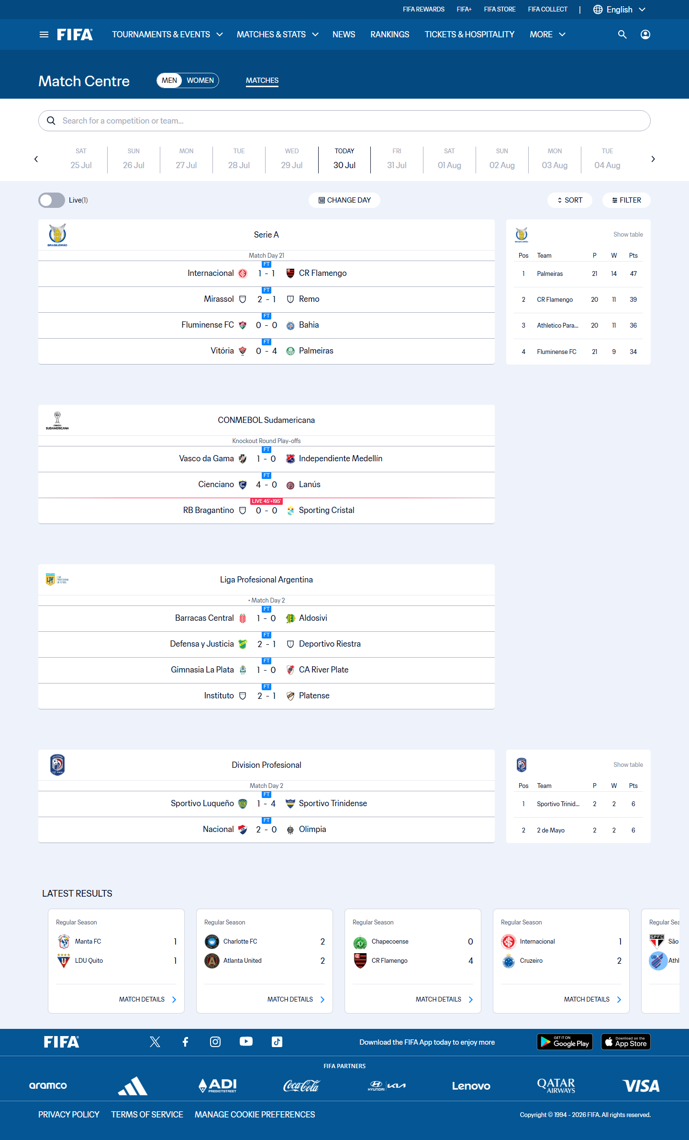
Figure UR-A01. Full approved image for F2-E03. Observed state: Match Centre with gender control, date rail, search, live toggle, date, sort and filter controls, match rows, tables, and latest results. Supported claim: Date-based mental model; visible match status; multiple narrowing controls; long scanning surface. Limitation: A measured completion time or participant difficulty.
Source: capture-work/fifa/desktop/fifa-06-match-centre.png; URL: https://www.fifa.com/en/match-centre; captured: 2026-07-30 14:47:35 +07:00
Related: F-P1; F-P2; FR-T1
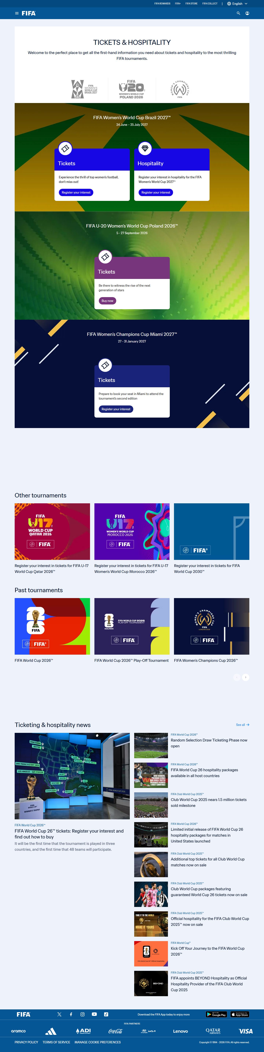
Figure UR-A02. Full approved image for F2-E09. Observed state: Tickets and Hospitality landing page with tournament logos, ticket and hospitality cards, mixed register-interest and buy-now labels, other tournaments, news, and footer. Supported claim: Tournament-based ticket entry; card destinations; no consolidated cross-tournament status dashboard. Limitation: Seat map; waiting room; resale dashboard; verified partner redirect.
Source: capture-work/fifa/desktop/fifa-20-tickets-hospitality-landing.png; URL: https://www.fifa.com/en/tickets; captured: 2026-07-30 14:54:42 +07:00
Related: F-P3; FR-T3
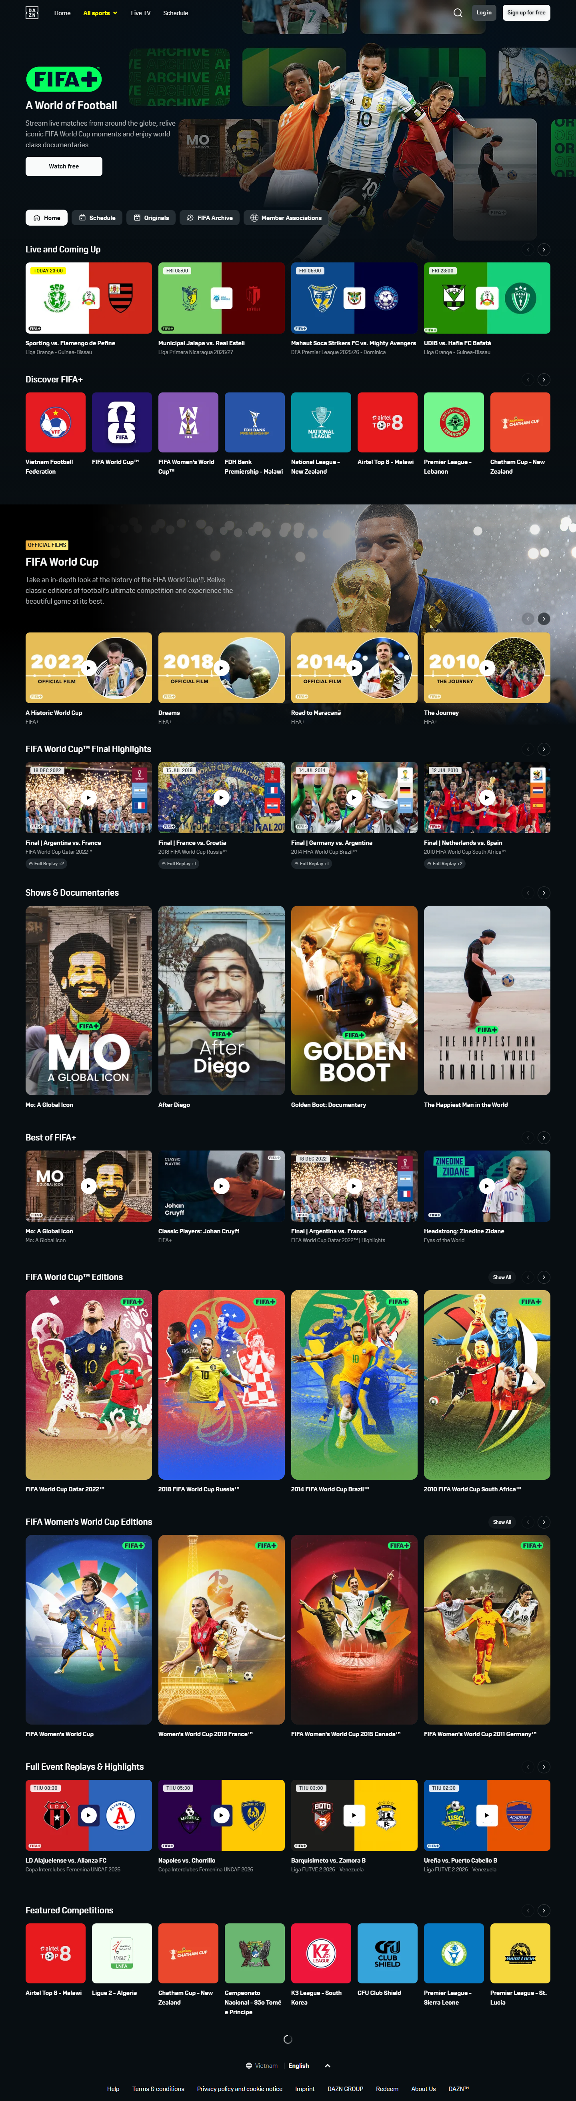
Figure UR-A03. Full approved image for F2-E11. Observed state: Dark DAZN-hosted FIFA+ page with FIFA+ hero, sign-in controls, navigation, event cards, and media rails. Supported claim: Brand and account boundary; different IA; dense watch rails; need for handoff feedforward. Limitation: A tested trust failure or universal confusion.
Source: capture-work/fifa/desktop/fifa-35-fifa-plus-dazn-landing.png; URL: https://www.plus.fifa.com/; captured: 2026-07-30 15:03:26 +07:00
Related: F-P3; FR-T4
Figure UR-A04. Full approved image for F2-E18. Observed state: Mobile Tickets and Hospitality page with stacked cards, horizontal carousels, news, and footer. Supported claim: Narrow-screen ticket discovery; card-based selection and long continuation. Limitation: Unified status dashboard; waiting room; partner redirect.
Source: capture-work/fifa/mobile/fifa-51-tickets-mobile.png; URL: https://www.fifa.com/en/tickets; captured: 2026-07-30 15:13:08 +07:00
Related: F-P3; FR-T3
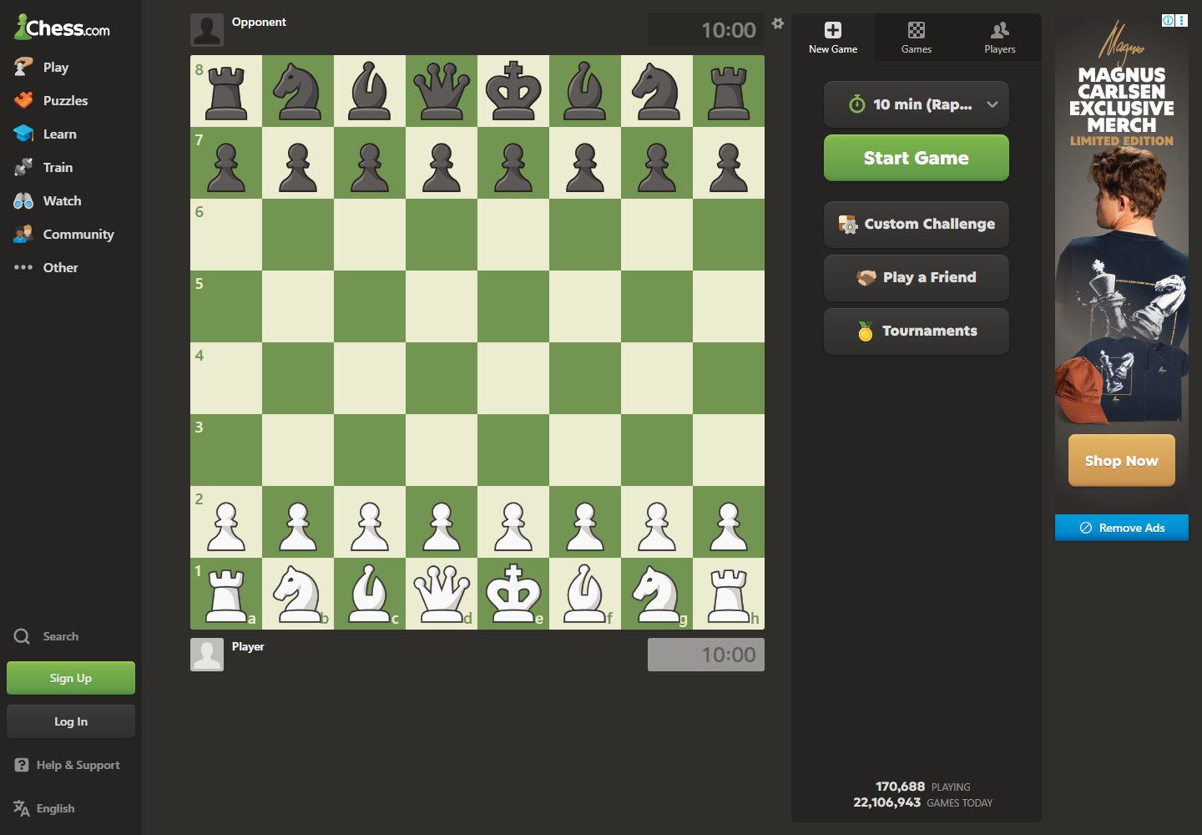
Figure UR-A05. Full approved image for C2-E02. Observed state: Play entry with board, clocks, time control, Start Game, Custom Challenge, Play a Friend, Tournaments, navigation, and advertisement. Supported claim: Direct board mental model; fast-play options; competing controls and advertising. Limitation: Active game in progress.
Source: capture-work/chess/desktop/chess-05-play-entry.png; URL: https://www.chess.com/play/online; captured: 2026-07-30 15:15:04 +07:00
Related: C-P1; C-P2; C-P3; CR-T1
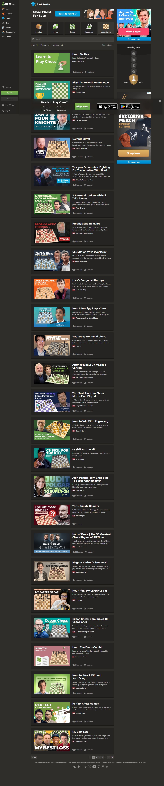
Figure UR-A06. Full approved image for C2-E07. Observed state: Lessons page with category tabs, upgrade messaging, learning rank, ads, app promotion, long course list, pagination, and footer. Supported claim: Multiple learning categories; paid messaging and ads near learning content; long course list. Limitation: A specific lesson completed or premium entitlement interruption.
Source: capture-work/chess/desktop/chess-24-lessons-landing-loaded.png; URL: https://www.chess.com/lessons; captured: 2026-07-30 15:25:36 +07:00
Related: C-P1; C-P3; CR-T3
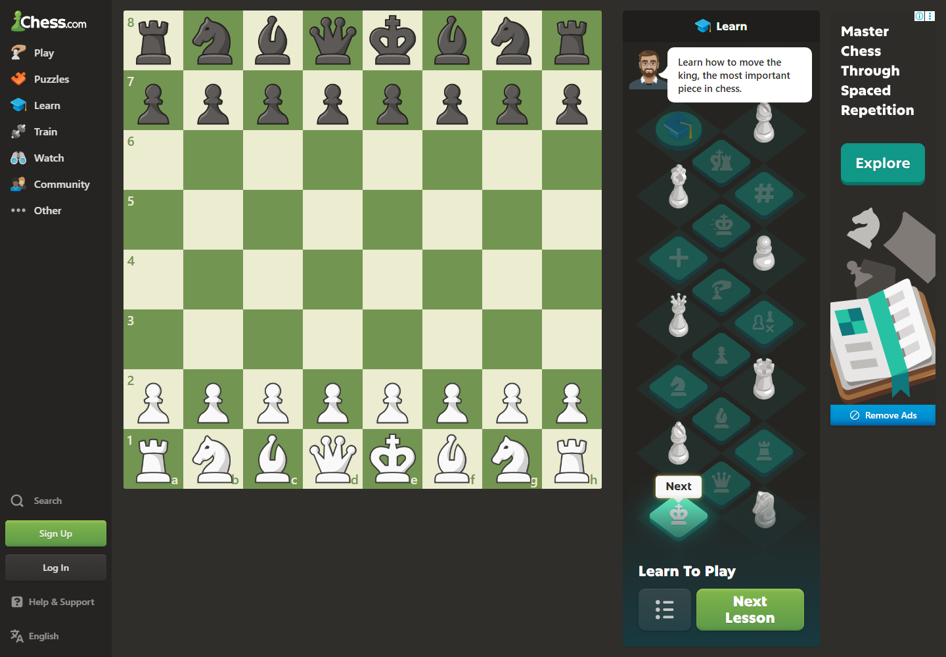
Figure UR-A07. Full approved image for C2-E08. Observed state: Learn-to-Play board with progressive lesson path, prompt, and Next Lesson control. Supported claim: Progressive guided-learning pattern; clear next action. Limitation: Measured learning improvement.
Source: capture-work/chess/desktop/chess-26-learn-page.png; URL: https://www.chess.com/learn; captured: 2026-07-30 15:26:44 +07:00
Related: C-P1; CR-T3
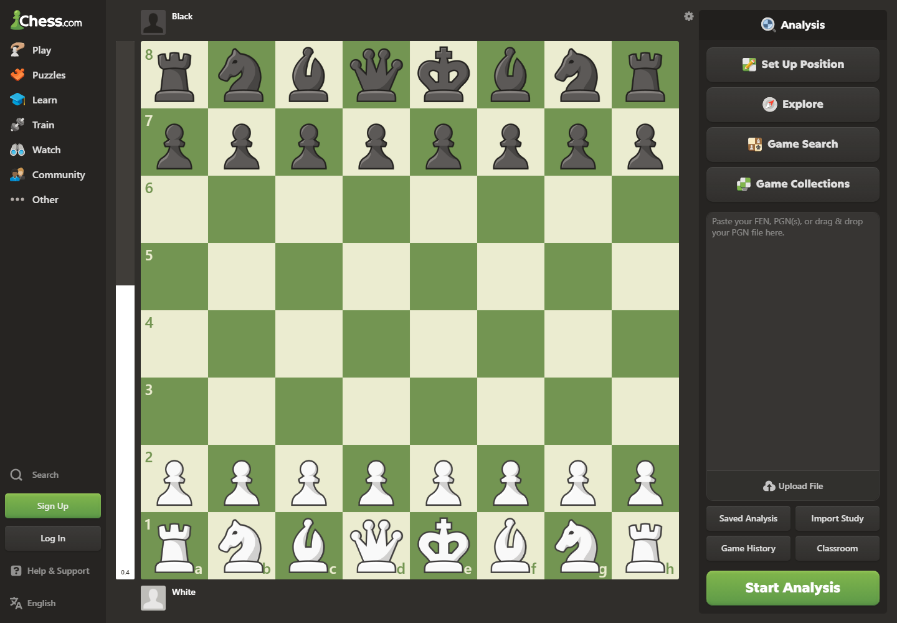
Figure UR-A08. Full approved image for C2-E10. Observed state: Analysis entry board with Set Up Position, Explore, Game Search, Game Collections, import/upload options, and Start Analysis. Supported claim: Advanced entry exposes several paths and controls. Limitation: Completed review; engine lines; chart; classifications; beginner explanation.
Source: capture-work/chess/desktop/chess-29-analysis-board.png; URL: https://www.chess.com/analysis; captured: 2026-07-30 15:28:05 +07:00
Related: C-P1; C-P3; CR-T4
ID | State | Supported claim | Unsupported claim
F2-E01 | Full homepage with global header, tournament circles, stacked sections, footer, and a promotional modal over first-view content. | Promotional interruption; broad hierarchy; task-entry competition. | Clean default homepage; cookie banner; distinct navigation-open state.
F2-E02 | Long mobile homepage with compact header, stacked content, ranking content, and footer. | Mobile density; long vertical scanning; compact navigation. | Open mobile menu.
F2-E03 | Match Centre with gender control, date rail, search, live toggle, date, sort and filter controls, match rows, tables, and latest results. | Date-based mental model; visible match status; multiple narrowing controls; long scanning surface. | A measured completion time or participant difficulty.
F2-E04 | Match Centre dimmed behind an open A-to-Z Competitions filter drawer. | Filter structure; added scan and selection work; panel-to-results relationship. | A selected competition result.
F2-E05 | Search results for world cup with content-type and date filters, mixed article cards, sorting, and pagination. | Mixed-content search; comparison among result types; filtering and pagination. | User success rate or search relevance quality.
F2-E06 | Ticketing media-release page with header, hero, article content, a large sparse body interval, related content, and footer. | Article structure; utility action is not persistently visible; captured body includes a long sparse interval. | Universal production loading defect; full body-content assessment.
F2-E07 | Tournament landing page covered by a registration-interest modal. | Modal interruption; obscured browsing context. | Dismissed modal.
F2-E08 | Men's World Ranking page with ranking cards, table, explanation, media, related articles, and footer. | Dedicated official ranking content; separation of reading and utility navigation. | Participant comprehension or ranking accuracy.
F2-E09 | Tickets and Hospitality landing page with tournament logos, ticket and hospitality cards, mixed register-interest and buy-now labels, other tournaments, news, and footer. | Tournament-based ticket entry; card destinations; no consolidated cross-tournament status dashboard. | Seat map; waiting room; resale dashboard; verified partner redirect.
F2-E10 | FIFA-branded page with assistant-referee flag image and an error or unavailable-state message. | Captured entry route does not expose watch content; possible continuity loss in this state. | Every FIFA+ session fails.
F2-E11 | Dark DAZN-hosted FIFA+ page with FIFA+ hero, sign-in controls, navigation, event cards, and media rails. | Brand and account boundary; different IA; dense watch rails; need for handoff feedforward. | A tested trust failure or universal confusion.
F2-E12 | DAZN-hosted FIFA+ landing page darkened by a cookie-preferences panel. | Consent handling adds a step before content access. | A distinct rail state.
F2-E13 | Unobstructed upper portion of the FIFA+ landing page with hero, category controls, and event cards. | Normal landing layout; hero, categories, and media entry. | Seven distinct rail states.
F2-E14 | Bright retail page with store-specific header, merchandising hero, product grids, category tiles, and retail footer. | Cross-property visual and task-model change; retail navigation differs from information navigation. | Ticket availability or FIFA.com navigation continuity.
F2-E15 | Dark FIFA Collect marketplace with subscription prompt, collectibles, clubs, prices, filters, and marketplace language. | Cross-property mental-model change; separate transaction vocabulary and structure. | Conventional merchandise shopping flow.
F2-E16 | Black FIFA Rewards page with Join Now, tier cards, FAQs, and FIFA footer. | Distinct sibling-property identity; account-oriented reward task. | A completed sign-up or reward redemption.
F2-E17 | Mobile Match Centre with compact header, gender control, match groups, latest results, load-more control, and long footer. | Mobile fixture checking; long vertical task surface. | Open filter menu or measured scroll effort.
F2-E18 | Mobile Tickets and Hospitality page with stacked cards, horizontal carousels, news, and footer. | Narrow-screen ticket discovery; card-based selection and long continuation. | Unified status dashboard; waiting room; partner redirect.
F2-E19 | Mobile ticketing article with header, hero, body content separated by a long sparse interval, related topics, and footer. | Little persistent task continuation; long mobile reading surface. | Full article comprehension or universal loading defect.
F2-E20 | Mobile FIFA+ entry route with assistant-referee flag and error or unavailable-state message. | Mobile entry failure in the captured state. | Normal FIFA+ mobile landing page.
C2-E01 | Long homepage with persistent left navigation, Play hero, Lessons, Bots, Puzzles, Watch, app promotion, and footer. | Feature-rich entry; recognition of categories; many first-level routes; long scan. | A user preference for the whitespace.
C2-E02 | Play entry with board, clocks, time control, Start Game, Custom Challenge, Play a Friend, Tournaments, navigation, and advertisement. | Direct board mental model; fast-play options; competing controls and advertising. | Active game in progress.
C2-E03 | Skill-level modal over the Play page with Sign Up, Log In, and Play as a Guest. | Account/onboarding interruption; skill-level setup decision. | A completed custom-game configuration.
C2-E04 | Bot-selection page with board preview, bot categories and levels, options, Play button, navigation, and advertisement. | Many choices before bot play; category and difficulty structure. | Active game; move feedback; premove; Focus Mode.
C2-E05 | Puzzle board with move context, progression map, Solve Puzzles control, navigation, and advertisement. | Direct manipulation; board/progression split; ad attention competition. | Correct or incorrect result state.
C2-E06 | Puzzle board with highlighted move context and progression map. | Move affordance and immediate action state. | Correct or incorrect result.
C2-E07 | Lessons page with category tabs, upgrade messaging, learning rank, ads, app promotion, long course list, pagination, and footer. | Multiple learning categories; paid messaging and ads near learning content; long course list. | A specific lesson completed or premium entitlement interruption.
C2-E08 | Learn-to-Play board with progressive lesson path, prompt, and Next Lesson control. | Progressive guided-learning pattern; clear next action. | Measured learning improvement.
C2-E09 | Long article titled Chess Study Plans for All Levels with navigation, article content, comments, and related content. | Study guidance exists as content rather than a unified personalized dashboard. | A verified personalized learning path.
C2-E10 | Analysis entry board with Set Up Position, Explore, Game Search, Game Collections, import/upload options, and Start Analysis. | Advanced entry exposes several paths and controls. | Completed review; engine lines; chart; classifications; beginner explanation.
C2-E11 | Homepage-like content; no unambiguous high-salience advertisement is visible in the inspected pixels. | Homepage task hierarchy only. | Advertising competition unless an ad is visibly identifiable.
C2-E12 | Mobile homepage with hamburger icon, Sign Up and Log In, stacked Play, Lessons, Bots, Puzzles, Watch, app content, and footer. | Mobile content stacking and long vertical scanning. | Open mobile menu.
C2-E13 | Mobile Play entry with board, clocks, bottom task navigation, time control, Start Game, and alternative play options. | Mobile play entry and vertical continuation. | Active game.
C2-E14 | Mobile puzzle progression map with coach prompt and Solve Puzzles control. | Mobile puzzle entry and progression. | Puzzle result or board interaction.
C2-E15 | Very long mobile Lessons page with categories, course cards, promotion, ranking, and footer. | Extended vertical scanning on mobile learning content. | A completed lesson or measured difficulty.
C2-E16 | Mobile bot-selection/setup page with bot identity, board preview, categories, options, and Play. | Mobile bot selection and setup. | Active game.

