PROJECT ASSIGNMENT 2

Group10-PA2 Use Case Document
FIFA.com and Chess.com
Course | CSC13112 - UI/UX Design, FIT-HCMUS
Group | Group10
Team | Le Minh (21127645); Nguyen Vu Bach (21127224); Pham Nguyen Gia Bao (20127119); Trang Minh Nhut (22127318)

Contents
1. Scope, actors, and notation — 4
2. Detailed use cases — 6
2.1 F-UC01 - Select tournament context — 6
Main flow — 7
Alternate flows — 7
Exception flows — 7
2.2 F-UC02 - Compare ticket states — 9
Main flow — 9
Alternate flows — 9
Exception flows — 9
2.3 F-UC03 - Inspect freshness — 11
Main flow — 11
Alternate flows — 11
Exception flows — 11
2.4 F-UC04 - Preview destination — 13
Main flow — 13
Alternate flows — 13
Exception flows — 13
2.5 F-UC05 - Subscribe to alert — 15
Main flow — 15
Alternate flows — 15
Exception flows — 15
2.6 F-UC06 - Continue, stay or return — 17
Main flow — 17
Alternate flows — 17
Exception flows — 17
2.7 C-UC01 - Open game — 19
Main flow — 19
Alternate flows — 19
Exception flows — 19
2.8 C-UC02 - Select beginner review — 21
Main flow — 21
Alternate flows — 21
Exception flows — 21
2.9 C-UC03 - Identify mistake — 23
Main flow — 23
Alternate flows — 23
Exception flows — 23
2.10 C-UC04 - Try better move — 25
Main flow — 25
Alternate flows — 25
Exception flows — 25
2.11 C-UC05 - Read explanation — 27
Main flow — 27
Alternate flows — 27
Exception flows — 27
2.12 C-UC06 - Continue to practice or advanced depth — 29
Main flow — 29
Alternate flows — 29
Exception flows — 29
3. Edge-case coverage — 30
4. Design rationale and validation target — 31
5. State and Recovery Reference — 32
5.1 Complete Empty, Error, and Validation Matrix — 33
6. Practical Difficulties and Lessons Learned — 36

1. Scope, actors, and notation
System | Primary actor | External systems | Use cases
FIFA Ticket Confidence Module | Ticket planner | FIFA tournament catalog; governed ticket-state feed; official ticketing partner; notification and identity services | F-UC01-F-UC06
Chess Guided Beginner Review Module | Beginner / returning learner | Game store; analysis service; explanation service; learning catalog | C-UC01-C-UC06
Notation: Solid lines are actor associations. Dashed arrows labeled <<include>> point to required reused behavior. Dashed arrows labeled <<extend>> point from optional/conditional behavior to its base use case. External systems remain outside the system boundary.

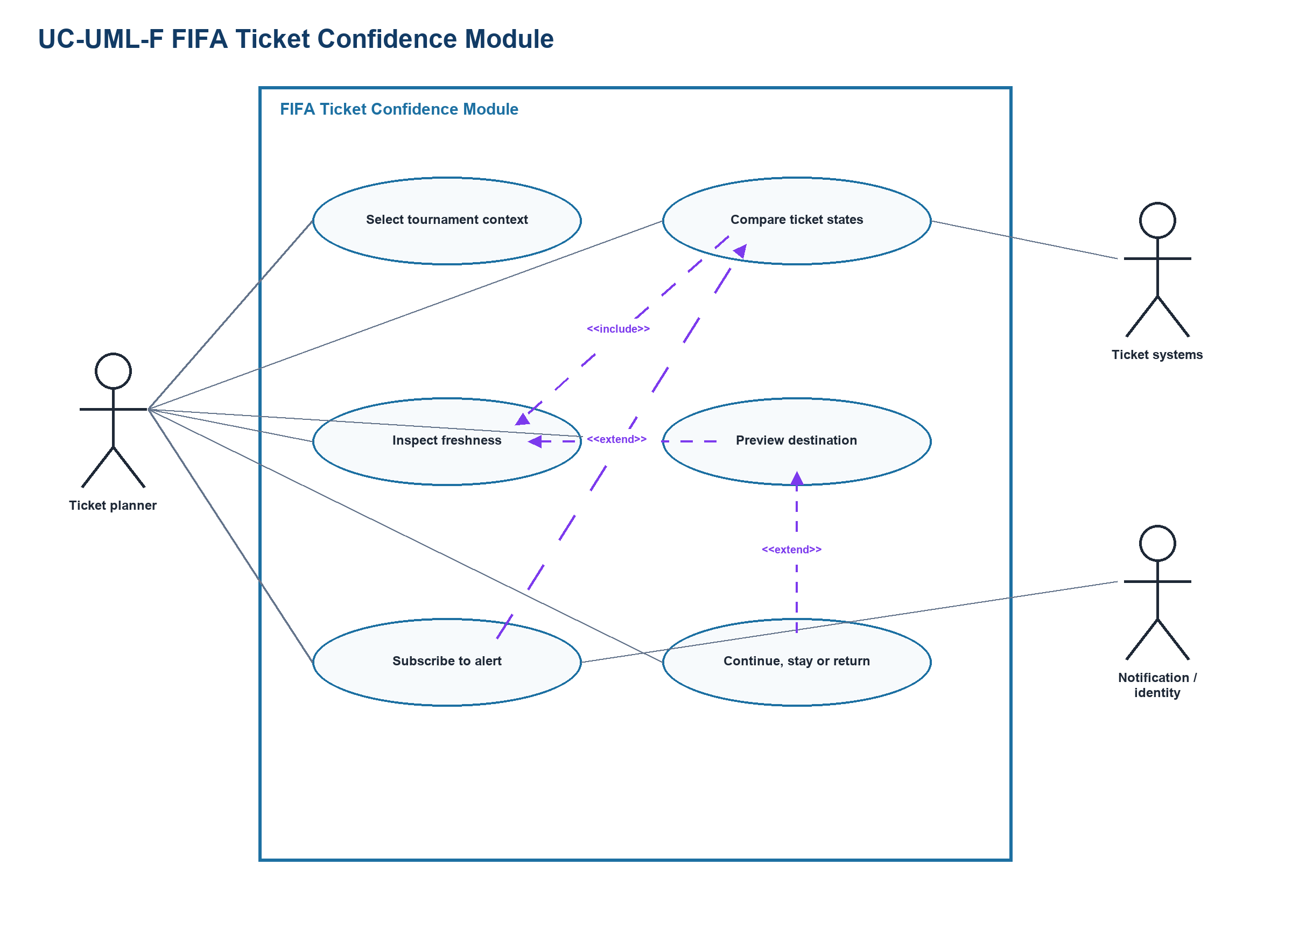
Figure UC-UML-01. FIFA UML use-case diagram
Source: Design inference; actors and systems derived from F-A1 and the traceability matrix
Related: F-UC01-F-UC06
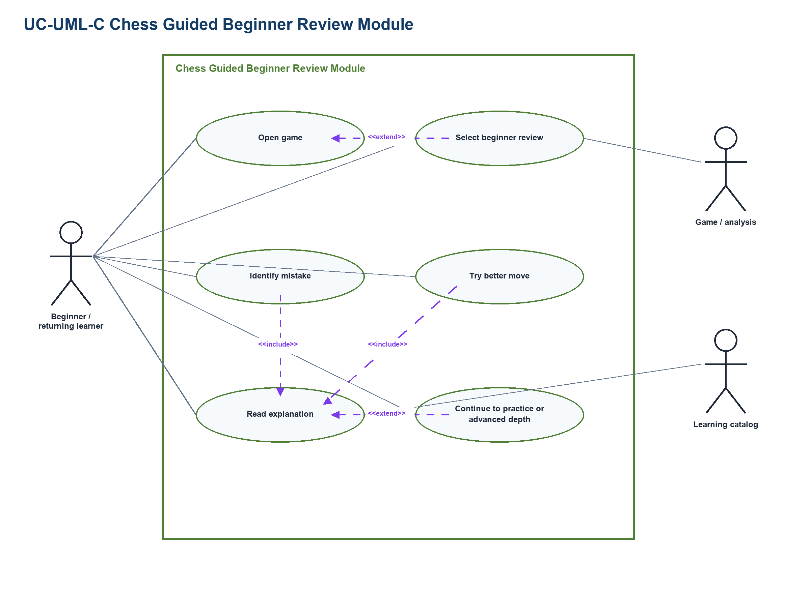
Figure UC-UML-02. Chess UML use-case diagram
Source: Design inference; actors and systems derived from C-A1 and the traceability matrix
Related: C-UC01-C-UC06

2. Detailed use cases

2.1 F-UC01 - Select tournament context
Field | Record
ID | F-UC01
Goal | Select tournament context
Scope | FIFA Ticket Confidence Module
Primary actor | Ticket planner
Supporting actor | FIFA tournament catalog
Trigger | User opens the module from a tournament or ticket entry.
Preconditions | Module is available; a catalog response or safe cached list exists.
Success guarantee | A labeled tournament/team context is selected and preserved.
Priority | High
Frequency | Each new planning context

Main flow
- Open the tournament selector.
- Review searchable tournament and team labels.
- Choose a tournament and optional team.
- Confirm the selected context.
- Load the ticket-state comparison for that context.

Alternate flows
- A1 at step 2: Catalog is unavailable; show the last timestamped list and a retry action.
- A2 at step 3: No context matches; clear filters and preserve the query.

Exception flows
- E1: Network loss retains the selection locally and labels the state offline.
- E2: Login mismatch offers account switch without exposing another account's plan.
Field | Record
Business rules | Tournament identity and freshness must be visible; no state is inferred from an absent catalog row.
Data | Tournament ID, team ID, locale, selected context, timestamp.
Usability | Recognition over recall; selected context stays visible.
Accessibility | Keyboard-operable search and selection; labels are announced.
Privacy | Selection may remain local until the user explicitly saves it.
Traceability | PA1 FIFA drawback -> F2-E03/E04/E09 -> F-SES-03/04 -> UR-P-F2 -> UR-F03 -> Mobile overview -> 1 vote -> TP-FIFA -> F-A1 -> PA3 context-resumption test.
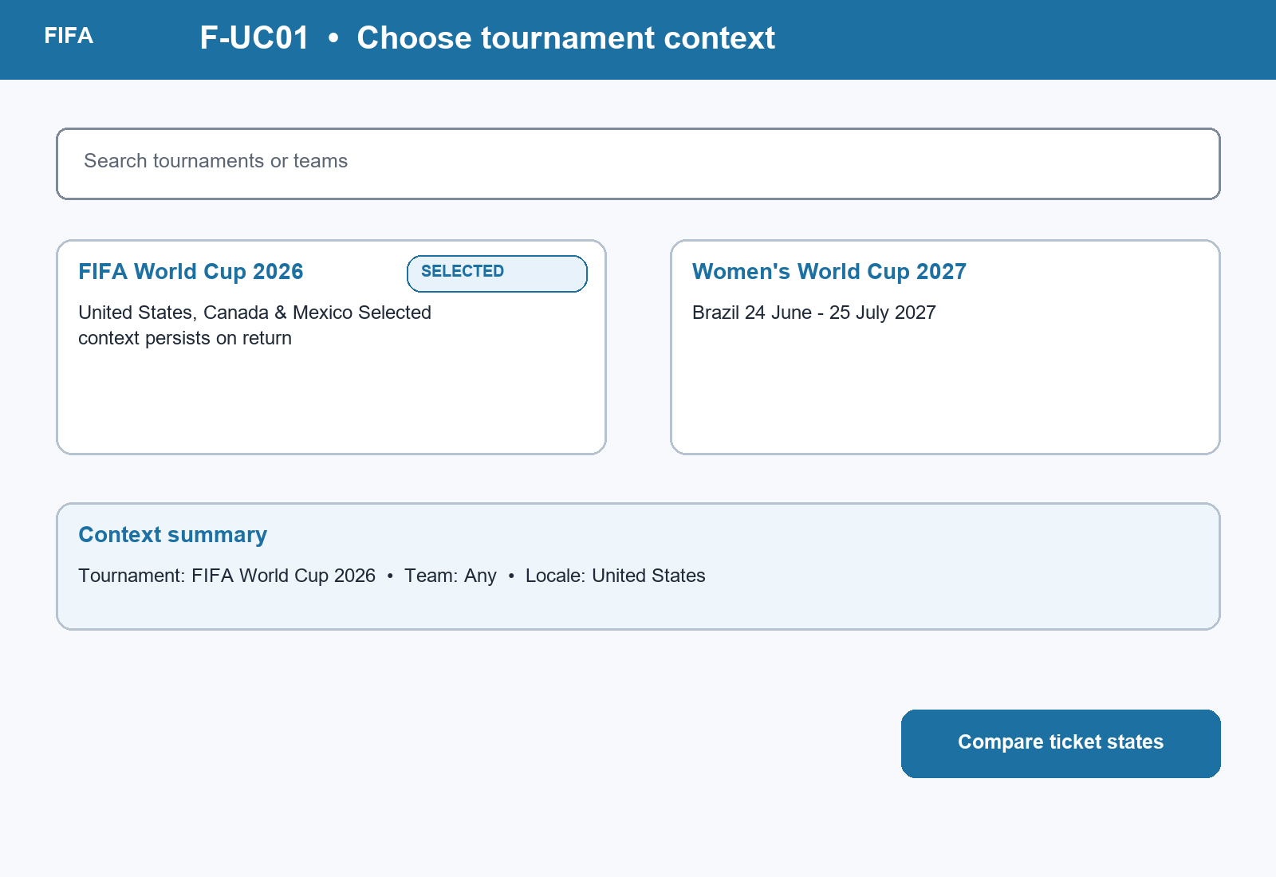
Figure UC-VIS-F-UC01. F-UC01 mini prototype for its specific task, showing concrete data, the primary action, and an explicit recovery or boundary cue.

2.2 F-UC02 - Compare ticket states
Field | Record
ID | F-UC02
Goal | Compare ticket states
Scope | FIFA Ticket Confidence Module
Primary actor | Ticket planner
Supporting actor | Governed ticket-state feed
Trigger | A tournament context is selected.
Preconditions | Context is valid; state feed may return current, stale, missing, sold out, resale, waiting room, or hospitality states.
Success guarantee | Available states are compared without treating missing data as an outcome.
Priority | Critical
Frequency | Every planning visit

Main flow
- Request states for the selected context.
- Display each channel with a text state label.
- Compare primary sale, resale, hospitality, wait, and interest options.
- Explain unavailable and sold-out distinctions.
- Choose a state to inspect or stay on the comparison.

Alternate flows
- A1 at step 2: State is stale; retain it with timestamp and warning.
- A2 at step 2: State is missing; show unknown and retry, not sold out.
- A3 at step 3: Waiting room is active; explain temporary queue behavior.

Exception flows
- E1: Feed conflict shows both governed sources and blocks a confident action.
- E2: Network loss retains the last labeled snapshot.
Field | Record
Business rules | Sold out, resale, waiting room, missing, and stale are mutually explicit labels.
Data | Context, channel, state, source, timestamp, eligibility note.
Usability | Visibility of system status and error prevention.
Accessibility | State uses text and icon, never color alone; table headers are semantic.
Privacy | No personal data required for comparison.
Traceability | PA1 FIFA ticket drawback -> F2-E09 -> F-SES-04/05/06 -> UR-P-F1 -> UR-F01 -> Ticket status clarity -> 10 votes -> TP-FIFA -> F-A1 -> recommendation -> PA3 state-accuracy test.
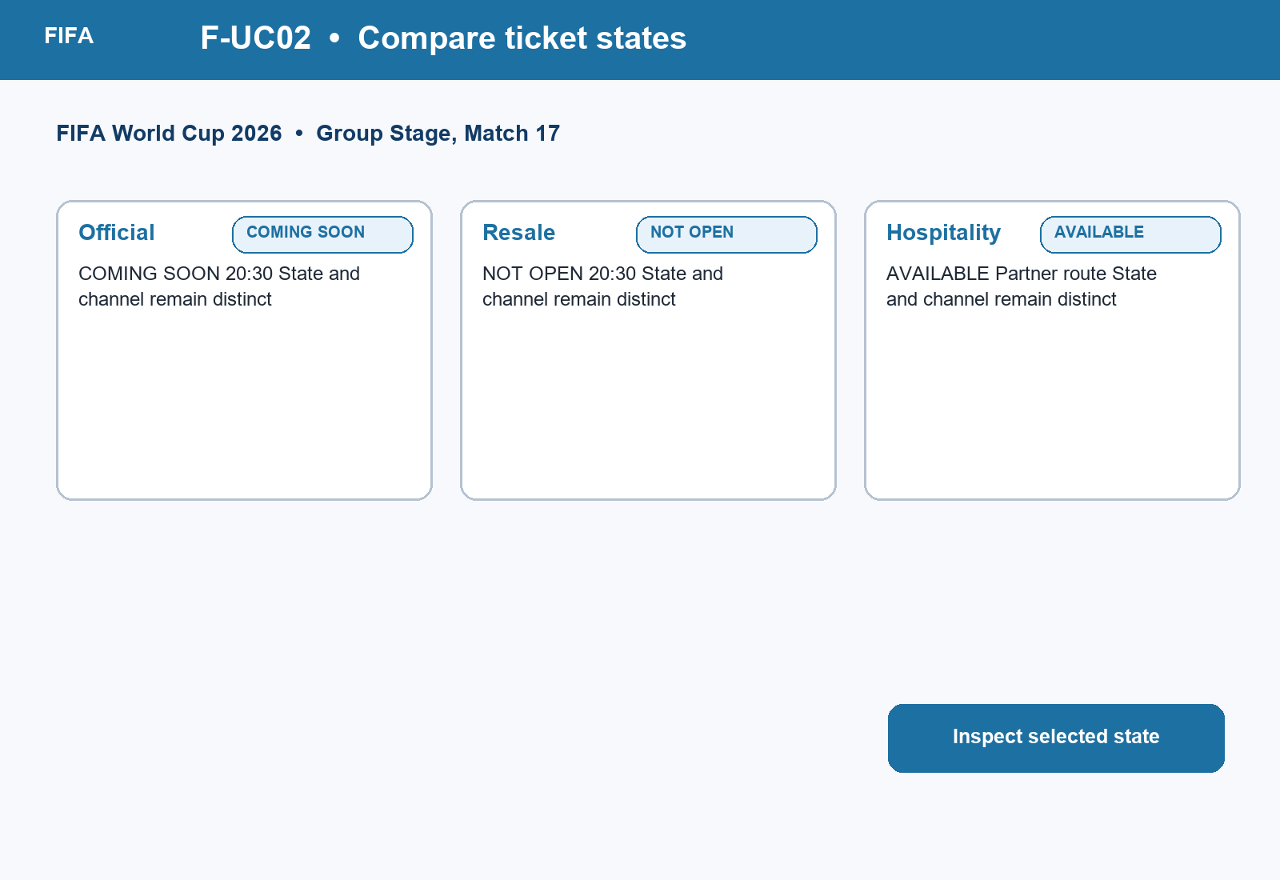
Figure UC-VIS-F-UC02. F-UC02 mini prototype for its specific task, showing concrete data, the primary action, and an explicit recovery or boundary cue.

2.3 F-UC03 - Inspect freshness
Field | Record
ID | F-UC03
Goal | Inspect freshness
Scope | FIFA Ticket Confidence Module
Primary actor | Ticket planner
Supporting actor | Governed ticket-state feed
Trigger | User opens freshness details for a ticket state.
Preconditions | A state record exists, even if stale or missing.
Success guarantee | Timestamp, source, and confidence boundary are visible.
Priority | Critical
Frequency | At important sale decisions

Main flow
- Open freshness details.
- Read last-updated time and source.
- Compare current time with the freshness policy.
- Review stale or missing explanation.
- Refresh or return to comparison.

Alternate flows
- A1 at step 3: Record is stale; block unqualified action and offer refresh.
- A2 at step 4: No update exists; show unknown and escalation guidance.

Exception flows
- E1: Refresh fails; keep prior timestamp and recovery action.
Field | Record
Business rules | A refresh attempt does not erase a valid prior timestamp.
Data | State ID, observed time, source ID, freshness threshold.
Usability | Clear feedback and calibrated confidence.
Accessibility | Time is readable in local format and available to assistive technology.
Privacy | No additional personal data.
Traceability | PA1 evidence rules -> F2-E09 -> F-SES-04/06 -> UR-P-F1 -> UR-F01 -> Freshness and alerts -> 3 votes -> TP-FIFA -> F-A1 -> PA3 freshness test.
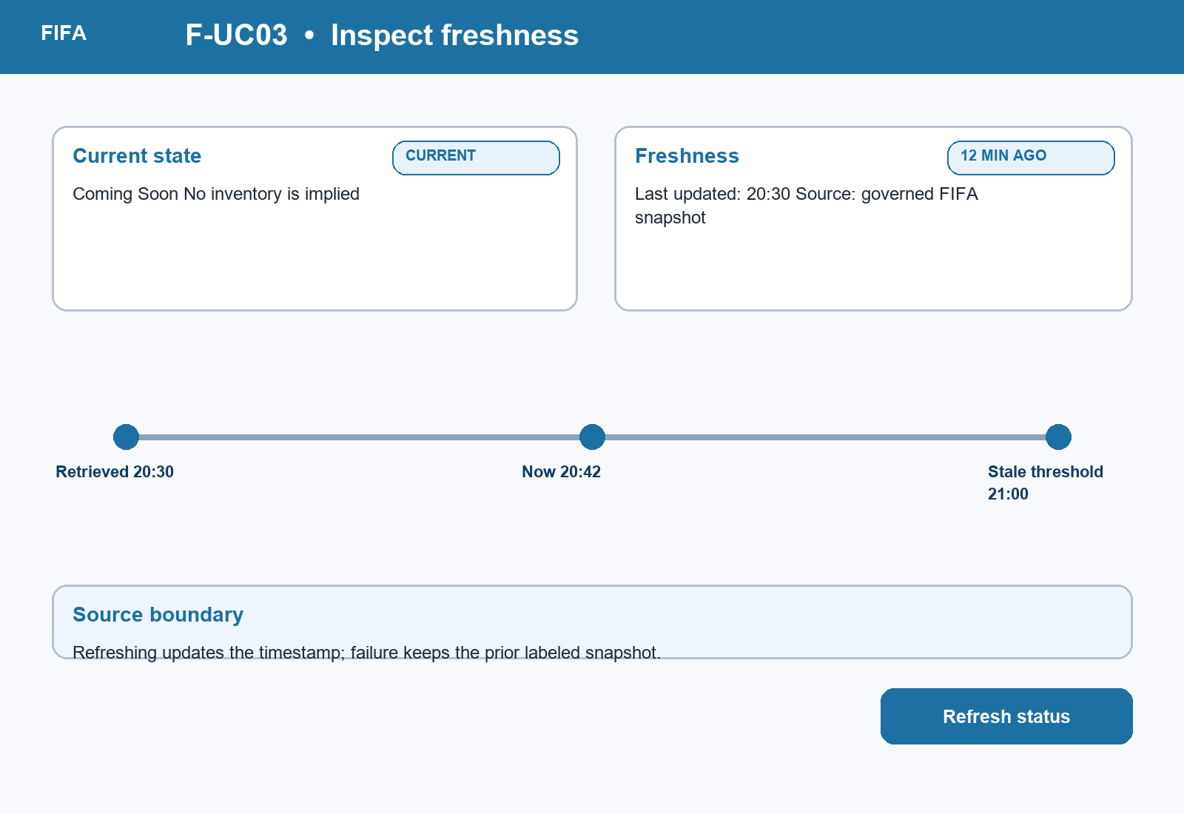
Figure UC-VIS-F-UC03. F-UC03 mini prototype for its specific task, showing concrete data, the primary action, and an explicit recovery or boundary cue.

2.4 F-UC04 - Preview destination
Field | Record
ID | F-UC04
Goal | Preview destination
Scope | FIFA Ticket Confidence Module
Primary actor | Ticket planner
Supporting actor | Official ticketing partner
Trigger | User selects an outbound ticket action.
Preconditions | Destination metadata exists or the action remains blocked safely.
Success guarantee | Domain, purpose, context transfer, and return behavior are previewed before departure.
Priority | Critical
Frequency | Before each outbound action

Main flow
- Open destination preview.
- Read official partner name, domain, and purpose.
- Review what context will transfer.
- Choose Continue, Stay, or Return.
- If Continue is chosen, open the destination with a return route.

Alternate flows
- A1 at step 2: Metadata is partial; offer Stay and report the limitation.
- A2 at step 4: User stays; preserve comparison context.

Exception flows
- E1: Partner failure returns the user to the preserved state with an explanation.
Field | Record
Business rules | The module never claims a partner transaction is complete.
Data | Partner ID, domain, purpose, context token, return URI.
Usability | User control, trust calibration, and error prevention.
Accessibility | Destination and choices have explicit labels and logical focus order.
Privacy | Transfer only required context after consent; do not expose plan data in a URL.
Traceability | PA1 handoff drawback -> F2-E09 -> F-SES-02/05 -> UR-P-F1 -> UR-F02 -> Handoff trust -> 8 votes -> TP-FIFA -> F-A1 -> recommendation -> PA3 destination-recognition test.
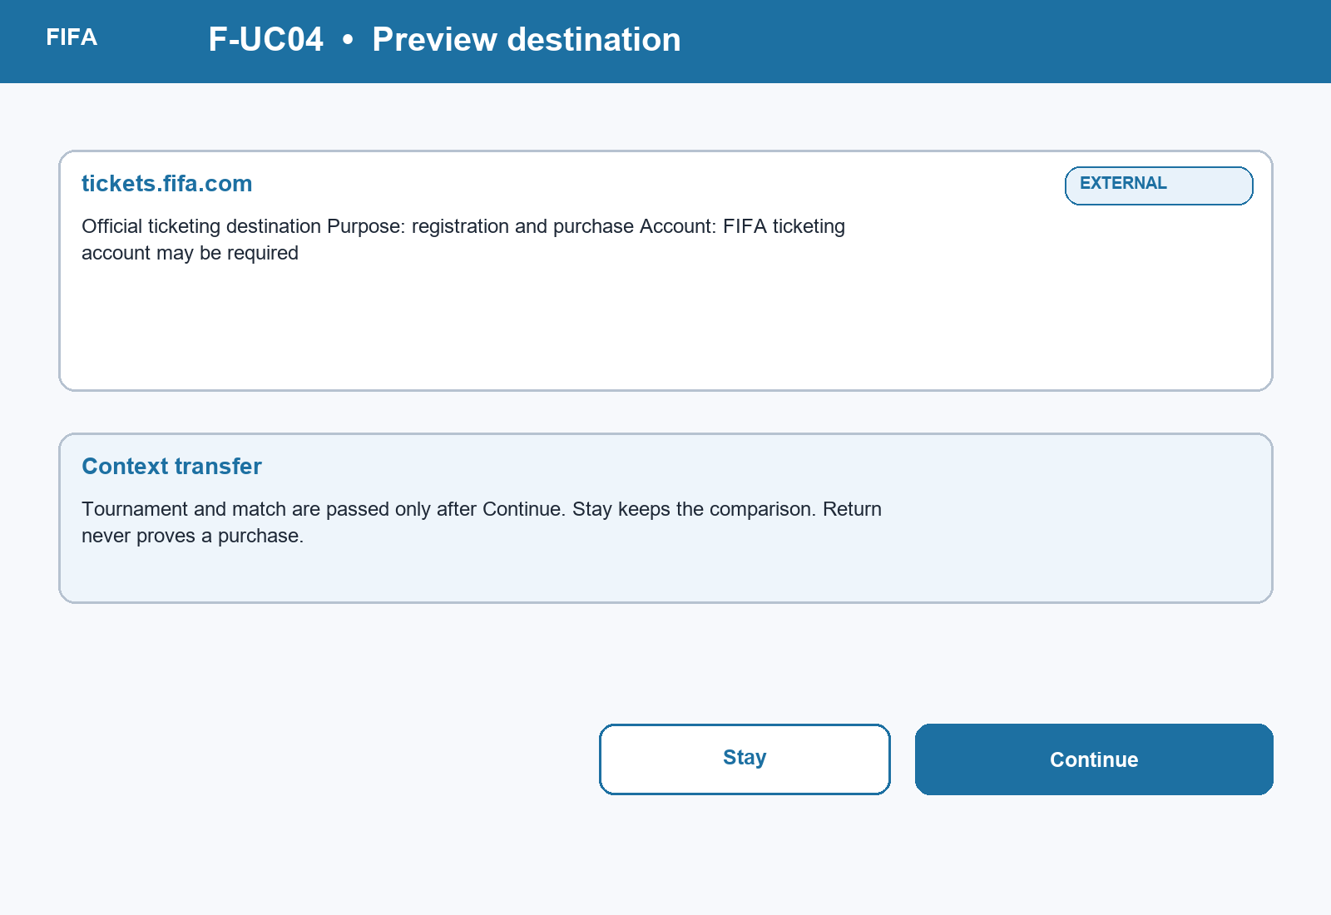
Figure UC-VIS-F-UC04. F-UC04 mini prototype for its specific task, showing concrete data, the primary action, and an explicit recovery or boundary cue.

2.5 F-UC05 - Subscribe to alert
Field | Record
ID | F-UC05
Goal | Subscribe to alert
Scope | FIFA Ticket Confidence Module
Primary actor | Ticket planner
Supporting actor | Notification service
Trigger | User chooses to follow a state change.
Preconditions | A context is selected; permission is not assumed.
Success guarantee | Alert preference is saved or a clear non-notification alternative is provided.
Priority | High
Frequency | During wait/interest states

Main flow
- Choose Subscribe to alert.
- Select relevant state changes and channel.
- Review frequency, privacy, and permission explanation.
- Grant permission and confirm.
- Edit, snooze, or stop the alert later.

Alternate flows
- A1 at step 4: Notification is denied; keep a local saved plan and show manual refresh.
- A2 at step 2: No channel is available; offer in-module status check.

Exception flows
- E1: Service failure preserves unsent preferences for retry.
Field | Record
Business rules | No alert is enabled without affirmative consent; every alert has an unsubscribe control.
Data | Context, selected changes, channel, consent timestamp, retention state.
Usability | Control, prevention of notification fatigue, and clear status.
Accessibility | Permission explanation is plain text; controls are keyboard operable.
Privacy | Minimize contact data and disclose retention.
Traceability | PA1 ticket uncertainty -> F2-E09 -> F-SES-06 -> UR-P-F1 -> UR-F01 -> Freshness and alerts -> 3 votes -> TP-FIFA -> F-A3 -> retained PA3 prototype -> notification-denial test.
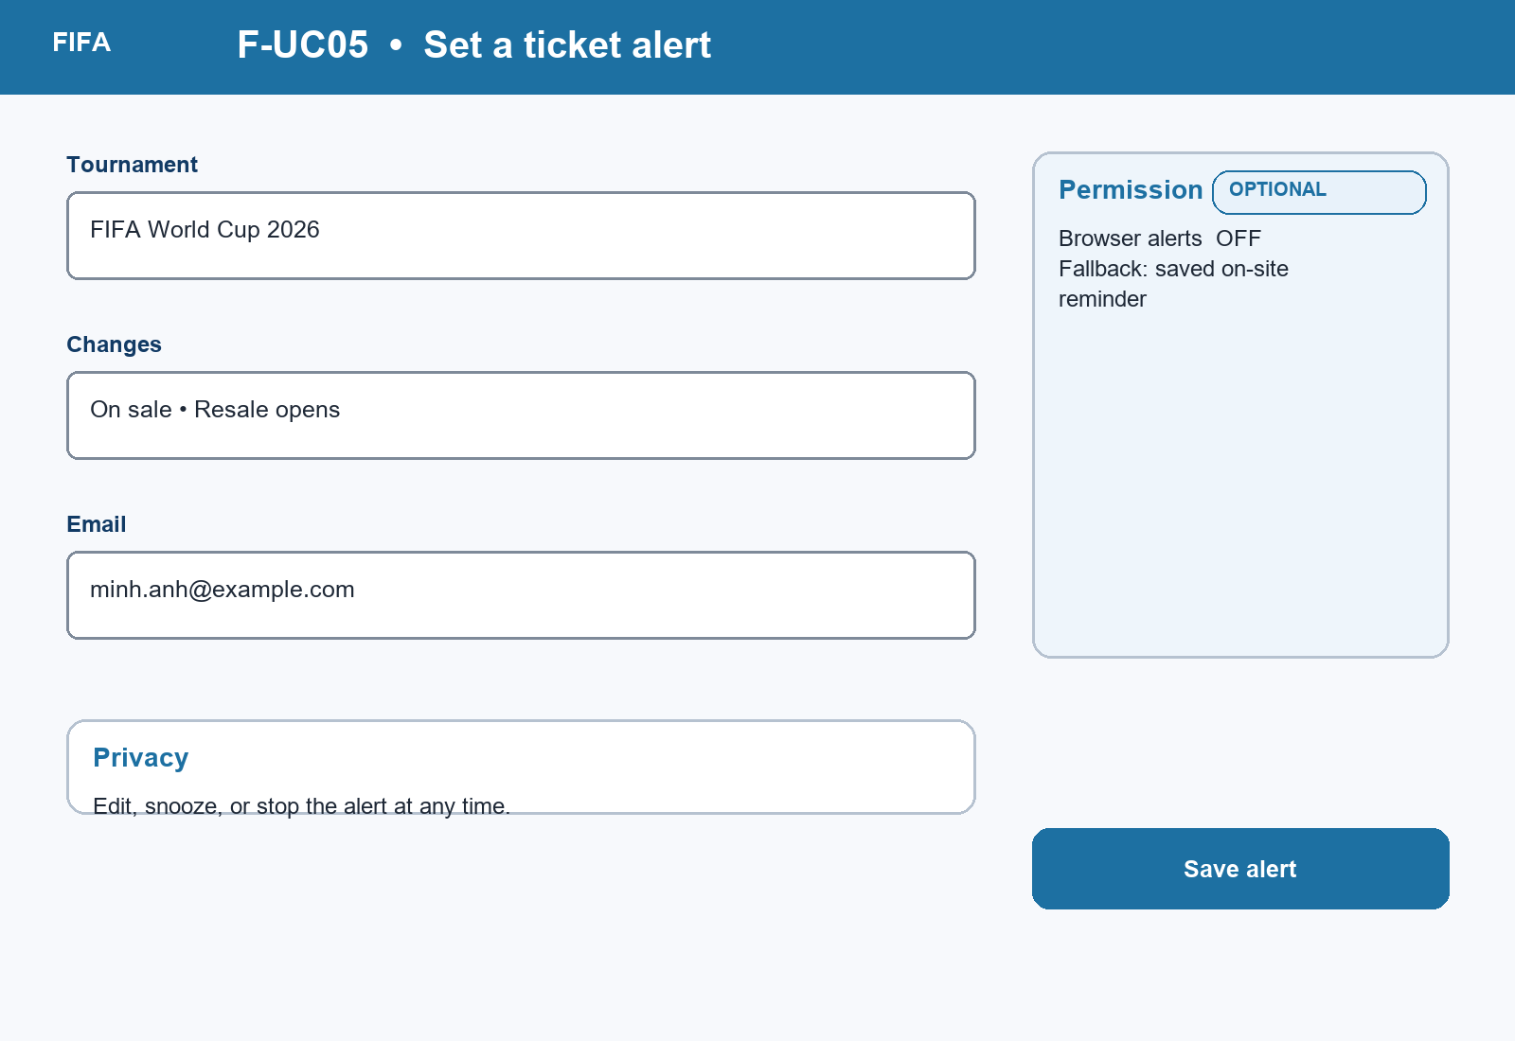
Figure UC-VIS-F-UC05. F-UC05 mini prototype for its specific task, showing concrete data, the primary action, and an explicit recovery or boundary cue.

2.6 F-UC06 - Continue, stay or return
Field | Record
ID | F-UC06
Goal | Continue, stay or return
Scope | FIFA Ticket Confidence Module
Primary actor | Ticket planner
Supporting actor | Official ticketing partner; identity service
Trigger | User acts from destination preview or reopens a return route.
Preconditions | Comparison context exists; any return token is validated.
Success guarantee | User remains oriented and partner-side completion is never inferred.
Priority | Critical
Frequency | Each handoff and return

Main flow
- Choose Continue, Stay, or Return.
- If Continue, transfer only consented context.
- If Stay, preserve the comparison state.
- If Return, validate token or identity.
- Restore context, freshness, and available actions.

Alternate flows
- A1 at step 4: Token expired; offer safe account lookup or plan recreation.
- A2 at step 5: Login mismatch; switch account without exposing stored data.

Exception flows
- E1: Partner or network failure restores the last safe state.
Field | Record
Business rules | A return is not proof of purchase; tokens are time-limited and single-purpose.
Data | Context, return token, account reference, last state and timestamp.
Usability | Recovery, memorability, and persistent orientation.
Accessibility | Restoration is announced without unexpected focus movement.
Privacy | Validate identity before revealing saved plans.
Traceability | PA1 handoff drawback -> F2-E09 -> F-SES-02/03/05/06 -> UR-P-F1/F2 -> UR-F02/F03 -> Recovery and return -> 1 vote -> TP-FIFA -> F-A1 -> PA3 return test.
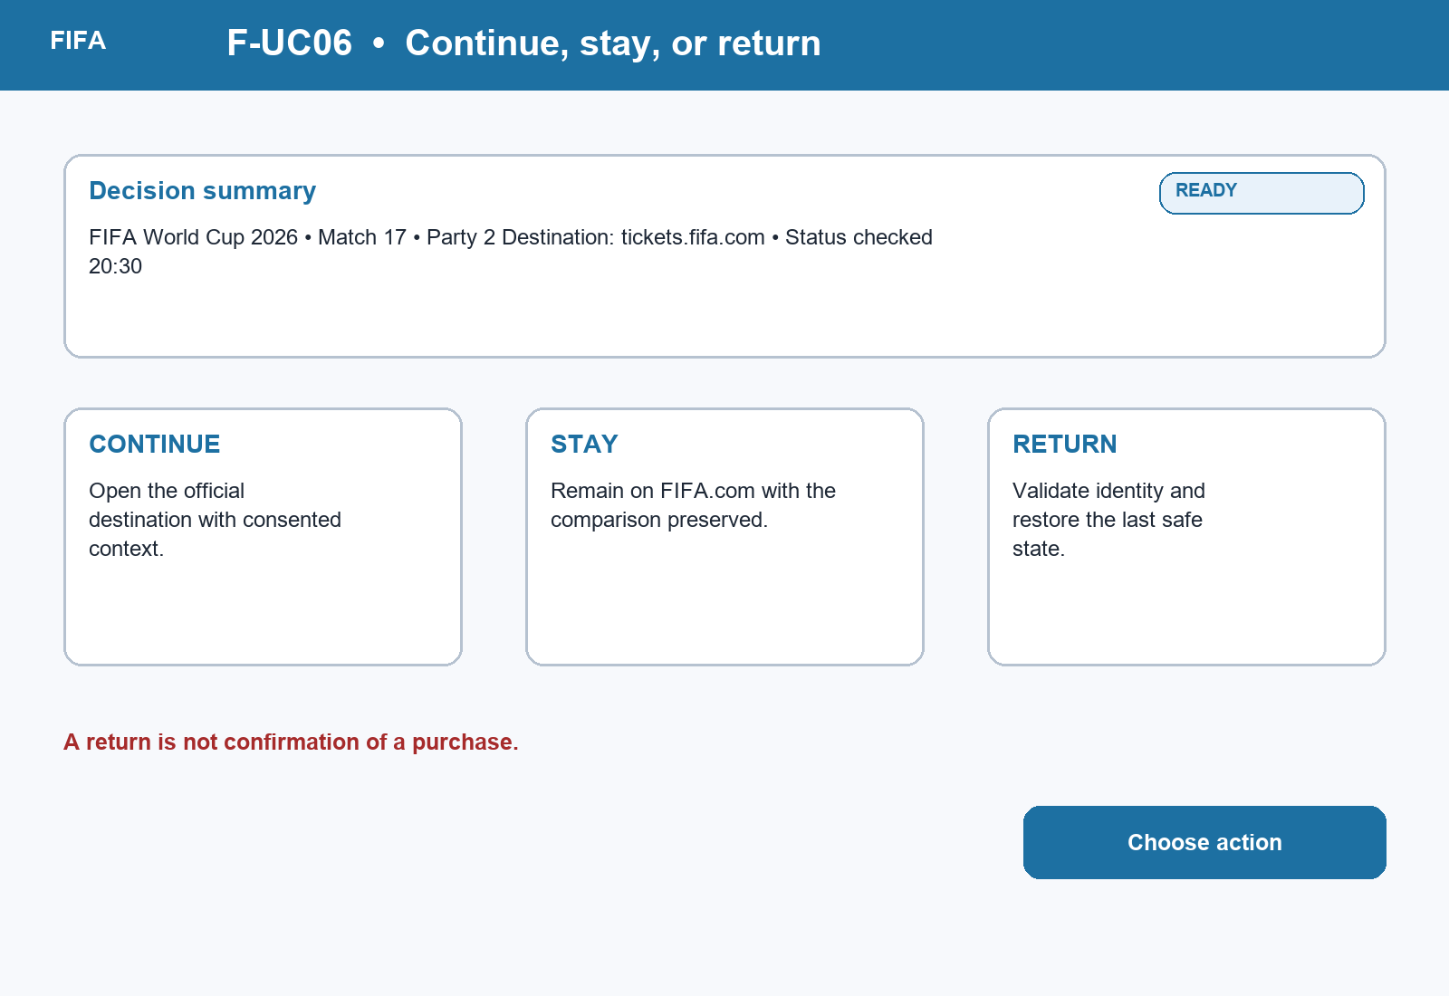
Figure UC-VIS-F-UC06. F-UC06 mini prototype for its specific task, showing concrete data, the primary action, and an explicit recovery or boundary cue.

2.7 C-UC01 - Open game
Field | Record
ID | C-UC01
Goal | Open game
Scope | Chess Guided Beginner Review Module
Primary actor | Beginner / returning learner
Supporting actor | Game store
Trigger | User chooses a recent game, PGN import, or board setup.
Preconditions | A source route is available; input may be absent or invalid.
Success guarantee | A valid review artifact is opened or input is preserved with a clear correction path.
Priority | High
Frequency | Each review

Main flow
- Choose Recent game, Import PGN, or Set up position.
- Select or enter the game artifact.
- Confirm side to move and board orientation.
- Validate notation and access rights.
- Open the review entry.

Alternate flows
- A1 at step 1: No game exists; emphasize import/setup routes.
- A2 at step 4: PGN is invalid; identify the first error and preserve input.

Exception flows
- E1: Mobile interruption preserves the draft locally.
Field | Record
Business rules | Private games follow account permissions; invalid PGN is never silently changed.
Data | Game ID, PGN, ownership, side to move, orientation.
Usability | Clear setup choices and recoverable validation.
Accessibility | Text notation alternative and fully labeled board controls.
Privacy | Respect game visibility and minimize copied metadata.
Traceability | PA1 analysis drawback -> C2-E10 -> C-SES-01/02/05 -> UR-P-C1 -> UR-C01 -> Review setup -> 3 votes -> TP-CHESS -> C-A1 -> recommendation -> PA3 setup test.
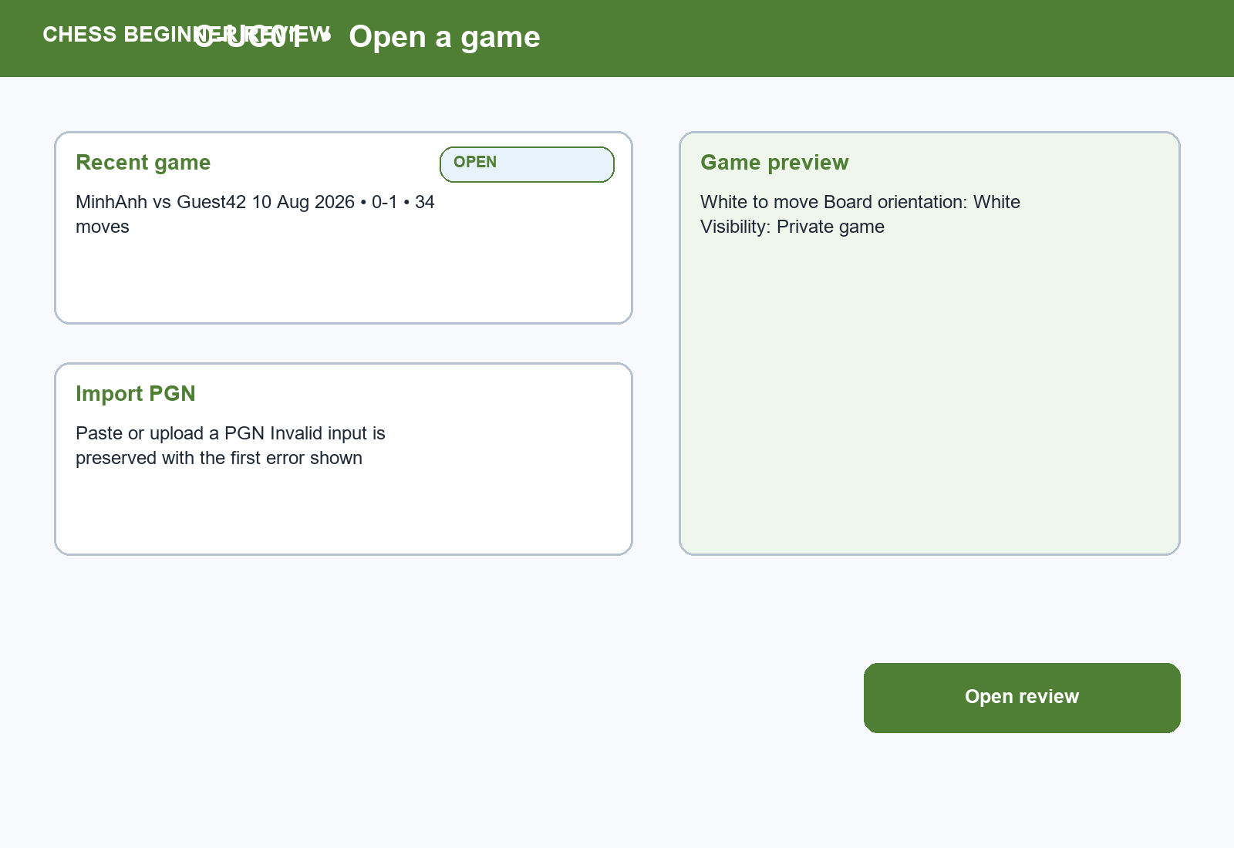
Figure UC-VIS-C-UC01. C-UC01 mini prototype for its specific task, showing concrete data, the primary action, and an explicit recovery or boundary cue.

2.8 C-UC02 - Select beginner review
Field | Record
ID | C-UC02
Goal | Select beginner review
Scope | Chess Guided Beginner Review Module
Primary actor | Beginner / returning learner
Supporting actor | Analysis service
Trigger | A valid game artifact is opened.
Preconditions | Review entry is visible; premium/access restrictions may apply.
Success guarantee | The beginner preset is selected without removing advanced analysis access.
Priority | Critical
Frequency | Each beginner review

Main flow
- Open review choices.
- Read Beginner Review purpose and scope.
- Select Beginner Review.
- Confirm the game and perspective.
- Start the guided review.

Alternate flows
- A1 at step 2: Terminology help is requested; show inline explanation.
- A2 at step 3: Premium restriction applies; explain available scope and alternatives.

Exception flows
- E1: Analysis service unavailable; offer retry and practice from the unreviewed game.
Field | Record
Business rules | Restrictions are stated before commitment; expert controls remain available by choice.
Data | Game artifact, preset, perspective, entitlement.
Usability | Recognition over recall and progressive disclosure.
Accessibility | Keyboard-only selection and focus-visible controls.
Privacy | No extra personal data beyond game access.
Traceability | PA1 analysis drawback -> C2-E10 -> C-SES-01/02/05 -> UR-P-C1 -> UR-C01 -> Entry choice overload -> 4 votes -> TP-CHESS -> C-A1 -> recommendation -> PA3 entry-choice test.
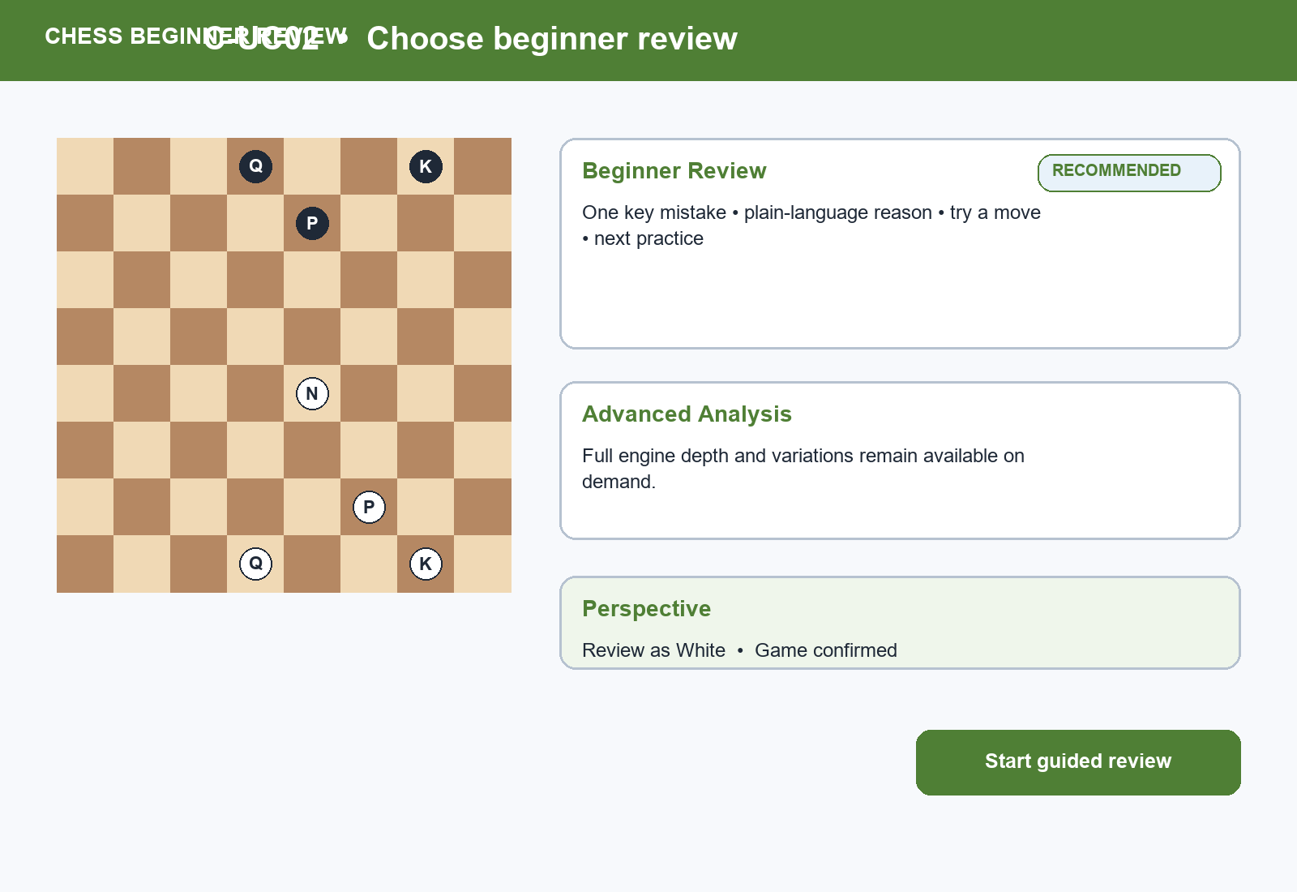
Figure UC-VIS-C-UC02. C-UC02 mini prototype for its specific task, showing concrete data, the primary action, and an explicit recovery or boundary cue.

2.9 C-UC03 - Identify mistake
Field | Record
ID | C-UC03
Goal | Identify mistake
Scope | Chess Guided Beginner Review Module
Primary actor | Beginner / returning learner
Supporting actor | Analysis service
Trigger | Guided review completes its first pass.
Preconditions | A review is available; there may be no major mistake or several comparable mistakes.
Success guarantee | One learning priority is shown with honest uncertainty.
Priority | Critical
Frequency | Each review

Main flow
- Receive the guided review.
- Show the most important mistake or state that no major mistake exists.
- Display the position and move context.
- Explain why this moment matters in plain language.
- Offer Try a better move.

Alternate flows
- A1 at step 2: No major mistake; show a useful improvement instead.
- A2 at step 2: Multiple mistakes are comparable; explain the selection and allow comparison.

Exception flows
- E1: Engine result is partial; label uncertainty and avoid a definitive claim.
Field | Record
Business rules | One priority does not imply all other moves are irrelevant.
Data | Position, move, evaluation change, confidence, explanation key.
Usability | Effectiveness, clear hierarchy, and calibrated status.
Accessibility | Text description accompanies board highlight; no color-only meaning.
Privacy | Game visibility rules continue to apply.
Traceability | PA1 learning/analysis gap -> C2-E10 -> C-SES-02/04/06 -> UR-P-C1/C2 -> UR-C02 -> Learning priority -> 3 votes -> TP-CHESS -> C-A1 -> recommendation -> PA3 mistake-comprehension test.
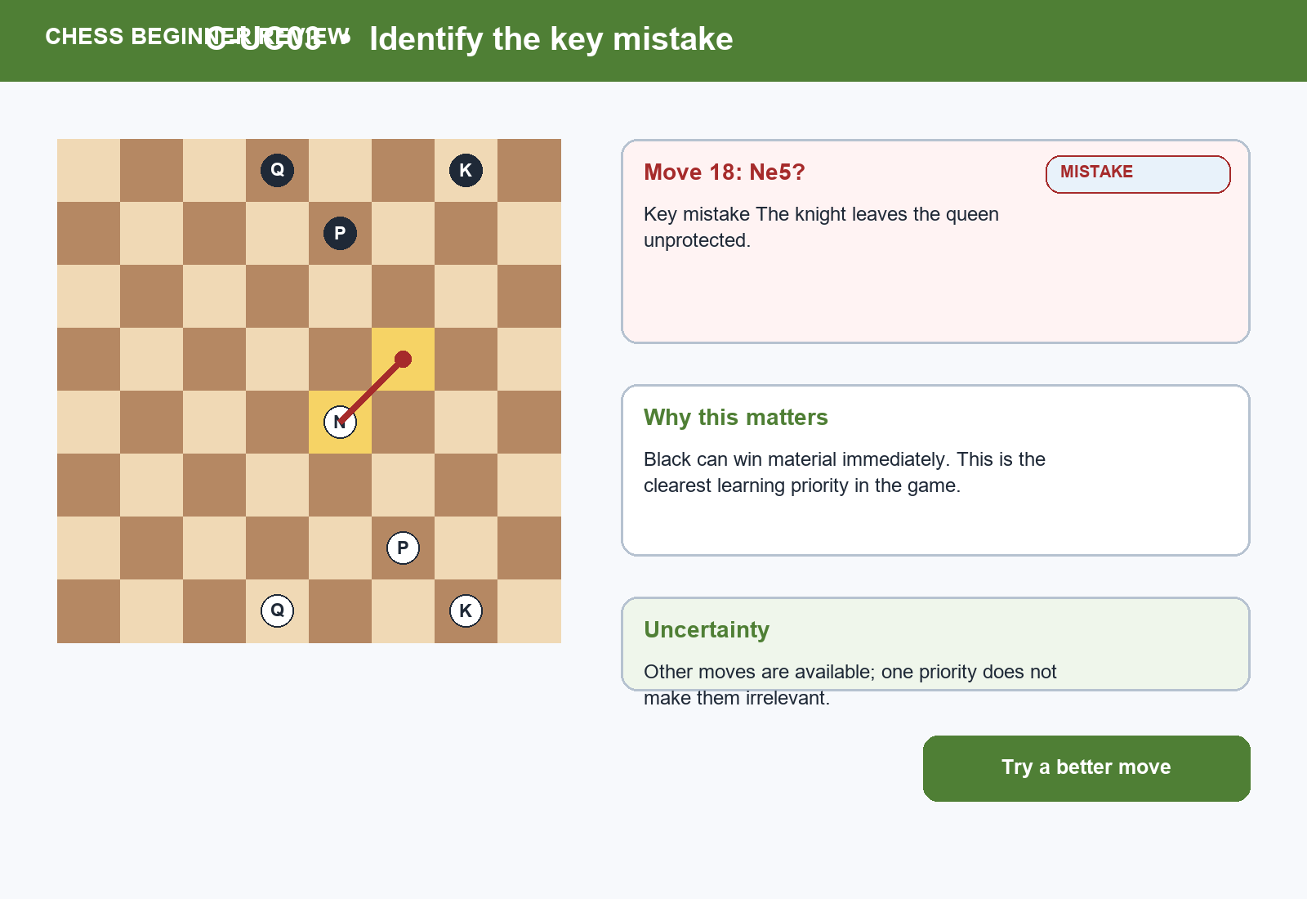
Figure UC-VIS-C-UC03. C-UC03 mini prototype for its specific task, showing concrete data, the primary action, and an explicit recovery or boundary cue.

2.10 C-UC04 - Try better move
Field | Record
ID | C-UC04
Goal | Try better move
Scope | Chess Guided Beginner Review Module
Primary actor | Beginner / returning learner
Supporting actor | Analysis service
Trigger | User chooses Try a better move.
Preconditions | A review position and legal move set exist.
Success guarantee | The attempted move receives feedback without losing the original position.
Priority | High
Frequency | At each selected mistake

Main flow
- Open the review position in trial mode.
- Enter a legal candidate move.
- Compare it with the learning priority.
- Receive concise feedback.
- Retry, reveal the recommended move, or return.

Alternate flows
- A1 at step 2: Move is illegal; explain the rule and keep focus on the board.
- A2 at step 3: Move is also strong; acknowledge it and compare ideas.

Exception flows
- E1: Engine unavailable; record the trial locally and defer comparison.
Field | Record
Business rules | User action in trial mode never changes the stored game.
Data | Position, candidate move, legal moves, comparison result.
Usability | Immediate feedback, user control, and safe experimentation.
Accessibility | Keyboard coordinate entry and announced feedback.
Privacy | Trial data stays with the selected review unless saved.
Traceability | PA1 analysis opportunity -> C2-E10 -> C-SES-02/06 -> UR-P-C1/C2 -> UR-C02 -> Learning priority -> 3 votes -> TP-CHESS -> C-A1 -> PA3 move-trial test.
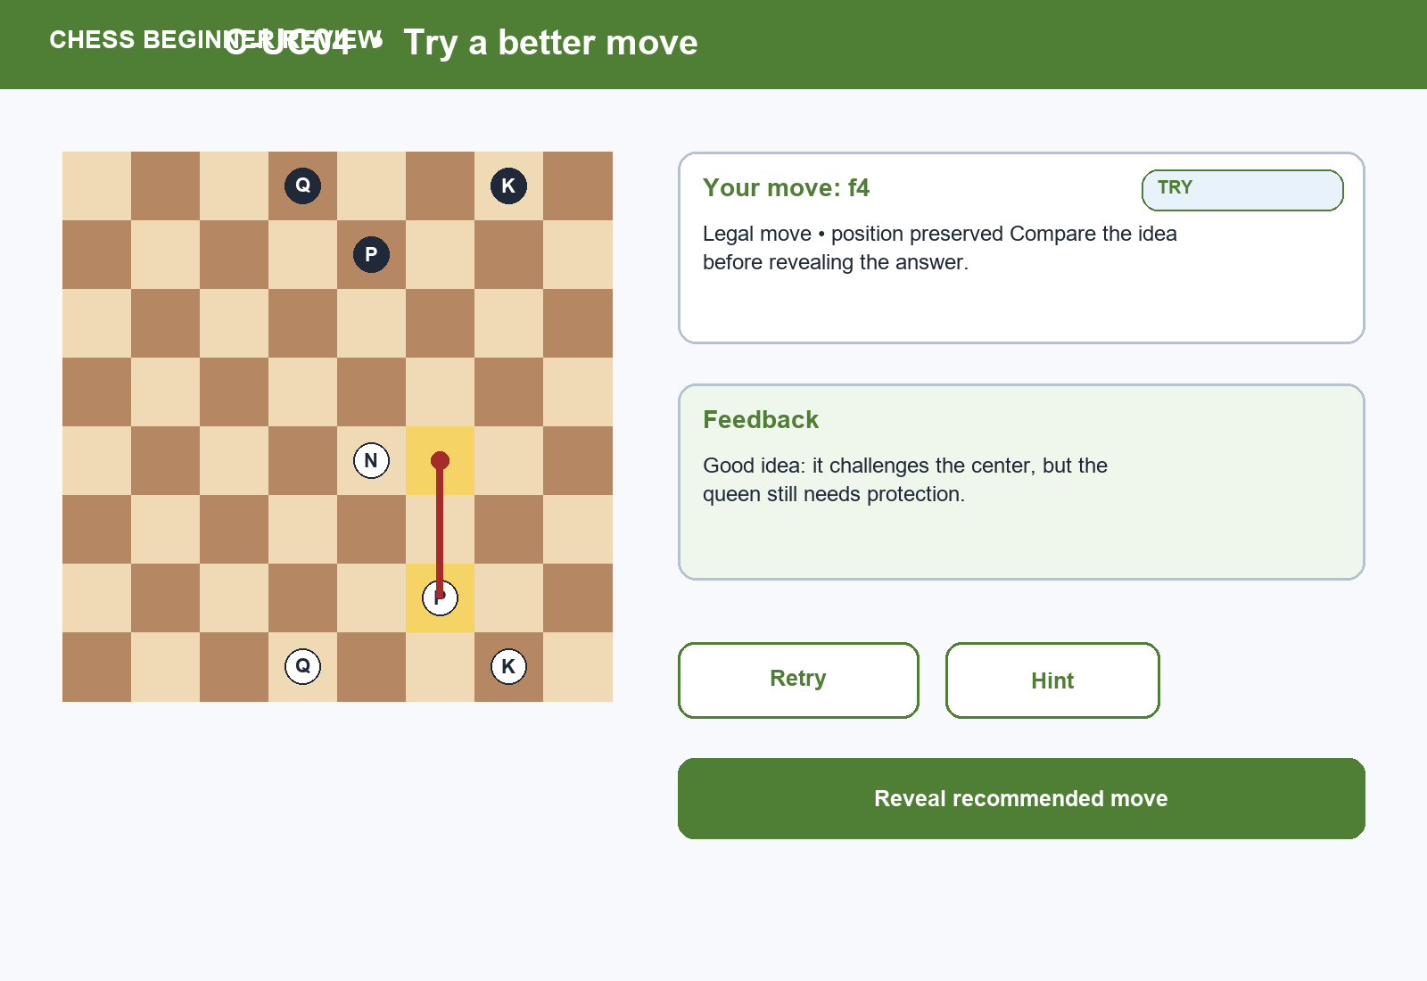
Figure UC-VIS-C-UC04. C-UC04 mini prototype for its specific task, showing concrete data, the primary action, and an explicit recovery or boundary cue.

2.11 C-UC05 - Read explanation
Field | Record
ID | C-UC05
Goal | Read explanation
Scope | Chess Guided Beginner Review Module
Primary actor | Beginner / returning learner
Supporting actor | Explanation service
Trigger | A mistake or better move is selected.
Preconditions | An explanation exists or a safe fallback can describe the position.
Success guarantee | Plain language leads and terminology help is available on demand.
Priority | Critical
Frequency | Each selected mistake

Main flow
- Open the explanation card.
- Read the one-sentence learning point.
- Review board evidence and move comparison.
- Open terminology help if needed.
- Choose Try again, Continue practice, or Advanced detail.

Alternate flows
- A1 at step 2: Explanation is unavailable; show factual board changes and avoid invented rationale.
- A2 at step 4: Terminology help opens inline and returns focus to the term.

Exception flows
- E1: Service failure keeps the move trial and offers retry.
Field | Record
Business rules | Explanations distinguish fact, recommendation, and uncertainty.
Data | Learning point, board evidence, glossary terms, explanation version.
Usability | Plain language, satisfaction, and recognition over recall.
Accessibility | Readable text, glossary semantics, and no forced motion.
Privacy | No unrelated conversation or profile data.
Traceability | PA1 terminology drawback -> C2-E10 -> C-SES-01/02/04/06 -> UR-P-C1/C2 -> UR-C02 -> Vocabulary load -> 5 votes -> TP-CHESS -> C-A1 -> recommendation -> PA3 explanation test.
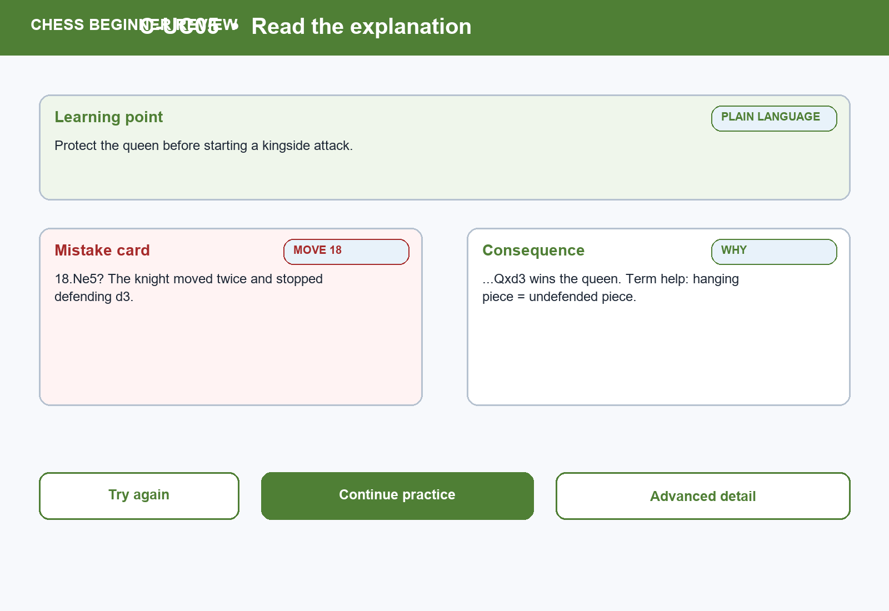
Figure UC-VIS-C-UC05. C-UC05 mini prototype for its specific task, showing concrete data, the primary action, and an explicit recovery or boundary cue.

2.12 C-UC06 - Continue to practice or advanced depth
Field | Record
ID | C-UC06
Goal | Continue to practice or advanced depth
Scope | Chess Guided Beginner Review Module
Primary actor | Beginner / returning learner
Supporting actor | Learning catalog; analysis service
Trigger | User completes the explanation.
Preconditions | A learning point exists; practice or depth may be unavailable.
Success guarantee | One relevant practice action is offered before optional advanced depth.
Priority | Critical
Frequency | Each completed explanation

Main flow
- Review the recommended lesson or puzzle.
- Read why it matches the mistake.
- Choose Continue to practice or Reveal advanced detail.
- Open the chosen destination with review context.
- Return to the review when desired.

Alternate flows
- A1 at step 1: No exact practice exists; offer a broader topic and explain the gap.
- A2 at step 3: Advanced detail is restricted; explain scope without blocking practice.

Exception flows
- E1: Mobile interruption preserves the review and selected next step.
Field | Record
Business rules | Practice relevance is explainable; advanced depth is opt-in, not removed.
Data | Learning point, catalog item, relevance reason, disclosure state.
Usability | Continuation, memorability, and progressive disclosure.
Accessibility | Destination choice and return route are keyboard/screen-reader operable.
Privacy | Share only the minimum review context with the learning catalog.
Traceability | PA1 learning strength + analysis drawback -> C2-E05/E07/E10 -> C-SES-03/04/06 -> UR-P-C2 -> UR-C03 -> Practice continuation -> 5 votes -> TP-CHESS -> C-A1 -> recommendation -> PA3 continuation test.
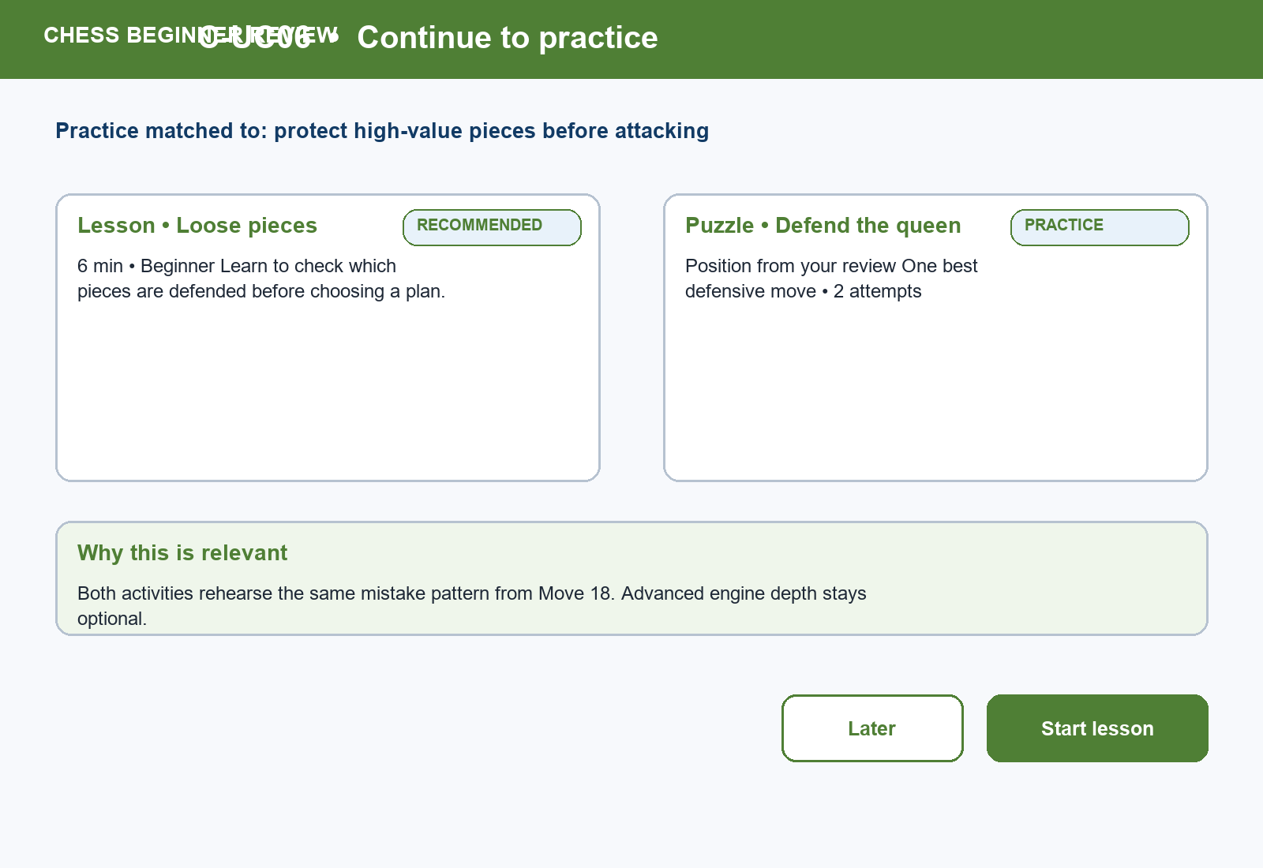
Figure UC-VIS-C-UC06. C-UC06 mini prototype for its specific task, showing concrete data, the primary action, and an explicit recovery or boundary cue.

3. Edge-case coverage
Product | Required edge case | Covered by
FIFA | Stale state; missing state; sold out; resale; waiting room | F-UC02-F-UC03
FIFA | Partner failure; login mismatch; notification denied; network loss | F-UC01, F-UC04-F-UC06
Chess | No game; invalid PGN; engine unavailable | C-UC01-C-UC04
Chess | No major mistake; multiple mistakes; premium restriction | C-UC02-C-UC03
Chess | Mobile interruption; keyboard-only; terminology help | C-UC01-C-UC02, C-UC05-C-UC06

4. Design rationale and validation target
HCI rationale: Course basis: LN01 - Introduction - v2.pdf, pp. 20, 22, 24; LN02 - Fundamental Concepts - Usability Dimensions_2.pdf, pp. 62-67, 74-76, 83-84, 101-115; LN03 - UI Design Process.pdf, pp. 16-19, 23-24, 28-30, 34-36; LN04 - Task Analysis.pdf, pp. 3, 6-15, 39-49.
PA3 validation target: Test the six core steps per product and the stated alternate/exception flows without assuming implementation success.

5. State and Recovery Reference
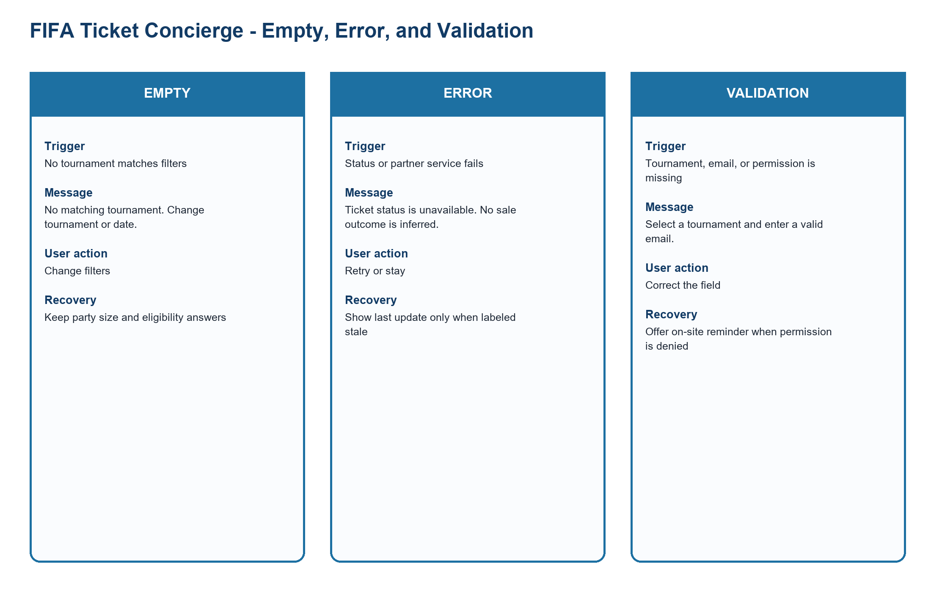
Figure UC-STATE-FIFA. FIFA empty, error, and validation reference
Source: PA2 design QA artifact
Related: F-UC01-F-UC06
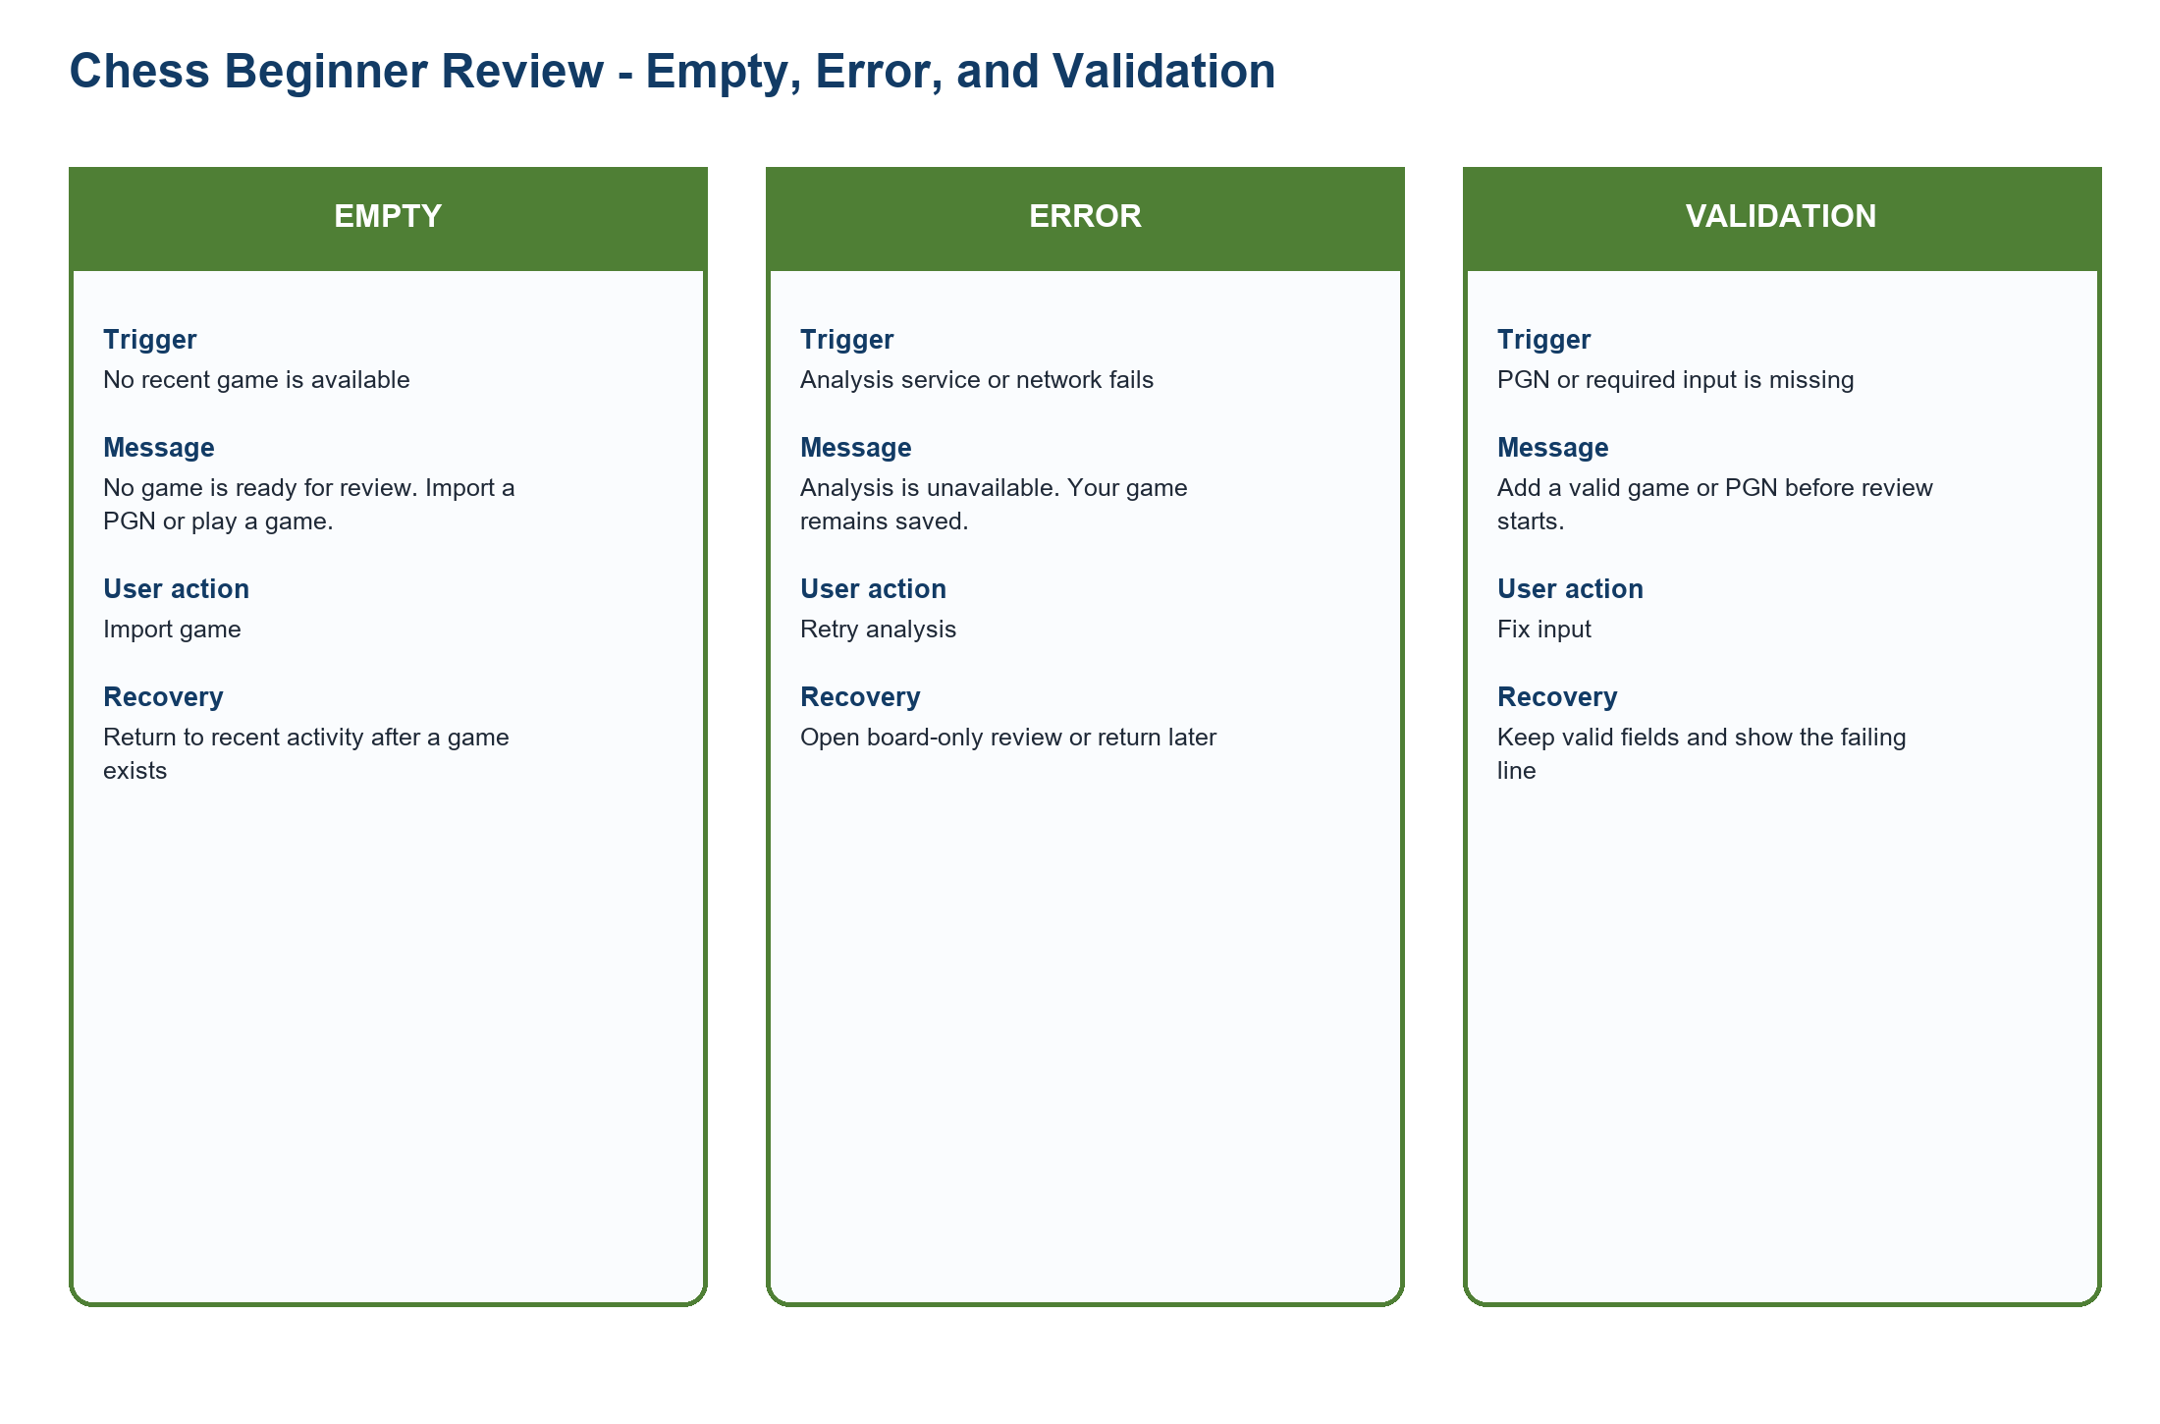
Figure UC-STATE-CHESS. Chess empty, error, and validation reference
Source: PA2 design QA artifact
Related: C-UC01-C-UC06

5.1 Complete Empty, Error, and Validation Matrix
State | Contract
FIFA - EMPTY - No tournament | Trigger: No tournament  Message: No tournament matches the selected context.  Action: Change tournament or date.  Recovery: Keep party size and other valid answers.
FIFA - EMPTY - No available ticket route | Trigger: No available ticket route  Message: No official route is available for this event.  Action: Compare wait, interest, resale, or hospitality when allowed.  Recovery: Return to the saved event without restarting.
FIFA - ERROR - Ticket status unavailable | Trigger: Ticket status unavailable  Message: Ticket status is unavailable; no sale outcome is inferred.  Action: Retry or stay.  Recovery: Show a labeled last update only when available.
FIFA - ERROR - Partner unavailable | Trigger: Partner unavailable  Message: The official destination cannot respond.  Action: Stay on FIFA.com.  Recovery: Preserve context and retry later.
FIFA - ERROR - Network error | Trigger: Network error  Message: The request failed before a result was confirmed.  Action: Retry the request.  Recovery: Resume at the state check with valid answers intact.
FIFA - VALIDATION - Tournament not selected | Trigger: Tournament not selected  Message: Select a tournament to continue.  Action: Choose a tournament.  Recovery: Return to the question step.
FIFA - VALIDATION - Invalid email | Trigger: Invalid email  Message: Enter a valid email address.  Action: Correct the email.  Recovery: Retain all other answers.
FIFA - VALIDATION - Permission denied | Trigger: Permission denied  Message: Browser alerts are off.  Action: Use an on-site reminder or change permission.  Recovery: Do not block the ticket decision.
Chess - EMPTY - No game to review | Trigger: No game to review  Message: No game is ready for review.  Action: Import a PGN or play a game.  Recovery: Return to review after a game exists.
Chess - EMPTY - No recent game | Trigger: No recent game  Message: No recent game was found.  Action: Open the archive or import a game.  Recovery: Keep the chosen beginner-review mode.
Chess - ERROR - Analysis unavailable | Trigger: Analysis unavailable  Message: Analysis is unavailable; the game remains saved.  Action: Retry analysis.  Recovery: Open board-only review or return later.
Chess - ERROR - Import failed | Trigger: Import failed  Message: The game could not be imported.  Action: Review the PGN and retry.  Recovery: Keep the original input for correction.
Chess - ERROR - Network error | Trigger: Network error  Message: The analysis request failed.  Action: Retry when connected.  Recovery: Return to the saved game.
Chess - VALIDATION - Invalid PGN | Trigger: Invalid PGN  Message: The PGN contains an invalid or unsupported line.  Action: Correct the marked line.  Recovery: Retain valid metadata and moves.
Chess - VALIDATION - Missing required game | Trigger: Missing required game  Message: Choose or import a game before review starts.  Action: Select a game.  Recovery: Return to the review entry.
Chess - VALIDATION - Unsupported input | Trigger: Unsupported input  Message: This input format is not supported.  Action: Use PGN or a recent saved game.  Recovery: Keep the current page and help link.

6. Practical Difficulties and Lessons Learned
Practical difficulty | How the group handled it | Lesson learned | Impact on the final version
Use cases with similar verbs began to repeat the same path. | The group separated trigger, success guarantee, alternate flow, and visual for every ID. | A unique goal needs a unique state transition and visual. | All twelve use cases now have a different visual beside the detailed specification.
Error branches were easy to hide in long tables. | The group added a shared state reference while keeping case-specific exception text. | Recovery must preserve valid context and name the next action. | FIFA and Chess now distinguish empty, service error, and validation failure.

