PROJECT ASSIGNMENT 2

Group10-PA2 User Analysis
FIFA.com and Chess.com
Course | CSC13112 - UI/UX Design, FIT-HCMUS
Group | Group10
Team | Le Minh (21127645); Nguyen Vu Bach (21127224); Pham Nguyen Gia Bao (20127119); Trang Minh Nhut (22127318)

Contents
1. Analysis boundary and source discipline — 2
2. Simulated brainstorming session — 3
3. Representative Notes — 4
4. Affinity diagrams and cluster synthesis — 5
5. Simulated dot voting — 8
6. Weighted prioritization — 10
6.1 FIFA candidates — 11
6.2 Chess candidates — 12
7. Tough problems — 13
7.1 TP-FIFA — 13
7.2 TP-CHESS — 13
8. Design rationale and validation target — 14
8.1 Complete Affinity Diagram — 15
8.2 Voting Visualization — 19
8.3 Final Rationale — 20
9. Practical Difficulties and Lessons Learned — 20
Appendix A - All 72 Raw Notes — 21

1. Analysis boundary and source discipline
Simulated brainstorming record: The workshop, raw-note generation, votes, discussion, attendance, and consensus below are scenario-based synthetic evidence prepared for course reporting. They are not contemporaneous meeting evidence.

Screen evidence: Visible interface states seed observable notes only.
Simulated study: Participant-behavior notes and votes are synthetic scenario records.
Design inference: Clusters and priorities are interpretations that require PA3 testing.

2. Simulated brainstorming session
Field | Record
Record type | Simulated brainstorming record
Date and duration | 22 Jul 2026, 19:30-20:45 (75 minutes)
Participants | Le Minh; Nguyen Vu Bach; Pham Nguyen Gia Bao; Trang Minh Nhut
Objective | Transform PA1 continuity, screen evidence, and simulated-study patterns into prioritized PA2 problems.
Silent note generation | 12 minutes; each member drafts atomic notes independently.
Round-robin sharing | 16 minutes; one note per turn, no evaluation during sharing.
Clustering | 18 minutes; group by user task and breakdown rather than feature.
Duplicate merging | 8 minutes; retain the clearest atomic wording and all source tags.
Cluster naming | 6 minutes; name clusters with user-facing task language.
Prioritization | 8 minutes; six simulated votes per member per product.
Consensus | 5 minutes; review weighted scores and resolve the selected problem statement.
Owner assignment | 2 minutes; Bach owns FIFA synthesis, Bao owns Chess synthesis, Nhut owns diagrams/HCI mapping, Le owns integration/traceability.

3. Representative Notes
Fourteen representative notes remain in the main report. All 72 atomic notes are retained in Appendix A.
Note ID | Product | Cluster | Representative note
F-RN-01 | FIFA | Ticket status clarity | Current sale state needs one label
F-RN-02 | FIFA | Ticket status clarity | Missing state differs from sold out
F-RN-03 | FIFA | Ticket status clarity | Resale must not look like primary sale
F-RN-04 | FIFA | Ticket status clarity | Waiting room is a temporary state
F-RN-05 | FIFA | Ticket status clarity | Hospitality is a distinct option
F-RN-06 | FIFA | Ticket status clarity | State comparison belongs in one view
F-RN-07 | FIFA | Handoff trust | Preview the destination domain
C-RN-01 | Chess | Entry choice overload | Beginner review needs one named entry
C-RN-02 | Chess | Entry choice overload | Analysis setup paths compete
C-RN-03 | Chess | Entry choice overload | Feature names require recall
C-RN-04 | Chess | Entry choice overload | Completed game should expose review
C-RN-05 | Chess | Entry choice overload | Expert view opens too early
C-RN-06 | Chess | Entry choice overload | Outcome labels are easier to recognize
C-RN-07 | Chess | Learning priority | Show one important mistake first

4. Affinity diagrams and cluster synthesis
Product | Cluster | Count | Representative notes | Pattern | Affected task | Severity | Design direction
FIFA | Ticket status clarity | 6 | Current sale state needs one label; Missing state differs from sold out | Repeated task-state or orientation breakdown | Compare ticket states | Critical | One comparison dashboard
FIFA | Handoff trust | 6 | Preview the destination domain; Explain why departure is needed | Repeated task-state or orientation breakdown | Preview destination | High | Destination preview + stay/return
FIFA | Mobile overview | 6 | Keep selected tournament first; Avoid a long undifferentiated card stack | Repeated task-state or orientation breakdown | Resume on mobile | Medium | Persist tournament context
FIFA | Browse load | 6 | Ticket entry competes with content; Repeated cards increase scanning | Repeated task-state or orientation breakdown | Find ticket entry | Medium | Task-led entry
FIFA | Freshness and alerts | 6 | Show last-updated time; Name the governed source | Repeated task-state or orientation breakdown | Inspect freshness / subscribe | Medium | Timestamp + controlled alerts
FIFA | Recovery and return | 6 | Retry missing state without losing context; Network loss should retain the last snapshot | Repeated task-state or orientation breakdown | Recover and return | Medium | State-specific recovery
Chess | Entry choice overload | 6 | Beginner review needs one named entry; Analysis setup paths compete | Repeated task-state or orientation breakdown | Open review | Critical | Beginner review preset
Chess | Learning priority | 5 | Show one important mistake first; Explain why before numeric depth | Repeated task-state or orientation breakdown | Identify mistake | High | One mistake first
Chess | Review setup | 5 | No game needs a clear setup route; Invalid PGN must preserve input | Repeated task-state or orientation breakdown | Open game | Medium | Validated setup states
Chess | Vocabulary load | 5 | Evaluation terms need inline help; Plain language should lead | Repeated task-state or orientation breakdown | Read explanation | High | Inline plain-language help
Chess | Mobile scanning | 5 | Keep the board and main mistake together; Collapse secondary panels | Repeated task-state or orientation breakdown | Review on mobile | Medium | Primary-card hierarchy
Chess | Practice continuation | 5 | Link the mistake to one lesson; Offer one relevant puzzle | Repeated task-state or orientation breakdown | Continue practice | High | One relevant next exercise
Chess | Advanced depth disclosure | 5 | Reveal engine detail on demand; Do not remove expert access | Repeated task-state or orientation breakdown | Reveal detail | Medium | Progressive disclosure

5. Simulated dot voting
Simulated brainstorming record: Each member receives six votes for FIFA and six for Chess; totals equal 24 votes per product.

Member |  | Status |  | Handoff |  | Mobile |  | Browse | Freshness | Recovery | Total
Le Minh |  | 3 |  | 2 |  | 0 |  | 0 | 1 | 0 | 6
Nguyen Vu Bach |  | 3 |  | 2 |  | 0 |  | 0 | 0 | 1 | 6
Pham Nguyen Gia Bao |  | 2 |  | 2 |  | 0 |  | 1 | 1 | 0 | 6
Trang Minh Nhut |  | 2 |  | 2 |  | 1 |  | 0 | 1 | 0 | 6
FIFA cluster |  |  |  |  |  |  |  | Total votes
Ticket status clarity |  |  |  |  |  |  |  | 10
Handoff trust |  |  |  |  |  |  |  | 8
Freshness and alerts |  |  |  |  |  |  |  | 3
Mobile overview |  |  |  |  |  |  |  | 1
Browse load |  |  |  |  |  |  |  | 1
Recovery and return |  |  |  |  |  |  |  | 1
Member | Entry |  | Priority |  | Setup |  | Vocabulary | Mobile | Practice | Depth | Total
Le Minh | 1 |  | 0 |  | 0 |  | 2 | 0 | 2 | 1 | 6
Nguyen Vu Bach | 1 |  | 1 |  | 1 |  | 1 | 0 | 1 | 1 | 6
Pham Nguyen Gia Bao | 1 |  | 1 |  | 1 |  | 1 | 0 | 2 | 0 | 6
Trang Minh Nhut | 1 |  | 1 |  | 1 |  | 1 | 1 | 0 | 1 | 6
Chess cluster |  |  |  |  |  |  |  | Total votes
Vocabulary load |  |  |  |  |  |  |  | 5
Practice continuation |  |  |  |  |  |  |  | 5
Entry choice overload |  |  |  |  |  |  |  | 4
Learning priority |  |  |  |  |  |  |  | 3
Review setup |  |  |  |  |  |  |  | 3
Advanced depth disclosure |  |  |  |  |  |  |  | 3
Mobile scanning |  |  |  |  |  |  |  | 1
Field |  |  |  |  |  |  |  | Record
Discussion notes |  |  |  |  |  |  |  | FIFA votes concentrate on status and handoff confidence. Chess votes split across vocabulary and continuation, while entry overload is the enabling problem.
Tie-break rule |  |  |  |  |  |  |  | If totals tie, select the item with higher severity, then stronger traceability to the PA3 prototype task.
Consensus statement |  |  |  |  |  |  |  | Prioritize FIFA ticket status plus handoff confidence, and treat Chess entry, explanation, and continuation as one guided beginner review problem.
Selected problems |  |  |  |  |  |  |  | FIFA: ticket status clarity and handoff trust. Chess: guided beginner review.

6. Weighted prioritization
Formula: Weighted score = Severity x 25% + Task frequency x 15% + Risk x 20% + Reach x 10% + Evidence strength x 15% + PA3 relevance x 15%. Each factor is scored 1-5; maximum is 5.00.

6.1 FIFA candidates
Candidate | Criterion scores | Weighted | Score rationale
FIFA status + freshness | Severity 5 | Frequency 4 | Risk 5 | Reach 4 | Evidence 4 | PA3 5 | 4.60 | Critical ambiguity; frequent planning; trust risk; broad reach; strong screen/synthetic trace; direct PA3 module.
FIFA handoff confidence | Severity 5 | Frequency 3 | Risk 5 | Reach 4 | Evidence 4 | PA3 5 | 4.45 | Critical departure risk; lower frequency; broad consequence; direct PA3 decision.
FIFA mobile overview | Severity 3 | Frequency 4 | Risk 3 | Reach 4 | Evidence 4 | PA3 3 | 3.50 | Frequent but lower consequence; evidence supports orientation rather than transaction risk.

6.2 Chess candidates
Candidate | Criterion scores | Weighted | Score rationale
Chess guided beginner review | Severity 5 | Frequency 5 | Risk 4 | Reach 5 | Evidence 4 | PA3 5 | 4.65 | High learning severity/frequency/reach; strong PA3 relevance; synthetic outcomes require validation.
Chess mobile scanning | Severity 3 | Frequency 4 | Risk 3 | Reach 4 | Evidence 3 | PA3 3 | 3.35 | Broad but secondary to entry and learning-priority breakdown.
Chess advanced depth | Severity 3 | Frequency 2 | Risk 3 | Reach 3 | Evidence 3 | PA3 4 | 3.00 | Important control but lower beginner frequency; retained as a disclosure requirement.

7. Tough problems

7.1 TP-FIFA
TP-FIFA: Users need to compare current ticket state, freshness and official destination before leaving FIFA.com.

Field | Record
Affected users | Trust-sensitive planners and tournament followers
Context | Ticket planning before an outbound handoff
Screen evidence | F2-E03/E04/E09
Simulated study result | F-SIM-02/04/05/06 show status or handoff hesitation and 2-3/5 confidence
Root cause | State, freshness, and destination are separated
Consequence | Delayed action, unsafe assumption, or abandonment
Market gap | Official sports sites rarely combine governed state, freshness, and destination preview in one decision view
Scope | Comparison, preview, alerts, and recovery inside FIFA.com
Out of scope | Transaction, inventory creation, pricing, or partner redesign
PA3 test question | Can users accurately choose buy, wait, register interest, resale, hospitality, or stay?

7.2 TP-CHESS
TP-CHESS: Beginners need one interpretable mistake and one next practice action before advanced analysis.

Field | Record
Affected users | First-time beginners and returning low-analysis learners
Context | After-game review and practice continuation
Screen evidence | C2-E05/E07-E10
Simulated study result | C-SIM-01/02/04/05/06 show wrong paths, vocabulary hesitation, and continuation need
Root cause | Feature/setup organization precedes the learning outcome
Consequence | Expert view without an actionable learning priority
Market gap | Many analysis tools optimize depth before beginner interpretation and continuation
Scope | Beginner preset, one mistake, try move, explanation, practice, optional depth
Out of scope | Engine redesign, coaching guarantees, or removal of expert controls
PA3 test question | Can users explain one mistake and select one relevant practice action?

8. Design rationale and validation target
HCI rationale: Course basis: LN01 - Introduction - v2.pdf, pp. 20, 22, 24; LN02 - Fundamental Concepts - Usability Dimensions_2.pdf, pp. 62-67, 74-76, 83-84, 101-115; LN03 - UI Design Process.pdf, pp. 16-19, 23-24, 28-30, 34-36; LN04 - Task Analysis.pdf, pp. 3, 6-15, 39-49.
Design inference: The selection balances effectiveness, efficiency, learnability, memorability, errors, satisfaction, status visibility, recognition, progressive disclosure, user control, and error prevention.

8.1 Complete Affinity Diagram
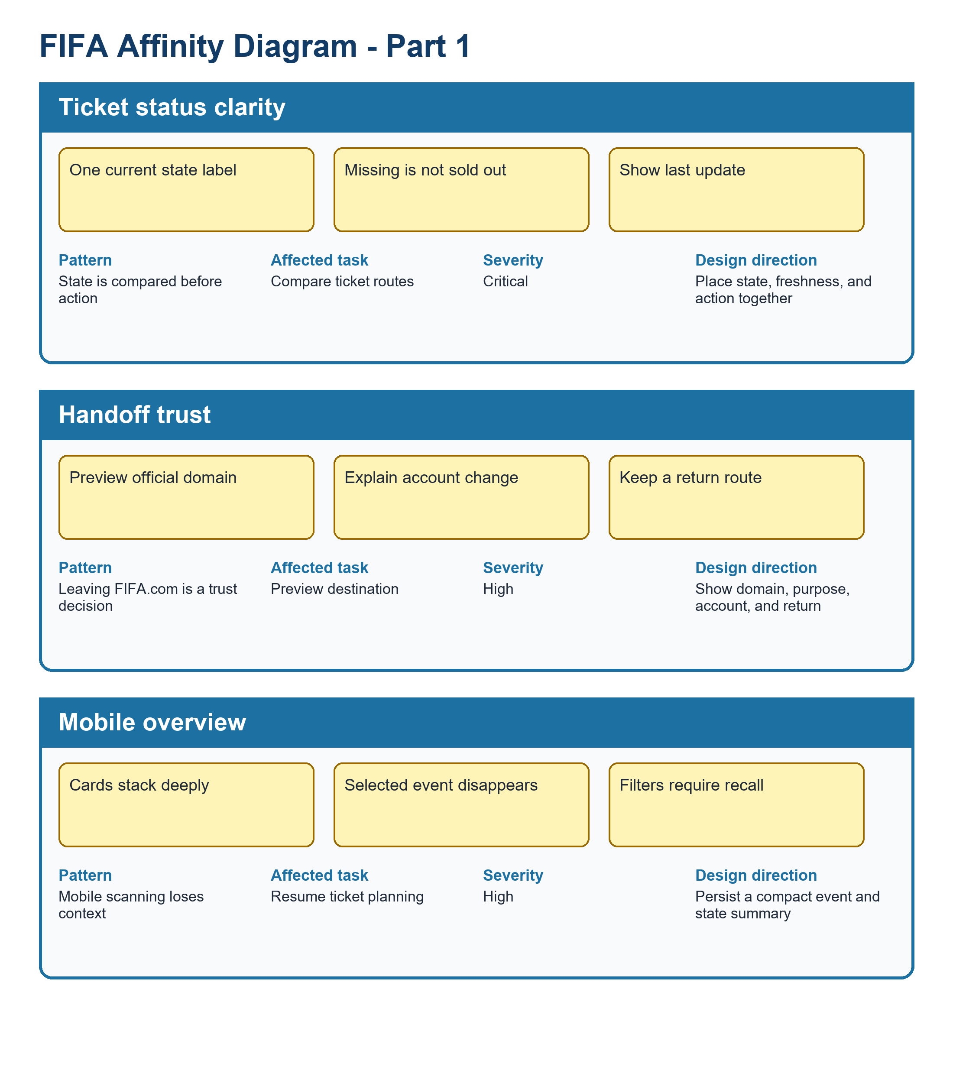
Figure UA-AFFINITY-FIFA-A. FIFA clusters, part 1: status clarity, handoff trust, and mobile overview.
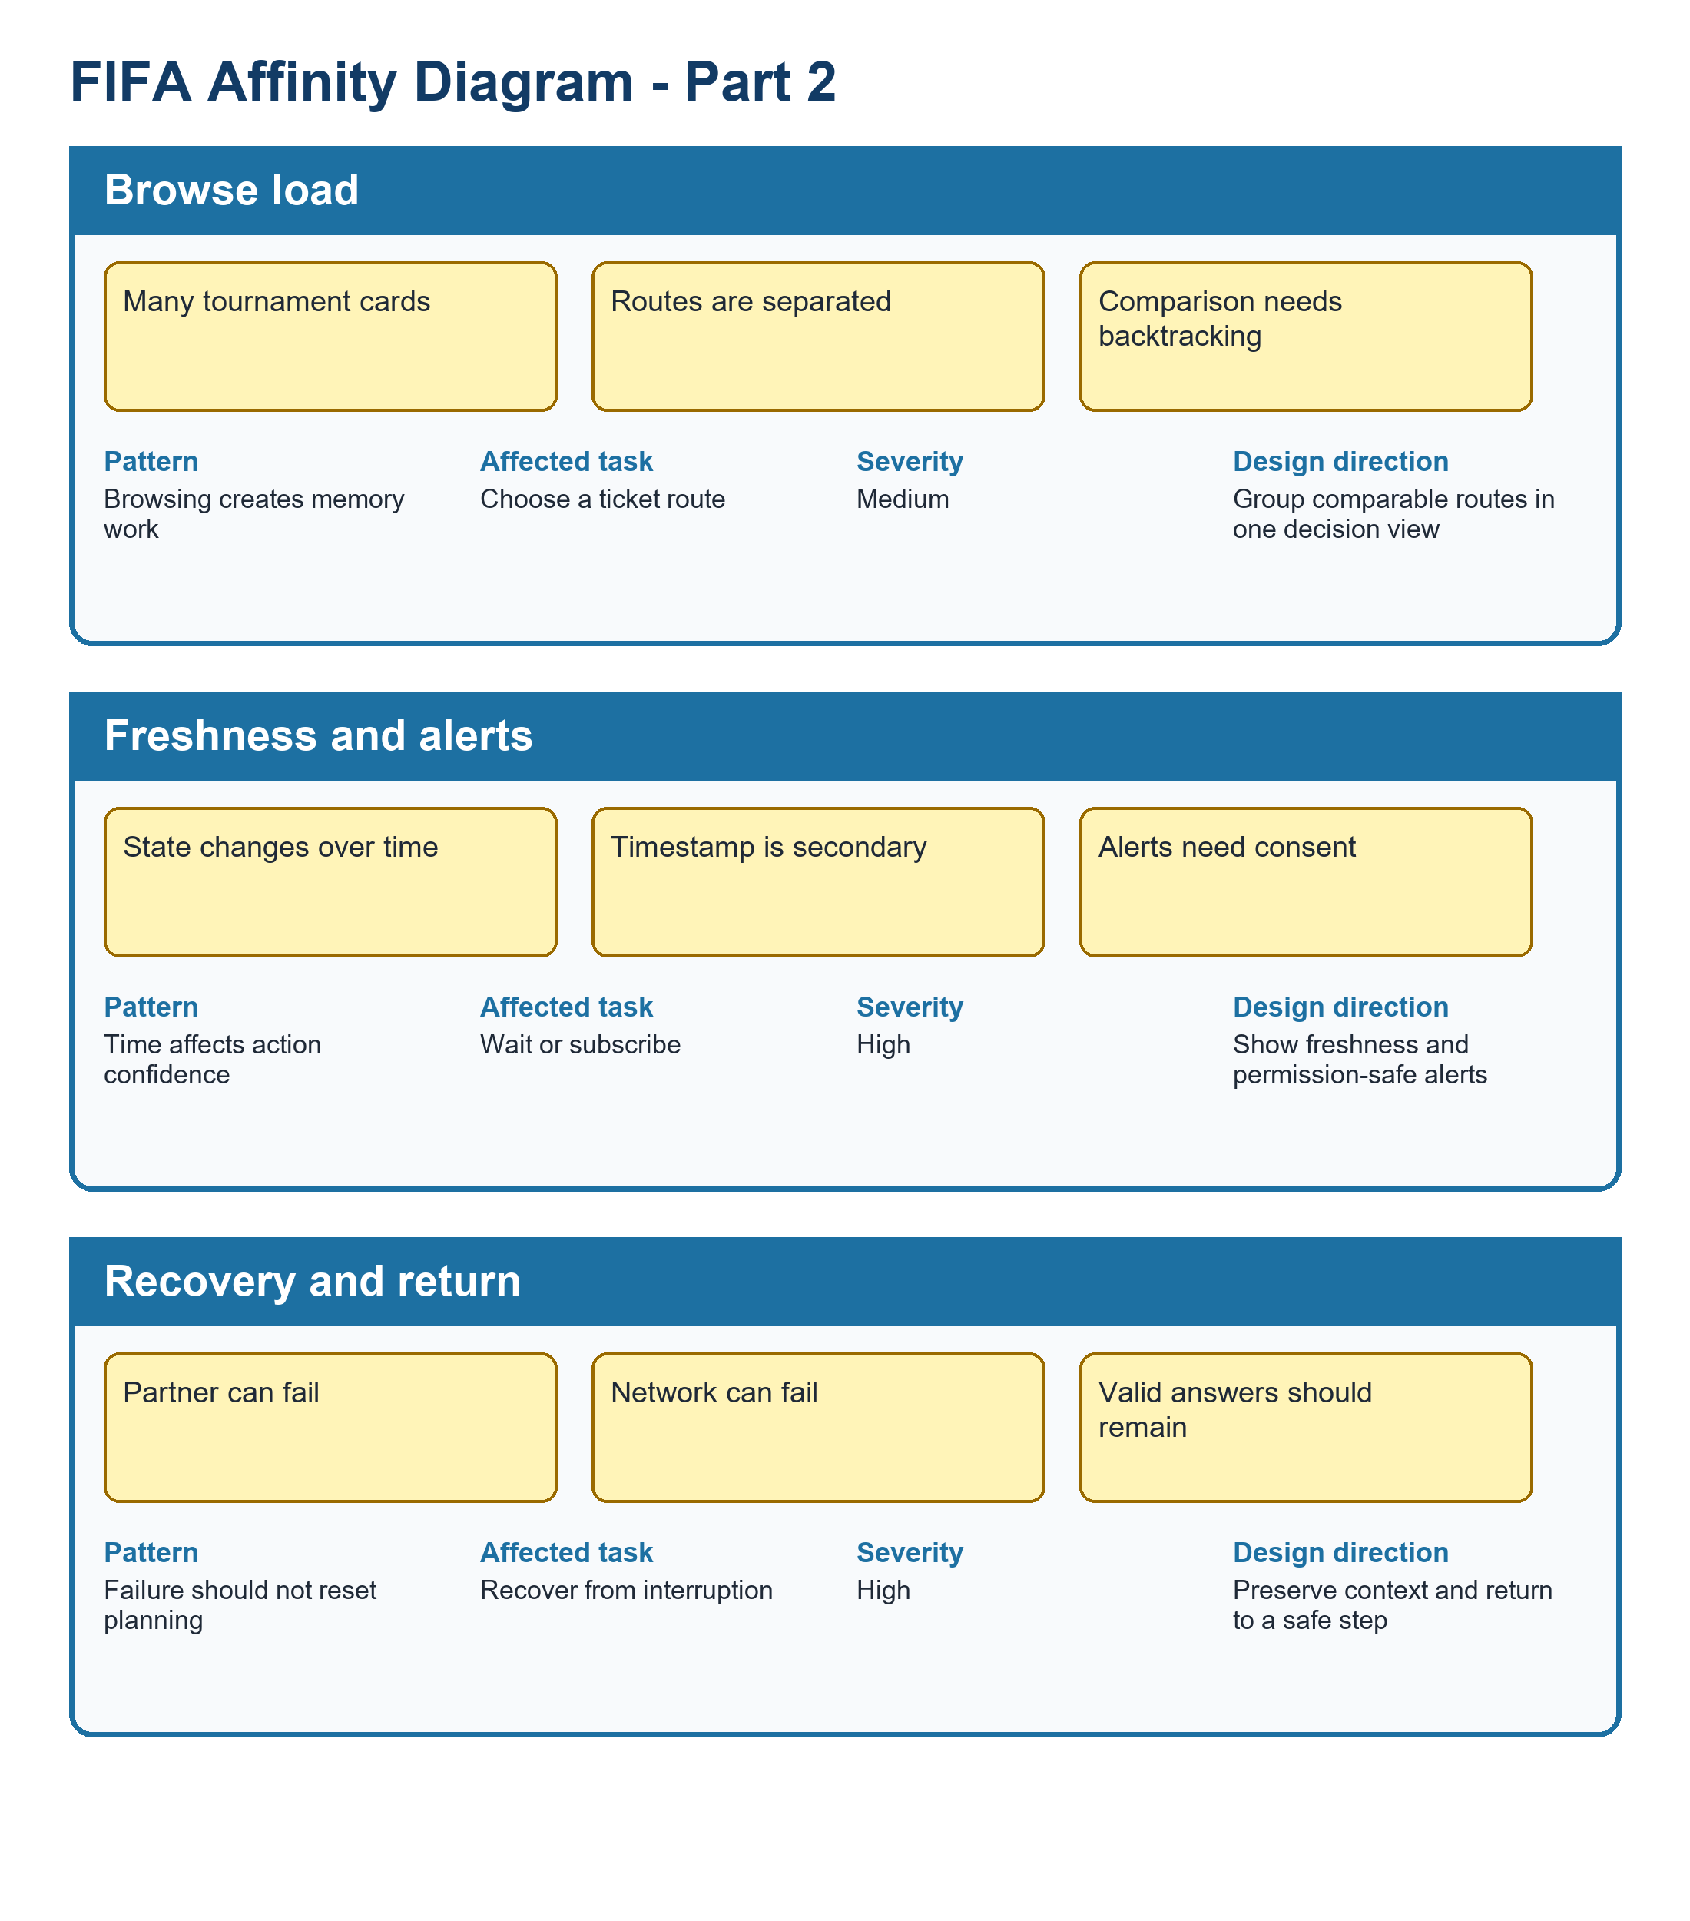
Figure UA-AFFINITY-FIFA-B. FIFA clusters, part 2: browse load, freshness and alerts, and recovery and return.
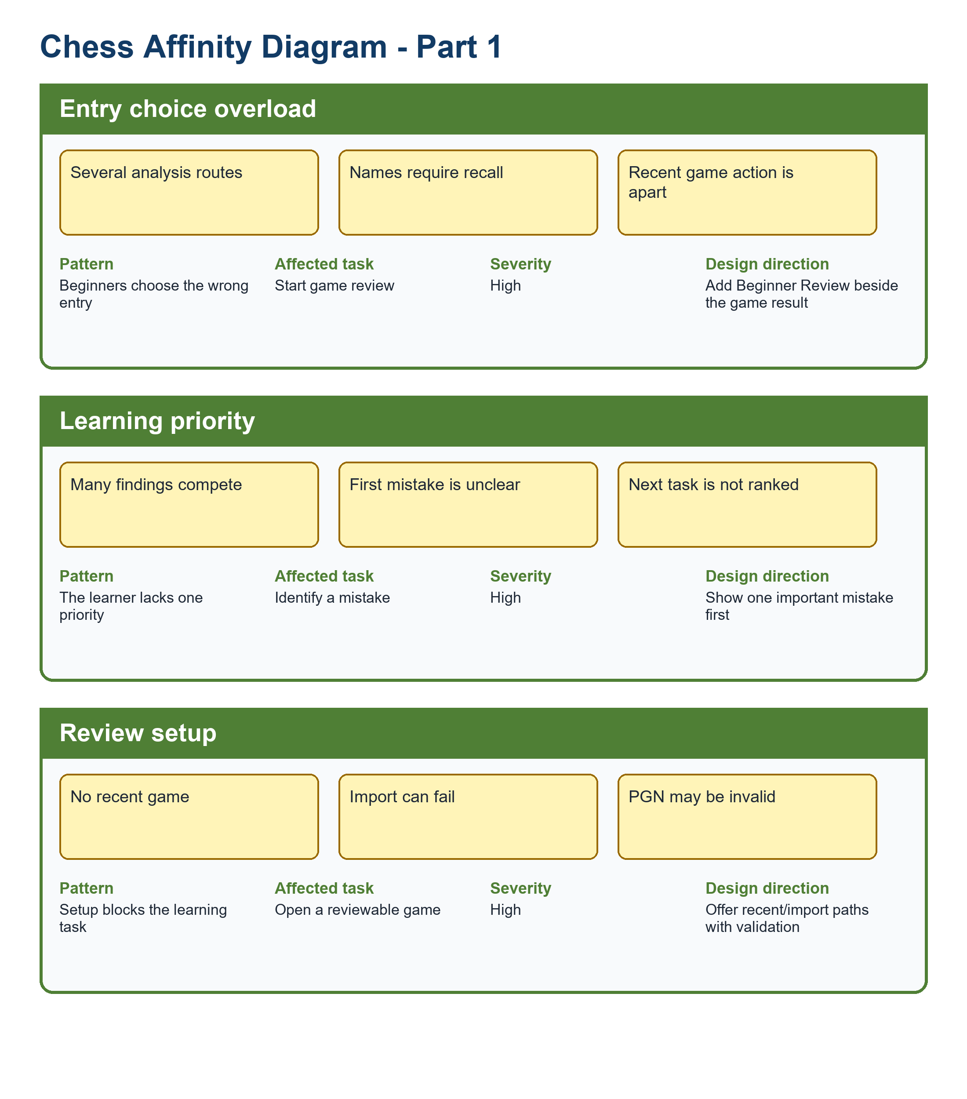
Figure UA-AFFINITY-CHESS-A. Chess clusters, part 1: entry choice, learning priority, review setup, and vocabulary load.
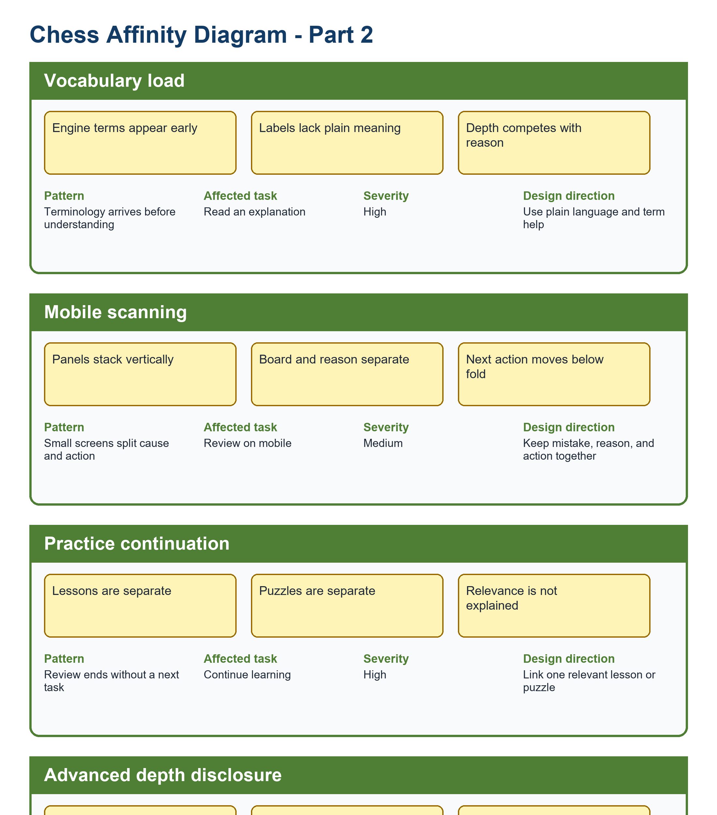
Figure UA-AFFINITY-CHESS-B. Chess clusters, part 2: mobile scanning, practice continuation, and advanced-depth disclosure.
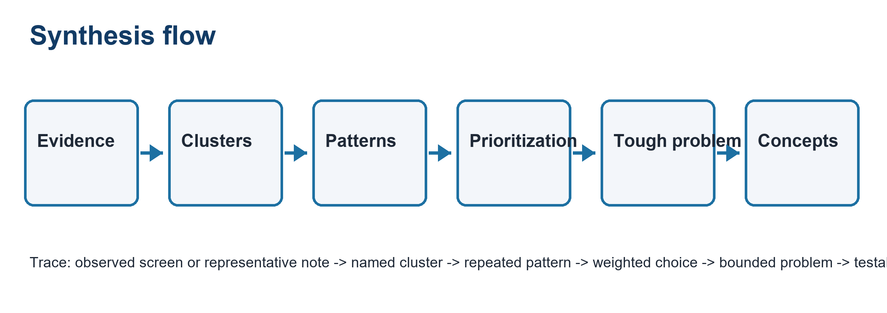
Figure UA-AF-SYNTHESIS. Evidence -> clusters -> patterns -> prioritization -> tough problem -> concepts.
Synthesis flow: Evidence -> Clusters -> Patterns -> Prioritization -> Tough problem -> Concepts. This sequence keeps the affinity diagram separate from a task sequence.

8.2 Voting Visualization
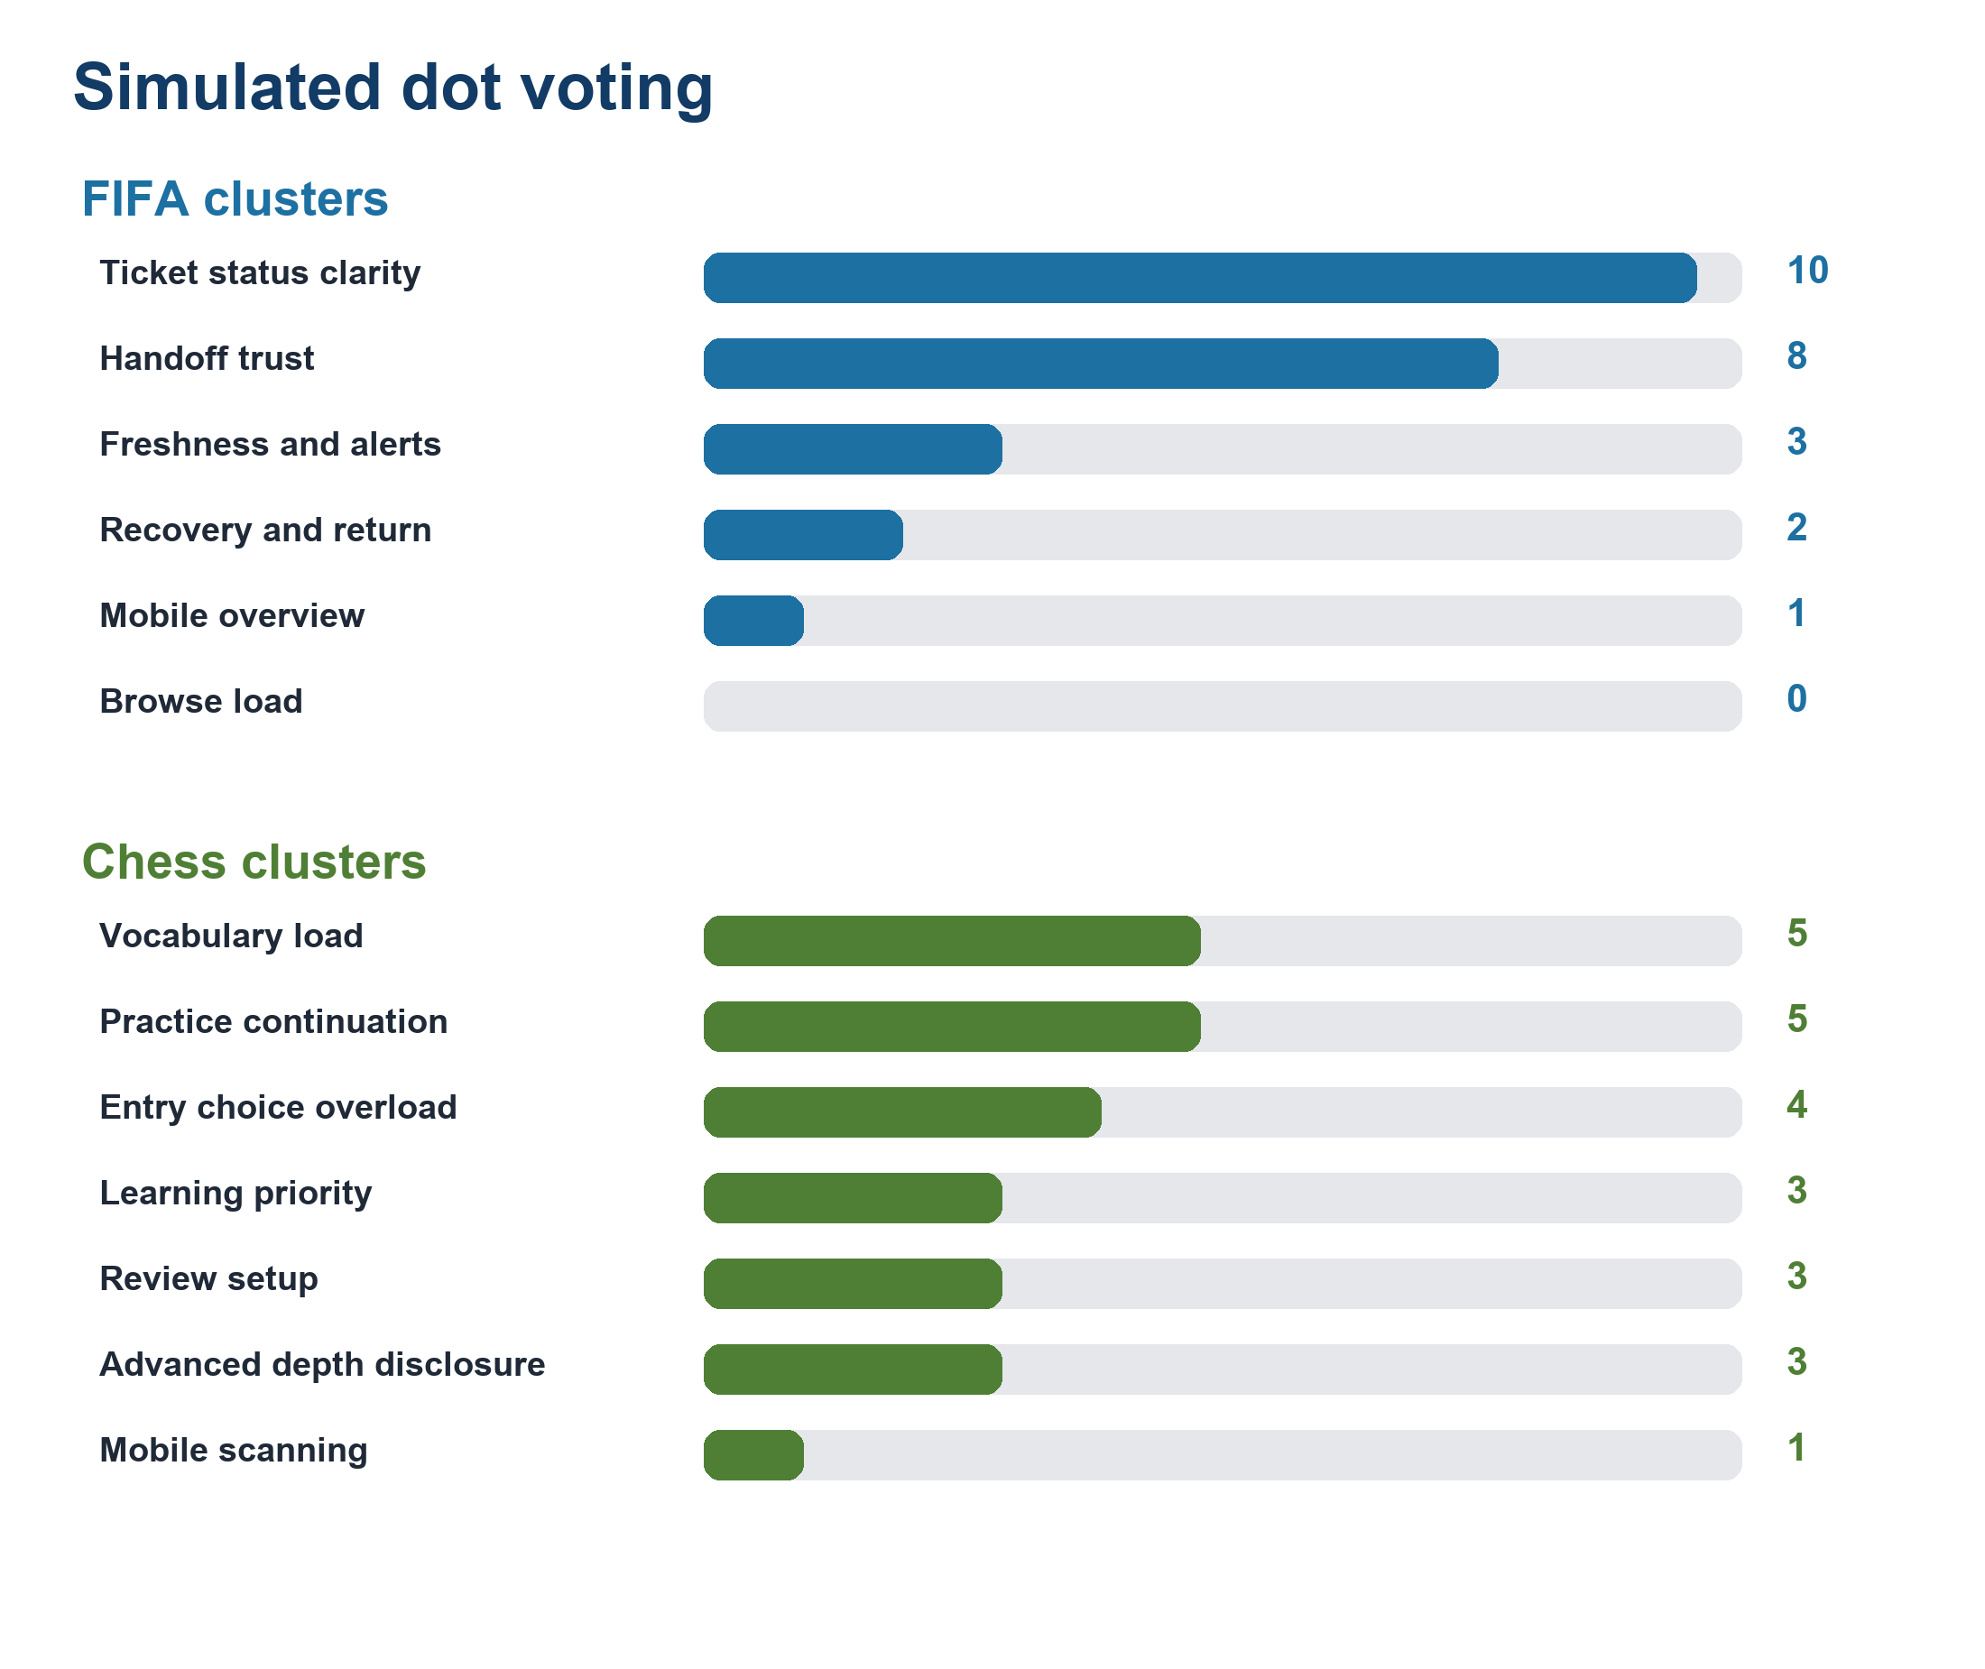
Figure UA-VOTE-01. Horizontal bars show the simulated dot counts; the tables retain member-level totals and tie-break detail.

8.3 Final Rationale
Final rationale: FIFA status and freshness remains the highest-priority problem because it combines high severity, trust risk, repeated planning use, and direct PA3 testability. Chess beginner review remains the selected problem because explanation and practice continuation jointly determine whether review becomes learning.

9. Practical Difficulties and Lessons Learned
Practical difficulty | How the group handled it | Lesson learned | Impact on the final version
Seventy-two notes could not remain legible on one page. | The group split product views and kept only three representative notes in each visible cluster. | Affinity synthesis should show the transformation, not only the notes. | The final figures expose pattern, task, severity, and design implication.
Use-case and PA1 terms drifted during clustering. | Stable FIFA and Chess cluster names were used across analysis and proposal sections. | Terminology is part of traceability. | The revised diagrams link each problem to one named design direction.

Appendix A - All 72 Raw Notes

Note ID | Product | Cluster | Atomic note | Source type
F-RN-01 | FIFA | Ticket status clarity | Current sale state needs one label | screen evidence
F-RN-02 | FIFA | Ticket status clarity | Missing state differs from sold out | simulated participant behavior
F-RN-03 | FIFA | Ticket status clarity | Resale must not look like primary sale | PA1 inherited finding
F-RN-04 | FIFA | Ticket status clarity | Waiting room is a temporary state | design inference
F-RN-05 | FIFA | Ticket status clarity | Hospitality is a distinct option | screen evidence
F-RN-06 | FIFA | Ticket status clarity | State comparison belongs in one view | simulated participant behavior
F-RN-07 | FIFA | Handoff trust | Preview the destination domain | PA1 inherited finding
F-RN-08 | FIFA | Handoff trust | Explain why departure is needed | design inference
F-RN-09 | FIFA | Handoff trust | Offer stay on FIFA.com | screen evidence
F-RN-10 | FIFA | Handoff trust | Preserve a safe return route | simulated participant behavior
F-RN-11 | FIFA | Handoff trust | Do not imply partner transaction status | PA1 inherited finding
F-RN-12 | FIFA | Handoff trust | Keep tournament context through handoff | design inference
F-RN-13 | FIFA | Mobile overview | Keep selected tournament first | screen evidence
F-RN-14 | FIFA | Mobile overview | Avoid a long undifferentiated card stack | simulated participant behavior
F-RN-15 | FIFA | Mobile overview | Restore filters on return | PA1 inherited finding
F-RN-16 | FIFA | Mobile overview | Use labels that survive small screens | design inference
F-RN-17 | FIFA | Mobile overview | Make status scannable without color | screen evidence
F-RN-18 | FIFA | Mobile overview | Resume with one recognition step | simulated participant behavior
F-RN-19 | FIFA | Browse load | Ticket entry competes with content | PA1 inherited finding
F-RN-20 | FIFA | Browse load | Repeated cards increase scanning | design inference
F-RN-21 | FIFA | Browse load | Tournament identity should anchor actions | screen evidence
F-RN-22 | FIFA | Browse load | Reduce cross-page comparison | simulated participant behavior
F-RN-23 | FIFA | Browse load | Keep action wording consistent | PA1 inherited finding
F-RN-24 | FIFA | Browse load | Separate browse from purchase intent | design inference
F-RN-25 | FIFA | Freshness and alerts | Show last-updated time | screen evidence
F-RN-26 | FIFA | Freshness and alerts | Name the governed source | simulated participant behavior
F-RN-27 | FIFA | Freshness and alerts | Label stale data explicitly | PA1 inherited finding
F-RN-28 | FIFA | Freshness and alerts | Allow relevant change alerts | design inference
F-RN-29 | FIFA | Freshness and alerts | Explain notification permission | screen evidence
F-RN-30 | FIFA | Freshness and alerts | Let users edit or stop alerts | simulated participant behavior
F-RN-31 | FIFA | Recovery and return | Retry missing state without losing context | PA1 inherited finding
F-RN-32 | FIFA | Recovery and return | Network loss should retain the last snapshot | design inference
F-RN-33 | FIFA | Recovery and return | Login mismatch needs safe recovery | screen evidence
F-RN-34 | FIFA | Recovery and return | Expired return links need explanation | simulated participant behavior
F-RN-35 | FIFA | Recovery and return | Partner failure must offer stay | PA1 inherited finding
F-RN-36 | FIFA | Recovery and return | Never infer purchase completion | design inference
C-RN-01 | Chess | Entry choice overload | Beginner review needs one named entry | screen evidence
C-RN-02 | Chess | Entry choice overload | Analysis setup paths compete | simulated participant behavior
C-RN-03 | Chess | Entry choice overload | Feature names require recall | PA1 inherited finding
C-RN-04 | Chess | Entry choice overload | Completed game should expose review | design inference
C-RN-05 | Chess | Entry choice overload | Expert view opens too early | screen evidence
C-RN-06 | Chess | Entry choice overload | Outcome labels are easier to recognize | simulated participant behavior
C-RN-07 | Chess | Learning priority | Show one important mistake first | PA1 inherited finding
C-RN-08 | Chess | Learning priority | Explain why before numeric depth | design inference
C-RN-09 | Chess | Learning priority | Make the next action explicit | screen evidence
C-RN-10 | Chess | Learning priority | Keep the lesson goal visible | simulated participant behavior
C-RN-11 | Chess | Learning priority | Do not present every candidate equally | PA1 inherited finding
C-RN-12 | Chess | Review setup | No game needs a clear setup route | design inference
C-RN-13 | Chess | Review setup | Invalid PGN must preserve input | screen evidence
C-RN-14 | Chess | Review setup | Board orientation needs confirmation | simulated participant behavior
C-RN-15 | Chess | Review setup | Engine failure needs a safe fallback | PA1 inherited finding
C-RN-16 | Chess | Review setup | Premium restriction needs honest scope | design inference
C-RN-17 | Chess | Vocabulary load | Evaluation terms need inline help | screen evidence
C-RN-18 | Chess | Vocabulary load | Plain language should lead | simulated participant behavior
C-RN-19 | Chess | Vocabulary load | Terminology help should not interrupt | PA1 inherited finding
C-RN-20 | Chess | Vocabulary load | Returning learners forget feature names | design inference
C-RN-21 | Chess | Vocabulary load | Recognition should replace recall | screen evidence
C-RN-22 | Chess | Mobile scanning | Keep the board and main mistake together | simulated participant behavior
C-RN-23 | Chess | Mobile scanning | Collapse secondary panels | PA1 inherited finding
C-RN-24 | Chess | Mobile scanning | Use color-independent indicators | design inference
C-RN-25 | Chess | Mobile scanning | Preserve state after interruption | screen evidence
C-RN-26 | Chess | Mobile scanning | Maintain readable tap targets | simulated participant behavior
C-RN-27 | Chess | Practice continuation | Link the mistake to one lesson | PA1 inherited finding
C-RN-28 | Chess | Practice continuation | Offer one relevant puzzle | design inference
C-RN-29 | Chess | Practice continuation | Preserve the reviewed position | screen evidence
C-RN-30 | Chess | Practice continuation | Let users continue later | simulated participant behavior
C-RN-31 | Chess | Practice continuation | Explain why the practice is relevant | PA1 inherited finding
C-RN-32 | Chess | Advanced depth disclosure | Reveal engine detail on demand | design inference
C-RN-33 | Chess | Advanced depth disclosure | Do not remove expert access | screen evidence
C-RN-34 | Chess | Advanced depth disclosure | Remember the disclosure choice | simulated participant behavior
C-RN-35 | Chess | Advanced depth disclosure | Keep beginner explanation stable | PA1 inherited finding
C-RN-36 | Chess | Advanced depth disclosure | Separate learning priority from depth | design inference
Scenario-based synthetic evidence: All 72 notes are one-idea records; simulated participant behavior notes are not real observation claims.

