PROJECT ASSIGNMENT 2

Group10-PA2 User Research
FIFA.com and Chess.com
Course | CSC13112 - UI/UX Design, FIT-HCMUS
Group | Group10
Team | Le Minh (21127645); Nguyen Vu Bach (21127224); Pham Nguyen Gia Bao (20127119); Trang Minh Nhut (22127318)

Contents
1. Research scope, methods, and validity boundary — 3
2. Tasks and protocol — 4
2.1 FIFA task set — 4
2.2 Chess task set — 4
3. Simulated participants — 4
4. Three-day simulated session plan — 8
5. Representative Sessions and Patterns — 9
5.1 Pattern Summary — 10
5.2 Result Summary — 10
6. Simulated task results — 10
7. Personas — 11
7.1 FIFA trust-sensitive ticket planner — 11
7.2 FIFA returning tournament follower — 12
7.3 Chess first-time beginner — 13
7.4 Chess returning learner who forgets analysis terms — 14
8. Representative Screenshot Evidence — 15
9. Findings — 26
9.1 Findings Summary — 27
10. Evidence boundary and citations — 27
11. Revised Work Models — 28
Work Model Coverage Checklist — 34
12. Practical Difficulties and Lessons Learned — 35
Appendix A - Twelve Detailed Simulated Note Sheets — 36

A.1 Note sheet F-SIM-01 — 37

A.2 Note sheet F-SIM-02 — 38

A.3 Note sheet F-SIM-03 — 39

A.4 Note sheet F-SIM-04 — 40

A.5 Note sheet F-SIM-05 — 41

A.6 Note sheet F-SIM-06 — 42

A.7 Note sheet C-SIM-01 — 43

A.8 Note sheet C-SIM-02 — 44

A.9 Note sheet C-SIM-03 — 45

A.10 Note sheet C-SIM-04 — 46

A.11 Note sheet C-SIM-05 — 47

A.12 Note sheet C-SIM-06 — 48
1. Research scope, methods, and validity boundary
Simulated-study disclosure: All participant profiles, sessions, quotations, observations, task outcomes, and ratings in this report are scenario-based synthetic evidence created to test design hypotheses; they are not presented as research with real users.

Method | What it supports | Boundary | Source label
Source analysis | Interface inventory, documented states, PA1 continuity | A file or screen does not prove behavior | Screen evidence / PA1 inherited finding
Try-it-yourself walkthrough | Task path, transition, recovery, and handoff inspection | Shows the path available to the evaluator, not population performance | Screen evidence / Design inference
Simulated user sessions | Scenario coverage, test cases, hypotheses, and comparison logic | Does not represent real-user measurement | Simulated study / PA3 validation target
Course source: Course basis: LN01 - Introduction - v2.pdf, pp. 20, 22, 24; LN02 - Fundamental Concepts - Usability Dimensions_2.pdf, pp. 62-67, 74-76, 83-84, 101-115; LN03 - UI Design Process.pdf, pp. 16-19, 23-24, 28-30, 34-36; LN04 - Task Analysis.pdf, pp. 3, 6-15, 39-49.
PA1 inherited finding: FIFA separates useful tournament content from ticket decision confidence; Chess.com provides strong play and learning functions but exposes analysis choices with high recall demand.
Design inference: Visibility of system status, recognition over recall, progressive disclosure, user control, and error prevention organize the PA2 questions.

2. Tasks and protocol

2.1 FIFA task set
- Find ticket entry.
- Compare tournament status.
- Decide buy, wait, register interest, resale, or hospitality.
- Identify destination before leaving FIFA.com.
- Resume on mobile.
- Recover from missing or stale status.

2.2 Chess task set
- Choose a beginner route.
- Continue a lesson.
- Solve a puzzle.
- Open analysis or review.
- Identify one important mistake.
- Try a better move.
- Read a plain-language explanation.
- Continue to practice.
- Reveal advanced detail on demand.
Simulated research session protocol: Each 25-35 minute record uses 5 minutes of introduction, 15-20 minutes of task work, and 5 minutes of follow-up. Notes are structured; no audio or video is recorded.

3. Simulated participants

ID | Role | Age | Device | Domain / application experience | Frequency | Motivation and context | Constraints / accessibility | Tasks
F-SIM-01 | Casual football fan | 18-24 | Android phone | Follows major finals; Occasional FIFA.com visitor | Monthly in season | Find ticket entry without planning expertise; Commute; one-handed use | Limited time and data; Large tap targets | F1-F6
F-SIM-02 | Casual football fan | 25-34 | Windows laptop + phone | Watches selected national-team matches; Uses Match Centre occasionally | Several times per tournament | Compare match and ticket status; Evening planning at home | Avoids creating accounts early; High contrast | F1-F6
F-SIM-03 | Tournament follower | 25-34 | iPhone | Tracks brackets and schedules; Returning FIFA.com visitor | Weekly in tournament periods | Coordinate a group trip; Mobile-first, shared planning | Needs fast resumption; Text zoom | F1-F6
F-SIM-04 | Tournament follower | 35-44 | MacBook + Android phone | Follows multiple competitions; Regular Match Centre user | Weekly | Connect schedule context to ticket action; Desk-to-mobile transition | Many open tabs; Keyboard access on laptop | F1-F6
F-SIM-05 | Trust-sensitive ticket planner | 35-44 | Windows laptop | Has bought event tickets online; Knows FIFA.com but not partner boundaries | At key sale windows | Avoid unofficial or stale destinations; Family purchase planning | Needs provenance before leaving site; Clear status text, not color alone | F1-F6
F-SIM-06 | Trust-sensitive ticket planner | 45-54 | Android phone | Plans international tournament travel; Low-frequency FIFA.com visitor | A few times per year | Know whether to buy, wait, or register interest; Mobile on variable network | Low confidence after handoff; Plain language and persistent focus | F1-F6
C-SIM-01 | First-time beginner | 18-24 | Android phone | Knows piece movement; First Chess.com week | Daily trial week | Choose a safe beginner route; Short study breaks | Unfamiliar analysis terms; Plain language | C1-C9
C-SIM-02 | First-time beginner | 25-34 | Windows laptop | Played fewer than ten games; New account | Twice weekly | Understand one mistake; Home learning session | Fears breaking the position; Keyboard-only path | C1-C9
C-SIM-03 | Returning learner | 18-24 | iPhone | Completed basic lessons; Returns after four months | Weekly when active | Resume without relearning navigation; Mobile evening practice | Forgets feature locations; Text zoom | C1-C9
C-SIM-04 | Returning learner | 35-44 | MacBook | Knows opening principles; Intermittent lesson and puzzle use | Monthly | Reconnect review to practice; Desktop at home | Forgets analysis vocabulary; Reduced motion | C1-C9
C-SIM-05 | Intermediate player with low analysis use | 25-34 | Windows laptop | Club-level casual; Plays games and puzzles | Weekly | Review without engine overload; After-game desktop session | Skips dense panels; Keyboard shortcuts with labels | C1-C9
C-SIM-06 | Intermediate player with low analysis use | 35-44 | Android tablet | Understands tactics; Rarely opens analysis | Several times per month | Find one actionable improvement; Tablet practice session | Terminology slows scanning; Color-independent indicators | C1-C9
Scenario-based synthetic evidence: IDs are fictional study roles; no names identify participants.

4. Three-day simulated session plan
Session ID | Date | Duration | Participant | Device | Tasks | Facilitator | Note taker | Recording method
F-SES-01 | 16 Jul 2026 | 28 min | F-SIM-01 | Android phone | F1, F2, F4, F5 | Nguyen Vu Bach | Trang Minh Nhut | Structured notes only; no audio/video
F-SES-02 | 16 Jul 2026 | 31 min | F-SIM-02 | Windows laptop + phone | F1-F6 | Nguyen Vu Bach | Le Minh | Structured notes only; no audio/video
C-SES-01 | 16 Jul 2026 | 29 min | C-SIM-01 | Android phone | C1-C3, C7-C9 | Pham Nguyen Gia Bao | Trang Minh Nhut | Structured notes only; no audio/video
C-SES-02 | 16 Jul 2026 | 32 min | C-SIM-02 | Windows laptop | C1-C9 | Pham Nguyen Gia Bao | Le Minh | Structured notes only; no audio/video
F-SES-03 | 17 Jul 2026 | 30 min | F-SIM-03 | iPhone | F1-F6 | Nguyen Vu Bach | Trang Minh Nhut | Structured notes only; no audio/video
F-SES-04 | 17 Jul 2026 | 34 min | F-SIM-04 | MacBook + Android phone | F1-F6 | Nguyen Vu Bach | Le Minh | Structured notes only; no audio/video
C-SES-03 | 17 Jul 2026 | 27 min | C-SIM-03 | iPhone | C1-C3, C5-C9 | Pham Nguyen Gia Bao | Trang Minh Nhut | Structured notes only; no audio/video
C-SES-04 | 17 Jul 2026 | 35 min | C-SIM-04 | MacBook | C1-C9 | Pham Nguyen Gia Bao | Le Minh | Structured notes only; no audio/video
F-SES-05 | 18 Jul 2026 | 33 min | F-SIM-05 | Windows laptop | F1-F6 | Nguyen Vu Bach | Trang Minh Nhut | Structured notes only; no audio/video
F-SES-06 | 18 Jul 2026 | 35 min | F-SIM-06 | Android phone | F1-F6 | Nguyen Vu Bach | Le Minh | Structured notes only; no audio/video
C-SES-05 | 18 Jul 2026 | 30 min | C-SIM-05 | Windows laptop | C1-C9 | Pham Nguyen Gia Bao | Trang Minh Nhut | Structured notes only; no audio/video
C-SES-06 | 18 Jul 2026 | 34 min | C-SIM-06 | Android tablet | C1-C9 | Pham Nguyen Gia Bao | Le Minh | Structured notes only; no audio/video
Simulated research session: This is a simulated session record used for scenario coverage and planning, not an attendance or research claim.

5. Representative Sessions and Patterns
Six representative sessions keep the main report concise. The remaining detailed note sheets are retained in Appendix A.
Session | Task focus | Observed pattern | Recovery or result
F-SES-01 | Find ticket entry on mobile | The entry was found, but the selected tournament moved out of view. | Return to the tournament summary before choosing a route.
F-SES-04 | Connect Match Centre to ticket action | Schedule context did not fully carry into ticket planning. | Re-select the event and verify the current ticket state.
F-SES-05 | Compare ticket status and destination | Freshness and partner boundaries shaped confidence. | Stay on FIFA.com when the state or destination is unclear.
C-SES-01 | Choose a beginner route | Several entry choices increased recall demand. | Return to the recent game and select Beginner Review.
C-SES-04 | Continue from explanation to practice | The next relevant lesson or puzzle was not obvious. | Use one mistake-linked practice recommendation.
C-SES-06 | Review a game on a smaller screen | Dense analysis competed with the learning priority. | Show one mistake first and disclose advanced depth later.

5.1 Pattern Summary
FIFA patterns center on ticket-state clarity, freshness, mobile context, and partner handoff trust. Chess patterns center on entry choice, beginner explanation, and a clear continuation into practice.

5.2 Result Summary
The simulated sessions support two PA3 hypotheses: a FIFA decision layer should keep state, freshness, route, and recovery together; a Chess beginner review should show one interpretable mistake and one next practice action before advanced analysis.

6. Simulated task results
Trace | Task completion | Hesitations | Wrong paths | Recoveries | Confidence | Clarity
F-SIM-01 / F-SES-01 | 3/4 | 3 | 1 | 1 | 3/5 | 3/5
F-SIM-02 / F-SES-02 | 5/6 | 2 | 1 | 1 | 3/5 | 4/5
F-SIM-03 / F-SES-03 | 4/6 | 3 | 1 | 1 | 3/5 | 3/5
F-SIM-04 / F-SES-04 | 4/6 | 3 | 0 | 1 | 2/5 | 3/5
F-SIM-05 / F-SES-05 | 4/6 | 4 | 1 | 1 | 2/5 | 3/5
F-SIM-06 / F-SES-06 | 3/6 | 4 | 2 | 2 | 2/5 | 2/5
C-SIM-01 / C-SES-01 | 5/6 | 3 | 2 | 1 | 3/5 | 3/5
C-SIM-02 / C-SES-02 | 7/9 | 4 | 2 | 1 | 3/5 | 3/5
C-SIM-03 / C-SES-03 | 6/8 | 3 | 2 | 2 | 3/5 | 3/5
C-SIM-04 / C-SES-04 | 7/9 | 3 | 1 | 1 | 3/5 | 4/5
C-SIM-05 / C-SES-05 | 7/9 | 3 | 2 | 1 | 3/5 | 3/5
C-SIM-06 / C-SES-06 | 8/9 | 2 | 1 | 1 | 4/5 | 4/5
Simulated task result: The FIFA status/handoff records contain lower confidence and more hesitation than schedule-oriented work. Chess analysis entry has more wrong paths than puzzles; guided lesson work is clearer than analysis entry. No row is perfect, and every number traces to one note sheet.

7. Personas

7.1 FIFA trust-sensitive ticket planner
Field | Record
Persona ID | UR-P-F1
Summary | FIFA trust-sensitive ticket planner
Goals | Compares state and official destination before departure
Behaviors | Checks labels, timestamp, domain, and return route
Context | Family purchase at a sale window
Domain / application experience | High ticket-domain experience; moderate FIFA.com experience
Device pattern | Laptop first; phone resume
Frustrations | Ambiguous status and unexplained handoff
Capabilities | Careful comparison and risk detection
Limitations | Will wait rather than accept uncertainty
Simulated quote | “I need the state and destination before I leave.”
Scenario | Compare sale, resale, hospitality, then choose act or stay.
Evidence basis | F-SIM-05/06; F2-E09; PA1 inherited ticket drawback
Assumptions to validate | Whether destination preview improves calibrated trust

7.2 FIFA returning tournament follower
Field | Record
Persona ID | UR-P-F2
Summary | FIFA returning tournament follower
Goals | Reconnect schedule context to ticket action
Behaviors | Starts in Match Centre and expects tournament continuity
Context | Weekly tournament planning
Domain / application experience | High competition knowledge; regular FIFA.com use
Device pattern | Phone first; laptop comparison
Frustrations | Mobile stack and lost filters
Capabilities | Fast recognition of tournaments and schedules
Limitations | Does not remember ticket channel wording
Simulated quote | “Keep my tournament context when I switch devices.”
Scenario | Follow a tournament, inspect status, resume on mobile.
Evidence basis | F-SIM-03/04; F2-E03/E04; PA1 continuity
Assumptions to validate | Whether persisted context reduces recovery work

7.3 Chess first-time beginner
Field | Record
Persona ID | UR-P-C1
Summary | Chess first-time beginner
Goals | Understand one important mistake and next action
Behaviors | Uses Learn and Puzzles; avoids engine terminology
Context | Short mobile learning session
Domain / application experience | Basic rules; first week on Chess.com
Device pattern | Phone; occasional laptop
Frustrations | Too many entry choices
Capabilities | Willing to try a move and read a short explanation
Limitations | Cannot interpret evaluation vocabulary
Simulated quote | “Show me what to learn first.”
Scenario | Complete a lesson, puzzle, and beginner review.
Evidence basis | C-SIM-01/02; C2-E05-E10; PA1 learning strength
Assumptions to validate | Whether one preset improves entry selection

7.4 Chess returning learner who forgets analysis terms
Field | Record
Persona ID | UR-P-C2
Summary | Chess returning learner who forgets analysis terms
Goals | Resume review and practice after a gap
Behaviors | Recognizes recent game and lesson outcomes over feature names
Context | Intermittent desktop session
Domain / application experience | Moderate chess knowledge; low analysis use
Device pattern | Laptop; tablet backup
Frustrations | Recall-heavy labels and dense advanced panels
Capabilities | Can compare moves with plain explanations
Limitations | Forgets analysis terminology
Simulated quote | “I remember the game, not the analysis label.”
Scenario | Open recent game, identify one mistake, continue practice.
Evidence basis | C-SIM-03/04/05; C2-E07-E10
Assumptions to validate | Whether outcome-oriented labels improve memorability

8. Representative Screenshot Evidence
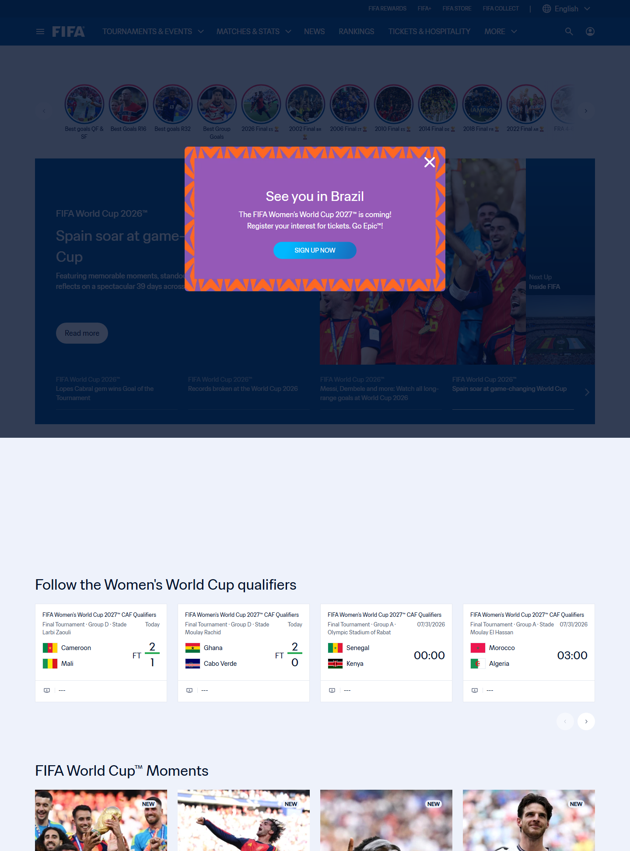
Figure UR-EV-03. State: FIFA homepage / entry. What is visible: Homepage hero, navigation, and entry choices. Why it matters: Establishes the starting context. Limitation: The capture does not prove which route a user chooses.
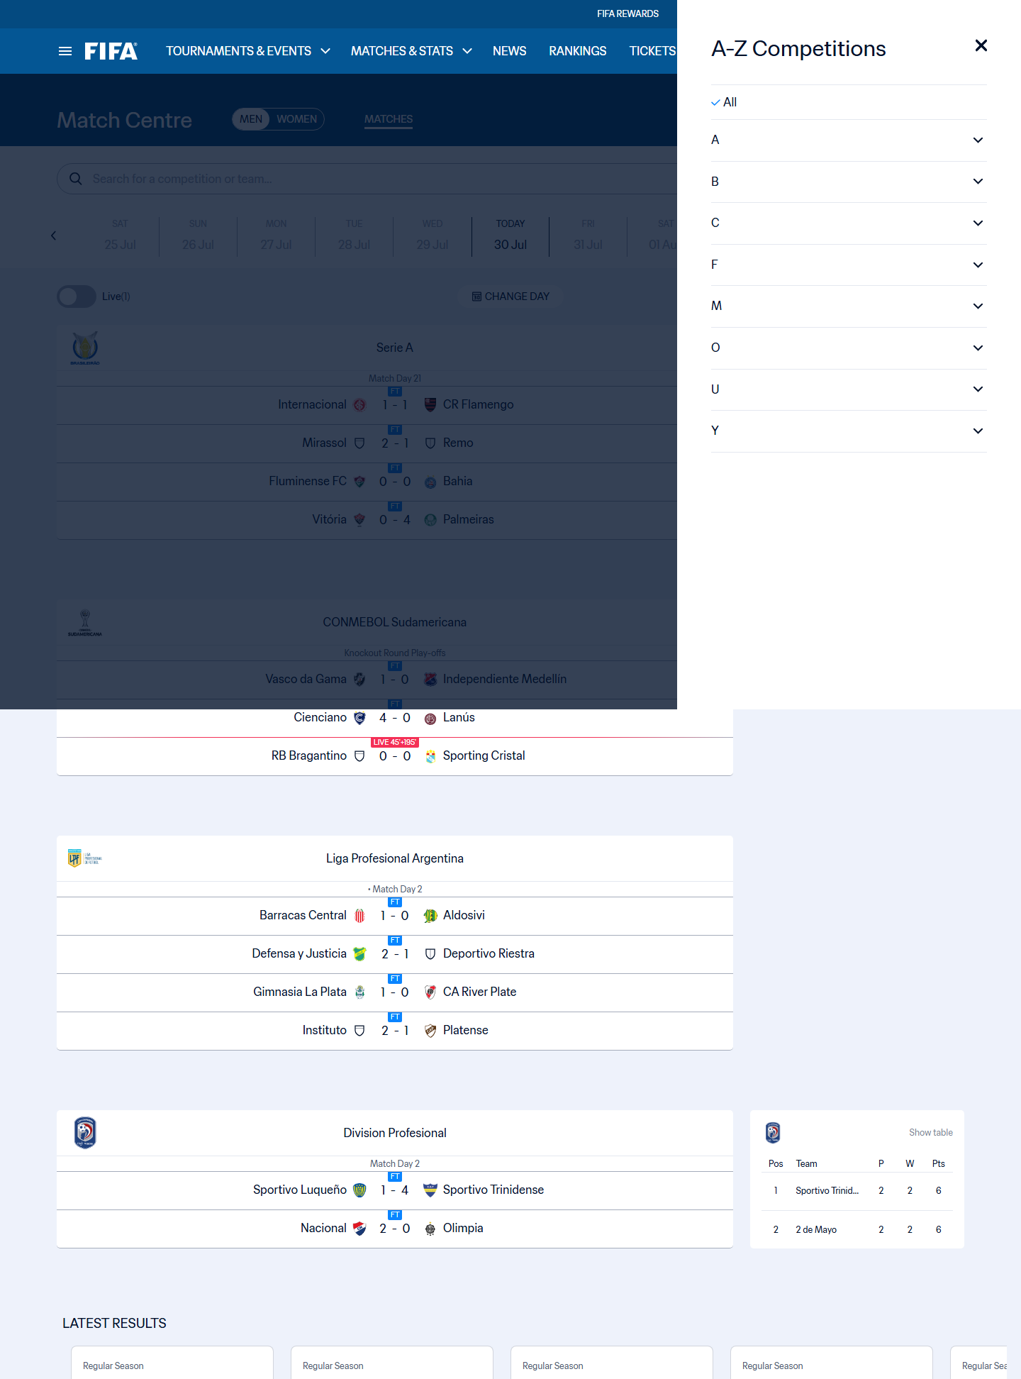
Figure UR-EV-04. State: FIFA Match Centre filters. What is visible: Date, competition, and match filtering controls. Why it matters: Shows the context users must preserve. Limitation: Live match availability changes over time.
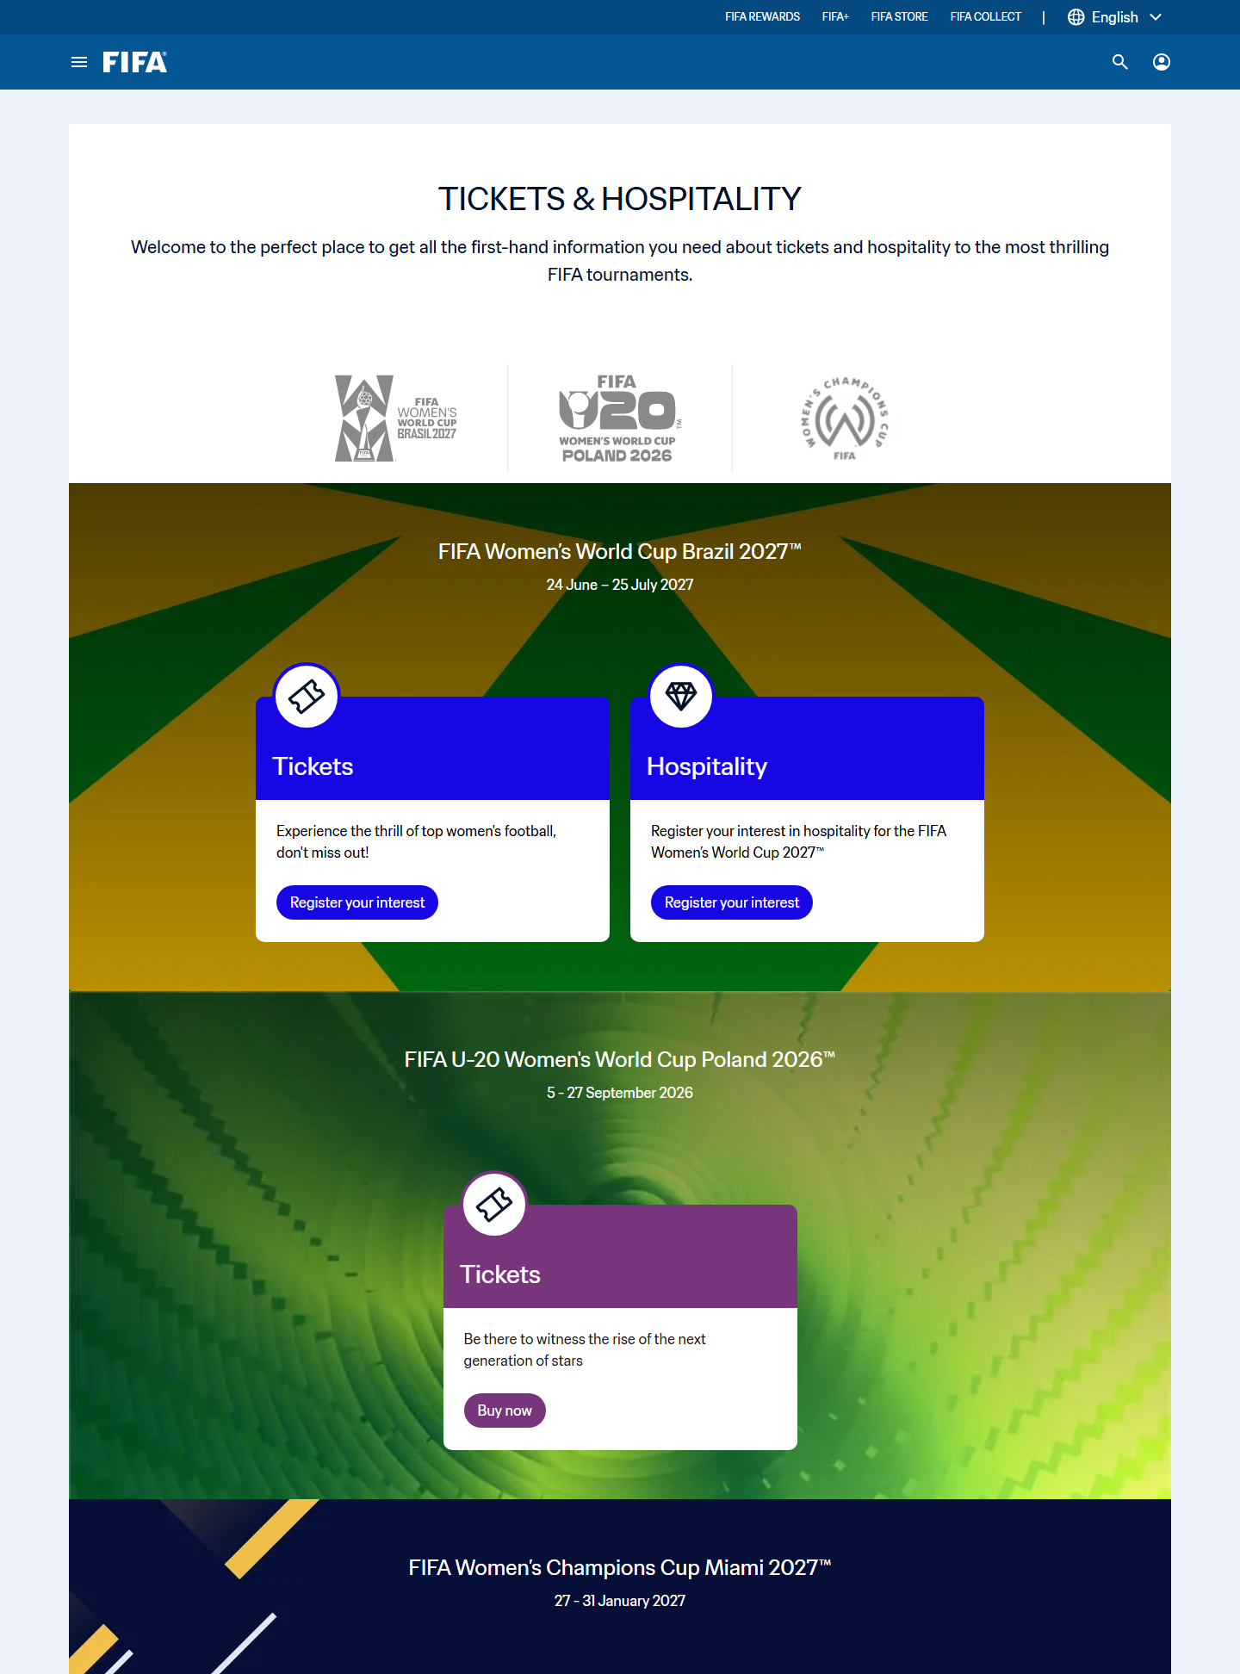
Figure UR-EV-05. State: Tickets and Hospitality landing. What is visible: Ticket and hospitality entry cards. Why it matters: Shows multiple planning routes. Limitation: It does not confirm current inventory.
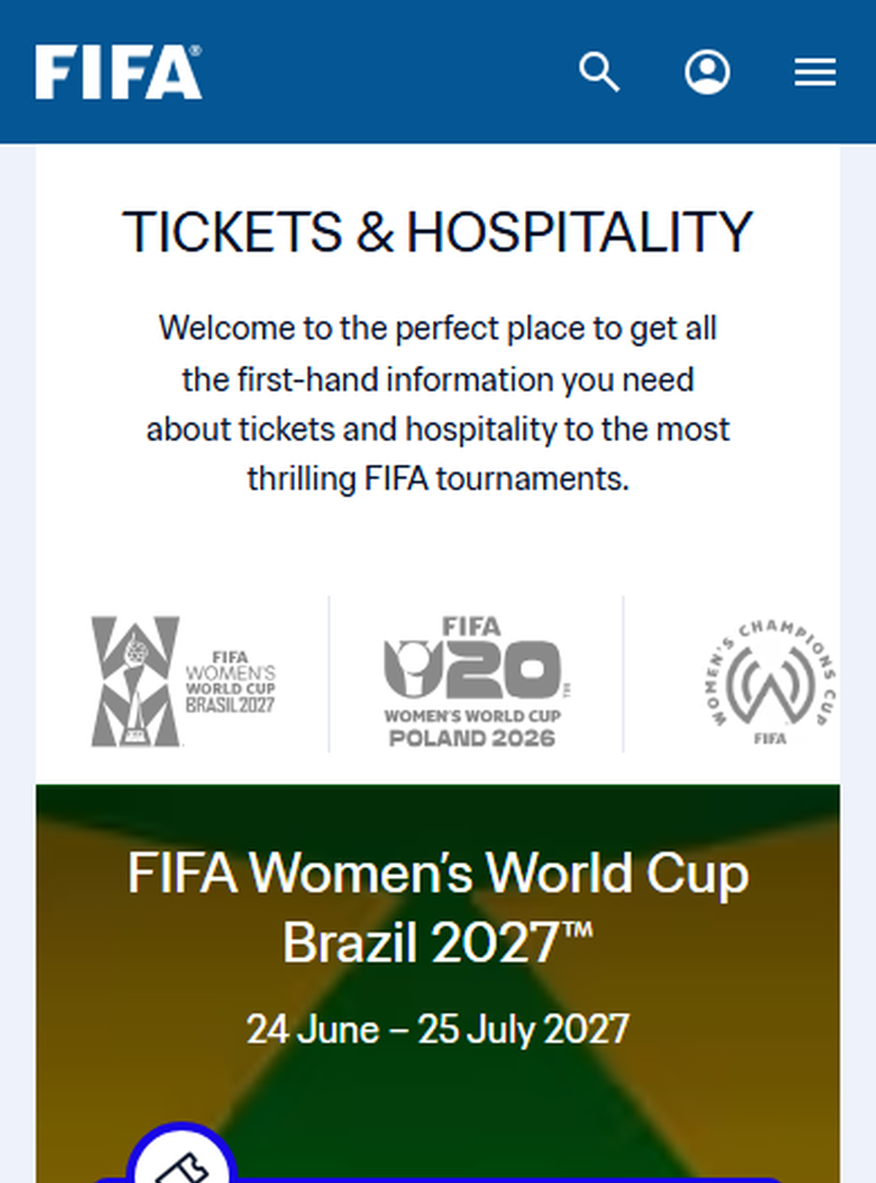
Figure UR-EV-06A. State: Mobile tickets - top segment. What is visible: The first readable ticket cards. Why it matters: Shows the start of the mobile decision surface. Limitation: This is only the top window of a long page.
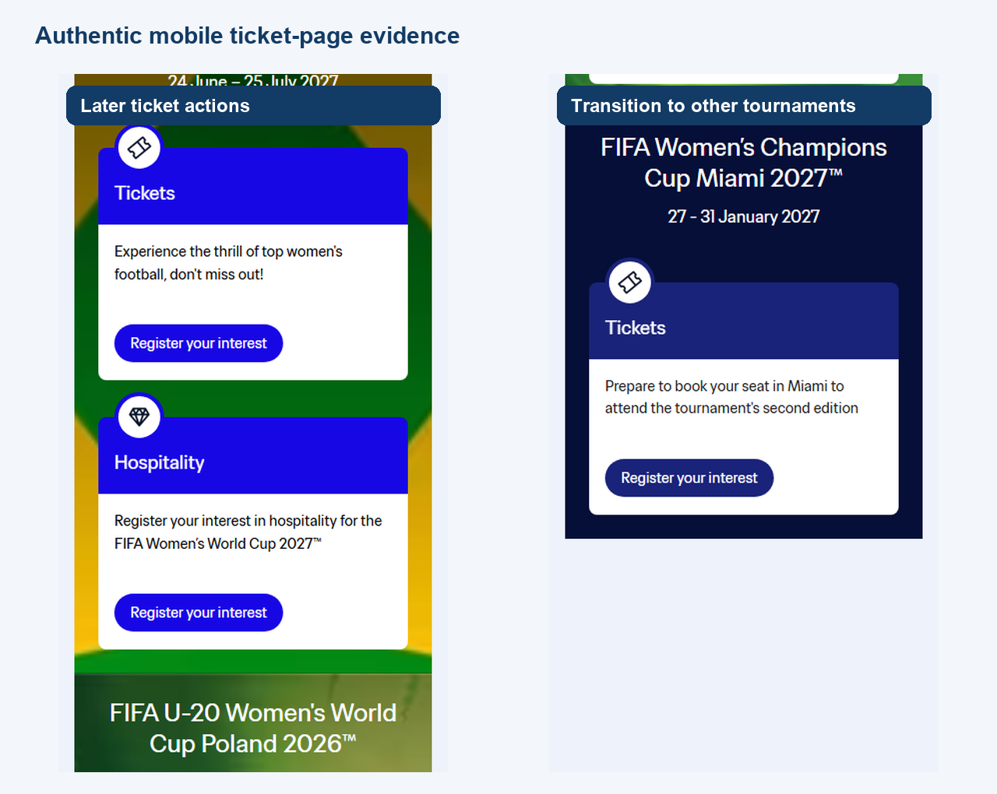
Figure UR-EV-06B. State: Mobile tickets - later action cards. Authentic crops show later ticket actions and the transition to other tournaments; they do not use footer-only content as action evidence.
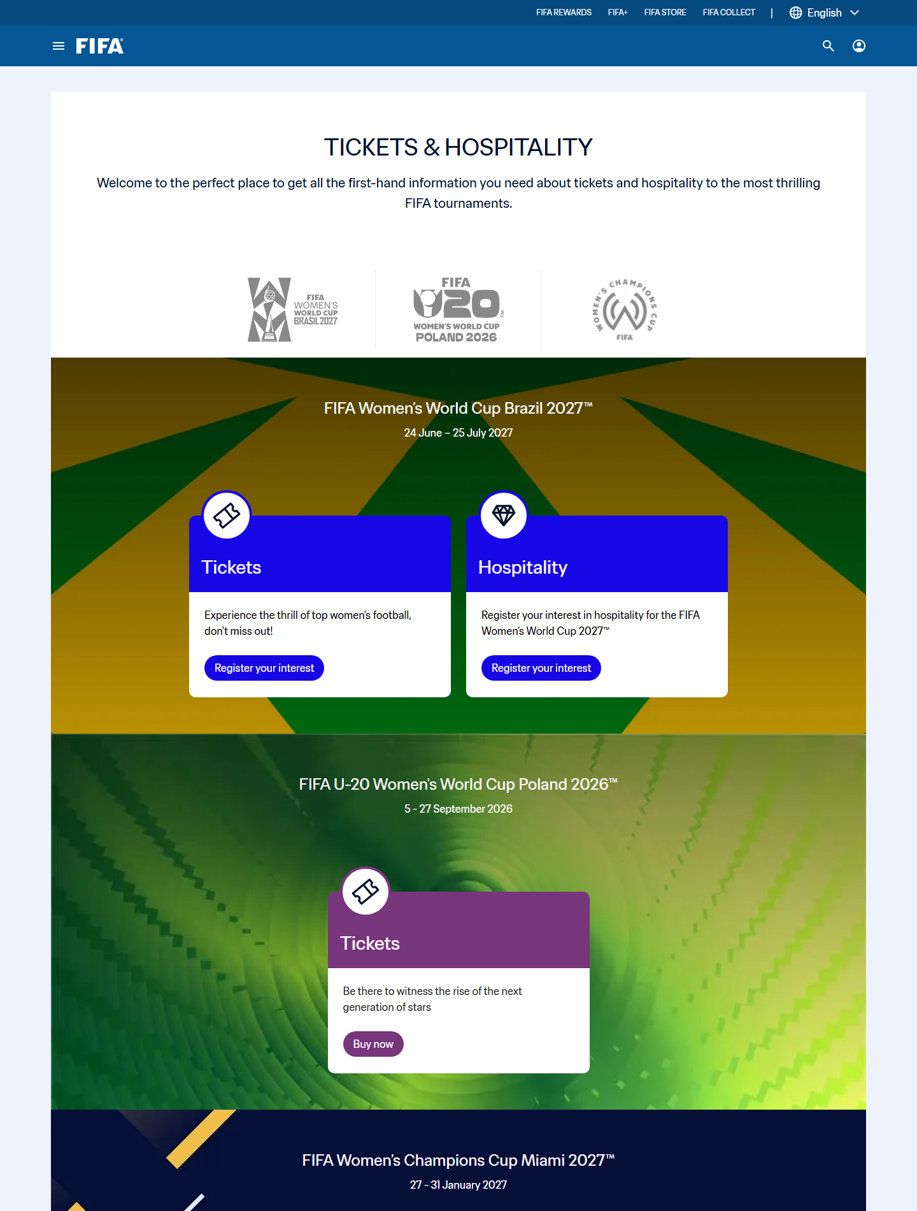
Figure UR-EV-07. State: Pre-handoff ticket route state. The captured redirect remained on FIFA Tickets & Hospitality, so this evidence documents the route before partner handoff and does not claim that a partner destination loaded.
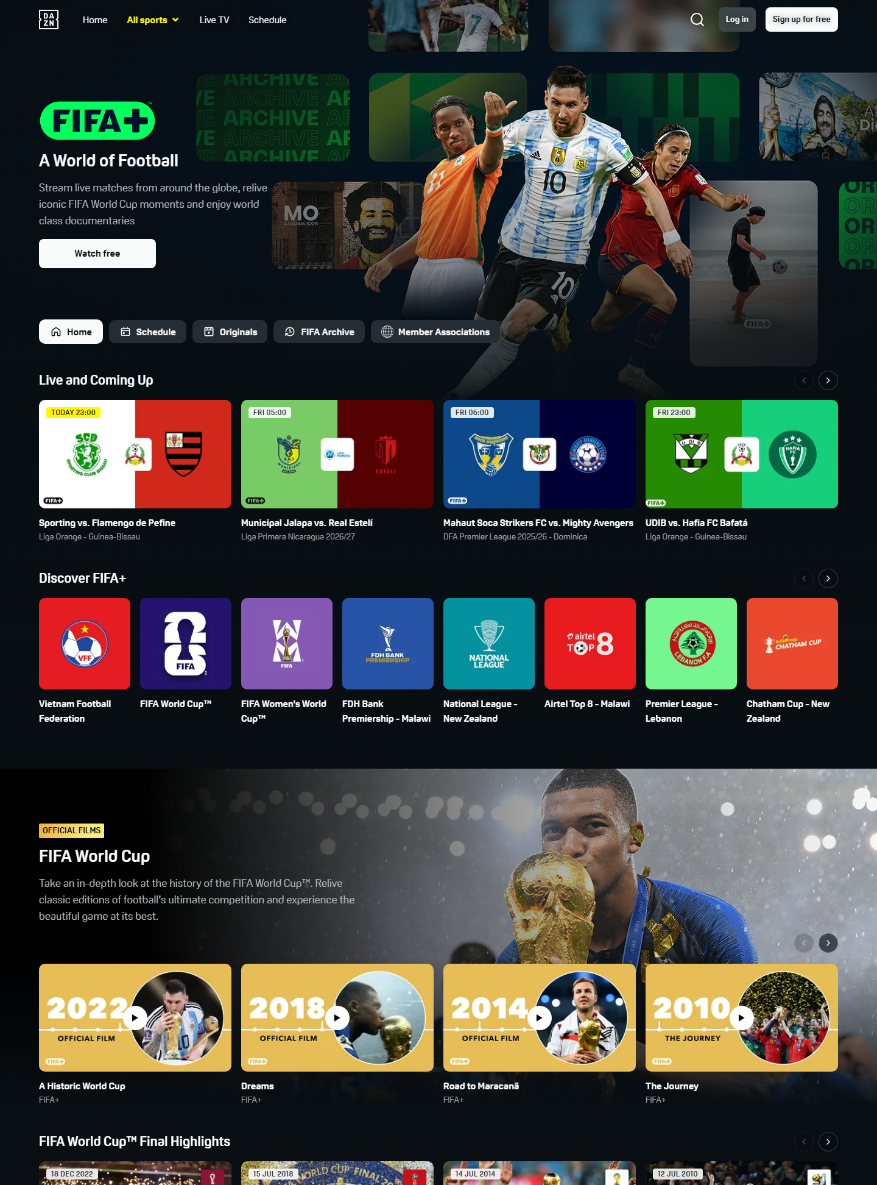
Figure UR-EV-08. State: FIFA+ destination. What is visible: External media destination and branding. Why it matters: Shows another handoff boundary. Limitation: Availability and account rules may vary.
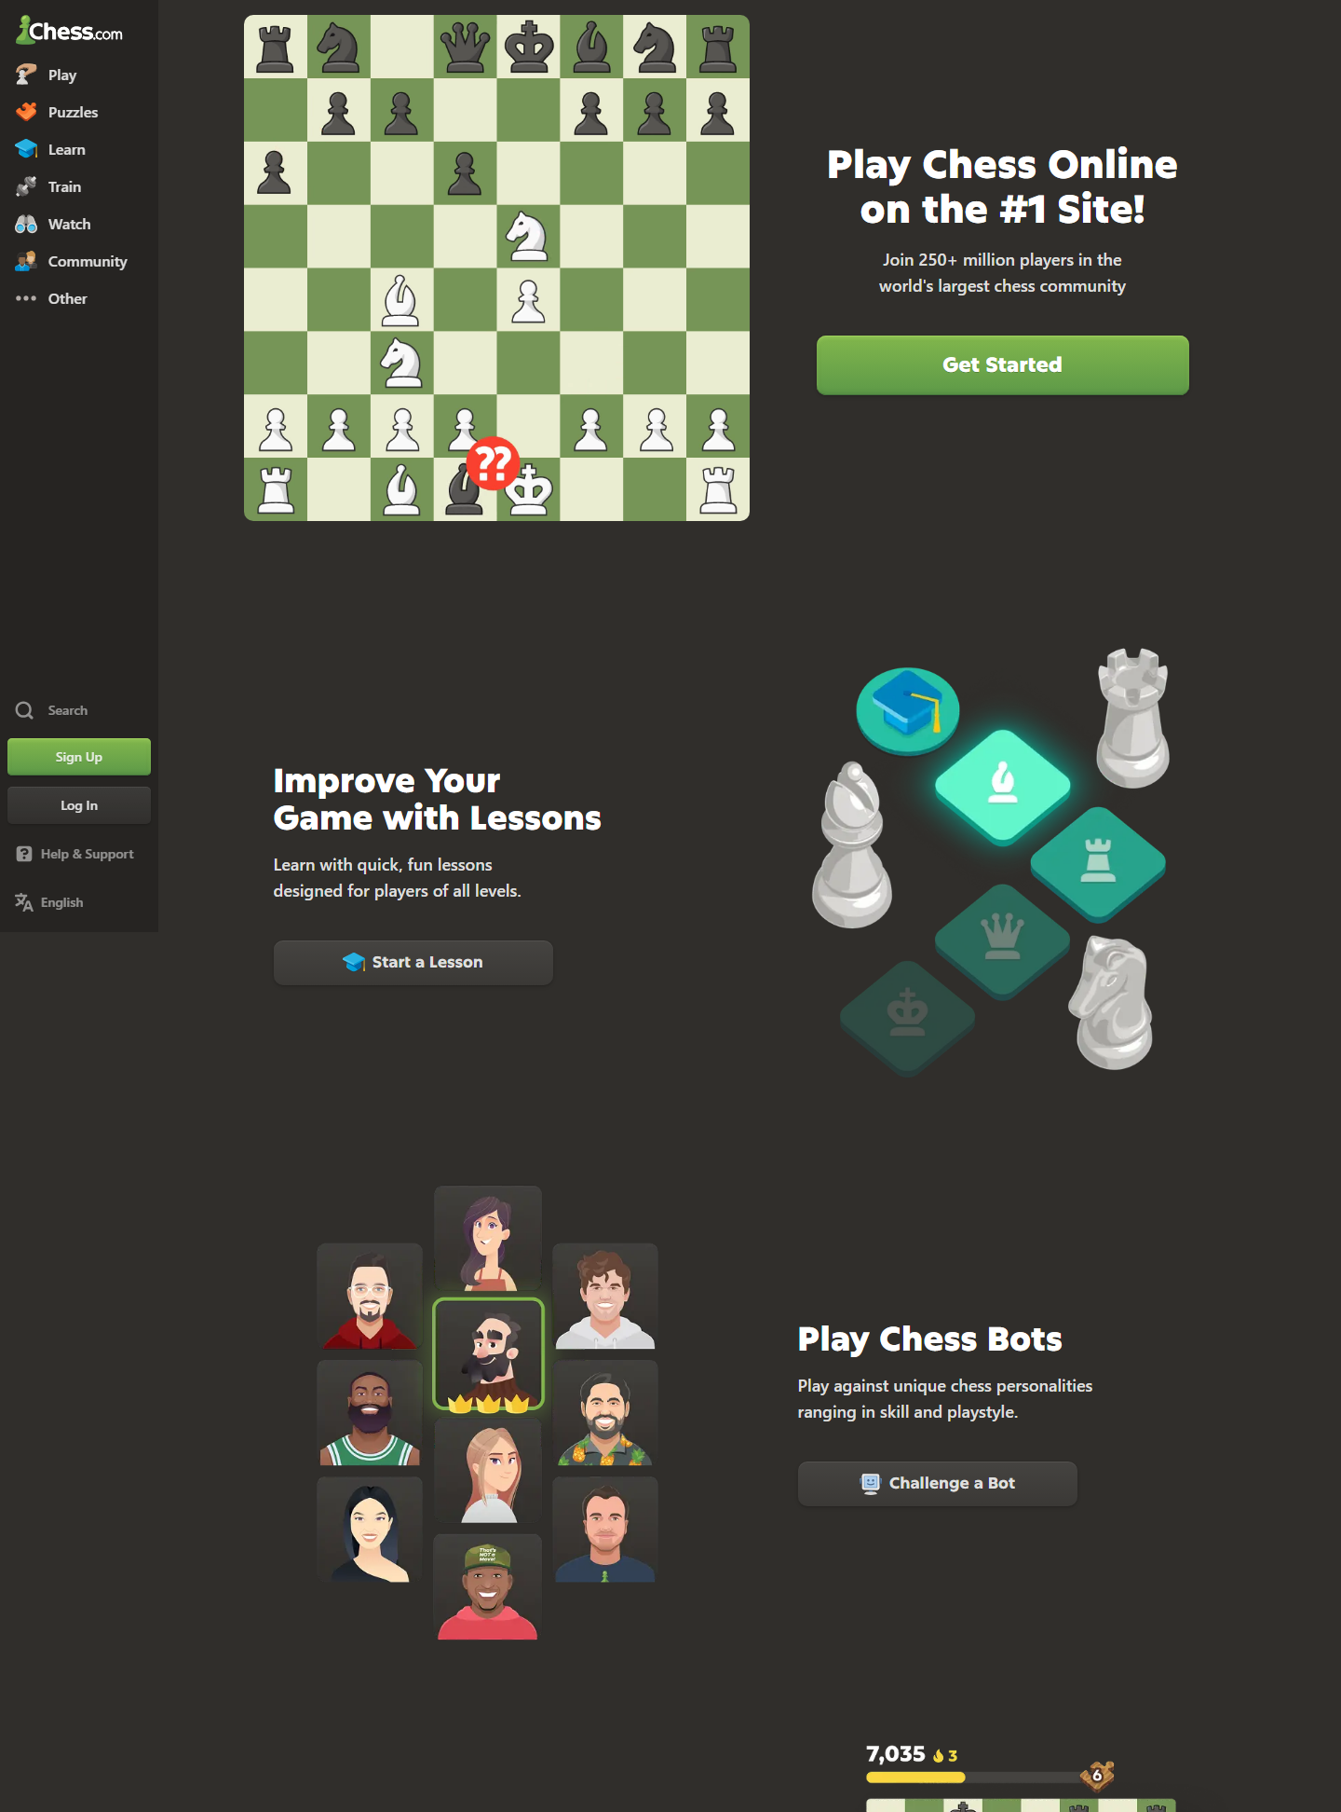
Figure UR-EV-09. State: Chess homepage. What is visible: Play and learning entry choices. Why it matters: Establishes the beginner starting point. Limitation: The capture does not measure choice difficulty.
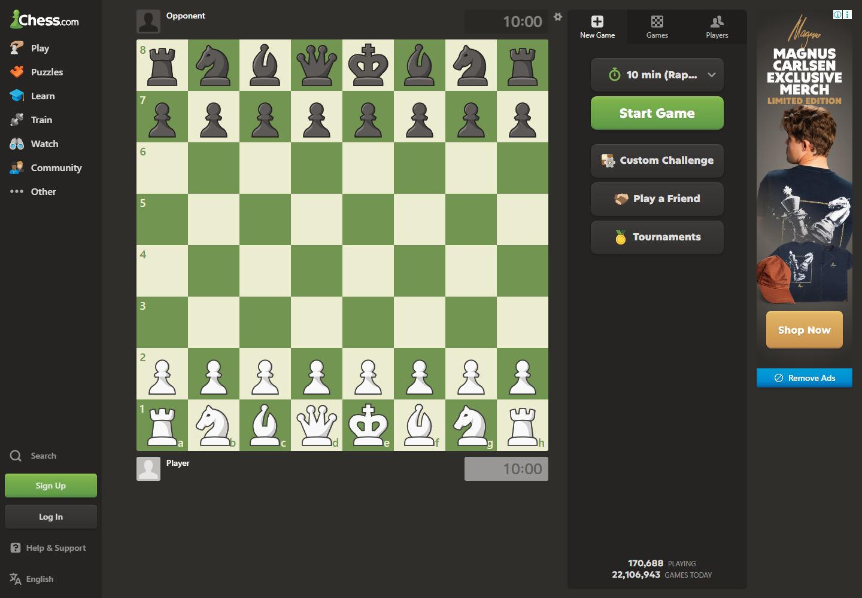
Figure UR-EV-10. State: Chess play entry. What is visible: Game-start choices and controls. Why it matters: Shows one route to a reviewable game. Limitation: A completed game is not shown.
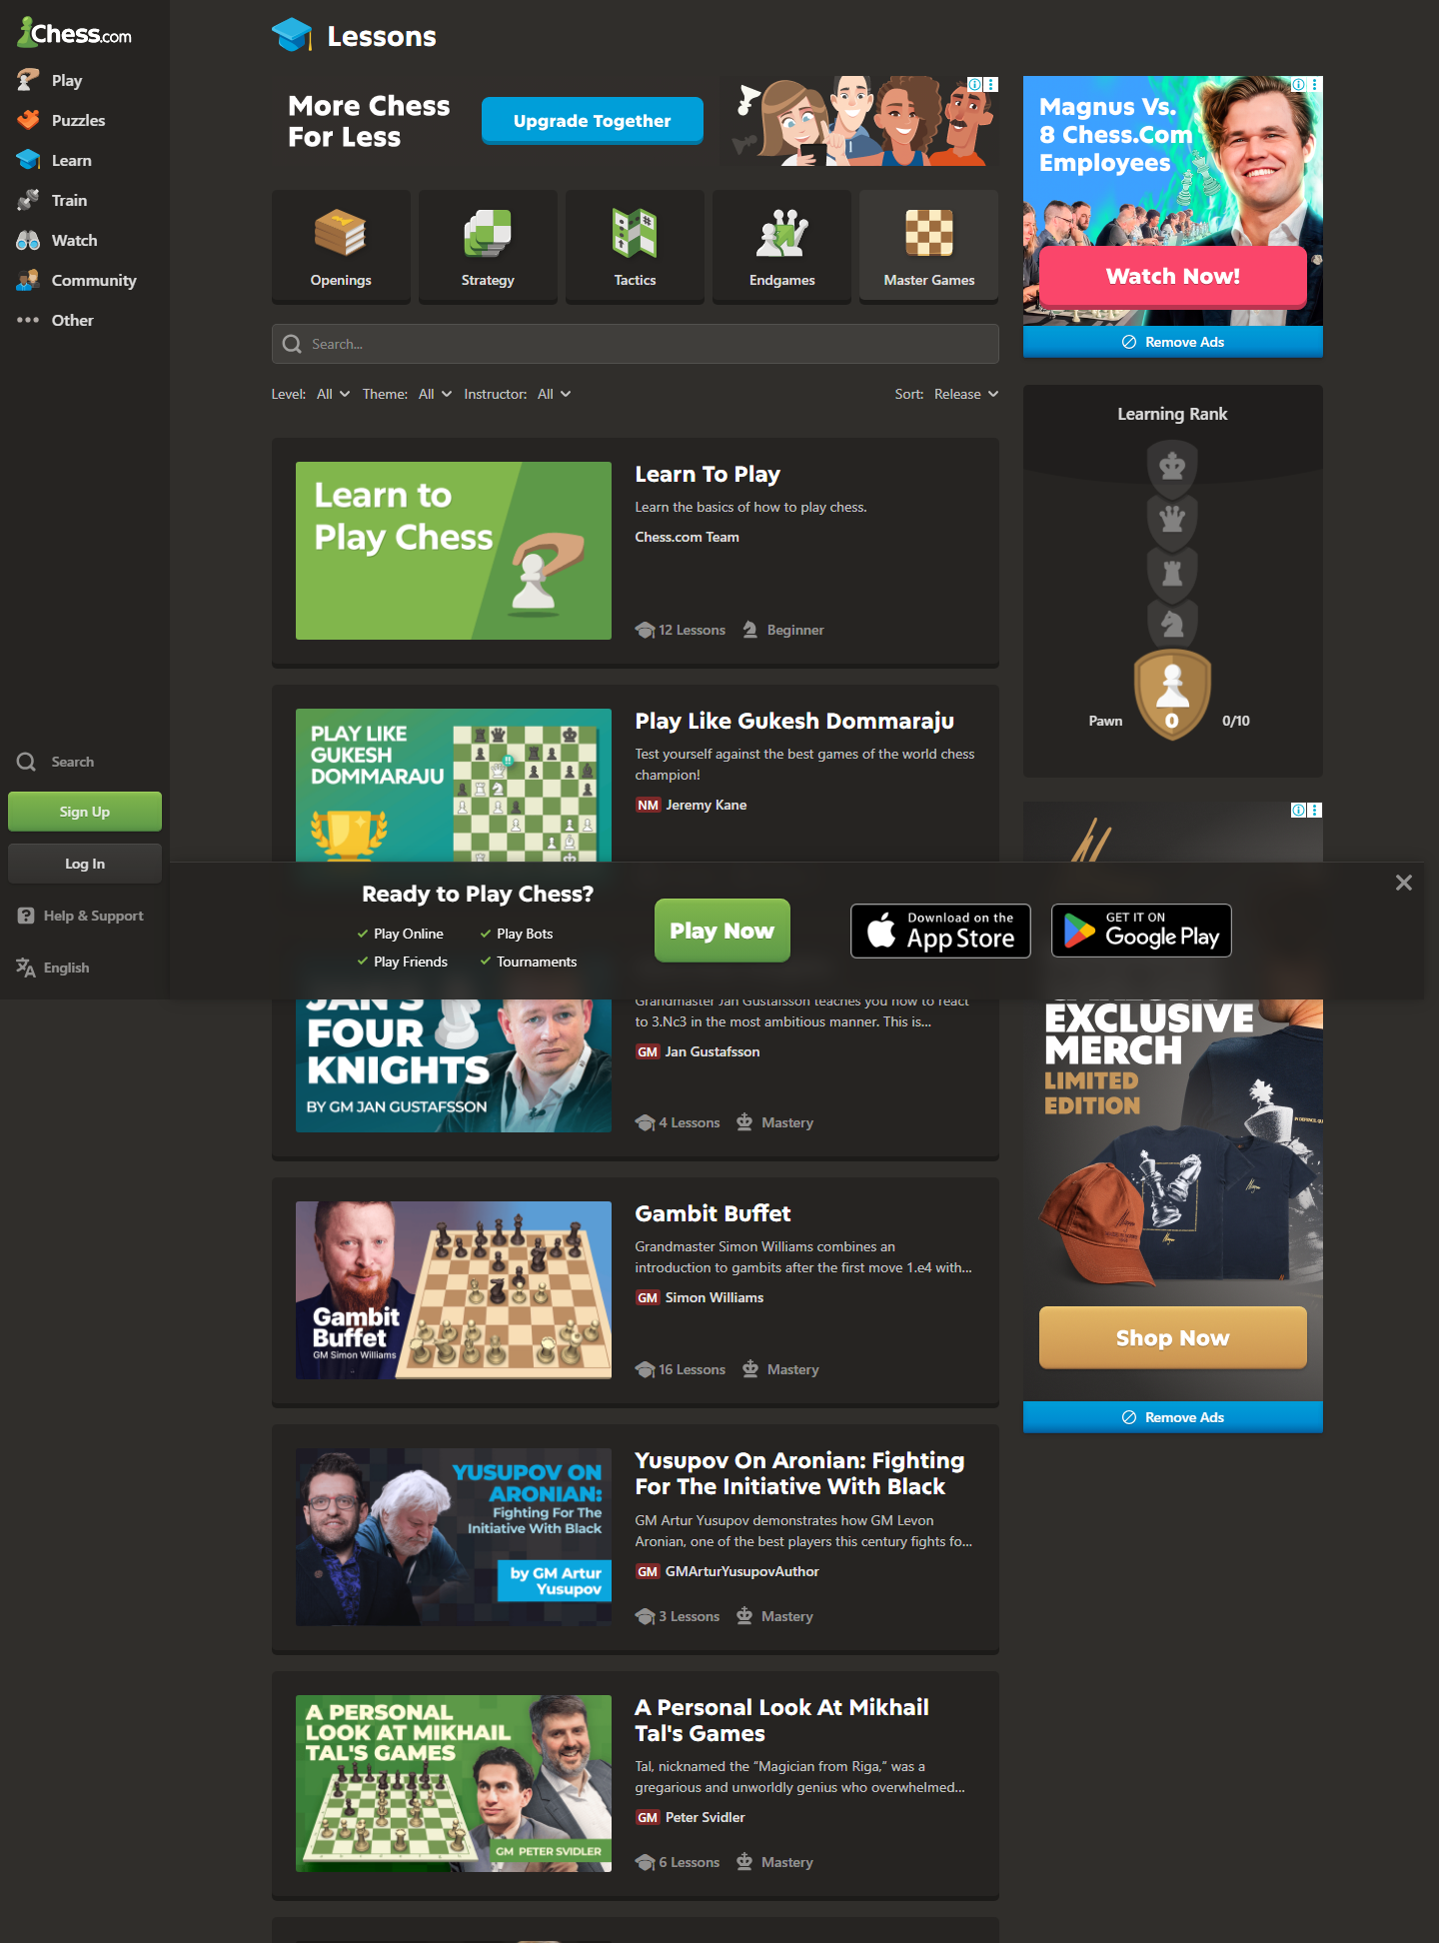
Figure UR-EV-11. State: Chess lessons. What is visible: Lesson groups and progression choices. Why it matters: Shows the learning catalog available after review. Limitation: The capture does not prove which lesson is relevant to a mistake.
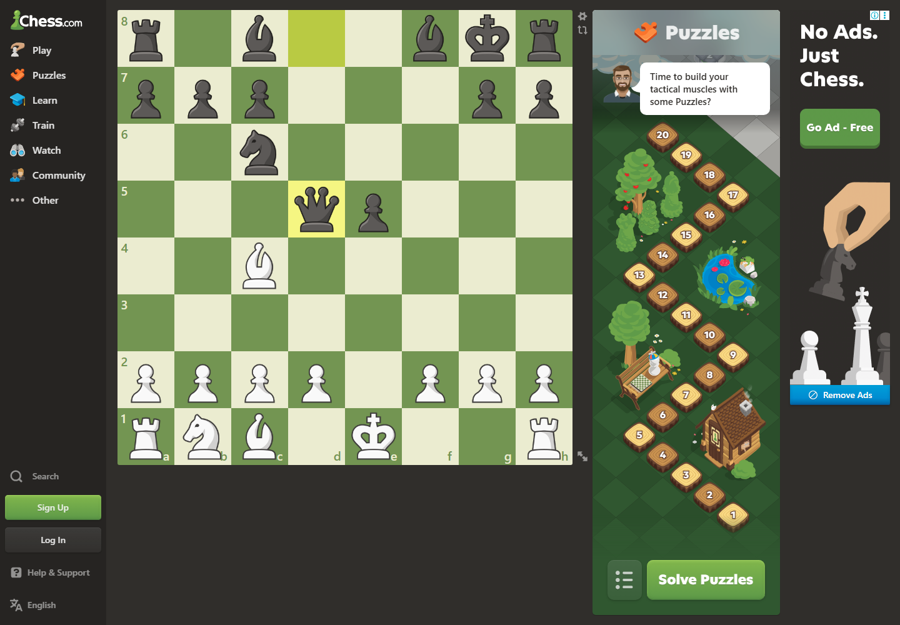
Figure UR-EV-12. State: Chess puzzle entry. What is visible: Puzzle task and practice entry. Why it matters: Shows a possible continuation action. Limitation: Relevance to a specific reviewed game is not established.
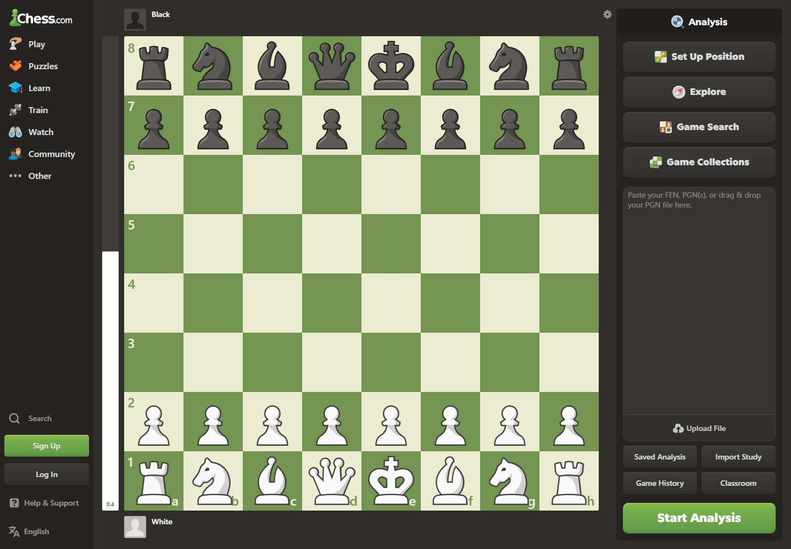
Figure UR-EV-13. State: Chess analysis entry. What is visible: Board, move list, and analysis controls. Why it matters: Shows the density a beginner must interpret. Limitation: The capture does not validate a complete Game Review journey.

9. Findings
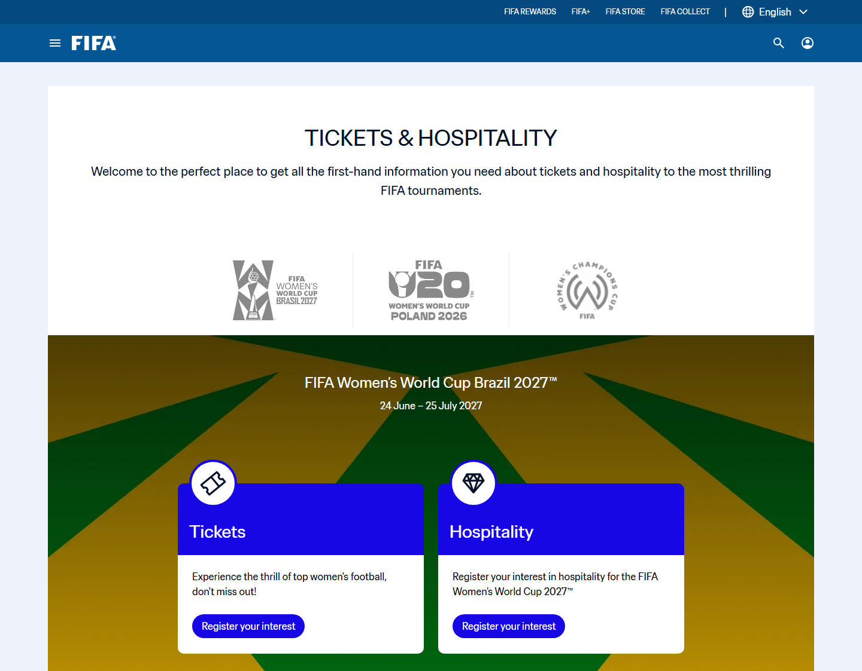
Figure UR-EV-01. FIFA ticket decision surface used by UR-F01 and UR-F02
Source: Screen evidence F2-E09; captured interface state only
Related: Ticket status clarity, freshness, handoff trust, and TP-FIFA
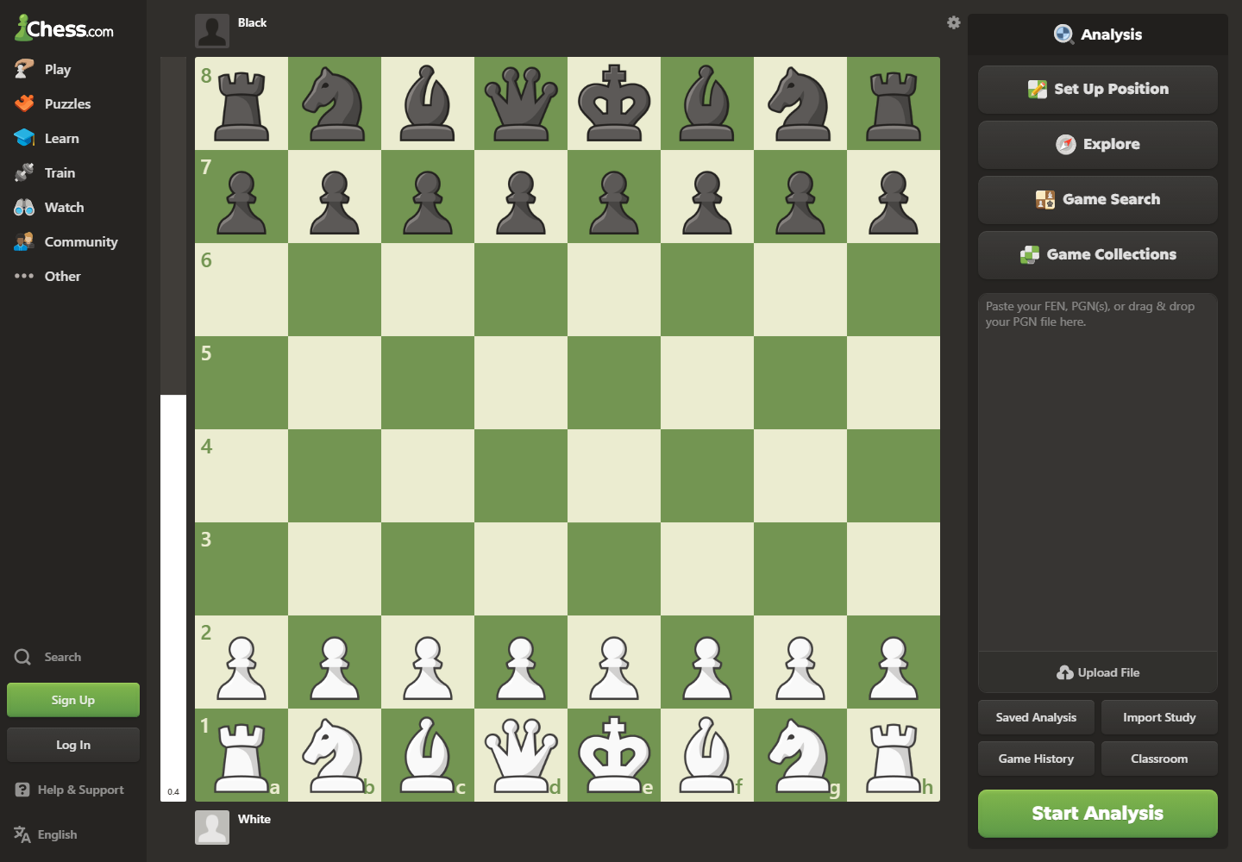
Figure UR-EV-02. Chess analysis-entry decision surface used by UR-C01 and UR-C02
Source: Screen evidence C2-E10; captured interface state only
Related: Entry choice overload, learning priority, vocabulary load, and TP-CHESS

9.1 Findings Summary
Finding | Evidence | Pattern | Design direction
UR-F01 | F2-E09; F-SIM-04/05/06 | Ticket state and freshness are separated | Show state, freshness, and next action together
UR-F02 | F2-E09; F-SIM-02/05 | Destination purpose and return path are unclear | Preview official domain, account, and return
UR-F03 | F2-E02/E03/E04; F-SIM-03/04 | Mobile browsing loses tournament context | Persist a compact tournament summary
UR-C01 | C2-E10; C-SIM-01/02/05 | Beginners face several review entries | Place Beginner Review beside the game result
UR-C02 | C2-E07/E08/E10; C-SIM-02/04/06 | Advanced detail precedes one learning priority | Show one mistake and plain-language reason first
UR-C03 | C2-E05/E07/E10; C-SIM-03/04/06 | Review does not lead to relevant practice | Link one lesson or puzzle to the mistake

10. Evidence boundary and citations
Screen evidence: F2-E02-E04 and F2-E09 support FIFA navigation/status claims; C2-E05, C2-E07-E10 support Chess learning and analysis-entry claims.
PA1 inherited finding: The product pair, drawbacks, and evidence limits remain continuous with PA1.
Simulated study: Twelve scenario records generate hypotheses and traceable synthetic metrics only.
Design inference: Effectiveness, efficiency, learnability, memorability, errors, satisfaction, visibility, recognition, progressive disclosure, control, and prevention guide the implications.
PA3 validation target: Prototype testing must replace synthetic expectations with observed user evidence.
Course basis: LN01 - Introduction - v2.pdf, pp. 20, 22, 24; LN02 - Fundamental Concepts - Usability Dimensions_2.pdf, pp. 62-67, 74-76, 83-84, 101-115; LN03 - UI Design Process.pdf, pp. 16-19, 23-24, 28-30, 34-36; LN04 - Task Analysis.pdf, pp. 3, 6-15, 39-49.

11. Revised Work Models
Each model uses a distinct shape for actor, task/artifact/system, decision, interruption, recovery, and output. The flow reads left to right. Captions identify the current state, problem point, user decision, recovery path, and design opportunity.
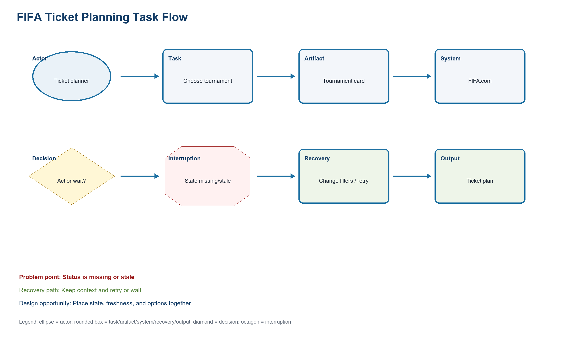
Figure UR-WM-FIFA-PLANNING. Wm Fifa Planning
Source: PA2 design QA artifact
Related: FIFA or Chess task evidence, interruption, recovery, and design opportunity
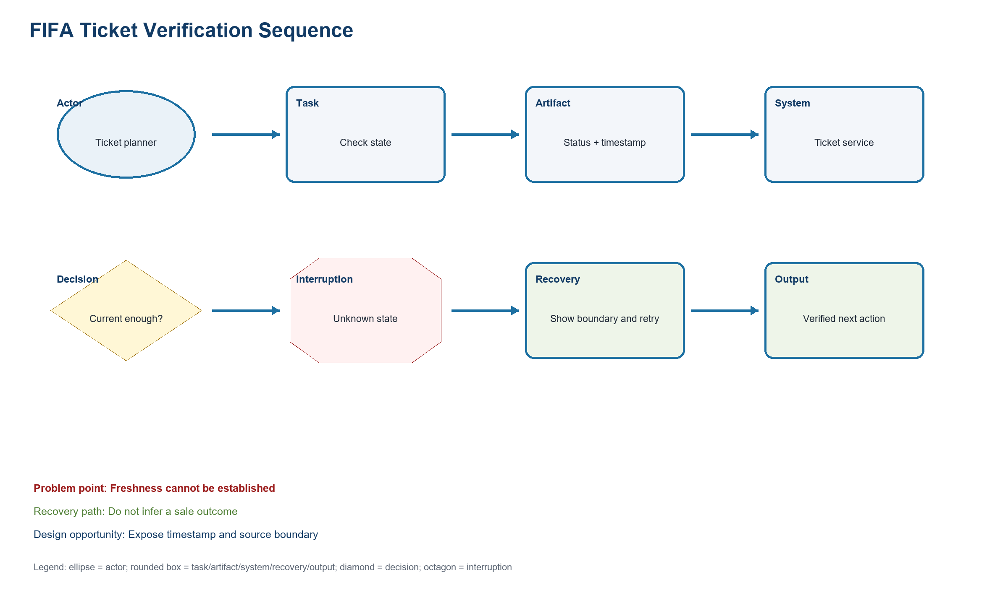
Figure UR-WM-FIFA-VERIFICATION. Wm Fifa Verification
Source: PA2 design QA artifact
Related: FIFA or Chess task evidence, interruption, recovery, and design opportunity
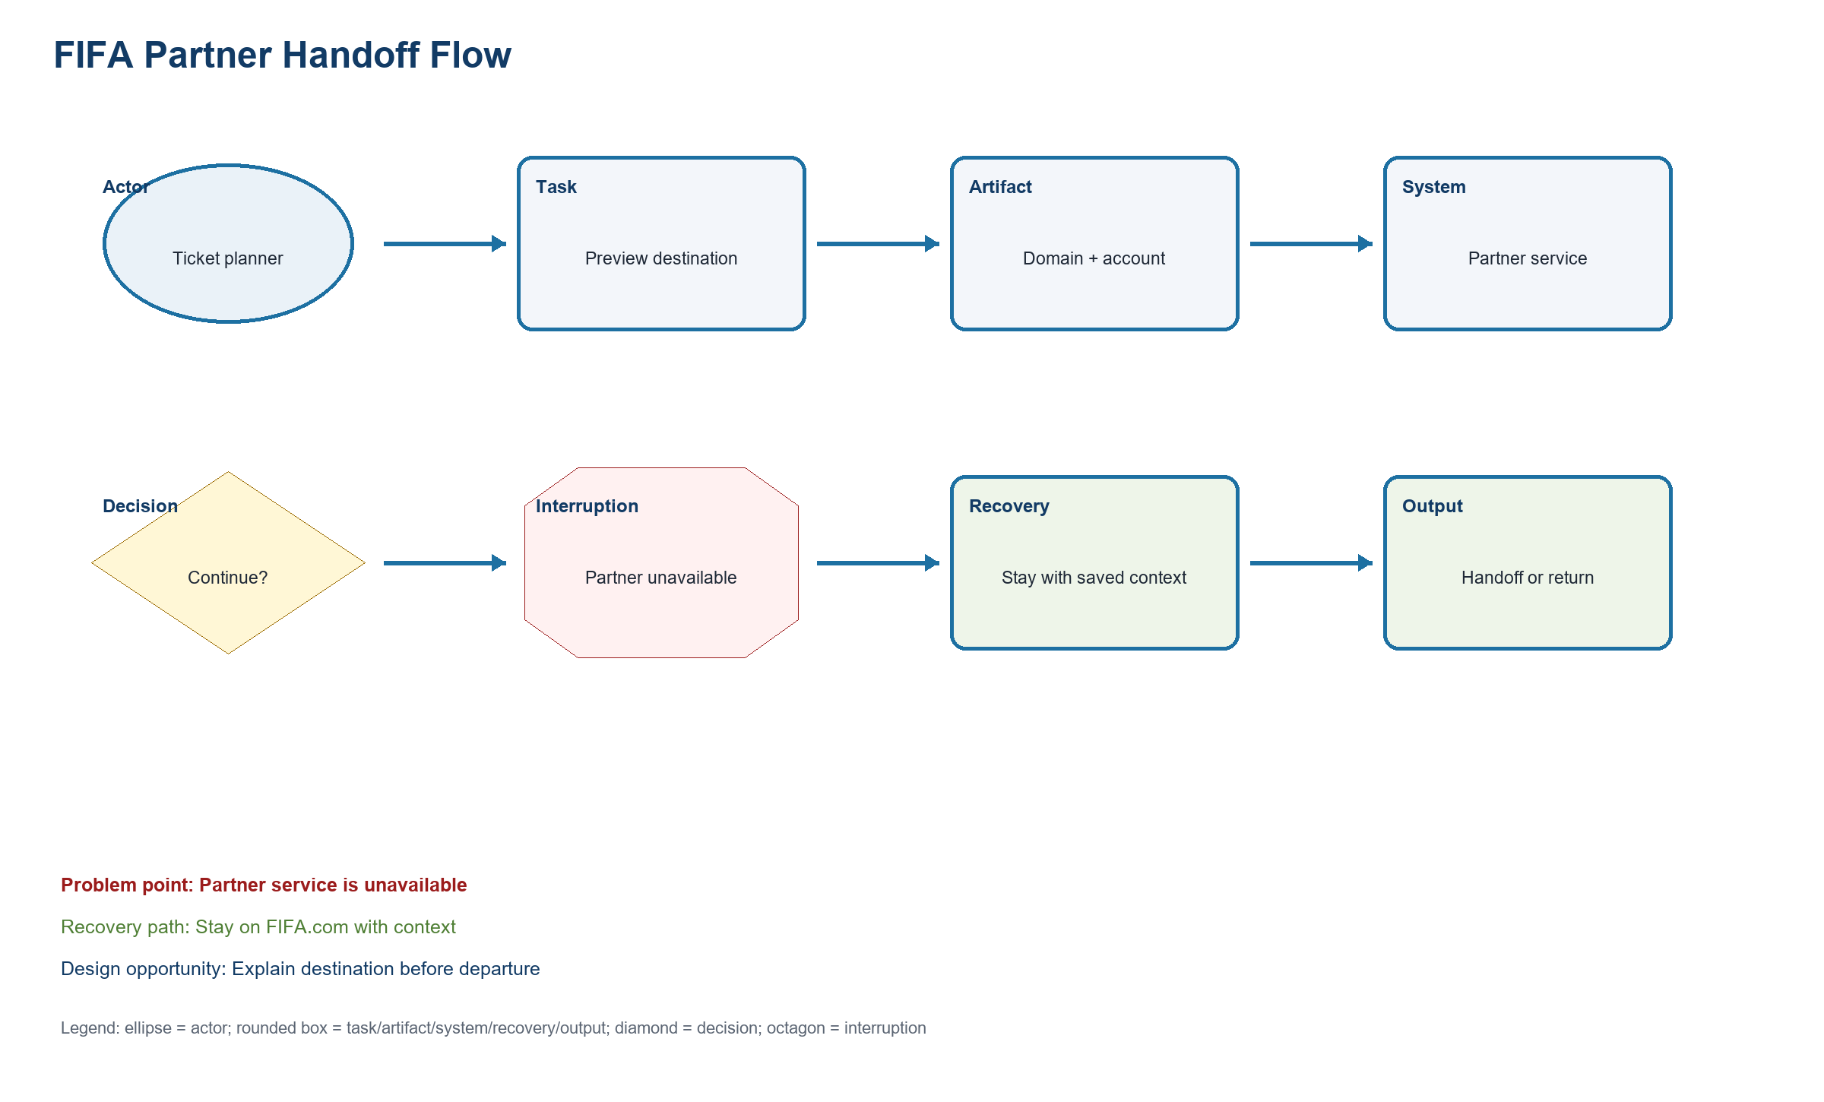
Figure UR-WM-FIFA-HANDOFF. Wm Fifa Handoff
Source: PA2 design QA artifact
Related: FIFA or Chess task evidence, interruption, recovery, and design opportunity
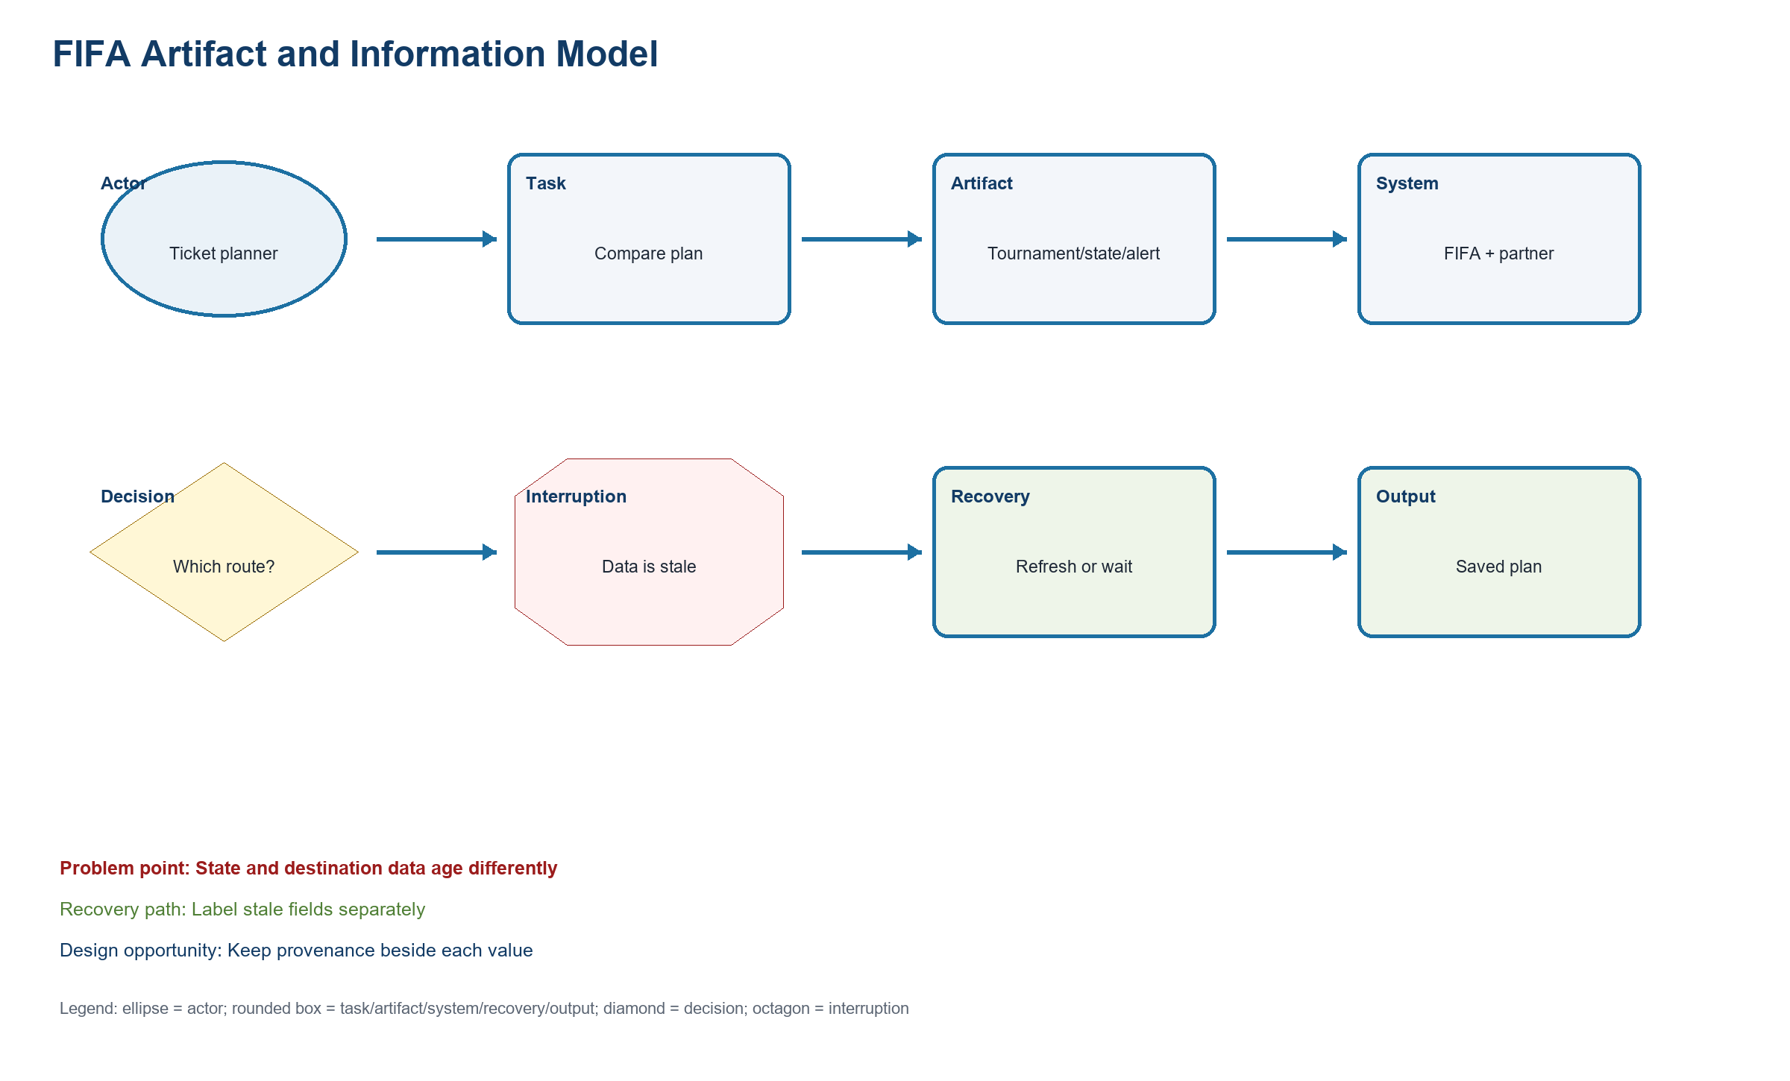
Figure UR-WM-FIFA-ARTIFACT. Wm Fifa Artifact
Source: PA2 design QA artifact
Related: FIFA or Chess task evidence, interruption, recovery, and design opportunity
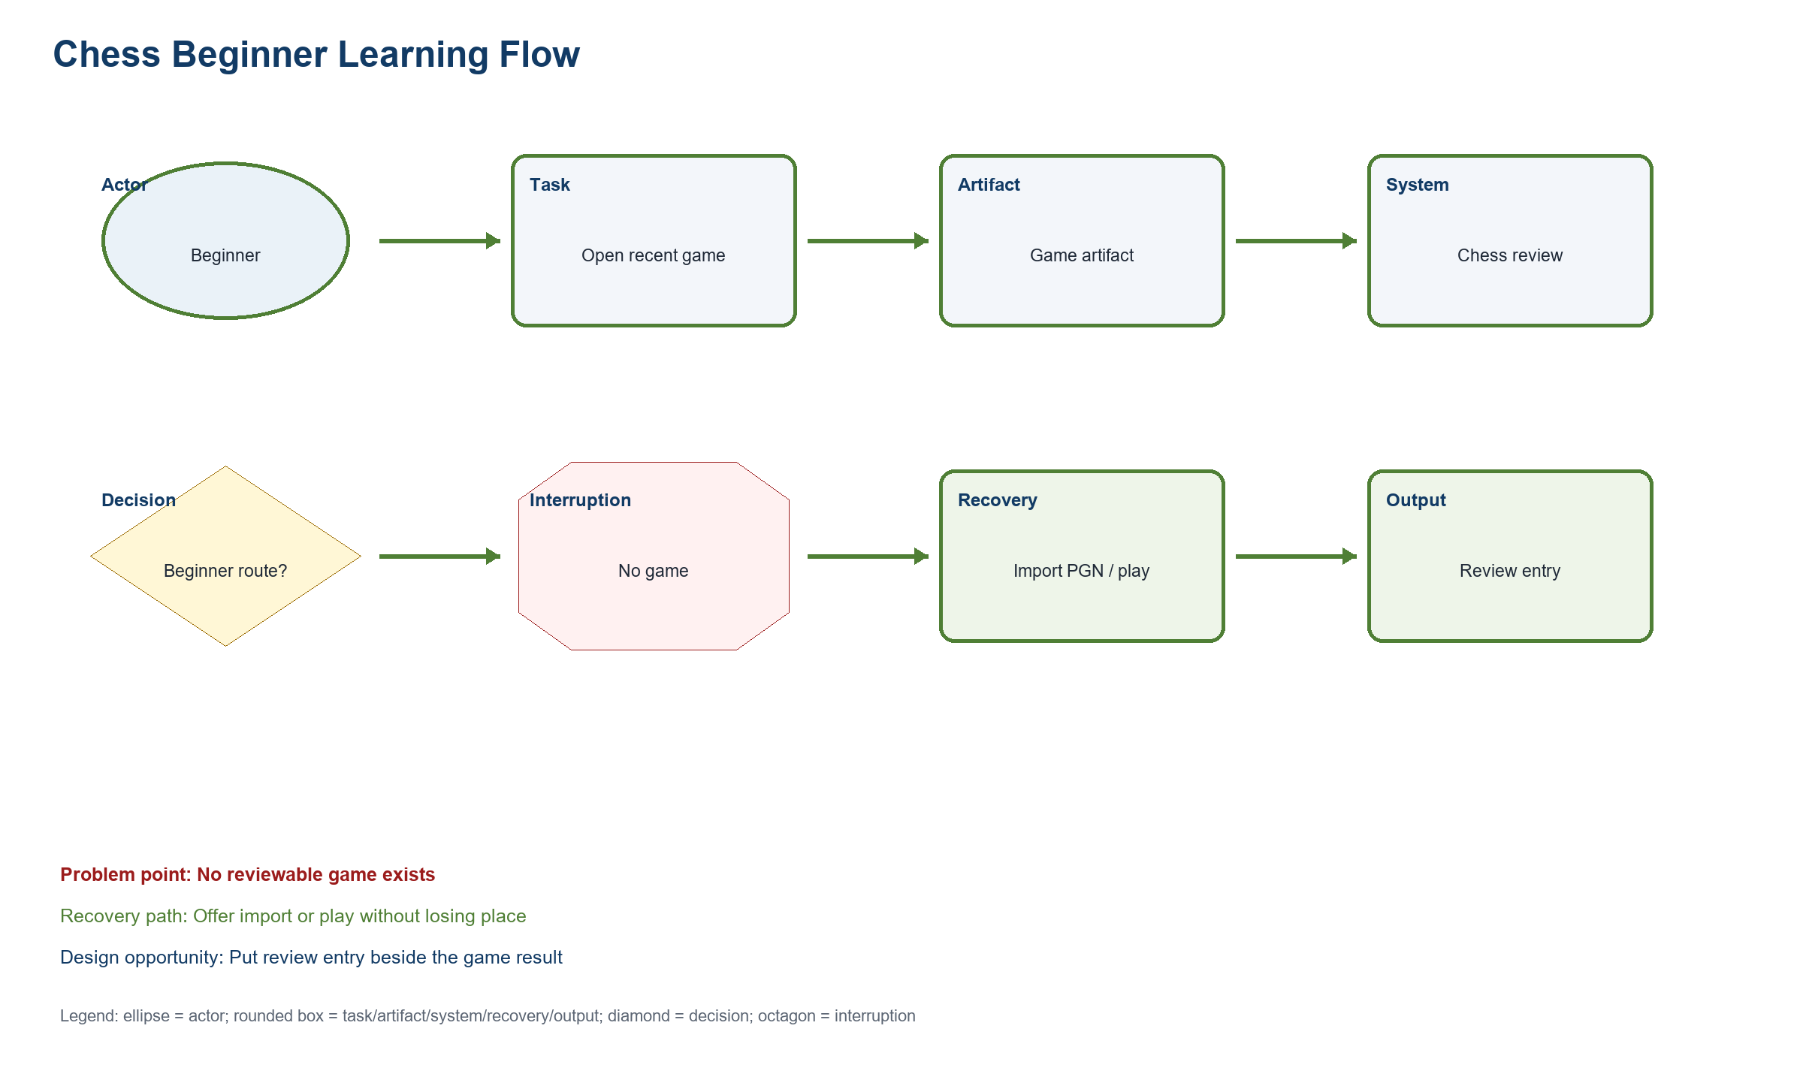
Figure UR-WM-CHESS-LEARNING. Wm Chess Learning
Source: PA2 design QA artifact
Related: FIFA or Chess task evidence, interruption, recovery, and design opportunity
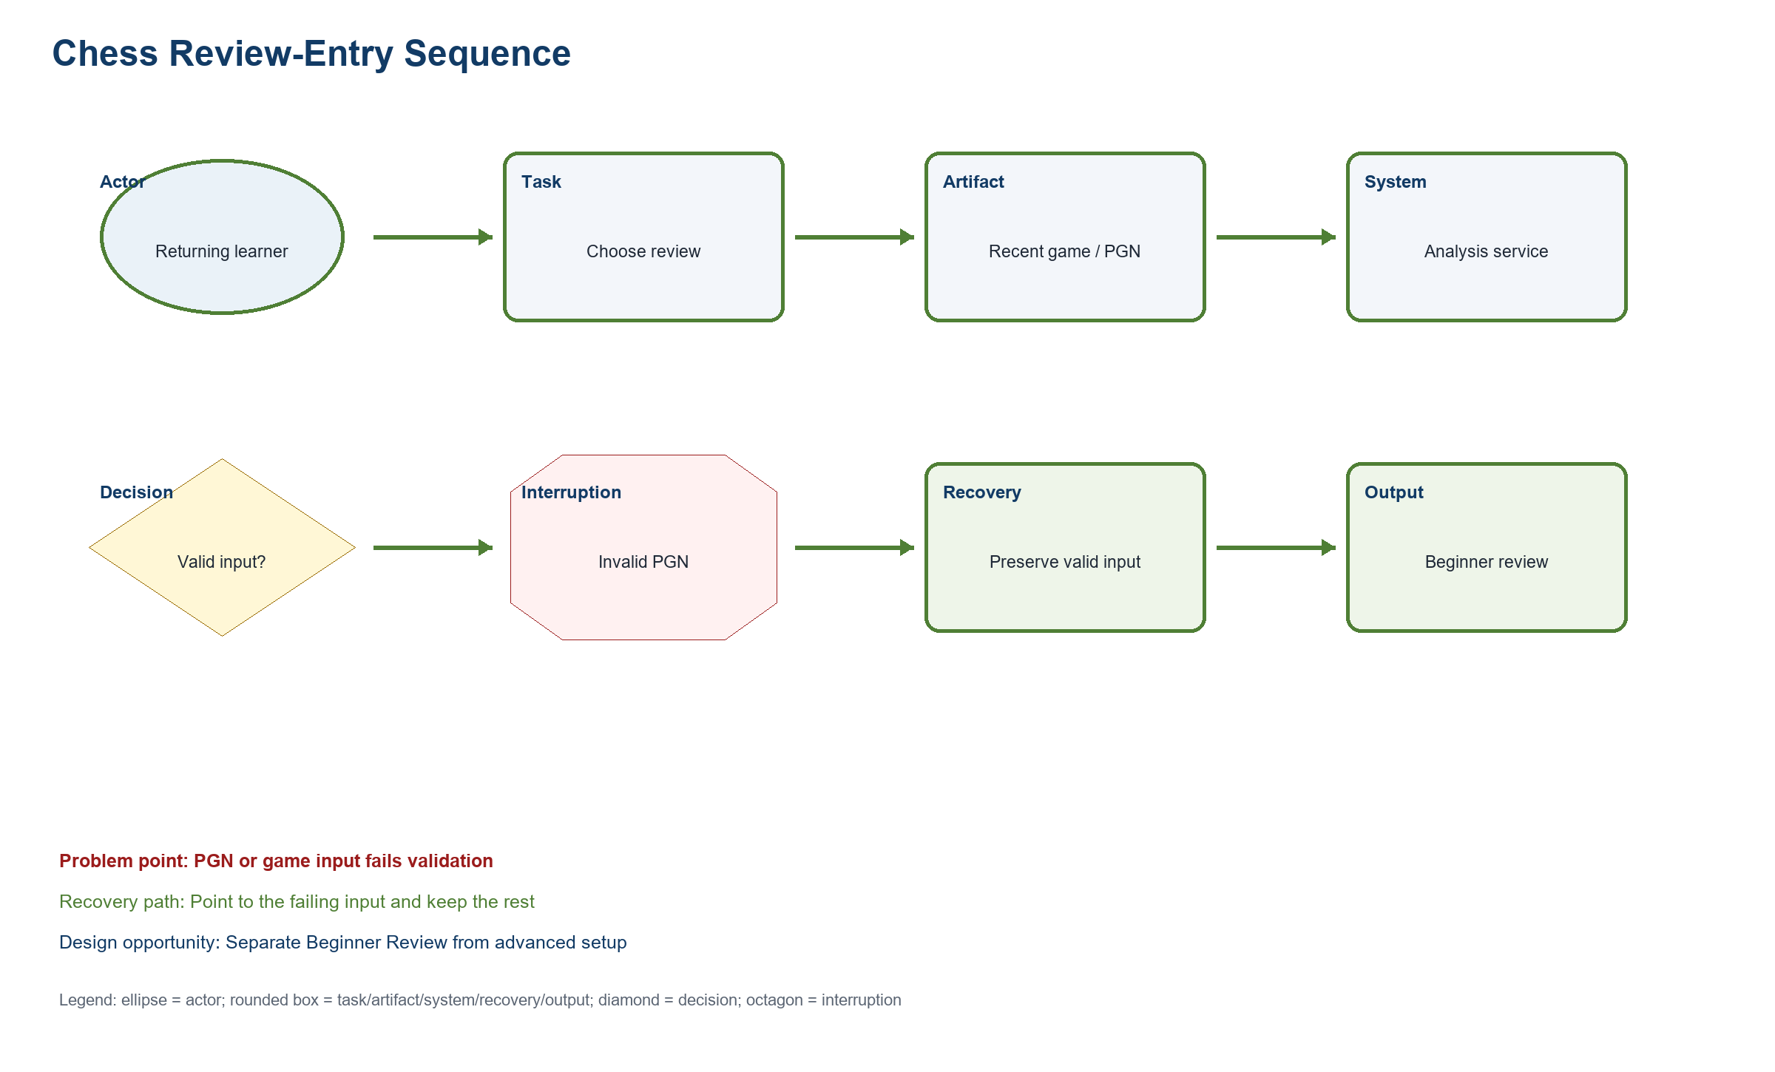
Figure UR-WM-CHESS-ENTRY. Wm Chess Entry
Source: PA2 design QA artifact
Related: FIFA or Chess task evidence, interruption, recovery, and design opportunity
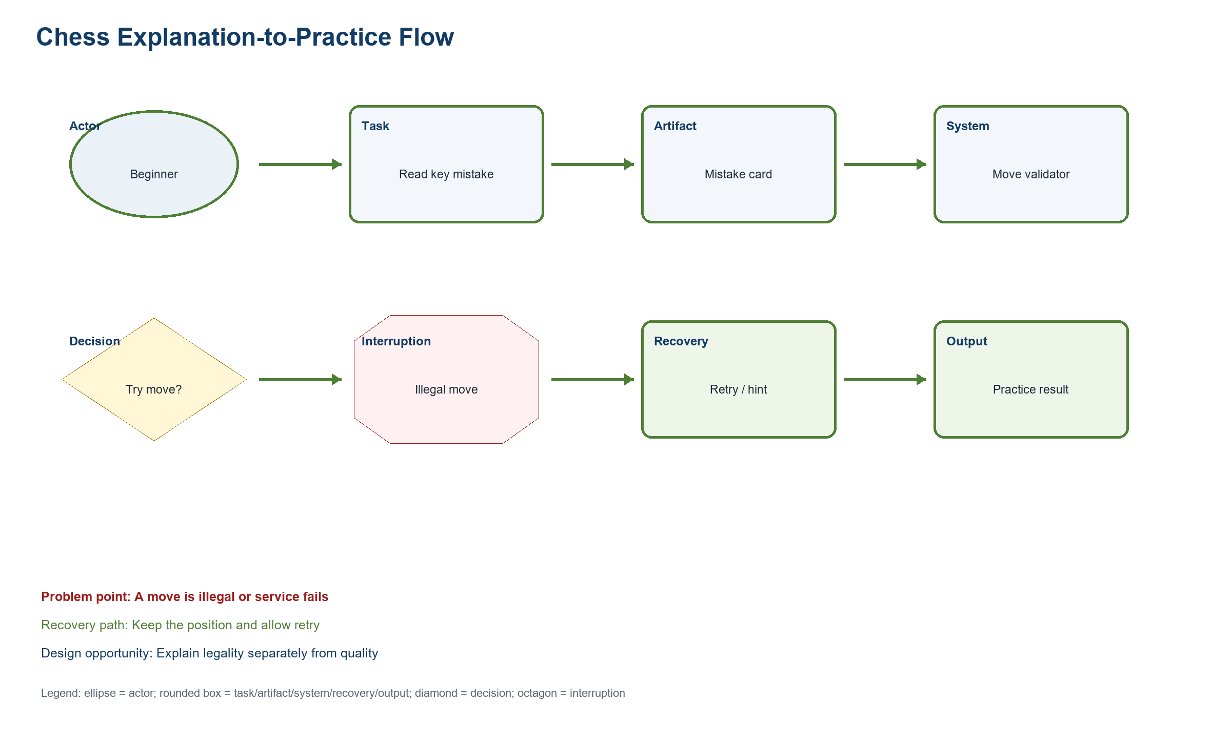
Figure UR-WM-CHESS-PRACTICE. Wm Chess Practice
Source: PA2 design QA artifact
Related: FIFA or Chess task evidence, interruption, recovery, and design opportunity
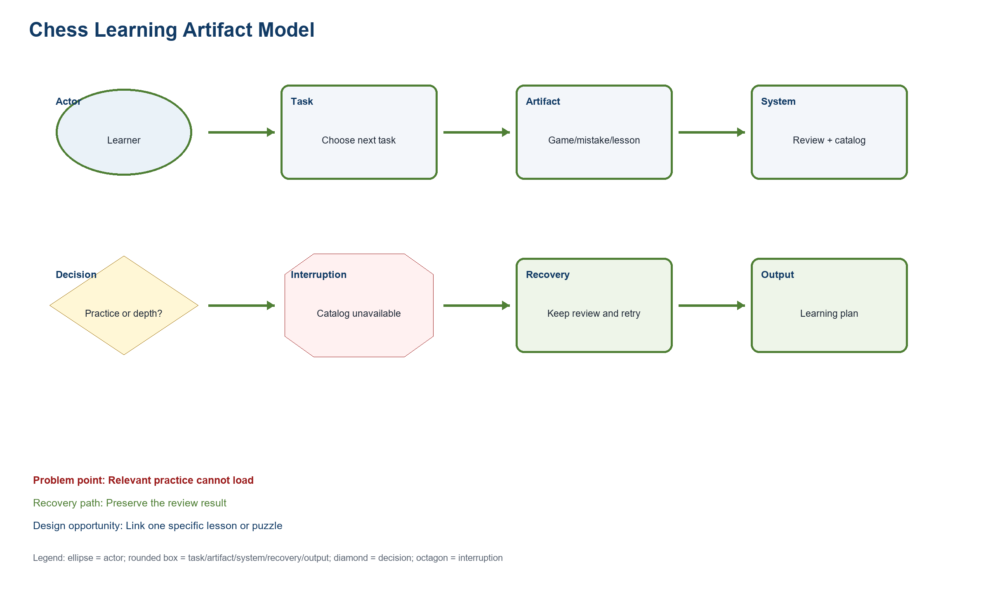
Figure UR-WM-CHESS-ARTIFACT. Wm Chess Artifact
Source: PA2 design QA artifact
Related: FIFA or Chess task evidence, interruption, recovery, and design opportunity

Work Model Coverage Checklist
Model | Trigger | System response | Decision / interruption | Recovery | Output / opportunity
FIFA ticket planning | Open ticket planning | Load tournament and route state | Act now or wait; state may be missing | Change filters or retry | Ticket plan; combine state and action
FIFA ticket verification | Inspect freshness | Return timestamp and source | Current enough; status may be unknown | Keep last labeled update and retry | Verified next action; expose provenance
FIFA partner handoff | Choose an outbound route | Preview domain and account boundary | Continue or stay; partner may fail | Stay with saved context | Handoff or return; explain destination
FIFA information model | Compare saved plan | Assemble event, state, alert, and source | Choose a route; data may be stale | Refresh only stale fields | Saved plan; keep provenance beside values
Chess beginner learning | Open a recent game | Offer Beginner Review | Choose route; no game may exist | Import PGN or play | Review entry; place action beside result
Chess review entry | Select review | Validate recent game or PGN | Valid input; PGN may fail | Correct input without losing metadata | Guided review; identify failing line
Chess explanation to practice | Open key mistake | Show reason and one practice link | Continue or reveal depth; service may fail | Retry or keep board-only view | Practice action; explain relevance
Chess learning artifact | Inspect review artifact | Link position, reason, lesson, and depth | Choose next artifact; content may be unavailable | Return to saved game | Learning path; preserve beginner focus

12. Practical Difficulties and Lessons Learned
Practical difficulty | How the group handled it | Lesson learned | Impact on the final version
Screenshots did not always show the state needed for a claim. | The group separated captured state from simulated behavior and design inference. | A screenshot proves only the visible state and capture time. | Claims now name their evidence boundary and recovery assumptions.
Desktop and mobile pages expose different ordering and page length. | The group used separate mobile evidence and task models. | Cross-device continuity must be specified as a requirement. | The revised models preserve tournament/game context during recovery.

Appendix A - Twelve Detailed Simulated Note Sheets

A.1 Note sheet F-SIM-01
Simulated observation: F-SES-01 - 16 Jul 2026 - 28 min; structured notes only; no audio/video.

Field | Record
Participant profile | Simulated participant F-SIM-01; Casual football fan; 18-24; Android phone; motivation: Find ticket entry without planning expertise; constraint: Limited time and data; accessibility: Large tap targets
Task | F1, F2, F4, F5
Action sequence | Opens menu, scrolls to Tickets & Hospitality, returns to Match Centre, then reopens ticket page.
Hesitation point | Pauses at tournament cards with different CTA wording.
Visible interface trigger | Tickets & Hospitality card and tournament status text.
Inferred mental model | Ticket page should give one current action.
Simulated quote | “I can find tickets, but I still do not know what is open.”
Simulated task result | Partial success
Workaround | Uses Match Centre as a comparison anchor.
Design opportunity | Show state, freshness, and next action together.
Limitation | Scenario-based; no live sale data.
PA3 validation target: Test whether the proposed response reduces the hesitation in F-SES-01 without hiding needed control.

A.2 Note sheet F-SIM-02
Simulated observation: F-SES-02 - 16 Jul 2026 - 31 min; structured notes only; no audio/video.

Field | Record
Participant profile | Simulated participant F-SIM-02; Casual football fan; 25-34; Windows laptop + phone; motivation: Compare match and ticket status; constraint: Avoids creating accounts early; accessibility: High contrast
Task | F1-F6
Action sequence | Finds Match Centre quickly, compares schedule, opens ticket entry, then checks destination preview.
Hesitation point | Hesitates before the external handoff.
Visible interface trigger | Match Centre filters and partner CTA.
Inferred mental model | An official domain preview should precede departure.
Simulated quote | “The schedule is clear; the handoff is the risky part.”
Simulated task result | Success with hesitation
Workaround | Opens destination in a second tab.
Design opportunity | Keep tournament context and return route.
Limitation | Scenario-based; partner response not tested.
PA3 validation target: Test whether the proposed response reduces the hesitation in F-SES-02 without hiding needed control.

A.3 Note sheet F-SIM-03
Simulated observation: F-SES-03 - 17 Jul 2026 - 30 min; structured notes only; no audio/video.

Field | Record
Participant profile | Simulated participant F-SIM-03; Tournament follower; 25-34; iPhone; motivation: Coordinate a group trip; constraint: Needs fast resumption; accessibility: Text zoom
Task | F1-F6
Action sequence | Selects tournament, saves context mentally, moves to phone view, and searches for the same state.
Hesitation point | Loses orientation after the mobile stack changes order.
Visible interface trigger | Long mobile tournament-card stack.
Inferred mental model | Mobile should restore the selected tournament first.
Simulated quote | “I want the same tournament to stay at the top.”
Simulated task result | Partial success
Workaround | Uses page search and browser history.
Design opportunity | Persist context across devices.
Limitation | Scenario-based; account synchronization assumed.
PA3 validation target: Test whether the proposed response reduces the hesitation in F-SES-03 without hiding needed control.

A.4 Note sheet F-SIM-04
Simulated observation: F-SES-04 - 17 Jul 2026 - 34 min; structured notes only; no audio/video.

Field | Record
Participant profile | Simulated participant F-SIM-04; Tournament follower; 35-44; MacBook + Android phone; motivation: Connect schedule context to ticket action; constraint: Many open tabs; accessibility: Keyboard access on laptop
Task | F1-F6
Action sequence | Uses Match Centre filters, opens ticket card, checks freshness, then returns.
Hesitation point | Questions whether the status changed since the last visit.
Visible interface trigger | Status label without a prominent timestamp.
Inferred mental model | Current state requires visible provenance.
Simulated quote | “Is this from today or from the last sale window?”
Simulated task result | Failure on freshness
Workaround | Refreshes and compares wording.
Design opportunity | Display updated time and governed source.
Limitation | Scenario-based; timestamp policy unknown.
PA3 validation target: Test whether the proposed response reduces the hesitation in F-SES-04 without hiding needed control.

A.5 Note sheet F-SIM-05
Simulated observation: F-SES-05 - 18 Jul 2026 - 33 min; structured notes only; no audio/video.

Field | Record
Participant profile | Simulated participant F-SIM-05; Trust-sensitive ticket planner; 35-44; Windows laptop; motivation: Avoid unofficial or stale destinations; constraint: Needs provenance before leaving site; accessibility: Clear status text, not color alone
Task | F1-F6
Action sequence | Compares buy, wait, resale, and hospitality paths before choosing to stay.
Hesitation point | Stops when official destination is not explained.
Visible interface trigger | Multiple commercial paths and outbound CTA.
Inferred mental model | Departure requires trust evidence and safe cancellation.
Simulated quote | “I will not leave until I know where this goes.”
Simulated task result | Success by choosing stay
Workaround | Copies the domain name for separate checking.
Design opportunity | Preview destination, purpose, and return behavior.
Limitation | Scenario-based; no transaction attempted.
PA3 validation target: Test whether the proposed response reduces the hesitation in F-SES-05 without hiding needed control.

A.6 Note sheet F-SIM-06
Simulated observation: F-SES-06 - 18 Jul 2026 - 35 min; structured notes only; no audio/video.

Field | Record
Participant profile | Simulated participant F-SIM-06; Trust-sensitive ticket planner; 45-54; Android phone; motivation: Know whether to buy, wait, or register interest; constraint: Low confidence after handoff; accessibility: Plain language and persistent focus
Task | F1-F6
Action sequence | Finds ticket page, encounters missing state, retries on variable network, then subscribes conceptually.
Hesitation point | Cannot distinguish missing from sold out.
Visible interface trigger | Empty or stale status region.
Inferred mental model | Missing data is not a ticket outcome.
Simulated quote | “No status should not look like no tickets.”
Simulated task result | Recovered after retry
Workaround | Returns to homepage and tries again.
Design opportunity | Differentiate missing, stale, sold out, and waiting room.
Limitation | Scenario-based; notification permission simulated.
PA3 validation target: Test whether the proposed response reduces the hesitation in F-SES-06 without hiding needed control.

A.7 Note sheet C-SIM-01
Simulated observation: C-SES-01 - 16 Jul 2026 - 29 min; structured notes only; no audio/video.

Field | Record
Participant profile | Simulated participant C-SIM-01; First-time beginner; 18-24; Android phone; motivation: Choose a safe beginner route; constraint: Unfamiliar analysis terms; accessibility: Plain language
Task | C1-C3, C7-C9
Action sequence | Chooses Learn, continues a lesson, solves a puzzle, then looks for review.
Hesitation point | Opens several analysis entry choices.
Visible interface trigger | Learn cards, puzzle board, analysis entry menu.
Inferred mental model | Review should start with a beginner preset.
Simulated quote | “Which button tells me what I did wrong?”
Simulated task result | Partial success
Workaround | Returns to the completed game screen.
Design opportunity | Offer one labeled beginner route.
Limitation | Scenario-based; no engine output claimed.
PA3 validation target: Test whether the proposed response reduces the hesitation in C-SES-01 without hiding needed control.

A.8 Note sheet C-SIM-02
Simulated observation: C-SES-02 - 16 Jul 2026 - 32 min; structured notes only; no audio/video.

Field | Record
Participant profile | Simulated participant C-SIM-02; First-time beginner; 25-34; Windows laptop; motivation: Understand one mistake; constraint: Fears breaking the position; accessibility: Keyboard-only path
Task | C1-C9
Action sequence | Uses keyboard to open a game, selects beginner review, tries a move, and reads help.
Hesitation point | Focus order reaches advanced controls before explanation.
Visible interface trigger | Analysis controls and terminology links.
Inferred mental model | The main mistake should precede advanced depth.
Simulated quote | “I found analysis, but not the first thing to learn.”
Simulated task result | Success with wrong path
Workaround | Uses Tab and headings to relocate.
Design opportunity | Order content by learning priority.
Limitation | Scenario-based; keyboard path modeled.
PA3 validation target: Test whether the proposed response reduces the hesitation in C-SES-02 without hiding needed control.

A.9 Note sheet C-SIM-03
Simulated observation: C-SES-03 - 17 Jul 2026 - 27 min; structured notes only; no audio/video.

Field | Record
Participant profile | Simulated participant C-SIM-03; Returning learner; 18-24; iPhone; motivation: Resume without relearning navigation; constraint: Forgets feature locations; accessibility: Text zoom
Task | C1-C3, C5-C9
Action sequence | Recognizes puzzles, resumes a lesson, opens a completed game, then searches for analysis.
Hesitation point | Forgets the name of the review feature.
Visible interface trigger | Navigation labels and game actions.
Inferred mental model | Returning learners recognize outcomes, not feature terms.
Simulated quote | “I remember the result, not the menu name.”
Simulated task result | Recovered
Workaround | Uses recent activity to reopen the game.
Design opportunity | Add review action at the completed game.
Limitation | Scenario-based; recency history assumed.
PA3 validation target: Test whether the proposed response reduces the hesitation in C-SES-03 without hiding needed control.

A.10 Note sheet C-SIM-04
Simulated observation: C-SES-04 - 17 Jul 2026 - 35 min; structured notes only; no audio/video.

Field | Record
Participant profile | Simulated participant C-SIM-04; Returning learner; 35-44; MacBook; motivation: Reconnect review to practice; constraint: Forgets analysis vocabulary; accessibility: Reduced motion
Task | C1-C9
Action sequence | Opens game, selects review, reads one explanation, then continues to a lesson.
Hesitation point | Stops at evaluation and engine terms.
Visible interface trigger | Evaluation label and advanced analysis controls.
Inferred mental model | Terminology help should be available in place.
Simulated quote | “Tell me why before showing the numbers.”
Simulated task result | Success with hesitation
Workaround | Opens help text and ignores depth.
Design opportunity | Plain-language explanation with optional terms.
Limitation | Scenario-based; explanation quality not measured.
PA3 validation target: Test whether the proposed response reduces the hesitation in C-SES-04 without hiding needed control.

A.11 Note sheet C-SIM-05
Simulated observation: C-SES-05 - 18 Jul 2026 - 30 min; structured notes only; no audio/video.

Field | Record
Participant profile | Simulated participant C-SIM-05; Intermediate player with low analysis use; 25-34; Windows laptop; motivation: Review without engine overload; constraint: Skips dense panels; accessibility: Keyboard shortcuts with labels
Task | C1-C9
Action sequence | Finds analysis, follows one candidate line, returns, and selects a puzzle.
Hesitation point | Takes a wrong path into full analysis first.
Visible interface trigger | Multiple setup paths and engine panel.
Inferred mental model | Low-analysis users need a preset at entry.
Simulated quote | “I opened the expert view by accident.”
Simulated task result | Recovered
Workaround | Backs out and uses review link.
Design opportunity | Default to beginner review for the scenario.
Limitation | Scenario-based; recommendation accuracy not claimed.
PA3 validation target: Test whether the proposed response reduces the hesitation in C-SES-05 without hiding needed control.

A.12 Note sheet C-SIM-06
Simulated observation: C-SES-06 - 18 Jul 2026 - 34 min; structured notes only; no audio/video.

Field | Record
Participant profile | Simulated participant C-SIM-06; Intermediate player with low analysis use; 35-44; Android tablet; motivation: Find one actionable improvement; constraint: Terminology slows scanning; accessibility: Color-independent indicators
Task | C1-C9
Action sequence | Opens recent game, identifies one turning point, tries a move, and reveals advanced detail.
Hesitation point | Scans slowly on tablet because labels compete.
Visible interface trigger | Board, move list, explanation, depth disclosure.
Inferred mental model | A single learning card should lead the visual hierarchy.
Simulated quote | “One mistake and one next exercise is enough.”
Simulated task result | Success
Workaround | Collapses side panels.
Design opportunity | Progressive disclosure and continuation action.
Limitation | Scenario-based; engine availability assumed.
PA3 validation target: Test whether the proposed response reduces the hesitation in C-SES-06 without hiding needed control.

