PROJECT ASSIGNMENT 2

Group10-PA2 Peer Review
  - Internal / simulated peer review for design QA
FIFA.com and Chess.com
Course | CSC13112 - UI/UX Design, FIT-HCMUS
Group | Group10
Team | Le Minh (21127645); Nguyen Vu Bach (21127224); Pham Nguyen Gia Bao (20127119); Trang Minh Nhut (22127318)
Scope | Internal / simulated peer review for design QA

Contents
[[TOC]]

INTERNAL / SIMULATED PEER REVIEW FOR DESIGN QA
Review boundary: No verified presentation feedback is available. The items below are an internal, simulated review of visible screenshots, diagrams, and report pages. They are not presented as comments from external peers.

QA-01 - FIFA mobile ticket cards
Field | Review record
Screen or artifact | FIFA mobile ticket cards
Issue | The selected tournament can move below a long vertical card stack.
Severity | High
Reason | The mobile capture shows repeated stacked cards before later options.
Recommendation | Keep the selected tournament and current state in a compact summary.
Affected report | Project Proposal; Use Case Document
Action taken | Added persistent context to the Concierge and F-UC01 visual.
Result after revision | The next decision remains visible after filters change.

QA-02 - Chess mobile lessons
Field | Review record
Screen or artifact | Chess mobile lessons
Issue | The long lesson list makes the next beginner task hard to locate.
Severity | Medium
Reason | The capture shows many lesson groups in one vertical sequence.
Recommendation | Place one Continue lesson action before the catalog.
Affected report | User Research; User Analysis
Action taken | Added a learning-priority step to the Chess work model.
Result after revision | The model leads to one lesson or puzzle before advanced depth.

QA-03 - Guided Concierge question step
Field | Review record
Screen or artifact | Guided Concierge question step
Issue | Required tournament and email input lacked a defined validation response.
Severity | High
Reason | The earlier low-fidelity screen listed fields but no field-level error or recovery.
Recommendation | Add inline message, preserve valid answers, and provide a correction action.
Affected report | Project Proposal; Use Case Document
Action taken | Added validation screen and state contract.
Result after revision | The user can correct one field without restarting.

QA-04 - Ticket destination handoff
Field | Review record
Screen or artifact | Ticket destination handoff
Issue | The partner boundary was not explained before Continue.
Severity | High
Reason | Existing ticket captures show an outbound action and a later partner state.
Recommendation | Preview domain, account expectation, and return behavior.
Affected report | Project Proposal; Use Case Document
Action taken | Added destination preview and Continue/Stay decision.
Result after revision | The handoff identifies what changes and what context remains.

QA-05 - Use-case document
Field | Review record
Screen or artifact | Use-case document
Issue | A repeated overview image would not prove twelve distinct task states.
Severity | Medium
Reason | The use cases have different triggers and outputs.
Recommendation | Use a different UI state for every use case.
Affected report | Use Case Document
Action taken | Added twelve unique use-case visuals beside their specifications.
Result after revision | Each visual now matches its trigger and primary action.

QA-06 - Shared state feedback
Field | Review record
Screen or artifact | Shared state feedback
Issue | Color alone would not distinguish status, error, and success.
Severity | High
Reason | Status chips and error panels use related accent colors.
Recommendation | Pair color with a state label, message, action, and recovery.
Affected report | Project Proposal; Use Case Document
Action taken | Added text labels to every state card.
Result after revision | The state meaning remains available without relying on color.

QA-07 - Mobile controls
Field | Review record
Screen or artifact | Mobile controls
Issue | The source screenshots do not provide a reliable pixel measurement for every tap target.
Severity | Medium
Reason | Screenshot scaling prevents a defensible size claim.
Recommendation | Set a design rule instead of claiming the current controls fail.
Affected report | Project Proposal
Action taken | Specified 48 px button height and persistent labels.
Result after revision | The concept has a measurable mobile acceptance rule.

Evidence excerpts
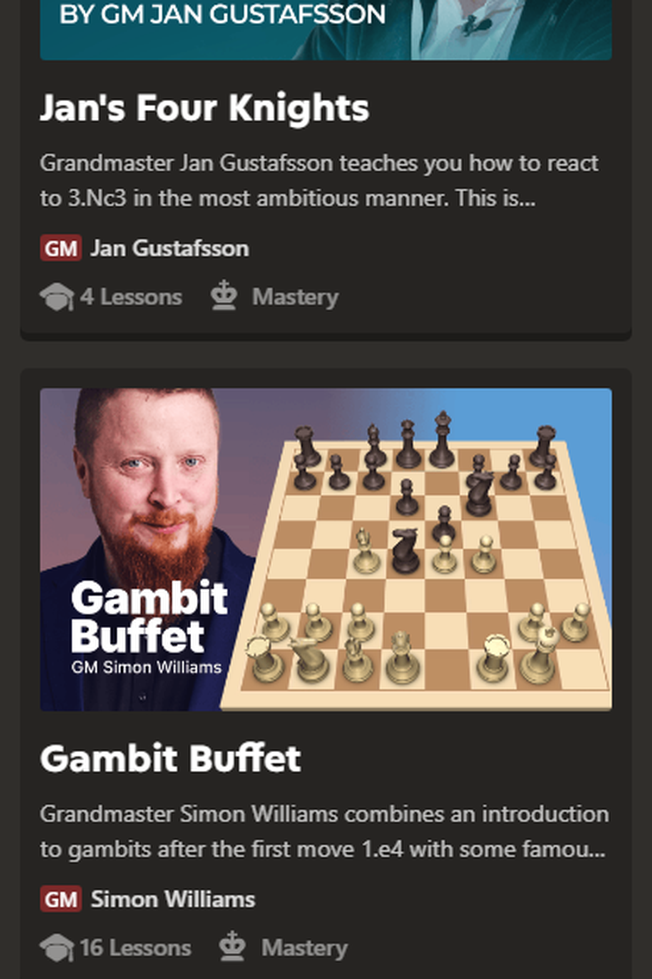
Figure PR-EV-01A. Chess mobile Lessons page - Top; the first visible learning groups.
Source: Internal design QA item
Related: 14.0

Figure PR-EV-01B. Chess mobile Lessons page - Middle; the continued lesson sequence.
Source: Internal design QA item
Related: 14.0

Figure PR-EV-01C. Chess mobile Lessons page - Bottom; later groups and page end.
Source: Internal design QA item
Related: 14.0
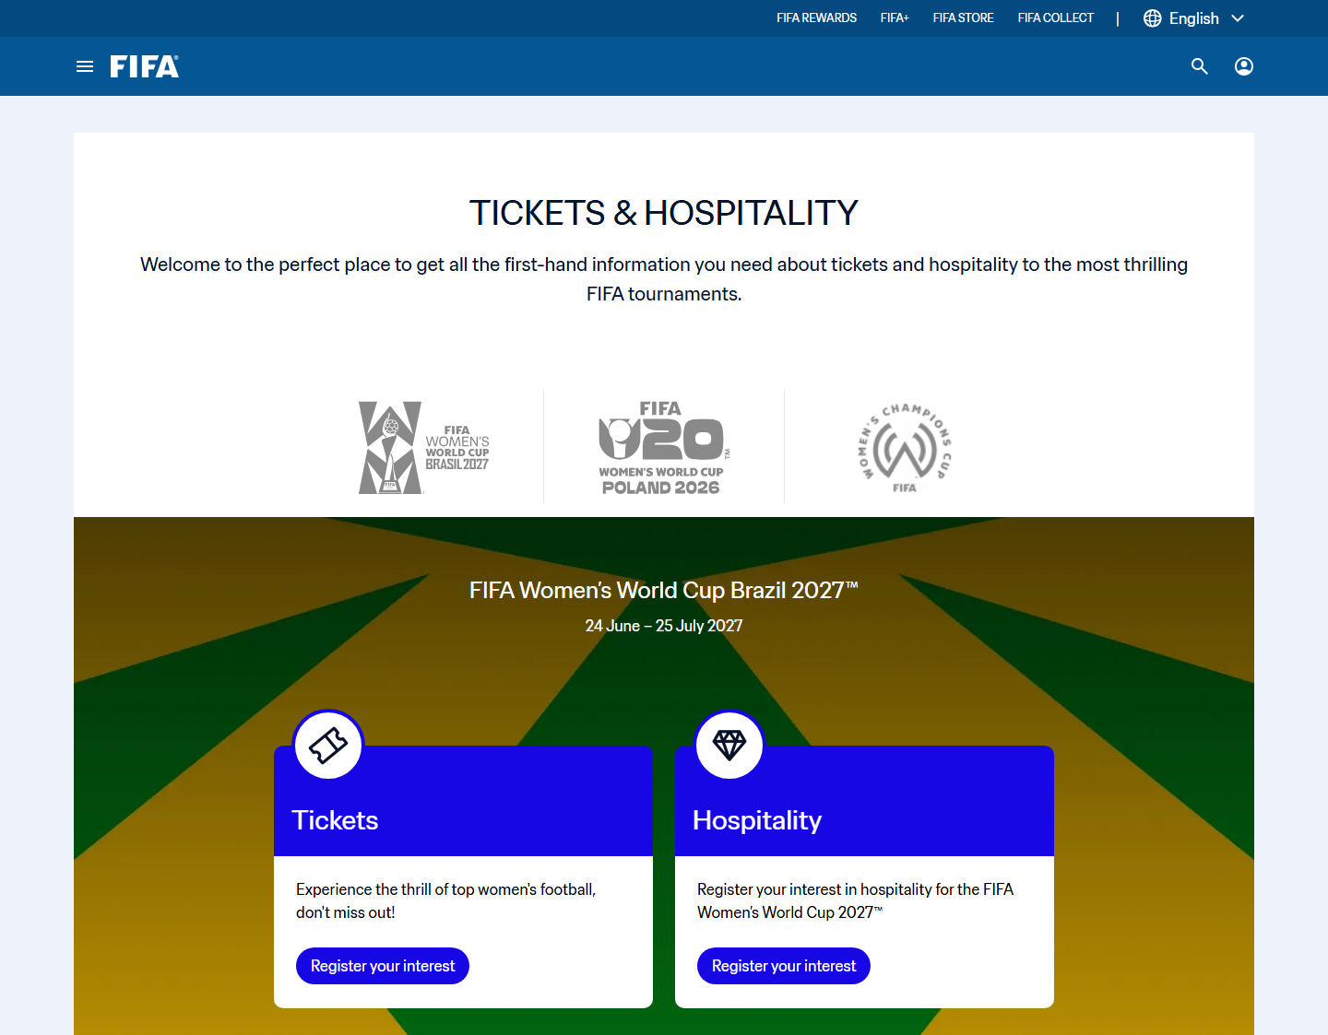
Figure PR-EV-02. FIFA ticket decision surface used to review state and handoff wording.
Source: Internal design QA item
Related: 14.0
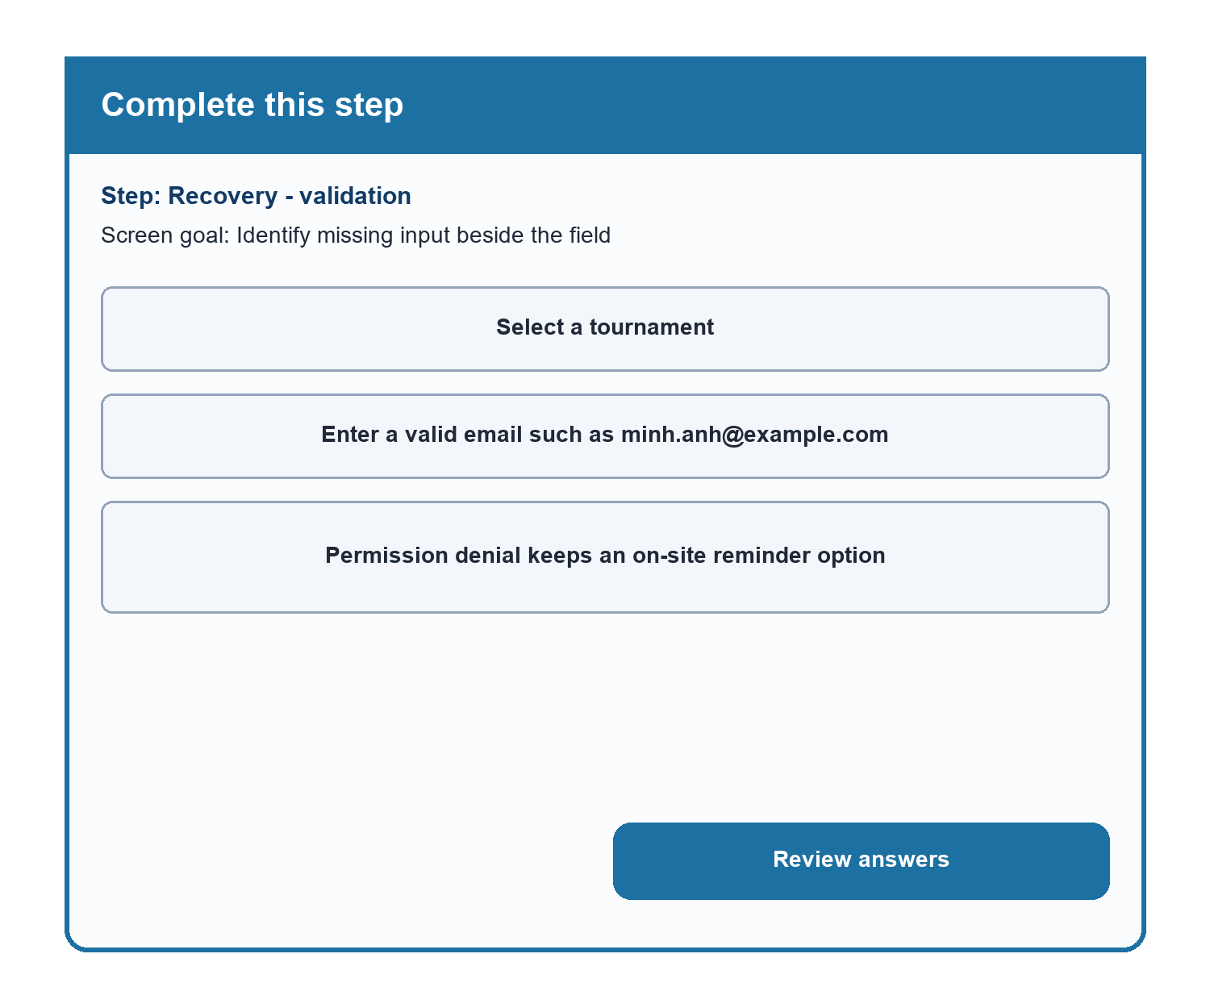
Figure PR-EV-03. Revised validation state showing field message, correction action, and recovery.
Source: Internal design QA item
Related: 14.0

Practical Difficulties and Lessons Learned
Practical difficulty | How the group handled it | Lesson learned | Impact on the final version
No verified presentation feedback existed. | The group changed the artifact title and disclosure to internal/simulated design QA. | Feedback provenance must be explicit. | The final review does not attribute comments to external peers.
Some review claims could not be measured from scaled screenshots. | The group converted them into measurable design requirements instead of unsupported findings. | Evidence limits should change the wording of a review item. | Tap targets now have a 48 px concept rule without claiming a measured defect in the source.

