PROJECT ASSIGNMENT 2

Group10-PA2 Project Proposal
FIFA.com and Chess.com
Course | CSC13112 - UI/UX Design, FIT-HCMUS
Group | Group10
Team | Le Minh (21127645); Nguyen Vu Bach (21127224); Pham Nguyen Gia Bao (20127119); Trang Minh Nhut (22127318)

Contents
1. Proposal scope and traceability — 2
2. FIFA Ticket Confidence Module alternatives — 3
2.1 F-A1 Status Dashboard — 3
2.2 F-A2 Guided Concierge — 4
2.3 F-A3 Alert-First Planner — 5
3. Chess Guided Beginner Review Module alternatives — 6
3.1 C-A1 Beginner Review Preset — 6
3.2 C-A2 Conversational Coach — 8
3.3 C-A3 Visual Game Story — 9
4. Weighted comparison method — 11
5. Recommendations and retained alternatives — 12
6. PA3 parallel-prototyping plan — 13
7. Design rationale and validation target — 14
8. Guided Concierge Flow - Detailed Revision — 14
8.1 Guided Concierge branch matrix — 16
8.2 Guided Concierge Screens — 18
9. Empty, Error, and Validation State Contract — 22
9.1 Complete Empty, Error, and Validation Matrix — 24
10. Mini Design System Appendix — 27
11. Practical Difficulties and Lessons Learned — 28

1. Proposal scope and traceability
FIFA Ticket Confidence Module: Users need to compare current ticket state, freshness and official destination before leaving FIFA.com.

Chess Guided Beginner Review Module: Beginners need one interpretable mistake and one next practice action before advanced analysis.

Screen evidence: F2-E03/E04/E09 and C2-E05/E07-E10 bound the visible interface claims.
Simulated study: Scenario records inform hypothesis coverage only; no expected benefit is an observed outcome.
Design inference: The modules preserve current products and introduce bounded decision/learning layers.

2. FIFA Ticket Confidence Module alternatives

2.1 F-A1 Status Dashboard
Field | Record
Concept | Status Dashboard within FIFA Ticket Confidence Module
Target user | Trust-sensitive ticket planners
Task flow | Choose context -> compare states -> inspect freshness -> preview official destination -> act or stay
Main screen | Status comparison dashboard
Interaction | Filter, expand provenance, preview handoff, save/alert
Problem coverage | Directly covers status, freshness, and destination confidence
Accessibility | Text labels, table semantics, keyboard order, color-independent states
Privacy | Minimize saved preferences; explicit alert consent
Data dependency | Governed ticket-state feed, timestamps, partner metadata
Failure recovery | Keep last timestamped state, distinguish missing/stale, retry without losing context
Risk | Feed inconsistency or false confidence
Tradeoff | Highest clarity; requires reliable governed data
PA3 test plan | Test state interpretation, destination recognition, stay/continue choice, and recovery
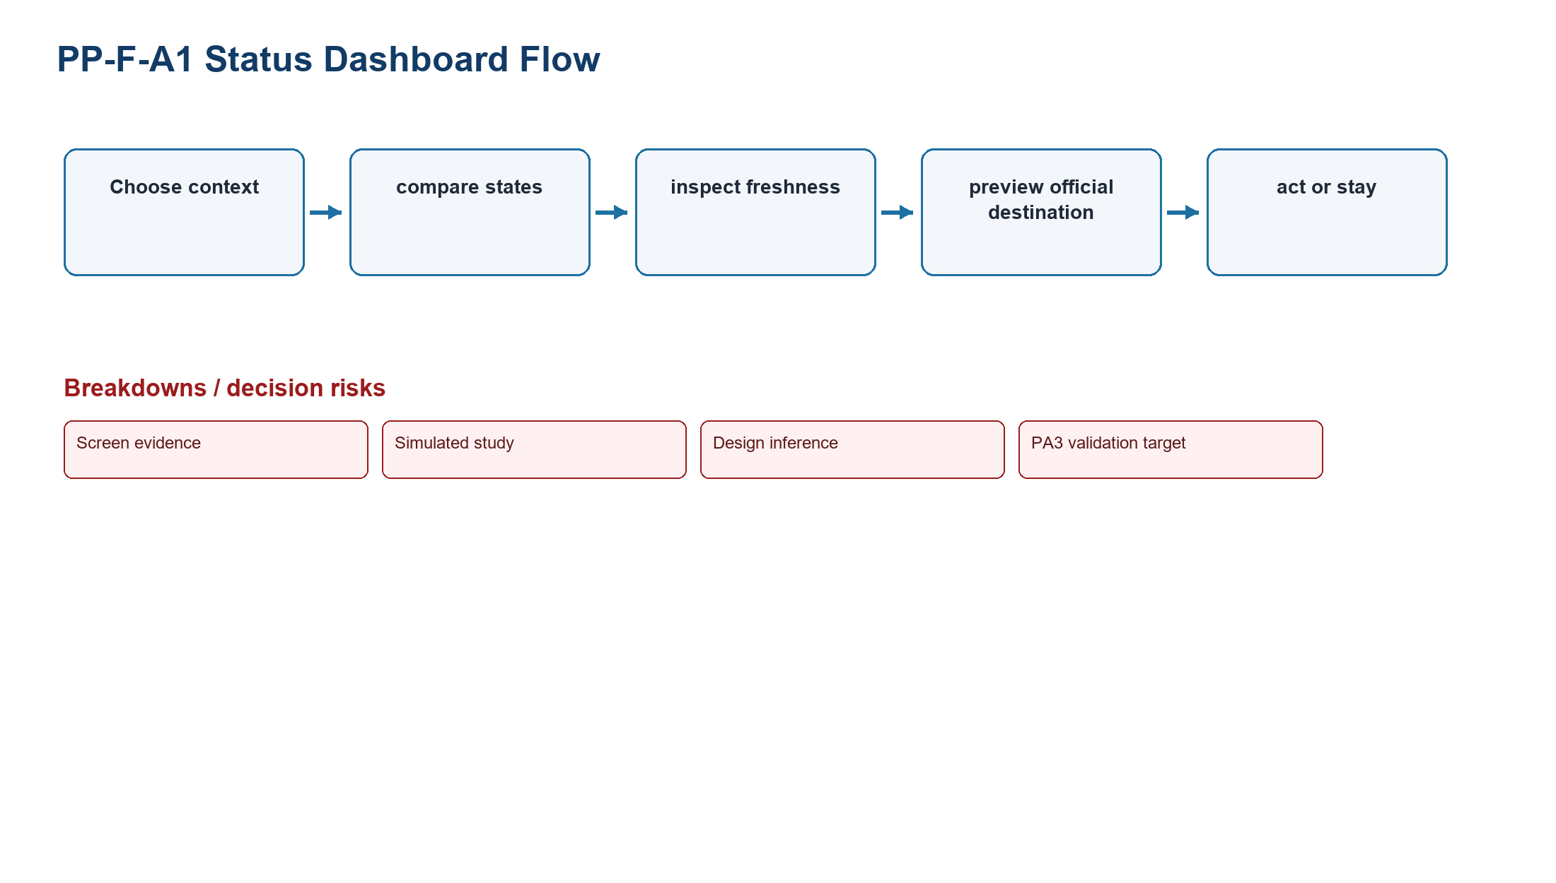
Figure PP-F-A1. Status Dashboard task-flow model
Source: Design inference based on TP-FIFA
Related: Test state interpretation, destination recognition, stay/continue choice, and recovery

2.2 F-A2 Guided Concierge
Field | Record
Concept | Guided Concierge within FIFA Ticket Confidence Module
Target user | Infrequent and first-time planners
Task flow | See Section 8: detailed 16-step Guided Concierge flow, branch matrix, and recovery states.
Main screen | Step-by-step concierge
Interaction | Single-choice questions, back/edit, recommendation rationale
Problem coverage | Covers complex choice and handoff confidence
Accessibility | Progress, plain labels, keyboard/radio semantics
Privacy | Avoid sensitive profiling; delete draft answers
Data dependency | Eligibility rules, ticket channels, partner metadata
Failure recovery | Explain unsupported markets, preserve answers, offer dashboard
Risk | Long flow and rule maintenance
Tradeoff | More guidance; slower comparison
PA3 test plan | Test completion, backtracking, recommendation comprehension, and unsupported-state recovery

2.3 F-A3 Alert-First Planner
Field | Record
Concept | Alert-First Planner within FIFA Ticket Confidence Module
Target user | Followers waiting for sale changes
Task flow | Follow context -> set preference -> wait -> receive verified change -> open destination
Main screen | Saved-plan and alert center
Interaction | Follow, consent, edit, snooze, stop, open alert
Problem coverage | Covers freshness and return; weaker immediate comparison
Accessibility | Channel alternatives, readable timestamps, no color-only urgency
Privacy | Explicit permission, minimal contact data, retention limit
Data dependency | Change events, notification channel, partner metadata
Failure recovery | Retain local plan if permission denied; retry irrelevant or failed alerts
Risk | Notification fatigue and delayed data
Tradeoff | Strong return support; depends on alert quality
PA3 test plan | Test permission denial, alert relevance, freshness comprehension, and return context
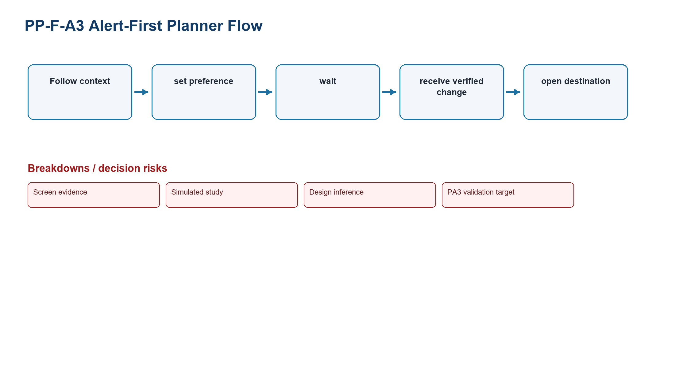
Figure PP-F-A3. Alert-First Planner task-flow model
Source: Design inference based on TP-FIFA
Related: Test permission denial, alert relevance, freshness comprehension, and return context

3. Chess Guided Beginner Review Module alternatives

3.1 C-A1 Beginner Review Preset
Field | Record
Concept | Beginner Review Preset within Chess Guided Beginner Review Module
Target user | First-time and returning low-analysis learners
Task flow | Open game -> select preset -> identify one mistake -> try move -> read explanation -> practice or depth
Main screen | Primary mistake card beside board
Interaction | Try move, reveal why, continue practice, reveal advanced detail
Problem coverage | Directly covers one interpretable mistake and next practice action
Accessibility | Keyboard board alternative, focus order, plain language, color-independent evaluation
Privacy | Use only selected game; explain retention and sharing
Data dependency | Game artifact, analysis service, explanation rules, learning catalog
Failure recovery | Handle no game, invalid PGN, engine unavailable, no major mistake, restriction
Risk | Oversimplification or incorrect explanation
Tradeoff | Strongest beginner interpretation; constrains initial depth
PA3 test plan | Test mistake comprehension, move trial, practice selection, and depth disclosure
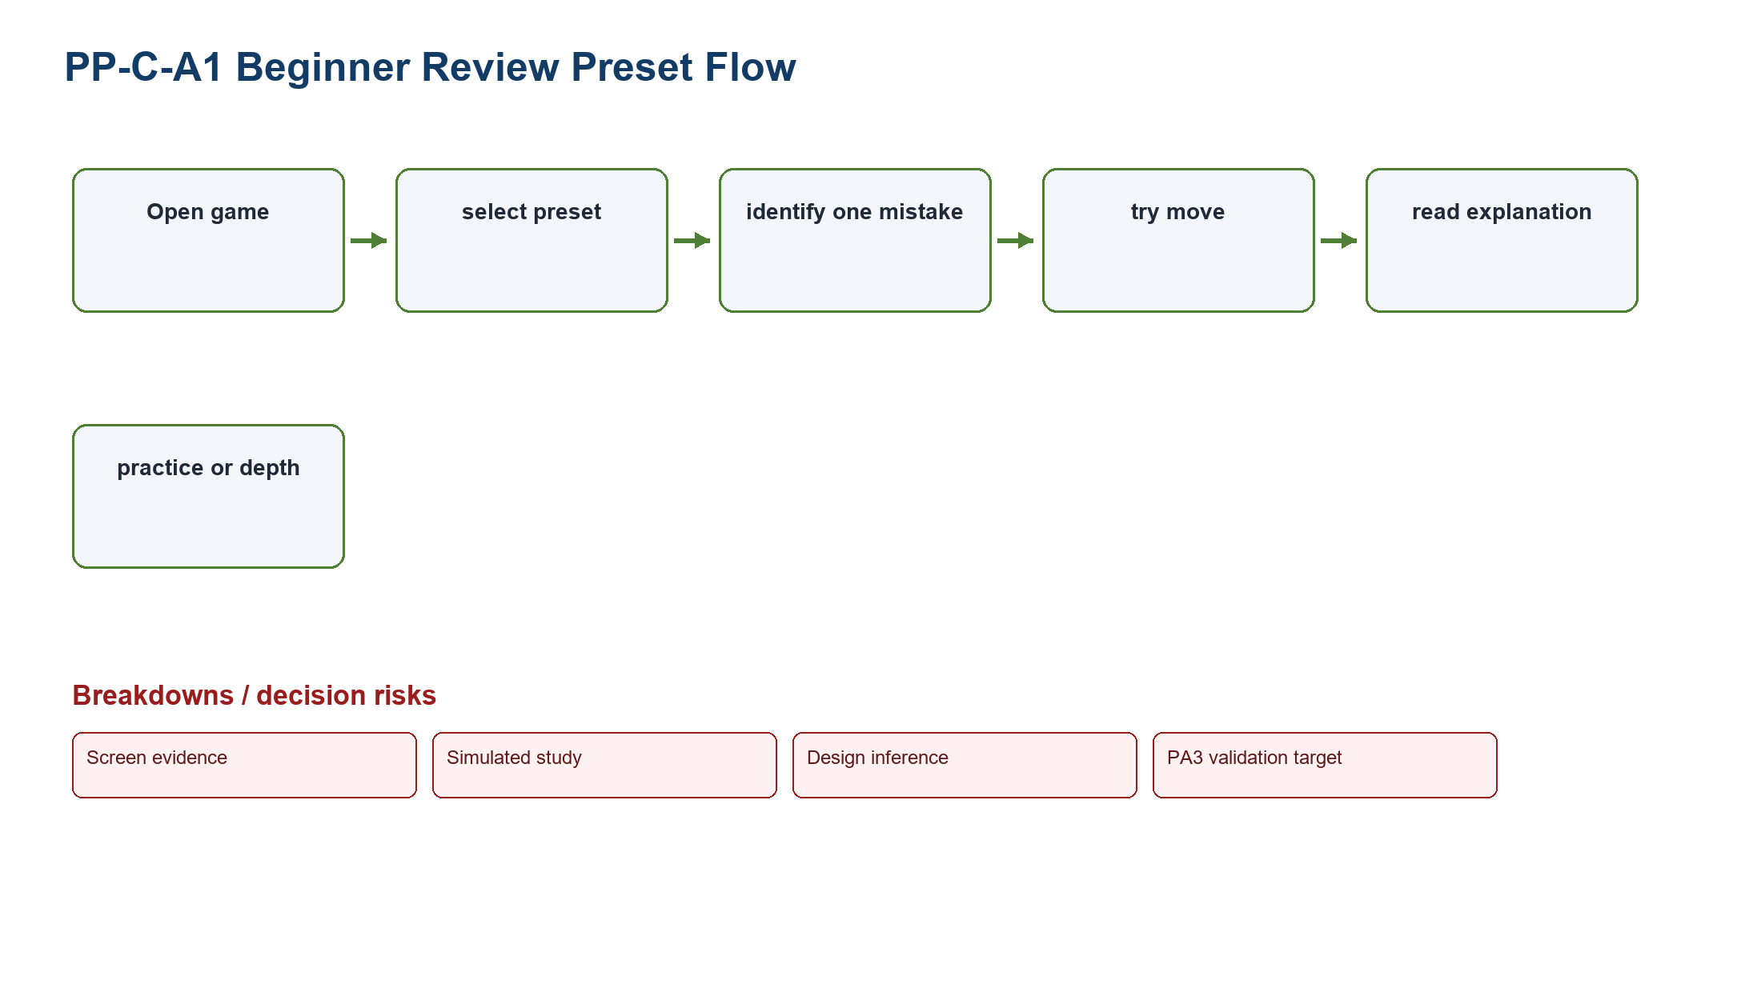
Figure PP-C-A1. Beginner Review Preset task-flow model
Source: Design inference based on TP-CHESS
Related: Test mistake comprehension, move trial, practice selection, and depth disclosure

3.2 C-A2 Conversational Coach
Field | Record
Concept | Conversational Coach within Chess Guided Beginner Review Module
Target user | Beginners who prefer question-led guidance
Task flow | Open review -> state intent -> coach clarifies -> explain position -> try move -> practice
Main screen | Conversation plus board
Interaction | Choose intent, ask why, try move, request another explanation
Problem coverage | Covers interpretation and vocabulary
Accessibility | Structured choices, transcript headings, keyboard board alternative
Privacy | Do not collect unrelated personal data; clear conversation retention
Data dependency | Game artifact, explanation service, learning catalog
Failure recovery | Offer fixed explanation cards if the coach service fails
Risk | Wording can vary and the extra question adds time
Tradeoff | The question-led route can address several intentions, but response consistency must be tested.
PA3 test plan | Test response consistency, vocabulary comprehension, and service fallback
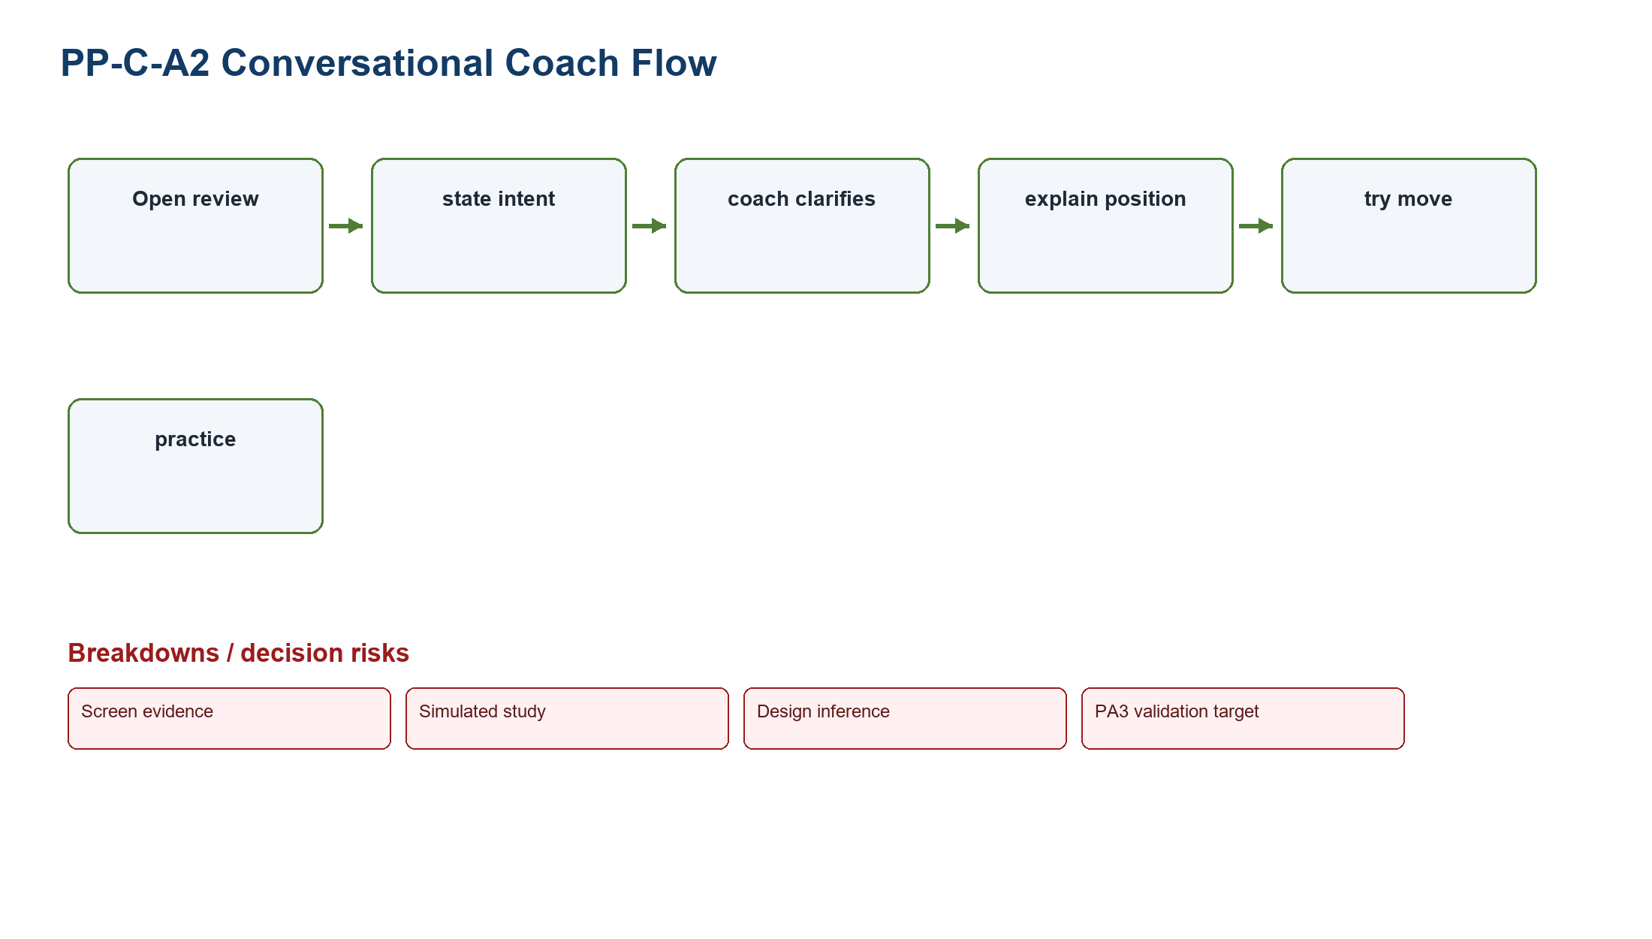
Figure PP-C-A2. Conversational Coach task-flow model
Source: Design inference based on TP-CHESS
Related: Test response consistency, vocabulary comprehension, and service fallback

3.3 C-A3 Visual Game Story
Field | Record
Concept | Visual Game Story within Chess Guided Beginner Review Module
Target user | Returning learners who scan game turning points
Task flow | Open review -> view chapters -> inspect turning point -> replay chance -> choose next action
Main screen | Chapter timeline with board snapshots
Interaction | Scrub chapters, select turning point, replay, continue
Problem coverage | Covers prioritization and narrative continuation
Accessibility | Text chapter list, reduced motion, keyboard timeline
Privacy | Use game data only; respect game visibility
Data dependency | Game segmentation, analysis service, learning catalog
Failure recovery | Fall back to a single mistake card if segmentation fails
Risk | Long games and multiple comparable mistakes
Tradeoff | Strong overview; less direct for first-time beginners
PA3 test plan | Test turning-point recognition, replay accuracy, and continuation choice
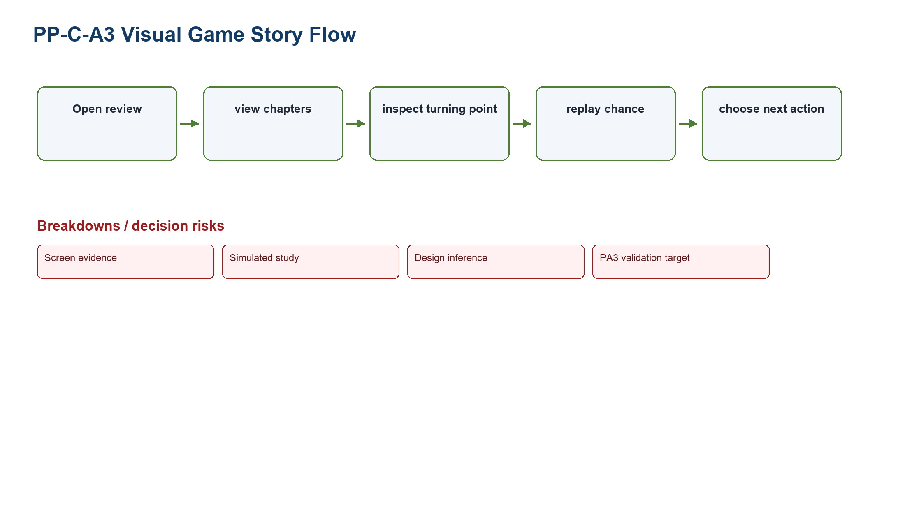
Figure PP-C-A3. Visual Game Story task-flow model
Source: Design inference based on TP-CHESS
Related: Test turning-point recognition, replay accuracy, and continuation choice

4. Weighted comparison method
Formula: Weighted score = Problem coverage x 30% + Learnability x 20% + Accessibility x 15% + Recovery x 15% + Data feasibility x 10% + PA3 testability x 10%. Factors use 1-5; maximum is 5.00.

Alternative | Weighted score | Score rationale
F-A1 Status Dashboard | 4.55 | Direct comparison and recovery; reliable feed is the main dependency.
F-A2 Guided Concierge | 4.05 | High guidance but a longer flow and heavier rule maintenance.
F-A3 Alert-First Planner | 3.65 | Strong freshness/return support but weaker immediate comparison.
C-A1 Beginner Review Preset | 4.90 | Best alignment to one mistake, move trial, explanation, and practice.
C-A2 Conversational Coach | 3.75 | The extra question may clarify intent, but wording consistency and service fallback still need testing.
C-A3 Visual Game Story | 3.90 | Good overview but less direct for a first-time beginner.

5. Recommendations and retained alternatives
Recommendation - FIFA: Select Status Dashboard because it most directly combines ticket state, freshness, official destination preview, user control, and recovery. Guided Concierge and Alert-First Planner remain PA3 parallel prototypes.

Recommendation - Chess: Select Beginner Review Preset because it establishes one interpretable mistake and one next practice action before advanced depth. Conversational Coach and Visual Game Story remain PA3 parallel prototypes.

Recommendation | Reason | Principal risk | PA3 validation target
F-A1 Status Dashboard | Highest weighted FIFA score and strongest tough-problem coverage | Stale or conflicting governed data | Accurate state/freshness interpretation and calibrated handoff confidence
C-A1 Beginner Review Preset | Highest weighted Chess score and clearest learning priority | Oversimplification or explanation error | Mistake comprehension, better-move trial, and relevant practice choice

6. PA3 parallel-prototyping plan
Product | Parallel concepts | Common scenario | Measures | Stop/iterate rule
FIFA | Status Dashboard; Guided Concierge; Alert-First Planner | Compare a missing/stale ticket state and decide whether to leave FIFA.com | State accuracy; destination recognition; confidence calibration; recovery | Reject a concept that causes state misinterpretation or implies partner completion
Chess | Beginner Review Preset; Conversational Coach; Visual Game Story | Open a completed game, identify one mistake, try a better move, continue practice | Explanation accuracy; wrong path; continuation relevance; depth control | Reject a concept that hides correction, blocks keyboard use, or overstates certainty
PA3 validation target: Expected benefits remain hypotheses until prototype sessions produce observed evidence.

7. Design rationale and validation target
HCI rationale: Course basis: LN01 - Introduction - v2.pdf, pp. 20, 22, 24; LN02 - Fundamental Concepts - Usability Dimensions_2.pdf, pp. 62-67, 74-76, 83-84, 101-115; LN03 - UI Design Process.pdf, pp. 16-19, 23-24, 28-30, 34-36; LN04 - Task Analysis.pdf, pp. 3, 6-15, 39-49.

8. Guided Concierge Flow - Detailed Revision
- User enters Ticket Concierge.
- User selects a tournament.
- User selects a match or event preference.
- User selects party size.
- User answers eligibility and context questions.
- System checks the known ticket state.
- System explains the current state in plain language.
- System shows the available next options.
- User compares official ticket, register interest, resale, hospitality, and wait.
- System previews the destination.
- User chooses Continue or Stay.
- If Continue, the system explains the partner domain and account expectation.
- If Stay, the system preserves tournament, match, and party context.
- User may set an alert.
- System confirms the choice and saved context.
- A recovery branch returns the user to a safe step without discarding valid answers.
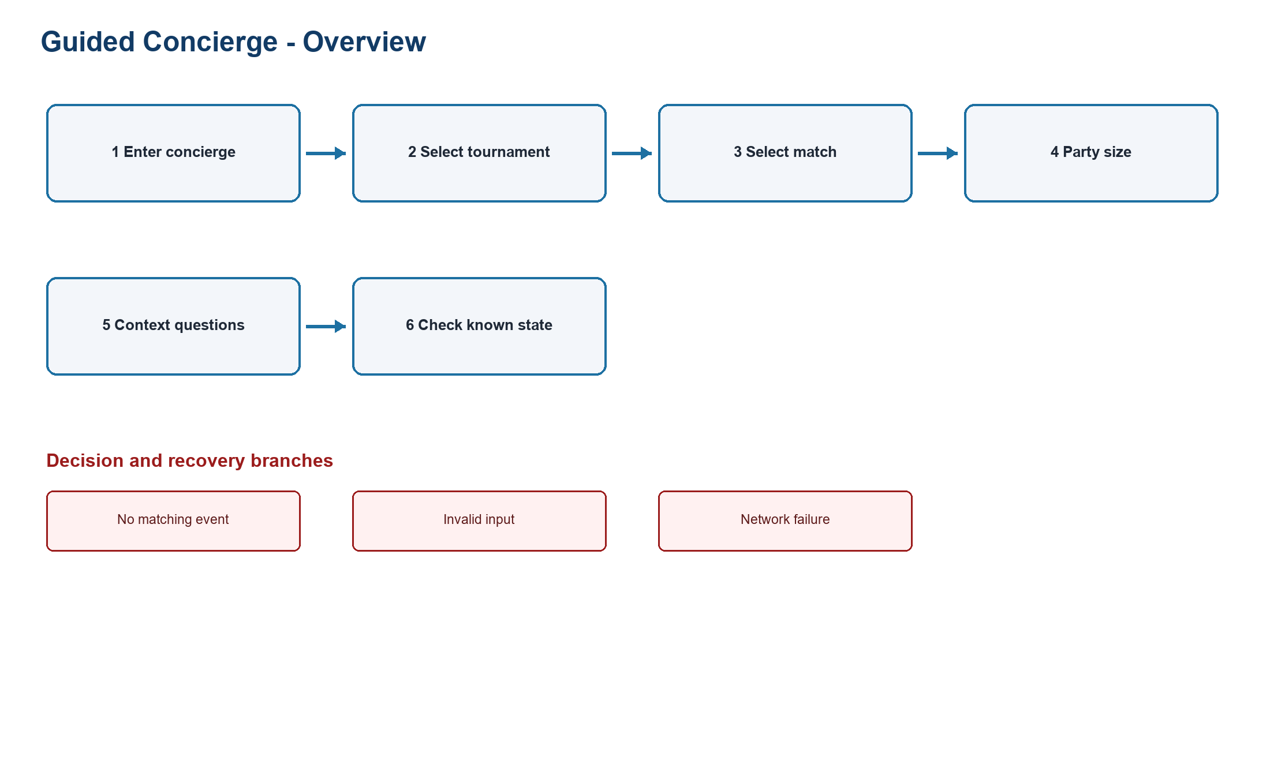
Figure PP-GC-FLOW-01. Guided Concierge overview flow
Source: PA2 design QA artifact
Related: Steps 1-6; entry, context, and known-state check
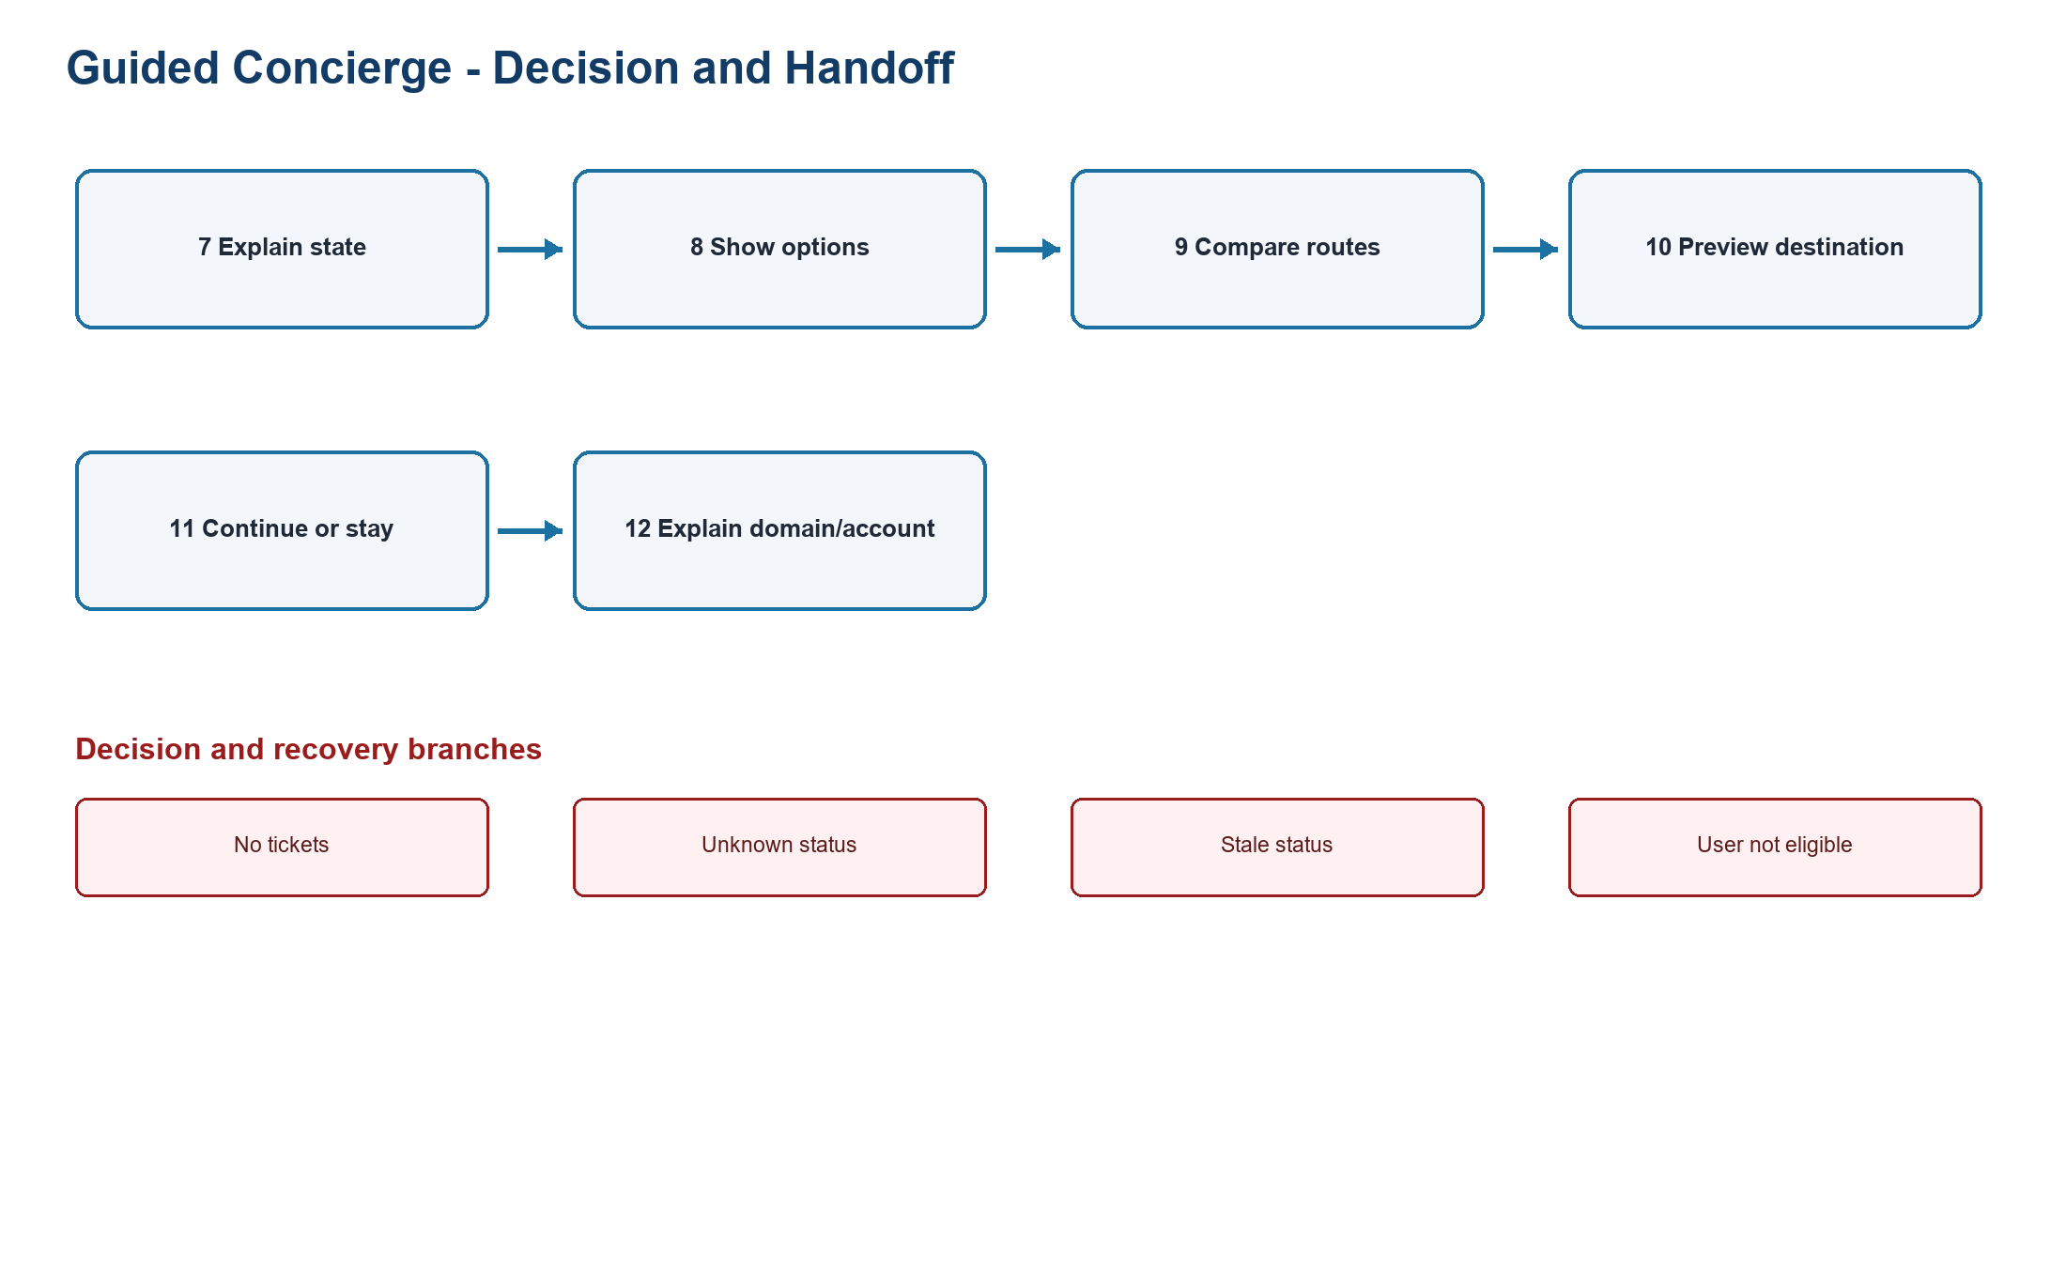
Figure PP-GC-FLOW-02. Guided Concierge decision branch flow
Source: PA2 design QA artifact
Related: Steps 7-12; option comparison, destination preview, Continue or Stay
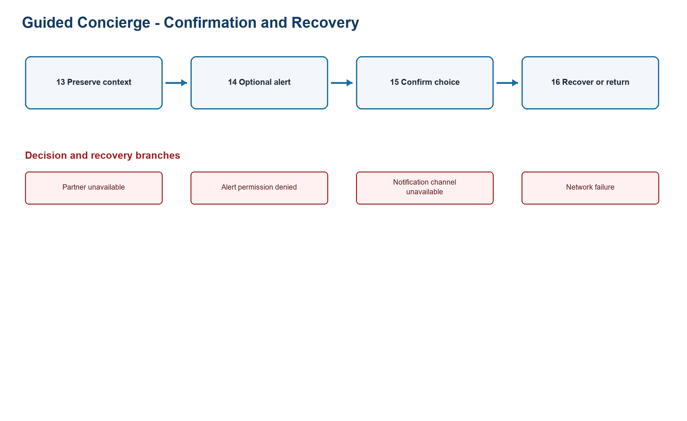
Figure PP-GC-FLOW-03. Guided Concierge error and recovery flow
Source: PA2 design QA artifact
Related: Steps 13-16; preserved context, alert, confirmation, and recovery

8.1 Guided Concierge branch matrix
Branch | Trigger | Message | User action | Recovery path
No tickets | Known state shows no official inventory | No official tickets are available for this selection. | Compare register interest, resale, hospitality, or wait | Keep the selection and return to options
Unknown status | No governed status is available | Current ticket status is unknown; this is not a sold-out result. | Stay or retry | Retry the state check without losing answers
Stale status | Last update exceeds the freshness rule | This status may be outdated. | Refresh or wait | Show the last update only with a stale label
Partner unavailable | The official destination cannot respond | The partner service is unavailable. | Stay on FIFA.com | Preserve context and retry later
User not eligible | Eligibility answer conflicts with route rules | This route is not available for the supplied context. | Review answers or compare other routes | Return to the relevant question
No matching event | Tournament/match filters return no result | No event matches these filters. | Change tournament or match | Keep party size and eligibility
Invalid input | A required answer is missing or malformed | Correct the highlighted field. | Edit the field | Keep all valid answers
Alert permission denied | Browser notification permission is denied | Browser alerts are off. | Use an on-site reminder or change permission | Do not block the ticket decision
Network failure | The state request times out | The network request failed; no ticket outcome is inferred. | Retry or stay | Resume from the state check

8.2 Guided Concierge Screens
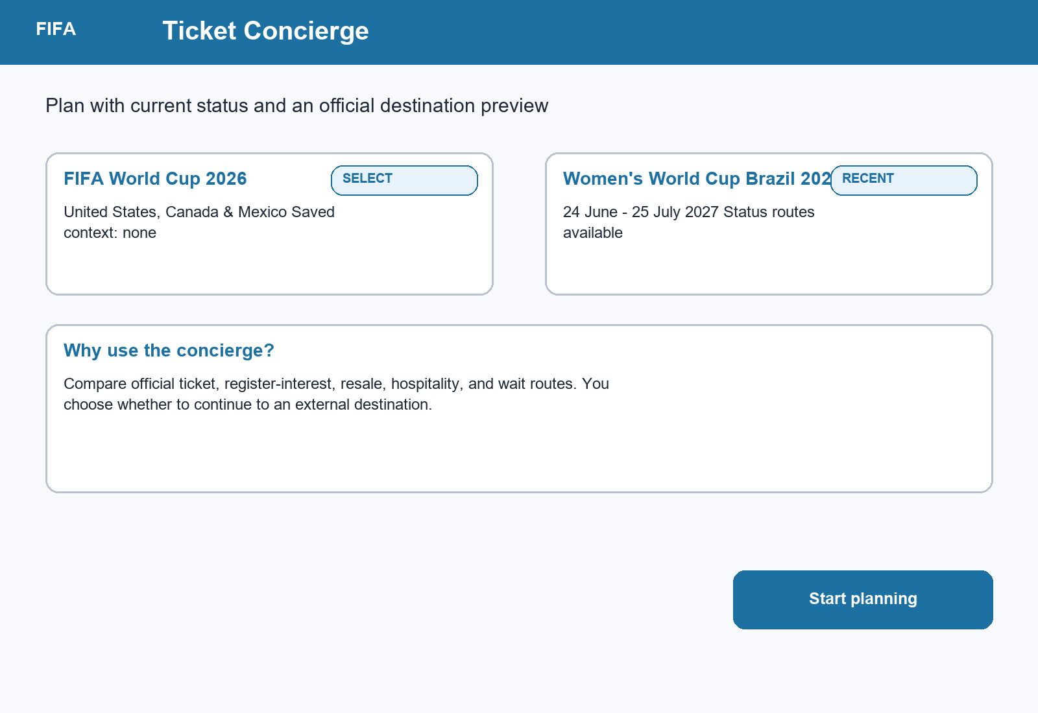
Figure PP-GC-ENTRY. Entry screen with selectable tournament cards and a clear explanation of the concierge boundary.
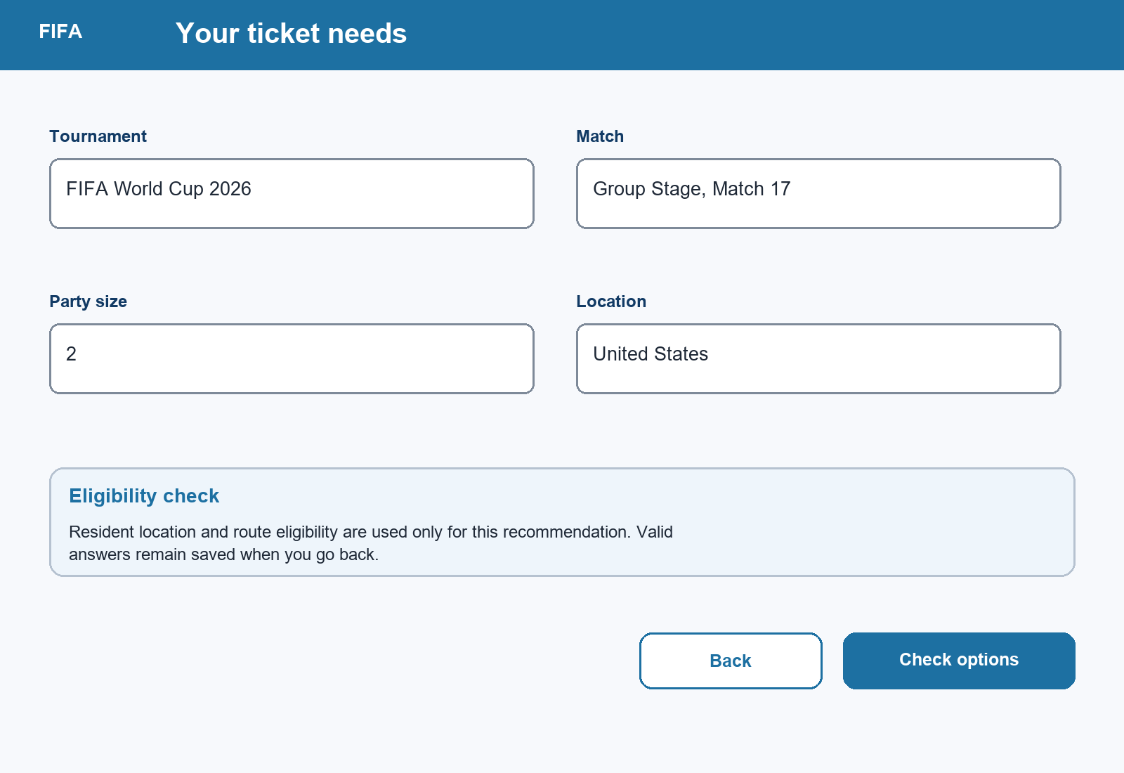
Figure PP-GC-QUESTION. Question step with concrete tournament, match, party-size, location, and eligibility values; Back preserves valid answers.
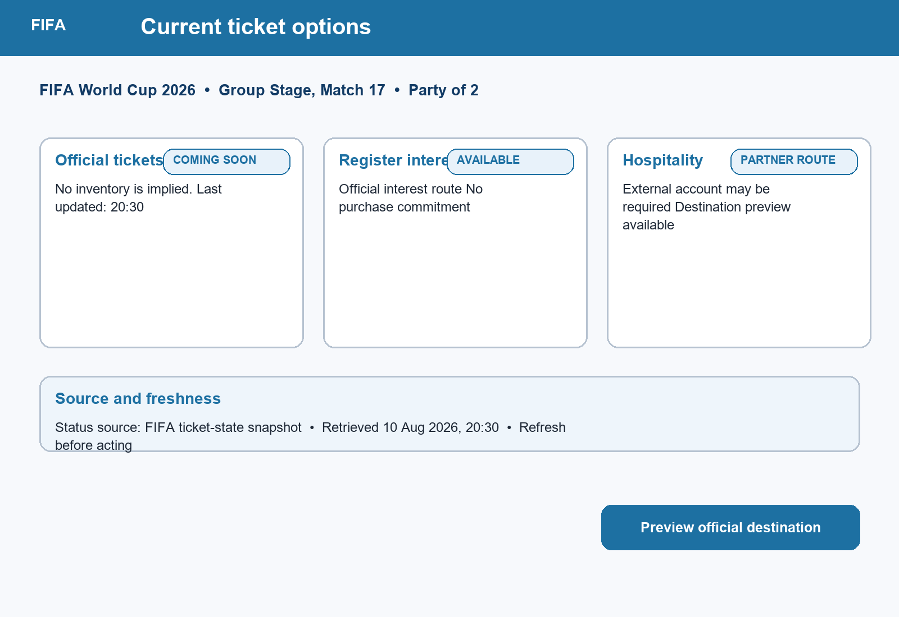
Figure PP-GC-RECOMMENDATION. Recommendation screen with status chips, last-updated time, source boundary, and route-specific cards.
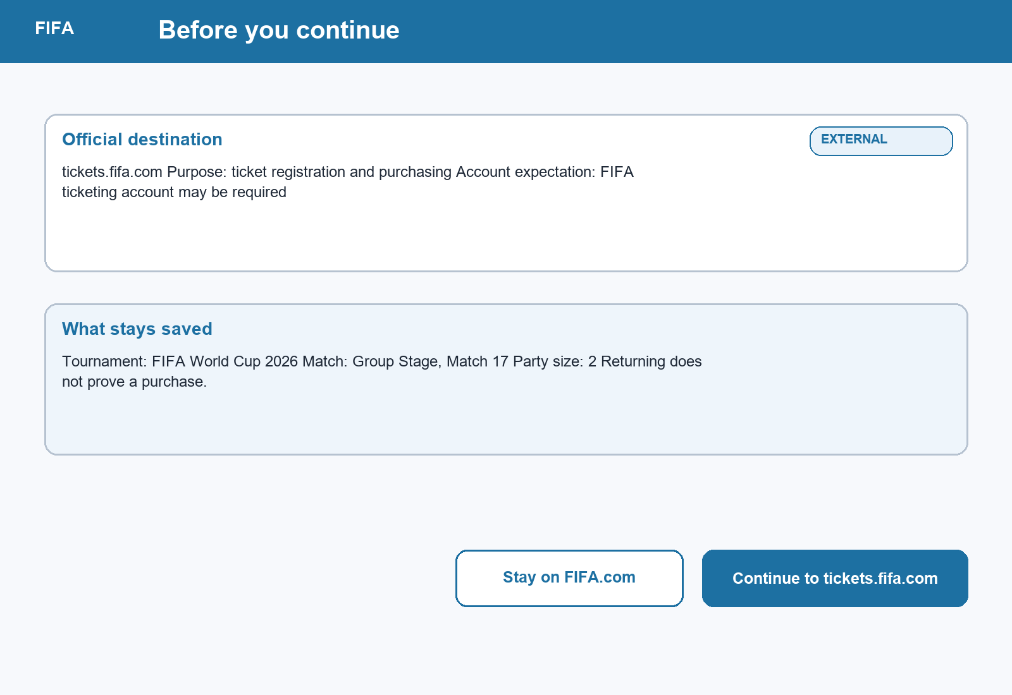
Figure PP-GC-DESTINATION. Destination preview naming tickets.fifa.com, account expectations, transferred context, and Continue/Stay choices.
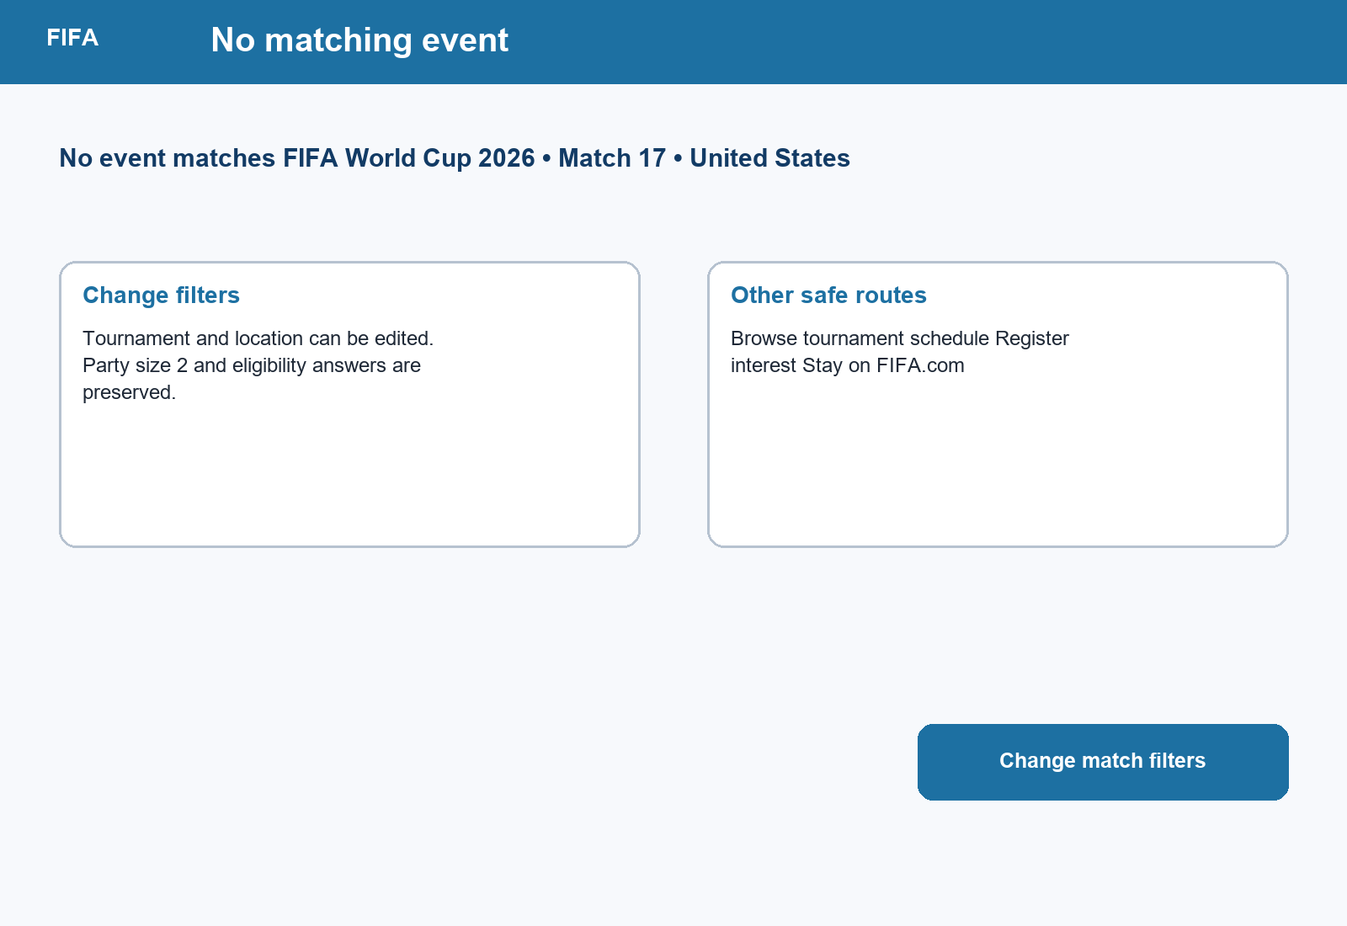
Figure PP-GC-EMPTY. No-match state with preserved answers, editable filters, and alternative safe routes.
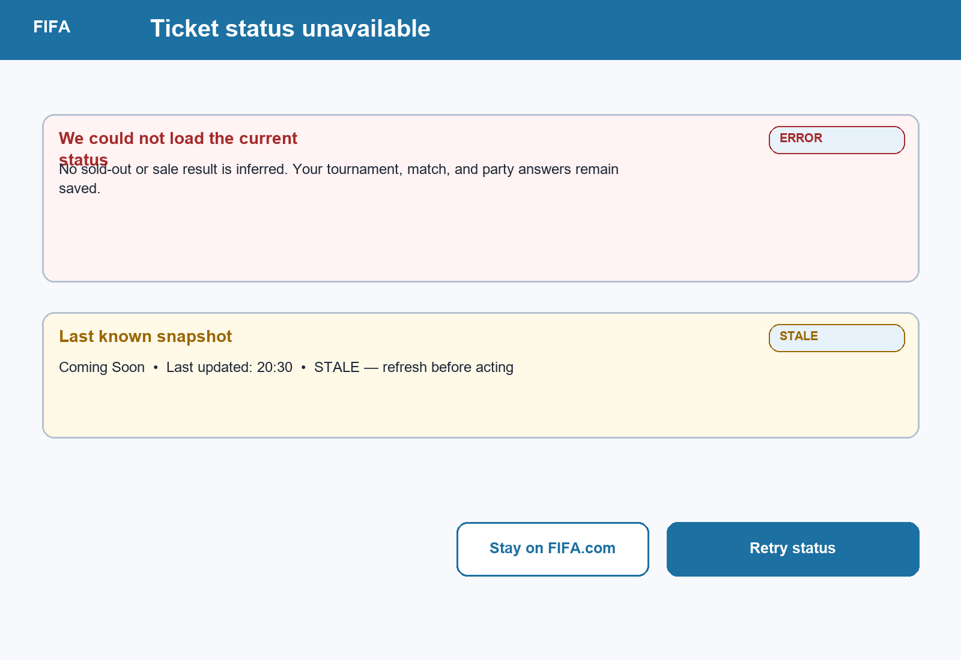
Figure PP-GC-ERROR. Unavailable-status state with no inferred outcome, a labeled stale snapshot, and Retry/Stay recovery.
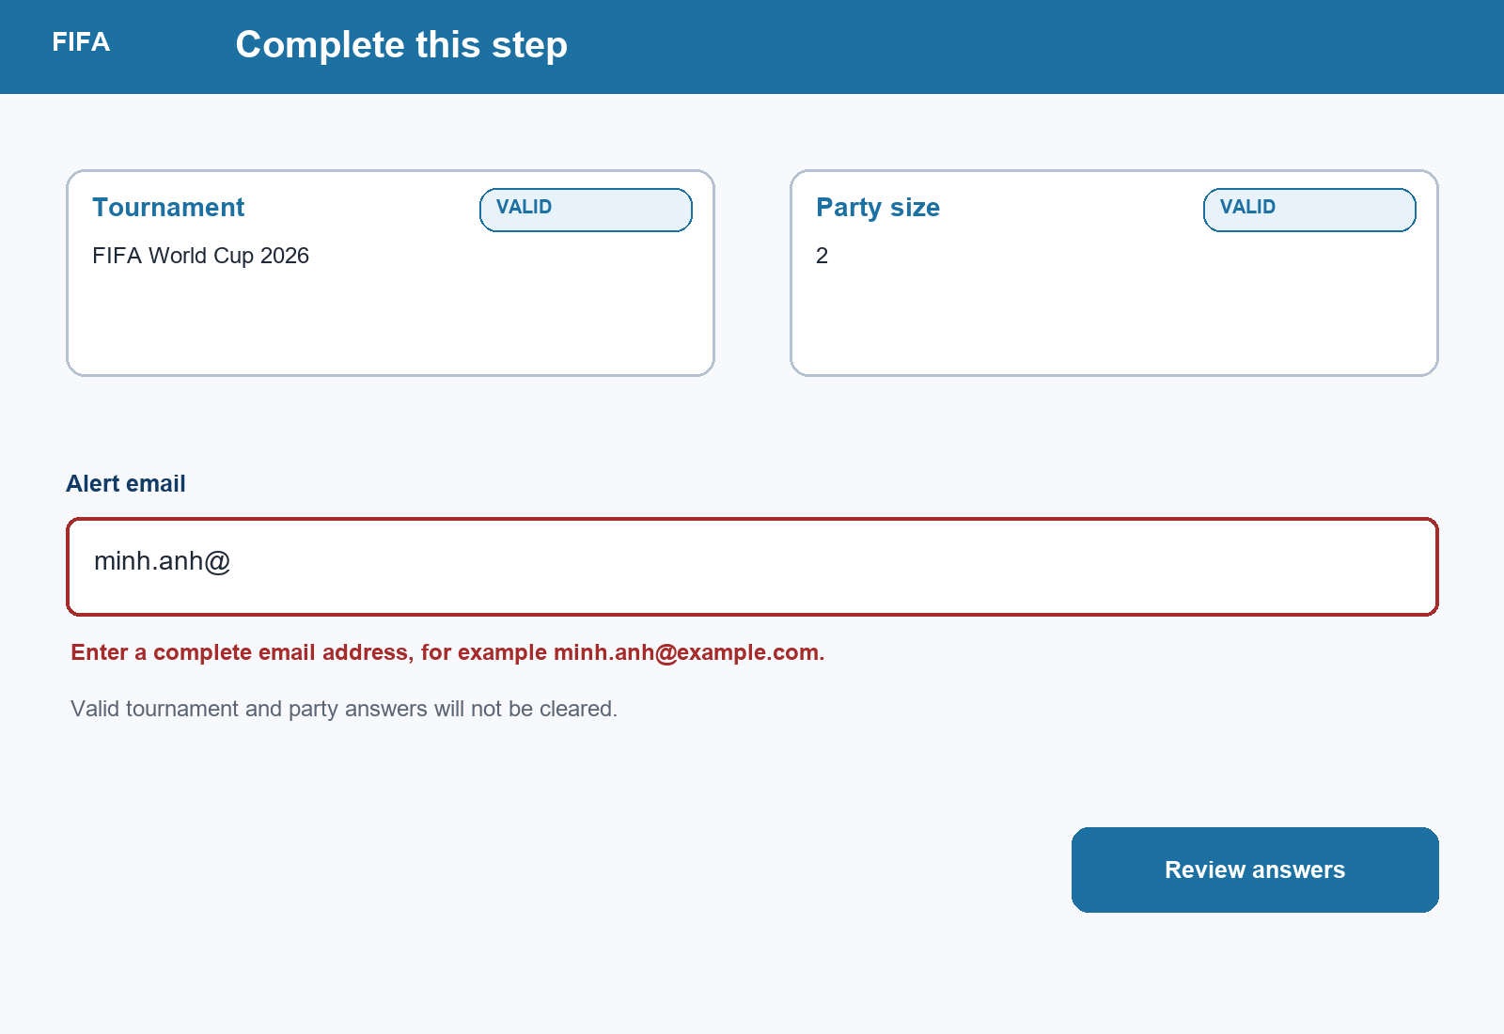
Figure PP-GC-VALIDATION. Field-level email validation that retains the valid tournament and party-size answers.

9. Empty, Error, and Validation State Contract
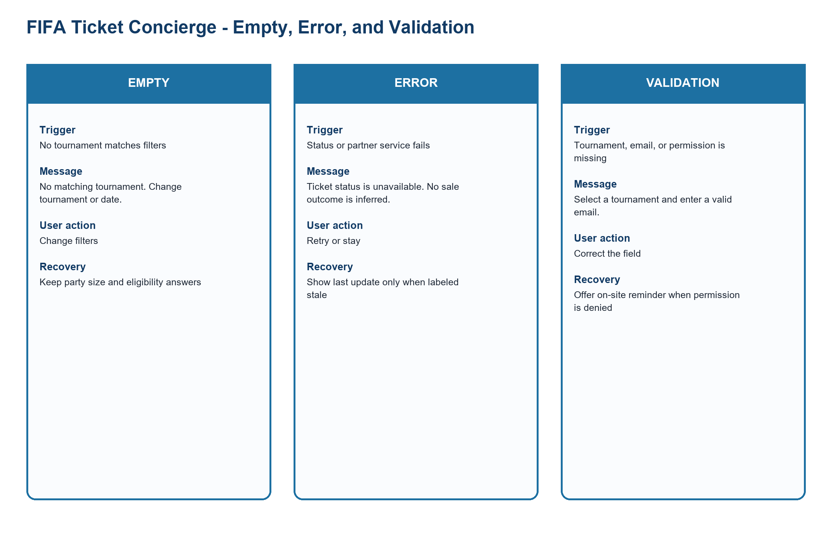
Figure PP-STATE-FIFA. FIFA state contract with trigger, message, action, and recovery
Source: PA2 design QA artifact
Related: No match, status/partner failure, invalid tournament/email/permission
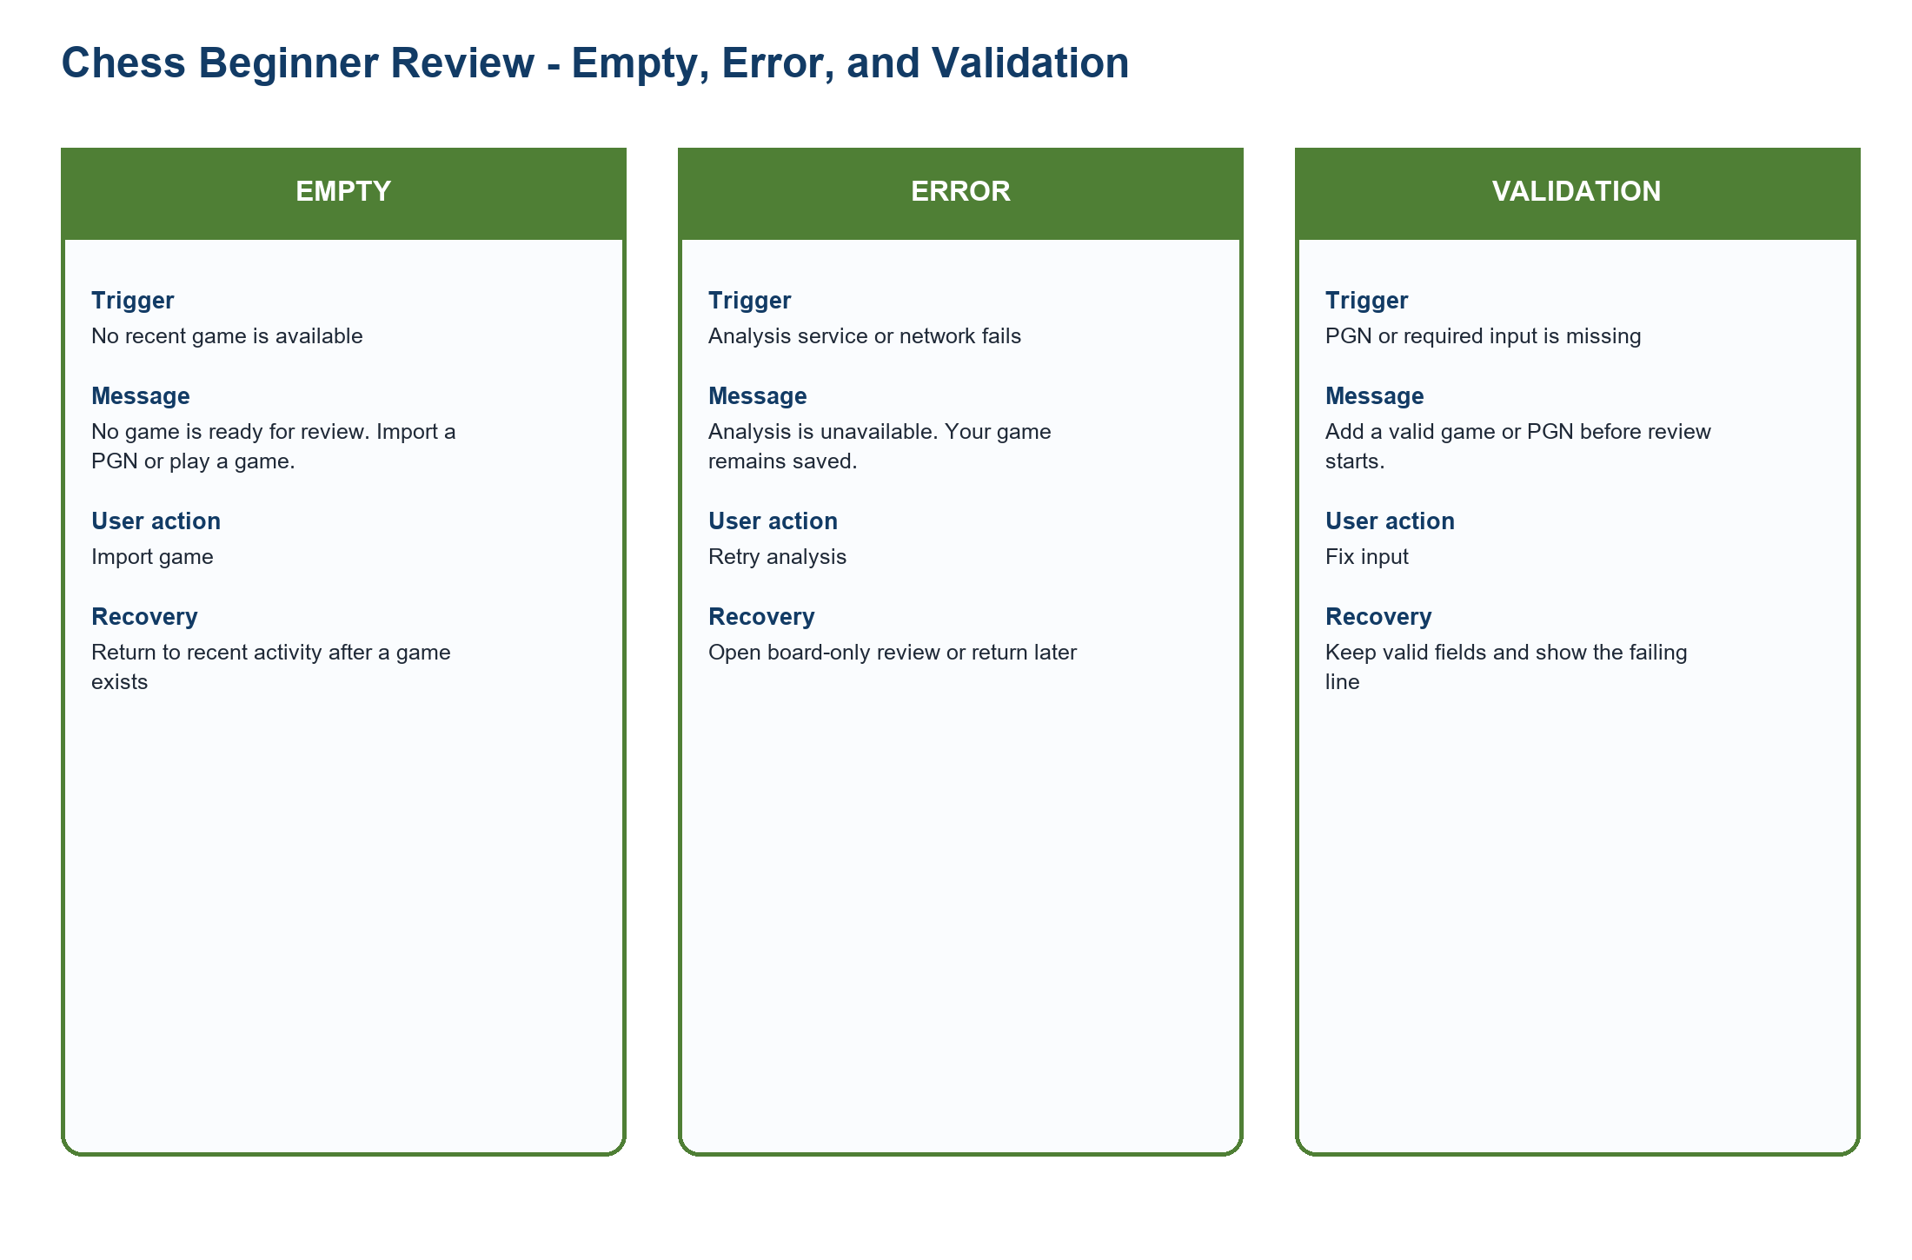
Figure PP-STATE-CHESS. Chess state contract with trigger, message, action, and recovery
Source: PA2 design QA artifact
Related: No game, analysis/network failure, invalid PGN or required input
Concept and state | Trigger | Message | User action | Recovery path
FIFA Ticket Concierge - EMPTY | No tournament matches | No matching tournament. Change tournament or date. | Change filters | Keep party size and eligibility
FIFA Ticket Concierge - ERROR | Ticket status or partner service fails | Ticket status is unavailable; no sale outcome is inferred. | Retry or stay | Use a labeled last update or retry
FIFA Ticket Concierge - VALIDATION | Tournament or email is invalid | Select a tournament and enter a valid email such as minh.anh@example.com. | Correct the field | Retain every valid answer
Chess Beginner Review - EMPTY | No recent game exists | No game is ready for review. Import a PGN or play a game. | Import game | Return after a game exists
Chess Beginner Review - ERROR | Analysis service or network fails | Analysis is unavailable; the game remains saved. | Retry analysis | Open board-only review or return later
Chess Beginner Review - VALIDATION | PGN or required input is missing | Add a valid game or PGN before review starts. | Fix input | Keep valid fields and identify the failing line

9.1 Complete Empty, Error, and Validation Matrix
State | Contract
FIFA - EMPTY - No tournament | Trigger: No tournament  Message: No tournament matches the selected context.  Action: Change tournament or date.  Recovery: Keep party size and other valid answers.
FIFA - EMPTY - No available ticket route | Trigger: No available ticket route  Message: No official route is available for this event.  Action: Compare wait, interest, resale, or hospitality when allowed.  Recovery: Return to the saved event without restarting.
FIFA - ERROR - Ticket status unavailable | Trigger: Ticket status unavailable  Message: Ticket status is unavailable; no sale outcome is inferred.  Action: Retry or stay.  Recovery: Show a labeled last update only when available.
FIFA - ERROR - Partner unavailable | Trigger: Partner unavailable  Message: The official destination cannot respond.  Action: Stay on FIFA.com.  Recovery: Preserve context and retry later.
FIFA - ERROR - Network error | Trigger: Network error  Message: The request failed before a result was confirmed.  Action: Retry the request.  Recovery: Resume at the state check with valid answers intact.
FIFA - VALIDATION - Tournament not selected | Trigger: Tournament not selected  Message: Select a tournament to continue.  Action: Choose a tournament.  Recovery: Return to the question step.
FIFA - VALIDATION - Invalid email | Trigger: Invalid email  Message: Enter a valid email address.  Action: Correct the email.  Recovery: Retain all other answers.
FIFA - VALIDATION - Permission denied | Trigger: Permission denied  Message: Browser alerts are off.  Action: Use an on-site reminder or change permission.  Recovery: Do not block the ticket decision.
Chess - EMPTY - No game to review | Trigger: No game to review  Message: No game is ready for review.  Action: Import a PGN or play a game.  Recovery: Return to review after a game exists.
Chess - EMPTY - No recent game | Trigger: No recent game  Message: No recent game was found.  Action: Open the archive or import a game.  Recovery: Keep the chosen beginner-review mode.
Chess - ERROR - Analysis unavailable | Trigger: Analysis unavailable  Message: Analysis is unavailable; the game remains saved.  Action: Retry analysis.  Recovery: Open board-only review or return later.
Chess - ERROR - Import failed | Trigger: Import failed  Message: The game could not be imported.  Action: Review the PGN and retry.  Recovery: Keep the original input for correction.
Chess - ERROR - Network error | Trigger: Network error  Message: The analysis request failed.  Action: Retry when connected.  Recovery: Return to the saved game.
Chess - VALIDATION - Invalid PGN | Trigger: Invalid PGN  Message: The PGN contains an invalid or unsupported line.  Action: Correct the marked line.  Recovery: Retain valid metadata and moves.
Chess - VALIDATION - Missing required game | Trigger: Missing required game  Message: Choose or import a game before review starts.  Action: Select a game.  Recovery: Return to the review entry.
Chess - VALIDATION - Unsupported input | Trigger: Unsupported input  Message: This input format is not supported.  Action: Use PGN or a recent saved game.  Recovery: Keep the current page and help link.

10. Mini Design System Appendix
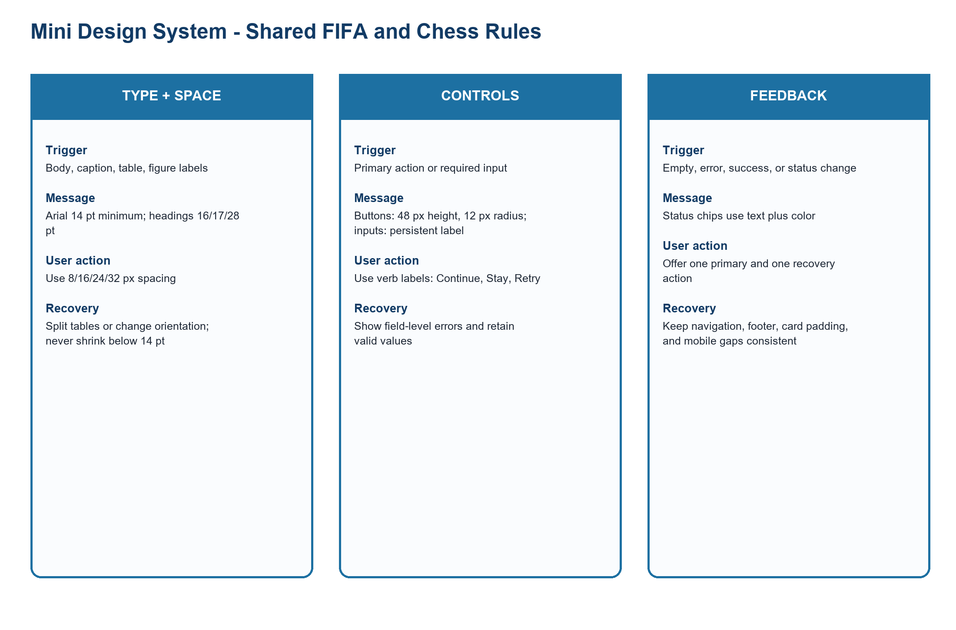
Figure PP-DS-01. Shared typography, spacing, control, card, status, error, success, and empty-state rules
Source: FIFA and Chess concept screens
Related: 16.0
Token or component | Shared rule
Typography | Arial; body, caption, table, and figure labels use 14 pt minimum; headings use 16/17/28 pt.
Spacing | Use 8/16/24/32 px steps; mobile cards keep a 16 px gap.
Buttons | 48 px height, 12 px radius, verb label such as Continue, Stay, or Retry.
Inputs | Persistent label, 48 px height, field-level error, and retained valid values.
Cards | 16 px radius and 16 px padding.
Status chips | Status chips use a text label plus color; include freshness where it affects a decision.
Error and validation | State the problem, one user action, and one recovery path.
Success and empty | Confirm saved context or explain what is missing and how to continue.
Navigation and footer | Use the same order, labels, icon size, and mobile spacing across concept screens.

11. Practical Difficulties and Lessons Learned
Practical difficulty | How the group handled it | Lesson learned | Impact on the final version
Empty, error, and validation screens exposed requirements missing from the happy path. | The group added triggers, messages, user actions, and recovery paths before comparing concepts. | A concept is incomplete when failure changes the user decision. | The final proposal includes two product state contracts and three recovery flows.
The original Guided Concierge flow was too compressed. | The group divided it into overview, decision/handoff, and recovery flows. | Long flows should be split at decision boundaries. | The final version contains 16 numbered steps and nine named branches.

