PROJECT ASSIGNMENT 2

Group10-PA2 Weekly Report
FIFA.com and Chess.com
Course | CSC13112 - UI/UX Design, FIT-HCMUS
Group | Group10
Team | Le Minh (21127645); Nguyen Vu Bach (21127224); Pham Nguyen Gia Bao (20127119); Trang Minh Nhut (22127318)

Contents
1. Process Overview — 3
2. Meeting Conduct and Cross-Report Decisions — 3
3. Team Roster and Three-Week Schedule — 4
4. Sprint Planning — 5
4.1 Sprint Planning Meeting — 5
5. Week 1 Scrum — 7
5.1 Weekly Scrum - Week 1 — 7
6. Week 2 Scrum — 9
6.1 Simulated Brainstorming Session — 9
6.2 Weekly Scrum - Week 2 — 10
7. Week 3 Scrum — 12
7.1 Weekly Scrum - Week 3 — 12
8. Sprint Review and Retrospective — 14
8.1 Sprint Review and Retrospective — 14
9. Workload Summary — 16
10. Acceptance Checklist — 16
11. Submission Status — 17
12. Continuity with PA1 — 18
13. RUP + Scrum Process Flow — 18
14. Cross-report Lessons Applied — 19

1. Process Overview
Disclosure: This report documents a reconstructed three-week project process prepared for course reporting.

The process combines RUP phases with Scrum cadence: Inception establishes PA1 continuity and evidence rules; Elaboration defines simulated-study protocol, synthesis, and alternatives; Construction produces proposal, UML, use cases, traceability, and document builds; Transition performs visual QA and packaging.
Reconstructed project record: Dates, meetings, attendance, workload, and progress below are reconstructed or simulated project records; they are not presented as contemporaneous records.

2. Meeting Conduct and Cross-Report Decisions
Rule | Application
Evidence before claim | Screen states prove interface state; PA1 findings remain inherited; simulated study remains labeled; design implications remain inference.
Cross-report IDs | Participant, session, finding, cluster, problem, concept, recommendation, use case, and PA3 target IDs stay stable.
No unrecorded media | Structured notes only; no external communication references.
Decision control | Status Dashboard and Beginner Review Preset are recommendations; remaining alternatives stay in PA3 parallel prototyping.
Evidence validation | The PA1 lesson on wrong interface states becomes a PA2 validation gate for every figure and claim.

3. Team Roster and Three-Week Schedule
Member | Primary ownership | Research | Writing |  | Review | Presentation / packaging
Le Minh | Coordination, integration, traceability, packaging, Weekly Report | Protocol integration | Weekly and cross-report sections |  | Traceability and acceptance | Presentation and submission packaging
Nguyen Vu Bach | FIFA research, simulated sessions, findings, proposal, use cases | FIFA tasks/sessions | FIFA modules |  | FIFA source/claim review | FIFA presentation
Pham Nguyen Gia Bao | Chess research, simulated sessions, findings, proposal, use cases | Chess tasks/sessions | Chess modules |  | Chess source/claim review | Chess presentation
Trang Minh Nhut | Brainstorming, affinity, prioritization, HCI mapping, diagrams, visual QA | Synthesis protocol | Analysis and HCI mapping |  | Diagram and layout review | Visual consistency
Week | Dates | RUP focus |  | Scrum goal |  | Main outputs
1 | 14-18 Jul 2026 | Inception / early Elaboration |  | Scope, PA1 continuity, evidence audit, research plan, simulated session design, walkthrough |  | Protocol, participants, session records, screen-evidence boundary
2 | 20-24 Jul 2026 | Elaboration |  | Synthetic synthesis, brainstorming, affinity, voting, prioritization, tough problems, alternatives |  | 72 notes, clusters, votes, weighted problems, six alternatives
3 | 27-30 Jul 2026 | Construction / Transition |  | Proposal, UML, use cases, traceability, QA, packaging |  | Five revised DOCX reports and DOCX-only QA records

4. Sprint Planning

4.1 Sprint Planning Meeting
Field |  | Record
Record type |  | Reconstructed project record / Simulated meeting record
Date |  | 14 Jul 2026
Time |  | 20:00-20:50
Present |  | Le Minh; Nguyen Vu Bach; Pham Nguyen Gia Bao; Trang Minh Nhut
Absent |  | None
Objective |  | Translate PA2 rubric into a three-week backlog while preserving PA1 continuity.
Topics |  | Two products; PA1 drawbacks; evidence boundary; simulated-study labels; report ownership; definition of done.
Decisions |  | Keep FIFA and Chess; use three methods; label every synthetic record; label Peer Review as internal/simulated design QA; require traceability and page-render QA.
Actions |  | Le builds traceability skeleton; Bach audits FIFA; Bao audits Chess; Nhut maps lecture concepts and visual rules.
Summary |  | The team accepts one integrated sprint with weekly checkpoints and a final transition gate.
Backlog item | Owner | Acceptance condition | Week
PA1 continuity and screen-evidence audit | Le + Bach + Bao | Every high-level claim has a source label | 1
12 simulated profiles/sessions/note sheets | Bach + Bao | IDs and metrics trace one-to-one | 1
72 notes, affinity, votes, prioritization | Nhut | 36 notes per product; 24 votes per product | 2
Six alternatives and weighted comparison | Bach + Bao | All required evaluation fields and PA3 plan | 2
12 detailed use cases and UML | Bach + Bao + Nhut | Six per product; include/extend; edge cases | 3
Build, traceability, DOCX render QA, and submission review | Le + Nhut | Five DOCX files only; each opens and passes the DOCX checklist | 3

5. Week 1 Scrum

5.1 Weekly Scrum - Week 1
Field |  | Record
Record type |  | Reconstructed project record / Simulated meeting record
Date |  | 17 Jul 2026
Time |  | 20:00-20:30
Present |  | Le Minh; Nguyen Vu Bach; Pham Nguyen Gia Bao; Trang Minh Nhut
Absent |  | None
Objective |  | Check scope, evidence audit, protocol, simulated-session design, and walkthrough progress.
Topics |  | PA1 continuity; screen inventory; task lists; participant balance; evidence-state mistakes.
Decisions |  | Retain 12 scenario profiles across two products; every note sheet must contain limitation and PA3 question.
Actions |  | Finish final two sessions on 18 Jul; map each result to one note sheet; flag partner/engine claims as untested.
Summary |  | Week 1 establishes a bounded research artifact without representing synthetic sessions as real research.
Member | Completed | Next | Obstacle
Le Minh | Rubric matrix, continuity chain, source-label rules | Integrate task/result IDs | Legacy files use provisional wording
Nguyen Vu Bach | FIFA walkthrough, six profiles, first four session records | Finish FIFA notes and findings | Ticket feed and partner state unavailable
Pham Nguyen Gia Bao | Chess walkthrough, six profiles, first four session records | Finish Chess notes and findings | No completed engine review evidence
Trang Minh Nhut | Lecture mapping and evidence visual audit | Model legends and layout rules | Long captures require readable splits

6. Week 2 Scrum

6.1 Simulated Brainstorming Session
Field | Record
Record type | Reconstructed project record / Simulated meeting record
Date | 22 Jul 2026
Time | 19:30-20:45
Present | Le Minh; Nguyen Vu Bach; Pham Nguyen Gia Bao; Trang Minh Nhut
Absent | None
Objective | Cluster 72 atomic notes and establish product priorities.
Topics | Silent generation; round-robin; duplicate merging; cluster naming; simulated voting; weighted scoring.
Decisions | FIFA prioritizes status and handoff confidence; Chess consolidates entry, explanation, and continuation into guided beginner review.
Actions | Nhut maintains clusters/votes; Bach and Bao write problem profiles; Le checks traceability.
Summary | The synthetic workshop produces design hypotheses and is not contemporaneous meeting evidence.

6.2 Weekly Scrum - Week 2
Field |  | Record
Record type |  | Reconstructed project record / Simulated meeting record
Date |  | 24 Jul 2026
Time |  | 20:00-20:30
Present |  | Le Minh; Nguyen Vu Bach; Pham Nguyen Gia Bao; Trang Minh Nhut
Absent |  | None
Objective |  | Review synthesis, tough problems, and six alternatives.
Topics |  | Affinity counts; vote totals; weighted rationale; product boundary; PA3 parallel prototypes.
Decisions |  | Select TP-FIFA and TP-CHESS; recommend F-A1 and C-A1 while retaining four alternatives.
Actions |  | Draft comparison formula, accessibility/privacy/data/recovery fields, and PA3 test measures.
Summary |  | Week 2 converts evidence and synthetic patterns into explicit, testable design directions.
Member | Completed | Next | Obstacle
Le Minh | Traceability through tough problems | Integrate recommendations and use cases | Cross-report terminology drift
Nguyen Vu Bach | FIFA findings, clusters, alternatives | FIFA proposal and six use cases | State taxonomy depends on governed data
Pham Nguyen Gia Bao | Chess findings, clusters, alternatives | Chess proposal and six use cases | Explanation quality requires PA3 validation
Trang Minh Nhut | 72-note affinity, vote tables, HCI dimensions | UML and visual QA | Wide tables require landscape sections

7. Week 3 Scrum

7.1 Weekly Scrum - Week 3
Field |  | Record
Record type |  | Reconstructed project record / Simulated meeting record
Date |  | 29 Jul 2026
Time |  | 20:00-20:30
Present |  | Le Minh; Nguyen Vu Bach; Pham Nguyen Gia Bao; Trang Minh Nhut
Absent |  | None
Objective |  | Close proposal, UML, detailed use cases, traceability, and build defects.
Topics |  | Weighted recommendations; include/extend direction; use-case numbering; edge cases; source labels; layout.
Decisions |  | Use 12 exact use cases; restart every main flow at 1; preserve advanced Chess depth by disclosure; never infer FIFA partner completion.
Actions |  | Build the five revised DOCX files, inspect every rendered DOCX page, and correct layout or banned text.
Summary |  | Week 3 moves from content completion to evidence-backed transition QA.
Member | Completed | Next | Obstacle
Le Minh | Proposal integration, traceability CSV, weekly draft | DOCX set and final acceptance | TOC fields require a final DOCX update
Nguyen Vu Bach | FIFA proposal and use cases | Cross-check FIFA edge cases | Partner failure cannot be live-tested
Pham Nguyen Gia Bao | Chess proposal and use cases | Cross-check Chess edge cases | Engine unavailable path is scenario-based
Trang Minh Nhut | UML, diagrams, landscape tables | All-page visual QA | Dense note and traceability tables

8. Sprint Review and Retrospective

8.1 Sprint Review and Retrospective
Field | Record
Record type | Reconstructed project record / Simulated meeting record
Date | 30 Jul 2026
Time | 20:00-20:50
Present | Le Minh; Nguyen Vu Bach; Pham Nguyen Gia Bao; Trang Minh Nhut
Absent | None
Objective | Inspect final artifacts against rubric and record improvements for PA3.
Topics | Research completeness; analysis trace; recommendation logic; UML/use cases; simulated labels; DOCX page render and acceptance checklist.
Decisions | Accept five revised reports when QA passes; publish Peer Review as internal/simulated design QA; carry all unverified benefits to PA3 targets.
Actions | Le completes the five-document set; Nhut records DOCX QA; Bach and Bao verify product-specific claims and edge cases.
Summary | The sprint review closes the five PA2 reports and leaves PA3 with explicit validation questions rather than synthetic certainty.
Field | Record
What went well | Stable IDs, source labels, and separate FIFA/Chess traces reduced ambiguity.
What went wrong | Some screenshots captured the wrong state, and long mobile pages became unreadable when reduced.
Problems encountered | Ticket and partner states changed; Chess analysis had several entry paths; affinity notes and use cases became dense.
Causes | Time-sensitive services, different mobile/desktop ordering, repeated terminology, and tables that tried to carry too much detail.
What we changed | We split long captures, moved raw records to appendices, separated empty/error/validation states, and gave each use case a unique visual.
Lessons learned | Validate the visible state before capture, preserve context during recovery, and split information at decision boundaries.
Actions for PA3 | Test the Concierge branches and Beginner Review with representative users; measure interpretation, recovery, and continuation.

9. Workload Summary
Balanced contribution across four members
Member | Research | Writing | Review | Presentation / packaging
Le Minh | Protocol integration | Weekly report, traceability, integration | Acceptance and cross-report consistency | Submission structure and packaging
Nguyen Vu Bach | FIFA walkthrough and sessions | FIFA findings, proposal, and use cases | FIFA claims and edge cases | FIFA presentation support
Pham Nguyen Gia Bao | Chess walkthrough and sessions | Chess findings, proposal, and use cases | Chess claims and edge cases | Chess presentation support
Trang Minh Nhut | Synthesis protocol | Affinity and HCI mapping | Diagram and layout consistency | Visual QA and presentation consistency

10. Acceptance Checklist
Acceptance item | Evidence | Status
User Research | 12 profiles; six representative sessions; 12 detailed sheets in Appendix A; evidence figures; eight work models | Complete
User Analysis | 14 representative notes; 72 raw notes in Appendix A; 13 clusters; vote visualization; weighted prioritization | Complete
Project Proposal | Six alternatives; detailed Guided Concierge; complete state and recovery matrix | Complete
Use Case Document | Two UML diagrams; 12 detailed use cases; 12 unique visuals; state reference | Complete
Weekly Report | Three weeks; RUP + Scrum; expanded retrospective; balanced contribution summary | Complete

11. Submission Status
Artifact | Owner | Submission state
Group10-PA2-UserResearch.docx | Bach + Bao + Le | Ready after DOCX QA
Group10-PA2-UserAnalysis.docx | Nhut + Le | Ready after DOCX QA
Group10-PA2-ProjectProposal.docx | Bach + Bao | Ready after DOCX QA
Group10-PA2-UseCaseDocument.docx | Bach + Bao + Nhut | Ready after DOCX QA
Group10-PA2-WeeklyReport.docx | Le Minh | Ready after DOCX QA

12. Continuity with PA1
- The same FIFA.com and Chess.com product pair continues.
- The same four members and responsibilities continue.
- PA1 drawbacks become PA2 tough problems.
- PA1 evidence rules become the PA2 research protocol.
- The PA1 lesson about screenshots showing the wrong state becomes the PA2 evidence-validation gate.

13. RUP + Scrum Process Flow
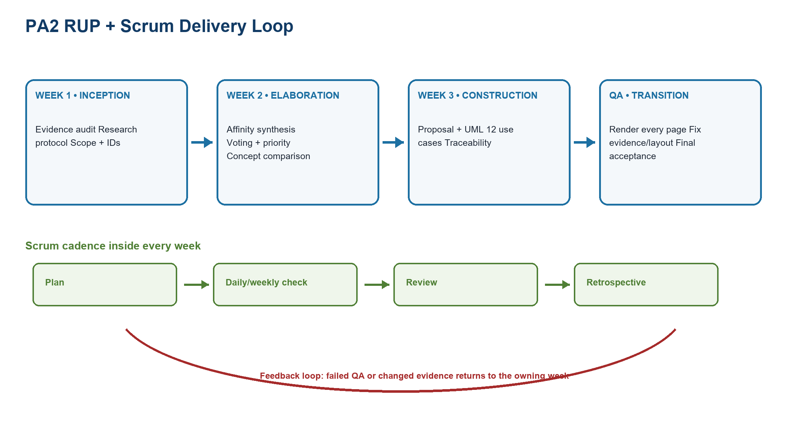
Figure WR-FLOW-01. RUP phases aligned to Week 1, Week 2, Week 3, and final QA, with Scrum cadence inside each week and a feedback loop to the owning phase.

14. Cross-report Lessons Applied
Practical difficulty | How the group handled it | Lesson learned | Impact on the final version
The first evidence crop showed a page footer instead of a ticket action. | The team reopened the full capture, selected the visible action region, and narrowed the caption to what the pixels prove. | Caption wording must be validated against the exact crop, not the source filename. | User Research now distinguishes later actions, pre-handoff state, and an unverified redirect.
Wide prioritization data created continuation pages with little content. | The team split FIFA and Chess candidates and combined criterion scores into a readable field. | Pagination is part of information architecture, especially for comparison tables. | The priority section is shorter and each product can be reviewed independently.
Early mockups used repeated boxes and generic labels. | The team added real tournament, match, party, status, timestamp, domain, board, move, lesson, and puzzle data. | A prototype must expose the decision and interaction, not merely name a component. | Guided Concierge and all 12 use-case visuals now demonstrate product-specific UI states.
Static contents drifted after sections moved and pages changed. | The team repaginated in Word and rebuilt each contents list from actual Heading 1-3 paragraphs. | Navigation must be verified after the final layout pass. | All five DOCX files have refreshed section order and page references.
A compact appendix still needed to retain all synthetic note fields at 14 pt. | The team moved note sheets to a landscape appendix with compact padding and one sheet per page. | Density should be solved with page geometry and grouping before reducing type size. | All 12 note sheets remain complete without two-page spillovers.

