PROJECT ASSIGNMENT 3

Group10-PA3 Paper Prototypes
  - Parallel lo-fi alternatives for FIFA.com and Chess.com
Field | Record
Course | CSC13112 - UI/UX Design, FIT-HCMUS
Group | Group10
Team | Le Minh (21127645); Nguyen Vu Bach (21127224); Pham Nguyen Gia Bao (20127119); Trang Minh Nhut (22127318)
Scope | FIFA.com and Chess.com

YouTube Demo Links
Prototype | Demo
FIFA - Status Dashboard | [YOUTUBE LINK REQUIRED]
FIFA - Timeline Tracker | [YOUTUBE LINK REQUIRED]
FIFA - Action Hub | [YOUTUBE LINK REQUIRED]
Chess - Beginner Review Flow | [YOUTUBE LINK REQUIRED]
Chess - Visual Card Dashboard | [YOUTUBE LINK REQUIRED]
Chess - Side-by-Side Assistant | [YOUTUBE LINK REQUIRED]

1. Introduction and Project Continuity
PA1 identified product-level drawbacks, including FIFA ticket-state uncertainty (F-D4) and dense Chess analysis before novices know what matters (C-D2). PA2 converted those concerns into provisional tough problems, solution alternatives, and use cases. PA3 now compares behaviorally distinct lo-fi interaction models before any PA4 hi-fi commitment.
Evidence boundary: Expected benefits are hypotheses. No genuine PA3 participant evidence or YouTube demo links were found, so this document does not declare a winning design.

2. Problem and Traceability Overview
Chain | FIFA.com | Chess.com
PA1 | F-D4; F-S7 Ticket status dashboard; F-S8 Official availability alerts | C-D2; C-S3 Beginner analysis preset; C-S4 Inline analysis glossary
PA2 tough problem | TP-FIFA: compare governed visible states, freshness, and official destination before acting or leaving | TP-CHESS: make one beginner path explicit, then connect a critical position to optional depth and practice
PA2 alternatives | F-A1 Status Dashboard; F-A2 Guided Ticket Concierge; F-A3 Alert-First Ticket Planner | C-A1 Beginner Analysis Preset; C-A2 Conversational Coach; C-A3 Visual Game Story
PA2 use cases | F-UC01-F-UC06 | C-UC01-C-UC06
PA3 scenarios | Plan and Manage Tickets with Confidence | Beginner Review After a Game
PA3 testing target | State, freshness, next action, official destination, and handoff understanding | Mistake comprehension, recommended-move trial, control, and relevant practice continuation

Identifier note: The handwritten sketch annotations reuse some F-A/C-A labels inconsistently with final PA2. Formal mappings above preserve final-PA2 meanings; the six PA3 concepts are identified by descriptive names.

3. Scenario 1 - FIFA.com: Plan and Manage Tickets with Confidence
Target user and context: A trust-sensitive ticket planner or tournament follower needs to understand the current visible ticket situation, decide whether to act or wait, and recognize the official destination before an outbound handoff.
Design objective: Apply state before action, one clear next action, trust through provenance, and accessible redundancy while keeping transaction processing and partner redesign out of scope.

3.1 Status Dashboard
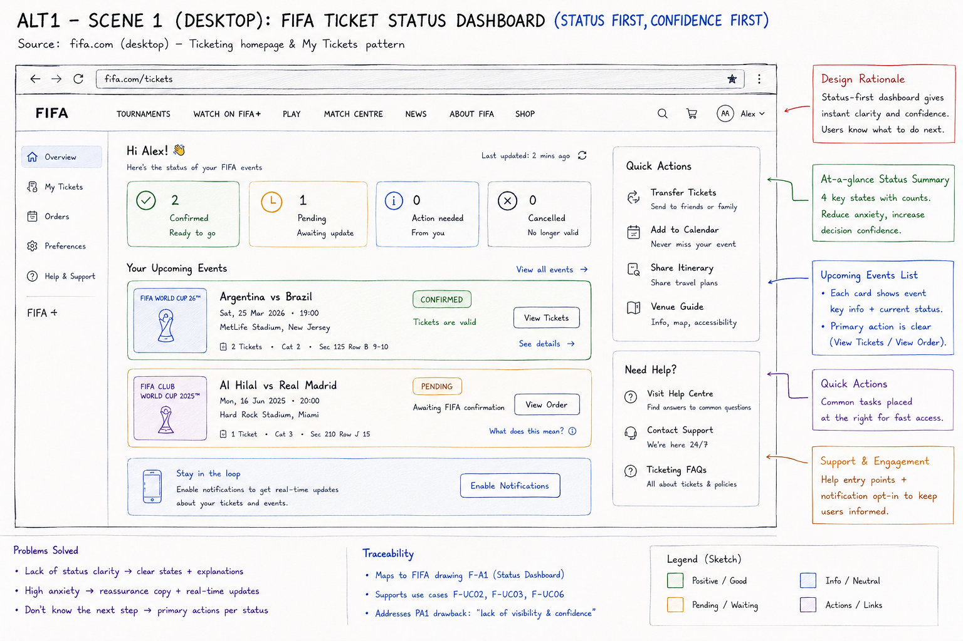
Figure PP-F-01. FIFA.com - Status Dashboard full paper prototype.
Source: Group10 PA3 paper-prototype asset. Related: F-UC01, F-UC02, F-UC03, F-UC06
Dimension | Evidence-grounded analysis
Concept / interaction model | Status-first, confidence-first dashboard.
Primary workflow | Scan aggregate states -> select an event -> follow the status-specific action or explanation.
Problem addressed | Makes governed ticket state, action-needed status, and event-level next actions visible before users leave FIFA.com.
Motivation | Direct evolution of PA2 F-A1 Status Dashboard and the PA1 F-S7 ticket-status concept.
Strengths | Fast triage; explicit Confirmed/Pending/Action needed/Cancelled states; contextual primary actions; visible last update.
Weaknesses | Dense summary plus side actions; a count does not explain the process; Pending still needs a reason.
Usability risks | Color dependence; users may read zero action needed too broadly; confirmed allocation may be confused with a usable mobile ticket.
Formative hypothesis | Users can identify the pending event, explain whether action is required, and choose the correct event action without detouring.
Exact PA2 use-case coverage | F-UC01, F-UC02, F-UC03, F-UC06

3.2 Timeline Tracker
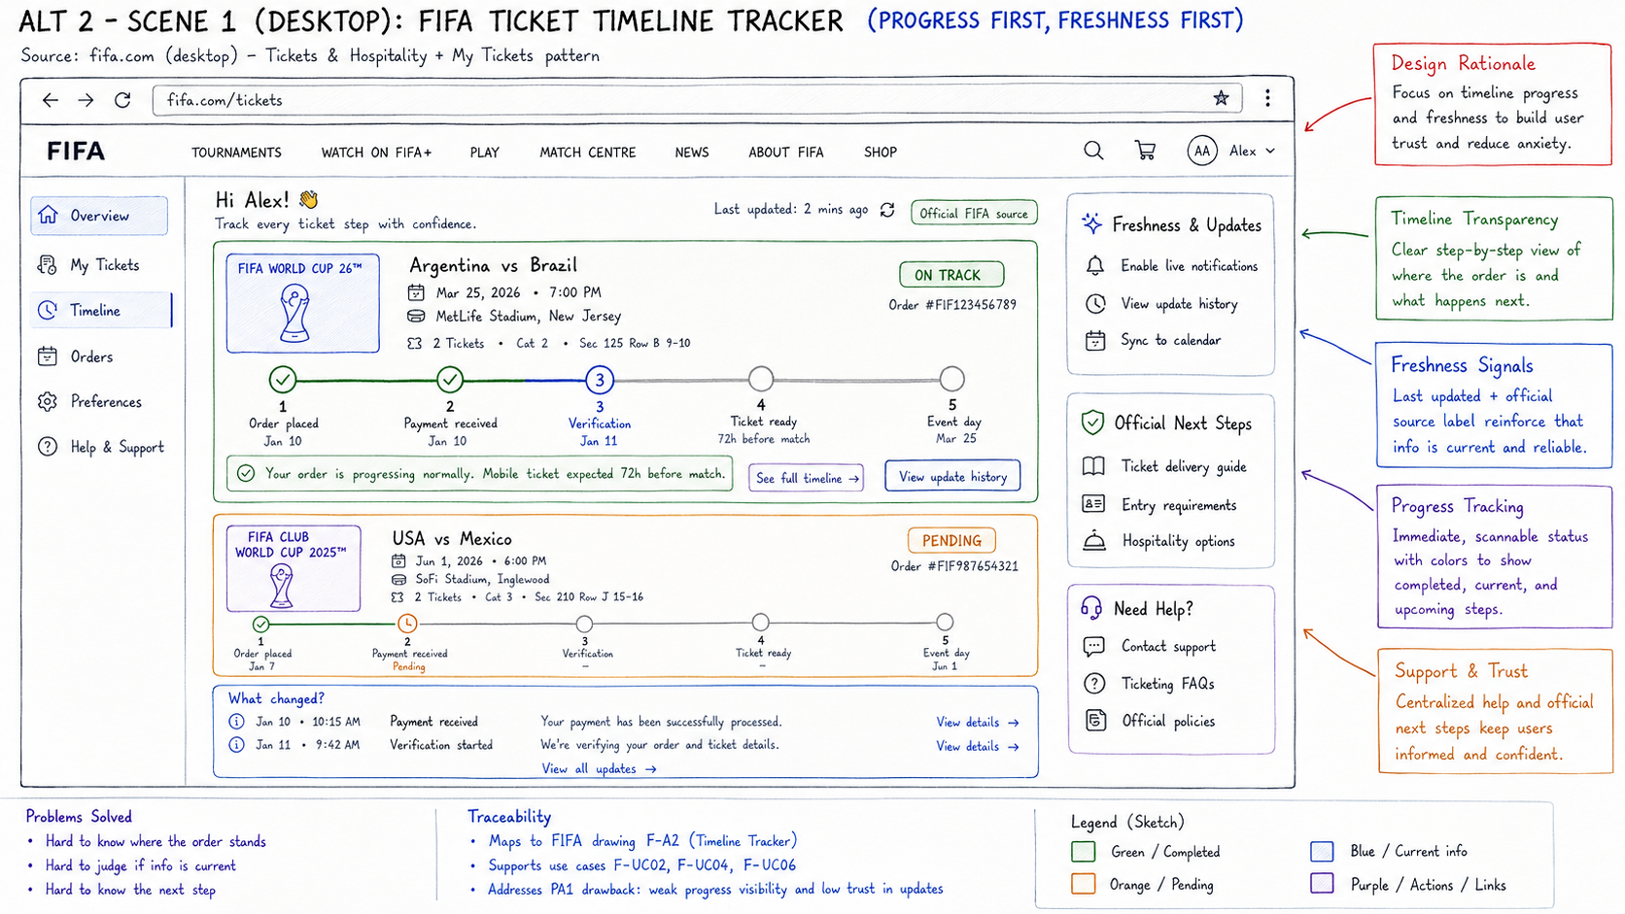
Figure PP-F-02. FIFA.com - Timeline Tracker full paper prototype.
Source: Group10 PA3 paper-prototype asset. Related: F-UC02, F-UC03, F-UC04, F-UC06
Dimension | Evidence-grounded analysis
Concept / interaction model | Progress-first, freshness-first milestone tracker.
Primary workflow | Select an event -> locate completed/current/future stages -> inspect what changed or official next-step guidance.
Problem addressed | Explains where an order stands, when the source changed, and what normally happens next.
Motivation | Explores PA2's state/freshness/provenance principles as a process model rather than a status dashboard.
Strengths | Strong process transparency; timestamps and update history; visible future delivery milestone and official source.
Weaknesses | More interpretation than a summary; dense timelines; verification terminology is unexplained.
Usability risks | A linear track may overpromise predictable fulfilment; future milestones may look like user tasks; small labels may be missed.
Formative hypothesis | Users can identify the current stage, distinguish normal waiting from a problem, and explain the next expected event and freshness source.
Exact PA2 use-case coverage | F-UC02, F-UC03, F-UC04, F-UC06

3.3 Action Hub
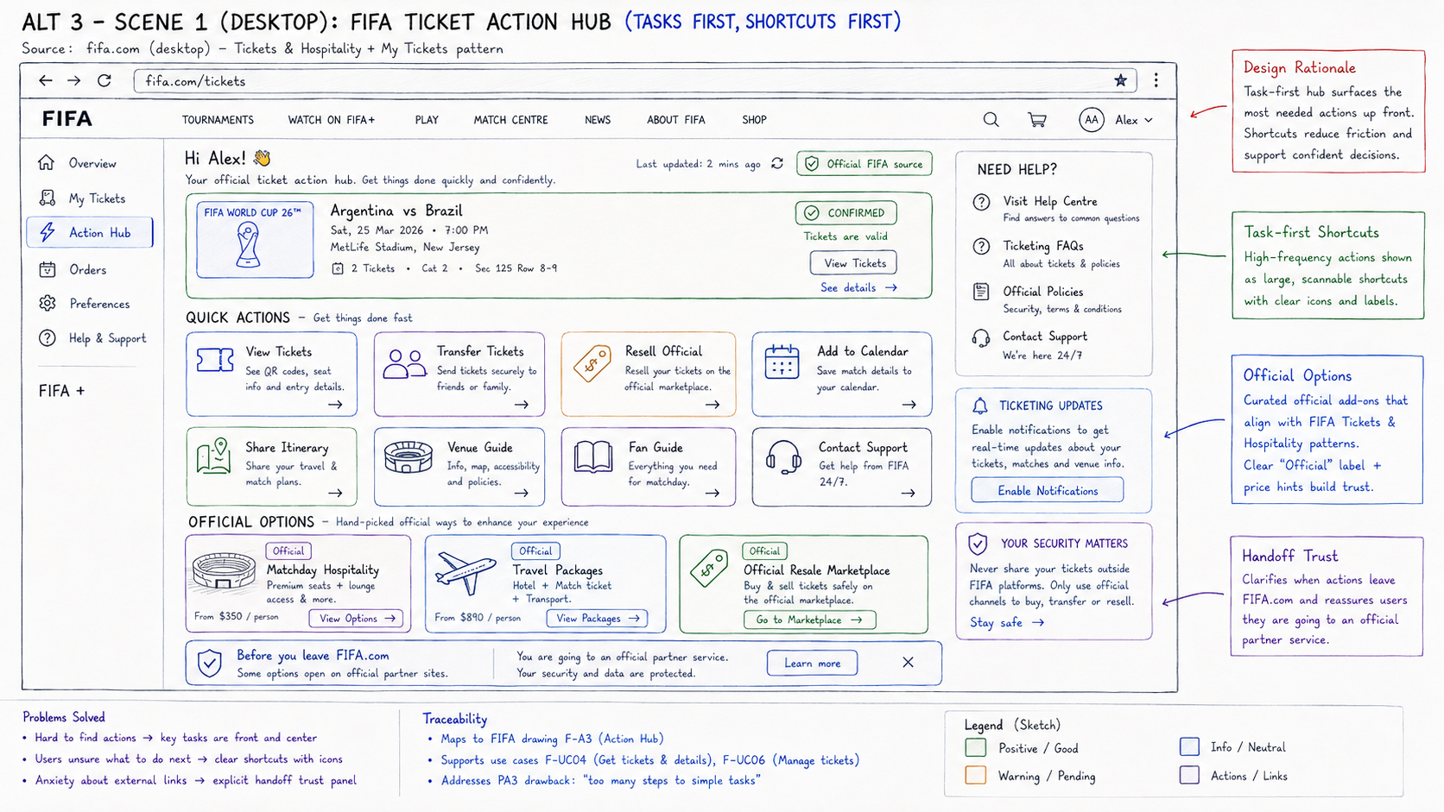
Figure PP-F-03. FIFA.com - Action Hub full paper prototype.
Source: Group10 PA3 paper-prototype asset. Related: F-UC02, F-UC04, F-UC05, F-UC06
Dimension | Evidence-grounded analysis
Concept / interaction model | Task-first shortcut hub with official-option and handoff cues.
Primary workflow | Confirm the event -> select a management shortcut -> complete on FIFA or review the partner boundary before leaving.
Problem addressed | Reduces navigation effort for common ticket tasks and makes external destinations more explicit.
Motivation | Tests one-clear-next-action and trust-through-provenance principles using shortcuts rather than guided sequencing.
Strengths | Direct task access; broad ticket-management coverage; explicit official badges and pre-handoff reassurance.
Weaknesses | Choice-heavy; critical management tasks compete with commercial options; little progress detail.
Usability risks | Promotional cards may reduce trust; Official may not explain provider/data terms; equally weighted shortcuts slow routine work.
Formative hypothesis | Users choose the correct shortcut, separate included ticket tasks from optional purchases, and recognize the partner handoff before clicking.
Exact PA2 use-case coverage | F-UC02, F-UC04, F-UC05, F-UC06

3.4 FIFA Alternative Comparison
Dimension | Status Dashboard | Timeline Tracker | Action Hub
Information architecture | Aggregate states + event cards | Event milestones + update history | Ticket tasks + official options
Primary interaction | Scan then select | Trace progress then inspect | Choose shortcut then act
User control | Moderate | Moderate | High
Cognitive load | Low-medium | Medium-high | Medium-high choice load
Status visibility | Highest | Stage-based | Compact current event
Freshness visibility | Timestamp | Highest: source + history | Timestamp + source badge
Next-step clarity | Status-specific action | Expected future milestone | Direct task shortcuts
External-handoff trust | Limited | Official source/steps | Highest pre-handoff cue
Principal risk | Counts oversimplify | Linear model overpromises | Commercial/choice distraction

4. Scenario 2 - Chess.com: Beginner Review After a Game
Target user and context: A first-time beginner or returning low-analysis learner has completed a game and needs one interpretable mistake, a recommended move they can try safely, and a relevant next-learning action before optional advanced analysis.
Evidence caution: PA2 captured analysis-entry choices, not completed-review overload. These sketches test a proposed learning flow; they do not prove that current Chess.com users experience the depicted breakdowns.

4.1 Beginner Review Flow
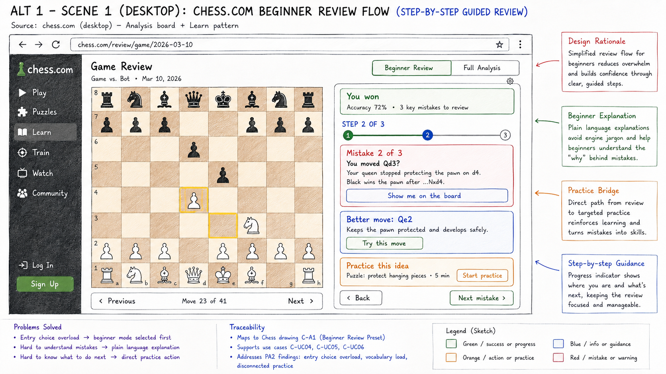
Figure PP-C-01. Chess.com - Beginner Review Flow full paper prototype.
Source: Group10 PA3 paper-prototype asset. Related: C-UC02, C-UC03, C-UC04, C-UC05, C-UC06
Dimension | Evidence-grounded analysis
Concept / interaction model | Linear guided wizard; the system controls review order.
Primary workflow | Enter Beginner Review -> inspect one mistake -> show/try the recommended move -> practice or continue.
Problem addressed | Makes one learning priority and one next-learning action explicit before advanced analysis.
Motivation | Direct evolution of PA2 C-A1 Beginner Analysis Preset and PA1 C-S3 Beginner analysis preset.
Strengths | Clear progress; plain causal explanation; manageable chunking; direct practice bridge; advanced analysis remains available.
Weaknesses | Forced order; notation and terms remain; leaving for practice may interrupt review context.
Usability risks | Simplification can hide nuance; users may memorize Qe2 without understanding the idea; board/text split attention.
Formative hypothesis | Beginners can explain the mistake in their own words, try the recommended move, and find relevant practice without facilitator help.
Exact PA2 use-case coverage | C-UC02, C-UC03, C-UC04, C-UC05, C-UC06

4.2 Visual Card Dashboard
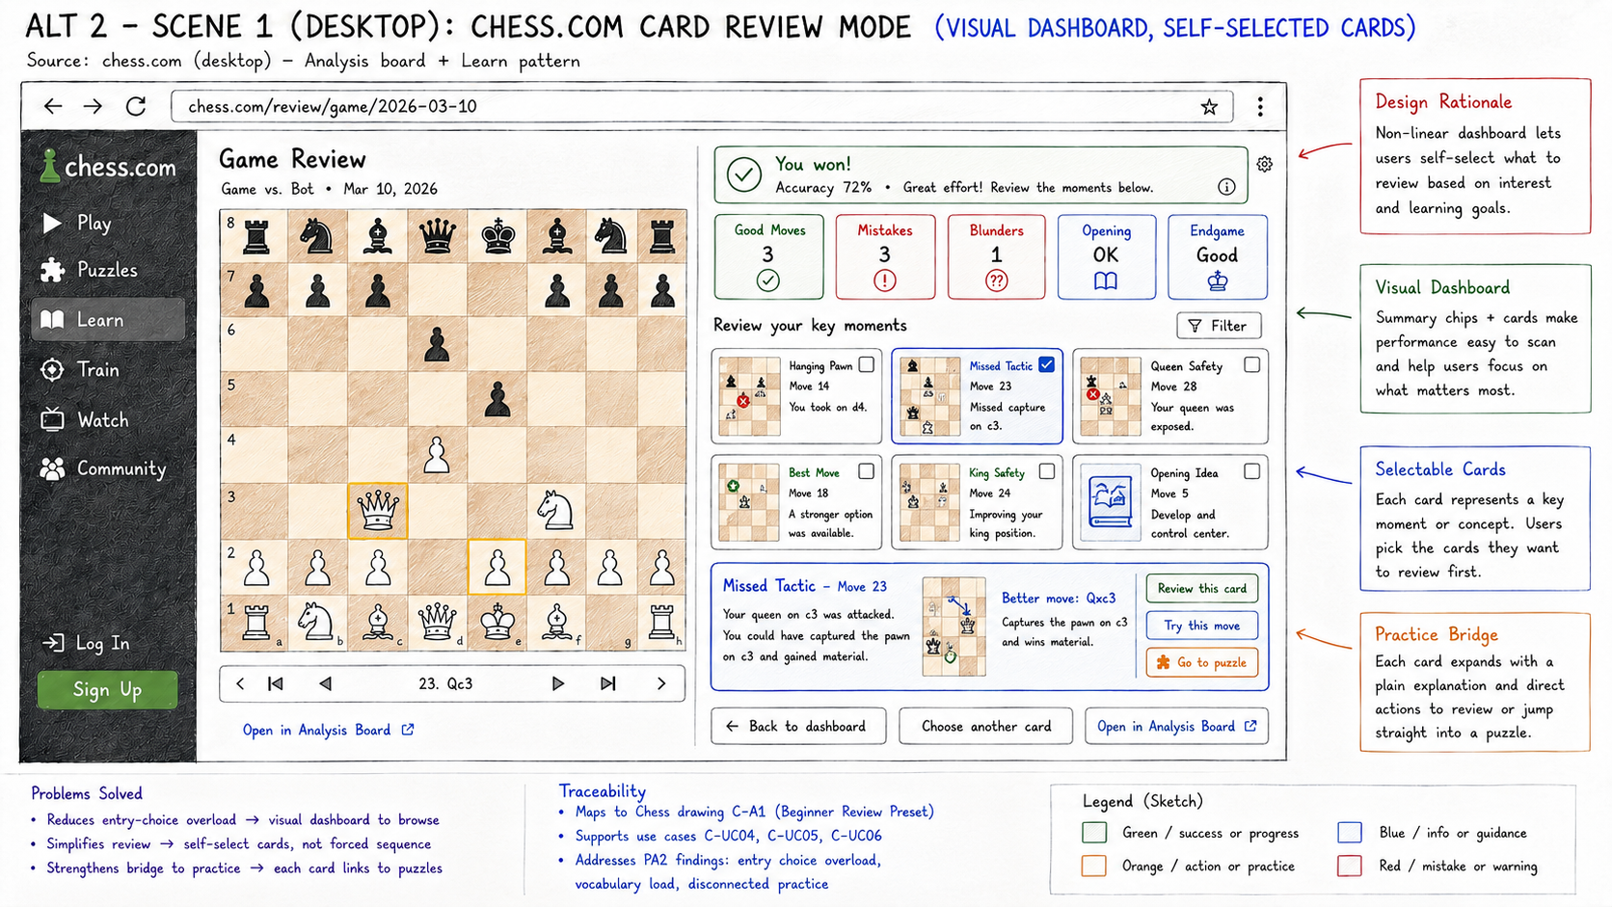
Figure PP-C-02. Chess.com - Visual Card Dashboard full paper prototype.
Source: Group10 PA3 paper-prototype asset. Related: C-UC03, C-UC04, C-UC05, C-UC06
Dimension | Evidence-grounded analysis
Concept / interaction model | Non-linear overview; users self-select review cards.
Primary workflow | Scan category summary -> choose a moment card -> read/try/practice -> select another card.
Problem addressed | Supports scan-first review and user-chosen order while retaining direct learning actions.
Motivation | Explores PA2 C-A3 Visual Game Story as a card-based overview rather than a fixed chapter timeline.
Strengths | Strong scanability; visual previews; user control; direct links from each concept to review, trial, or puzzle.
Weaknesses | High initial choice load; category terms are unexplained; checks may mean selection or completion.
Usability risks | Beginners may skip the highest-value mistake; dense cards; positive/opening cards can dilute the learning priority.
Formative hypothesis | Users understand card selection, choose a useful priority, relate the thumbnail to the board, and distinguish Review, Try, and Puzzle.
Exact PA2 use-case coverage | C-UC03, C-UC04, C-UC05, C-UC06

4.3 Side-by-Side Assistant
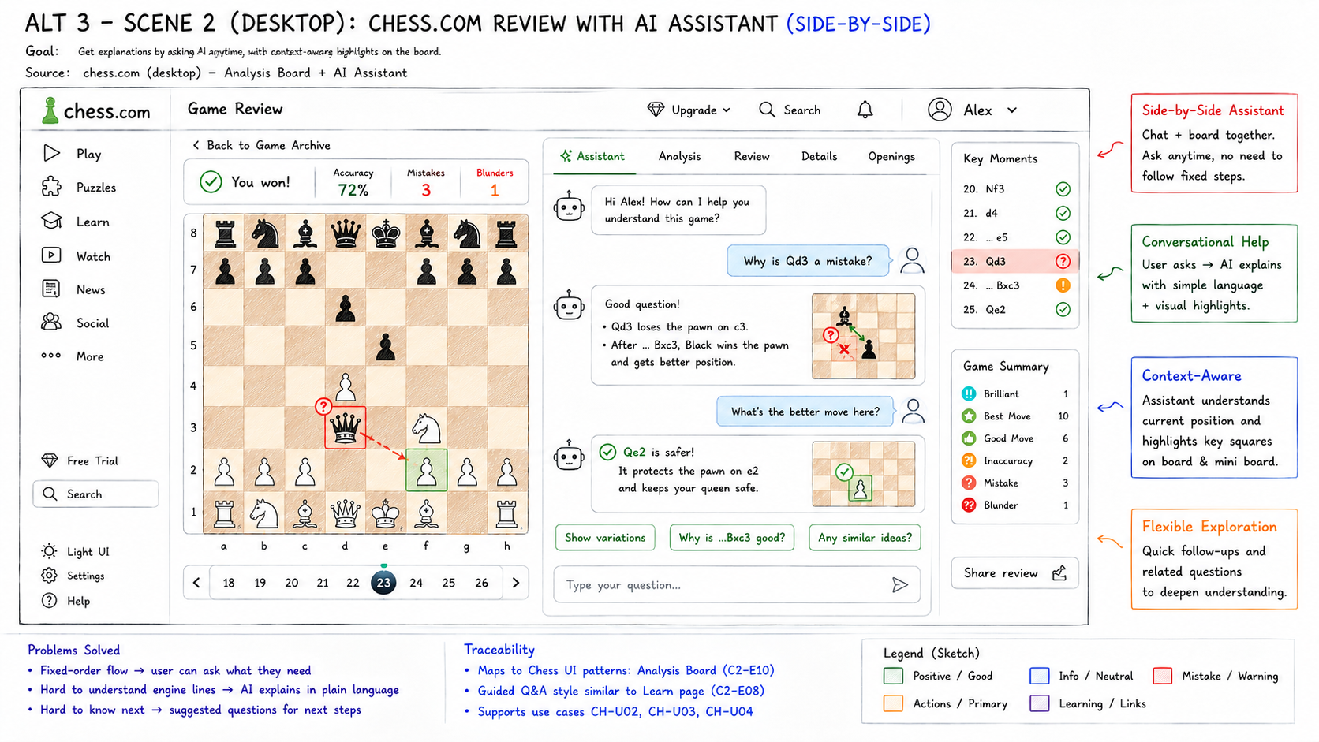
Figure PP-C-03. Chess.com - Side-by-Side Assistant full paper prototype.
Source: Group10 PA3 paper-prototype asset. Related: C-UC03, C-UC04, C-UC05, C-UC06
Dimension | Evidence-grounded analysis
Concept / interaction model | Conversational contextual review; users decide what to ask.
Primary workflow | Select a key moment -> ask or choose a suggested question -> inspect board-linked explanation -> follow up.
Problem addressed | Lets learners request plain-language explanations without following a fixed review order.
Motivation | Evolves PA2 C-A2 Conversational Coach with the board and contextual assistant visible together.
Strengths | Flexible follow-up; contextual board highlights; suggested prompts reduce blank-page friction; explanation and position stay together.
Weaknesses | No bounded completion path; text-heavy; user questions determine coverage.
Usability risks | Answer correctness and inconsistency; important mistakes may be skipped; notation remains; conversation competes with board attention.
Formative hypothesis | Users can start without composing a prompt, map an answer to the board, navigate key moments, and recognize when an explanation is uncertain.
Exact PA2 use-case coverage | C-UC03, C-UC04, C-UC05, C-UC06

4.4 Chess Alternative Comparison
Dimension | Beginner Review Flow | Visual Card Dashboard | Side-by-Side Assistant
Workflow authority | System-led | User-led | User-led questions
Navigation | Linear | Non-linear | Conversational/contextual
Information density | Low-medium | High overview | High dialogue + board
Learnability | Highest initial guidance | Requires category/card literacy | Requires prompt/answer literacy
User control | Bounded | High | Highest
Memory load | Low | Medium | Medium-high across dialogue
Explanation style | Prepared plain-language steps | Expandable card explanation | Adaptive Q&A
Practice bridge | Direct recommended practice | Per-card puzzle action | Suggested; needs explicit practice action
Likely beginner suitability | Strong for first review | Strong for self-directed learners | Strong if answers are reliable
Principal risk | Passive compliance | Choice overload/skipping | Incorrect or unbounded dialogue

5. Cross-Scenario Design Reflection
- The most guided concepts reduce immediate decision burden but can constrain exploration.
- The most user-controlled concepts accelerate expert or confident behavior but increase choice and interpretation demands.
- Freshness, provenance, plain-language explanation, and recovery must be observable rather than assumed.
- Color supports scanning but must not be the only carrier of status or severity.
- No alternative is proven best until genuine novice participants complete the core tasks.

6. Testing Hypotheses for Requirement 2
Scenario | Alternative | Observable hypothesis
FIFA | Status Dashboard | Users can identify the pending event, explain whether action is required, and choose the correct event action without detouring.
FIFA | Timeline Tracker | Users can identify the current stage, distinguish normal waiting from a problem, and explain the next expected event and freshness source.
FIFA | Action Hub | Users choose the correct shortcut, separate included ticket tasks from optional purchases, and recognize the partner handoff before clicking.
Chess | Beginner Review Flow | Beginners can explain the mistake in their own words, try the recommended move, and find relevant practice without facilitator help.
Chess | Visual Card Dashboard | Users understand card selection, choose a useful priority, relate the thumbnail to the board, and distinguish Review, Try, and Puzzle.
Chess | Side-by-Side Assistant | Users can start without composing a prompt, map an answer to the board, navigate key moments, and recognize when an explanation is uncertain.

7. Strengths and Weaknesses Summary
The portfolio deliberately spans status, progress, task, guided, non-linear, and conversational models. This breadth enables formative testing to expose which representation best supports the target task without treating visual polish as evidence. Each concept retains a plausible strength and a falsifiable risk.

8. Conclusion
All six paper prototypes are documented as alternatives to evaluate. Final best-prototype selection pending real formative testing. Six YouTube demonstration links must also be inserted on the first page before submission.

Evidence References
- Group10-PA1-PotentialSolutions.pdf, especially F-D4/F-S7/F-S8 and C-D2/C-S3/C-S4.
- Group10-PA2-UserAnalysis.pdf, final tough-problem and recommendation wording.
- Group10-PA2-ProjectProposal.pdf, final alternatives and PA3 validation targets.
- Group10-PA2-UseCaseDocument.pdf, final F-UC01-F-UC06 and C-UC01-C-UC06 names.
- PA3-LKDuy-2026-Public.pdf, Requirements 1-2 and submission rules.

