GroupID-PA1 Potential Solutions: FIFA and Chess.com
Executive summary
The solution set keeps FIFA focused on task-first navigation, continuity across FIFA+, clearer ticket status, and utility entry points. It keeps Chess.com focused on novice onboarding, simpler analysis, expectation-setting around access limits, safer premoves, and clearer Focus Mode discovery.

Drawback inventory

ID | Product | Drawback | Linked finding | Severity
F-D1 | FIFA | Ecosystem sprawl across sibling FIFA properties | F-HCI6 | High
F-D2 | FIFA | FIFA+ handoff breaks continuity | F-HCI7 | High
F-D3 | FIFA | FIFA+ scan overload | F-HCI8 | Medium
F-D4 | FIFA | Ticket status uncertainty | F-HCI9 | High
F-D5 | FIFA | Browse-first friction for quick utilitarian tasks | F-HCI10 | Medium
C-D1 | Chess.com | Menu and feature overload for novices | C-HCI7 | High
C-D2 | Chess.com | Analysis overload | C-HCI10 | High
C-D3 | Chess.com | Premium gating interrupts learning momentum | C-HCI10 | Medium
C-D4 | Chess.com | Premove blunder risk | C-HCI8 | High
C-D5 | Chess.com | Focus Mode is hard to discover | C-HCI9 | Medium
Drawback evidence and visual solution mapping

Drawback ID | Screenshot figure | Problem | Persona | Context | HCI principle | Solutions | Solution description | Mockup figure | Expected improvement | Tradeoff | Priority | Effort
F-D1 | F-01/F-02 | Match information is not always the most visible item for quick score users. | F-P1 | Mobile short break | information scent | F-S1/F-S2 | Task-first navigation and intent chips | S-01 | Faster entry to Match Centre | Less exposure for commercial links | High | Medium
F-D2 | F-03 | Mobile navigation hides important sections behind menu layers. | F-P1 | One-handed mobile use | progressive disclosure | F-S3/F-S4 | Mobile task-first menu and handoff orientation | S-01/S-04 | Fewer hidden steps | More header/state rules | High | Medium
F-D3 | F-04 | Competition or match filters require too much scanning. | F-P2 | Tournament comparison | cognitive load | F-S5/F-S6 | Filter-first rail and compact scan mode | S-02 | Lower scan cost | Metadata quality dependency | High | Medium
F-D4 | F-06/F-08 | Article and  media-heavy pages overload mobile readers. | F-P1/F-P2 | Interrupted reading | attention | F-S9/F-S10 | Article utility rail and action chips | S-03 | Keeps task continuity | May distract from reading | Medium | Low
F-D5 | F-05 | Search/discovery results do not separate categories clearly enough for official lookup tasks. | F-P3 | Research lookup | recognition | F-S7/F-S8 | Status dashboard and alerts for official tasks | S-02/S-03 | Clearer official path | Requires governance | Medium | Medium
C-D1 | C-01/C-06 | Feature-rich navigation overloads beginners. | C-P1 | First visit | memory load | C-S1/C-S2 | Goal-based onboarding and personal dashboard | S-05 | Better first success | Adds onboarding state | High | Medium
C-D2 | C-10 | Sign-in or account prompts interrupt fast play intent. | C-P2 | Fast play | user control | C-S5/C-S6 | Upfront labels and soft landing | S-08 | Fewer surprise interruptions | More copy to maintain | High | Low

Drawback ID | Screenshot figure | Problem | Persona | Context | HCI principle | Solutions | Solution description | Mockup figure | Expected improvement | Tradeoff | Priority | Effort
C-D3 | C-07 | Mobile board interaction increases mis-tap risk under time pressure. | C-P2 | Mobile blitz | motor accuracy | C-S7/C-S8 | Premove queue preview and clear shortcut | S-06 | Reduced accidental input | One more visible control | High | Medium
C-D4 | C-05 | Learning section lacks one obvious beginner path. | C-P1 | Beginner study | progressive disclosure | C-S1/C-S5 | Beginner path and entitlement labels | S-08 | Clear next step | May reduce exploration | Medium | Low
C-D5 | C-12 | Game feedback is too dense for casual users after a match. | C-P3 | Post-game review | informative feedback | C-S3/C-S4 | Beginner analysis preset and glossary | S-07 | Readable feedback first | Advanced controls move deeper | High | Low
Drawback-to-solution mapping

Drawback | Solutions
F-D1 | F-S1, F-S2
F-D2 | F-S3, F-S4
F-D3 | F-S5, F-S6
F-D4 | F-S7, F-S8
F-D5 | F-S9, F-S10
C-D1 | C-S1, C-S2
C-D2 | C-S3, C-S4
C-D3 | C-S5, C-S6
C-D4 | C-S7, C-S8
C-D5 | C-S9, C-S10
Visual solution figures

Figure S-01. FIFA task-first navigation

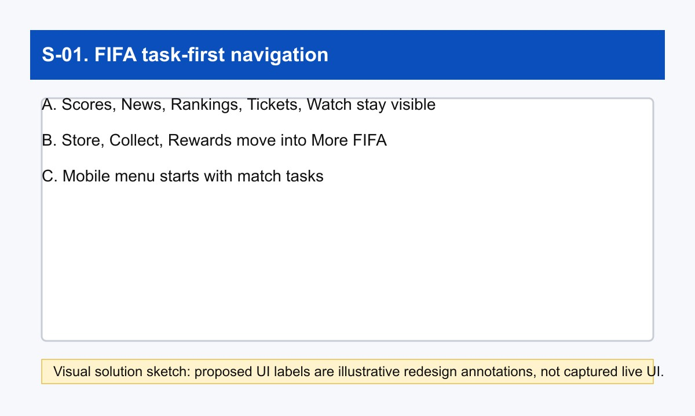
A task-first header reduces hidden navigation cost for casual fans and tournament followers.

Figure S-02. FIFA Match Centre filter bar

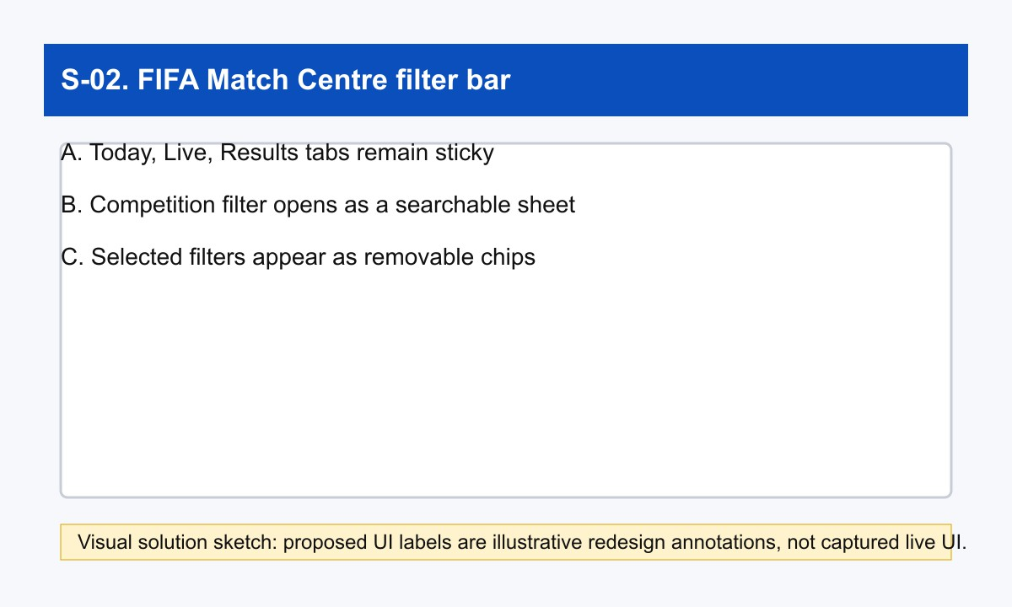
Sticky date, live, result, and competition controls reduce scanning in the Match Centre.

Figure S-03. FIFA article utility rail

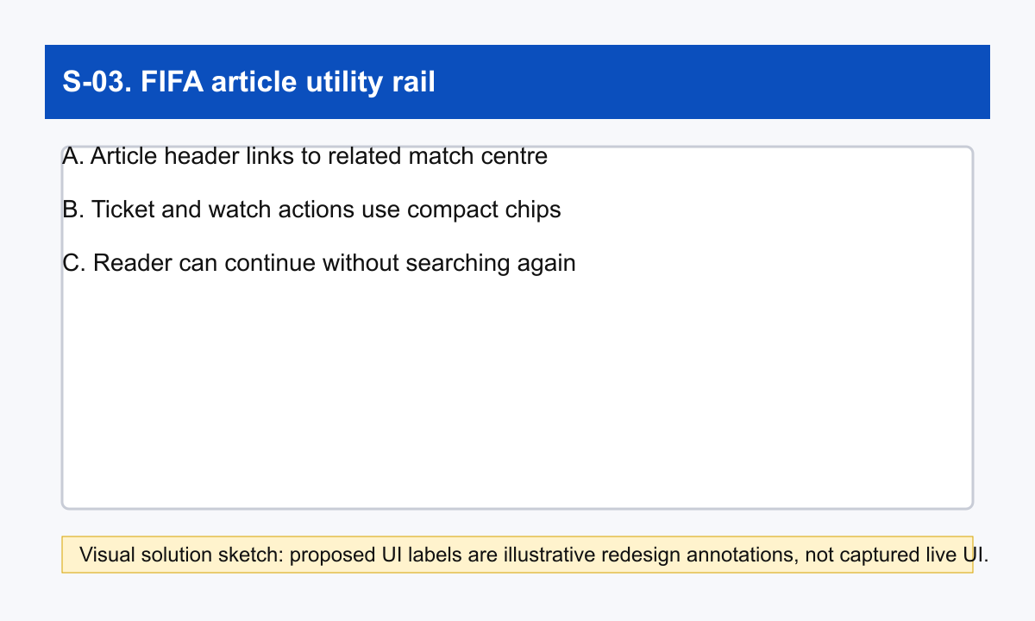
Context chips let an article reader jump to scores, tickets, or watch actions without re-searching.

Figure S-04. FIFA+ handoff explainer

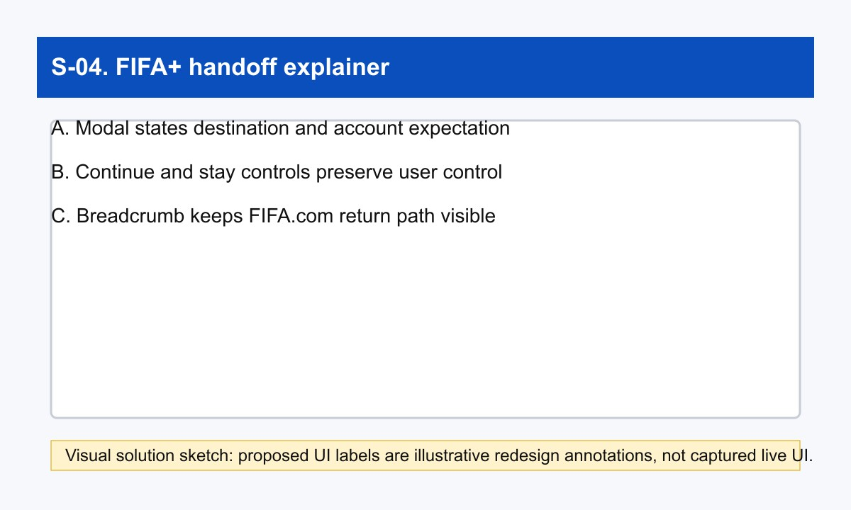
A handoff explainer improves trust and user control before switching context to FIFA+.

Figure S-05. Chess.com beginner home

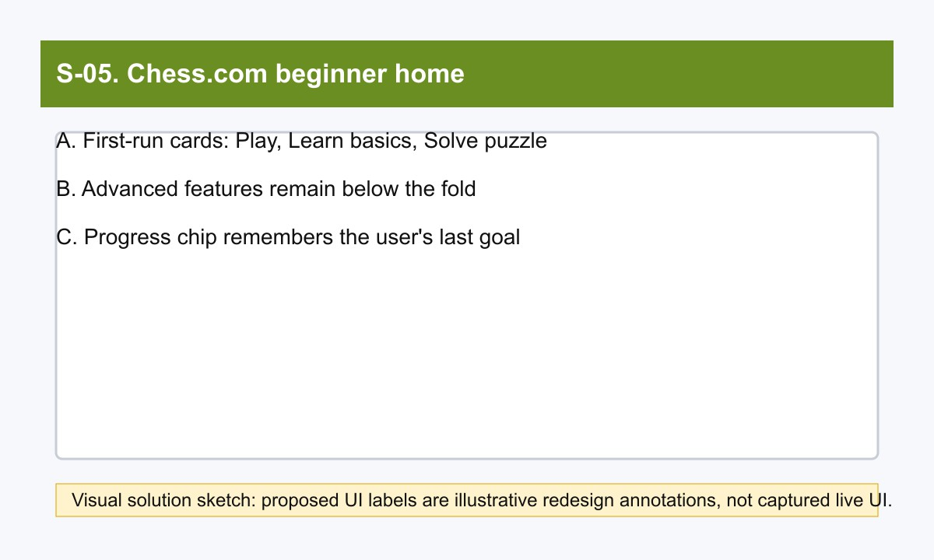
Goal-based cards reduce beginner feature overload before the user learns product taxonomy.

Figure S-06. Chess.com mobile board guard

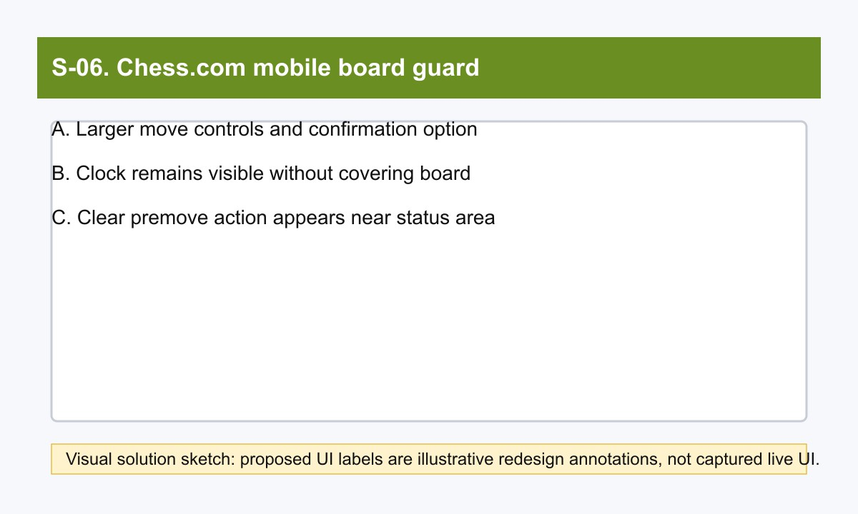
Larger controls and a clear premove action reduce mobile mis-tap risk under time pressure.

Figure S-07. Chess.com beginner analysis preset

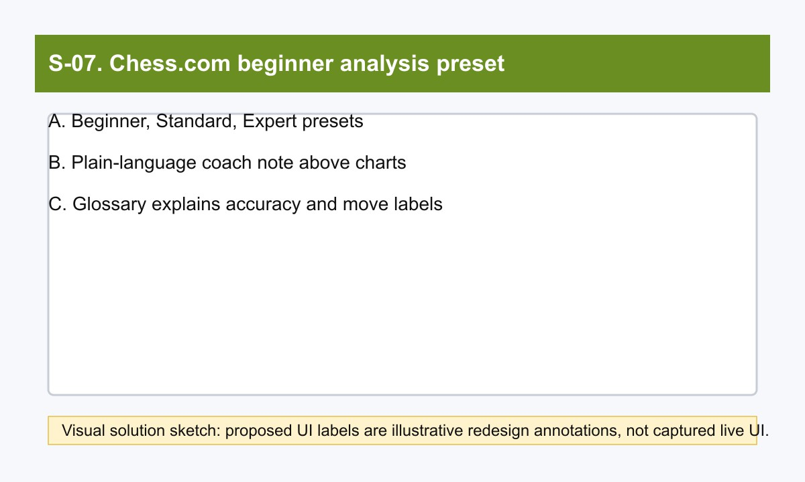
Beginner, standard, and expert presets progressively reveal game-review complexity.

Figure S-08. Chess.com learn path

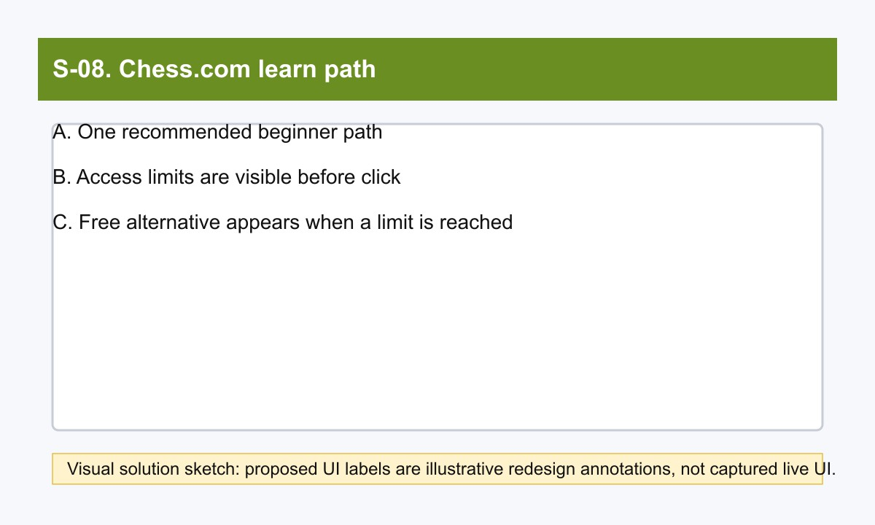
A recommended beginner path and visible access labels reduce learning-path uncertainty.

Solution details

ID | Drawback | Design concept | Detailed UI behavior | Mockup description in words | HCI principle mapping | Affected personas | Affected contexts | Expected effect | Tradeoff | Priority | Effort
F-S1 | F-D1 | Task-first global nav | Keep Match Centre, News, Rankings, Tickets, Watch at top level; move Store, Collect, and Rewards into More FIFA. | Slim header with one primary task row and one tucked ecosystem menu. | Recognition over recall; cognitive load reduction | F-P1/F-P2/F-P3 | Short task entry, office browsing, ticket planning | Fewer property jumps for common tasks. | Store and collectibles receive less top-level exposure. | High | Medium
F-S2 | F-D1 | Audience intent switcher | Add five quick-intent chips under the hero: Scores, News, Rankings, Tickets, Watch. | Horizontal chip bar under page title. | Feedforward; efficient entry | F-P1/F-P2/F-P3 | Short sessions with unclear starting point | Users choose by intent before reading navigation labels. | One more row competes for  above-fold attention. | High | Low
F-S3 | F-D2 | Handoff explainer card | Before leaving FIFA.com, show You are opening FIFA+ powered by DAZN with destination benefits and sign-in expectation. | Centered modal with Continue and Stay on FIFA.com. | Visibility of system status; trust | F-P3 | Family watch handoff | Users understand why branding and login state change. | Adds one step for repeat viewers. | High | Low

ID | Drawback | Design concept | Detailed UI behavior | Mockup description in words | HCI principle mapping | Affected personas | Affected contexts | Expected effect | Tradeoff | Priority | Effort
F-S4 | F-D2 | Shared breadcrumb and visual bridge | Add persistent Back to FIFA.com strip and tournament breadcrumb on FIFA+. | Thin top bar with FIFA icon, destination label, and return link. | Continuity; orientation | F-P3 | FIFA+ watch browsing after ticket/news research | Users retain orientation across the watch boundary. | Needs cross-property coordination. | Medium | Medium
F-S5 | F-D3 | Filter-first rail controls | Provide filters for Live, Highlights, Documentaries, Competition, and Duration above rails. | Sticky filter row above content rails. | Visual filtering; reduced scan cost | F-P3 | Evening highlight search | Users narrow a large content surface faster. | Filter accuracy depends on metadata quality. | High | Medium
F-S6 | F-D3 | Compact scan mode | Collapse nonmatching rails into section labels until expanded. | Condensed page with one expanded rail and folded sections. | Progressive disclosure; visual economy | F-P3 | Slow browsing with family waiting | Lower vertical scanning burden. | Some content feels less discoverable. | Medium | Medium
F-S7 | F-D4 | Ticket status dashboard | Show Official sale, Resale open, Waiting room, Coming soon, and Latest update time by tournament. | Small status cards above ticket links. | Visibility of system status; planning support | F-P3 | Trust-sensitive ticket planning | Users know whether to act now or wait. | Requires reliable status data and governance. | High | Medium
F-S8 | F-D4 | Official availability alerts | Offer email and browser alerts by tournament and market, confirmed by receipt. | Alert drawer with checkbox list and next release note. | Memory load reduction; trust | F-P3 | Family travel planning over many days | Users stop manually rechecking availability. | Notification fatigue and opt-in compliance. | Medium | Medium
F-S9 | F-D5 | Utility rail on story pages | Add right rail or sticky side sheet for Scores today, Rankings latest, Tickets official source, Watch now. | Compact side module with four task cards. | Task continuity; reduced jumping | F-P1/F-P2/F-P3 | Reading story then switching task | Story readers can branch into utilitarian tasks in context. | May distract from article reading. | Medium | Low
F-S10 | F-D5 | Embedded action chips in articles | Add context chips in article header: Open Match Centre, View Tickets, Watch on FIFA+. | Chip row under headline metadata. | Contextual navigation; information scent | F-P1/F-P2/F-P3 | Tournament article with adjacent action need | Users can act from the article without searching navigation again. | Requires article metadata rules. | Medium | Low
C-S1 | C-D1 | Goal-based onboarding home | First-run chooser: Play now, Review last game, Learn basics, Solve puzzles, Join tournament. | Large task cards above default homepage feed. | Progressive disclosure; recognition over recall | C-P1/C-P2/C-P3 | First visit after signup | New users see goals before feature taxonomy. | Adds onboarding state management. | High | Medium
C-S2 | C-D1 | Personal dashboard mode | User pins top three tasks and hides unused modules for 30 days. | Compact home with pinned cards and Edit layout button. | Personalization; cognitive load reduction | C-P1/C-P2/C-P3 | Repeated use with stable goals | Homepage better matches user intent. | May hide growth paths if poorly explained. | Medium | Medium
C-S3 | C-D2 | Beginner analysis preset | One-click preset keeps evaluation bar, best move, and  plain-language coach notes. | Preset chips at top of analysis panel: Beginner, Standard, Expert. | Progressive disclosure; low-friction defaults | C-P1 | Post-loss beginner review | Novices get a readable analysis surface. | Advanced controls become one step deeper. | High | Low
C-S4 | C-D2 | Inline analysis glossary | Hover or tap chart and toggle labels for  plain-language explanations. | Right-side info drawer with What this means text. | Learnability; reduced memory load | C-P1/C-P3 | Analysis and Game Review study sessions | Users learn the meaning of graphs and labels in place. | Adds copy maintenance and localization work. | Medium | Medium
C-S5 | C-D3 | Upfront entitlement labels | Mark each lesson, puzzle, and analysis feature with access labels before click. | Small pill tags: Free, 3/day, 1 lesson/day, Diamond. | Expectation setting; error prevention | C-P1/C-P3 | Learning path selection | Users know limits before investing attention. | Access labels may add visual noise. | High | Low
C-S6 | C-D3 | Soft-landing after limit reached | After a limit wall, offer free alternative, reset timer, and queue for later. | Modal with Continue learning free, Save for later, Upgrade. | Continuity; frustration reduction | C-P1 | Study session after a daily limit | Users keep learning instead of stopping abruptly. | May reduce upgrade pressure. | Medium | Medium
C-S7 | C-D4 | Premove queue preview | Show pending premoves with danger icon when opponent reply tree makes risk high. | Tiny queue strip above board, first item tinted warning color. | Error prevention; system status | C-P2 | Blitz and bullet time trouble | Users see what will execute before it happens. | Risk estimate can be imperfect. | High | Medium

ID | Drawback | Design concept | Detailed UI behavior | Mockup description in words | HCI principle mapping | Affected personas | Affected contexts | Expected effect | Tradeoff | Priority | Effort
C-S8 | C-D4 | Fast clear shortcut | One-click Clear or Esc clears queued premove chain. | Small Clear premoves pill next to clocks or settings. | Recoverability; user control | C-P2 | Fast play after unexpected opponent move | Users recover from risky queued intent quickly. | Adds one more in-game control. | Medium | Low
C-S9 | C-D5 | First-time coachmark | After two full games, show Need fewer distractions? Try Focus Mode. | Tooltip near board corner. | Discoverability; contextual help | C-P2 | Post-game moment before next serious game | Users learn the hidden control when it is relevant. | Coachmarks can annoy expert users. | Medium | Low
C-S10 | C-D5 | Persistent settings shortcut | Add Focus Mode toggle into board settings and keyboard shortcut help. | Settings panel item with live preview thumbnail. | Consistency; discoverability | C-P2/C-P3 | Board settings and serious-game setup | Focus Mode becomes findable without hover discovery. | Settings panel grows slightly. | Medium | Low
Prioritized impact-effort matrix

Solution | Concept | Priority | Effort | Rollout bucket
F-S1 | Task-first global nav | High | Medium | Deeper redesign
F-S2 | Audience intent switcher | High | Low | Quick win
F-S3 | Handoff explainer card | High | Low | Quick win
F-S4 | Shared breadcrumb and visual bridge | Medium | Medium | Deeper redesign
F-S5 | Filter-first rail controls | High | Medium | Deeper redesign
F-S6 | Compact scan mode | Medium | Medium | Deeper redesign
F-S7 | Ticket status dashboard | High | Medium | Deeper redesign
F-S8 | Official availability alerts | Medium | Medium | Deeper redesign
F-S9 | Utility rail on story pages | Medium | Low | Quick win
F-S10 | Embedded action chips in articles | Medium | Low | Quick win
C-S1 | Goal-based onboarding home | High | Medium | Deeper redesign
C-S2 | Personal dashboard mode | Medium | Medium | Deeper redesign
C-S3 | Beginner analysis preset | High | Low | Quick win
C-S4 | Inline analysis glossary | Medium | Medium | Deeper redesign
C-S5 | Upfront entitlement labels | High | Low | Quick win
C-S6 | Soft-landing after limit reached | Medium | Medium | Deeper redesign
C-S7 | Premove queue preview | High | Medium | Deeper redesign
C-S8 | Fast clear shortcut | Medium | Low | Quick win
C-S9 | First-time coachmark | Medium | Low | Quick win
C-S10 | Persistent settings shortcut | Medium | Low | Quick win
Quick wins

ID | Concept | Why first
F-S2 | Audience intent switcher | High priority with Low effort; concrete UI can be tested without changing core architecture.
F-S3 | Handoff explainer card | High priority with Low effort; concrete UI can be tested without changing core architecture.
F-S9 | Utility rail on story pages | Medium priority with Low effort; concrete UI can be tested without changing core architecture.
F-S10 | Embedded action chips in articles | Medium priority with Low effort; concrete UI can be tested without changing core architecture.
C-S3 | Beginner analysis preset | High priority with Low effort; concrete UI can be tested without changing core architecture.
C-S5 | Upfront entitlement labels | High priority with Low effort; concrete UI can be tested without changing core architecture.
C-S8 | Fast clear shortcut | Medium priority with Low effort; concrete UI can be tested without changing core architecture.
C-S9 | First-time coachmark | Medium priority with Low effort; concrete UI can be tested without changing core architecture.

ID | Concept | Why first
C-S10 | Persistent settings shortcut | Medium priority with Low effort; concrete UI can be tested without changing core architecture.
Deeper redesigns

ID | Concept | Why deeper
F-S1 | Task-first global nav | Requires cross-page, data, personalization, or cross-property coordination.
F-S4 | Shared breadcrumb and visual bridge | Requires cross-page, data, personalization, or cross-property coordination.
F-S5 | Filter-first rail controls | Requires cross-page, data, personalization, or cross-property coordination.
F-S6 | Compact scan mode | Requires cross-page, data, personalization, or cross-property coordination.
F-S7 | Ticket status dashboard | Requires cross-page, data, personalization, or cross-property coordination.
F-S8 | Official availability alerts | Requires cross-page, data, personalization, or cross-property coordination.
C-S1 | Goal-based onboarding home | Requires cross-page, data, personalization, or cross-property coordination.
C-S2 | Personal dashboard mode | Requires cross-page, data, personalization, or cross-property coordination.
C-S4 | Inline analysis glossary | Requires cross-page, data, personalization, or cross-property coordination.
C-S6 | Soft-landing after limit reached | Requires cross-page, data, personalization, or cross-property coordination.
C-S7 | Premove queue preview | Requires cross-page, data, personalization, or cross-property coordination.
Rollout plan
Sprint 1 implements quick wins, tests wording and UI placement, and validates with the personas most affected by each drawback. Sprint 2 handles task-first navigation, ticket status, FIFA+ filters, personalized Chess.com home, glossary behavior, and premove queue preview. QA checks that every drawback from ProductResearch still maps to exactly two solutions.

References
- Inside FIFA. Official FIFA news and navigation. https://inside.fifa.com/. Accessed 2026-06-10. Supports: Inside FIFA exposes Latest FIFA News and the global navigation labels Match Centre, News, Rankings, Tickets & Hospitality, Play, Inside FIFA, plus sibling destinations such as FIFA+, Store, Collect, and Rewards.
- All stories & topics. Official FIFA topic index. https://inside.fifa.com/all-stories. Accessed 2026-06-10. Supports: The all stories page supports exploratory browsing through categories, content types, articles, blogs, media releases, videos, and albums.
- FIFA World Cup 26 Ticketing Programme launches this September. Official FIFA media release.
https://inside.fifa.com/tournament-organisation/commercial/media-releases/world-cup-26-ticketing-programme-launch-september. Accessed 2026-06-10. Supports: FIFA directs fans to FIFA.com/tickets to register interest, create a FIFA ID, and follow phased ticket releases.
- FIFA World Cup 2026 Last-Minute Sales Phase. Official FIFA media release. https://inside.fifa.com/media-releases/last-minute-ticket-sales-phase-fifa-world-cup-2026. Accessed 2026-06-10. Supports: FIFA.com/tickets is identified as the official and preferred ticket source; fans are asked to check it regularly; the official Resale/Exchange Marketplace is available for eligible ticket holders.
- Watch FIFA+ Live Stream Online. Official FIFA+ watch destination. https://www.plus.fifa.com/. Accessed 2026-06-10. Supports: FIFA+ presents a watch surface with sign-in or get-started controls, live or upcoming content, highlights, replays, documentaries, and archive content. The FIFA+ destination is presented through a DAZN-branded page.
- Tickets & Hospitality. Official FIFA tickets page. https://www.fifa.com/en/tickets. Accessed 2026-06-10. Supports: The tickets URL is the official entry point for first-hand FIFA tournament ticket and hospitality information; the page is client-side rendered in crawled text.
- Chess.com homepage. Official Chess.com homepage. https://www.chess.com/. Accessed 2026-06-10. Supports: The homepage foregrounds Play, Puzzles, Learn, Train, Watch, Community, Get Started, lessons, bots, puzzles, and watching events.
- How do I start a game on Chess.com?. Official Chess.com help. https://support.chess.com/en/articles/8609779-how-do-i-start-a-game-on-chess-com. Accessed 2026-06-10. Supports: Users can start games from the homescreen or site-wide Play menu, using recent time control, custom settings, random opponent, bots, or friends.
- What are pre-moves and how do they work?. Official Chess.com help. https://support.chess.com/en/articles/8562432-what-are-pre-moves-and-how-do-they-work. Accessed 2026-06-10. Supports: Premoves can be enabled and then entered while it is the opponent's turn; the feature saves time but executes automatically if legal.
- What is focus mode? How do I turn it on?. Official Chess.com help. https://support.chess.com/en/articles/8588088-what-is-focus-mode-how-do-i-turn-it-on. Accessed 2026-06-10. Supports: Focus Mode minimizes distractions by expanding the board and showing only the board, clocks, draw, and resign controls.
- How do I change my board size?. Official Chess.com help. https://support.chess.com/en/articles/8609533-how-do-i-change-my-board-size. Accessed 2026-06-10. Supports: Board settings, Focus Mode, Theatre Mode, and Flip Board appear when hovering near the board/sidebar boundary, creating a discoverability issue for hidden controls.

- How does Game Review work?. Official Chess.com help. https://support.chess.com/en/articles/8584089-how-does-game-review-work. Accessed 2026-06-10. Supports: Game Review appears after a game and provides a detailed review flow with accuracy, move classifications, key moves, coach guidance, graphs, and retry learning.
[17] How do I use the analysis board?. Official Chess.com help. https://support.chess.com/en/articles/8583825-how-do-i-use-the-analysis-board. Accessed 2026-06-10. Supports: The Analysis Board supports direct manipulation, setup position, FEN/PGN loading, game history, collections, engine settings, evaluation bar, lines, arrows, and move feedback.
[19] How do Lessons work on Chess.com?. Official Chess.com help. https://support.chess.com/en/articles/8609703-how-do-lessons-work-on-chess-com. Accessed 2026-06-10. Supports: Lessons are reached from Learn, use interactive practice challenges, and include access limits by membership level.
[20] Chess Study Plans for All Levels. Official Chess.com article. https://www.chess.com/article/view/study-plan-directory. Accessed 2026-06-10. Supports: Study plans guide players by skill level and help organize training time through curated lessons and videos.

