GROUP 10 | CSC13112 | UI/UX DESIGN | PA3
Group10-PA3 Paper Prototypes
Requirement 1 - Storyboarding, motivation, problem/solution, strengths/weaknesses
Field | Value
Group | Group 10
Project | FIFA.com Ticket Confidence + Chess.com Beginner Review
Prototype alternatives | 6 paper prototypes: 3 FIFA and 3 Chess.com
Selected directions | FIFA Alt 1 Status Dashboard  Chess Alt 2 Card Review Mode

Prototype Demonstration Video
This video presents all six paper prototypes:
- FIFA Status Dashboard
- FIFA Timeline Tracker
- FIFA Action Hub
- Chess Beginner Review Flow
- Chess Card Review Mode
- Chess Side-by-Side AI Assistant
Video: https://www.youtube.com/watch?v=1DvikSQqgyQ&feature=youtu.be

1. Scenario and design space
The group designed three FIFA alternatives and three Chess alternatives for the two scenarios. FIFA focuses on ticket status, progress, and action; Chess focuses on guided review, review cards, and an assistant-led review. The alternatives are different approaches for the same scenarios, not six features that would appear together.

2. FIFA alternatives
Scenario 1: a ticket holder needs status, the next step, and a common action before travelling.

FIFA Alt 1 - Status Dashboard
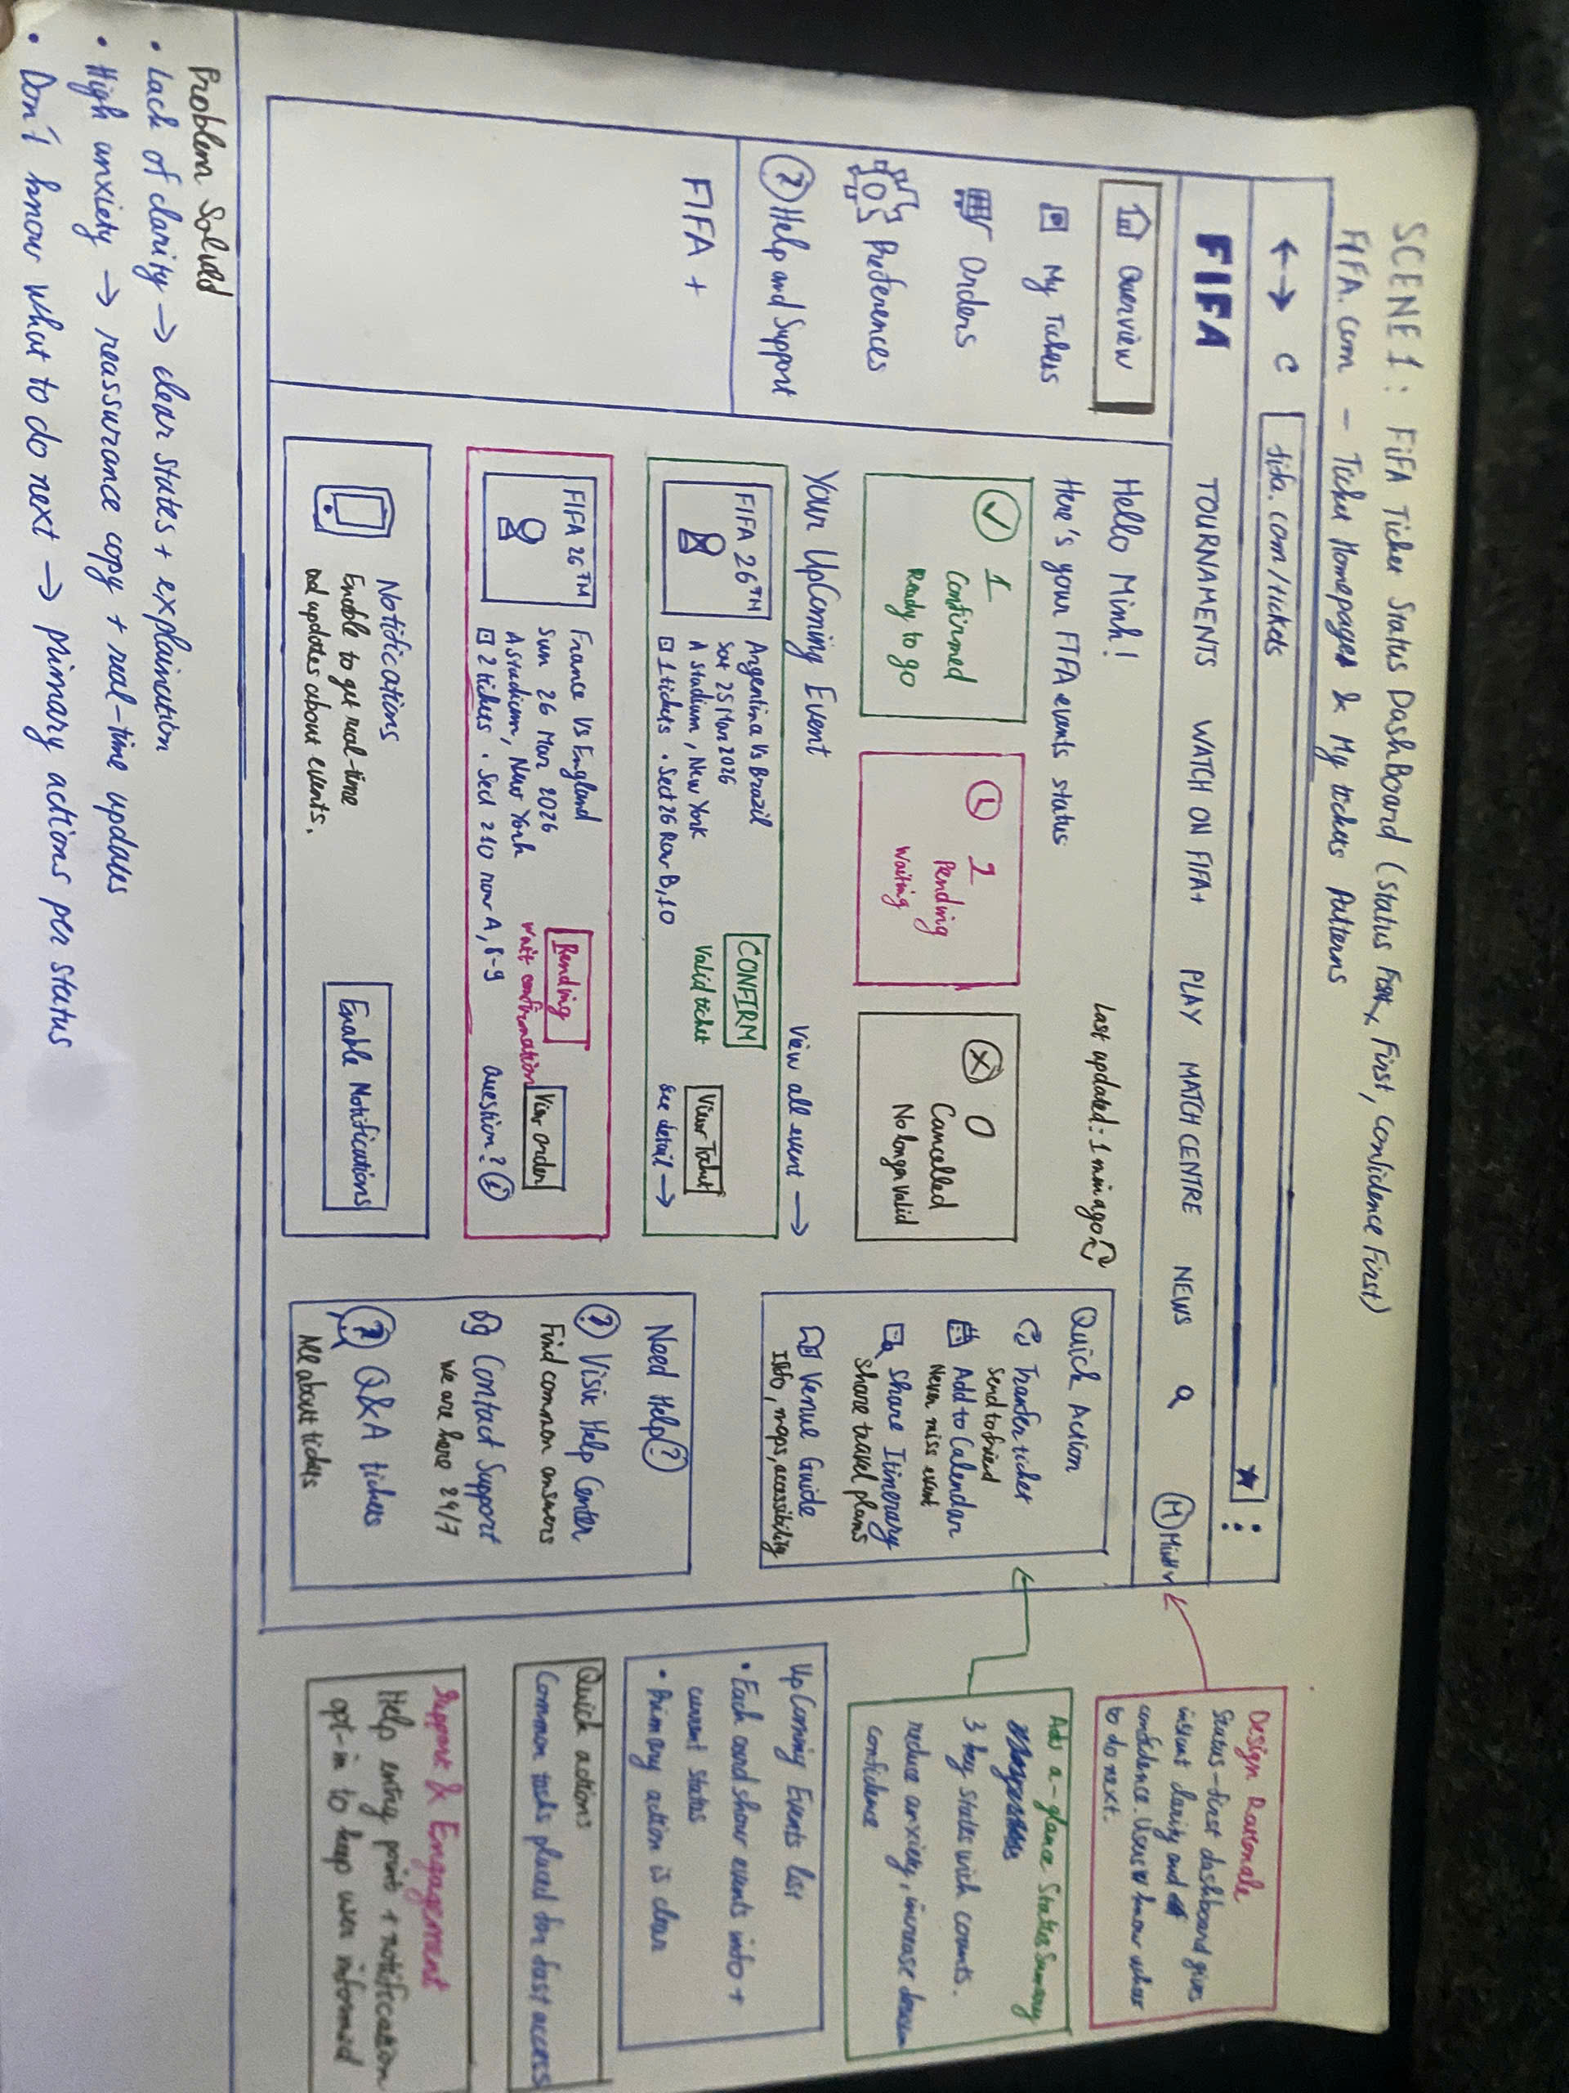
Figure 1. FIFA Alt 1 - Status Dashboard
Problem: A novice needs to know whether a ticket is safe, pending, or needs action before travel.
Motivation: Reduce status uncertainty to one first scan while keeping common ticket actions close to the state.
Solution: A status-first dashboard with summary counts, event cards, a pending/confirmed distinction, freshness cue, and quick actions.
Strengths: Fast current-state recognition; confirmed and pending states are scannable; direct actions are close to the relevant event.
Weaknesses: Pending originally lacked a clear reason, owner, timing, and partner-transition cue; View Order and View Tickets could be confused.

Storyboard
Step | Stage | User action | Paper response
1 | Context | User opens the ticket dashboard and sees one confirmed and one pending event. | The dashboard shows status summary cards and event-level status.
2 | Trigger | User selects the pending event. | The event card shows the current status and the related action.
3 | Interaction | User checks what Pending means. | The card explains the current state and the next available action.
4 | Action | User selects View Order or another ticket action. | The related ticket information opens and the destination is clear.
5 | Goal | User understands the ticket state and knows what to do next. | The user returns to the dashboard if further status checking is needed.

FIFA Alt 2 - Timeline Tracker
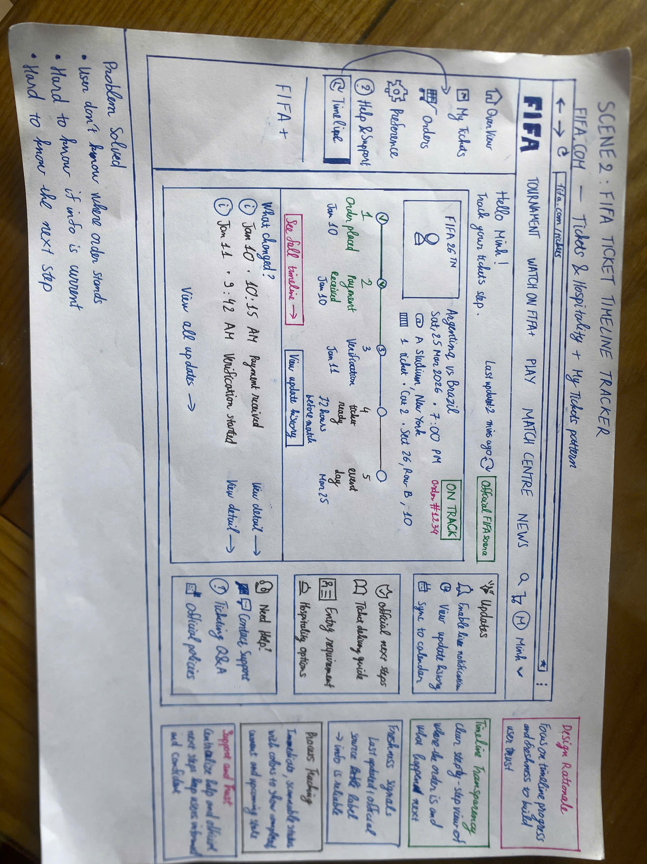
Figure 2. FIFA Alt 2 - Timeline Tracker
Problem: A novice needs to understand where an order is in a multi-stage ticket process.
Motivation: Make progress, freshness, and the next expected milestone visible as a sequence.
Solution: Per-event timelines distinguish completed, current, and upcoming stages and pair progress with source/update cues.
Strengths: Strong process visibility; current stage and freshness cues support trust; pending work has a visible position.
Weaknesses: Ticket actions can disappear from the scan path; future stages may look like user tasks; ownership and timing need clearer labels.

Storyboard
Step | Stage | User action | Paper response
1 | Context | User opens the timeline for an event with several ticket stages. | The timeline shows completed, current, and upcoming stages.
2 | Trigger | User scans the current marker and the later stages. | The current step and the next milestone are visually separated.
3 | Interaction | User selects a stage or opens its details. | The stage explains its status, owner, and last update.
4 | Action | User looks for a ticket action from the event details. | The timeline links the user to the relevant ticket action.
5 | Goal | User understands progress and what is expected next. | The user returns to the timeline when the event still needs checking.

FIFA Alt 3 - Action Hub
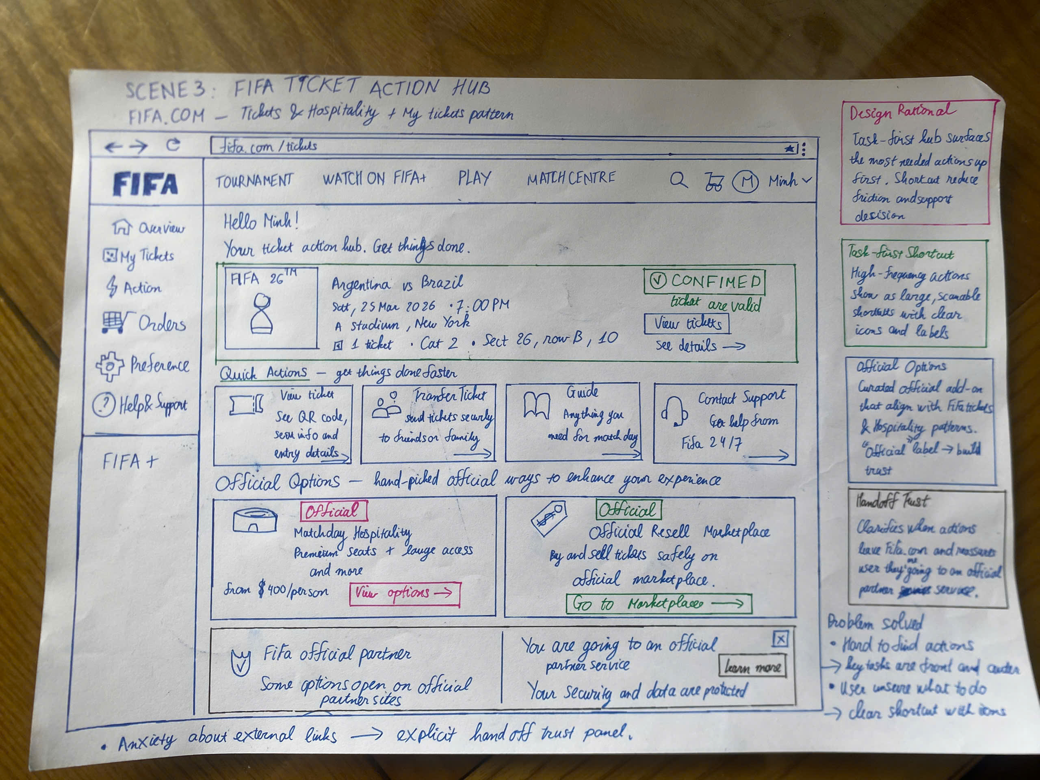
Figure 3. FIFA Alt 3 - Action Hub
Problem: A novice needs a fast route to common ticket actions without losing trust context.
Motivation: Put high-frequency actions first and explain the partner boundary before the user leaves FIFA.com.
Solution: A shortcut-led hub groups transfer, calendar, ticket, support, and official-option actions.
Strengths: Fast action discovery; familiar labels; useful shortcuts and a visible partner-transition treatment.
Weaknesses: Action-first entry can hide status meaning; equal-weight tiles create choice load; official context can arrive too late.

Storyboard
Step | Stage | User action | Paper response
1 | Context | User opens the action hub because they need a ticket-related action. | The hub presents View Tickets, Transfer Ticket, Add to Calendar, and support.
2 | Trigger | User scans the quick-action labels. | The action cards explain the scope of each option.
3 | Interaction | User selects Transfer Ticket, Add to Calendar, or View Tickets. | The selected card shows the information needed before continuing.
4 | Action | User opens an official option or support path. | The hub explains whether the next step stays on FIFA.com or uses a partner service.
5 | Goal | User completes the common action with enough context to trust it. | The user returns to the hub to choose another action or check the ticket state.

3. Chess alternatives
Scenario 2 asks a beginner to understand one important mistake, learn a better move, and decide what to practise next.

Chess Alt 1 - Beginner Review Flow
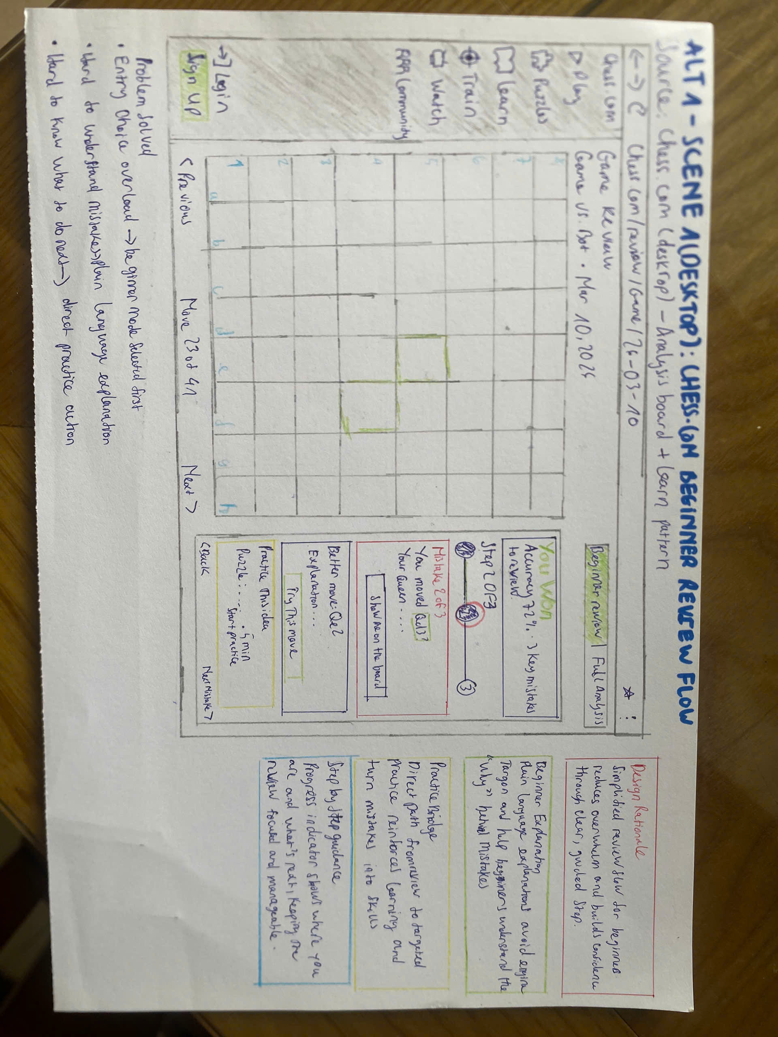
Figure 4. Chess Alt 1 - Beginner Review Flow
Problem: A beginner needs to turn one unfamiliar chess mistake into an understandable practice step.
Motivation: Lower memory load by controlling the order from mistake to explanation to practice.
Solution: A guided flow with progress, plain-language cause, better move, try interaction, practice bridge, and next-mistake recovery.
Strengths: Clear novice entry; strong mistake-to-practice continuity; one focused sequence limits choice load.
Weaknesses: The original flow could hide recovery, alternate review, and the practical meaning of notation.

Storyboard
Step | Stage | User action | Paper response
1 | Context | User opens a completed game and chooses Beginner Review. | The review opens with one mistake and a progress indicator.
2 | Trigger | User starts the first review step. | The flow identifies the game move and the current review step.
3 | Interaction | User reads the plain-language cause and the suggested better move. | The board and explanation show what changed and why it matters.
4 | Action | User tries the move or opens the board demonstration. | The paper state shows the move result and links it to practice.
5 | Goal | User practises the idea or moves to the next mistake. | Practice, help, next-mistake, and back controls keep the learning path clear.

Chess Alt 2 - Card Review Mode
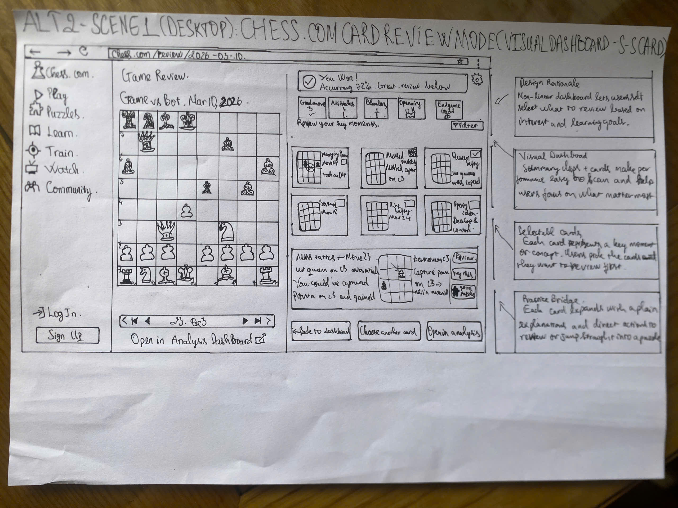
Figure 5. Chess Alt 2 - Card Review Mode
Problem: A learner may want to choose which game moment to review first.
Motivation: Expose choice and visual scanning while retaining a recommended learning entry.
Solution: A card grid with mini-boards, selected-card explanation, and a practice route.
Strengths: Scannable review moments; user control; visual choice can support deliberate review.
Weaknesses: Priority is ambiguous without a Start here cue; several cards can compete before learning begins.

Storyboard
Step | Stage | User action | Paper response
1 | Context | User opens a game with several review moments. | Cards group moments such as mistakes, blunders, openings, and endgames.
2 | Trigger | User scans the cards and compares their visual cues. | Each card shows a short label and a small board state.
3 | Interaction | User selects a card or the recommended first moment. | The selected card expands into an explanation of that moment.
4 | Action | User reviews the move, tries it, or opens analysis. | The card keeps the move explanation and practice action together.
5 | Goal | User understands one moment and chooses whether to continue. | The user returns to the card set or selects another review moment.

Chess Alt 3 - Side-by-Side AI Assistant
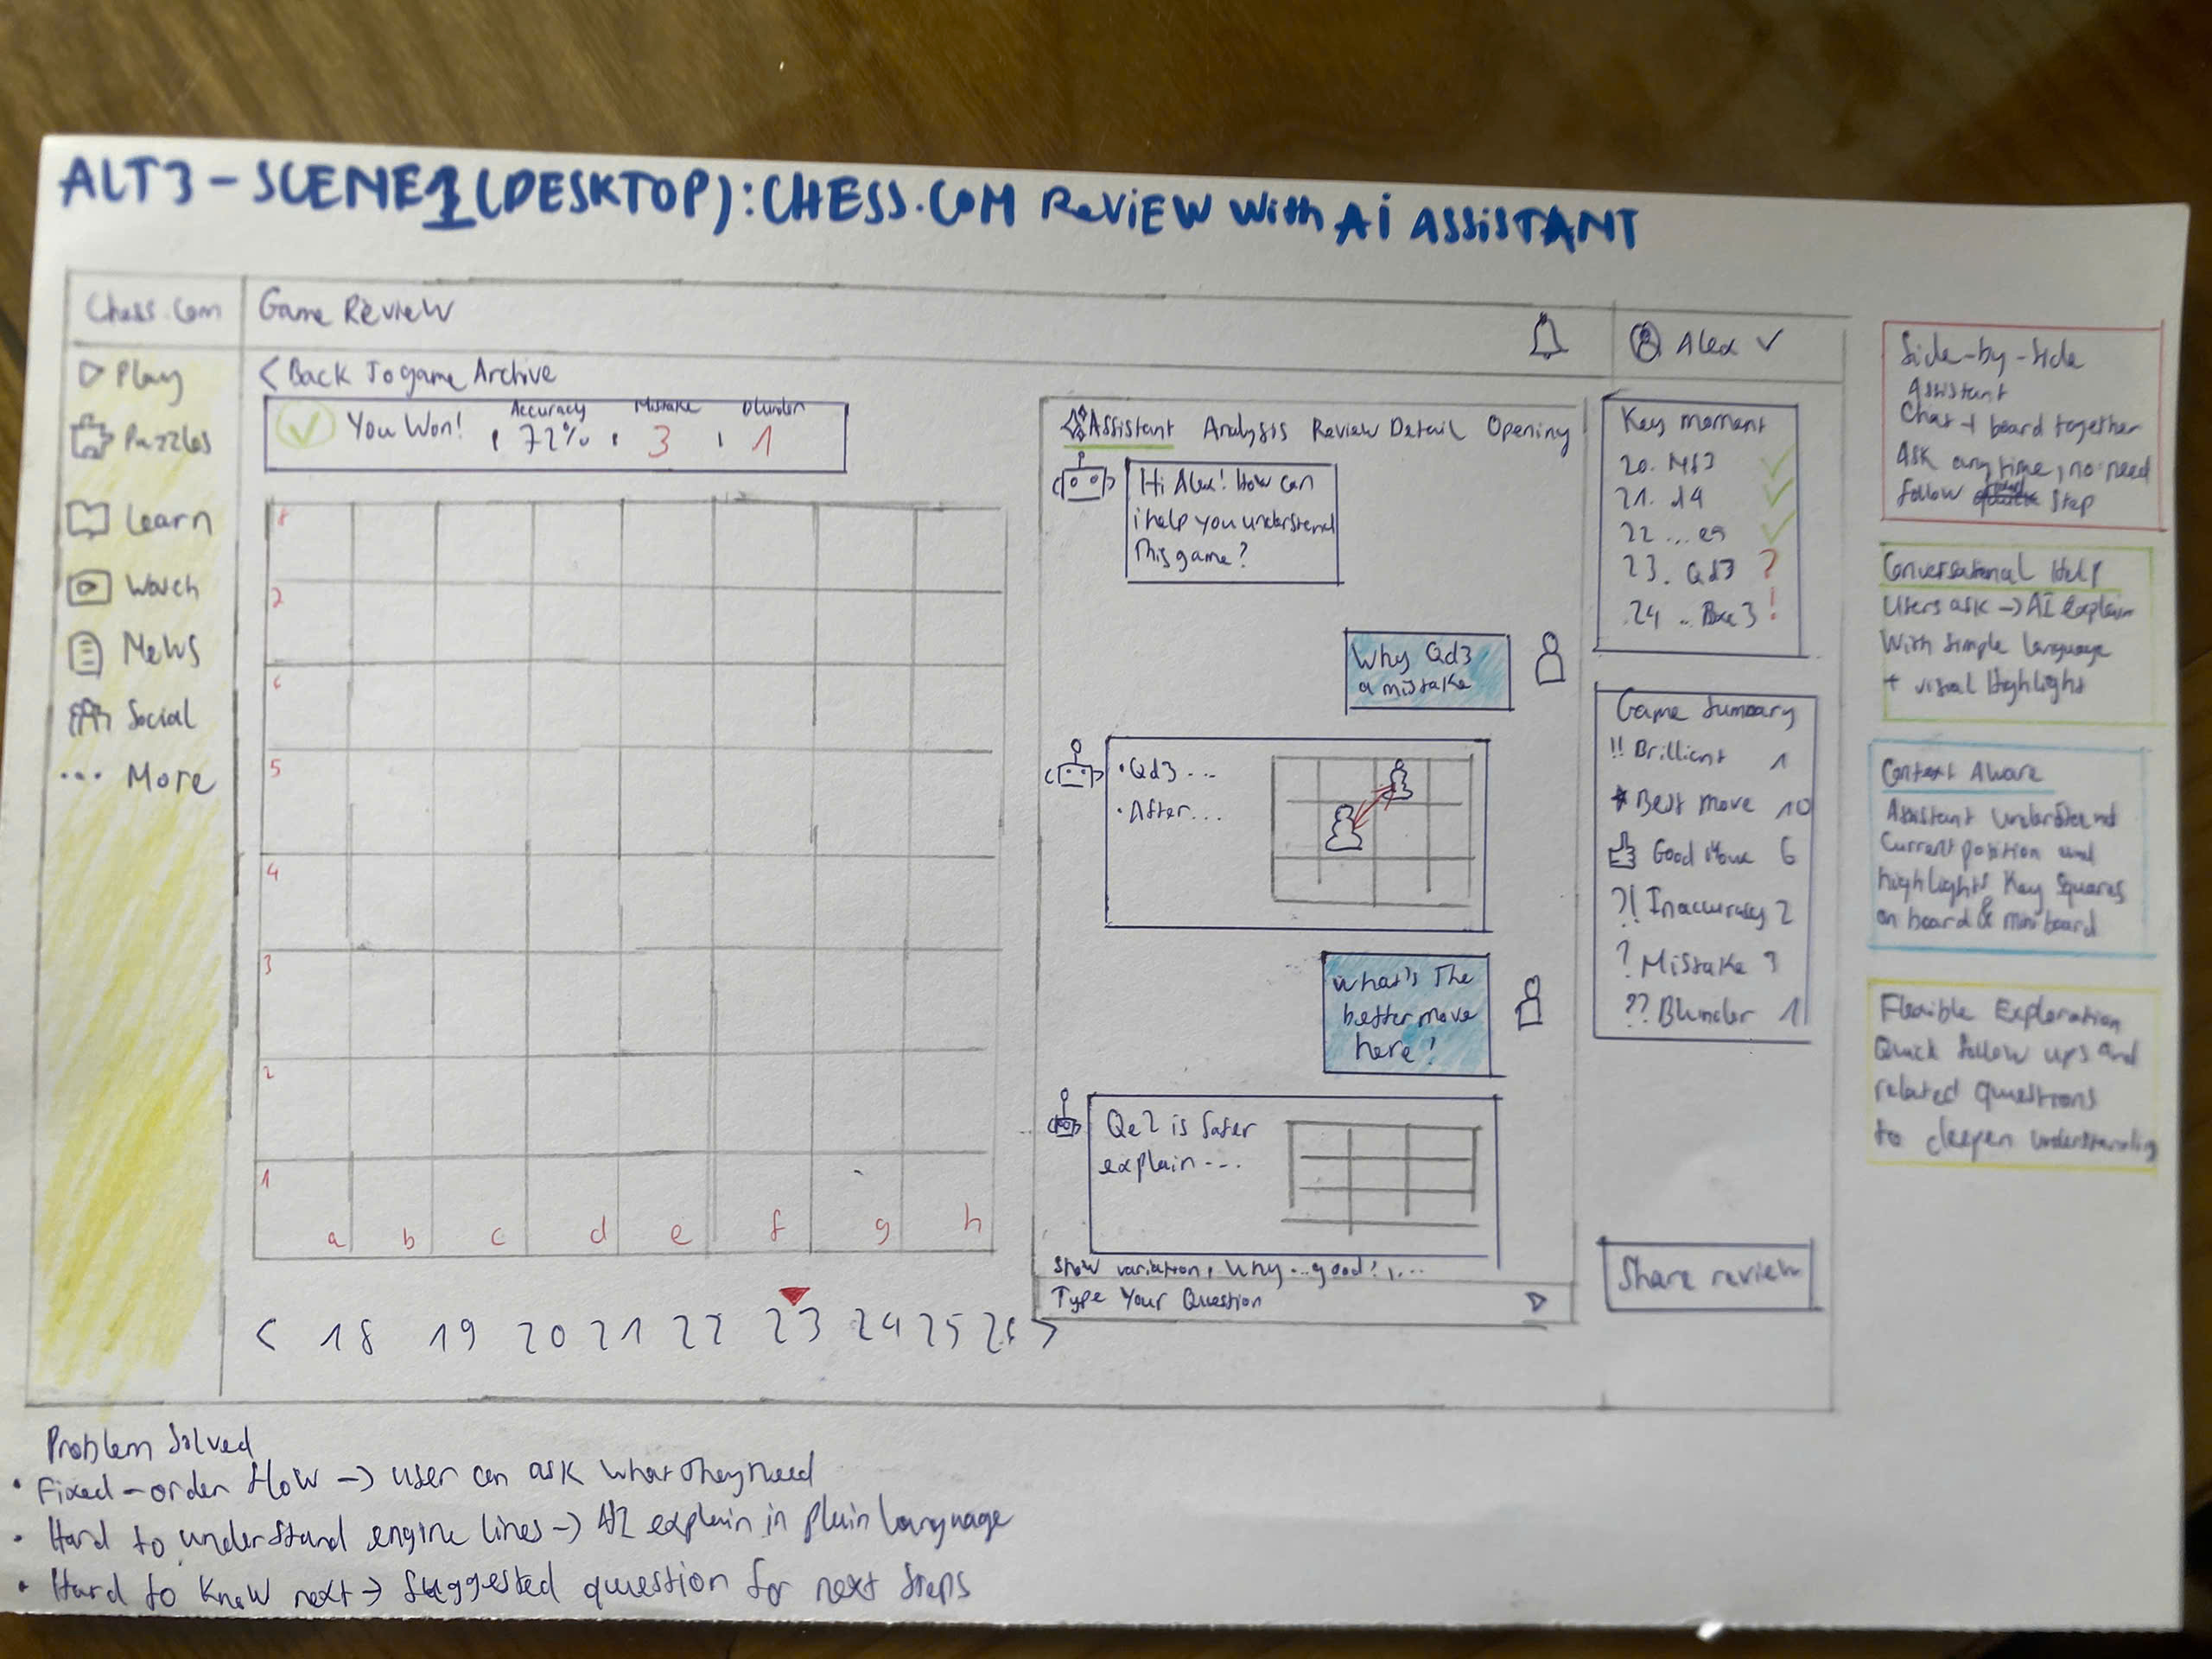
Figure 6. Chess Alt 3 - Side-by-Side AI Assistant
Problem: A learner may want to ask a question beside the board while exploring a mistake.
Motivation: Offer flexible questions and contextual explanation without losing the path to practice.
Solution: An assistant panel pairs board context, suggested prompts, explanation, follow-up questions, and practice.
Strengths: Flexible exploration; prompts reduce blank-input load; contextual follow-up can answer a learner's question.
Weaknesses: Open input can delay the first learning action; scope and confidence need bounds; practice can become secondary.

Storyboard
Step | Stage | User action | Paper response
1 | Context | User opens a game review with the board and assistant panel visible. | The assistant shows the current position and suggested questions.
2 | Trigger | User chooses a suggested question or types a question. | The assistant connects the question to the visible board position.
3 | Interaction | User asks why the move was a mistake. | The assistant highlights the relevant pieces and explains the cause.
4 | Action | User asks for a better move or uses a suggested follow-up. | The assistant shows the move and an optional board variation.
5 | Goal | User practises the idea or asks one more bounded question. | The assistant keeps a clear next question and a path back to review.

4. Conclusion
The six alternatives represent different interaction approaches for the two scenarios.
Requirement 2 later selected FIFA Alt 1 Status Dashboard and Chess Alt 2 Card Review Mode.
The full testing results, reviewer data, and selection reasoning are documented in the Formative Testing report.

