GROUP 10 · CSC13112 · UI/UX DESIGN · PA3
Group10-PA3 Formative Testing
Requirement 2 · AI-Agent Formative Testing plan, completed R1-R5 evidence, selection, and improved prototypes
Field | Value
Group | Group 10
Project | FIFA.com ticket confidence + Chess.com beginner review
Evidence mode | AI-Agent Formative Testing · R1-R5 independent reviewer records
Submission artifact | Group10-PA3-FormativeTesting.docx / .pdf
Date prepared | 18 August 2026

AI-Agent Formative Testing completed
Five independent AI reviewers evaluated six alternatives across two scenarios and 19 tasks per reviewer: 285 task outcomes total. Selected directions are FIFA Alt 1 Status Dashboard and Chess Alt 1 Beginner Review Flow. This is AI-agent evidence, not a claim of human participant testing.

External evidence blocker
No verified improved-prototype YouTube URL was located in the repository. The improved editable deck and rendered images are included locally for the required external upload/link step.

1. Testing Plan

1.1 Objectives
ID | Objective | Signal captured
O1 | Learnability | First action and entry-point discovery without instruction
O2 | Task completion | Independent success, hesitation, failure, and stopping point
O3 | Comprehension | Own-words explanation of ticket state or chess mistake
O4 | Next step | Correct action, resolution, or practice step
O5 | Trust / provenance | Freshness, official source, handoff, and return path
O6 | Cognitive load | Hesitation, repeated scanning, and confusion
O7 | Alternative differentiation | Distinct trade-offs across interaction models
O8 | Improvement | Every recurring issue becomes a concrete PA4 revision
O9 | Alternative differentiation | Each model creates an understandable trade-off
O10 | Revision priority | Which changes are essential before PA4

1.2 Target reviewer group
The target is modelled through five independent AI reviewer agents configured as novice users. Each reviewer begins with the same written protocol, scenario prompts, task wording, prototype images, and success criteria, with no project briefing or prior output from another reviewer. Profiles vary in digital literacy, domain familiarity, scan speed, and preference for guided workflow.
Reviewer | Novice profile | FIFA order | Chess order
R1 | Higher digital literacy; low FIFA familiarity; no Chess analysis familiarity | Alt 1 → Alt 2 → Alt 3 | Alt 1 → Alt 2 → Alt 3
R2 | Careful reader; low FIFA and Chess.com familiarity | Alt 2 → Alt 3 → Alt 1 | Alt 2 → Alt 3 → Alt 1
R3 | Lower digital confidence; action-oriented; low domain familiarity | Alt 3 → Alt 1 → Alt 2 | Alt 3 → Alt 1 → Alt 2
R4 | Fast-scanning novice; low patience for long text | Alt 1 → Alt 3 → Alt 2 | Alt 1 → Alt 3 → Alt 2
R5 | Guided-workflow preference; moderate digital literacy | Alt 2 → Alt 1 → Alt 3 | Alt 2 → Alt 1 → Alt 3

1.3 AI-Agent Formative Testing method
- Task-based formative evaluation over the fixed six-image set; the reviewer states expectations, first action, hesitation, wrong path, interpretation, feedback, and proposed revision.
- Think-aloud and neutral probes: ‘What would you try next?’ and ‘What makes you think that?’ The protocol does not point to controls, praise choices, teach later alternatives, or reveal the expected selection.
- Each alternative is reset to the same paper context. Outcome coding is Independent Success, Success With Hesitation, or Failure.
- Preference is recorded after the task sequence as a supporting signal; it is not a standalone winner rule.
- The planned session sequence is 3 minutes setup/isolation check, 2 minutes neutral practice, 12–15 minutes FIFA, 12–15 minutes Chess, 5–8 minutes comparison, and 1–2 minutes close. Exact duration is a planning guide, not an invented observation.

1.4 Reviewer independence
R1-R5 are separate records. No reviewer receives another reviewer’s output. Results are attributed to AI reviewers throughout this report; no human participants, personal names, quotes, attendance, or population claims are inferred.

1.5 Order and bias control
The five orders rotate the alternatives across both scenarios. This reduces learning-effect bias. The same task wording, reset, probe threshold, issue schema, and outcome coding are used for every reviewer.

1.6 FIFA scenario and tasks
Scenario prompt: ‘You have tickets connected to two football events. One event is confirmed and one is pending. Understand whether everything is okay, what happens next, and how to perform a common ticket action before travelling.’
ID | Task | Success signal
F1 | Find the confirmed event | Correctly identifies the confirmed event or order
F2 | Find the pending event | Correctly identifies what still requires attention
F3 | Explain the current state | Explains the state in own words
F4 | Identify what happens next | Finds the next expected step or timing
F5 | Check information freshness | Finds last-updated or current-information evidence
F6 | Judge official-source trust | Identifies the official source signal
F7 | Find ticket details | Finds the relevant ticket-detail action
F8 | Transfer a ticket | Finds and interprets the transfer action
F9 | Add the event to a calendar | Finds the calendar action and understands its scope
F10 | Recover from an unresolved state | Returns to the useful status path and identifies remaining support or resolution

1.7 FIFA functionalities under test
Alternative | Functionality
Alt 1 — Status Dashboard | status cards, confirmed/pending distinction, event list, primary next action, quick actions, support, current-state summary
Alt 2 — Timeline Tracker | completed/current/upcoming stages, progress message, freshness and official-source cues, update history
Alt 3 — Action Hub | quick actions, ticket-management shortcuts, official options, support/security, partner handoff cue

Core comparison: Alt 1 answers ‘What is true now?’, Alt 2 answers ‘Where am I in the process?’, and Alt 3 answers ‘What can I do right now?’

1.8 Chess scenario and tasks
Scenario prompt: ‘You have finished a chess game. You know that you made mistakes, but you are not familiar with analysis tools. Understand one important mistake, learn a better move, and decide what to practice next.’
ID | Task | Success signal
C1 | Find where to begin | Starts review without analysis-tool instruction
C2 | Identify one mistake | Selects an important moment or explanation
C3 | Explain why | Describes why the move was a mistake in own words
C4 | Find the better move | Locates and interprets the suggested move
C5 | Try the better move | Uses the move-trial interaction
C6 | Find practice | Finds a relevant practice bridge
C7 | Ask for or inspect more explanation | Uses depth or follow-up support appropriately
C8 | Choose another review moment | Uses control to continue or change the review
C9 | Return to a useful next step | Identifies what to do next after exploring

1.9 Chess functionalities under test
Alternative | Functionality
Alt 1 — Beginner Review Flow | guided sequence, progress indicator, plain-language explanation, better move, practice bridge, optional depth
Alt 2 — Card Review Mode | review-moment cards, mini-board scan, selected-card explanation, user-controlled priority, practice entry
Alt 3 — Side-by-Side AI Assistant | question entry, assistant explanation, board highlights, context awareness, follow-up prompts, practice action

Core comparison: Alt 1 uses system-selected order, Alt 2 uses user-selected content, and Alt 3 uses a user-selected question.

1.10 Success criteria
Criterion | Pass signal | Escalate / revise if
Independent completion | At least 4 of 5 complete a core task without rescue. | Fewer than 4 complete or the same blocker stops 2+ reviewers.
Own-words comprehension | At least 4 of 5 explain the state or mistake. | Two or more form the same critical wrong mental model.
Next step | At least 4 of 5 identify the intended action or practice step. | Ownership, destination, or relevance stays ambiguous.
Intervention | No more than 1 of 5 needs intervention on a core task. | Two or more interventions at the same step.
Trust / practice continuity | Freshness/source/handoff or practice bridge is understood. | Source, return path, or practice action is invisible.

1.11 Data collection framework
Capture | Record | Why it matters
Reviewer + order | Reviewer ID, profile, scenario, alternative, order position | Separates design effect from learning effect
Task result | Independent success / hesitation / failure and stopping point | Shows effectiveness and rescue burden
Observation | First action, hesitation, wrong path, recovery | Locates cognitive-load hotspots
Feedback | Clear, confusing, missing, unnecessary; clarity/confidence rating | Captures perception without replacing behavior
Issue + revision | Category, severity, problem → cause → recommendation | Turns evidence into PA4 change candidates
Comparison | Preference, reason, strength, weakness, unresolved concern | Supports synthesis; not a standalone selection rule

1.12 Issue categories and severity
Issue categories include entry/learnability, comprehension, hierarchy, terminology, navigation, ownership, trust/provenance, action visibility, practice continuity, control/flexibility, and recovery. Critical breaks the core task or trust boundary; High is a repeated blocker or wrong mental model; Medium makes the task possible but inefficient or unclear; Low is polish or optional detail.

2. Completed Testing Results
The independent records contain 285 task outcomes: 190 Independent Success, 56 Success With Hesitation, and 39 Failure. FIFA contributes 150 outcomes (50 per alternative); Chess contributes 135 outcomes (45 per alternative).

2.1 R1 — independent record summary
Scenario | Alt 1 I/H/F | Alt 2 I/H/F | Alt 3 I/H/F | Preference
FIFA | 7/2/1 | 5/2/3 | 8/0/2 | Alt 1
Chess | 8/1/0 | 7/2/0 | 6/2/1 | Alt 1

2.2 R2 — independent record summary
Scenario | Alt 1 I/H/F | Alt 2 I/H/F | Alt 3 I/H/F | Preference
FIFA | 7/2/1 | 5/2/3 | 8/0/2 | Alt 2
Chess | 7/2/0 | 7/2/0 | 4/4/1 | Alt 1

2.3 R3 — independent record summary
Scenario | Alt 1 I/H/F | Alt 2 I/H/F | Alt 3 I/H/F | Preference
FIFA | 5/3/2 | 5/2/3 | 7/1/2 | Alt 1
Chess | 7/2/0 | 7/2/0 | 5/3/1 | Alt 1

2.4 R4 — independent record summary
Scenario | Alt 1 I/H/F | Alt 2 I/H/F | Alt 3 I/H/F | Preference
FIFA | 6/2/2 | 6/1/3 | 7/1/2 | Alt 1
Chess | 7/2/0 | 7/2/0 | 6/2/1 | Alt 1

2.5 R5 — independent record summary
Scenario | Alt 1 I/H/F | Alt 2 I/H/F | Alt 3 I/H/F | Preference
FIFA | 6/2/2 | 5/2/3 | 7/1/2 | Alt 2
Chess | 7/1/1 | 6/3/0 | 5/3/1 | Alt 1

2.6 Cross-reviewer aggregate
Scenario | Alternative | Independent | Hesitation | Failure | Total
FIFA | Alt 1 | 31 | 11 | 8 | 50
FIFA | Alt 2 | 26 | 9 | 15 | 50
FIFA | Alt 3 | 37 | 3 | 10 | 50
Chess | Alt 1 | 36 | 8 | 1 | 45
Chess | Alt 2 | 34 | 11 | 0 | 45
Chess | Alt 3 | 26 | 14 | 5 | 45

Scenario | Preference signal
FIFA | R1 Alt 1 · R2 Alt 2 · R3 Alt 1 · R4 Alt 1 · R5 Alt 2 → Alt 1 3/5, Alt 2 2/5, Alt 3 0/5
Chess | R1-R5 Alt 1 → Alt 1 5/5, Alt 2 0/5, Alt 3 0/5

3. Evaluation and Selection

3.1 FIFA alternative comparison
Alternative | I / H / F | Evidence interpretation | Selection role
Alt 1 — Status Dashboard | 31 / 11 / 8 | Compact status-first scan; repeated Pending reason/owner/timing and source/handoff gaps; 3/5 preference. | Selected; targeted revision preserves its stable entry.
Alt 2 — Timeline Tracker | 26 / 9 / 15 | Strong progress/freshness cues, but ticket actions and ownership remain unclear; 2/5 preference. | Borrow timeline and ownership cues.
Alt 3 — Action Hub | 37 / 3 / 10 | Fastest independent completion, but status context and partner boundary can be skipped; 0/5 preference. | Borrow action grouping and handoff treatment.

3.2 Selected FIFA direction
FIFA Alt 1 — Status Dashboard is selected because it offers the clearest first scan and the strongest preference signal (3/5), while its main problems are bounded, evidence-linked additions: explain Pending, name the owner, show timing, clarify action destinations, and preview the partner boundary. Alt 3 has higher raw independent completion but also carries context/handoff risk; Alt 2 supplies valuable process and freshness cues but leaves more ticket actions off the main path.

3.3 Chess alternative comparison
Alternative | I / H / F | Evidence interpretation | Selection role
Alt 1 — Beginner Review Flow | 36 / 8 / 1 | Best entry, explanation-to-practice continuity, and 5/5 preference; remaining risk is recovery and depth visibility. | Selected; targeted revision preserves guided sequence.
Alt 2 — Card Review Mode | 34 / 11 / 0 | Low failure and strong scan/control, but the first learning priority is ambiguous; 0/5 preference. | Borrow Start here and priority cue.
Alt 3 — Side-by-Side AI Assistant | 26 / 14 / 5 | Flexible prompts help, but blank input and continuation/scope create friction; 0/5 preference. | Borrow bounded prompts and follow-up help.

3.4 Selected Chess direction
Chess Alt 1 — Beginner Review Flow is selected because all five reviewers preferred it and its 36/45 independent outcomes, one failure, and repeated mistake-to-practice strengths show the most coherent novice path. The revision cost is focused: make entry, notation, plain-language cause, feedback, help, practice, and recovery explicit without changing the one-mistake-at-a-time model.

3.5 Selection method
Selection combines task outcomes, recurring issue severity and recurrence, comprehension and next-step clarity, trust/provenance or practice continuity, error risk, preference, and revision effort. Preference alone does not select a direction.

4. Points of Improvement

4.1 FIFA selected-prototype revisions
ID | Evidence-linked change | Trace | Iteration 2 treatment
F-IMP-01 | Pending card gains reason. | R1-R5 recurring Pending ambiguity; especially F4/F10 issue and feedback records. | Add ‘Awaiting FIFA confirmation’ directly beside Pending.
F-IMP-02 | Pending card gains owner. | R1-R5 recurring ownership gap in pending-state observations. | State ‘Owner: FIFA’ so system progress is not read as user work.
F-IMP-03 | Pending card gains expected timing. | R1-R5 F4 next-step/timing friction. | Add ‘Expected timing: next confirmation update.’
F-IMP-04 | Add explicit No action required / Action required. | R1-R5 F2/F4/F10 confusion about whether the reviewer must act. | Add ‘No action is required from you right now’ to the Pending state.
F-IMP-05 | Add Official FIFA source beside freshness. | R1/R3/R4/R5 trust and provenance observations around F5/F6. | Place the source label beside ‘Last updated’.
F-IMP-06 | Clarify View Order versus View Tickets. | R1/R2/R3/R5 action-label ambiguity around F7. | Keep both actions but state their distinct destination.
F-IMP-07 | Add per-action external partner cue. | R1-R5 F10 handoff and external-service warning issues. | Show partner destination before Continue.
F-IMP-08 | Preserve compact status-first overview. | R1/R3/R4/R5 status-scan strength and preference evidence. | Keep the summary, event card, and action grouping as the main entry.

4.2 Chess selected-prototype revisions
ID | Evidence-linked change | Trace | Iteration 2 treatment
C-IMP-01 | Explicit Start Beginner Review. | R1-R5 C1 entry observations; Alt 1 was preferred by all five reviewers. | Make the first action a visible Start Beginner Review control.
C-IMP-02 | Clear Review step versus Game move labels. | R1-R5 C1/C2 entry and orientation notes. | Show ‘Review step 1 of 3 · Game move 23’.
C-IMP-03 | Pair notation with plain-language piece movement. | R1/R2/R3/R4/R5 C3 vocabulary and explanation feedback. | Pair Qe2 with ‘move the queen to e2 to protect the pawn’.
C-IMP-04 | Explain another way / Need more help. | R1-R5 C7/C9 recovery and depth-support observations. | Keep explicit support and alternate-explanation controls.
C-IMP-05 | Visible feedback after Try this move. | R1-R5 C5/C6 feedback and practice-continuity observations. | State the changed board result after Qe2 is tried.
C-IMP-06 | Persistent Practice this idea. | R1-R5 C6 practice-bridge issues and Alt 1 strength. | Keep the practice action next to the explanation and result.
C-IMP-07 | Clear Next mistake and review recovery. | R1-R5 C8/C9 continuation and recovery observations. | Keep next-mistake and recovery actions visible after exploration.
C-IMP-08 | Preserve one-mistake-at-a-time sequence. | R1-R5 overall comparison; Alt 1 had the clearest learning continuity. | Keep the guided sequence as the selected core path.

4.3 Improvement principles
- Keep the selected prototype’s strongest interaction model; revise the recurring blocker rather than replacing the design hypothesis.
- Make ownership, timing, provenance, and handoff visible where a reviewer previously had to infer them.
- Make a novice learning path explicit: entry, cause, move, result, practice, help, and recovery.
- Borrow the strongest cue from a non-selected alternative only when it solves a traced issue without importing its larger trade-off.

5. Best Improved Paper Prototype
Improved artifacts included
The editable native deck is Group10-PA3-ImprovedLoFi.pptx. The two rendered images below are the local improved-prototype evidence used in this report. No verified YouTube demo link was found.

5.1 FIFA Status Dashboard, Iteration 2
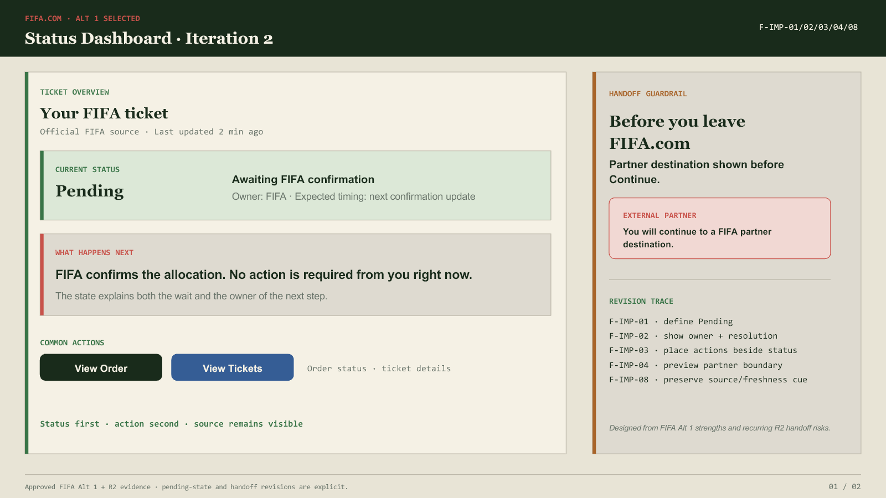
Status-first overview retained; Pending now has reason, owner, timing, action requirement, source, destination distinction, and handoff guardrail.

5.2 Chess Beginner Review Flow, Iteration 2
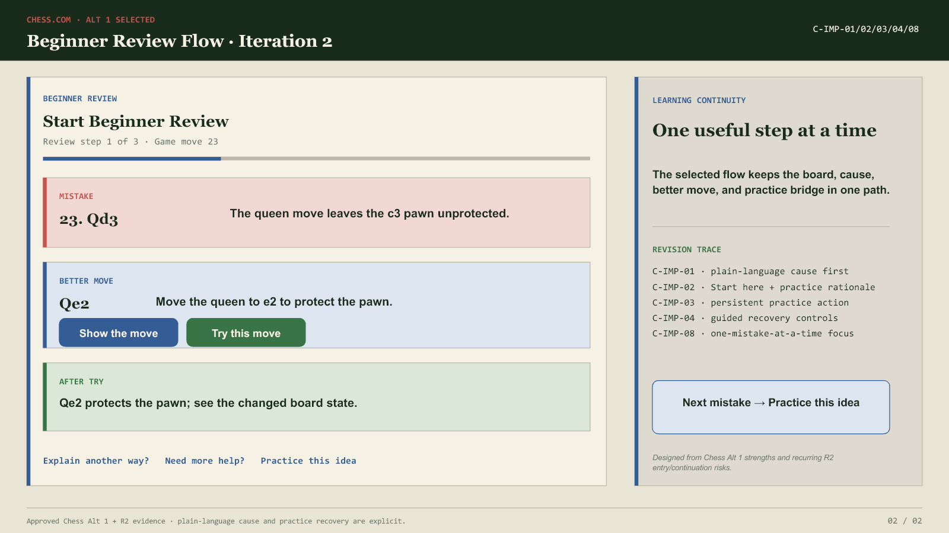
Guided sequence retained; entry, step/move labels, plain-language explanation, move feedback, help, practice, and recovery are visible.

5.3 Improved evidence and demo status
Improved prototype | Local evidence | YouTube status
FIFA Status Dashboard, Iteration 2 | Native PPTX + fifa-status-dashboard-iteration2.png | No verified URL located; external upload/link required
Chess Beginner Review Flow, Iteration 2 | Native PPTX + chess-beginner-review-flow-iteration2.png | No verified URL located; external upload/link required

6. Limitations and responsible interpretation
AI reviewers model novice interpretation through supplied images and a written protocol. They are useful for exposing likely hierarchy, terminology, workflow, comprehension, trust, and learning-continuity issues, but they do not reproduce physical paper manipulation, motor behavior, accessibility needs, emotional response, or every variability of a live moderated session. The report therefore makes no human-participant or population claim; R1-R5 are labelled as AI-Agent Formative Testing throughout.

7. Conclusion
Requirement 2 local evidence is complete as an AI-Agent Formative Testing package: five independent reviewers, six alternatives, 19 tasks per reviewer, and 285 coded outcomes. FIFA Alt 1 Status Dashboard and Chess Alt 1 Beginner Review Flow are selected for PA4 refinement. The remaining external gates are the six original demo links, the improved demo link(s), and verified lecture/class peer-review evidence for Requirement 3.

Appendix A — R1-R5 task-outcome trace
Reviewer | Scenario | Alternative | Task outcome codes (I/H/F) | Totals
R1 | FIFA | Alt 1 · Status | F1 I; F2 I; F3 I; F4 H; F5 I; F6 H; F7 I; F8 I; F9 I; F10 F | 7/2/1
R1 | FIFA | Alt 2 · Timeline | F1 I; F2 I; F3 I; F4 H; F5 I; F6 I; F7 F; F8 F; F9 H; F10 F | 5/2/3
R1 | FIFA | Alt 3 · Action | F1 I; F2 F; F3 I; F4 F; F5 I; F6 I; F7 I; F8 I; F9 I; F10 I | 8/0/2
R1 | Chess | Alt 1 · Guided | C1 I; C2 I; C3 I; C4 I; C5 I; C6 I; C7 I; C8 I; C9 H | 8/1/0
R1 | Chess | Alt 2 · Cards | C1 H; C2 I; C3 I; C4 I; C5 I; C6 I; C7 I; C8 I; C9 H | 7/2/0
R1 | Chess | Alt 3 · Assistant | C1 H; C2 I; C3 I; C4 I; C5 I; C6 H; C7 F; C8 I; C9 I | 6/2/1
R2 | FIFA | Alt 1 · Status | F1 I; F2 I; F3 I; F4 H; F5 I; F6 H; F7 I; F8 I; F9 I; F10 F | 7/2/1
R2 | FIFA | Alt 2 · Timeline | F1 I; F2 I; F3 H; F4 I; F5 I; F6 I; F7 F; F8 F; F9 H; F10 F | 5/2/3
R2 | FIFA | Alt 3 · Action | F1 I; F2 F; F3 I; F4 F; F5 I; F6 I; F7 I; F8 I; F9 I; F10 I | 8/0/2
R2 | Chess | Alt 1 · Guided | C1 I; C2 I; C3 I; C4 I; C5 H; C6 I; C7 I; C8 I; C9 H | 7/2/0
R2 | Chess | Alt 2 · Cards | C1 H; C2 I; C3 I; C4 I; C5 I; C6 I; C7 I; C8 I; C9 H | 7/2/0
R2 | Chess | Alt 3 · Assistant | C1 H; C2 I; C3 I; C4 I; C5 H; C6 H; C7 F; C8 H; C9 I | 4/4/1
R3 | FIFA | Alt 1 · Status | F1 I; F2 I; F3 H; F4 F; F5 H; F6 H; F7 I; F8 I; F9 I; F10 F | 5/3/2
R3 | FIFA | Alt 2 · Timeline | F1 I; F2 I; F3 H; F4 I; F5 I; F6 I; F7 F; F8 F; F9 H; F10 F | 5/2/3
R3 | FIFA | Alt 3 · Action | F1 H; F2 F; F3 I; F4 F; F5 I; F6 I; F7 I; F8 I; F9 I; F10 I | 7/1/2
R3 | Chess | Alt 1 · Guided | C1 H; C2 I; C3 I; C4 I; C5 I; C6 I; C7 I; C8 I; C9 H | 7/2/0
R3 | Chess | Alt 2 · Cards | C1 H; C2 I; C3 I; C4 I; C5 I; C6 I; C7 I; C8 I; C9 H | 7/2/0
R3 | Chess | Alt 3 · Assistant | C1 H; C2 I; C3 I; C4 I; C5 I; C6 H; C7 F; C8 H; C9 I | 5/3/1
R4 | FIFA | Alt 1 · Status | F1 I; F2 I; F3 H; F4 F; F5 I; F6 H; F7 I; F8 I; F9 I; F10 F | 6/2/2
R4 | FIFA | Alt 2 · Timeline | F1 I; F2 I; F3 I; F4 I; F5 I; F6 I; F7 F; F8 F; F9 H; F10 F | 6/1/3
R4 | FIFA | Alt 3 · Action | F1 H; F2 F; F3 I; F4 F; F5 I; F6 I; F7 I; F8 I; F9 I; F10 I | 7/1/2
R4 | Chess | Alt 1 · Guided | C1 H; C2 I; C3 I; C4 I; C5 I; C6 I; C7 I; C8 I; C9 H | 7/2/0
R4 | Chess | Alt 2 · Cards | C1 H; C2 I; C3 I; C4 I; C5 I; C6 I; C7 I; C8 I; C9 H | 7/2/0
R4 | Chess | Alt 3 · Assistant | C1 H; C2 I; C3 I; C4 I; C5 I; C6 H; C7 F; C8 I; C9 I | 6/2/1
R5 | FIFA | Alt 1 · Status | F1 I; F2 I; F3 H; F4 F; F5 I; F6 H; F7 I; F8 I; F9 I; F10 F | 6/2/2
R5 | FIFA | Alt 2 · Timeline | F1 I; F2 I; F3 H; F4 I; F5 I; F6 I; F7 F; F8 F; F9 H; F10 F | 5/2/3
R5 | FIFA | Alt 3 · Action | F1 I; F2 F; F3 I; F4 F; F5 I; F6 I; F7 I; F8 I; F9 I; F10 H | 7/1/2
R5 | Chess | Alt 1 · Guided | C1 H; C2 I; C3 I; C4 I; C5 I; C6 I; C7 I; C8 I; C9 F | 7/1/1
R5 | Chess | Alt 2 · Cards | C1 H; C2 I; C3 I; C4 I; C5 H; C6 I; C7 I; C8 I; C9 H | 6/3/0
R5 | Chess | Alt 3 · Assistant | C1 H; C2 I; C3 I; C4 I; C5 H; C6 H; C7 F; C8 I; C9 I | 5/3/1

Code key: I = Independent Success; H = Success With Hesitation; F = Failure. This appendix is a compact trace to the full independent source records in ai-testing/R1.md through R5.md.

Appendix B — Issue-to-improvement trace
Issue theme | Reviewer evidence | Revision family
FIFA Pending meaning / ownership / timing | R1-R5 · F4 and related observations/feedback | F-IMP-01, 02, 03, 04
FIFA source, freshness, and external boundary | R1-R5 · F5/F6/F10 trust and handoff observations | F-IMP-05, 07, 08
FIFA action-label distinction | R1/R2/R3/R5 · F7/F8 action discovery and label ambiguity | F-IMP-06
Chess entry and orientation | R1-R5 · C1/C2 | C-IMP-01, 02, 08
Chess explanation and move feedback | R1-R5 · C3/C4/C5 | C-IMP-03, 05
Chess practice and recovery | R1-R5 · C6/C7/C8/C9 | C-IMP-04, 06, 07

