GROUP 10 · CSC13112 · UI/UX DESIGN · PA3
Group10-PA3 Paper Prototypes
Requirement 1 · Storyboarding, motivation, problem/solution, strengths/weaknesses, and later evidence handoff
Field | Value
Group | Group 10
Project | FIFA.com ticket confidence + Chess.com beginner review
Evidence mode | AI-Agent Formative Testing · R1-R5 independent reviewer records
Submission artifact | Group10-PA3-PaperProtype.docx / .pdf
Date prepared | 18 August 2026

Local evidence status
Six approved alternatives are documented and preserved. The six required YouTube demonstrations were not found in the repository; each row below records that external blocker without inventing a URL.

Prototype demonstration status
Scenario / alternative | Prototype | Verified demo status
FIFA Alt 1 | Status Dashboard | No verified YouTube URL located in the repository — external upload/link evidence required
FIFA Alt 2 | Timeline Tracker | No verified YouTube URL located in the repository — external upload/link evidence required
FIFA Alt 3 | Action Hub | No verified YouTube URL located in the repository — external upload/link evidence required
Chess Alt 1 | Beginner Review Flow | No verified YouTube URL located in the repository — external upload/link evidence required
Chess Alt 2 | Card Review Mode | No verified YouTube URL located in the repository — external upload/link evidence required
Chess Alt 3 | Side-by-Side AI Assistant | No verified YouTube URL located in the repository — external upload/link evidence required

1. Scenario and design-space continuity
The six alternatives are parallel low-fidelity hypotheses carried forward from the approved PA1/PA2 design space. FIFA compares status recognition, process position, and action execution. Chess compares a guided sequence, user-selected review cards, and an open assistant. They are not six features claimed to coexist.
Scenario | Job to be done | Alternative contrast
FIFA.com | Understand whether tickets are okay, what happens next, and how to perform a common action before travel. | Alt 1: what is true now? · Alt 2: where am I in the process? · Alt 3: what can I do right now?
Chess.com | Understand one mistake, learn a better move, and decide what to practise next. | Alt 1: system-selected order · Alt 2: user-selected content · Alt 3: user-selected question.

2. Requirement 1 evidence map
Each alternative below retains the approved image, a problem statement, motivation, solution mechanism, strengths, weaknesses, and a five-stage storyboard. The later Requirement 2 result is acknowledged: FIFA Alt 1 Status Dashboard and Chess Alt 1 Beginner Review Flow were selected for PA4 refinement after the completed AI-Agent Formative Testing synthesis.

Scenario 1 — FIFA

FIFA Alt 1 — Status Dashboard
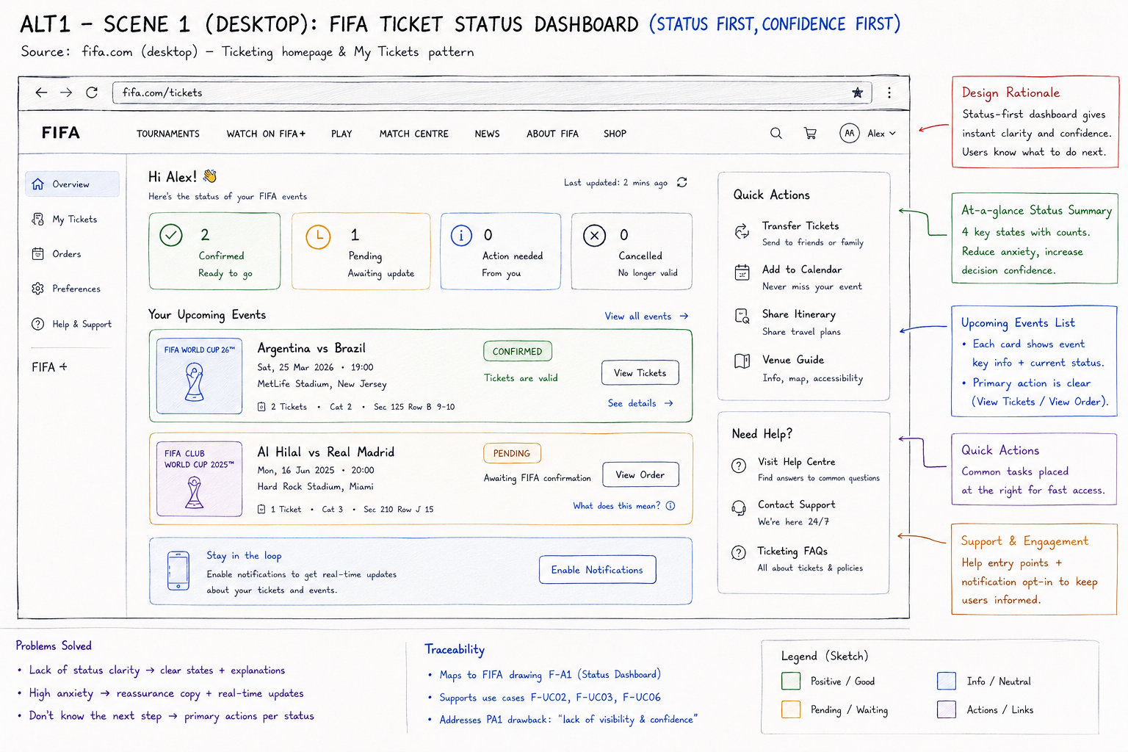
Approved Requirement 1 paper prototype image · alt1scenario1.png
Design evidence | Description
Problem | A novice needs to know whether a ticket is safe, pending, or needs action before travel.
Motivation | Reduce status uncertainty to one first scan while keeping common ticket actions close to the state.
Solution mechanism | A status-first dashboard with summary counts, event cards, a pending/confirmed distinction, freshness cue, and quick actions.
Strengths | Fast current-state recognition; confirmed and pending states are visually scannable; direct actions are discoverable.
Weaknesses / hypothesis | Pending state originally lacked reason, owner, timing, and a dependable handoff cue; View Order versus View Tickets was ambiguous.
Demo status | No verified YouTube URL located in the repository; the approved image and editable deck remain available for an external upload.

Storyboard
# | Stage | Reviewer / user action | Paper response | Purpose
1 | Context | Two events are visible: one confirmed and one pending. | The FIFA paper state makes the next cue visible. | Connect the paper state to the scenario goal.
2 | Trigger | The reviewer scans status tiles and selects the relevant event. | The FIFA paper state makes the next cue visible. | Connect the paper state to the scenario goal.
3 | First interaction | The reviewer opens the confirmed or pending event card. | The FIFA paper state makes the next cue visible. | Connect the paper state to the scenario goal.
4 | System response | The card exposes state, status explanation, and ticket action. | The FIFA paper state makes the next cue visible. | Connect the paper state to the scenario goal.
5 | Goal / recovery | The reviewer identifies the next step or returns to status when the state is unresolved. | The FIFA paper state makes the next cue visible. | Connect the paper state to the scenario goal.

FIFA Alt 2 — Timeline Tracker
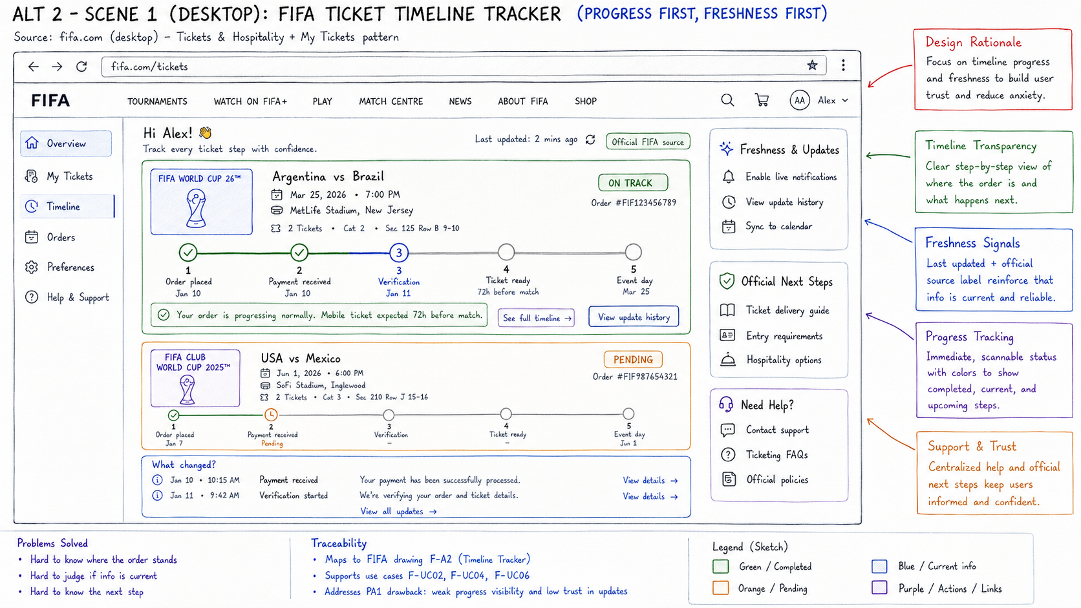
Approved Requirement 1 paper prototype image · alt2scenario1.png
Design evidence | Description
Problem | A novice needs to understand where an order is in a multi-stage ticket process.
Motivation | Make progress, freshness, and the next expected milestone visible as a sequence.
Solution mechanism | Per-event timelines distinguish completed, current, and upcoming stages and pair progress with source/update cues.
Strengths | Strong process visibility; current stage and freshness cues support trust; pending work has a visible position.
Weaknesses / hypothesis | Ticket actions can disappear from the scan path; future stages may look like user tasks; dashes need clearer ownership and timing.
Demo status | No verified YouTube URL located in the repository; the approved image and editable deck remain available for an external upload.

Storyboard
# | Stage | Reviewer / user action | Paper response | Purpose
1 | Context | Two event timelines show different points in the same ticket process. | The FIFA paper state makes the next cue visible. | Connect the paper state to the scenario goal.
2 | Trigger | The reviewer scans the current marker and later stages. | The FIFA paper state makes the next cue visible. | Connect the paper state to the scenario goal.
3 | First interaction | The reviewer selects a timeline stage or event detail. | The FIFA paper state makes the next cue visible. | Connect the paper state to the scenario goal.
4 | System response | The timeline explains progress, current ownership, and expected delivery. | The FIFA paper state makes the next cue visible. | Connect the paper state to the scenario goal.
5 | Goal / recovery | The reviewer finds a ticket action or returns to the event card when action is not visible. | The FIFA paper state makes the next cue visible. | Connect the paper state to the scenario goal.

FIFA Alt 3 — Action Hub
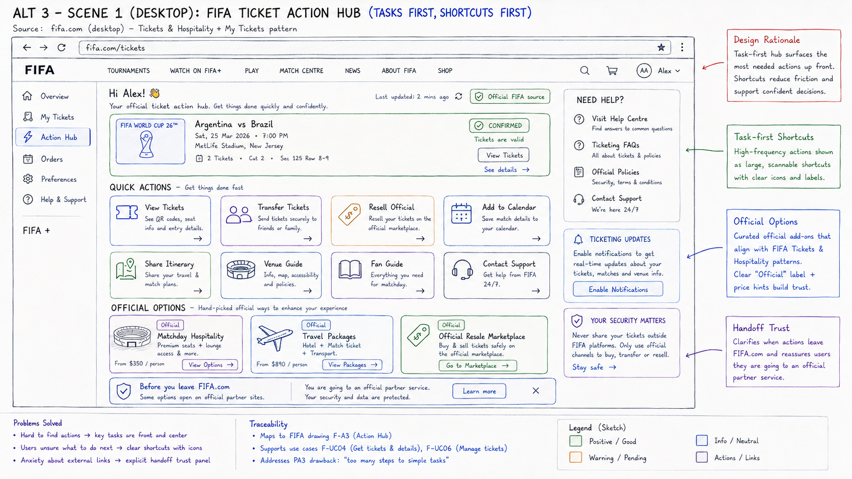
Approved Requirement 1 paper prototype image · alt3scenario1.png
Design evidence | Description
Problem | A novice needs a fast route to common ticket actions without losing trust context.
Motivation | Put high-frequency actions first and expose the external-partner boundary before leaving.
Solution mechanism | A shortcut-led hub groups transfer, calendar, ticket, support, and official-option actions.
Strengths | Fast action discovery; familiar labels; useful shortcuts and a visible handoff treatment.
Weaknesses / hypothesis | Action-first entry can hide status meaning; equal-weight tiles create choice load; official context can arrive too late.
Demo status | No verified YouTube URL located in the repository; the approved image and editable deck remain available for an external upload.

Storyboard
# | Stage | Reviewer / user action | Paper response | Purpose
1 | Context | The reviewer has a ticket-related task and wants a common action. | The FIFA paper state makes the next cue visible. | Connect the paper state to the scenario goal.
2 | Trigger | The reviewer scans the action hub for a matching label. | The FIFA paper state makes the next cue visible. | Connect the paper state to the scenario goal.
3 | First interaction | The reviewer selects Transfer Tickets, Add to Calendar, or View Tickets. | The FIFA paper state makes the next cue visible. | Connect the paper state to the scenario goal.
4 | System response | The hub explains the action and, where relevant, the partner boundary. | The FIFA paper state makes the next cue visible. | Connect the paper state to the scenario goal.
5 | Goal / recovery | The reviewer completes the action or returns to a status summary when context is missing. | The FIFA paper state makes the next cue visible. | Connect the paper state to the scenario goal.

Scenario 2 — Chess

Chess Alt 1 — Beginner Review Flow
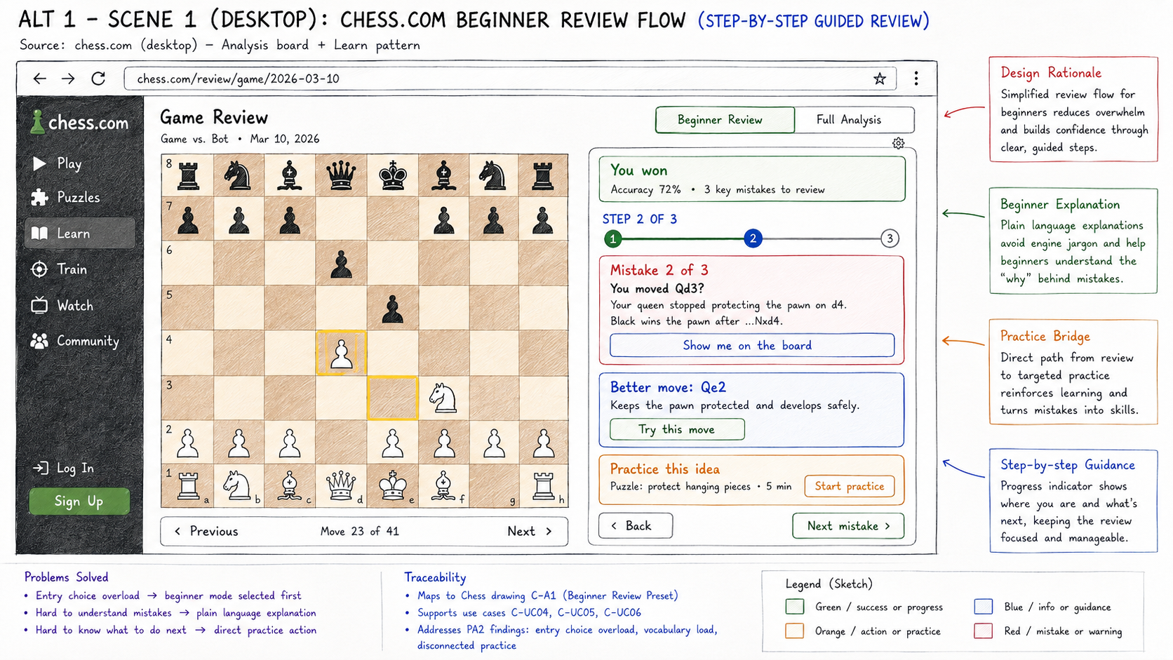
Approved Requirement 1 paper prototype image · alt1scenario2.png
Design evidence | Description
Problem | A beginner needs to turn one unfamiliar chess mistake into an understandable practice step.
Motivation | Lower memory load by controlling the order from mistake to explanation to practice.
Solution mechanism | A guided flow with progress, plain-language cause, better move, try interaction, practice bridge, and next-mistake recovery.
Strengths | Clear novice entry; strongest mistake-to-practice continuity; one focused sequence limits choice load.
Weaknesses / hypothesis | The original flow could hide recovery, alternate review, and the practical meaning of notation.
Demo status | No verified YouTube URL located in the repository; the approved image and editable deck remain available for an external upload.

Storyboard
# | Stage | Reviewer / user action | Paper response | Purpose
1 | Context | A completed game contains an important mistake. | The Chess paper state makes the next cue visible. | Connect the paper state to the scenario goal.
2 | Trigger | The reviewer starts the beginner review flow. | The Chess paper state makes the next cue visible. | Connect the paper state to the scenario goal.
3 | First interaction | The reviewer sees the mistake, plain-language cause, and better move. | The Chess paper state makes the next cue visible. | Connect the paper state to the scenario goal.
4 | System response | The reviewer can show or try the move and see the changed board state. | The Chess paper state makes the next cue visible. | Connect the paper state to the scenario goal.
5 | Goal / recovery | The reviewer practices the idea, asks for help, or moves to the next mistake. | The Chess paper state makes the next cue visible. | Connect the paper state to the scenario goal.

Chess Alt 2 — Card Review Mode
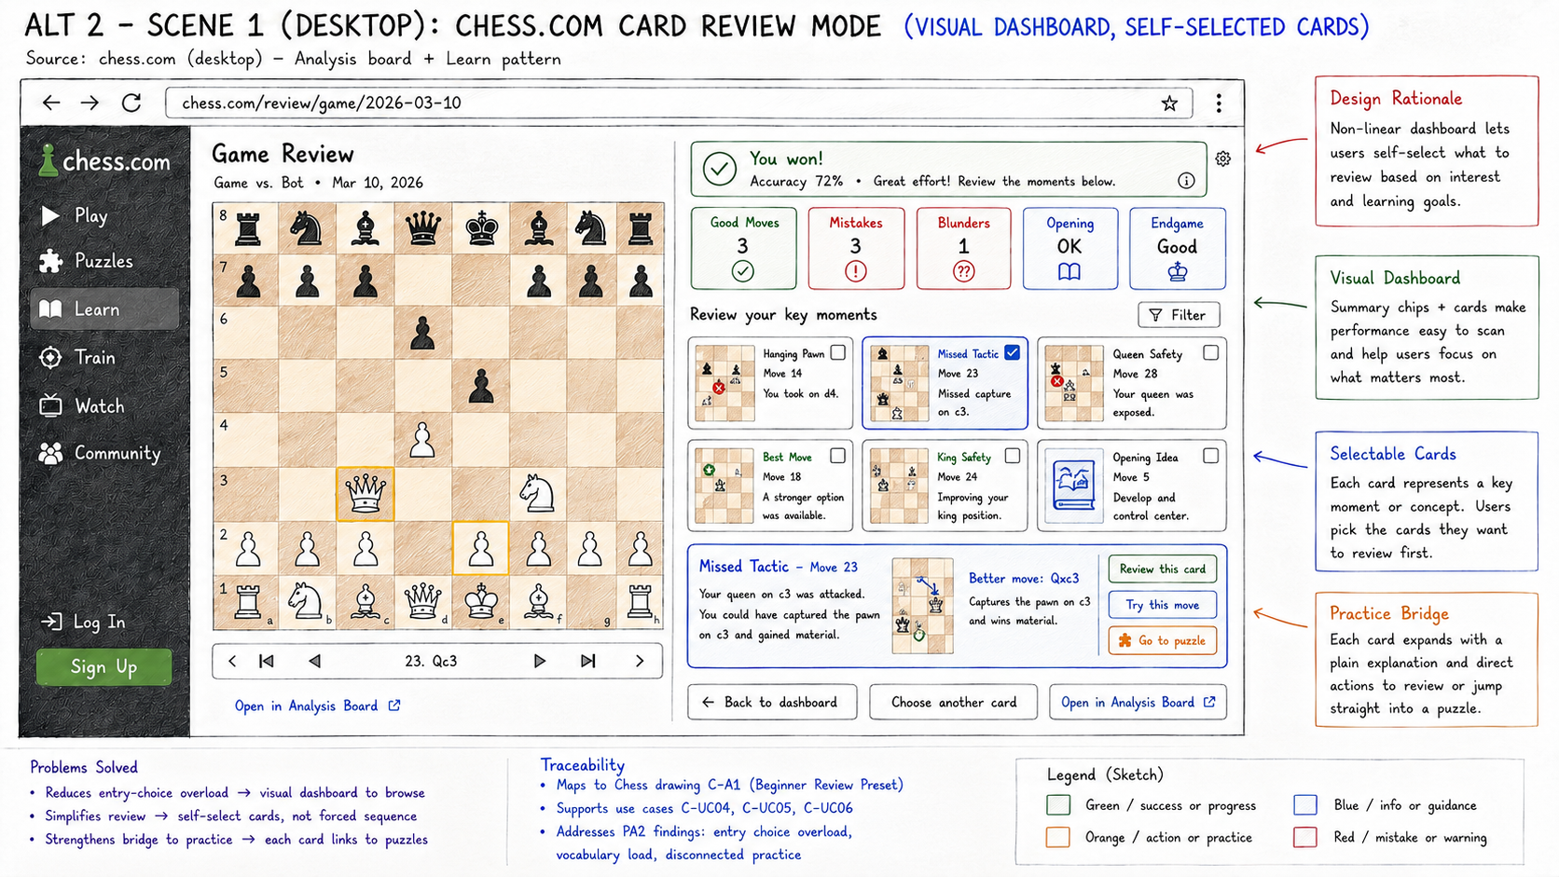
Approved Requirement 1 paper prototype image · alt2scenario2.png
Design evidence | Description
Problem | A learner may want to choose which game moment to review first.
Motivation | Expose choice and visual scan while retaining a recommended learning entry.
Solution mechanism | A card grid with mini-boards, selected-card explanation, and practice route.
Strengths | Scannable moments; user control; visual choice can support deliberate review.
Weaknesses / hypothesis | Priority is ambiguous without a Start here cue; several cards can compete before learning begins.
Demo status | No verified YouTube URL located in the repository; the approved image and editable deck remain available for an external upload.

Storyboard
# | Stage | Reviewer / user action | Paper response | Purpose
1 | Context | Several review moments are available from one game. | The Chess paper state makes the next cue visible. | Connect the paper state to the scenario goal.
2 | Trigger | The reviewer scans cards and compares their visual cues. | The Chess paper state makes the next cue visible. | Connect the paper state to the scenario goal.
3 | First interaction | The reviewer selects a card or the recommended first moment. | The Chess paper state makes the next cue visible. | Connect the paper state to the scenario goal.
4 | System response | The selected card expands into explanation and a practice action. | The Chess paper state makes the next cue visible. | Connect the paper state to the scenario goal.
5 | Goal / recovery | The reviewer returns to the card set or chooses another moment. | The Chess paper state makes the next cue visible. | Connect the paper state to the scenario goal.

Chess Alt 3 — Side-by-Side AI Assistant
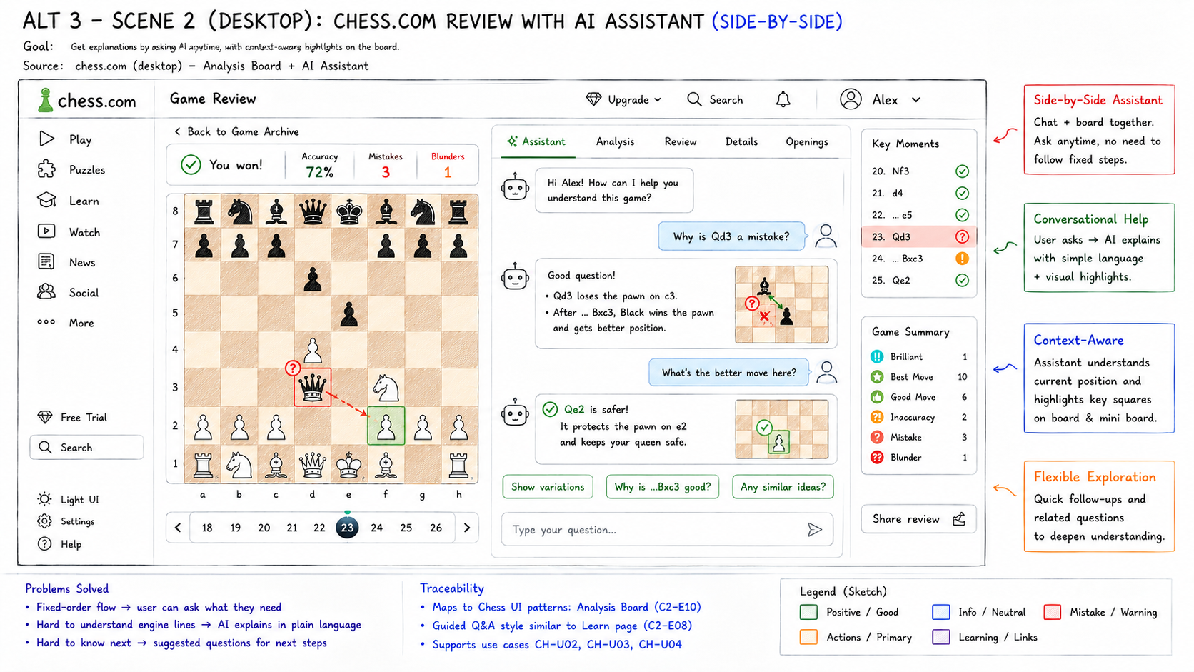
Approved Requirement 1 paper prototype image · alt3scenario2.png
Design evidence | Description
Problem | A learner may want to ask a question beside the board while exploring a mistake.
Motivation | Offer flexible questions and contextual explanation without losing the path to practice.
Solution mechanism | An assistant panel pairs board context, suggested prompts, explanation, follow-up questions, and practice.
Strengths | Flexible exploration; prompts reduce blank-input load; contextual follow-up can answer a learner's question.
Weaknesses / hypothesis | Open input can delay the first learning action; scope and confidence need bounds; practice can become secondary.
Demo status | No verified YouTube URL located in the repository; the approved image and editable deck remain available for an external upload.

Storyboard
# | Stage | Reviewer / user action | Paper response | Purpose
1 | Context | The reviewer sees a board position and wants to understand a mistake. | The Chess paper state makes the next cue visible. | Connect the paper state to the scenario goal.
2 | Trigger | The reviewer selects a suggested question or enters a question. | The Chess paper state makes the next cue visible. | Connect the paper state to the scenario goal.
3 | First interaction | The assistant responds beside the relevant board state. | The Chess paper state makes the next cue visible. | Connect the paper state to the scenario goal.
4 | System response | The assistant highlights the cause and suggests a next question or move. | The Chess paper state makes the next cue visible. | Connect the paper state to the scenario goal.
5 | Goal / recovery | The reviewer practices the idea or returns to a bounded review path. | The Chess paper state makes the next cue visible. | Connect the paper state to the scenario goal.

3. Reflection and handoff
The strengths and weaknesses in this report are design hypotheses at the Requirement 1 stage. The completed AI-Agent Formative Testing records in R1-R5 later tested the six alternatives using 19 tasks per reviewer. That evidence changed the next-step priorities: FIFA Alt 1 retained the compact status-first entry while gaining pending-state ownership, timing, source, action-label, and partner-boundary cues; Chess Alt 1 retained the guided sequence while gaining clearer entry, plain-language movement, feedback, help, practice, and recovery controls.
Selection handoff
Selected FIFA direction: Alt 1 — Status Dashboard. Selected Chess direction: Alt 1 — Beginner Review Flow. See Group10-PA3-FormativeTesting.docx for the complete reviewer method, counts, issue synthesis, and improved prototypes.

