Criterion C: Development

- Applet
- During session program

The class structure:
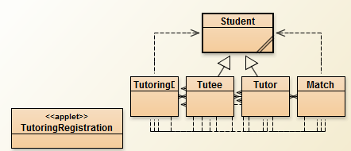
Where Tutee and Tutor are subclasses of Student.

a. Applet
The applet interface is coded using Java’s widget GUI toolkit swing.
The required classes and GUI components:
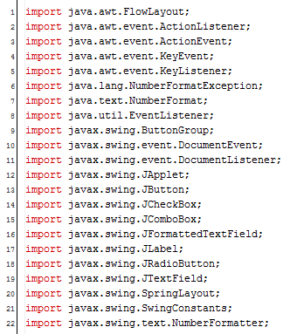

I decided to use SpringLayout layout manager for laying out my components because it allows me to specify relationships between the edges of all the components, which I thought would be useful in making a GUI for a form, especially to align all components and to have them in proper order.

The declaration of some of the components:
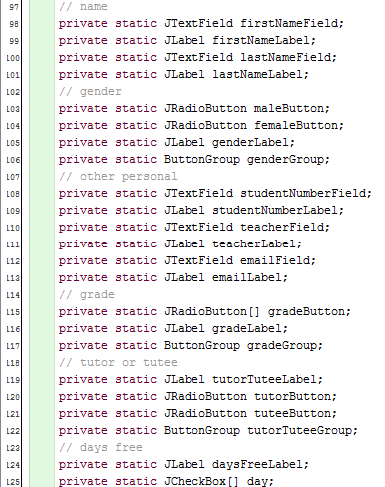
This was very extensive, since each element of the form needed the element itself, as well as an appropriate label.

Initialization and adding to the applet of some of the components:
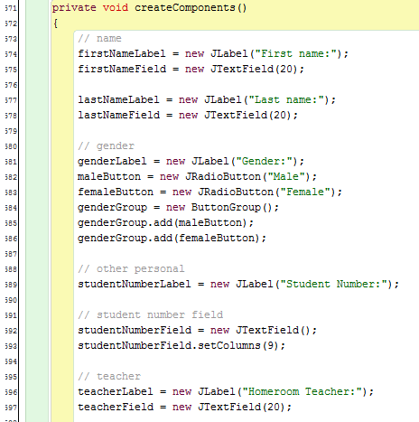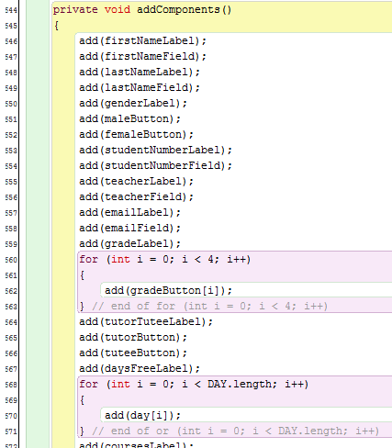
Once again, these processes very extensive due to the number of components that were on this form.

At this point, the components are added but without a specific layout. I used SpringLayout to lay out the components by defining the position of each component’s left or right, and top or bottom edge in relation to another component or to the applet’s window.
Laying out of the first seven components in the applet:
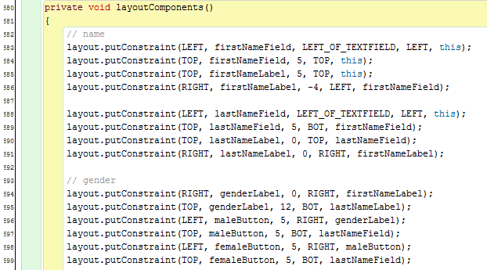
This involved some tweaking of numbers to get the layout clean and uniform. The creating, adding, and laying out of the first 7 components comes out to look like:
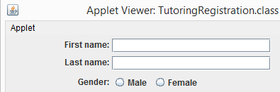

The ability for the applet to add and remove combo boxes for the courses was the hardest part of creating the applet.
To add a course combo box:
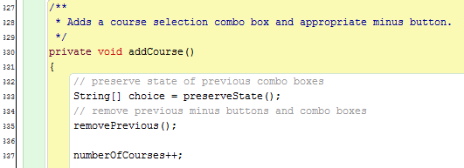
I had to preserve the state of all the combo boxes (the currently selected courses) and remove all combo boxes.

The preserveState() method:
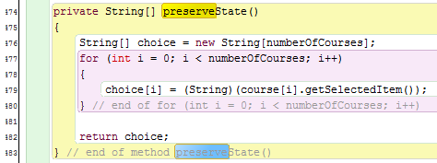
Allows me to record the state of every combo box, to assign to the new combo boxes once those are created.

The removePrevious() method:
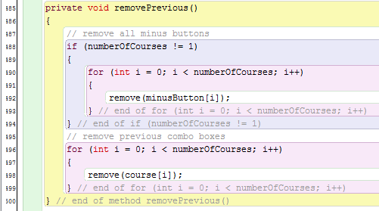
Removes all previous combo boxes, as well as the minus buttons that correspond to the combo boxes, unless there is only one combo box.

Creating new minus buttons, combo boxes, and assigning state to the combo boxes. Also adding the new components to the applet and setting their layout:
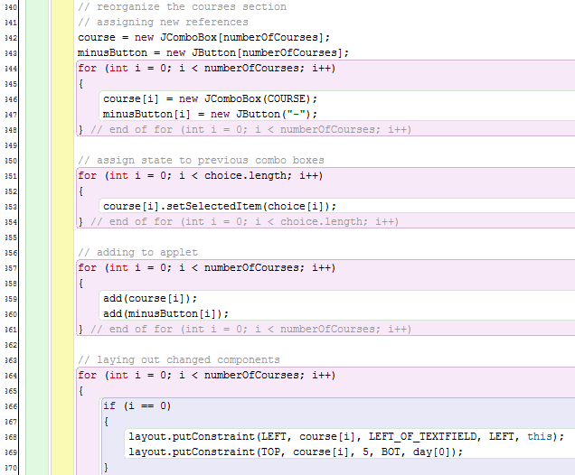

Add button is moved to next to the last combo box:

Adding listeners for the new minus buttons:
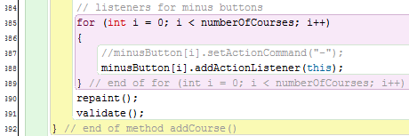

That is how I added a combo box. To remove a combo box is a similar process: remove all previous components, record state of them, create new combo boxes, assign previous states, move minus/add buttons, add listeners.

When any of the buttons are pressed:
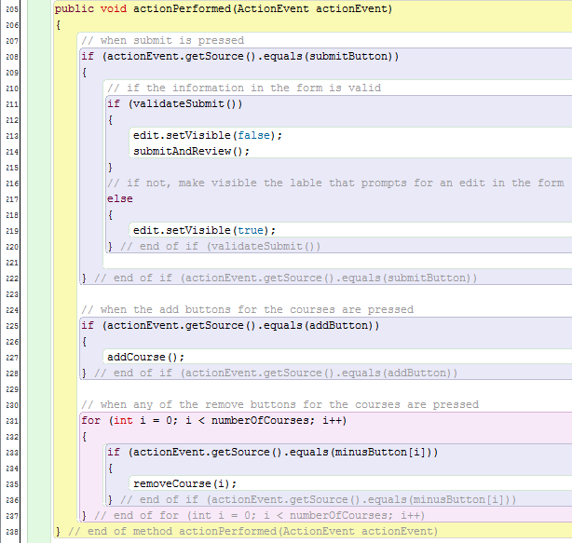
The appropriate methods are called.

The method validateSubmit() looks at every component in the form and as soon as one of the components has an invalid piece of information, the method returns false:
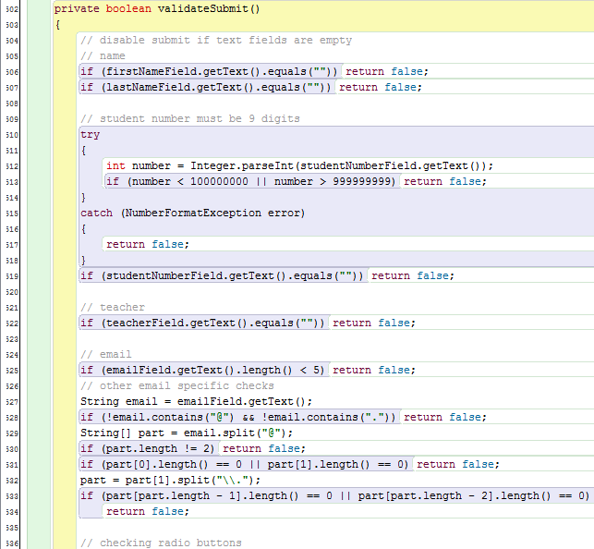
Each component has its own specific checks for validity.

The paint() method puts all of the above methods together into the appropriate order so that the applet is created and activated:
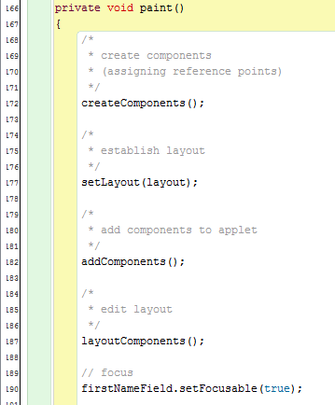
The paint() method is called by the init() method of the applet.

b. Offline portion
The databases:
The match database:
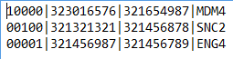
With the fields being match days (10100 means Monday and Wednesday match day), the tutor’s student number, the tutee’s student number, and the course(s) being tutored.

The tutee databases:
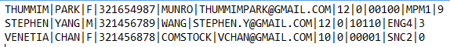
With the fields being name (first then last), gender, student number, teacher, email, grade, tutor/tutee designation, days free, courses, and attendance number (how many times the person has been there).
The tutor database is exactly the same, except for the 0 being a 1 in the fourth from the right field.

Classes:
In the Student class:
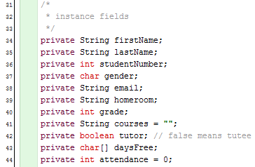
These are the instance fields that every student will know. The Student class has the appropriate methods for the access and mutation of all of these instance fields.

Creating a student object reads all of the information from either the tutor or tutee database file based on a given student number:
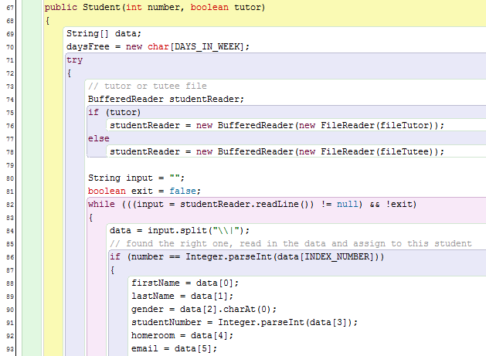
With the appropriate data being assigned to the instance fields declared above.

The method saveTutor(Student[] tutor), used to save changes made to an array of pre-existing tutors in the database:
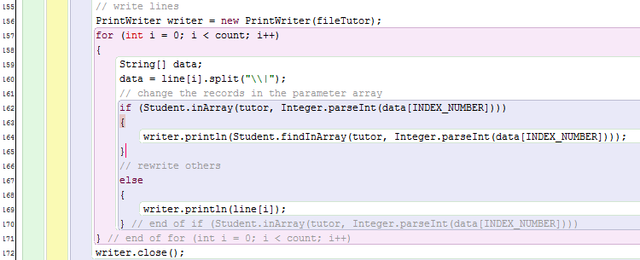
Rewrites lines that are not in the array of given tutors, and writes the appropriate changes to a line when that tutor is in the array of given tutors. A similar method exists to save changes made to tutees.

In the TutoringDBMS class:
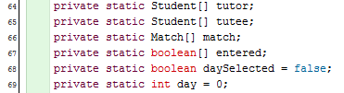
These static variables are used throughout the operation of the database management program, with match being the array of matches on the day, tutor/tutee being the array of tutors/tutees on the day, entered being the array that records whether a tutor/tutee has already signed in on the day, and day being the day that has been selected (Monday, Tuesday, etc.).

Operation begins at the main method:
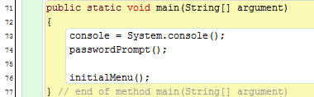

In passwordPrompt(), prompting for the coordinator password until it is entered. I set the password to 123456789 to being with (it is a static variable).
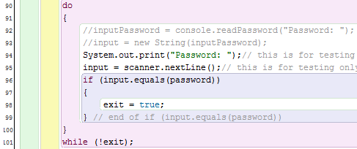

Choices in initialMenu():
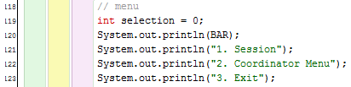
Are filtered into these methods:
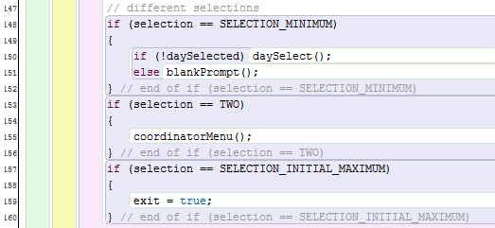

Choices in daySelect():
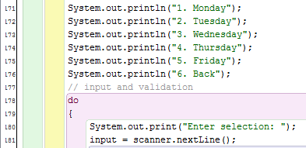
End of daySelect():
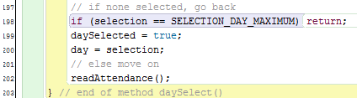
Records whether a day was actually selected or not. If not, daySelect() will be called again later on.

Reading matches for the day that is selected:
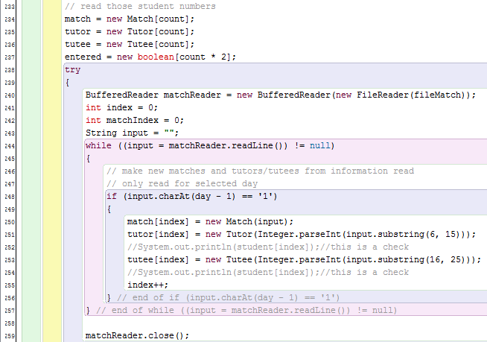
This is this initialization of the tutor, tutee, and match arrays from the reading of the match database. The tutor and tutee arrays also need to read from the tutor and tutee databases.

Then the blankPrompt() method is called:
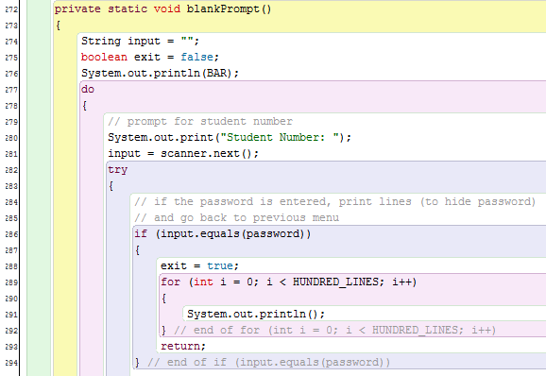
This is the beginning of the “session” operation, where the program takes in a student number or the password. If the password is entered, the previous menu is shown.

If not, the student number that is entered is compared to the array of tutors/tutees that are to be there on that day (read in method readAttendance()). Since “entered” is an array double the length of the tutor and tutee arrays since it has both tutors and tutees, I adjust the index found of the student number in the tutor or tutee array.
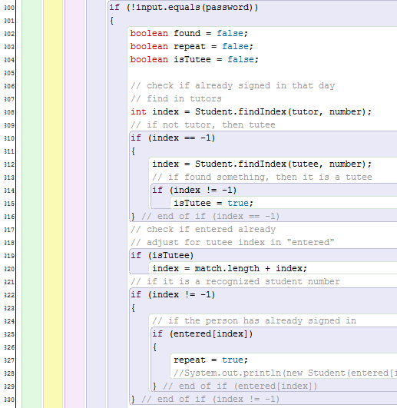

If not a repeat, then search the tutor/tutee array. If found, print a welcome message, increment attendance, and change the boolean value of found to true.
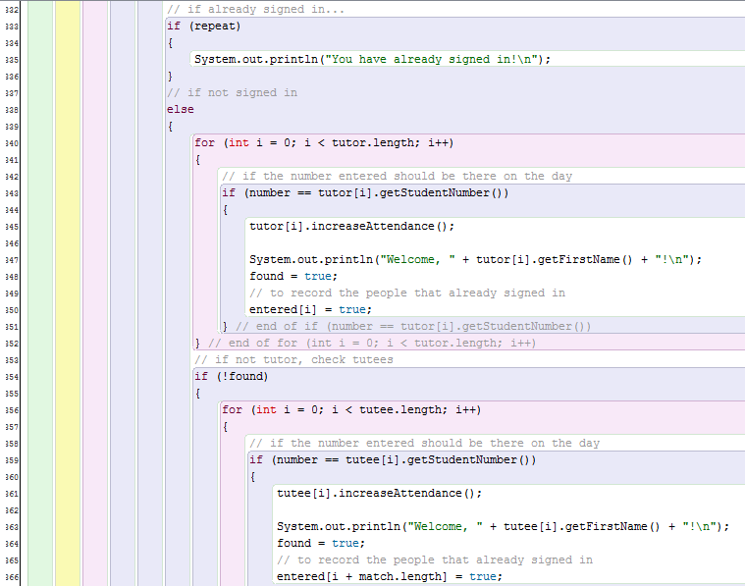

If the student number isn’t found in the day’s tutor/tutee array and it isn’t a repeat, that student number either doesn’t exist or shouldn’t be there on the day:
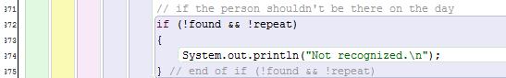

Save changes made to the array (attendance data) using methods in class Student:
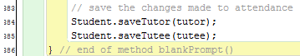

In the coordinator menu selection review, the method review():
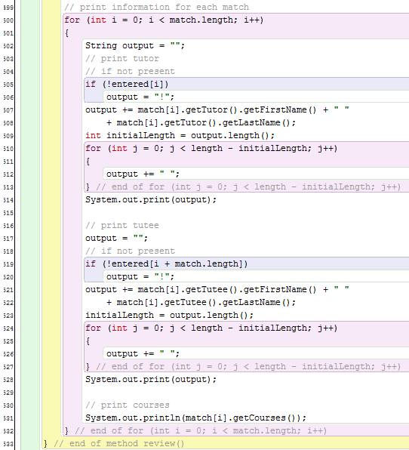
Output is lined up to a specified number of characters defined by “length.” A “!” is added in front of the name to indicate that the person has not yet signed in.

When adding a new tutor or tutee manually, check if they are already registered by comparing the student number to that of the registered tutors/tutees:
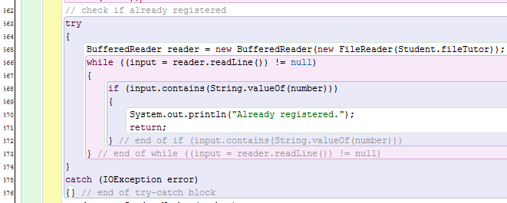

To add a match:
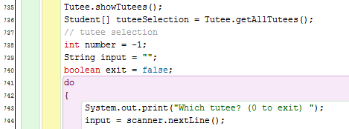
Show all tutees (from the tutee database) and ask for which tutee to make a match.
Take all tutors and filter them by day:
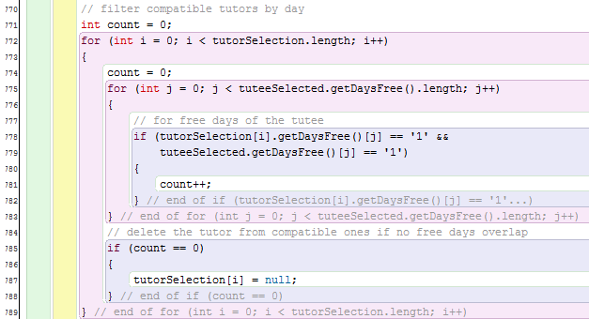
And remove incompatible tutors from the selection:
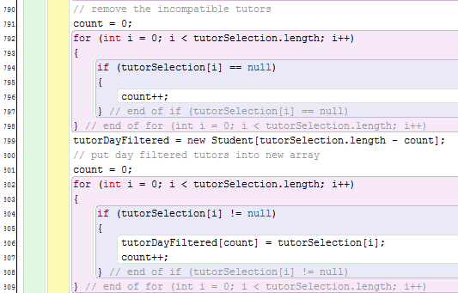
The filter tutors by course, and remove them in the same way as above:
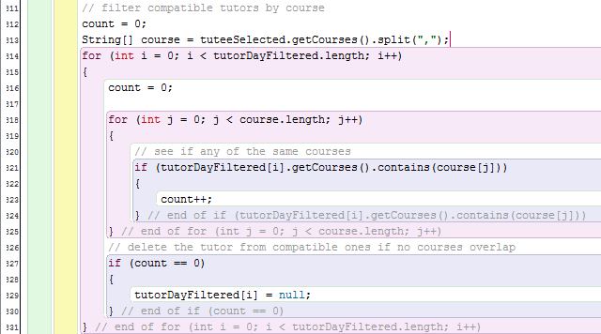
Show all compatible tutors (after filtering) and select one:
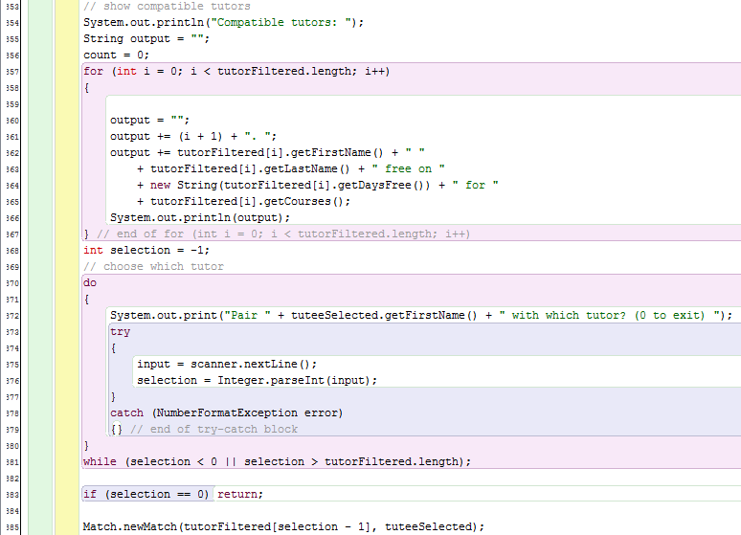
Then select the meet days, ensuring that the days selected match up with the tutor and tutee’s free days:
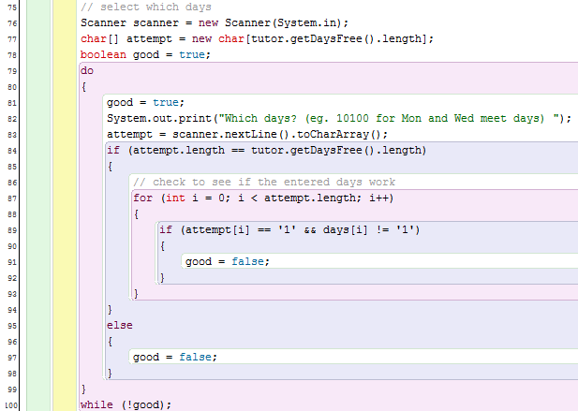
Then make the tutor and tutee not free on those days anymore, and save changes:
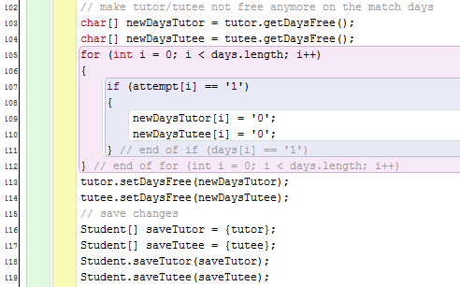
Finding the same courses:
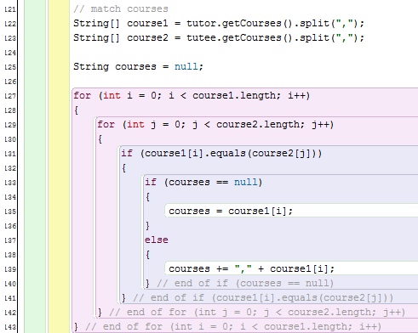

To delete a match, show all matches and select one to delete:
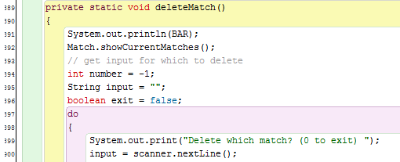
Read all matches in the database into an array and then change the days free of the individuals in the match:
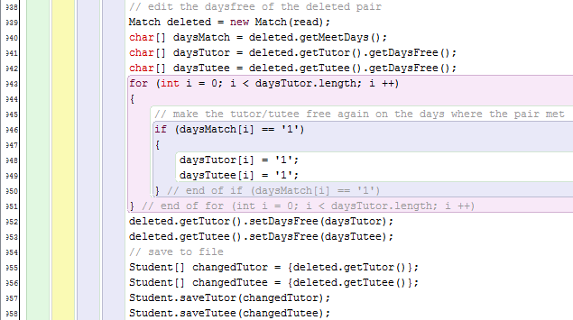
Write all matches back to file except the deleted one:
