**How to run the app?**



Step 1 : Extract the zip fie to any location . Lets say ( c:/users/jerry)

Step 2: Once extracted , the folder will be extracted as below

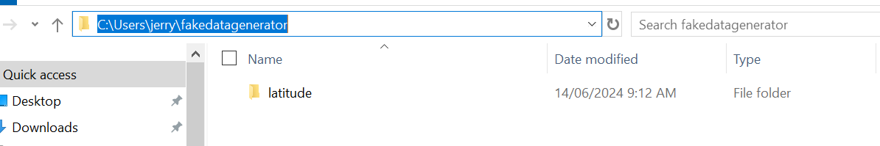

Step 3: Open CLI and proceed to the folder where the zip file is extracted

Step 4: Run the command

Python.exe C:\Users\jerry\fakedatagenerator\latitude\customer\start.py

Note : Replace the path with the correct path

Step 5: Open both output files

You will be seeing the following differences

1: First name and Last name are shiffled

2: Some parts of address are masked

3: No change is applied to date_of_birth

Fig 1: Source file

Fig 2: Anonymised file

**How to run the tests?**

Pytests were written for each function . Below are the steps to run those tests.

Step 1: Go to the project folder

Step 2: Open CLI and proceed to the folder where the zip file is extracted

Step 3: Run the command

pytest -v

System requirements

Python 3.9 +

Python packages :

pandas==1.1.5

numpy==1.21.5

pytest==7.4.4

Faker==18.13.0

**How to run the application with Docker ?**

Step 1: Go to project folder and create a docker image

Step 2: Run the command

docker build -t fakedatagenerator:1 .

This will create a docker image

Step 3: Ensure that the image is created

Step 4: get inside the container by following the command below

docker run -it fakedatagenerator:1 /bin/bash

Step 5: Run the command

python ./customer/start.py

Step 6: Now you can check the files with your editor of choice

Note : You can install the editor with the following commands in container shell

apt-get update

apt-get install vim

Actual file

Anonymised file

How to run the test cases with Docker ?

Step 1: Go inside the docker container with the command

docker run -it fakedatagenerator:1 /bin/bash

Step 2: run the command from the container shell

pytest -v ./customer

