Gradion — Security Testing & Architecture Review
Generated: 2026-07-02 15:13
Environment: Local Docker (frontend :5050, backend :5001)
Scope: Public landing + auth + admin CMS + API security controls
Method: OWASP-style manual review + negative/positive API checks + UI evidence screenshots

1) Executive summary
This report summarizes security testing and an architecture review for Gradion. It includes evidence-based checks (API responses and UI screenshots) and prioritizes findings by risk for public release readiness.

2) Architecture overview (high level)
Gradion is a Next.js (frontend) + Fastify (backend) application backed by Postgres via Prisma. Authentication uses JWT bearer tokens stored in browser localStorage. Admin functionality (Users, Landing CMS, CMS editor) is protected via role checks on the backend.

Security controls observed
- Fastify Helmet enabled with CSP directives (script/frame/img/connect restrictions).
- CORS allowlist with localhost exception.
- Rate limiting enabled globally and for auth endpoints (login/forgot).
- Zod validation used on most request payloads.
- Role-based access control via `requireRole()` middleware.

3) UI evidence (screenshots)
Landing page (desktop)
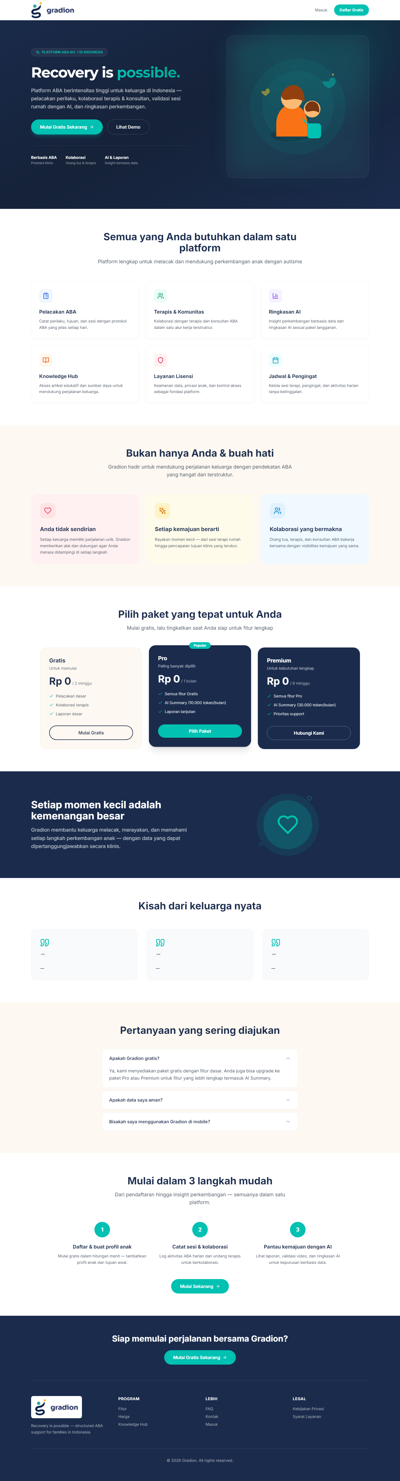
Login page
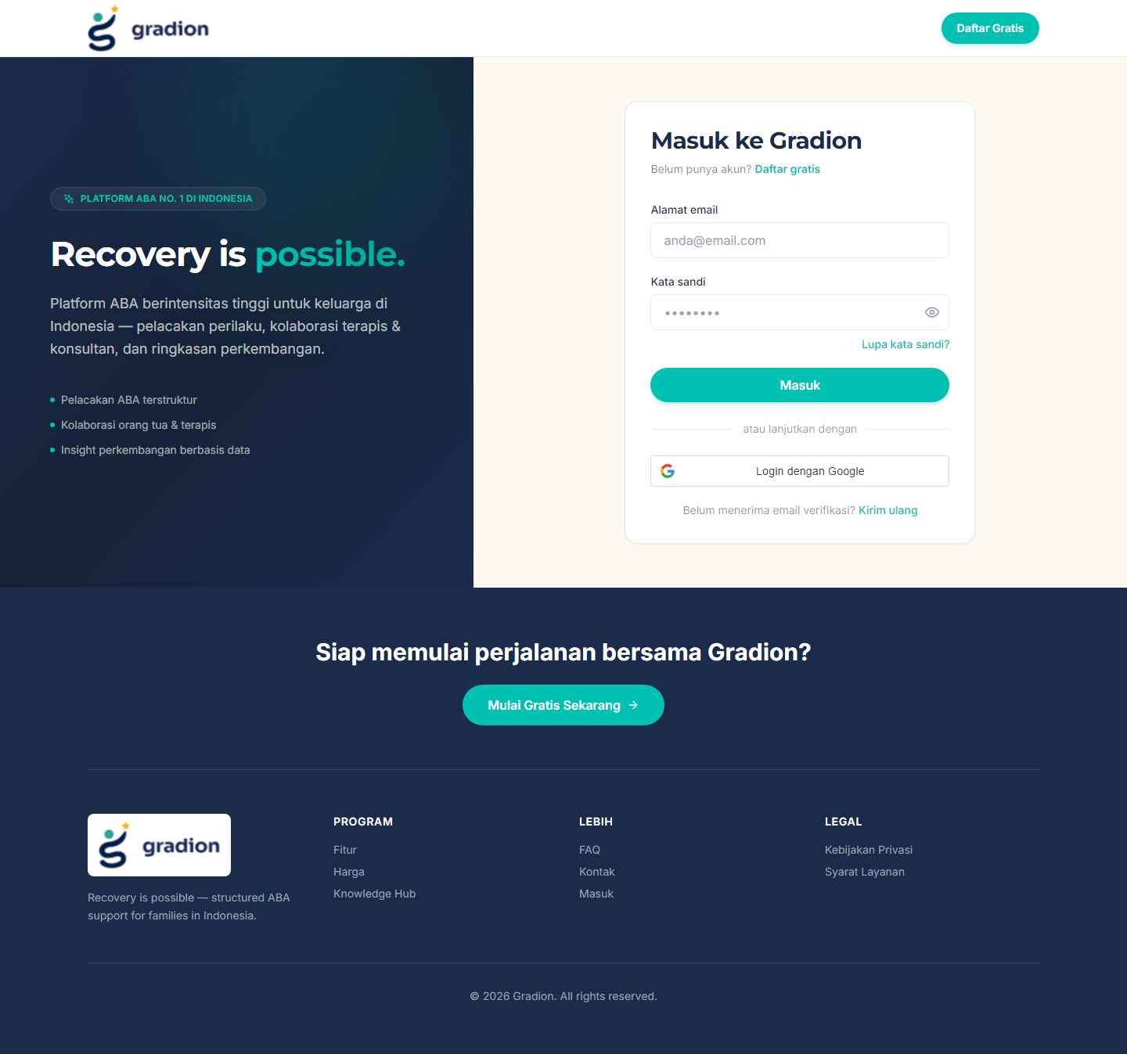
Dashboard after admin login
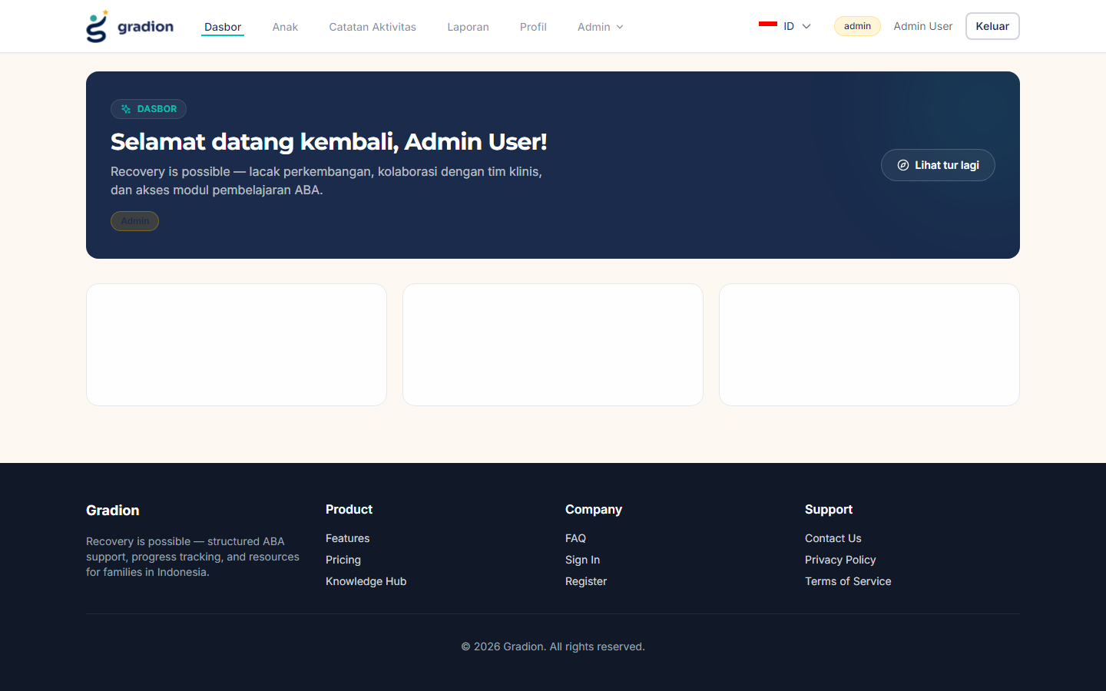
Landing Page CMS index
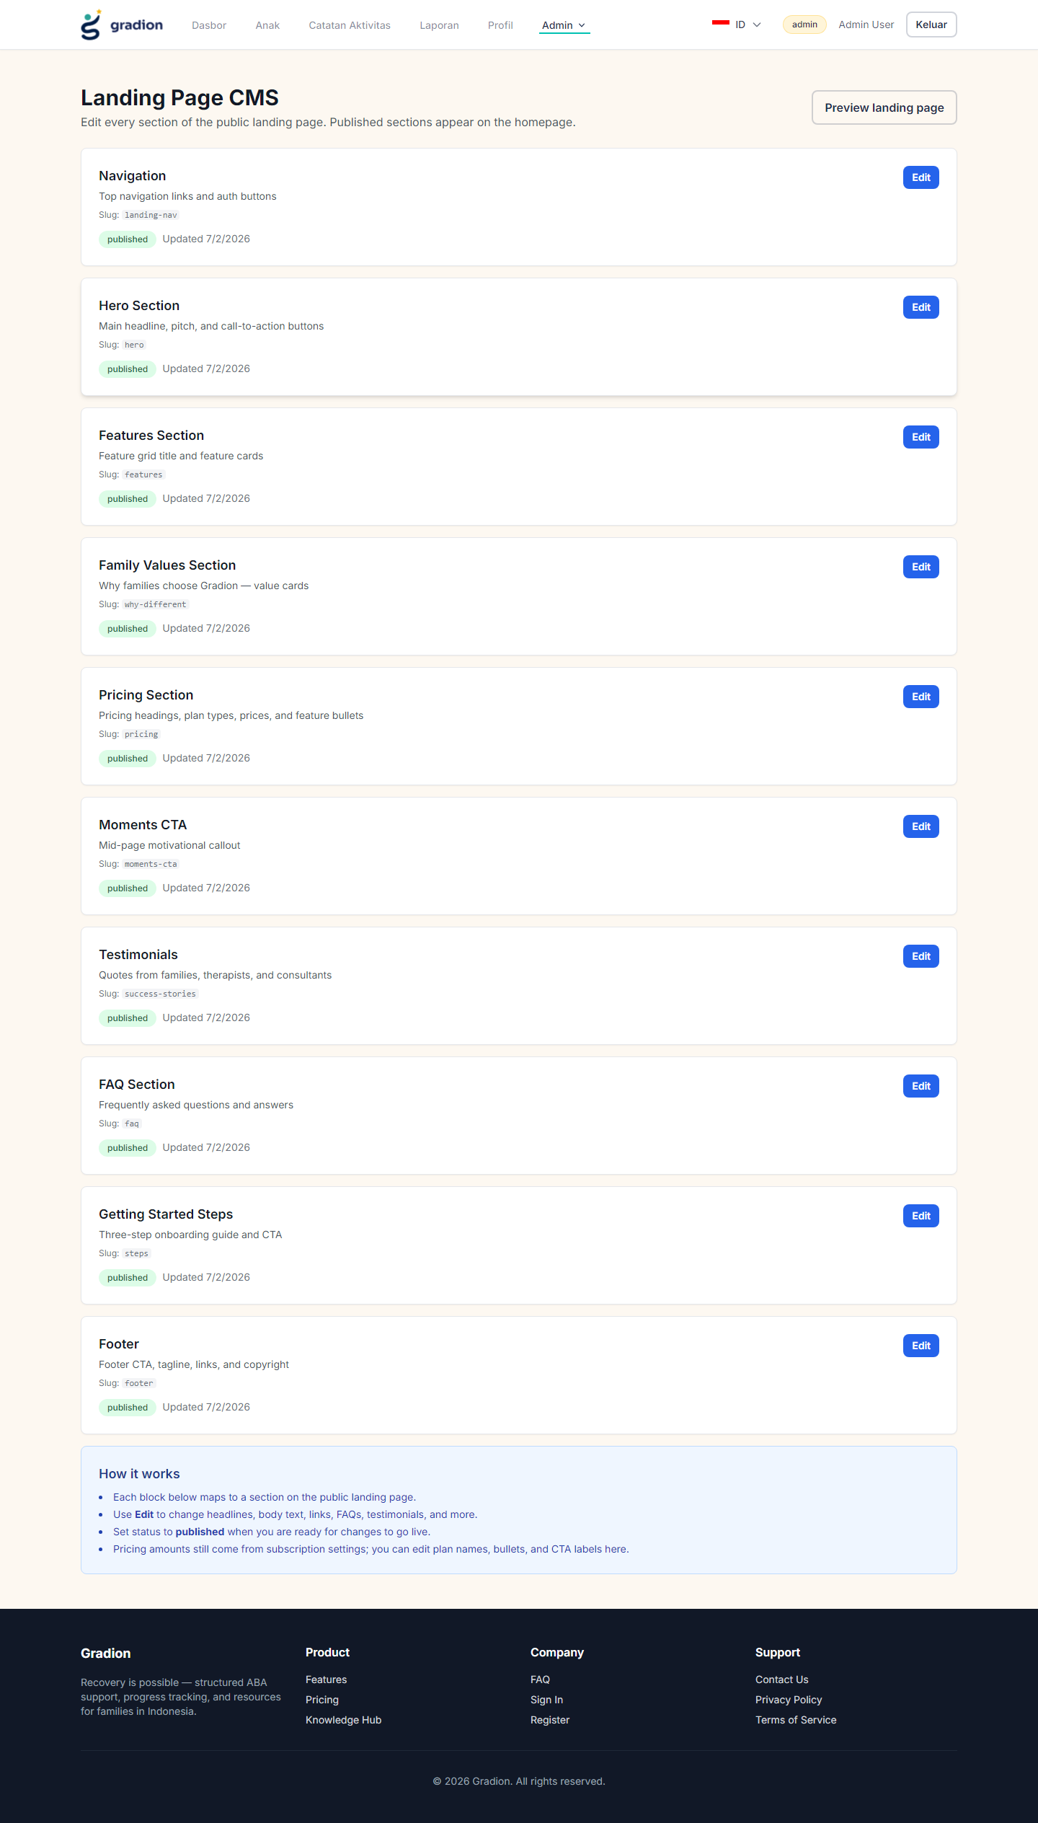
Landing Page CMS — Pricing editor
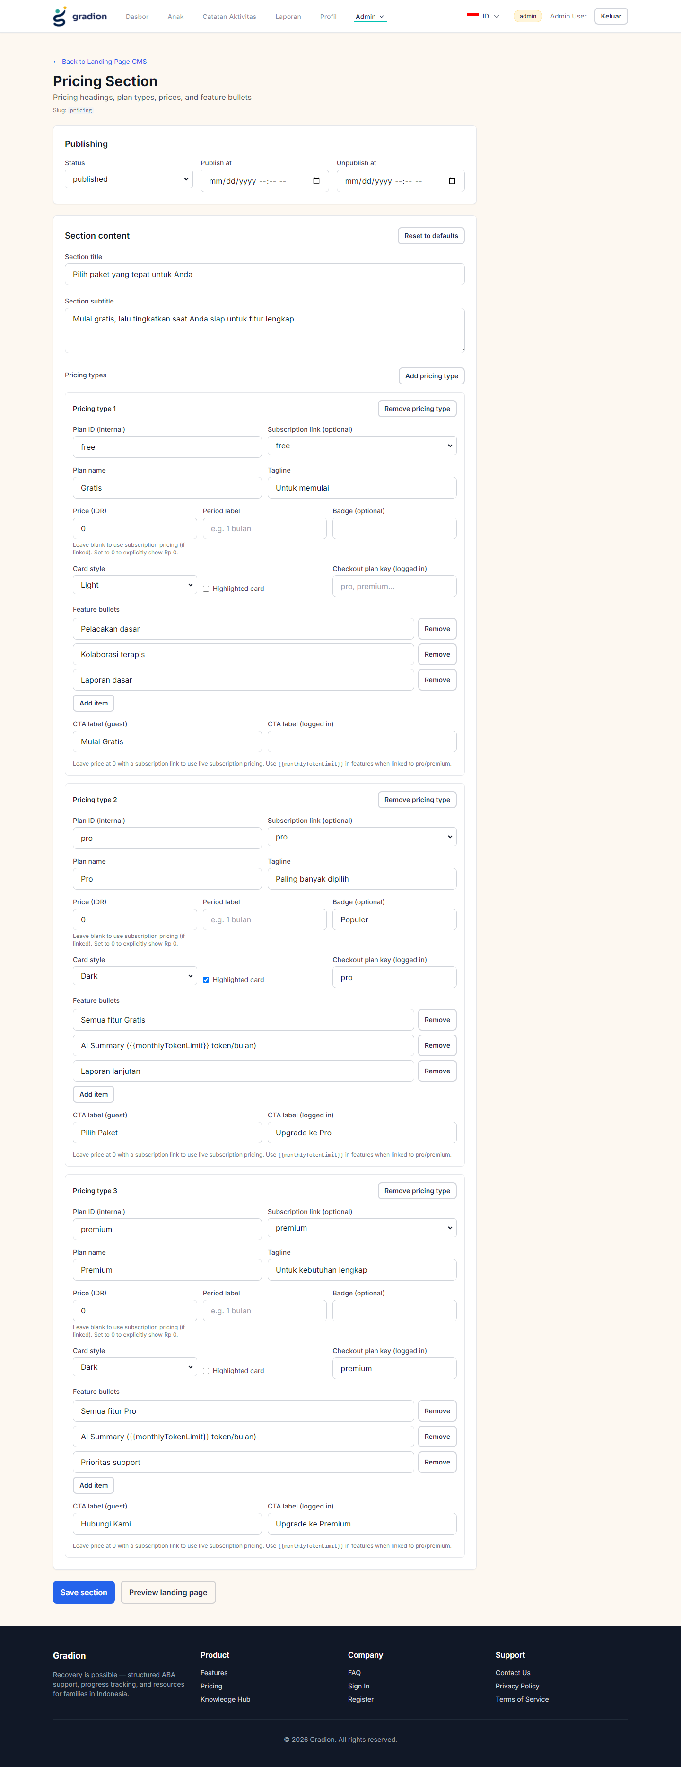
Landing Page CMS — Testimonials editor
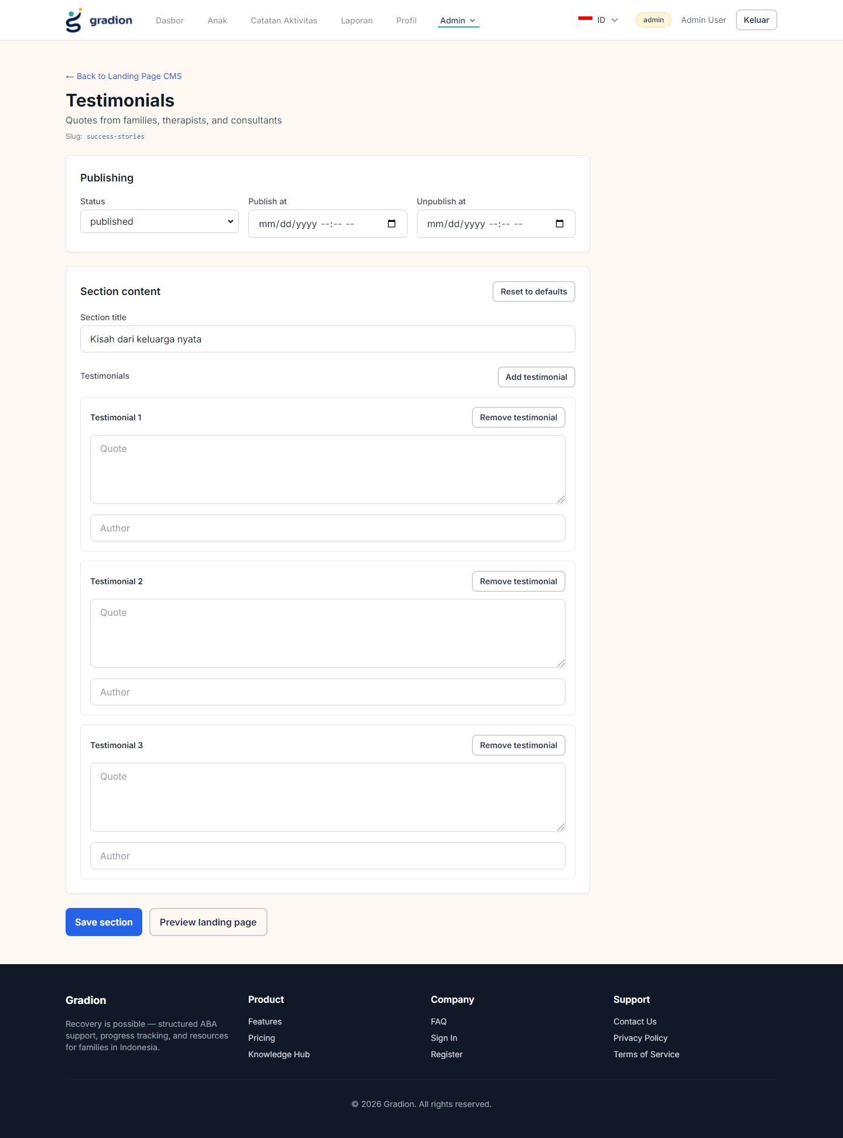
Landing Page CMS — FAQ editor
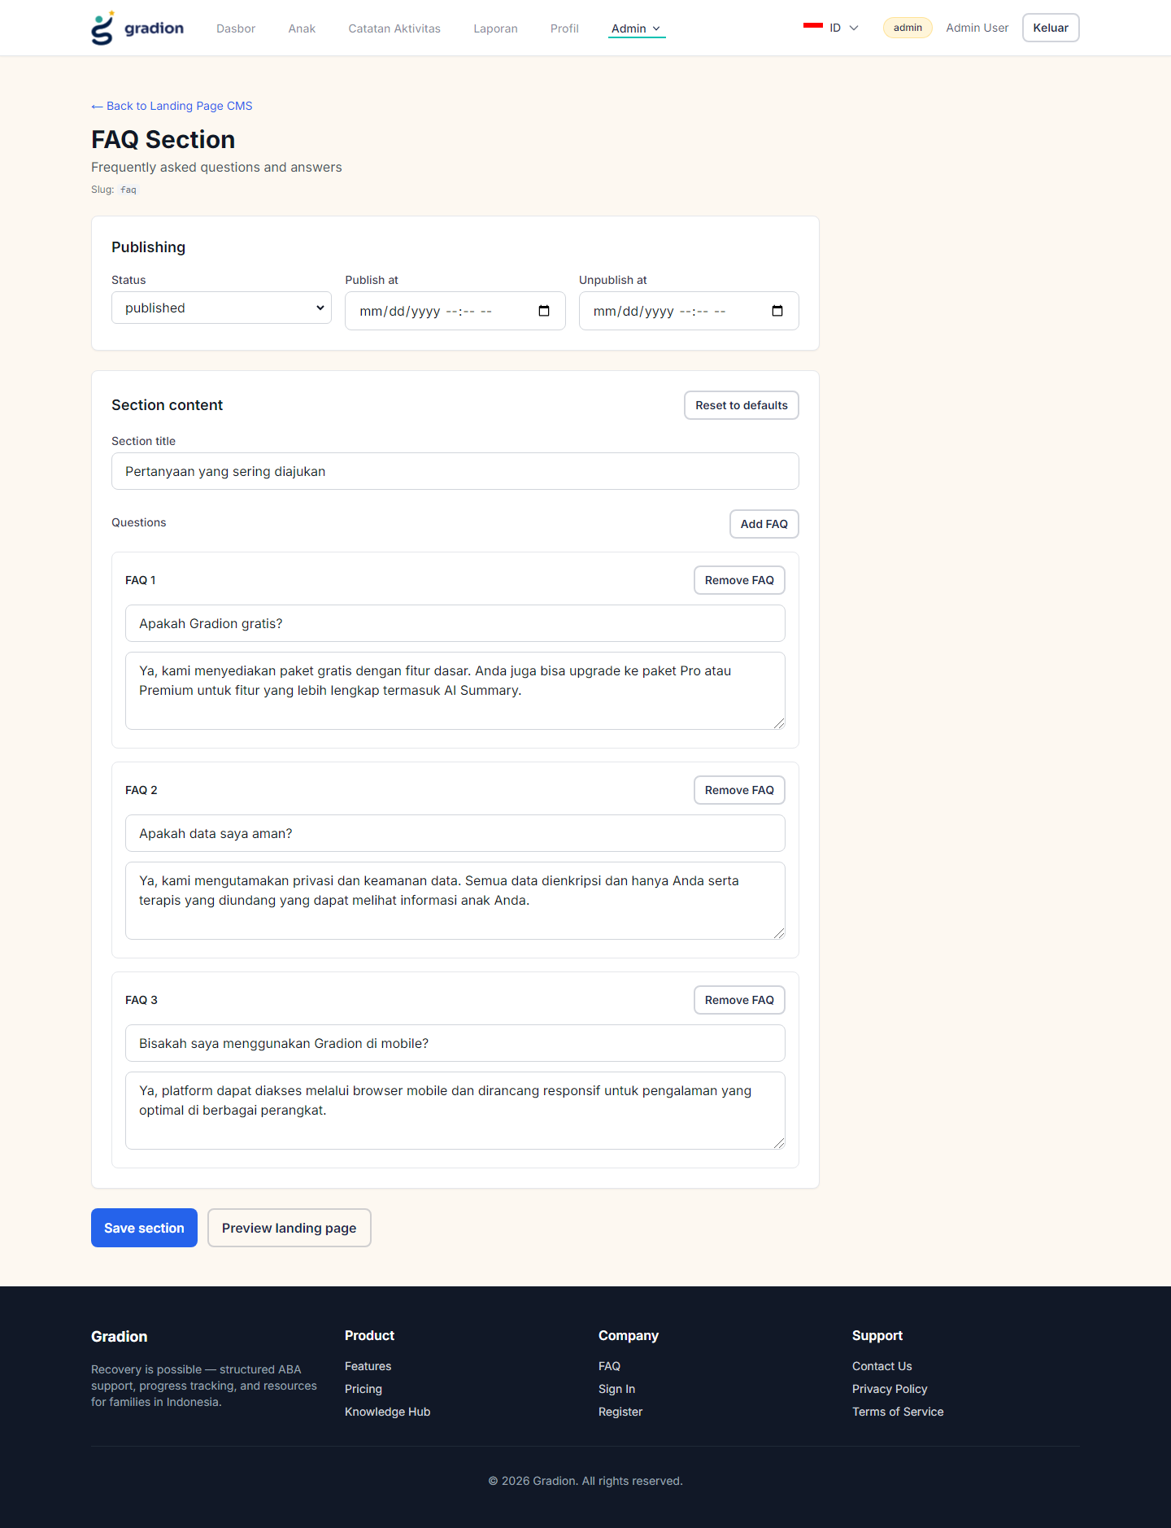

4) API security test results (positive + negative)

GET /health
Status: 200
OK: True
{"status":"ok","timestamp":"2026-07-02T08:05:16.088Z","uptime":9383.546018273,"environment":"production","version":"1.0.0"}

GET /cms/hero (public)
Status: 200
OK: True
{"success":true,"data":{"id":2,"title":"Hero Section","slug":"hero","content_html":"{\n \"version\": 1,\n \"section\": \"hero\",\n \"data\": {\n \"badge\": \"Platform ABA No. 1 di Indonesia\",\n \"headline\": \"Recovery is\",\n \"headlineHighlight\": \"possible.\",\n \"subtitle\": \"Platform ABA berintensitas tinggi untuk keluarga di Indonesia — pelacakan perilaku, kolaborasi terapis & konsultan, validasi sesi rumah dengan AI, dan ringkasan perkembangan.\",\n \"primaryCta\": {\n \"label\": \"Mulai Gratis Sekarang\",\n \"href\": \"/register\"\n },\n \"secondaryCta\": {\n \"label\": \"Lihat Demo\",\n \"href\": \"/#features\"\n },\n \"trustBadges\": [\n {\n \"label\": \"Berbasis ABA\",\n \"sub\": \"Protokol klinis\"\n },\n {\n \"label\": \"Kolaborasi\",\n \"sub\": \"Orang tua & terapis\"\n },\n {\n \"label\": \"AI & Laporan\",\n \"sub\": \"Insight berbasis data\"\n }\n ]\n }\n}","status":"published","publish_at":null,"unpublish_at":null,"banner_id":null,"created_at":"2026-07-02T04:46:15.835Z","updated_at":"2026-07-02T04:46:15.835Z"}}

POST /auth/login invalid password
Status: 401
OK: False

GET /admin/users without token
Status: 401
OK: False

POST /admin/users create verified parent
Status: 201
OK: True
{"success":true,"data":{"id":17,"name":"SecTest 1389825370","email":"sectest_verified1389825370@gradion.id","role":"parent","created_at":"2026-07-02T08:05:18.730Z","is_email_verified":true}}

GET /admin/users as parent (should 403)
Status: 403
OK: False

GET /admin/users/1 as parent (should 403)
Status: 403
OK: False

GET /admin/users?search=%27%20OR%201%3D1-- as admin
Status: 200
OK: True
{"success":true,"data":[],"pagination":{"page":1,"limit":50,"total":0,"total_pages":0}}

POST /auth/login rate limit after many attempts (expect 429)
Status: 429
OK: False

5) Findings and recommendations

High priority
- JWT stored in localStorage increases impact of any XSS. Consider httpOnly cookies or strict CSP + zero inline script. Ensure all user-supplied HTML is sanitized on render.
- CORS currently allows any origin containing 'localhost'. In production, remove the localhost wildcard exception.

Medium priority
- Public CMS pages render sanitized HTML. Keep sanitizer configuration tight and avoid allowing script/iframe unless required.
- Rate limiting exists for login; validate rate limiting is configured for all sensitive endpoints (admin create/update, password reset).

Low priority / hardening
- Add security headers for frontend delivery (HSTS, referrer policy) at the edge/proxy.
- Add automated dependency scanning (npm audit / Snyk / Dependabot).
- Add audit logging for admin actions (CMS publish, pricing edits, role changes).

6) Test plan checklist (recommended ongoing)
Frontend (positive/negative):
- Login/logout flows, incorrect password, locked-out/rate limited scenario.
- Unauthorized navigation to admin pages → should redirect/deny.
- CMS content rendering does not execute scripts (XSS attempt).
Backend API (positive/negative):
- Unauthorized requests to protected endpoints return 401/403.
- IDOR attempts blocked by role/ownership checks.
- Input validation rejects malformed IDs/emails.

End of report.

