Gradion
Bug Fix & Improvement Test Report
Child Creation, Initial Observation, Deletion & Reactivation
July 4, 2026 · Local environment (Docker: frontend :5050, backend :5001, PostgreSQL :5434)

1. Executive Summary
Two production bugs in the parent "Add Child" flow were diagnosed and fixed, five requested improvements were implemented, and the full flow was retested end-to-end in the local Docker environment through the real browser UI (Chrome automation) plus direct API tests. All items passed.
Item | Resolution | Status
Bug 1 — Parent cannot create child | Mandatory sliders no longer start "invisibly empty"; the Create button is always enabled and names every missing field | PASSED
Bug 2 — Child created twice | Synchronous double-click guard in the UI + database advisory lock and 5-minute dedup window in the API | PASSED
Imp 1 — Tantrum/Severity start at 0 | All Frequency/Severity sliders now run 0–5 and default to 0 | PASSED
Imp 2 — Mandatory/optional markers | Red * for mandatory, "(Optional)" tag for optional fields, plus a legend on both steps | PASSED
Imp 3 — Always-enabled Create button | Button stays enabled; submitting with gaps lists the exact mandatory fields per OBS | PASSED
Imp 4 — Delete / deactivate children | Parent delete hides the child completely; admin sees a "Deactivated" flag and can reactivate | PASSED
Imp 5 — Editable Behavior (OBS 1) | Parents can edit Behavior values until an assessment report or weekly ABA program exists | PASSED

A database migration (add_child_soft_delete) adds is_active, deactivated_at and deactivated_by columns to the children table. It was applied to the local database and is required in other environments before deploying this build.

2. Bug Fixes

2.1 Some parents could not create a child despite filling everything in
Root cause: every percentage and attention-span field in the Initial Observation checklist is mandatory, but their state started as empty while the sliders visually displayed "0". Parents believed the form was complete; the Create Child button silently stayed disabled with no explanation. The conditional "Other Major Disruptive Behavior" sliders had the same trap, and an accidentally added empty OBS tab could also block creation invisibly.
Fix: Frequency/Severity sliders now genuinely start at 0 (a valid answer), unfilled percentage fields are labeled "Not set — move the slider to fill", the Create button is always enabled, and submitting an incomplete form lists exactly which mandatory fields are missing, per OBS tab (see 3.3). Older saved drafts that carried the invisible-empty state are ignored via a draft version bump.

2.2 Some parents got the child created twice
Root cause: a fast double-click fired two simultaneous create requests. The button-disable relied on asynchronous React state, so the second click slipped through, and the backend had no idempotency protection: both requests passed the duplicate check before either row was inserted (verified by reproducing two rows with identical timestamps in testing).
Fix (two layers): the frontend now blocks re-entry synchronously with a ref guard, and the backend wraps the duplicate check and insert in a transaction serialized by a PostgreSQL advisory lock keyed on parent + child name. A repeat submission with the same name within 5 minutes returns the already-created child (flagged deduplicated: true) instead of inserting a new row. A stress test firing two concurrent requests produced exactly one row.

3. Improvements

3.1 Frequency & Severity sliders start at 0 (previously 1)
All Behavior (F / S) sliders — Tantrums, Self-Abuse, Aggression, Self-stim, Leaves Work Area, Hands and Feet Restless, and the optional "Other Major" rows — now run on a 0–5 scale and default to 0. The read-only checklist on the Child Detail page renders the same 0–5 scale.
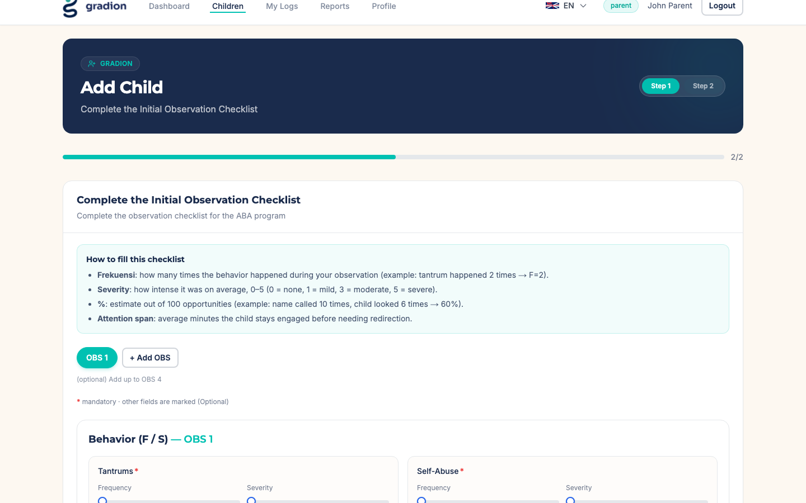
Step 2 — Behavior sliders default to 0 with mandatory (*) markers.

3.2 Mandatory vs optional field markers
Mandatory fields show a red asterisk (*); optional fields show an "(Optional)" / "(Opsional)" tag. A legend explains the convention on both steps.
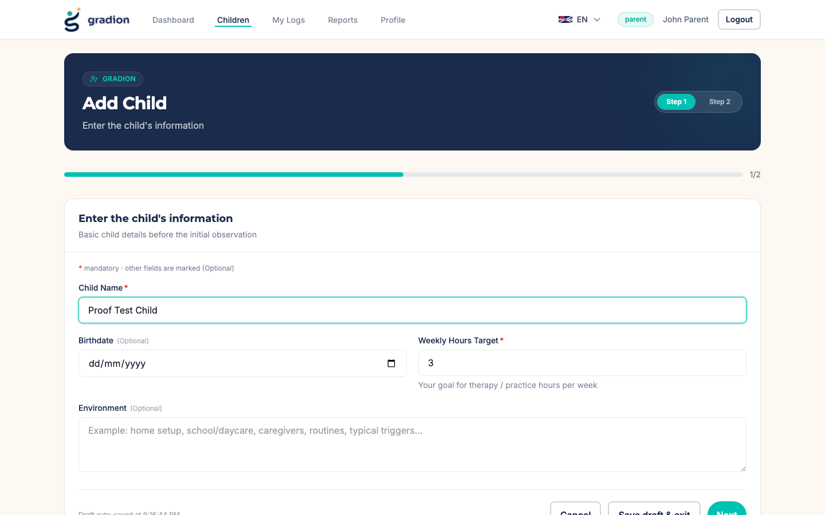
Step 1 — Child Name and Weekly Hours Target are mandatory; Birthdate and Environment are optional.

3.3 Create Child button always enabled, with specific errors
The Create Child button no longer disables itself. Clicking it with missing mandatory fields shows a precise message naming every unfilled field for each OBS tab, and the page scrolls to the message automatically.
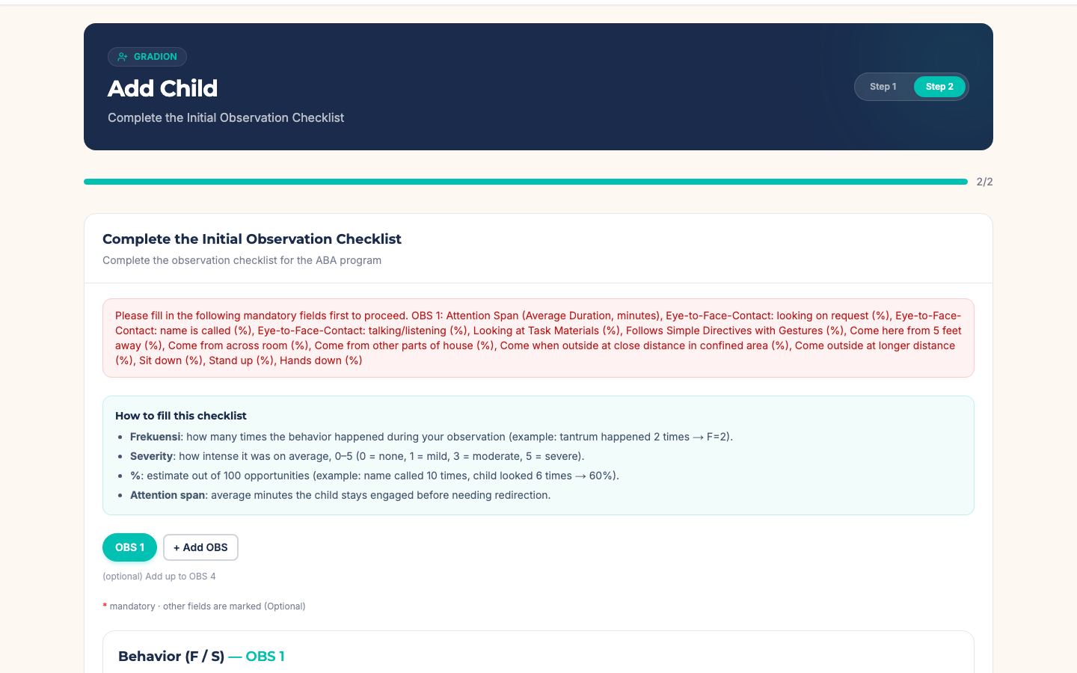
Submitting with gaps lists every missing mandatory field for OBS 1.

3.4 Delete children (parent) / deactivate & reactivate (admin)
A parent (or admin) can delete a child from the Child Detail page after an inline confirmation. For the parent the child disappears completely — list, detail and API access all behave as if it no longer exists. For admins the child remains visible, flagged "Deactivated / Nonaktif", and can be reactivated on request, which restores it to the parent untouched.
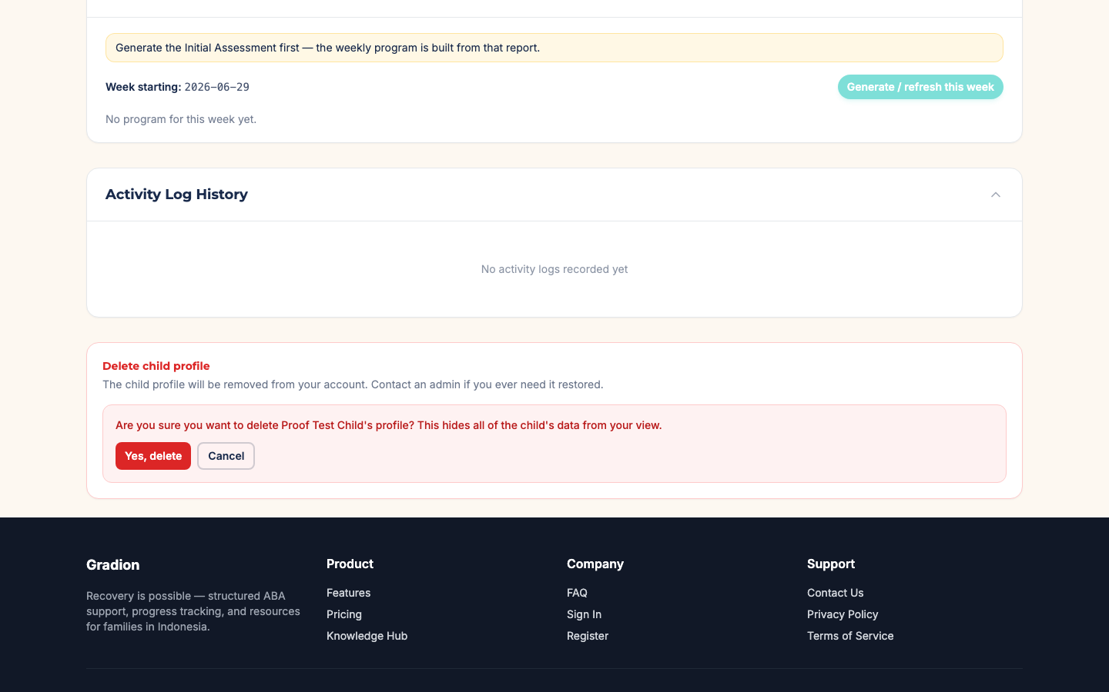
Parent-side delete with inline confirmation.
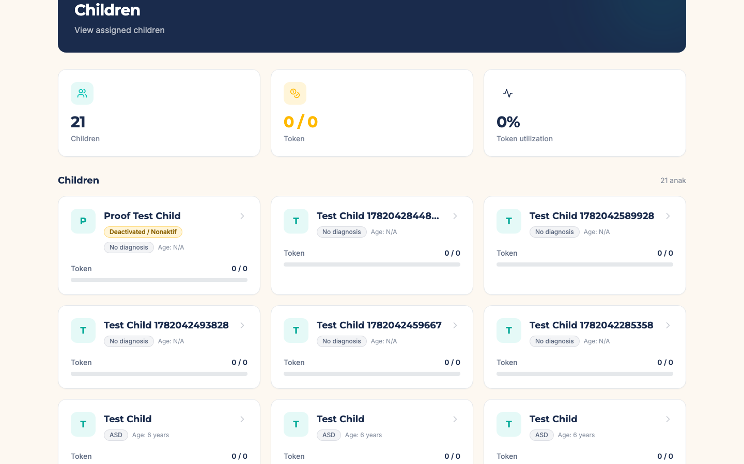
Admin children list — the deleted child carries a "Deactivated / Nonaktif" badge.
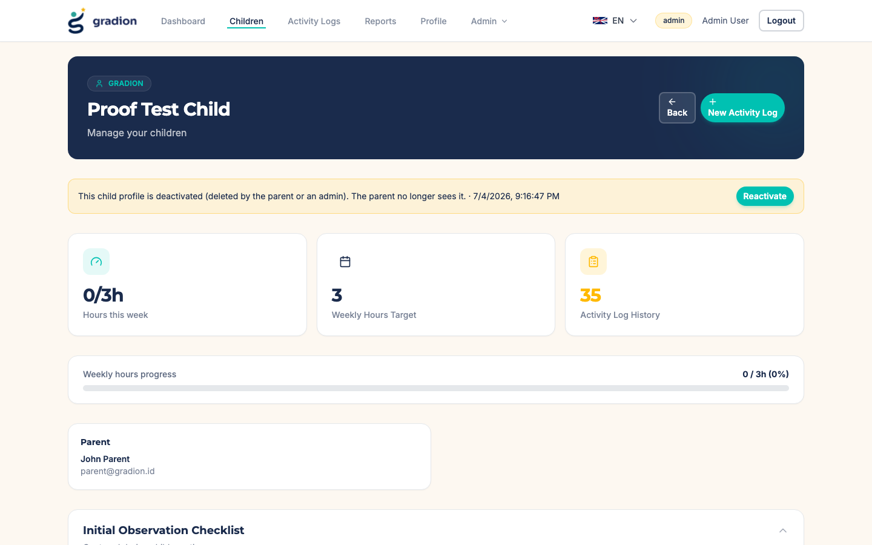
Admin child detail — deactivation banner with one-click Reactivate.
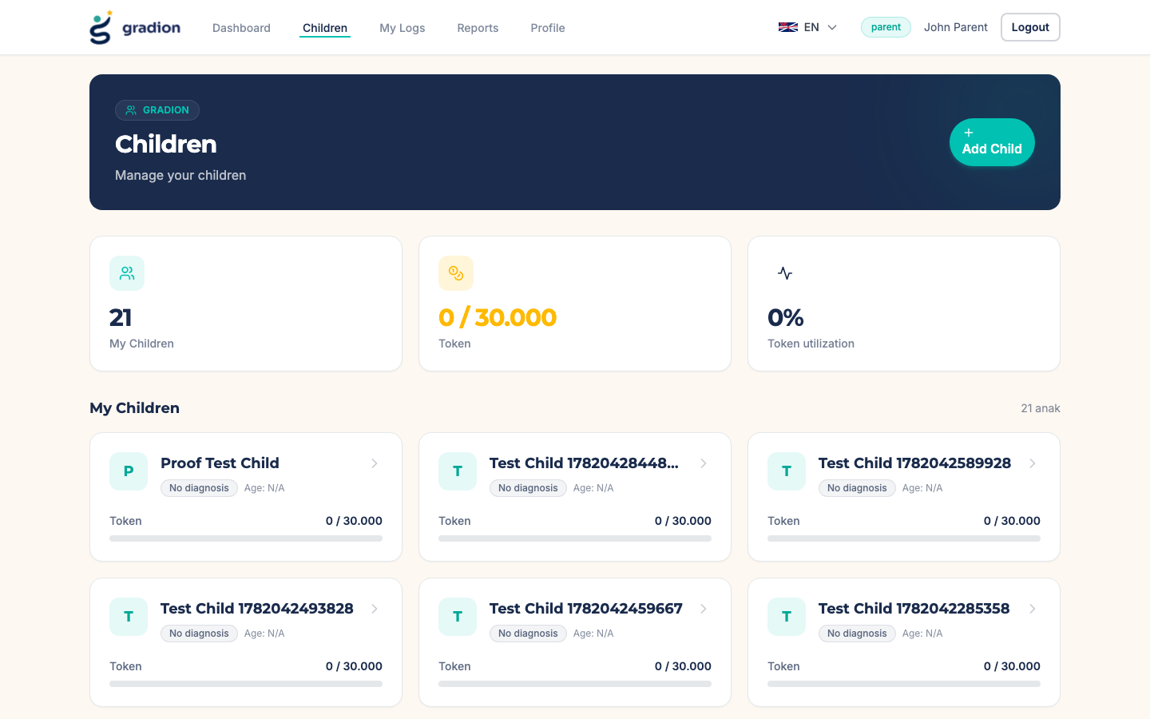
After admin reactivation the child is back in the parent’s list.

3.5 Editable Behavior (OBS 1) on the Child Detail page
While a child has no AI assessment report and no weekly ABA program yet, the Behavior (OBS 1) card shows an "Edit values" button for the parent (and admin). Values are edited on 0–5 sliders and saved back into the initial observation. Once an assessment or weekly program exists the endpoint refuses further edits (HTTP 409), because the observation is the immutable input that produced them.
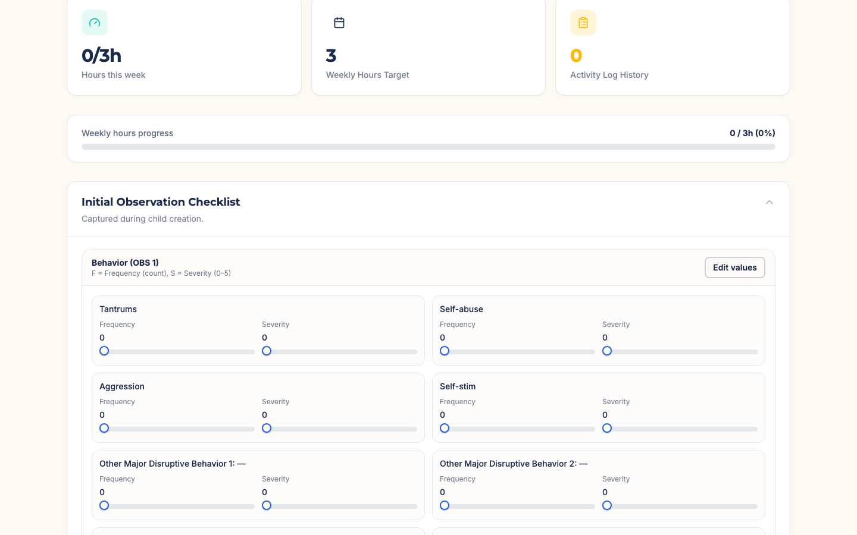
Behavior (OBS 1) card with the Edit values button while no assessment/ABA program exists.
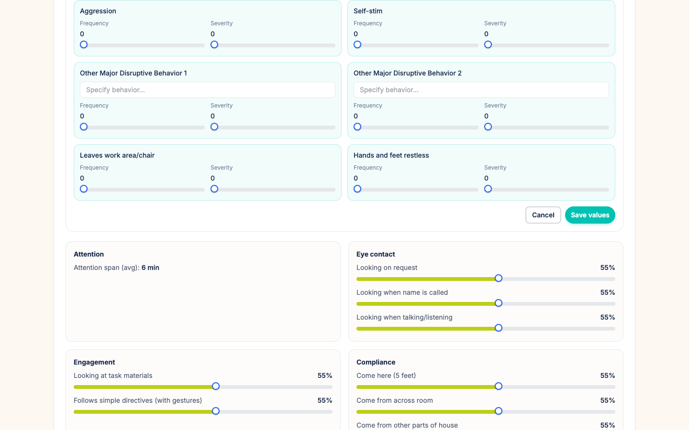
Edit mode — 0–5 sliders per behavior (Tantrums set to F=4, S=3).
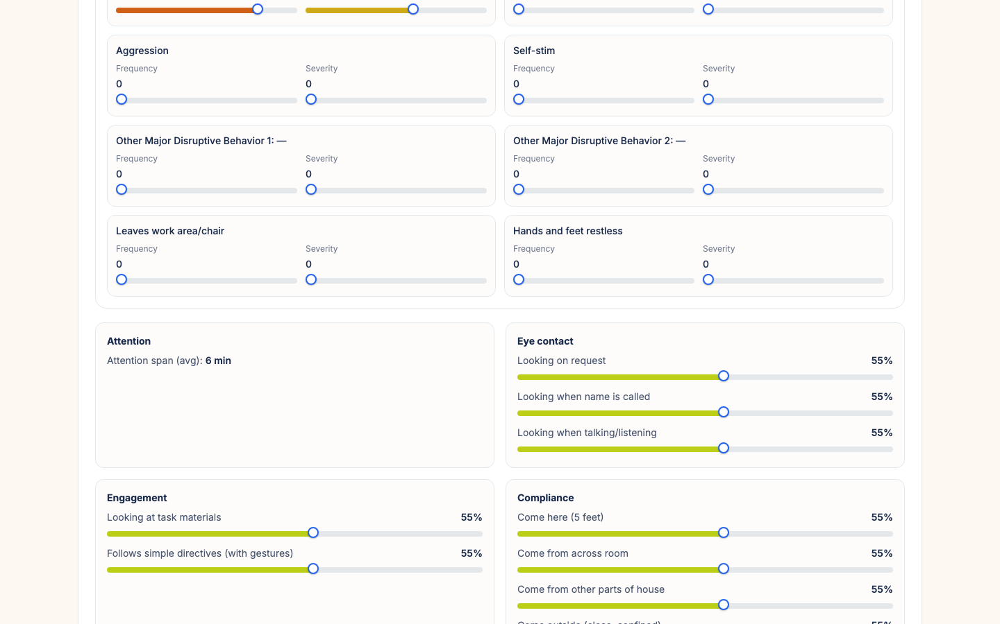
Values saved confirmation and updated read-only view.

4. End-to-End Test Evidence
The complete flow was executed against the rebuilt local Docker stack through the browser as a parent (parent@gradion.id) and an admin (admin@gradion.id): create child (including a deliberate double-click on Create), edit behavior values, delete the child, verify the parent no longer sees it, verify the admin sees the deactivation flag, reactivate, and verify the parent sees the child again.
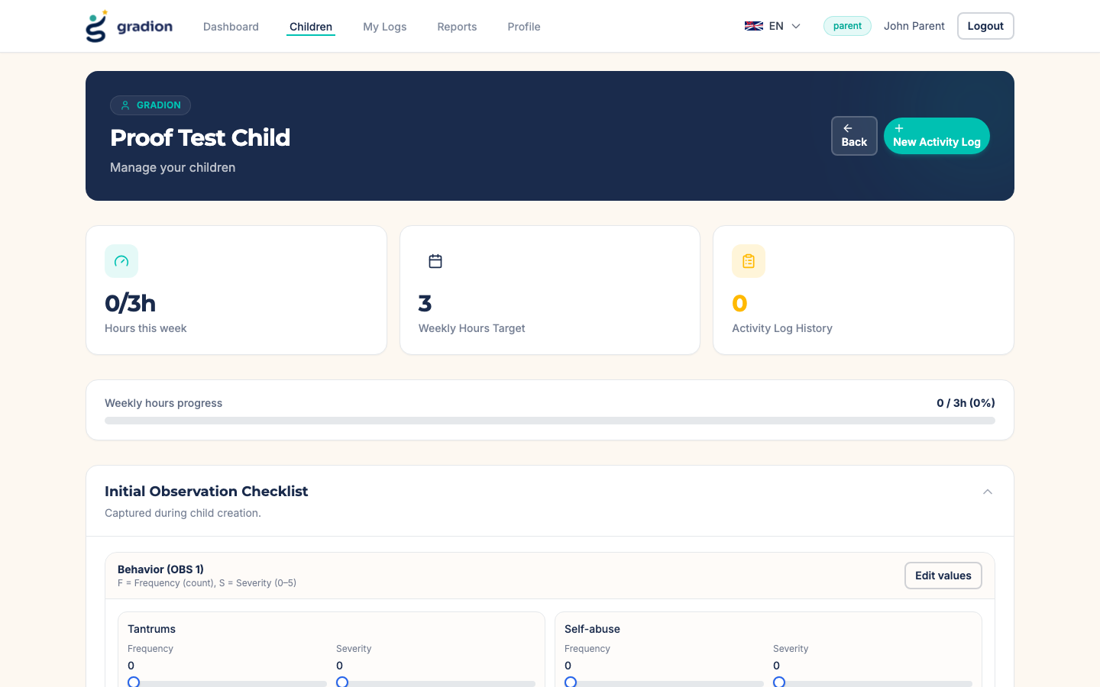
Child created successfully — a deliberate double-click produced exactly one child (verified in the database).
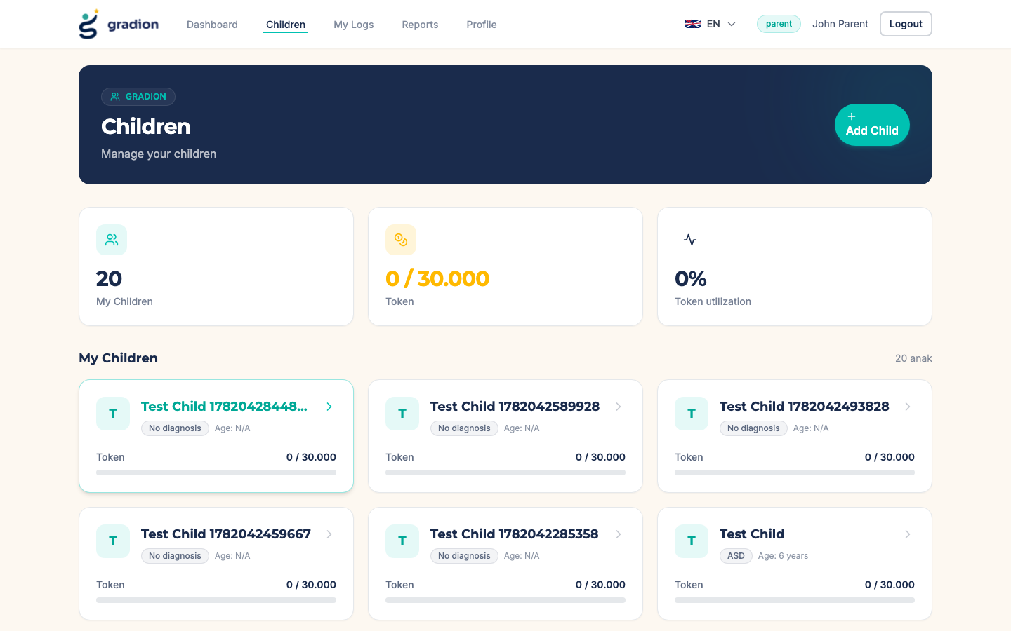
Parent children list immediately after deletion — the child is gone.
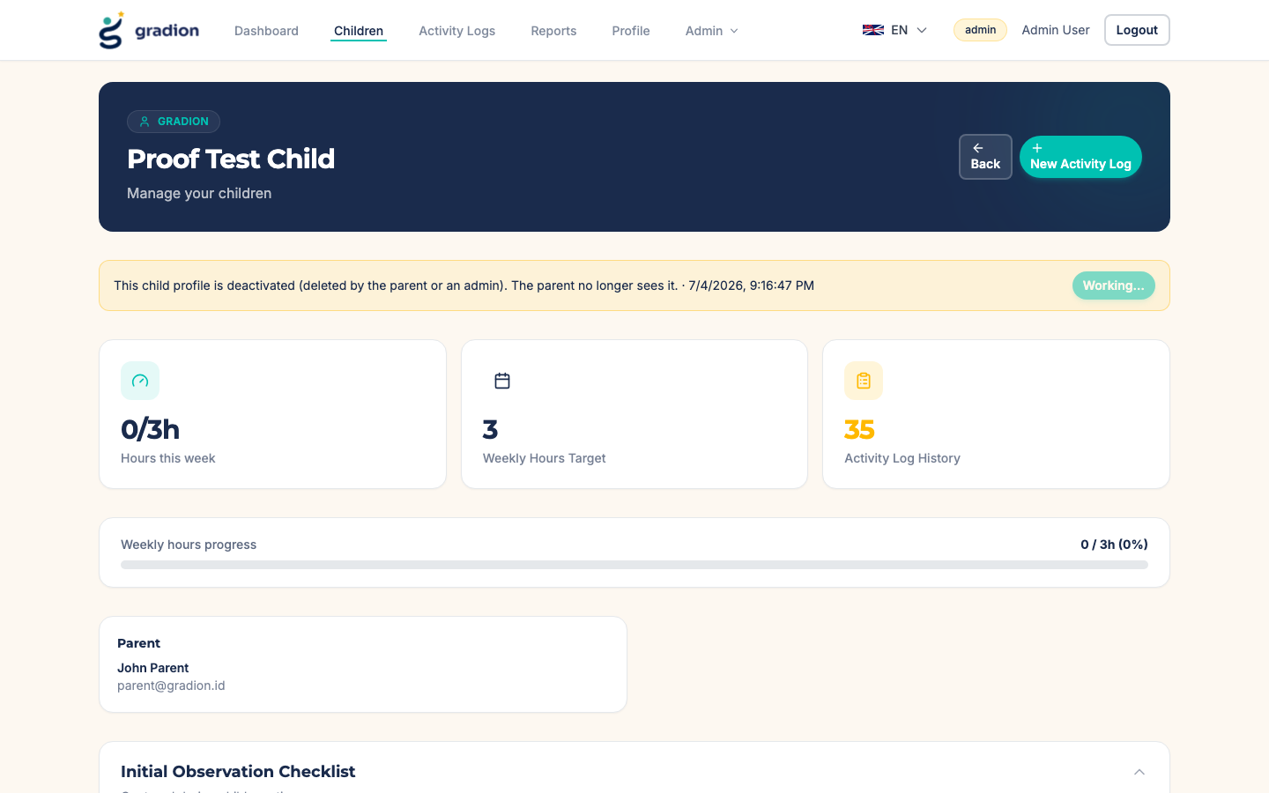
Admin view after reactivation — the deactivation banner is gone.

5. API-Level Test Results
API test | Observed result | Result
POST /children twice (sequential, same name) | Second call returns the same child with deduplicated: true | PASS
POST /children twice (concurrent) | Advisory lock serializes both; one row created, second deduplicated | PASS
PUT /children/:id/initial-observation/behaviors (no assessment) | Values updated and returned | PASS
Same endpoint after assessment/ABA exists | Rejected with HTTP 409 and explanatory error | PASS
DELETE /children/:id as parent | Child hidden from parent list; GET returns 404 for parent | PASS
GET /children/:id as admin (deactivated) | Admin still sees the child with is_active: false | PASS
POST /children/:id/reactivate as admin | Child active again and visible to the parent | PASS

6. Changes Delivered
- Backend routes (backend/src/routes/children.ts): advisory-lock idempotent create, soft-delete DELETE /children/:id, admin POST /children/:id/reactivate, guarded PUT /children/:id/initial-observation/behaviors, deactivated children filtered from parent/therapist queries.
- Database (prisma): children.is_active, children.deactivated_at, children.deactivated_by + migration 20260704090000_add_child_soft_delete.
- Create Child UI (NewChildPageContent, InitialObservationForm, initialObservationTemplate): 0-default 0–5 sliders, mandatory/optional markers with legend, always-enabled button with per-field validation errors, synchronous double-submit guard, draft version bump.
- Child Detail UI (ChildDetailPageContent): Behavior (OBS 1) inline editor, delete/deactivate danger zone, admin deactivation banner with reactivate, deactivated badge on admin child cards; fixed a display bug that blanked the "Other Major Disruptive Behavior" row titles.
- Test tooling: scripts/e2e-proof-screenshots.mjs (Playwright) reproduces this whole flow and captures the screenshots in this report.

7. Round 2 Enhancements
A second round of enhancements was implemented and tested on July 4, 2026, focusing on the AI-content review lifecycle and token utilization transparency.

7.1 Behavior (OBS 1) editable while content is pending review
The edit window for Behavior (OBS 1) now stays open while the assessment report and weekly ABA program are empty OR still awaiting admin approval. Only APPROVED content locks the observation. Verified via API: editing succeeded with a pending assessment and pending week, was refused with HTTP 409 immediately after approval, and became possible again after the admin reverted the content to pending.
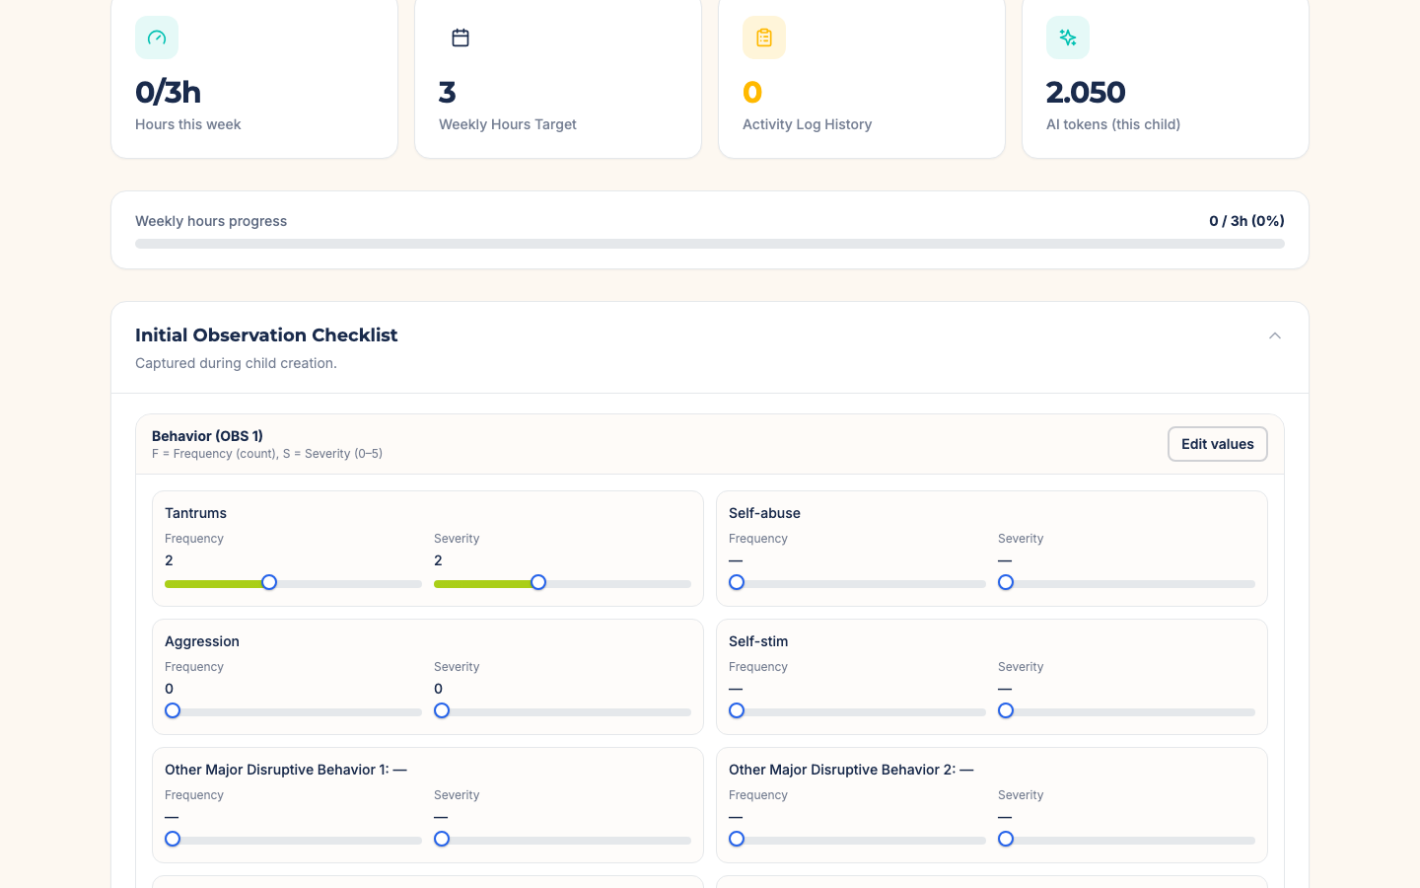
Parent can still edit Behavior (OBS 1) while the assessment and weekly program await admin review.

7.2 Admin gets the same pending-review view as parents
On the Child Detail page an admin now sees exactly what the parent sees: AI content that has not been approved is hidden behind "awaiting admin review" banners. Admins review and edit the actual content in the dedicated AI Content Review page.
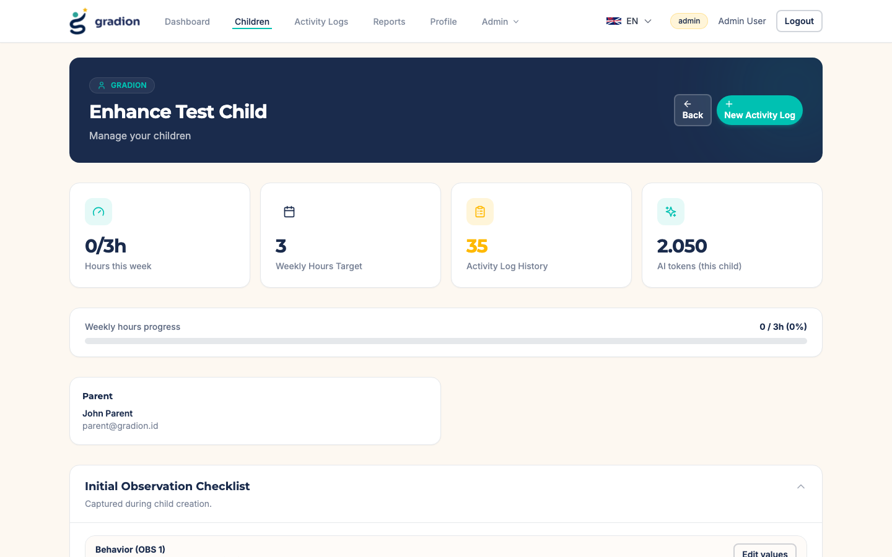
Admin viewing the child detail page — same pending banners as the parent.

7.3 AI Content Review: revert to pending, then edit and re-approve
The review queue gained a "Set pending" action for both assessment reports and weekly ABA programs. Reverting hides the content from the parent again (shown as awaiting approval) while the admin edits or adds content with the existing editors, then re-approves. The full cycle — approve, visible to parent, set pending, hidden from parent — was verified through both the API and the UI.
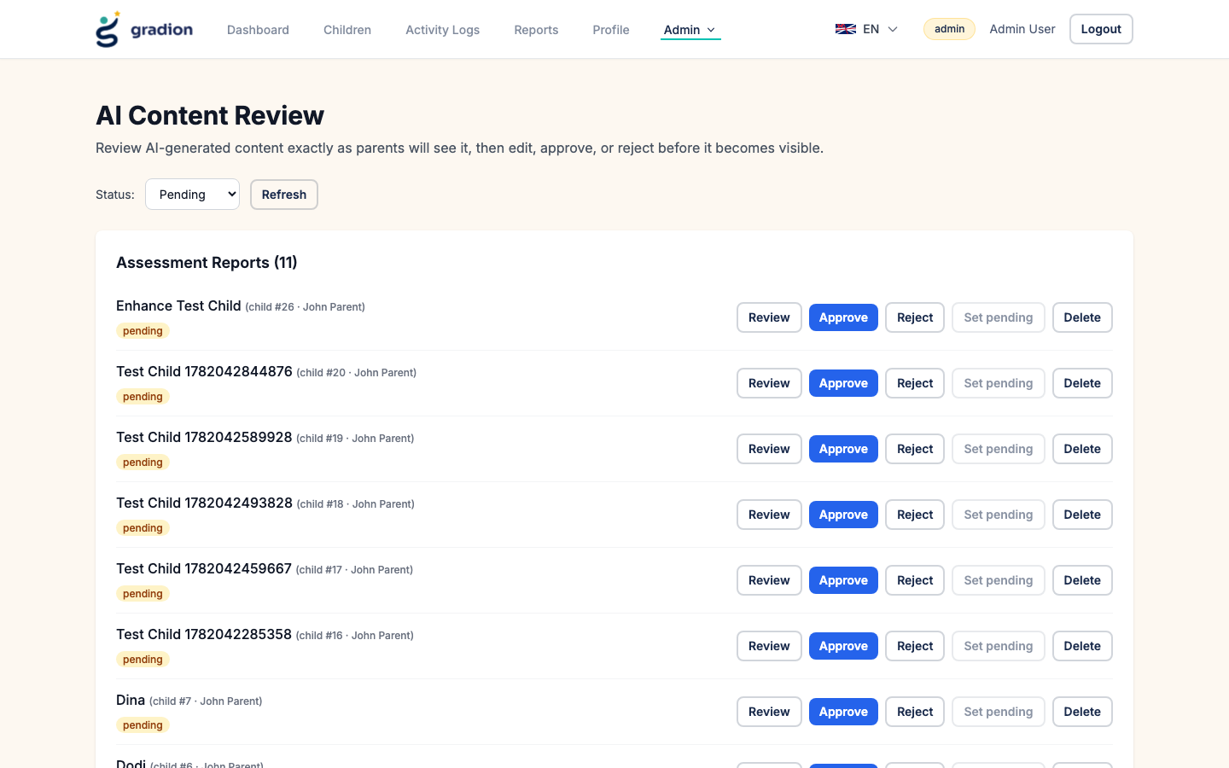
Review queue with the new Set pending action alongside Approve/Reject/Delete.
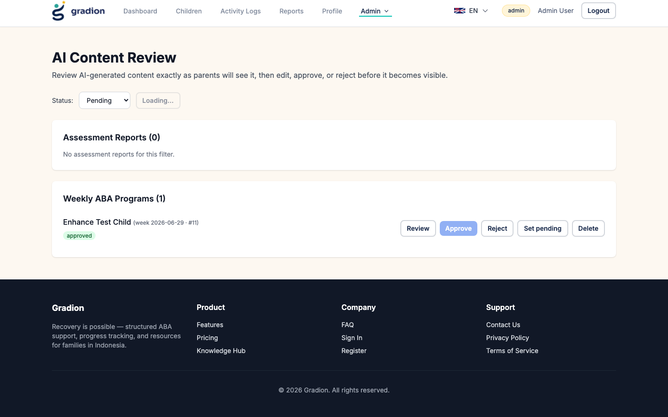
After approval, the item was reverted and appears in the Pending filter again.

7.4 Parent identity visible to admins
On the admin Dashboard (recent children) and the Children page, every child now shows the owning parent’s name and email, so admins can immediately identify the family.
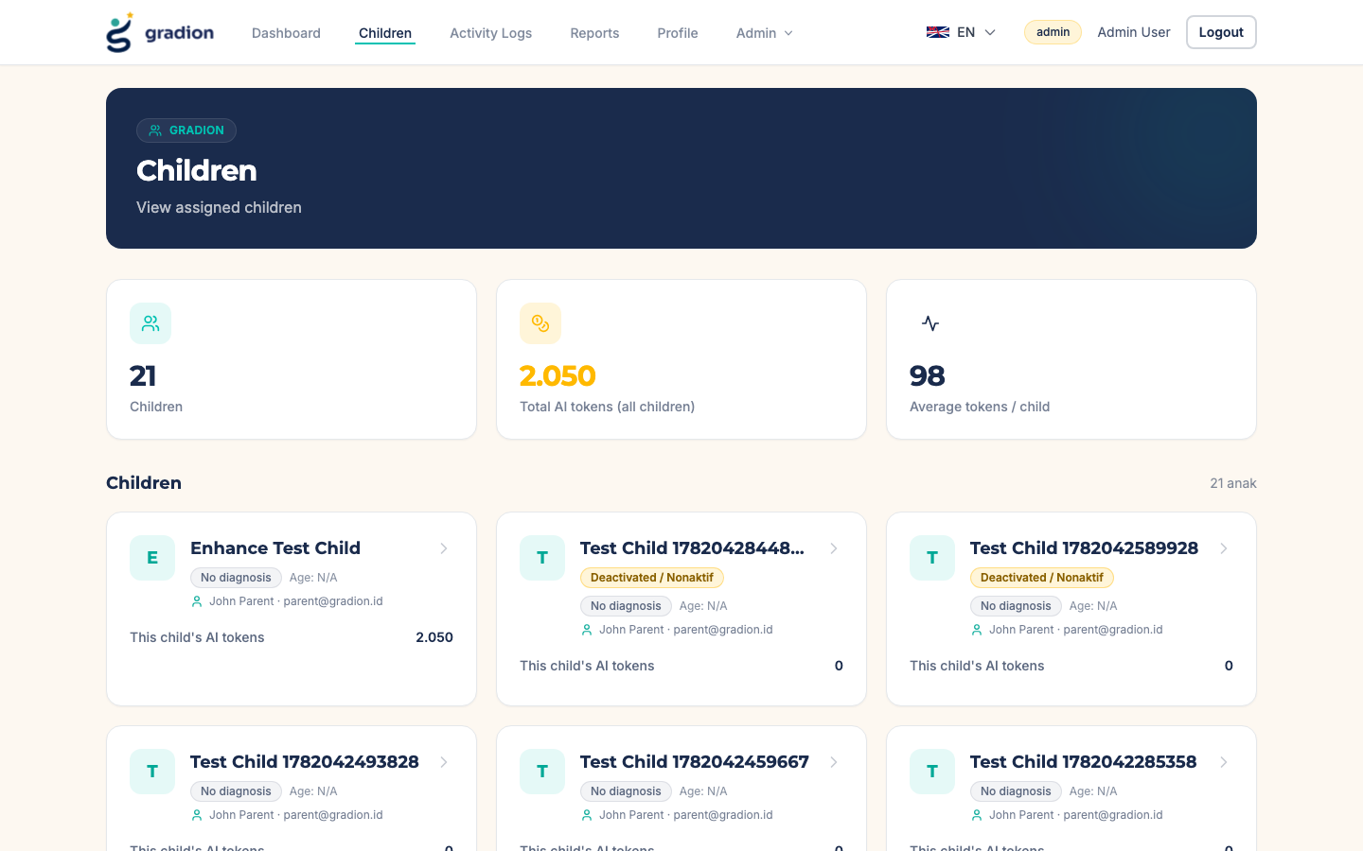
Admin children list — parent identity on every card plus per-child AI token usage.
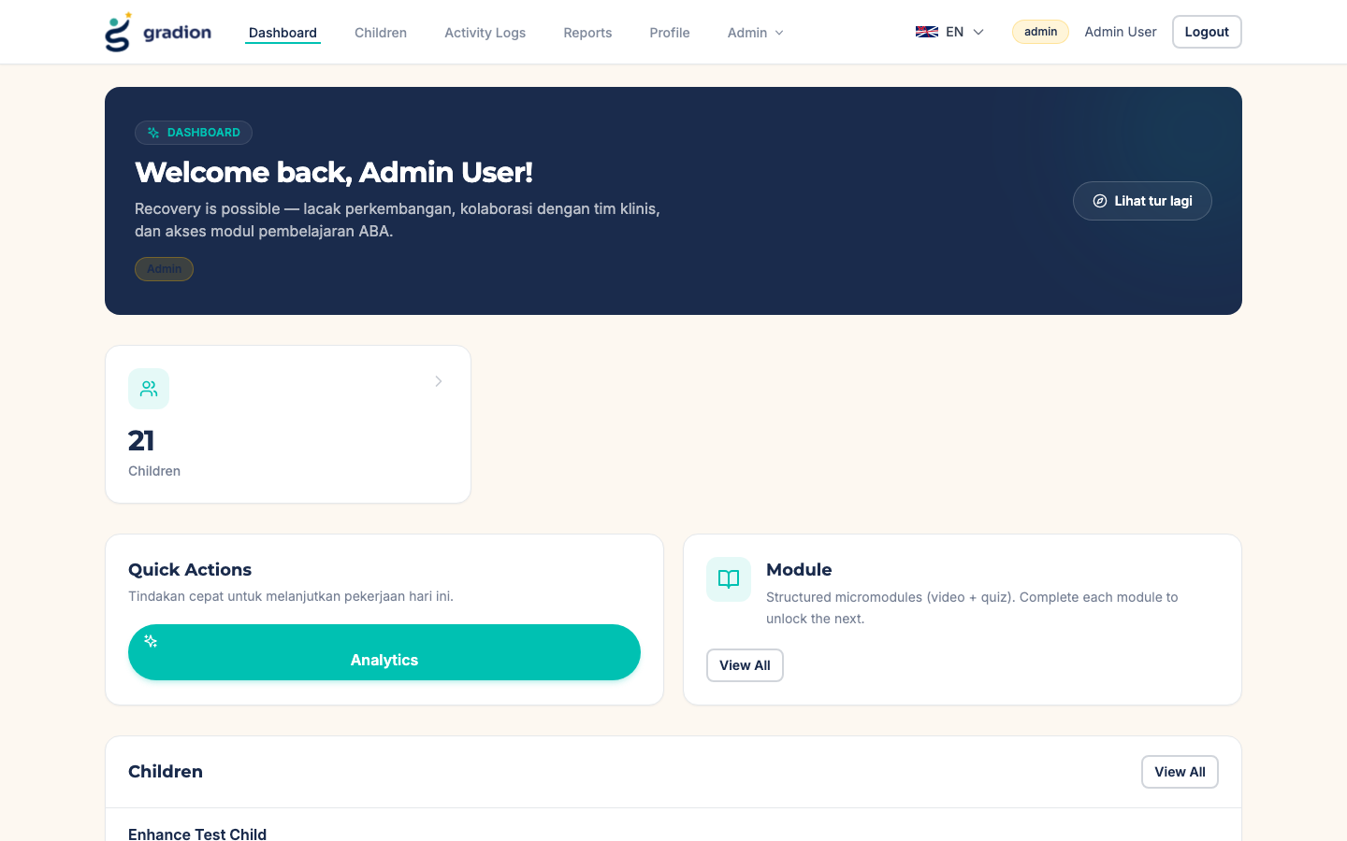
Admin dashboard — recent children annotated with the owning parent.

7.5 Token utilization: per-child ledger and consistent display
Previously every child card repeated the parent wallet’s aggregate numbers, so utilization could not be attributed to a child. A new ai_token_usage_logs ledger (migration 20260704150000_add_ai_token_usage_log, backfilled from report summaries and video jobs) records every AI spend with its child and feature. All seven AI features now log per-child usage (initial assessment, translation, weekly program, program translation, therapy-notes OCR, report summary, video fidelity).
- Children list (parent): each card shows THAT child’s tokens against the wallet limit; the summary cards keep wallet totals.
- Children list (admin/staff): summary cards show the total and average across listed children instead of the viewer’s own irrelevant wallet; each card shows the child’s own usage.
- Child Detail: a new "AI tokens (this child)" stat card shows the child’s lifetime usage.
- Profile & admin analytics already used wallet/plan aggregates consistently and were left unchanged.
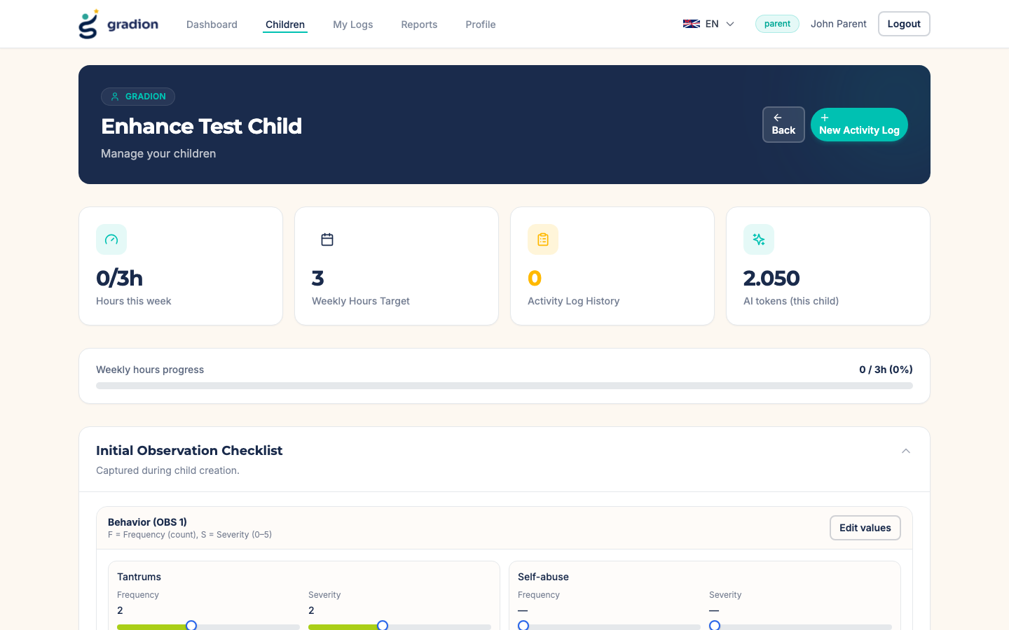
Child Detail — new per-child AI token stat card (2,050 tokens for this child).
Generated on July 4, 2026 — all tests executed against the local Docker environment.

