**Phase II: *Entity-Relationship Diagram Design and User Interface Design***

**Online Movie Retail System**

­­

**TABLE OF CONTENTS**

ER Diagram…………………..............................................................3

Explanation of ER Diagram……………………………………………..4

Overview and Introduction of ideas……….……………….…..…..…..8

User Interface Flow…………………………………………………..…..9

User Interface Design with comments…………………………..……..10

**ERDiagram**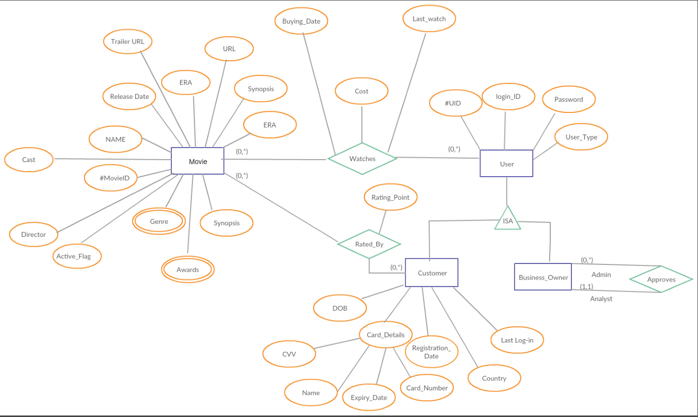

**Entities And Attributes Identified:**

1. Movie

* #MovieID(Primary key)
* Name
* Cast
* ERA
* URL
* Synopsis
* Trailer URL
* Director
* Active_Flag
* Release_Date
* Genre
* Awards

Movie Entity has #MovieID as the primary key, which uniquely identifies a movie. The attributes Genre and Awards are multivalued attributes.

1. User

* #UID(Primary key)
* Login_ID
* User_type
* Password

User Entity has #UID number as the primary attribute.

1. Customer

* #UID(Primary key)
* DOB
* Registration_Date
* Country
* Last Log_in
* Card_Details
  + CVV
  + Name
  + Expiry_Date
  + Card_Number

1. Business Owner

Roles:

* Analyst
* Admin

Every entity of Customer and Business Owner is also considered in User Entity, so they form an ISA hierarchy.

**Relationships and Cardinalities:**

1. Watches:

“Movie” entity and “User” entity participate in a watches relationship.

The Relation itself has the following attributes:

* Buying_date
* Cost
* Last_watch

Since one or more user can watch one or more movies, its cardinality is many to many.

Min-Max notation: (0,*) --------- (0,*)

1. Rated_By

“Customer” can rate movies according to their choices. This is shown via a Rated_By relationship.

Rated_By has the following attribute:

* Rating_Point

Since one or more Customer can rate one or movies, its cardinality is many to many.

Min-Max notation: (0,*) --------- (0,*)

2) Approves

Business_Owner Entity relates to itself and participates in a recursive relationship.

There are two types of roles that it has:

* Admin
* Analyst

The Business_Owner can analyze the sales data based on the purchase records for movies. He can also analyze trends such as: which movies are more popular, which age group makes the most purchases etc.

Based on these analyses the Business_Owner also serves the position of Admin to add and delete movies based on the analysis.

When any business user registers, it has to be approved by Admin to further log-in to the system.

Since we will have only one Admin user who will be approving registration request of 1 or many business users, the cardinality is one to many.

Min-Max notation: (0,*) --------- (1, 1)

**Overview/Idea of Interface:**

User View

In this Movie Rental site, the users can visit the site and search for movies and apply advanced search filters. If the user need to rent a movie, then he/she needs to log in (if an existing user) or sign up otherwise.

In the “Default search” and “Advanced search” are two search options that available to the user. Based on the need, the user can choose to use the required search option.

Based on search input, the site fetches many search results. On further selection, it leads to the “Movie” page from where movie details can be seen and movie can be rented.

For renting, the user is redirected to payment page where he/she makes the payment for all the movies selected.

Business View

The Business Owner has a separate log in from where he/she can analyze the sales and purchases.

He/She can choose filters to view different types of data results.

Based on the results the business owner can choose to add or delete movies.

**User Interface Flow:**

**User Interface Design:**

1. Welcome Screen

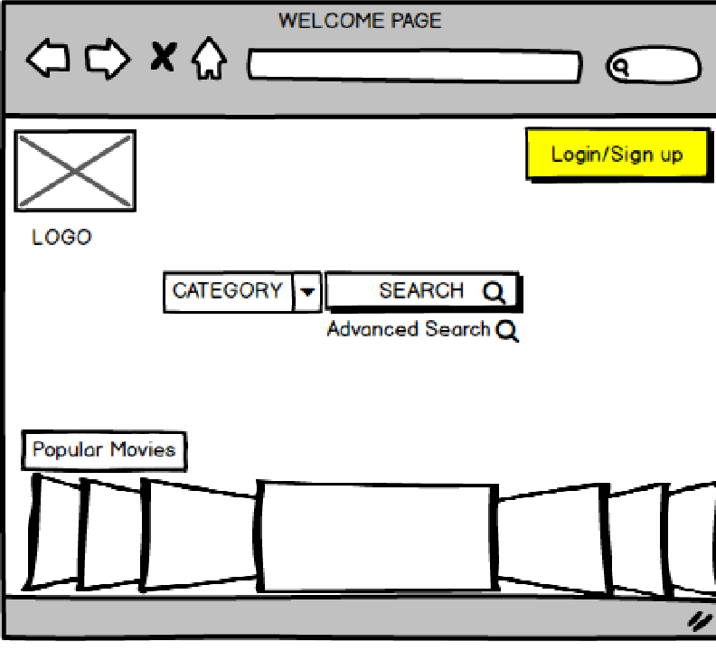

The yellow highlighted area indicates how the successive pages are linked.

1. Sign up Page

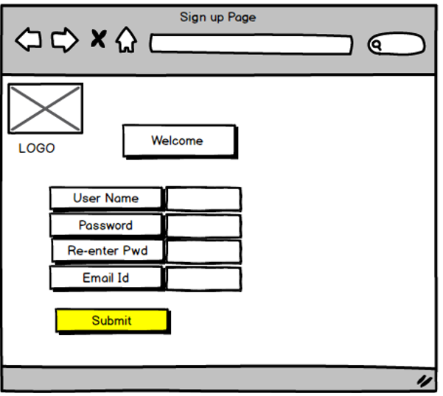

New users can fill their details and sign up.

1. User Log in Page

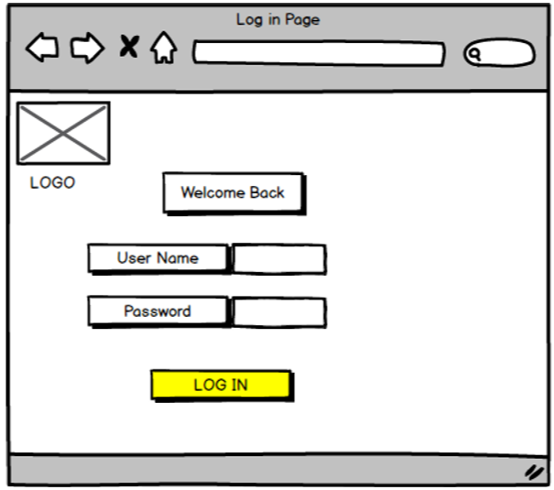

Once new users have signed up, they can log and rent movies and

give movie rating.

1. User Logged in Page

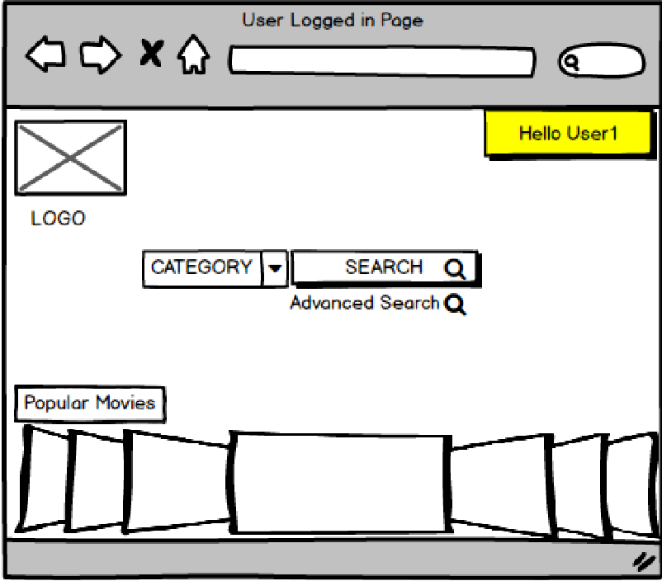

The user sees this page after logging in. Non users can also perform search operations but cannot rent movies without logging in.

1. User Logged Search Page

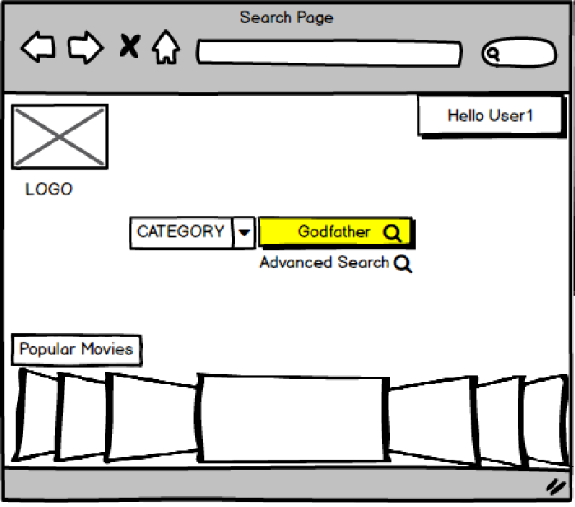

User can enter generalized search requests in the highlighted search bar.

1. Search Result

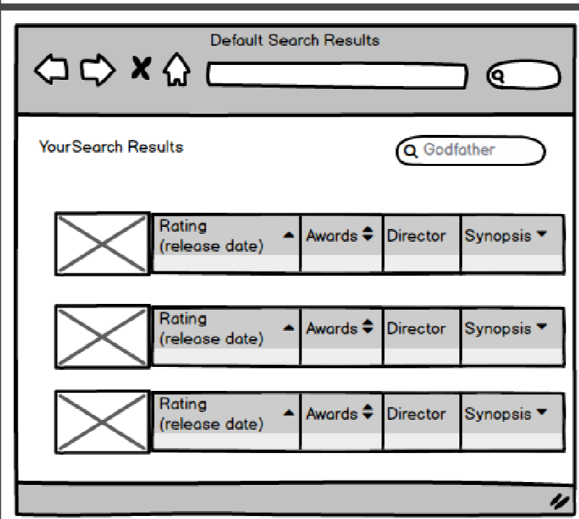

The search results gives the list of movies matching the search key. A detailed view can be obtained by expanding the required result.

1. Advanced Search

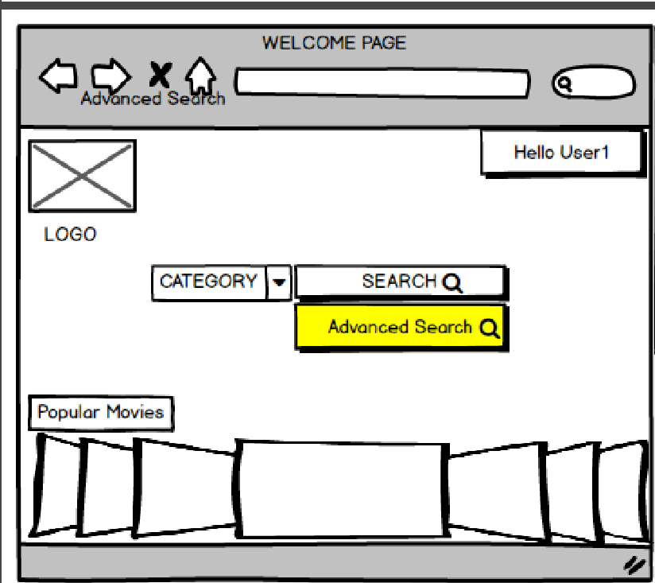

Advanced Search option enables the user to carry out more detailed search based on various filters.

1. Advanced Search Result

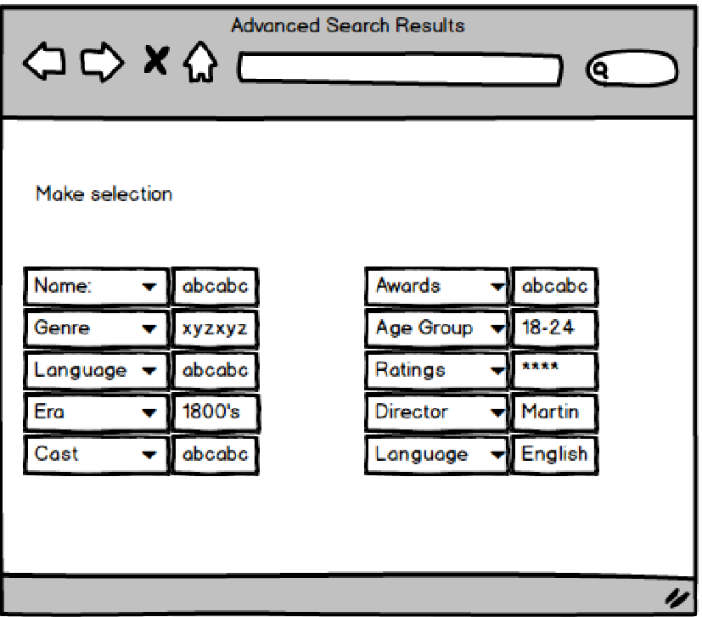

The above is a tentative list of filters we plan to provide. Based on utility and feasibility, further filters may be added/removed.

1. Movie Page

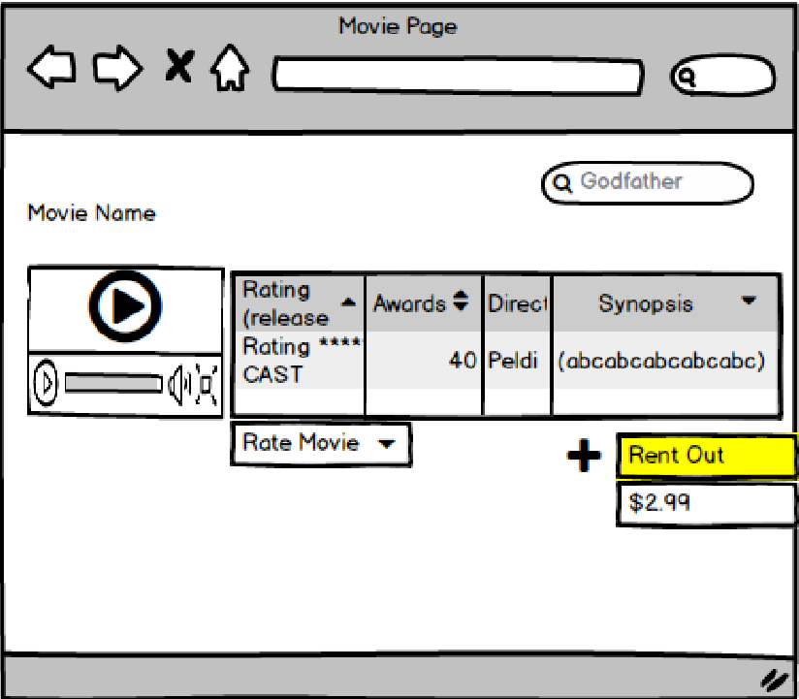

This page is obtained after the user selects a particular movie. (Either from Page 4 or results of Page 6). It gives a detailed view of the movie along with the option to rent and provide movie rating.

1. Payment Page

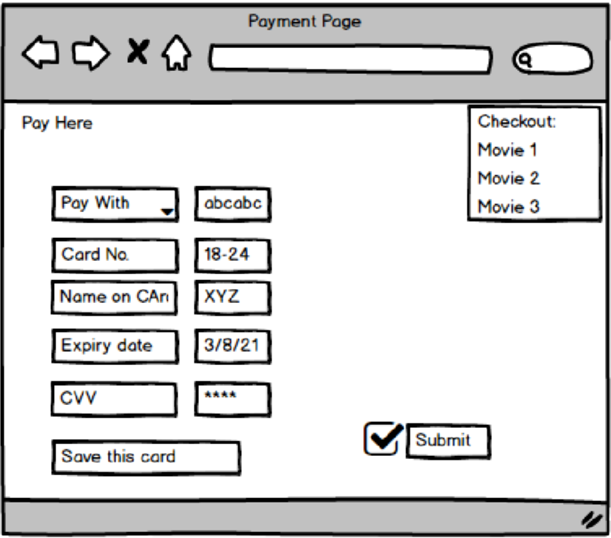

Once the user selects the movie for renting, he/she is directed to a payment page

1. Business User Page

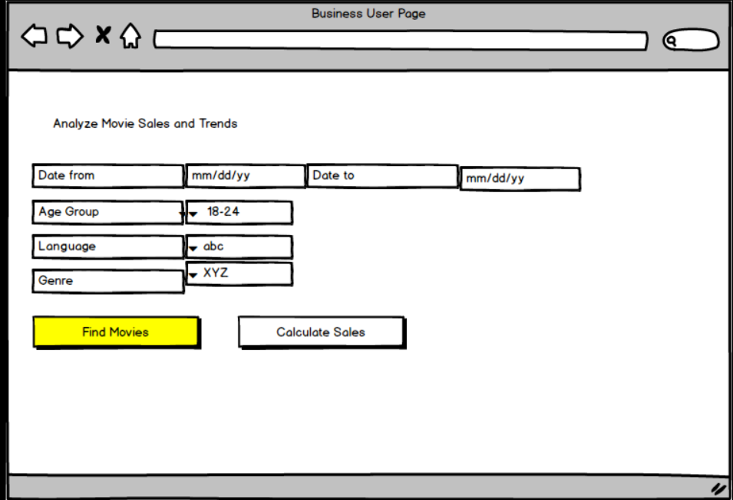

The Business owner can find the names of movies that match the required search criteria.

1. Business User Result Page

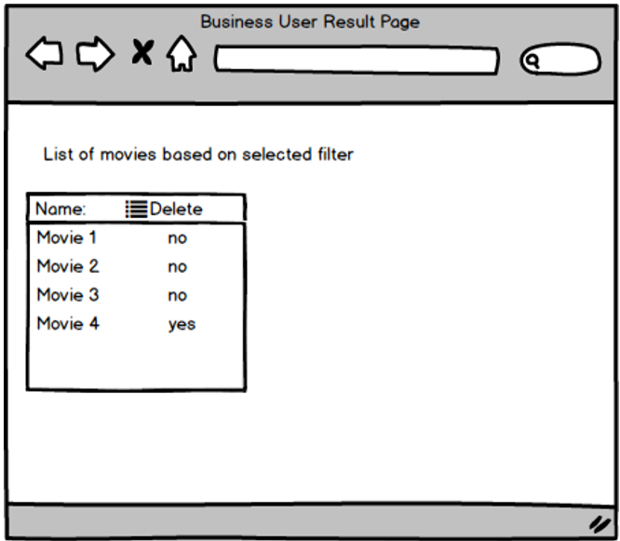

Based on the filters that the Business owner applied to find the list of movies, we get the above result.

1. Business User Page

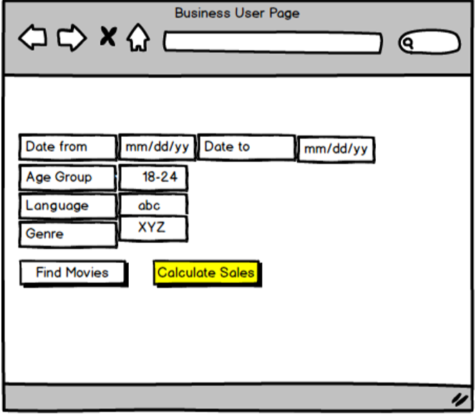

Similar to finding movies option, the business owner can use the same search criteria to find the total sales.

1. Business Result Page

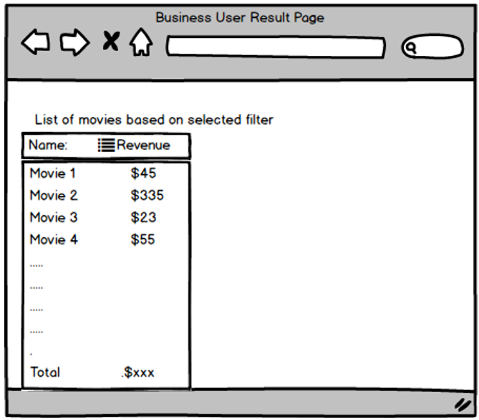

The above is the sales result based on the search criteria filled by business owner.