CST 370 Design and Analysis of Algorithms

SP’20 (Final Exam)

Name: ______jerry kankelborg_________________________

Four-digits ID: _______8404____________________

"On my honor, I have neither given nor received unauthorized aid in doing this assignment."

Signature [Type Your Name] ________ jerry kankelborg ____________

- Do not start until told to do so.
- Look over all the questions and observe their point values before you start.
- Use your time wisely—make sure to answer the questions you know first.
- Read the questions carefully.

1. (2 points) (a) Assume that Dr. Byun assigned a programming project which requires the time complexity of O(n²). If your program’s basic operation runs (2*n*logn + 25) times, can you say that your program meets the project requirement? (Yes/No).

(b) Consider the following algorithm.
- Algorithm Mystery(n)
- // Input: A nonnegative integer n
- S ← 0
- for i ← 1 to n do
- k ← i * i
- S ← S + k
- return S

Present the time complexity of the algorithm using the Θ notation. If you can’t represent it using the Θ notation, indicate it clearly.



2. (1 point) Let T(n) = 2*n + 3. Which of the following statements are true? (Choose all that apply.)
- T(n) = O(n)
- T(n) = Ω(n)
- T(n) = Θ(n²)
- T(n) = O(n³)

3. (2 points) (a) Is the following graph a DAG (= directed acyclic graph)? (Yes/No)

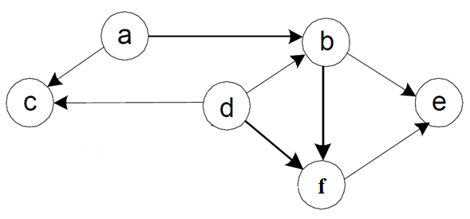


(b) Is this an AVL tree? (Yes/ No)

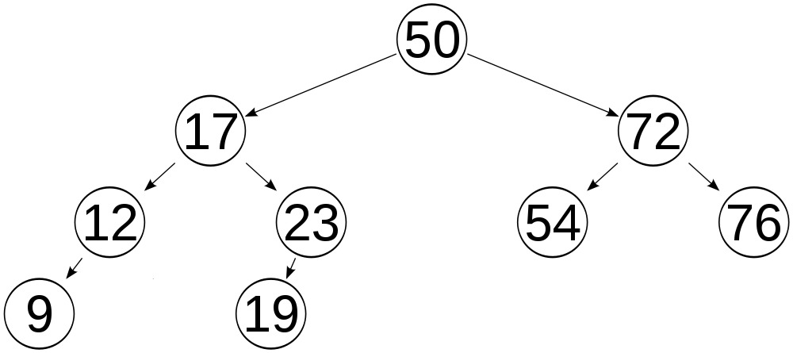

[Note] Before solving the problem 4, read the following description carefully.
In the problem 4, you have to present the result trees in the level-by-level order. This is an example of level-by-level order for a sample tree below. Note that the root value 50 is the level 0. Then, its children (= 30 and 70) should be the level 1. Also, because there’s no value in the level 4 and 5, we use “NONE” to indicate them.

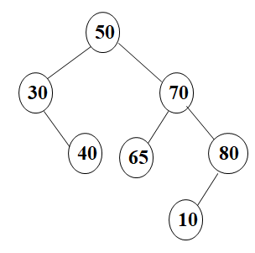
A Sample Tree

Level 0 | 50
Level 1 | 30, 70
Level 2 | 40, 65, 80
Level 3 | 10
Level 4 | NONE
Level 5 | NONE

Level-By-Level Order

4. (3 points) Consider a binary tree with ten nodes with the values 0, 1, …, 9 in such a way that the inorder and postorder traversals of the tree yield the following lists:

9, 1, 4, 0, 3, 6, 7, 5, 8, 2 (postorder)
9, 3, 1, 0, 4, 2, 7, 6, 8, 5 (inorder)

Note that the problem is asking to consider only one binary tree. For the problem, do not draw the result in the word file. Instead, write the values of the result tree level-by-level order.
If you think that it’s not possible to have a binary tree with the given information, explain why.

Level 0 | 2
Level 1 | 3, 8
Level 2 | 9, 0, 6, 5
Level 3 | 1, 4, 7
Level 4 | NONE

5. (5 points) Assume that you have five different data structures like below. In each data structure, there are n integer numbers and want to check if a specific number exists or not. In other words, you want to search a number in the data structure.
Write the worst case time complexity of the search operation in each data structure using the O notation.

Sorted array | O(n)
Unsorted singly linked list | O(n)
Binary search tree | O(n)
AVL tree | O(log(n))
Hashing (Linear Probing) | O(n)

6. (5 points) Assume that you conduct the linear probing with the hash function h(K) = K mod 5. This is the initial hash table for the problem. Note that the status ‘E’ indicates “Empty”.

Index | Content | Status
0 |  | E
1 |  | E
2 |  | E
3 |  | E
4 |  | E

Assume that you conduct the following six operations. Note that the load factor of the hashing for this problem is 0.5.

- insert 2
- insert 12
- insert 22
- insert 30
- delete 12
- insert 25

(a) Present the hash table size after finishing the six operations: _______4______

(b) This is a part of the hash table after finishing the six operations. Fill out it. For the status, use “E” for “Empty”, “A” for “Active”, and “D” for “Deleted”.

Index | Content | Status
0 | 25 | A
1 | 22 | A
2 | 12 | A
3 | 30 | A

7. (4 points) Assume that you use the Warshall’s algorithm to find the transitive closure of the following graph. For your understanding, R⁽⁰⁾ is already provided. Present R⁽¹⁾ and R⁽²⁾. Note that you don’t need to present and R⁽³⁾ and R⁽⁴⁾ for the problem.
1
2
3
4

 |  | 1 | 2 | 3 | 4
R⁽⁰⁾ = | 1 | 0 | 1 | 0 | 0
 | 2 | 0 | 0 | 0 | 1
 | 3 | 0 | 0 | 0 | 0
 | 4 | 1 | 0 | 1 | 0

 |  | 1 | 2 | 3 | 4
R⁽¹⁾ = | 1 | 0 | 1 | 0 | 0
 | 2 | 0 | 0 | 0 | 1
 | 3 | 0 | 1 | 0 | 0
 | 4 | 1 | 1 | 1 | 0

 |  | 1 | 2 | 3 | 4
R⁽²⁾ = | 1 | 0 | 1 | 1 | 1
 | 2 | 0 | 0 | 0 | 1
 | 3 | 1 | 1 | 0 | 1
 | 4 | 1 | 1 | 1 | 0

8. (2 points) (a) Assume that you should give 48 cents to a customer. How would you give the changes with the least number of coins? Choose the correct algorithm technique. ________
- Brute force algorithm
- Divide and conquer algorithm
- Dynamic programming algorithm
- Greedy algorithm


(b) Greedy algorithms always provide optimal solutions to their problems. (true / false)

9. (5 points) Assume that you are going to solve the minimum spanning tree (MST) using the Prim’s algorithm. Note that you start from the vertex c for the problem, and it is good enough for you to present first three steps (= three rows of the table). Again, you should pay attention that the starting vertex is “c”, not “a”.
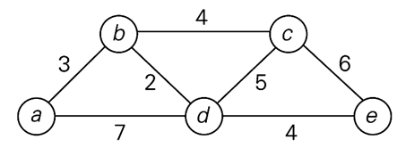

Vertex Visited | Remaining Vertexes
a(-,-) | b(a,3), c(-, infinity), d(a, 7), e(-, infinity)
b(a,3) | c(b,4), d(b,2), e(-, infinity)
c(b,4) | d(c,5), e(c,6)

10. [Puzzle] (2 points) What is the minimum number of moves needed for a chess knight to go from one corner of a 100 × 100 board to the diagonally opposite corner?

Note that the knight’s moves are L-shaped: It can move two squares horizontally and one square vertically, or two squares vertically and one square horizontally in a single move. For example, let’s assume that a chess knight is in the middle square of the following board. Then, it can move to 8 different squares as the diagram indicates.

For the problem, you don’t need to present your idea. Just write the minimum number of moves.




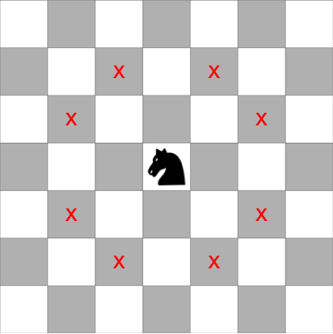

11. (3 points) Consider the following algorithm.

// Assume that n is a positive integer (= i.e. n >= 1), and A[1..n] is a global array.
// Note that the index of array A starts from one, not zero.
// And also, don’t forget the array A in the algorithm is global.

Algorithm DoSomething (n)
1. if (n = 1)
2. Print the current content of the whole array A in a single line;
3. Move the cursor to the next line.
4. else
5. for i ← 1 to n do
6. DoSomething(n – 1); // Recursive call.
7. if n is odd
8. swap A[1] and A[n];
9. else
10. swap A[i] and A[n];
11. return;

(a) Present the execution result of the algorithm where an array A has “5, 7”and n is 2. Note that the sequence of output results is important. Thus, you have to describe your answer clearly.

5, 7
7, 5

(b) Present the execution result of the algorithm where an array A has “3, 5, 7”and n is 3. Note that the sequence of output results is important. Thus, you have to describe your answer clearly.

3,5,7 7,3,5

5,3,7 3,7,5

5,7,3
7,5,3

