CST 370 Design and Analysis of Algorithms

Spring 2020 – Quiz 5

Name: _________jerry kankelborg______________________

Four-digits ID: ______8404_____________________________

"On my honor, I have neither given nor received unauthorized aid in doing this assignment."

Signature _________jerry_ kankelborg ________

- Do not start until told to do so.
- Look over all the questions and observe their point values before you start.
- Use your time wisely—make sure to answer the questions you know first.
- Read the questions carefully.

1. (2 points) Consider the following binary tree. Present the sequences of in-order and post-order traversals.

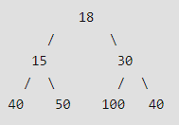

In-order: ____40, 15, 50, 18, 100, 30, 40_________________________

Post-order: ____40, 50, 15, 100, 40, 30, 18________________________

2. (1 point) (a) Is the following graph a DAG? (Yes/No)

0

1
2
3

(b) Is the following graph a DAG? (Yes/No)

0
2
1


3. (2 points) For the following graph, you are going to conduct the topological sorting.

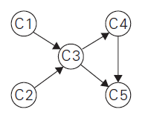

(a) Present the starting node(s) for the topological sorting.



(b) Conduct the topological sorting using the DFS algorithm. Then, present the topological order as we discussed in the class. For the problem, you have to follow our convention of alphabetical order.

Topological Order: ___C2, C1, C3, C4, C5___________________________

