**Newcomer to Chicago**

Chicago is the third largest city in the United States, with a population of nearly 3 million with more than 100 neighborhoods. It’s a vibrant multicultural cosmopolitan city of the North America.

New listings are harder to find and potential homebuyers want to know what's best area to live and grow your family. Finding a new home can be challenging for newcomers based as there are a number of neighborhoods to choose from. All the potential newcomers would be interested in knowing this information. The map below shows the different neighborhoods of Chicago area.

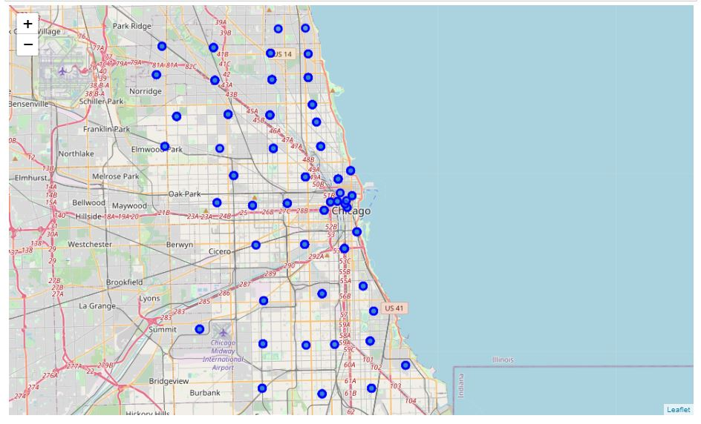

**Data Gathering:**

To get more insights to get meaningful information, we would used the data from Chicago neighborhood by zip code form the following link:

<https://www.dreamtown.com/maps/chicago-zipcode-map>

The geolocation data for the US zip code was found from the following link:

<https://public.opendatasoft.com/explore/dataset/us-zip-code-latitude-and-longitude/table/>

Both these datasets were merged to use for in our project.

Also, we used foursquare data to get places of interest in each neighborhood area.

**Methodology:**

The data was formatted and cleaned using pandas library. Using foursquare we found the places of interest in each neighborhood area. The dataset was merged with the Chicago area neighborhood data Then using k-clusters, the data was divided into 5 clusters of neighborhoods based on the places of interest which is shown in the figure below:

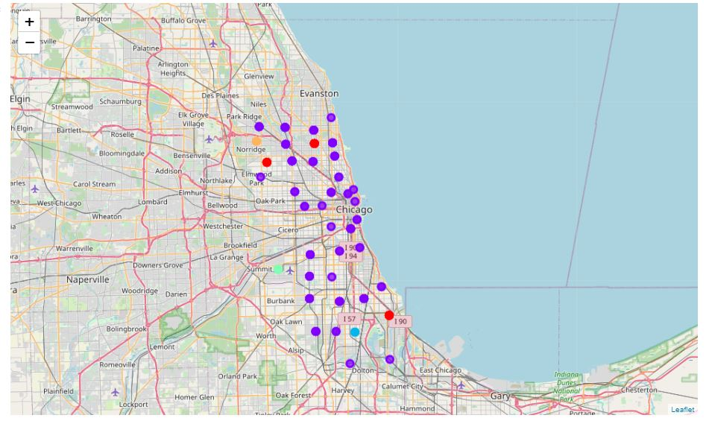

Each cluster was examined with the 10 most common places of interest. The clustered data set were as follows:

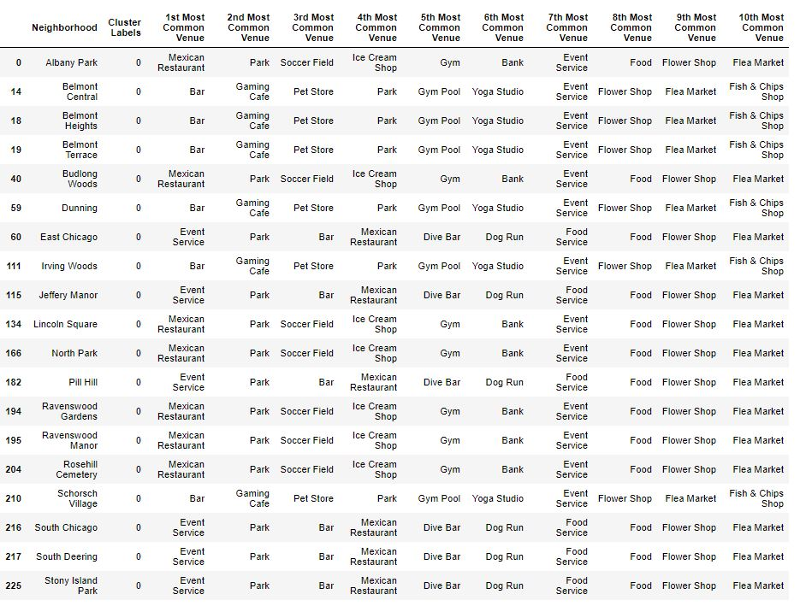

**Cluster 1**

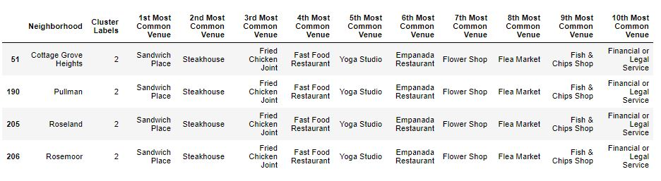

**Cluster 3**

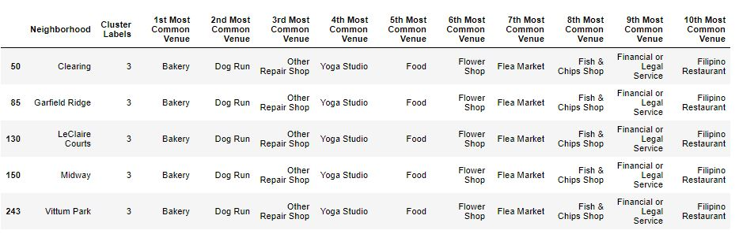

**Cluster 4**

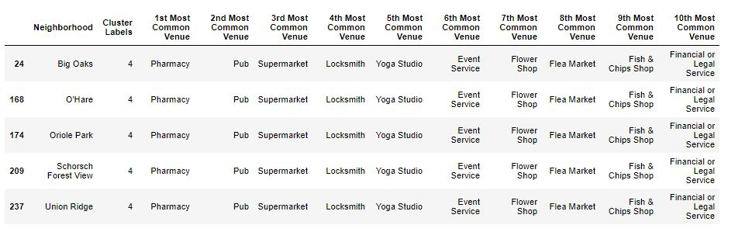

**Cluster 5**

**Conclusion:**

Upon examining these clusters, we concluded that the cluster 1 consists of some best neighborhoods to choose from, if looking for nearby restaurants, parks and recreation and would be best suitable to live.