Web编程实践实验报告

实验三 数组
学号： 姓名： 教师评分：

一、实验目的
（1）熟悉JavaScript中数组的概念
（2）掌握数组的创建，赋值，遍历等数组操作
（3）掌握数组中常用的属性和方法掌握。
二、实验环境
微机+Window操作系统+浏览器+ 网页编辑器
三、实验重点及难点
数组的访问与遍历、二维数组的创建与遍历、数组栈方法、数组检索方法。
四、预习内容及要求
（1）数组的创建：
使用Array对象创建数组，使用[]创建数组；
（2）数组的基本操作：
数组长度属性length；
数组的遍历：for( )循环，for(...in...)，for(...of...)；
数组元素的增加，修改，删除；
（3）多维数组的创建与遍历：
双重或多重循环；
（4）数组排序
（5）常见的数组方法：push( ),unshift( ),pop( ),shift( )......
五、实验内容
1. 编写网页sy3-1.html，存放5门成绩。统计成绩最大值和最小值。效果如图3-1所示。
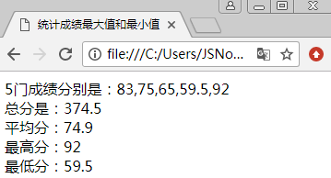
图3-1 计算结果展示
具体实现步骤如下：
- 定义一个数组arr，存放5门成绩。
- 定义总分变量sum=0。
- 定义最高分变量max=0。
- 定义最低分变量min=100。
- for循环遍历数组arr。
- 输出5门课程课程的成绩、最高分、最低分、总分和平均分。
代码：（将代码粘贴到空行位置）
<!DOCTYPE html>
<html lang="en">
<head>
<meta charset="UTF-8">
<title>Title</title>
</head>
<body>
<script>
var arr=[80,90,85,70,60];
var sum=0;
var max=0;
var min=100;
for(var i=0;i<arr.length;i++){
sum+=arr[i];
if(arr[i]>max){
max=arr[i];
}
if(arr[i]<min){
min=arr[i];
}
}
console.log("5门课程的成绩："+arr);
console.log("最高分："+max);
console.log("最低分："+min);
console.log("总分："+sum);
console.log("平均分："+sum/arr.length);
</script>
</body>
</html>

页面效果图：（将截图粘贴到空行位置）
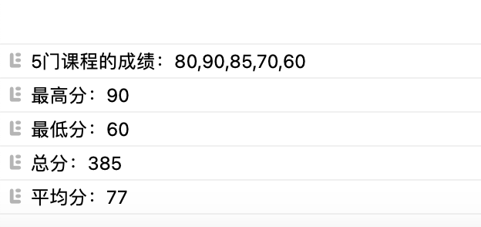
2. 编写网页sy3-2.html，上机验证答案，并将结题填写在括号内。
var arr=[ "apple","plum","banana" ];
document.write ( arr.unshift("orange","lemon" )); //结果显示：（ 5 ）
document.write("<br>");
document.write ( arr.push("pear","mango")); //结果显示：（ 7 ）
document.write("<br>");
document.write ( arr.pop( )); /结果显示：（ mango ）
document.write("<br>");
document.write ( arr.shift( )); //结果显示：（ orange ）
document.write("<br>");

页面效果图：（将截图粘贴到空行位置）
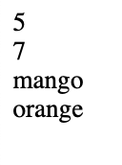
分析原因：（根据运行的结果在空行位置填写原因，即方法的功能）
unshift: 这个方法用于在数组的开头添加一个或多个元素，并返回新的数组长度。在这个例子中，"orange"和"lemon"被添加到数组的开头，所以新的数组长度是5。
push: 这个方法用于在数组的末尾添加一个或多个元素，并返回新的数组长度。在这个例子中，"pear"和"mango"被添加到数组的末尾，所以新的数组长度是7。
pop: 这个方法用于删除并返回数组的最后一个元素。在这个例子中，"mango"是数组的最后一个元素，所以它被删除并返回。
shift: 这个方法用于删除并返回数组的第一个元素。在这个例子中，"orange"是数组的第一个元素，所以它被删除并返回。

3. 编写网页sy3-3.html，上机验证答案，并将结题填写在括号内。
var arr=["lemon","apple","watermelon","fig","pear"];
document.write("<br>");
document.write (" 1:"+arr.sort( )); //结果显示：（1:apple,fig,lemon,pear,watermelon）
document.write("<br>");
document.write (" 2:"+arr.concat("plum","banana") ); //结果显示：（2:apple,fig,lemon,pear,watermelon,plum,banana）
document.write("<br>");
document.write (" 3:"+arr); //结果显示：（3:apple,fig,lemon,pear,watermelon）
document.write("<br>");
document.write (" 4:"+arr.slice(2,4)); //结果显示：（4:lemon,pear）
document.write("<br>");
document.write (" 5:"+arr); //结果显示：（5:apple,fig,lemon,pear,watermelon）
document.write("<br>");
document.write (" 6:"+arr.join("-") ); //结果显示：（6:apple-fig-lemon-pear-watermelon）
document.write("<br>");
document.write (" 7:"+arr.indexOf("lemon") ); //结果显示：（7:2）
document.write("<br>");
document.write (" 8:"+arr.indexOf("lemon",3) ); //结果显示：（8:-1）

页面效果图：（将截图粘贴到空行位置）
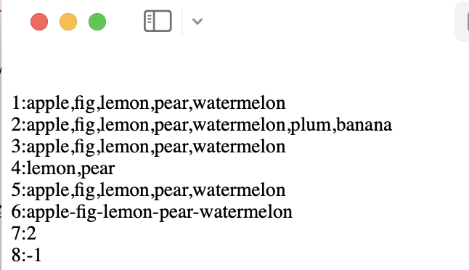
分析原因：（根据运行的结果在空行位置填写原因，即方法的功能）
sort: 这个方法用于对数组的元素进行排序。默认的排序顺序是根据字符串Unicode码点。在这个例子中，数组的元素被按照字母顺序排序。
concat: 这个方法用于合并两个或更多数组。这个方法不会改变现有的数组，而是返回一个新数组。在这个例子中，"plum"和"banana"被添加到原始数组的末尾，形成新的数组。
输出 arr：因为 concat 方法不改变原数组，所以此时的 arr 还是排序后的结果。
slice: 这个方法返回一个新的数组，包含从开始到结束（不包括结束）的选择的数组的一部分深拷贝到新数组对象。原始数组不会被改变。在这个例子中，它返回从索引2到索引4（不包括索引4）的元素，即"lemon"和"pear"。
再次输出 arr：因为 slice 方法不改变原数组，所以此时的 arr 还是排序后的结果。
join: 这个方法用于把数组中的所有元素放入一个字符串。元素通过指定的分隔符进行分隔。在这个例子中，数组的元素被"-"连接成一个字符串。
indexOf: 这个方法返回在数组中可以找到一个给定元素的第一个索引，如果不存在，则返回-1。在这个例子中，"lemon"的索引是2。
indexOf with start index: 当提供第二个参数时，搜索会从该索引开始。在这个例子中，从索引3开始搜索"lemon"，因为"lemon"在索引3之后不存在，所以返回-1。

4. 编写网页sy3-4.html，利用indexOf( )函数统计数组arr中元素d出现的次数，并同时返回其对应的所有下标。
- 效果如图3-2所示。
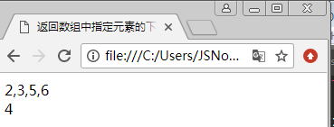
图3-2 返回所有d的坐标和出现的次数

- 具体实现步骤如下：
- 定义一个数组arr，存放数组元素['a','b','d','d','c','d','d']。
- 检索数组，在页面中输出d元素出现的索引下标和出现次数。
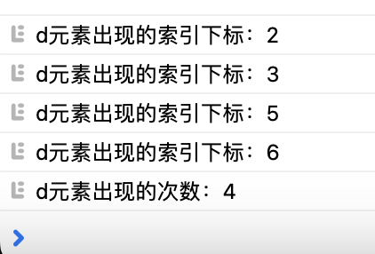
<!DOCTYPE html>
<html lang="en">
<head>
<meta charset="UTF-8">
<title>Title</title>
</head>
<body>
<script>
var arr=['a','b','d','d','c','d','d'];
var index=arr.indexOf('d');
var count=0;
while(index!=-1){
console.log("d元素出现的索引下标："+index);
count++;
index=arr.indexOf('d',index+1);
}
console.log("d元素出现的次数："+count);
</script>
</body>
</html>

5. 编写网页sy3-5.html，移出数组arr([1,2,3,4,2,5,6,2,7,2])中与2相等的元素，并生成一个新数组，不改变原数组，在控制台输出新数组。
代码：（将代码粘贴到空行位置）
<!DOCTYPE html>
<html lang="en">
<head>
<meta charset="UTF-8">
<title>Title</title>
</head>
<body>
<script>
var arr=[1,2,3,4,2,5,6,2,7,2];
var newArr=[];
for(var i=0;i<arr.length;i++){
if(arr[i]!=2){
newArr.push(arr[i]);
}
}
console.log(newArr);
</script>
</body>
</html>

页面效果图：（将截图粘贴到空行位置）
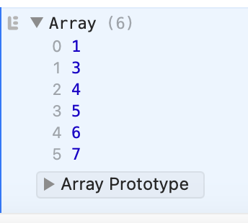
6. 编写网页sy3-6.html，已知一个字符串数组，求字符串数组中每一个元素的长度，存储到一个新的数组中。
效果如图3-6所示。
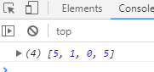
元素个数
具体实现步骤如下：
- 定义一个数组array，存放字符串元素。
- 定义个新数组newArray，用来存放字符串长度。
- for循环遍历array数组，并把每一项元素的长度赋值给newArray。
- 输出newArray新数组。
代码：（将代码粘贴到空行位置）
<!DOCTYPE html>
<html lang="en">
<head>
<meta charset="UTF-8">
<title>Title</title>
</head>
<body>
<script>
var array=["lemon","apple","watermelon","fig","pear"];
var newArray=[];
for(var i=0;i<array.length;i++){
newArray.push(array[i].length);
}
console.log(newArray);
</script>
</body>
</html>

运行结果图：（将截图粘贴到空行位置）
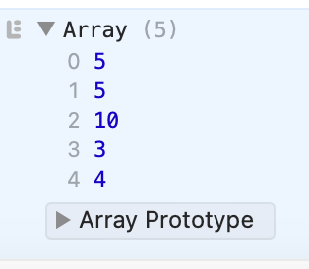

7. 编写网页sy3-7.html，实现二级联动菜单。效果如图3-3所示。
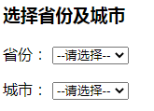
图3-3 二级联动菜单

代码：（将代码粘贴到空行位置）
<!DOCTYPE html>
<html>
<head>
<meta charset="UTF-8">
<title>省份城市的二级联动</title>
</head>
<body>
<h2>选择省份及城市</h2>
<form>
省份：<select id="province">
<option value="-1">请选择</option>
</select><br><br>
城市：<select id="city">
<option value="-1">请选择</option>
</select>
</form>
<script>
var province = document.getElementById("province");
var city = document.getElementById("city");
var provinceArr = ["广东省","广西省","湖南省","湖北省","河南省","河北省","山东省","山西省","陕西省","四川省","贵州省","云南省","甘肃省","青海省","江苏省","浙江省","安徽省","江西省","福建省","台湾省","黑龙江省","吉林省","辽宁省","内蒙古","新疆","西藏","宁夏","广东省","广西省","湖南省","湖北省","河南省","河北省","山东省","山西省","陕西省","四川省","贵州省","云南省","甘肃省","青海省","江苏省","浙江省","安徽省","江西省","福建省","台湾省","黑龙江省","吉林省","辽宁省","内蒙古","新疆","西藏","宁夏","澳门","香港"];
var cityArr = [
["珠海市","广州市","深圳市","汕头市","韶关市","佛山市","江门市","湛江市","茂名市","肇庆市","惠州市","梅州市","汕尾市","河源市","阳江市","清远市","东莞市","中山市","潮州市","揭阳市","云浮市"],
["南宁市","柳州市","桂林市","梧州市","北海市","防城港市","钦州市","贵港市","玉林市","百色市","贺州市","河池市","来宾市","崇左市"],
["长沙市","株洲市","湘潭市","衡阳市","邵阳市","岳阳市","常德市","张家界市","益阳市","郴州市","永州市","怀化市","娄底市","湘西土家族苗族自治州"],
["武汉市","黄石市","十堰市","宜昌市","襄阳市","鄂州市","荆门市","孝感市","荆州市","黄冈市","咸宁市","随州市","恩施土家族苗族自治州"],
["郑州市","开封市","洛阳市","平顶山市","安阳市","鹤壁市","新乡市","焦作市","濮阳市","许昌市","漯河市","三门峡市","南阳市","商丘市","信阳市","周口市","驻马店市"],
["石家庄市","唐山市","秦皇岛市","邯郸市","邢台市","保定市","张家口市","承德市","沧州市","廊坊市","衡水市"],
["济南市","青岛市","淄博市","枣庄市","东营市","烟台市","潍坊市","济宁市","泰安市","威海市","日照市","莱芜市","临沂市","德州市","聊城市","滨州市","菏泽市"],
["太原市","大同市","阳泉市","长治市","晋城市","朔州市","晋中市","运城市","忻州市","临汾市","吕梁市"],
["西安市","铜川市","宝鸡市","咸阳市","渭南市","延安市","汉中市","榆林市","安康市","商洛市"],
["成都市","自贡市","攀枝花市","泸州市","德阳市","绵阳市","广元市","遂宁市","内江市","乐山市","南充市","眉山市","宜宾市","广安市","达州市","雅安市","巴中市","资阳市","阿坝藏族羌族自治州","甘孜藏族自治州","凉山彝族自治州"],
["贵阳市","六盘水市","遵义市","安顺市","铜仁地区","黔西南布依族苗族自治州","毕节地区","黔东南苗族侗族自治州","黔南布依族苗族自治州"],
["昆明市","曲靖市","玉溪市","保山市","昭通市","丽江市","思茅市","临沧市","楚雄彝族自治州","红河哈尼族彝族自治州","文山壮族", "苗族自治州","西双版纳傣族自治州","大理白族自治州","德宏傣族景颇族自治州","怒江傈僳族自治州","迪庆藏族自治州"],
["兰州市","嘉峪关市","金昌市","白银市","天水市","武威市","张掖市","平凉市","酒泉市","庆阳市","定西市","陇南市","临夏回族自治州","甘南藏族自治州"],
["西宁市","海东地区","海北藏族自治州","黄南藏族自治州","海南藏族自治州","果洛藏族自治州","玉树藏族自治州","海西蒙古族藏族自治州"],
["南京市","无锡市","徐州市","常州市","苏州市","南通市","连云港市","淮安市","盐城市","扬州市","镇江市","泰州市","宿迁市"],
["杭州市","宁波市","温州市","嘉兴市","湖州市","绍兴市","金华市","衢州市","舟山市","台州市","丽水市"],
["合肥市","芜湖市","蚌埠市","淮南市","马鞍山市","淮北市","铜陵市","安庆市","黄山市","滁州市","阜阳市","宿州市","六安市","亳州市","池州市","宣城市"],
["南昌市","景德镇市","萍乡市","九江市","新余市","鹰潭市","赣州市","吉安市","宜春市","抚州市","上饶市"],
["福州市","厦门市","莆田市","三明市","泉州市","漳州市","南平市","龙岩市","宁德市"],
["台北市","高雄市","基隆市","台中市","台南市","新竹市","嘉义市"],
["哈尔滨市","齐齐哈尔市","鸡西市","鹤岗市","双鸭山市","大庆市","伊春市","佳木斯市","七台河市","牡丹江市","黑河市","绥化市","大兴安岭地区"],
["长春市","吉林市","四平市","辽源市","通化市","白山市","松原市","白城市","延边朝鲜族自治州"],
["沈阳市","大连市","鞍山市","抚顺市","本溪市","丹东市","锦州市","营口市","阜新市","辽阳市","盘锦市","铁岭市","朝阳市","葫芦岛市"],
["呼和浩特市","包头市","乌海市","赤峰市","通辽市","鄂尔多斯市","呼伦贝尔市","巴彦淖尔市","乌兰察布市","兴安盟","锡林郭勒盟","阿拉善盟"],
["乌鲁木齐市","克拉玛依市","吐鲁番地区","哈密地区","昌吉回族自治州","博尔塔拉蒙古自治州","巴音郭楞蒙古自治州","阿克苏地区","克孜勒苏柯尔克孜自治州","喀什地区","和田地区","伊犁哈萨克自治州","塔城地区","阿勒泰地区","石河子市","阿拉尔市","图木舒克市","五家渠市"],
["拉萨市","昌都地区","山南地区","日喀则地区","那曲地区","阿里地区","林芝地区"],
["银川市","石嘴山市","吴忠市","固原市","中卫市"],
["澳门"],
["香港"]
];
for(var i=0;i<provinceArr.length;i++){
var option = document.createElement("option");
option.value = i;
option.innerHTML = provinceArr[i];
province.appendChild(option);
}
province.onchange = function(){
city.length = 1;
if(province.value == -1) return;
for(var i=0;i<cityArr[province.value].length;i++){
var option = document.createElement("option");
option.value = i;
option.innerHTML = cityArr[province.value][i];
city.appendChild(option);
}
}
</script>
</body>
</html>

页面效果图：（将截图粘贴到空行位置）
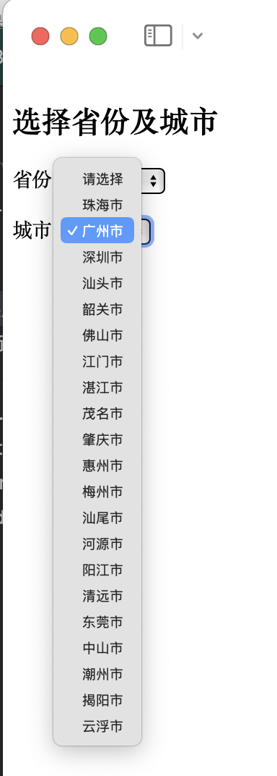
扩展题：编写网页sy3-7-2.html，实现省市县三级联动菜单。
代码：（将代码粘贴到空行位置）
<!DOCTYPE html>
<html>
<head>
<meta charset="UTF-8">
<title>省份城市的二级联动</title>
</head>
<body>
<h2>选择省份及城市</h2>
<form>
省份：<select id="province">
<option value="-1">请选择</option>
</select><br><br>
城市：<select id="city">
<option value="-1">请选择</option>
</select>
<br><br>
区县：<select id="county">
<option value="-1">请选择</option>
</select>
</form>
<script>
var province = document.getElementById("province");
var city = document.getElementById("city");
var county = document.getElementById("county");
var provinceArr = ["广东省","广西省","湖南省","湖北省","河南省","河北省","山东省","山西省","陕西省","四川省","贵州省","云南省","甘肃省","青海省","江苏省","浙江省","安徽省","江西省","福建省","台湾省","黑龙江省","吉林省","辽宁省","内蒙古","新疆","西藏","宁夏","广东省","广西省","湖南省","湖北省","河南省","河北省","山东省","山西省","陕西省","四川省","贵州省","云南省","甘肃省","青海省","江苏省","浙江省","安徽省","江西省","福建省","台湾省","黑龙江省","吉林省","辽宁省","内蒙古","新疆","西藏","宁夏","澳门","香港"];
var cityArr = [
["珠海市","广州市","深圳市","汕头市","韶关市","佛山市","江门市","湛江市","茂名市","肇庆市","惠州市","梅州市","汕尾市","河源市","阳江市","清远市","东莞市","中山市","潮州市","揭阳市","云浮市"],
["南宁市","柳州市","桂林市","梧州市","北海市","防城港市","钦州市","贵港市","玉林市","百色市","贺州市","河池市","来宾市","崇左市"],
["长沙市","株洲市","湘潭市","衡阳市","邵阳市","岳阳市","常德市","张家界市","益阳市","郴州市","永州市","怀化市","娄底市","湘西土家族苗族自治州"],
["武汉市","黄石市","十堰市","宜昌市","襄阳市","鄂州市","荆门市","孝感市","荆州市","黄冈市","咸宁市","随州市","恩施土家族苗族自治州"],
["郑州市","开封市","洛阳市","平顶山市","安阳市","鹤壁市","新乡市","焦作市","濮阳市","许昌市","漯河市","三门峡市","南阳市","商丘市","信阳市","周口市","驻马店市"],
["石家庄市","唐山市","秦皇岛市","邯郸市","邢台市","保定市","张家口市","承德市","沧州市","廊坊市","衡水市"],
["济南市","青岛市","淄博市","枣庄市","东营市","烟台市","潍坊市","济宁市","泰安市","威海市","日照市","莱芜市","临沂市","德州市","聊城市","滨州市","菏泽市"],
["太原市","大同市","阳泉市","长治市","晋城市","朔州市","晋中市","运城市","忻州市","临汾市","吕梁市"],
["西安市","铜川市","宝鸡市","咸阳市","渭南市","延安市","汉中市","榆林市","安康市","商洛市"],
["成都市","自贡市","攀枝花市","泸州市","德阳市","绵阳市","广元市","遂宁市","内江市","乐山市","南充市","眉山市","宜宾市","广安市","达州市","雅安市","巴中市","资阳市","阿坝藏族羌族自治州","甘孜藏族自治州","凉山彝族自治州"],
["贵阳市","六盘水市","遵义市","安顺市","铜仁地区","黔西南布依族苗族自治州","毕节地区","黔东南苗族侗族自治州","黔南布依族苗族自治州"],
["昆明市","曲靖市","玉溪市","保山市","昭通市","丽江市","思茅市","临沧市","楚雄彝族自治州","红河哈尼族彝族自治州","文山壮族", "苗族自治州","西双版纳傣族自治州","大理白族自治州","德宏傣族景颇族自治州","怒江傈僳族自治州","迪庆藏族自治州"],
["兰州市","嘉峪关市","金昌市","白银市","天水市","武威市","张掖市","平凉市","酒泉市","庆阳市","定西市","陇南市","临夏回族自治州","甘南藏族自治州"],
["西宁市","海东地区","海北藏族自治州","黄南藏族自治州","海南藏族自治州","果洛藏族自治州","玉树藏族自治州","海西蒙古族藏族自治州"],
["南京市","无锡市","徐州市","常州市","苏州市","南通市","连云港市","淮安市","盐城市","扬州市","镇江市","泰州市","宿迁市"],
["杭州市","宁波市","温州市","嘉兴市","湖州市","绍兴市","金华市","衢州市","舟山市","台州市","丽水市"],
["合肥市","芜湖市","蚌埠市","淮南市","马鞍山市","淮北市","铜陵市","安庆市","黄山市","滁州市","阜阳市","宿州市","六安市","亳州市","池州市","宣城市"],
["南昌市","景德镇市","萍乡市","九江市","新余市","鹰潭市","赣州市","吉安市","宜春市","抚州市","上饶市"],
["福州市","厦门市","莆田市","三明市","泉州市","漳州市","南平市","龙岩市","宁德市"],
["台北市","高雄市","基隆市","台中市","台南市","新竹市","嘉义市"],
["哈尔滨市","齐齐哈尔市","鸡西市","鹤岗市","双鸭山市","大庆市","伊春市","佳木斯市","七台河市","牡丹江市","黑河市","绥化市","大兴安岭地区"],
["长春市","吉林市","四平市","辽源市","通化市","白山市","松原市","白城市","延边朝鲜族自治州"],
["沈阳市","大连市","鞍山市","抚顺市","本溪市","丹东市","锦州市","营口市","阜新市","辽阳市","盘锦市","铁岭市","朝阳市","葫芦岛市"],
["呼和浩特市","包头市","乌海市","赤峰市","通辽市","鄂尔多斯市","呼伦贝尔市","巴彦淖尔市","乌兰察布市","兴安盟","锡林郭勒盟","阿拉善盟"],
["乌鲁木齐市","克拉玛依市","吐鲁番地区","哈密地区","昌吉回族自治州","博尔塔拉蒙古自治州","巴音郭楞蒙古自治州","阿克苏地区","克孜勒苏柯尔克孜自治州","喀什地区","和田地区","伊犁哈萨克自治州","塔城地区","阿勒泰地区","石河子市","阿拉尔市","图木舒克市","五家渠市"],
["拉萨市","昌都地区","山南地区","日喀则地区","那曲地区","阿里地区","林芝地区"],
["银川市","石嘴山市","吴忠市","固原市","中卫市"],
["澳门"],
["香港"]
];
var countyArr = [
[
["县"]
]
];
for(var i=0;i<provinceArr.length;i++){
var option = document.createElement("option");
option.value = i;
option.innerHTML = provinceArr[i];
province.appendChild(option);
}
province.onchange = function(){
city.length = 1;
county.length = 1;
if(province.value == -1) return;
for(var i=0;i<cityArr[province.value].length;i++){
var option = document.createElement("option");
option.value = i;
option.innerHTML = cityArr[province.value][i];
city.appendChild(option);
}
}
city.onchange = function(){
county.length = 1;
if(city.value == -1) return;
for(var i=0;i<countyArr[city.value].length;i++){
var option = document.createElement("option");
option.value = i;
option.innerHTML = countyArr[city.value][i];
county.appendChild(option);
}
}
county.onchange = function(){
if(county.value == -1) return;
alert(provinceArr[province.value] + cityArr[province.value][city.value] + countyArr[city.value][county.value]);
}
</script>
</body>
</html>

页面效果图：（将截图粘贴到空行位置）
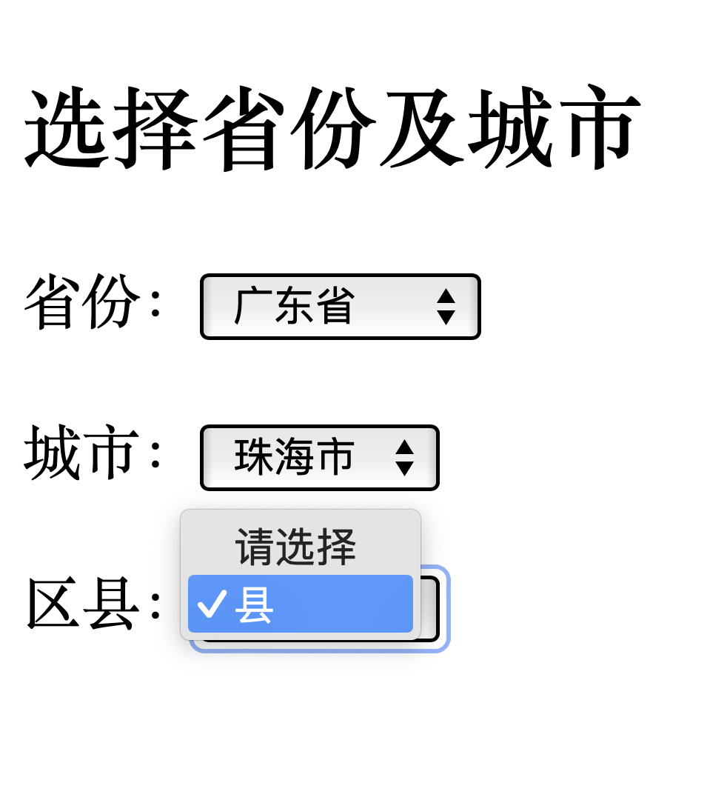

8. 打开网页sy3-8.html，编写javascript代码，使用数组存放四条信息，在页面加载时的文本域显示第一条信息，根据数组实际存放信息数在文本框中显示“共有几条”，单击【阅读】按钮显示下一条信息，当显示最后一条信息后，再次单击【阅读】按钮则提示“已经是最后一条信息了！”。
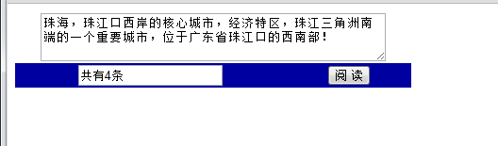
图3-4 依次读取公告栏信息
实现思路及步骤
（1） 创建如图所示HTML页面，文本域id设置为“teletype”，文本框id设置为“textNum”。
（2）定义数组和全局变量，参考代码如下：
<script type="text/javascript">
TextInput[0] = "珠海，珠江口西岸的核心城市，经济特区，珠江三角洲南端的一个重要城市，位于广东省珠江口的西南部！";
TextInput[1] = "珠海生态环境优美，山水相间，陆岛相望，气候宜人，是全国唯一以整体城市景观入选“全国旅游胜地四十佳”的城市。";
TextInput[2] = "珠海与澳门的横琴新区启动项目---珠海十字门商务区，继标志性建筑物'海之珠'诞生后，其城市设计概念中标方案出炉，HOK国际（亚太公司）的规划方案拔得头筹。";
TextInput[3]= "珠海是一座具有浓郁代文化氛围的城市。从浪漫的休闲海滩，到欧式的午夜酒吧；从万头攒动的娱乐广场，到温馨宁静的文化馆站，珠海文化的内涵被放大，成为一种具有经济推力的'大文化'";
</script>
其中变量i用户控制数组下标。
（3）单击阅读按钮显示下一条信息，定义相应函数。
（4）调用函数。
代码：（将代码粘贴到空行位置）
<!DOCTYPE html>
<html>
<head>
<meta charset="utf-8" />
<title>读取的公告栏文字</title>
<script type="text/javascript">
var TextInput = new Array();
TextInput[0] = "珠海，珠江口西岸的核心城市，经济特区，珠江三角洲南端的一个重要城市，位于广东省珠江口的西南部！";
TextInput[1] = "珠海生态环境优美，山水相间，陆岛相望，气候宜人，是全国唯一以整体城市景观入选“全国旅游胜地四十佳”的城市。";
TextInput[2] = "珠海与澳门的横琴新区启动项目-&#45;&#45;珠海十字门商务区，继标志性建筑物'海之珠'诞生后，其城市设计概念中标方案出炉，HOK国际（亚太公司）的规划方案拔得头筹。";
TextInput[3]= "珠海是一座具有浓郁代文化氛围的城市。从浪漫的休闲海滩，到欧式的午夜酒吧；从万头攒动的娱乐广场，到温馨宁静的文化馆站，珠海文化的内涵被放大，成为一种具有经济推力的'大文化'";
var i = 0;
function nextMessage(){
if(i < TextInput.length-1){
i++;
document.getElementById("teletype").value = TextInput[i];
document.getElementById("textNum").value = "共有" + TextInput.length + "条";
}else{
alert("已经是最后一条信息了！");
}
}
window.onload = function(){
document.getElementById("teletype").value = TextInput[0];
document.getElementById("textNum").value = "共有" + TextInput.length + "条";
}
</script>
</head>
<body>
<table width="420" cellpadding="0" cellspacing="0">
<tr>
<td width="100%" colspan="3" valign="top">
<div align="center">
<textarea name="teletype" id="teletype" rows="3" cols="49" wrap="yes"></textarea>
</div>
</td>
</tr>
<tr align="center">
<td width="30%" bgcolor="#0000A0" valign="top">
<input type="text" value="" sie="5" name="1" id="textNum">
</td>
<td width="30%" bgcolor="#0000A0" valign="top">
<input type="button" value="阅 读" onclick="nextMessage()">
</td>
</tr>
</table>
</body>
</html>

页面效果图：（将截图粘贴到空行位置）
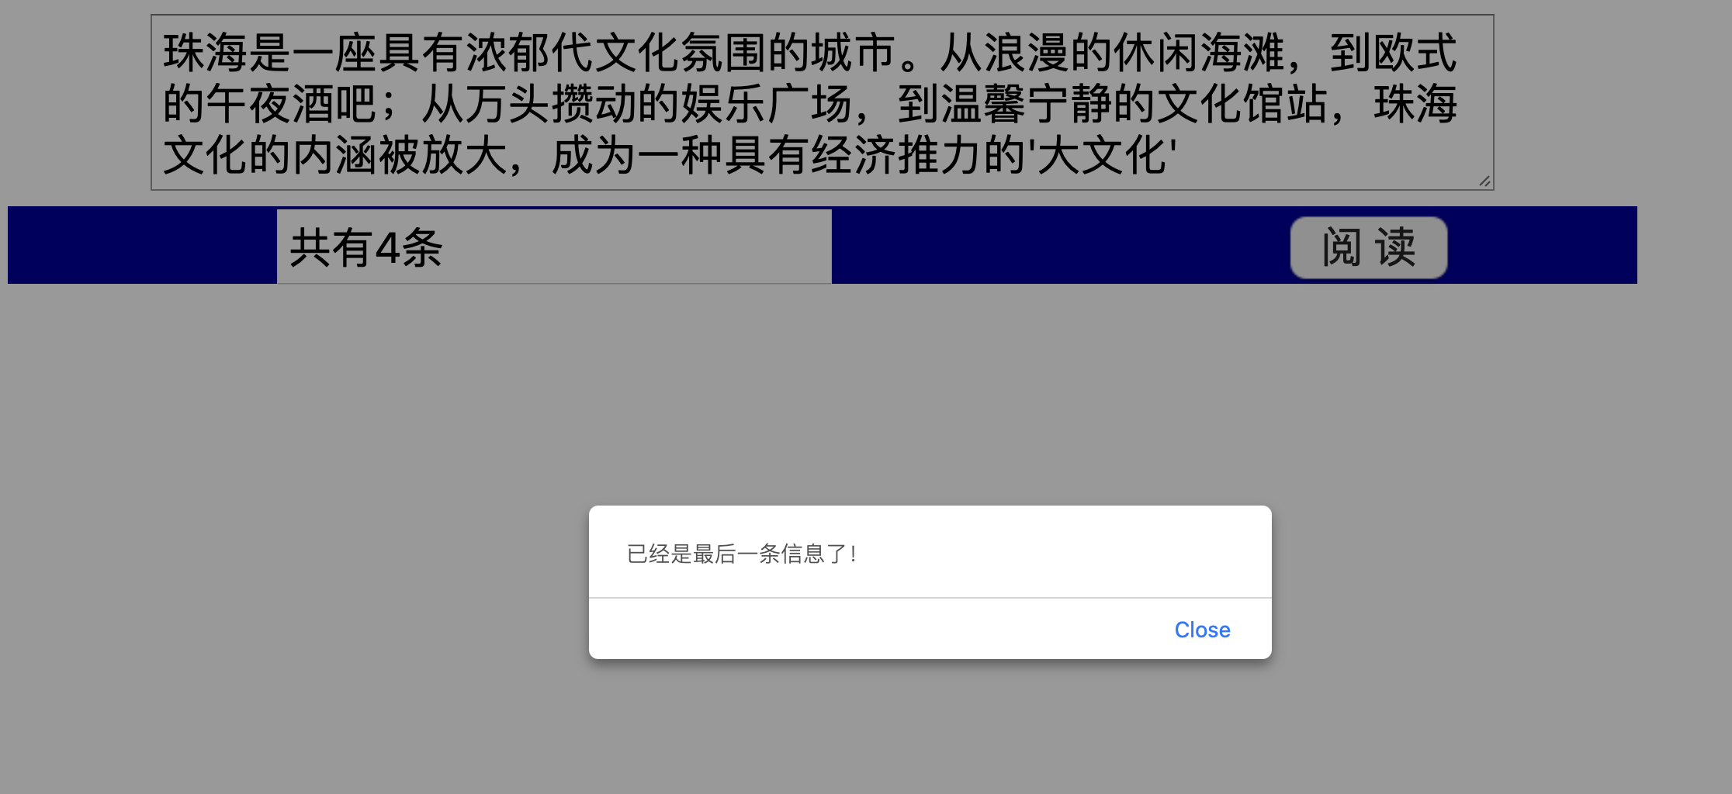

六、实验过程中所遇问题思考与讨论(个人体会,或相关理论知识)
本次实验主要涉及了JavaScript中数组的使用，包括数组的创建、赋值、访问、遍历、以及常用的数组方法等。通过实验，我对JavaScript数组有了更深入的理解和实践。

数组的创建和赋值：在JavaScript中，数组可以通过Array对象或者[]来创建。数组的元素可以是任何数据类型，包括数字、字符串、对象甚至其他数组（即多维数组）。

数组的访问和遍历：数组的每个元素都有一个索引，我们可以通过索引来访问数组的元素。遍历数组可以使用for循环，也可以使用for...in或者for...of循环。

数组的常用方法：JavaScript数组提供了非常丰富的方法，例如push()、pop()、shift()、unshift()、sort()、concat()、slice()、join()、indexOf()等。这些方法使得我们在处理数组时更加方便。

二维数组和多维数组：在JavaScript中，数组的元素也可以是数组，这样就形成了多维数组。在处理二维或多维数组时，通常需要使用嵌套的循环。

数组在实际问题中的应用：通过本次实验，我了解到数组在实际问题中的广泛应用，例如处理成绩、处理字符串、存储多层级的数据等。

在实验过程中，我遇到了一些问题，例如在处理多维数组时，我一开始不清楚如何正确地访问数组的元素。通过查阅资料和反复试验，我最终理解了多维数组的访问方式。此外，我也对JavaScript数组的一些方法有了更深入的理解和实践，这对我以后的编程工作会有很大的帮助。

总的来说，这次实验让我更好地理解了JavaScript数组的概念和使用方法，同时也提高了我解决实际问题的能力。我相信在未来的学习和工作中，我会更加熟练地使用数组来处理各种问题。
说 明：
1、所有实验环节均由每位学生独立完成，严禁抄袭他人实验结果，若发现有结果雷同者，按实验课考核办法处理。
2、创建文件夹，名称为学号+姓名，文件夹内存放实验报告doc文件和实验内容html文件，上传到教师机。

