Part 1 About You

*Question 1
Reasons for choosing your program and Waterloo (*Required)
Please tell us about your educational goals, your interest in your chosen program(s), and your reasons for applying to the University of Waterloo. If you have applied to more than one program please discuss your interest in each program. (900 character limit)
告诉我们你有什么学术目标，为什么对这个专业感兴趣，为什么要申请滑铁卢？如果申请的不止一个专业，需要分别说明。（900个字符，即900个字母、标点、空格，大约100多字）

Why Waterloo?

I like the atmosphere and the co-op program at Waterloo. What appeals to me most is the computer-related programs here.

CS and BBA Double degree

I am interested in computer science and have experiences in competitive programming. This program integrates computer science with business administration, which will increase my competitiveness as I pursue a managerial position in a computer technology company.

Software Programming

Although I don't have much experience developing large-scale software, I did use Typescript to create a plugin for the note-taking app Obsidian, along with ESBuild for compiling source code and Vitest for Test Driven Development, which I learned about from the book Clean Code but am still getting familiar with.

Mathematics

I have always been interested in Mathematics, which is the foundation of computer science, or to be more specific, algorithms.

Question 2
Extracurricular Activities
Please list any extracurricular activities or areas of significant interest. These could include leadership or participation in school organizations or projects, athletics, travel, community, social activities, drama, music, clubs, personal hobbies and/or significant volunteer work. (activity type包括：athletics, clubs, comm work, drama, hobbies, music, other, project, school org, social art, travel, volunteer)
课外活动
列出重要的课外活动，可以是在校内组织或者校外项目、运动、旅行、社区、社会活动、戏剧、音乐、社团、个人兴趣、志愿者等活动中的领导或者参与角色

Activity Type | Description / Title | Start Date | End Date | Grade | Hrs / Wk | Wks / Year
School Elective Course | Facing History and Ourselves | 2020-09 | 2021-06 | 10 | 1 | 40

Activity Type | Description / Title | Start Date | End Date | Grade | Hrs / Wk | Wks / Year
Hobbies | Learning Cardiopulmonary resuscitation | 2021-09 | 2022-06 | 11 | 1 | 40

Activity Type | Description / Title | Start Date | End Date | Grade | Hrs / Wk | Wks / Year
Clubs | Vice President of Emergency Action Club | 2021-09 | 2022-06 | 11 | 1 | 40

Activity Type | Description / Title | Start Date | End Date | Grade | Hrs / Wk | Wks / Year
Hobbies | Carving Rubber Stamps | 2018 | now | 10,11,12 | 1 | 53

Question 3
Special achievements, distinctions, and awards
If you have received any academic or non-academic awards or distinctions, please list them below. Please provide the Size of Competition if you know how many people participated.
奖项于荣誉
可以列出任何学术或非学术方面的荣誉。如果是比赛，需要注明参赛人数（数目不限）

Award Type | Award, Honour or Distinction | Year Received | Size of Competition if Applicable
academic | Euclid Contest Certificate of Distinction | 2021

Award Type | Award, Honour or Distinction | Year Received | Size of Competition if Applicable
academic | Euclid Contest Certificate of Distinction | 2022 | 22372

Award Type | Award, Honour or Distinction | Year Received | Size of Competition if Applicable
academic | Canadian Computing Competition Certificate of Distinction, Rank 23 | 2022 | 3262

Award Type | Award, Honour or Distinction | Year Received | Size of Competition if Applicable
academic | National Olympiad in Informatics in Provinces Senior Group National First Prize | 2020 | 11139

Award Type | Award, Honour or Distinction | Year Received | Size of Competition if Applicable
academic | National Olympiad in Informatics in Provinces Senior Group Jiangsu Provincial First Prize | 2020 | 11139

Award Type | Award, Honour or Distinction | Year Received | Size of Competition if Applicable
academic | National Olympiad in Informatics in Provinces Senior Group National Second Prize | 2021

Award Type | Award, Honour or Distinction | Year Received | Size of Competition if Applicable
academic | National Olympiad in Informatics in Provinces Senior Group Jiangsu Provincial First Prize | 2021

Award Type | Award, Honour or Distinction | Year Received | Size of Competition if Applicable
academic | National Olympiad in Informatics in Provinces Senior Group National Second Prize | 2019

Award Type | Award, Honour or Distinction | Year Received | Size of Competition if Applicable
academic | National Olympiad in Informatics in Provinces Senior Group Jiangsu Provincial First Prize | 2019

Award Type | Award, Honour or Distinction | Year Received | Size of Competition if Applicable
academic | Certified Software Professional Senior Group First Prize | 2020 | 11048

Award Type | Award, Honour or Distinction | Year Received | Size of Competition if Applicable
academic | Certified Software Professional Senior Group First Prize | 2021 | 11048

Award Type | Award, Honour or Distinction | Year Received | Size of Competition if Applicable
academic | Promoted to Gold from Silver in USACO US Open | 2020 | 2243

Award Type | Award, Honour or Distinction | Year Received | Size of Competition if Applicable
academic | CodeForces Rating 1672 Expert | 2021

Award Type | Award, Honour or Distinction | Year Received | Size of Competition if Applicable
academic | American Mathematics Competitions 12 Honor Roll | 2021 Spring | 30564

Award Type | Award, Honour or Distinction | Year Received | Size of Competition if Applicable
academic | American Mathematics Competitions 12 Honor Roll | 2021 Autumn | 30564

Award Type | Award, Honour or Distinction | Year Received | Size of Competition if Applicable
academic | American Mathematics Competitions 12 Certificate of Distinction | 2021 Spring | 30564

Award Type | Award, Honour or Distinction | Year Received | Size of Competition if Applicable
academic | American Invitational Mathematics Examination Participation, 14 points | 2021 Spring

Award Type | Award, Honour or Distinction | Year Received | Size of Competition if Applicable
academic | American Invitational Mathematics Examination Participation, 13 points | 2021 Autumn

Award Type | Award, Honour or Distinction | Year Received | Size of Competition if Applicable
academic | American Regions Mathematics League Local National Top 100 | 2022

Award Type | Award, Honour or Distinction | Year Received | Size of Competition if Applicable
academic | American Regions Mathematics League Local National Gold | 2022

Award Type | Award, Honour or Distinction | Year Received | Size of Competition if Applicable
academic | American Regions Mathematics League Local Global Top 100 Teams | 2022

Award Type | Award, Honour or Distinction | Year Received | Size of Competition if Applicable
academic | Duke Math Meet China Individual Top 10% | 2022

Award Type | Award, Honour or Distinction | Year Received | Size of Competition if Applicable
academic | Duke Math Meet China Team Top 50% | 2022

Award Type | Award, Honour or Distinction | Year Received | Size of Competition if Applicable
academic | Chinese High School Mathematics League Third Prize | 2021

Award Type | Award, Honour or Distinction | Year Received | Size of Competition if Applicable
academic | Chinese Physics Olympiad Nanjing Region Third Prize | 2021

Award Type | Award, Honour or Distinction | Year Received | Size of Competition if Applicable
academic | China High School Biology Olympiad National Third Prize | 2020

Award Type | Award, Honour or Distinction | Year Received | Size of Competition if Applicable
non-academic | National "Star of Ocarina" Individual Teenager Group B Bronze | 2020

Award Type | Award, Honour or Distinction | Year Received | Size of Competition if Applicable
non-academic | Zhou Enlai Scholarship Specialized Talent Award | 2021

Award Type | Award, Honour or Distinction | Year Received | Size of Competition if Applicable
non-academic | Nanjing Foreign Language School Five Star Student Award | 2021

Part 2 Course Information

列出12年级上下学期的课程
12年级上：
12年级下：
Note: The Course Name box allows only 8 characters.
(如果在读课程已经给我们，此处可以不填)

Courses not taken at your regular day school
Please provide a reason why any Grade 12 (or equivalent) courses listed above were not taken at your regular day school. (900 character limit)如有非在校的课程，请列出，12年级课程说明理由

Repeated Courses
Please provide a reason why any Grade 12 (or equivalent) courses listed above were repeated. (900 character limit) 如有补考课程，请列出，12年级补课请列出理由

Part 3 Programs

- Math & Computer Science
以下是申请数学或计算机学生要回答的
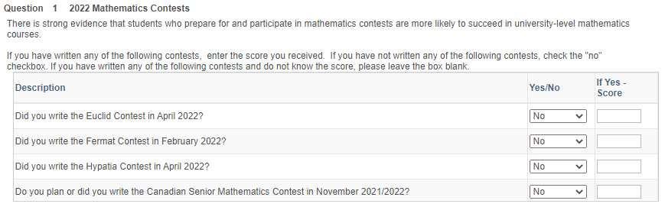
有没有参加过以上的数学竞赛
Yes No No No
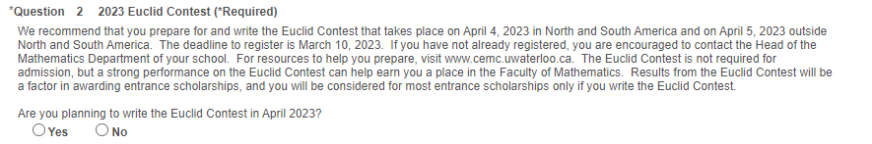
要不要参加2022年4月的欧几里得数学竞赛
Yes

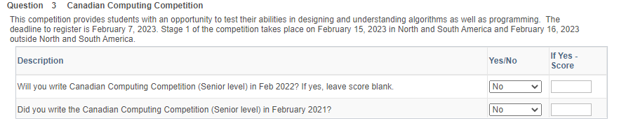
有没有参加这两个数学竞赛
Yes Yes

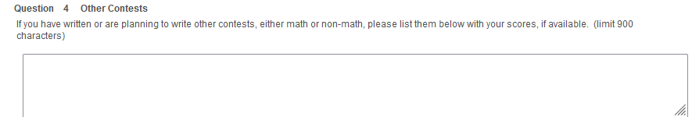
如果参加其他大型的数学竞赛，请列举
American Mathematics Competitions 12
American Invitational Mathematics Examination
American Regions Mathematics League Local
American Regions Mathematics League Power
Chinese High School Mathematics League
Duke Math Meet China

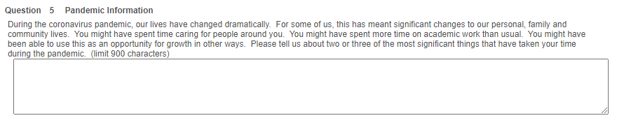
疫情期间做的2-3件重要的事（此题可以不写）

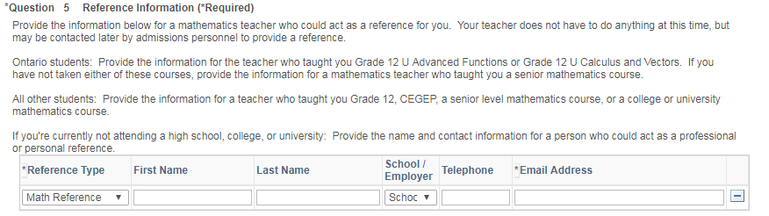
提供一个推荐人，即数学老师，需要：姓名和邮箱（有电话更好）

- Engineering 以下是申请工程的学生要回答的
* Question 1 Engineering Interests and Goals (*Required)
Briefly explain why you are interested in engineering and particularly in the program to which you have applied. Comment, for example, on your interests and abilities; your career goals; exposure to engineering through school-related and other experiences; and discussions you have had with engineers, teachers, current or past Waterloo students. (900 character limit)
说说为什么对工程尤其你选择的某个工程专业感兴趣，比如谈谈你的兴趣和能力，你的职业目标，参加过什么和学校有关的或者其他方面的工程类活动，以及你和工程师、老师、在读的或者毕业的滑铁卢学生的一些交流讨论。（900字符）

* Question 2 More About Your Goals (*Required)
What sorts of things would you like to do or accomplish in Waterloo Engineering and why? (900 character limit)
你希望在滑铁卢的工程取得哪些成绩，为什么？

Currently, I am reading Clean Code and learning to reconstruct my code. I realize that it is far from enough to simply make the code run. It need to be well constructed. Each class and function must be well defined and written for clarity, future development and to prevent errors. I haven't learned Object Oriented Programming systematically. The Single Responsibility Principle, Open Closed Principle, Dependency Inversion Principle and other concepts are unfamiliar to me. I don't know the differences between strongly/weakly typed language and dynamic/static typed language. I hope to learn programming systematically at Waterloo. I’m interested in the principles, the basics, and how everything works behind the scenes.
In addition, I want to earn hands-on experiences from Waterloo's co-op program, where I will gain two years of work experience. It will make me more competitive in job market.

Question 3 Programming Knowledge （只针对Software Engineering申请者，申请其他专业不用写这个问题）
If you have applied to Software Engineering you are required to demonstrate that you have experience in developing well-structured, modular programs. However, all applicants should list their programming experience if applicable.

For every programming language in which you have at least four months of programming experience, list the language, number of months experience you have in using the language (not how long you have known it), and capacity in which you used the language (e.g., courses completed, work experience, self education). (600 character limit)
如果你申请了软件工程，你需要展示你在开发结构良好的模块化程序方面的经验。另外，如适用，所有的申请者都请列出编程方面的经历。
如果有4个月以上学习某种程序语言的经验，请逐一列出，并注明已使用该语言多少个月（不是指会了多少个月），以及使用该语言的能力（例如：完成的课程，工作经验，自学） （600字符）

C++: Used since 2016, mainly in competitive programming. I don't know much about its grammar and libraries, only those for basic IO and algorithms.

Java: Learned in 2021, its basic features mastered. Not used to write any program.

Python: Learned in 2018 and used occasionally. No software developed, but some scripts written for productive use.

JavaScript and TypeScript: Learned in July 2022 and used since then. Wrote a plugin for the note-taking app Obsidian using TypeScript (https://github.com/jerrywcy/obsidian-path-finder) I know well its features and grammars and how to use regex and promises.

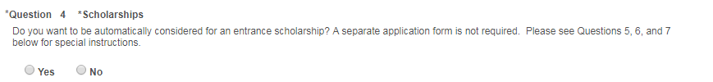
是否想要被自动考虑给予奖学金
Yes

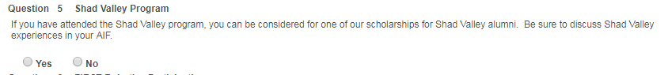
是否要加入Shad Valley项目（奖学金项目之一）
no

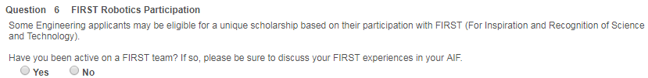
有没有参加过FIRST项目（正常是no）
no

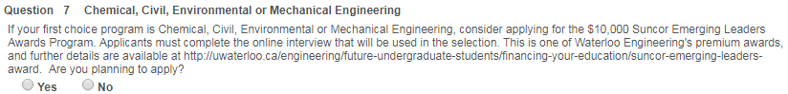
第一志愿是化学工程、土木工程、环境工程或者机械工程的申请人要不要申请Suncor Emerging Leaders奖

在以下工程专业中选择一个第二志愿（software engineering申请者不用选）
