the URL for your git repo.

<https://github.com/jerryyummy/distributed_system_2(for> client)

https://github.com/jerryyummy/assignment2_server

A short description of your data model (5 points) - Please state size of image used if not using the stock image, and also Database/File storage solution.

Size of image:12kb

The object in database includes a primary key named album_id, blob imagedata, string artist, string title, string year. When I try to save my file to database, I use the code below:

preparedStatement.setBlob(1, new FileInputStream(file));, which can convert imagefile to blob

use this statement to create table:

CREATE TABLE album (  
 album_id INT AUTO_INCREMENT PRIMARY KEY,  
 image_data LONGBLOB,  
 artist varchar(255),  
 year varchar(255),  
 title varchar(255)  
);

Output windows for the 3 client configuration tests run against a single server/DB (5 points)

|  |  |  |  |  |  |  |
| --- | --- | --- | --- | --- | --- | --- |
|  | time | throughput | mean | 99% time | Succeed request | Fail  request |
| 10,10,2 | 883605 | 226 | 393 ms | 88 ms | 92506 | 7494 |
| 10,20,2 | 1027410 | 389 | 306 ms | 75 ms | 100170 | 99830 |
| 10,30,2 | 1147122 | 523 | 328 ms | 93 ms | 193473 | 106527 |

For post

|  |  |  |  |  |  |  |
| --- | --- | --- | --- | --- | --- | --- |
|  | time | throughput | mean | 99% time | Succeed request | Fail  request |
| 10,10,2 | 883605 | 226 | 90 ms | 78 ms | 92739 | 7261 |
| 10,20,2 | 1027410 | 389 | 160 ms | 69 ms | 100117 | 99830 |
| 10,30,2 | 1147212 | 523 | 148 ms | 82 ms | 193473 | 106529 |

For get  
a plot comparing the throughout

Output windows for the 3 client configuration tests run against a two load balanced servers/DB (15 points)

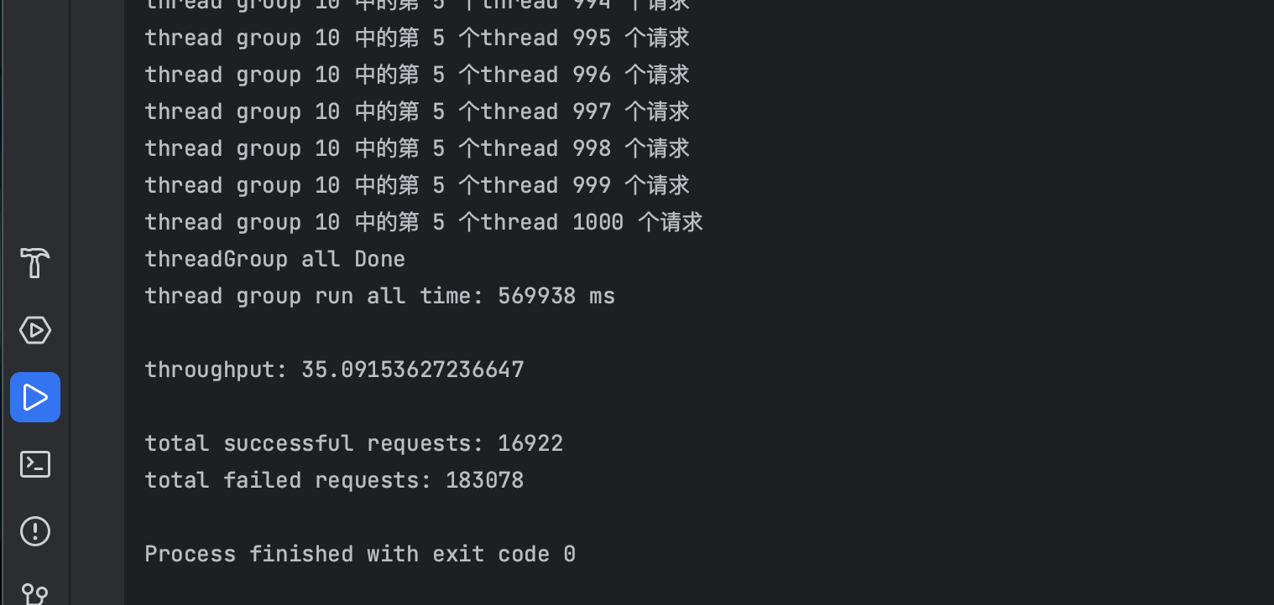

|  |  |  |  |  |  |  |  |  |
| --- | --- | --- | --- | --- | --- | --- | --- | --- |
|  | **Mean time** | **Median time** | **99% time** | **Min time** | **Max time** | **Wall time** | **throughput** | **Succeed request** |
| **10 10 2** | **614** | **533** | **146** | **125** | **17592** | **1335427** | **150** | **9118** |
| **10 20 2** | **520** | **452** | **137** | **116** | **4814** | **418706** | **955** | **16264** |
| **10 30 2** | **621** | **517** | **138** | **122** | **7686** | **1132342** | **530** | **27297** |

For post

|  |  |  |  |  |  |  |  |  |
| --- | --- | --- | --- | --- | --- | --- | --- | --- |
|  | **Mean time** | **Median time** | **99% time** | **Min time** | **Max time** | **Wall time** | **throughput** | **Succeed request** |
| **10 10 2** | **304** | **171** | **64** | **52** | **6295** | **1335427** | **150** | **6835** |
| **10 20 2** | **181** | **151** | **59** | **42** | **4764** | **418706** | **955** | **14332** |
| **10 30 2** | **172** | **147** | **61** | **46** | **5594** | **1132342** | **530** | **21582** |

For get

Output window for optimized server configuration for client with 30 Thread Groups. Briefly describe what configuration changes you made and what % throughput improvement you achieved (15 points)

I made two replicate for rds so that we can separate writing and reading , I also change the number of max connections in database, and I add one more instance in the load balancer for testing.

Wall time is 1038116ms, throughput is 578 per second, the succeed request is 166768, fail request is 433232 the total throughput improve about 9%, the performance improve a bit because we still use one database to write, and the max_connection in RDS is limited to 100.

|  |  |  |  |  |  |  |  |
| --- | --- | --- | --- | --- | --- | --- | --- |
|  | Mean response | Wall time | 99% time | Min response | Max response | throughput | succeed |
| Two instance | 621 | **1132342** | 138 | 122 | 7686 | 530 | 272970 |
| optimal | 489 | 960989 | 133 | 120 | 4348 | 578 | 270960 |

For post

|  |  |  |  |  |  |  |  |
| --- | --- | --- | --- | --- | --- | --- | --- |
|  | Mean response | Wall time | 99% time | Min response | Max response | throughput | succeed |
| Two instance | 172 | **1132342** | 147 | 46 | 5594 | 530 | 215820 |
| optimal | 167 | 960989 | 78 | 57 | 4373 | 578 | 349150 |

For get

Other optional but highly recommended to have in your submission:

What database looks like

Before optimalization

After optimalization

As we can see , we can decrease the cpu utilization from about 40% to 20%, and the maximum connections in every is about 60, which is less than 70.

Set up load balancer and target group

Target group after testing

Alb after testing