the URL for your git repo.

https://github.com/jerryyummy/distributed_system_2

A short description of your data model (5 points) - Please state size of image used if not using the stock image, and also Database/File storage solution.

Size of image:235kb

The object in database includes a primary key named album_id, blob imagedata, string artist, string title, string year. When I try to save my file to database, I use the code below:

preparedStatement.setBlob(1, new FileInputStream(file));, which can convert imagefile to blob

Output windows for the 3 client configuration tests run against a single server/DB (5 points)

|  |  |  |  |  |
| --- | --- | --- | --- | --- |
|  | time | throughput | mean | 99% time |
| 10,10,2 | 569938 | 35 | 127 ms | 46 ms |
| 10,20,2 | 781610 | 51 | 203 ms | 67 ms |
| 10,30,2 | 1060127 | 56 | 238 ms | 59 ms |

a plot comparing the throughout

Output windows for the 3 client configuration tests run against a two load balanced servers/DB (15 points)

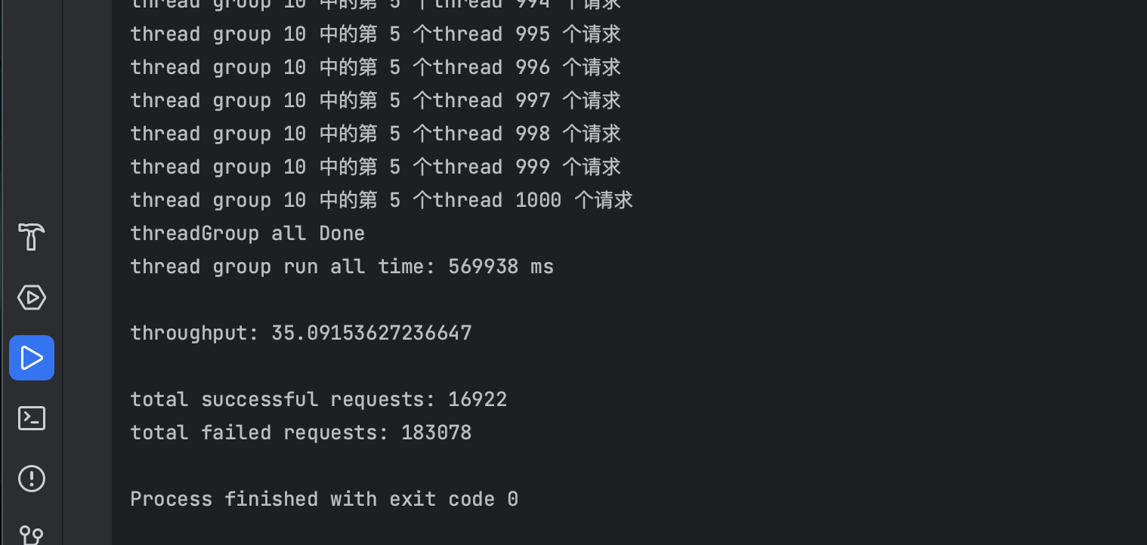

|  |  |  |  |  |  |  |  |
| --- | --- | --- | --- | --- | --- | --- | --- |
|  | **Mean time** | **Median time** | **99% time** | **Min time** | **Max time** | **Wall time** | **throughput** |
| **10 10 2** | **481** | **342** | **70** | **52** | **17592** | **569938** | **35** |
| **10 20 2** | **361** | **238** | **64** | **42** | **4814** | **914329** | **44** |
| **10 30 2** | **423** | **255** | **67** | **46** | **7687** | **1132342** | **53** |

Output window for optimized server configuration for client with 30 Thread Groups. Briefly describe what configuration changes you made and what % throughput improvement you achieved (15 points)

I change the number of max connections in database from 5 to 100, and I add one more instance for testing.

Other optional but highly recommended to have in your submission:

What database looks like

Before optimalization

After optimalization

As we can see , we can decrease the cpu utilization from about 40% to 20%, and the maximum connections in every is about 60, which is less than 70.