To run the MarsRover program, please make sure you have JDK/JRE 1.7 on your computer.

1. Rename MarsRovers.zi to MarsRovers.zip as gmail doesn’t allow to attach the zip file.
2. Unzip the MarsRovers.zip into your local folder (“MarsRovers”).
3. Go to folder MarsRovers, and execute **run.bat** to start the program.
4. You will be asked whether you want to turn the Log on or not by answer “y” or “n”, the default value is no if you just press Enter.



1. Then you need to select the input text file from the open window.

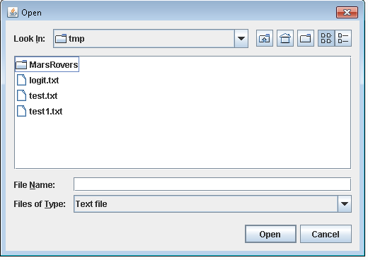

1. MarsRover program will start the navigation for the Rover and you should see the outcome in the window.
2. If there are any exception happened through the execution, you should see the error messasge rather than the success outcome.

The solution is done by JAVA, and the main entry class is MarsRovers.java, please see the class structure in the following diagram.

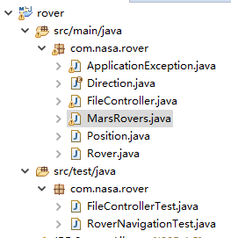

If you want to run directly from java class rather than through the run.bat, you can run by the following command.

java -jar target\rover-1.1T-jar-with-dependencies.jar