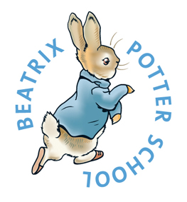
Beatrix Potter Primary School. Magdalen Road London SW18 3ER
info@beatrixpotter.wandsworth.sch.uk www.beatrixpotterschool.com

Equality Information and Objectives (Compliance with public sector duties)
Article 1 Everyone under the age of 18 has all the rights in the Convention.
Article 2 The Convention applies to everyone: whatever their race, religion or abilities, whatever they think or say, whatever type of family they come from

Approved by: | Simon Rhoades | Date: March 2023
 | Amanda Robertson | Date: March 2023
Last reviewed on: | March 2022
Next review due by: | March 2027

There are 9 protected characteristics under the Equality Act 2010:
- Age
- Sex
- Race
- Disability
- Religion or belief
- Sexual orientation
- Gender reassignment
- Pregnancy or maternity
- Marriage and civil partnership
Beatrix Potter is an inclusive school where we believe that diversity makes us stronger. Therefore we have appointed an Equality Champion whose role is to ensure that we promote the value in diversity, tackle discrimination, promote equality and foster good relationships between people.

Our approach to equality is based on the following key principles:

1. All learners are unique and of equal value
2. We recognise and respect difference
3. We foster positive attitudes and relationships and a shared sense of cohesion and belonging.
4. We observe good equalities practice in staff recruitment, retention and development.
5. We aim to reduce and remove inequalities and barriers that already exist.
6. We have the highest expectations of all our children.

Equality Information
Data may change throughout an academic year. At Spring census 2023 we had 324 children on roll between the ages of 3 and 11.

Information on pupils by protected characteristics
The Equality Act 2010 protects people from discrimination on the basis of protected characteristics. Every person has several of the protected characteristics, so the Act protects everyone against unfair treatment.
In order to ensure that all pupils are protected from discrimination, the school collects information on protected characteristics.

Information on other groups of pupils
In addition to pupils with protected characteristics, we gather further information on the following groups of pupils:

- Pupils eligible for Free School Meals (FSM)
- Pupils with Special Educational Needs (SEN)
- Disadvantaged group
- Pupils with English as an Additional Language (EAL)
- Young carers
- Looked after children
- Other vulnerable groups

It may be possible to identify individuals from the information provided when the number of pupils with a particular characteristic is low and the information is sensitive or personal.

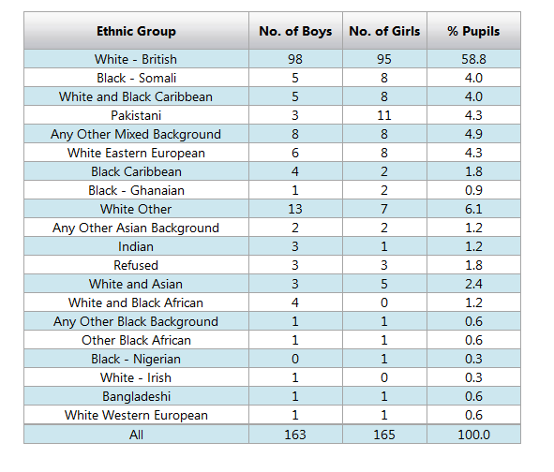

Gender: 49.7% male, 50.3% female
Pupils eligible for Free School Meals (FSM): 19%
Pupils eligible for Pupil Premium Finding – Disadvantage group: 19%
Pupils with Special Educational Needs (SEN) 14%
Pupils with English as an Additional Language (EAL): 27.6 %
Young carers: 0%
Looked after children: 0.6%

We analyse our data rigorously three times a year, with these tracking and monitoring individuals and all the groups of children. This includes progress and attainment, and by providing equal opportunities to access the curriculum and activities, alongside academic intervention, we aim to ensure that any gap in attainment for pupils within any of the above different groups is removed, or at least remains less than the gap nationally.

Eliminating discrimination
The school is aware of the requirements of the Equality Act 2010 and complies with non-discrimination provisions.
We:
- Publish policies relating to behaviour, anti-bullying, recruitment and pay
- Give annual reminders to staff and governors over their duties
- Train our staff in Equality matters once a year (admin, premises, support and teaching staff)
- Monitor equality issues through termly monitoring of behaviour incident records and as a standing agenda item on the senior leadership team meetings.
Advancing equality of opportunity
The PSED requires schools to show they are advancing equality of opportunity between people who share a protected characteristic and people who do not share it.
We:
- Keep attainment data and analyse it for how pupils with different characteristics are performing. This is reviewed at Governor Standards and Achievement sub committees as well as with teachers in termly ‘Pupil Progress Meetings’.
- Respond to the data through provision mapping for individuals. The school as a particular emphasis on prioritising pupil premium children for interventions.
- Track behaviour Incident reports and deal with any incidents of negative behaviour and attitudes around children with protected characteristics.
- Have appointed an ‘Equalities Champion’ whose role is to focus and improve the provision and outcomes for the protected characteristic groups.
Fostering good relations

The PSED requires schools to show they are fostering good relations between those who share a protected characteristic and those who do not share it.
We fulfil this aspect by:
- Using the SCARF CORAM PSHE curriculum which leads children through a curriculum that promote tolerance, friendship, and understanding of a range of religions and cultures
- Delivering assemblies which follow the Rights Respecting and Values agenda and enables the success (and struggles endured) for people of the protected characteristics groups
- Seeking involvement with local communities
- Twinning arrangements with other schools are being sought by the Equalities Champion
- Developing initiatives to deal with tensions between different groups of pupils within the school should they arise, (the responsibility of the Equalities Champion).

