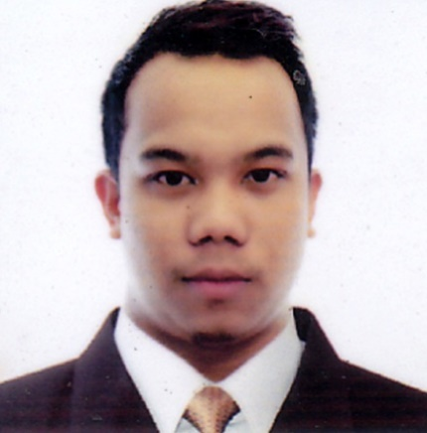{

Oct 2022 - Present

JAVA / PHP / ReactJS / Node.js / Android

MSSQL / MySQL / MongoDB / Oracle / PostgreSQL

HTML / CSS / Javascript / JQuery / AJAX / Servlet

Tomcat / IBM Websphere / XAMP

Spring MVC / Spring Boot / Laravel/ Bootstrap / Github / Eclipse / Visual Studio

**TeraSystem Incorporated**   
System Engineer

* Responsible for development 6+ projects including both front-end and back-end transactions.
* Performed unit testing and implementation.
* Fixed bugs from existing applications and implemented enhancements.
* Enhanced the quality of code and improved application performance.

**PROJECTS**

* Land Bank of the Philippines

1. Mobile Banking Application
   * Back Office & REST API’s
2. VISA Web Application
   * Reconciliation for Visa Transactions
3. CARC Web Application
   * Consolidating Financial Transactions
4. FRPS Web Application
   * Financial Report
5. LPA-AMS Web Application
   * Phone Access Application for Landbank Call Center
6. TSEA Web Application
   * Security application and encryption for Primary Account Numbers

* Bank of the Philippine Island

1. Development of Online Banking System

**Freelance Projects**

1. Billing & Invoice System
2. Inventory & Sales Management System
3. Website for Seller of Medical Equipment
4. Android App for Operation Research

**KodeGo**Part-time Web Developer Instructor  
  
Teaching different technologies for web development such as HTML, CSS, JavaScript, ReactJS, NodeJS, PHP, Laravel & MySQL Database.

**SKILLS**

**Mr. Earvin George Garcia**   
Senior System Engineer  
TeraSystem Incorporated  
+63 917 8524753

**REFERENCES**

**EDUCATION**

**B.S. Computer Engineering**  
Polytechnic University of the Philippines   
2008 – 2013  
  
Sauyo High School   
2004 – 2008  
  
Sauyo Elementary School  
1998 – 2004

Linkedin.com/in/jerum-p-galang

jerumpgalang@gmail.com

JERUM P. GALANG

**CAREER**



+63 915 4953603



May 2013 - Present

An ambitious problem solver with a passion for web development for **9+** years hands-on experience, and who would like to join a team of like-minded developers. Also, a good team player and have an excellent interaction skill to coordinate and work within a team. He has much experience of creating both logical and innovative solutions to complex web problems.

**PROFILE**



Area 5B Sitio Cabuyao, Sauyo Road, Novaliches Quezon City

