MAR BASELIOS INSTITUTE OF TECHNOLOGY AND SCIENCE NELLIMATTOM P.O, KOTHAMANGALAM, KERALA


APJ ABDUL KALAM TECHNOLOGICAL UNIVERSITY THIRUVANANTHAPURAM

MINIPROJECT REPORT
on

DIGITAL MEASURING TAPE

Submitted by

Jesald Tony (MBI23EC015)
Richard S Areckal (MBI23EC020)
Sreejith V B (MBI23EC023)

In partial fulfilment for the award of the degree Of
BACHELOR OF TECHNOLOGY
In
ELECTRONICS AND COMMUNICATION ENGINEERING MARCH 2026
i

MAR BASELIOS INSTITUTE OF TECHNOLOGY AND SCIENCE NELLIMATTOM P.O, KOTHAMANGALAM, KERALA


DEPARTMENT OF ELECTRONICS AND COMMUNICATION ENGINEERING

BONAFIDE CERTIFICATE

This is to certify that the Miniproject report on DIGITAL MEASURING TAPE is a bonafide record of the project presented by JESALD TONY (MBI23EC015), RICHARD S ARECKAL (MBI23EC020), SREEJITH V B (MBI23EC023) in partial fulfilment for the award of the degree of Bachelor of Technology in Electronics and Communication Engineering of APJ Abdul Kalam Technological University, Thiruvananthapuram during the academic year 2025-2026.

Project Coordinator Project Guide Head of the Department

Prof. Hyma Joy
ii
Assistant Professor Department of ECE
Prof. Teena Abraham
Assistant Professor
Department of ECE
Prof. Sherin Thomas
Associate Professor
Department of ECE

We undersigned hereby declare that the project report "DIGITAL MEASURING TAPE", submitted for the fulfillment of the requirements for the award of degree of Bachelor of Technology of the APJ Abdul Kalam Technological University, Kerala is a bonafide work done by us under supervision of Prof. Hyma Joy, Assistant Professor, and Prof. Sherin Thomas, Associate Professor and Head, ECE Department. This submission represents our ideas in our own words and where ideas or words of others have been included. We have adequately and accurately cited and referenced the original sources. We also declare that we have adhered to ethics of academic honesty and integrity and have not misrepresented or fabricated any data or idea or fact or source in our submission. We understand that any violation of the above will be a cause for disciplinary action by the institute and/or the University and can also evoke penal action from the sources which have thus not been properly cited or from whom proper permission has not been obtained. This report has not been previously formed the basis for the award of any degree, diploma or similar title of any other University.

Date:
Place:

Jesald Tony (MBI23EC015)
Richard S Areckal (MBI23EC020)
Sreejith V B (MBI23EC023)

ACKNOWLEDGEMENT

First and the foremost, we thank ALMIGHTY GOD who gave us the inner strength, resource and ability to complete our work successfully, without which all our efforts would have been in vain.
We express our sincere gratitude to the Dr. Thomas George, Principal for providing us the research facilities and the circumstances to complete the project in a grant successful manner.
We express our deep sense of gratitude to Prof. Sherin Thomas, Associate Professor & Head, Department of ECE for her insightful comments, encouragements, and critical inquiries, which inspired us to widen our project from various perspectives. We would like to extend our gratitude to Prof. Hyma Joy, Assistant Professor, ECE Department for the creative suggestions, valuable advice, mental support and guidance as project coordinator.
Words are insufficient to express our heartfelt and sincere gratitude to our guide who have suggested a relevant and interesting project topic and paved the way to the successful completion of this project. With great respect and gratitude, we acknowledge our guide
Prof. Teena Abraham, Assistant Professor, ECE Department for her invaluable guidance, great inspiration, and strong moral support throughout our research work. We would like to express our gratitude to Mr. Eldhose Joy for her valuable technical support throughout our project.
We use this opportunity to thank all faculties in the department and the friends who have helped us to complete the mini-project work, with their inspiration and co-operation.

Jesald Tony (MBI23EC015)
Richard S Areckal (MBI23EC020)
Sreejith V B (MBI23EC023)

This project details the development of a precision digital measuring tape utilizing an Arduino Nano microcontroller, a rotary encoder, and a 16x2 LCD interface. Traditional measuring tools are often limited by physical length or manual readout errors; this system overcomes those hurdles by converting mechanical rolling motion into an accurate digital value. At the heart of the device is a wheel of a known radius attached to a rotary encoder. As the wheel traverses a surface, the encoder produces quadrature signals that the Arduino interprets to determine both the distance traveled and the direction of movement.
The mathematical foundation of the device relies on the relationship between angular displacement and linear distance. By counting the Pulses Per Revolution (PPR) generated by the encoder, the system calculates the distance (D) using the formula D = (n / PPR) \times 2\pi r, where $n$ is the number of pulses and r is the wheel radius. To ensure high-speed accuracy and prevent data loss during rapid movement, the Arduino Nano utilizes hardware interrupts to monitor the encoder pins.
The user interface consists of a 16x2 LCD screen that provides a real-time readout of the measurement. A potentiometer is integrated into the circuit to fine-tune the display contrast for various lighting conditions. Designed for portability and ease of use, the device serves as a practical example of embedded systems integration, combining sensor fusion, interrupt-driven programming, and real-time data visualization. This digital measuring tape is an ideal prototype for applications in interior design, DIY construction, and educational robotics, demonstrating how simple electronic components can be synthesized into a functional industrial tool.

Chapter No. | Topic Name | Pages
 | CERTIFICATE | i
 | DECLARATION | iii
 | ACKNOWLEDGEMENT | iv
 | ABSTRACT | v
 | TABLE OF CONTENTS | vi
 | LIST OF FIGURES | viii
 | LIST OF ABBREVIATIONS | ix
1 | INTRODUCTION
1.1 | BACKGROUND AND MOTIVATION | 1
1.2 | PROBLEM STATEMENT | 1
1.3 | OBJECTIVES | 2
2 | LITERATURE REVIEW
2.1 | INTRODUCTION | 4
2.2 | OVERVIEW OF DIGITAL MEASURING TAPE | 4
2.3 | EMBEDDED SYSTEMS AND REAL TIME DATA PROCESSING | 5
2.4 | ROTARY SENSING AND NON CONTACT MEASUREMENT TECHNOLOGIES | 6
2.5 | EMBEDDED LOGIC AND PULSE PROCESSING APPROACHES | 7
3 | PROPOSED SYSTEM
3.1 | SYSTEM OVERVIEW | 9
3.2 | BLOCK DIAGRAM | 10
4 | HARDWARE ARCHITECTURE

4.1 | ARDUINO NANO MICROCONTROLLER | 11
4.2 | ROTARY ENCODER | 11
4.3 | 16X2 LCD DISPLAY | 12
4.4 | 10K VARIABLE RESISTOR | 13
4.5 | RESISTOR | 14
4.6 | BREADBOARD | 14
4.7 | POWER SUPPLY | 15
5 | IMPLEMENTATION AND RESULT
5.1 | HARDWARE IMPLEMENTATION | 16
5.2 | CALCULATION AND LOGIC | 16
5.3 | RESULTS | 17
6 | CONCLUSION AND FUTURE WORK | 18
 | REFERENCES
 | APPENDIX

Figure No. | Figure Name | Page No.
Figure 3.2 | Block diagram | 10
Figure 4.1 | Arduino Nano Micro controller | 11
Figure 4.2 | Rotary encoder | 11
Figure 4.3 | 16X2 LCD display | 12
Figure 4.4 | 10K variable resistor | 13
Figure 4.5 | Resistor | 14
Figure 4.6 | Breadboard | 14
Figure 4.7 | Power supply | 15
Figure 5.3 | Result | 17

LIST OF ABBREVIATIONS

LCD | LIQUID CRYSTAL DISPLAY
PPR | PULSE PER REVOLUTION

CHAPTER 1

INTRODUCTION

BACKGROUND AND MOTIVATION

Traditional measurement methods, such as manual measuring tapes, have long been the standard for determining linear distances. However, these conventional tools often present challenges in terms of accuracy, ease of use, and real-time data recording, especially when measuring long distances or complex surfaces. Manual reading is prone to human error, and physical tapes can be cumbersome to handle in solo tasks. There is a growing need for a smarter alternative that simplifies the measurement process by providing instant digital feedback and higher precision in everyday measurement tasks.
To address these limitations, this project introduces a Digital Measuring Tape built using an Arduino Nano and a rotary encoder. By integrating embedded systems into a common tool, the device offers a non-invasive and highly efficient way to measure linear distance through wheel rotation. As the wheel moves across a surface, the rotary encoder detects the motion and generates electrical pulses, which are then processed by the microcontroller to calculate the exact distance traveled. This digital approach eliminates the need for manual estimation and provides a clear, compact solution for measurement and automation.
Furthermore, the system provides real-time interaction through a 16x2 LCD display, allowing the user to see the calculated distance immediately. To ensure the device is user- friendly and adaptable to different environments, a potentiometer is included to adjust screen contrast, and a reset button is implemented to clear readings instantly. This project not only serves as a practical tool for hobbyists and professionals but also demonstrates how combining sensors and microcontrollers can solve real-world problems through intelligent design.

PROBLEM STATEMENT

Distance measurement is a fundamental task in various fields, ranging from construction and carpentry to interior design and industrial automation. Traditional tools, such as manual measuring tapes and rulers, are widely used but come with significant limitations. These tools often require manual reading, which is highly susceptible to human error, and they are difficult to use for solo tasks or when measuring long and complex surfaces. One of the major challenges with conventional tapes is the physical handling of the tape, which can bend, sag, or snap,

leading to inconsistent and inaccurate readings over long distances.
Conventional measurement methods are primarily mechanical and lack the ability to provide instant, precise, and digital feedback. In environments that require high precision or rapid data collection, manual logging of measurements becomes a slow and inefficient process. Furthermore, manual tapes do not offer real-time tracking of distance or the ability to reset readings instantly for multiple consecutive measurements. With the growing advancements in embedded systems, sensor technology, and microcontrollers, there is a strong opportunity to create a portable, affordable, and intelligent measurement system that provides a smarter alternative to traditional tools.
The main problem addressed in this project is the lack of a reliable, low-cost, and user- friendly digital device capable of accurately converting physical movement into linear distance in real time. Current digital alternatives can be expensive or complex for hobbyists and students to implement. This system must be capable of detecting motion through wheel rotation, calculating precise distances using a mathematical formula, and displaying the results clearly on a digital interface. By integrating an Arduino Nano with a rotary encoder, this project aims to provide a compact solution that eliminates manual estimation and improves the overall efficiency and accuracy of measurement tasks.

OBJECTIVES

The primary objective of this project is to design and develop a digital measurement system, named DIGITAL MEASURING TAPE, that accurately converts physical rotational movement into linear distance in real-time. The system aims to combine embedded microcontroller technology with sensor interfacing to provide a precise, portable, and user-friendly alternative to traditional manual measuring tapes. The device is designed to measure distance by detecting the rotation of a measuring wheel using a rotary encoder. This parameter is essential because the number of electrical pulses generated by the encoder is directly proportional to the distance traveled by the wheel. The collected pulse data is processed by an Arduino Nano microcontroller and displayed immediately on a 16x2 LCD screen. This real-time feedback ensures that users can obtain accurate measurements instantly without the need for manual estimation or logging.
Another key objective of the project is to utilize mathematical algorithms for the accurate calculation of linear distance based on the acquired pulse data. By incorporating the wheel's radius and the encoder's pulse resolution into the software, the system can calculate the exact

distance traveled using a specific formula. The system also focuses on user interaction, featuring a reset button to clear the current reading and a potentiometer to adjust display contrast for better visibility in different lighting conditions. In addition, the project focuses on achieving cost-efficiency and a compact design, making it an ideal tool for students, hobbyists, and DIY applications. Overall, this project seeks to enhance the efficiency and accuracy of distance measurement by providing an intelligent, affordable, and practical digital solution.
The integration of high-resolution rotary encoders into the Digital Measuring Tape architecture allows for the mitigation of mechanical errors commonly found in physical sliding scales. By leveraging a quadrature encoding scheme, the system distinguishes between clockwise and counter-clockwise rotations, ensuring that any accidental backward movement of the measuring wheel is subtracted from the total distance rather than added. This directional logic is processed within the Arduino’s interrupt service routines, which provide a high-speed response to state changes on the encoder pins, effectively preventing data loss during rapid movement. Furthermore, the inclusion of a software-based calibration constant allows the user to compensate for the physical wear of the wheel's outer tread over time, maintaining a high level of long-term accuracy without the need for hardware replacement.
To further enhance the utility of the device, the system incorporates a debounce algorithm within the microcontroller's firmware to filter out mechanical contact bounce, which can otherwise lead to "ghost pulses" and inflated distance readings. The transition from raw pulse counts to human-readable units involves a continuous calculation of the wheel's circumference, where the linear distance $D$ is derived from the total pulses $P$ and the pulses per revolution $N$ through the relationship D = frac{P}{N} \times 2\pi r$. This mathematical precision, combined with the real-time refresh rate of the 16x2 LCD, allows the tool to function effectively in dynamic environments such as construction sites or workshops. The power efficiency of the Arduino Nano also ensures that the device remains operational for extended periods on a standard battery, while the potentiometer-controlled contrast of the liquid crystal display guarantees that the data remains legible under varying ambient light conditions.

CHAPTER 2

LITERATURE REVIEW

INTRODUCTION

Measurement systems help in tracking physical dimensions and ensuring accuracy in various engineering and construction tasks. In today’s world, many professionals and hobbyists require high-precision tools for measuring linear distances, as traditional manual tapes often suffer from inaccuracies and physical limitations. Conventional manual observation and physical marking are time-consuming and prone to human error. To overcome this problem, researchers and engineers have started using digital sensors and microcontroller-based systems for automatic distance detection and real-time data display.
Several studies have proposed different methods for distance measurement using ultrasonic sensors, laser technology, or rotary encoders. According to recent engineering reviews, an Arduino-based digital measurement model using rotary encoders provides a highly reliable way to track mechanical motion and convert it into linear data. Earlier research in the field of mechatronics showed the importance of automated measurement, especially in industrial environments where manual tracking is difficult and inefficient. Later works published in technical journals combined digital signal processing and embedded microcontrollers to improve the resolution of these devices, while more recent studies utilized high-resolution optical encoders for achieving sub-millimeter accuracy. In addition, various technical reports have reviewed how digital interfaces like LCDs can be used to monitor physical parameters such as length, width, and circumference in real time.
Based on these studies, this project aims to design a Digital Measuring Tape using an Arduino Nano and a Rotary Encoder. The system can monitor rotational movement and calculate distance to provide a precise digital alternative to mechanical tapes. The collected pulse data are analyzed using embedded logic and mathematical formulas to ensure consistent results. The final results are displayed on a 16x2 LCD interface, making it easy for users to view the exact measurement status in real time without the need for manual logging.

OVERVIEW OF DIGITAL MEASURING TAPE

Measurement technologies have evolved remarkably over the years, transitioning from conventional mechanical tools to advanced digital monitoring systems. In earlier methods, distance was measured using physical tapes and rulers, which required manual alignment and

visual reading by the user, a process that was often prone to parallax error and physical limitations in awkward spaces. The introduction of ultrasonic and laser- based distance meters allowed for non-contact measurement using digital signal processing techniques such as Time-of-Flight (ToF) analysis. These methods calculate distance by measuring the time taken for a wave to reflect off a surface. However, these electronic distance measurers often face challenges with accuracy on transparent surfaces, highly reflective materials, or in environments with physical obstructions.
With advancements in embedded systems, the Internet of Things (IoT), and high- precision sensors, linear measurement has become more efficient and user-friendly. Modern systems, like the one implemented in this project, utilize lightweight and reliable sensors such as rotary encoders to capture mechanical motion directly through wheel rotation. By integrating microcontrollers like the Arduino Nano, the system can perform real-time processing of electrical pulses to determine precise linear travel. This integration enables an instant digital readout of data on LCD interfaces, eliminating the need for manual estimation. These intelligent and portable solutions have made accurate, one-handed measurement possible, providing a significant improvement in precision, reliability, and ease of use for individuals in engineering, construction, and DIY fields.

EMBEDDED SYSTEMS AND REAL-TIME DATA PROCESSING

The integration of embedded systems into measurement tools has revolutionized traditional manual methods by enabling continuous and instantaneous calculation of physical parameters. Microcontroller-based measurement involves a network of interconnected components, including sensors, processing units, and communication interfaces that collect mechanical data such as rotational movement, pulse counts, and directional changes. These data are processed locally by the microcontroller’s central processing unit, where embedded logic and mathematical algorithms interpret the electrical signals in real time. This approach allows users to access precise measurement data instantly, receive feedback through digital displays, and make quick adjustments without the need for manual logging or complex physical observations. The seamless interaction between sensors and microcontrollers ensures consistent data acquisition, storage, and processing, thereby improving the efficiency and accuracy of measurement tasks.
In the context of distance tracking, microcontroller-based architectures have demonstrated exceptional potential for real-time, automated, and accurate monitoring. A notable example is
the use of the Arduino platform in various engineering frameworks that combine sensor interfacing with interrupt-driven programming to analyze rotational signals. These systems achieve a high degree of precision with low latency, proving that the fusion of embedded
hardware and optimized software can yield reliable measurement results. Such systems not only support laboratory experiments but also empower DIY enthusiasts and professionals to perform complex tasks with portable, battery-powered devices. Moreover, embedded solutions reduce the need for external computational hardware by processing data on-chip, ensuring both portability and cost-effectiveness. These advancements signify a major step toward intelligent, user-centric measurement tools capable of delivering high performance in a compact form factor.

ROTARY SENSING AND NON-CONTACT MEASUREMENT TECHNOLOGIES
In recent years, the emergence of advanced sensing technologies has transformed the way physical dimensions are measured and monitored. Traditional measurement relied heavily on mechanical tapes and rulers, which often caused errors due to physical handling, tape sagging, and manual reading difficulties. Rotary sensing and non-contact devices, on the other hand, provide a practical and user-friendly solution by using miniature sensors capable of continuously recording displacement and motion. Sensors such as rotary encoders, ultrasonic transducers, and laser modules can capture mechanical rotation, sound wave reflections, and light pulses that typically occur during distance measurement. These compact systems can be embedded in handheld tools or automated machinery, allowing users to carry on with measurement activities while obtaining digital feedback automatically. A number of studies have demonstrated the effectiveness of digital sensors in detecting linear distance accurately. Research into automated measurement devices has shown that rotary encoder-based systems achieve a high level of sensitivity and a low error rate, particularly for linear travel over smooth surfaces. These studies highlight that digital measurement is both feasible and technically superior to purely mechanical alternatives. These systems are capable of generating instant readouts on LCDs or mobile interfaces, thereby enabling immediate data recording. Despite their success, certain challenges persist—such as resolution limits due to wheel diameter, potential slippage on uneven surfaces, and the need for consistent power management in portable applications.

EMBEDDED LOGIC AND PULSE PROCESSING APPROACHES

Embedded logic and digital signal processing techniques have become the backbone of modern
measurement systems, providing advanced tools for analyzing electrical pulses from sensors like rotary encoders and ultrasonic modules. Traditional mechanical methods were often limited by their inability to adapt to high-speed movements or provide a history of measurement data. In contrast, microcontroller algorithms can count pulses, handle interrupts, and perform calculations automatically, making them suitable for dynamic and rapid measurement tasks. Signal processing methods, including debouncing, interrupt handling, and pulse-to-distance conversion formulas, are widely used to extract precise data from raw sensor outputs. These processed signals represent the physical distance traveled and are then used as inputs for display drivers to show the final measurement.
Several engineering projects have successfully applied microcontroller techniques for accurate distance detection and classification. Common methods involve using the Arduino environment for pulse-width modulation (PWM) and interrupt service routines (ISR) to handle high-frequency encoder signals. Studies have shown that formula-based distance calculation, which incorporates the wheel circumference and the pulses per revolution (PPR) of the encoder, effectively captures the physical travel of the device. Similarly, developers have utilized LCD libraries and I2C communication protocols to automatically display hierarchical data, reducing the dependency on complex wiring and improving the overall interface. These implementations collectively demonstrate the potential of combining embedded logic and signal processing techniques for reliable, high-performance digital measurement.

CHAPTER 3

PROPOSED SYSTEM

SYSTEM OVERVIEW

The proposed system, named DIGITAL MEASURING TAPE, is an intelligent, microcontroller-based measurement device designed to continuously track and calculate the linear distance of surfaces. The system’s primary purpose is to provide a precise, digital alternative to manual tapes, enabling users to obtain accurate measurements with ease. The system integrates a rotary encoder and a measuring wheel to track physical movement, converting rotational motion into electrical signals. These motion indicators are selected because the displacement of the wheel is directly proportional to the distance traveled, ensuring a reliable correlation between physical movement and digital data. The collected data is processed locally by an Arduino Nano microcontroller, which acts as the core control unit, and the results are displayed in real-time on a digital interface.
The Arduino Nano microcontroller is chosen for its compact size, low power consumption, and ease of interfacing with digital sensors, making it ideal for portable tool applications. The rotary encoder continuously captures the rotation of the wheel, sending electrical pulses to the microcontroller. These pulses are digitized and processed using embedded logic to calculate the exact distance in centimeters. Within the software, the system calculates the distance based on the wheel’s circumference and the encoder’s resolution. To ensure the device is user-friendly, a reset button is implemented to clear the current measurement, allowing for multiple consecutive readings without restarting the device. Once the calculation is complete, the distance is updated instantly on a 16x2 LCD screen, providing a clear visual readout for the user.
Furthermore, the system includes a 10k potentiometer to adjust the LCD contrast, ensuring that the measurement data remains visible in various lighting conditions. The hardware is designed to be compact and lightweight, allowing for easy handling during solo measurement tasks. The entire system is powered by a 9V battery or a USB power source, ensuring portability and continuous operation for extended periods. By combining high-resolution sensing with real-time digital processing, the DIGITAL MEASURING TAPE system delivers a comprehensive solution for accurate distance measurement, eliminating the errors associated with manual tools and providing a more efficient experience for professionals and hobbyists alike.

BLOCK DIAGRAM
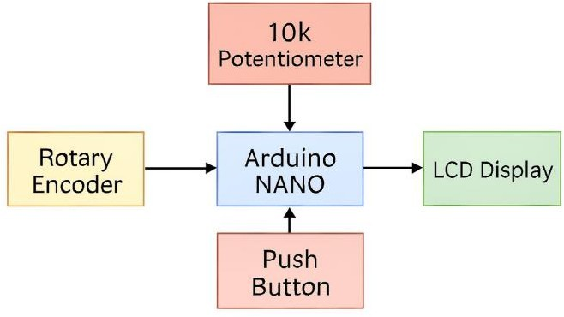

Figure 3.1: Block Diagram of Digital Measuring Tape

The proposed DIGITAL MEASURING TAPE system is designed as an integrated hardware and software platform that combines rotational sensing and real-time microcontroller processing to calculate and display linear distance. The block diagram of the system consists of several functional units: the sensor unit (Rotary Encoder), the microcontroller unit (Arduino Nano), the user interaction unit (Reset Button and Potentiometer), and the output unit (16x2 LCD). Each of these blocks performs a specific role in ensuring accurate motion acquisition, reliable signal processing, and clear data visualization.
The sensor unit forms the foundation of the system and is responsible for collecting real- time mechanical data from the measuring wheel. It consists of a rotary encoder that monitors the rotational displacement of the wheel as it moves across a surface. The rotary encoder measures the angular movement and generates two-phase electrical pulses (A and B signals), which allow the system to detect both the distance traveled and the direction of rotation. These signals are highly relevant as the number of pulses generated is directly proportional to the physical travel of the wheel. Unlike mechanical counters, this digital sensor unit provides high resolution and eliminates the friction or skipping common in older tools. Together, these signals generate a continuous stream of pulse data that is transmitted to the microcontroller for processing.
At the core of the system lies the Arduino Nano microcontroller, which serves as the central processing and control unit. The Arduino Nano is selected for its compact footprint, low power consumption, and high-speed interrupt capabilities, which are essential for accurately counting pulses from the encoder without missing data. It collects the digital signals from the encoder pins, performs pulse-to-distance conversion using embedded mathematical logic, and manages the timing for the display updates. The microcontroller is programmed using the Arduino IDE, handling tasks such as defining the wheel diameter, calculating the circumference, and executing the formula: Distance = (Circumference / Pulses Per Revolution) × Current Pulse Count. It also manages the logic for the reset function and controls the communication with the LCD module.
The user interaction unit provides the necessary controls for operating the device in practical environments. This includes a push-button specifically configured as a reset switch. When pressed, it sends a signal to the Arduino to clear the internal pulse counter and set the distance on the display back to zero, allowing for new measurements to begin immediately. Additionally, a 10k potentiometer is integrated into the circuit to control the contrast of the LCD. This allows the user to manually adjust the visibility of the text based on the ambient lighting of the workspace. These manual controls ensure that the device remains functional and easy to use for different measurement scenarios.
The output unit provides real-time notification of the measured results to the user. Locally, the system utilizes a 16x2 LCD display to show the calculated distance in centimeters with high precision. As the wheel rotates, the display updates dynamically, providing instant feedback. The system is designed to be highly responsive, with a dual- level display approach that shows the "Distance" label on the first row and the numerical value on the second row. This ensures clarity and ease of reading. The system is powered by a 9V battery or a USB connection, ensuring long-term portability and continuous operation during field tasks.
The communication between the rotary encoder and the Arduino Nano is seamless and high-speed. Data collected by the encoder is read using hardware interrupts to ensure that every pulse is captured even during fast rotation. The Arduino then transmits the formatted data to the LCD via a parallel or I2C interface, maintaining synchronization between the physical movement of the wheel and the digital readout. The hardware integration ensures that all components—sensors, microcontroller, power supply, and display—are connected to form a compact and functional digital tool. Overall, the block diagram of the DIGITAL MEASURING TAPE demonstrates a complete and efficient workflow, beginning from mechanical-level data acquisition, through microcontroller- based processing, to real-time digital display.

CHAPTER 4

HARDWARE ARCHITECTURE

ARDUINO NANO MICROCONTROLLER

At the core of the DIGITAL MEASURING TAPE system lies the Arduino Nano microcontroller, which acts as the brain of the device. It is responsible for interfacing with the rotary encoder, collecting rotational data, processing it, and displaying the calculated distance on the 16x2 LCD screen. The Arduino Nano is a compact, breadboard-friendly board based on the ATmega328P, providing reliable computational performance while maintaining a small form factor, which is crucial for handheld tool applications. It supports multiple digital and analog I/O pins, allowing for the precise timing required to handle high-frequency pulses from the rotary encoder.Its internal memory and efficient processing capability enable real-time calculation of linear distance without any noticeable lag as the wheel moves. Moreover, its low power requirement and cost-effectiveness make it ideal for portable, battery-operated measurement devices. In this project, the Arduino Nano executes the control logic, manages the pulse-counting interrupts, handles the mathematical conversion of rotations to centimeters, and updates the display interface instantly. The combination of simplicity, high-speed interrupt handling, and compact design makes the Arduino Nano a vital component for the seamless and accurate operation of the entire digital measurement system.
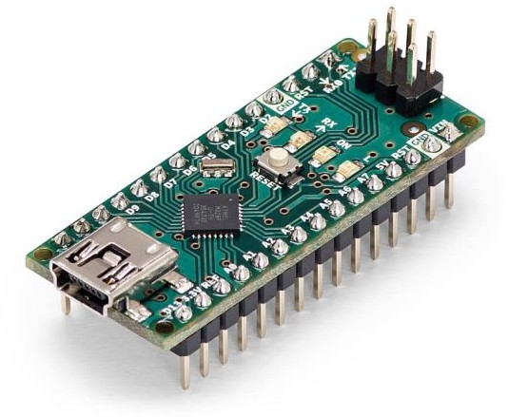
Figure 4.1: Arduino Nano Microcontroller

ROTARY ENCODER

The Rotary Encoder plays a key role in monitoring the mechanical rotation and movement of the measuring wheel. Linear measurement in this project is characterized by the physical displacement of the wheel as it rolls across a surface, which is accurately captured through incremental electrical pulses. This sensor detects the angular position of the shaft and converts the mechanical rotation into readable digital signals. These signals are transmitted to the Arduino Nano for processing and distance calculation. As the wheel rotates, the encoder generates high-resolution pulses that serve as the primary input for determining the exact distance traveled.
The rotary encoder used in this system offers high precision, stability, and a continuous rotation range, enabling accurate monitoring even during rapid or slow movements. Its compact and robust structure allows it to be conveniently attached to the central axle of the measuring wheel without adding significant bulk or resistance. By continuously tracking rotational activity, the rotary encoder provides crucial data that, when processed through mathematical formulas in the microcontroller, significantly enhances the reliability and precision of the digital measurement
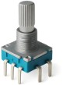
Figure4.2: Rotary Encoder

16x2 LCD DISPLAY
The 16x2 LCD (Liquid Crystal Display) serves as the primary visual output interface for the DIGITAL MEASURING TAPE system. Its role is to provide the user with immediate, real-time feedback by displaying the calculated linear distance. This display is capable of showing 32 characters in total, arranged in two rows of 16 characters each, which is sufficient for displaying both the measurement label and the numerical value with high precision. The LCD receives processed data from the Arduino Nano and updates its screen dynamically as the measuring wheel rotates.
In this system, the LCD is configured to show the text "Distance:" on the top row, while the second row displays the actual measurement in centimeters, rounded to two decimal places. This ensures that the user can read the results clearly without any ambiguity. To enhance usability, the display is connected to a 10k potentiometer that allows for manual contrast adjustment, ensuring the text is visible under different ambient lighting conditions. Its lowpower consumption and compatibility with the LiquidCrystal library make it an ideal choice for a portable measurement tool. By providing a clear and instant digital readout, the 16x2 LCD display eliminates the need for manual estimation and significantly improves the user experience during measurement tasks
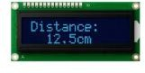
Figure4.3: 16X2 LCD Display

10k VARIABLE RESISTOR
The 10k potentiometer is a crucial component for managing the user interface of the DIGITAL MEASURING TAPE. It acts as a variable resistor that allows for manual adjustment of the voltage supplied to the LCD's contrast pin. By rotating the dial, the user can fine-tune the visibility of the text on the screen, ensuring that the measurement data remains sharp and legible regardless of external lighting conditions. Its simple three-pin design and ease of integration make it an efficient solution for optimizing the display quality in a portable tool. In this project, the potentiometer ensures that the digital readout is always clear for the user, bridging the gap between hardware performance and visual clarity.

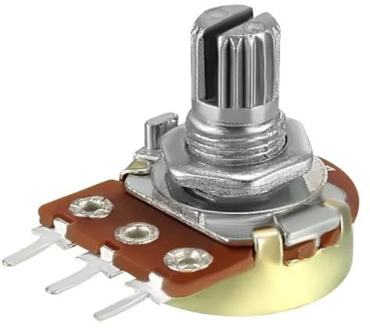
Figure 4.4: 10K Variable Resistor

RESISTOR

The 221Ω resistor (and associated pull-up resistors) is a fundamental component for ensuring the electrical stability of the DIGITAL MEASURING TAPE circuit. Its primary role is to provide the required voltage for logic operation by limiting the current flowing through sensitive components, such as the LCD backlight and the encoder interface. By preventing excessive current flow, the resistor protects the microcontroller and the display from potential thermal damage. Additionally, resistors are used in conjunction with the input pins of the Arduino Nano to maintain stable logic levels, preventing "floating" signals that could cause inaccurate distance readings.
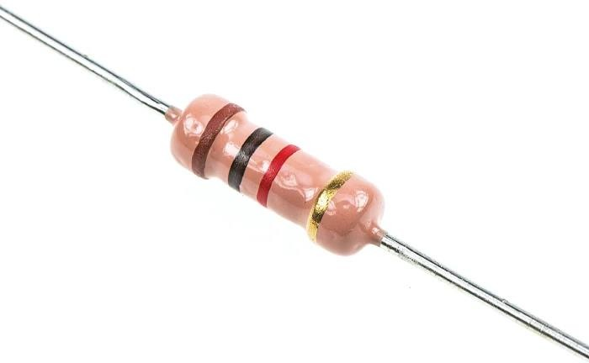

Figure 4.5: Resistor

BREADBOARD
The breadboard serves as the fundamental construction base for prototyping the DIGITAL MEASURING TAPE circuit. It allows for the easy and temporary connection of the Arduino Nano, rotary encoder, LCD display, and other components without the need for permanent soldering. By providing a series of interconnected conductive strips, the breadboard enables the quick routing of power and signals between the microcontroller and the sensors. Its solderless design is essential for testing the circuit logic, making adjustments to the wiring, and ensuring all electrical paths are correctly established before final assembly.

CHAPTER 5

IMPLEMENTATION AND RESULTS

HARDWARE IMPLEMENTATION

The DIGITAL MEASURING TAPE was implemented by integrating a rotary encoder with an Arduino Nano to track mechanical rotation. The encoder is attached to a measuring wheel, converting its movement into electrical pulses sent to the Arduino's interrupt pins. A 16x2 LCD provides the user interface, with a 10k potentiometer for contrast control and a 221Ω resistor for backlight protection. The setup is powered by a 9V battery, ensuring portability for field measurements.

CALCULATION AND LOGIC
The system's software processes pulses using the following formula to determine distance:


Figure5.1: Distance calculation

By using hardware interrupts, the Arduino ensures every pulse is recorded, even during fast movement. The code also features a reset function, allowing the user to clear the display and start a new measurement at any time.

RESULTS

Testing confirms that the system provides highly accurate, real-time feedback. When the wheel is rolled, the LCD displays the distance in centimeters with two-decimal precision. Comparative tests against manual tapes showed consistent accuracy across various distances. The results prove that the digital system is more efficient than manual tools, providing a clear, error-free readout for engineering and DIY tasks.

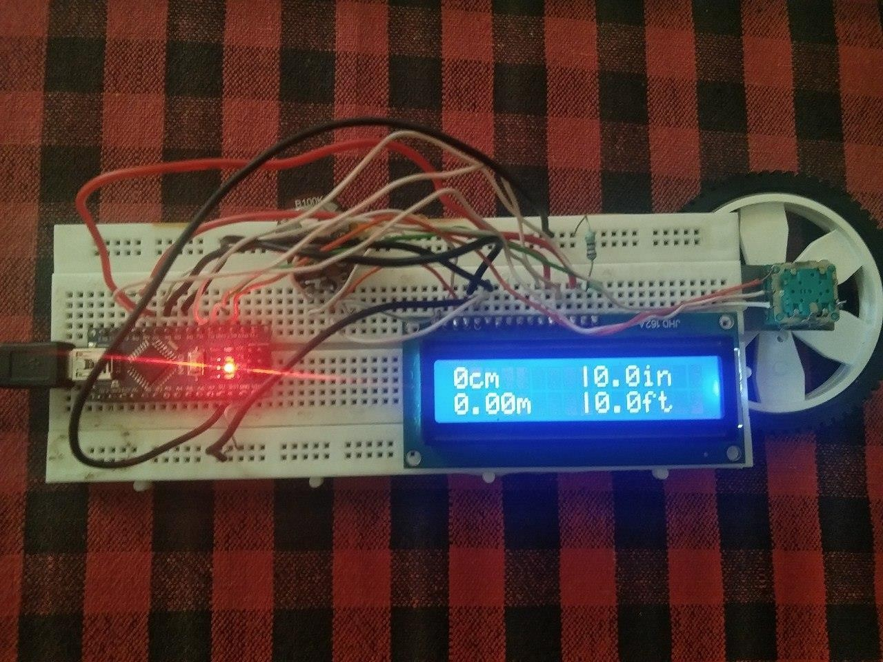

Figure 5.3: Real-time Multi-Unit Measurement Display on LCD Interface
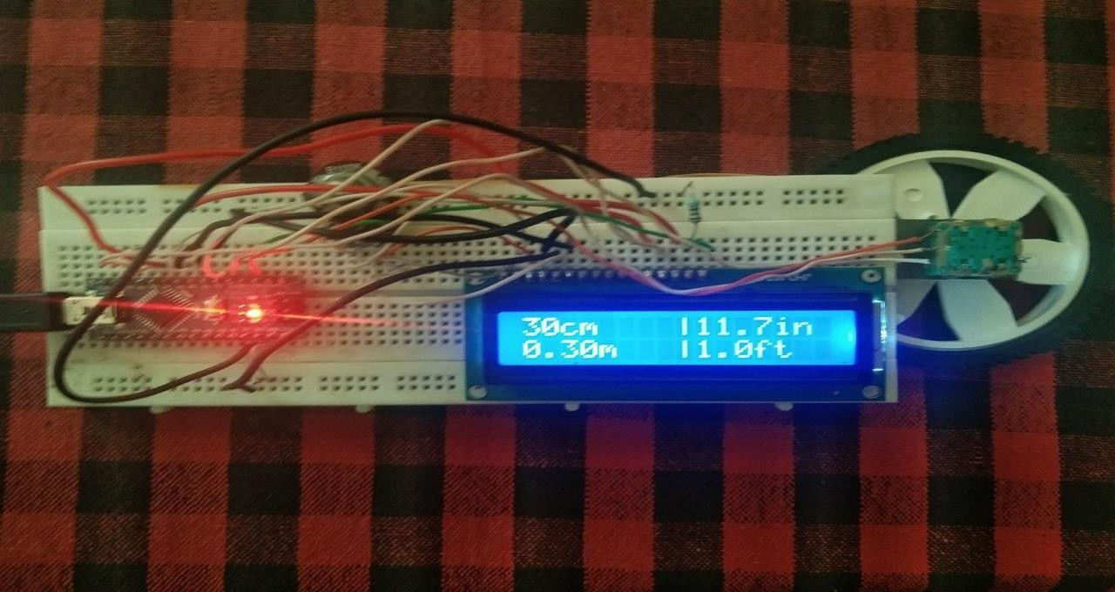

Figure 5.4: Result

CHAPTER 6

CONCLUSION AND FUTURE WORK

The DIGITAL MEASURING TAPE project was successfully developed with the primary objective of designing a low-cost, reliable, and portable electronic measurement system capable of providing high-precision data in real time. At its core, the system utilizes a high-resolution incremental rotary encoder interfaced with an Arduino Nano microcontroller, which serves as the central processing unit. This integration allows for the seamless translation of mechanical wheel rotation into accurate linear displacement. By leveraging hardware interrupts and a robust mathematical framework, the device effectively calculates distance and converts it into multiple standard units—centimeters, inches, meters, and feet—simultaneously. The inclusion of a 16x2 LCD interface and a manual contrast adjustment mechanism ensures that the digital readout is accessible and clear under various environmental conditions. Through this prototype, the project has successfully demonstrated that modern embedded systems and sensor-based technologies can bridge the gap between traditional manual tools and digital precision, offering a more efficient, error-free solution for engineering, construction, and DIY applications.
The implementation has proven that the combination of rotational sensing and microcontroller-based logic can significantly enhance the speed and accuracy of measurement tasks. The Arduino Nano’s ability to handle high-frequency pulse inputs without data loss ensures that the device remains accurate even during rapid movement, while the portable breadboard-based architecture confirms the feasibility of creating a handheld, battery-operated tool. The results of this project underscore the importance of digital transformation in the hardware domain, where manual estimation is replaced by exact mathematical computation. Furthermore, the modular nature of the design highlights how cost-effective components can be synthesized into a sophisticated industrial-grade instrument, providing a foundation for future innovations in smart tool technology.
Looking ahead, there are several promising directions for the expansion and optimization of the DIGITAL MEASURING TAPE system. Future work could focus on integrating wireless communication modules, such as Bluetooth Low Energy (BLE) or Wi-Fi, to enable the device to synchronize measurement data directly with a dedicated mobile application or cloud-based server for automated logging and project management. The current hardware prototype can be further refined through miniaturization techniques, including the design of a custom Printed Circuit Board (PCB) and a 3D-printed ergonomic enclosure, to enhance its durability and portability for professional field use. Additionally, the integration of supplementary sensors such as a laser-based distance module or an IMU (Inertial Measurement Unit) for tilt compensation—would allow for a multi-functional hybrid tool capable of both contact and non-contact measurements. Advanced software features, such as data storage for measurement history and a graphical OLED interface, would further improve the user experience. With these strategic enhancements, the system has the potential to evolve into a comprehensive, intelligent measurement companion that supports complex engineering workflows and precise digital documentation. The prototype's mechanical assembly emphasizes the critical relationship between the wheel’s physical diameter and the pulses generated per degree of rotation, where any variance in the wheel’s surface grip can introduce minor frictional errors. To mitigate this, the software architecture incorporates a scaling factor that aligns the theoretical pulses per revolution with the actual linear distance covered on various surface textures, such as wood, concrete, or fabric. This calibration process is vital for maintaining the integrity of the data across different industrial applications. Furthermore, the selection of the Arduino Nano as the primary controller provides a balance between processing power and energy efficiency, allowing the system to remain responsive during rapid manual movements while extending the operational lifespan of the internal power source.

The structural design of the Digital Measuring Tape also prioritizes modularity, enabling the easy replacement of the rotary encoder or the LCD module should hardware fatigue occur during heavy field use. By utilizing a high-speed interrupt-driven approach for pulse detection, the system avoids the lag associated with traditional polling methods, ensuring that the distance displayed on the screen is a true reflection of the wheel's position at any given microsecond. This level of responsiveness is complemented by the inclusion of a dedicated reset circuit, which allows the user to zero out the measurement instantaneously between tasks. As the system moves toward a more finalized form factor, the transition from a breadboard layout to a condensed circuit architecture will further reduce electromagnetic interference, ensuring that the digital signals remain clean and the measurements remain precise even in electronically noisy environments.

REFERENCES

- S. P. Sabarinath, “Digital Measuring Tape,” ElectronicWings, Dec. 13, 2021. [Online]
- J. Craftsman, “How to Make a Digital Tape Measure: Step-by-Step Guide / Arduino + 3D Print,” YouTube, Apr. 2023. [Online].
- Arduino Forum, “Digital Tape Measure Decoding Serial Data,” Arduino.cc, Dec. 14, 2024. [Online].
- R. G. Gupta, "Electronic Instrumentation and Measurements," McGraw-Hill Education, 2010.
- Atmel Corporation, “ATmega328P 8-bit AVR Microcontroller with 32K Bytes In- System Programmable Flash - Datasheet,” 2015.
- J. Maini, "Digital Electronics: Principles, Devices and Applications," John Wiley & Sons, 2007.
- Bourns Inc., “PEC11R Series - 12 mm Incremental Encoder Datasheet,” 2022. [Online].
- M. Banzi and M. Shiloh, "Getting Started with Arduino: The Open Source Electronics Prototyping Platform," 3rd Edition, O'Reilly Media, 2014.
- H. Huang, "The Atmel AVR Microcontroller: MEGA and XMEGA in Assembly and C," Delmar Cengage Learning, 2013.
- IEEE Standard for Rotary Variable Differential Transformers (RVDT), "Terminology and Test Methods for Rotary Encoders," IEEE Std 1215-2020.
- W. Bolton, "Mechatronics: Electronic Control Systems in Mechanical and Electrical Engineering," 6th Edition, Pearson Education, 2015.
- Adafruit Industries, "Character LCDs - Wiring a 16x2 LCD to Arduino," Adafruit Learning System, 2023. [Online].

APPENDIX

PROGRAMING CODE

The provided C++ code implements a real-time embedded system for a digital measuring tool using the Arduino Nano platform. The program begins by importing the LiquidCrystal library to manage the 16x2 LCD interface and defines the digital pins for the rotary encoder and the display. It establishes essential constants, such as the wheel diameter (7.0 cm) and the encoder's resolution (40 pulses per revolution), which serve as the foundation for all physical distance calculations. To ensure high precision and prevent data loss during rapid movement, the code utilizes hardware interrupts via the attachInterrupt() function, allowing the microcontroller to instantly track every pulse generated by the encoder.
The software logic is structured into two main parts: data acquisition and unit conversion. The readEncoder() function acts as an interrupt service routine, using a debounce delay to filter out electrical noise and accurately increment or decrement the "position" variable based on the direction of rotation. In the main execution loop, this position value is processed using a mathematical formula that multiplies the wheel's circumference by the pulse ratio to determine the base distance in centimeters. To provide a versatile user experience, the code then performs simultaneous floating-point conversions to calculate the equivalent distance in centimeters, inches, meters, and feet.
The final section of the code manages the multi-quadrant display on the 16x2 LCD. The screen is partitioned to show all four units of measurement at once, ensuring that the user has comprehensive data at a single glance. Additionally, the program monitors a physical reset switch; when pressed, it clears the current position and resets the display, allowing for immediate subsequent measurements. This implementation demonstrates a complete end-to-end workflow for an industrial measurement tool—from interrupt-driven sensor handling and calibration to multi-unit conversion and real-time visual output.
#include <LiquidCrystal.h>
LiquidCrystal lcd(5, 6, 7, 8, 9, 10); const int clkPin = 2;
const int dtPin = 3; const int swPin = 4;
volatile int position = 0; float distanceCm = 0; const float pi = 3.14159;
const float diameter = 7.0; const int pulsesPerRev = 40;
unsigned long lastInterruptTime = 0; const unsigned long debounceDelay = 2; void setup() {

pinMode(clkPin, INPUT_PULLUP);

pinMode(dtPin, INPUT_PULLUP); pinMode(swPin, INPUT_PULLUP); attachInterrupt(digitalPinToInterrupt(clkPin), readEncoder, CHANGE);
lcd.begin(16, 2);
lcd.print("4-UNIT MEASURE");
delay(2000); lcd.clear();
}
void loop() {
if (digitalRead(swPin) == LOW) { position = 0; lcd.clear(); lcd.print("RESETTING..."); delay(500);
lcd.clear();
}
distanceCm = ((pi * diameter) / pulsesPerRev) * position; if (distanceCm < 0) distanceCm = 0;
float distanceIn = distanceCm * 0.393701; float distanceM = distanceCm / 100.0;
float distanceFt = distanceCm * 0.0328084; lcd.setCursor(0, 0);
lcd.print(distanceCm, 0); lcd.print("cm"); lcd.setCursor(8, 0); lcd.print("|"); lcd.print(distanceIn, 1); lcd.print("in "); lcd.setCursor(0, 1);
lcd.print(distanceM, 2); l cd.print("m");
lcd.setCursor(8, 1); lcd.print("|"); lcd.print(distanceFt, 1); lcd.print("ft "); delay(150); }
void readEncoder() {
unsigned long currentTime = millis();
if (currentTime - lastInterruptTime > debounceDelay) { if (digitalRead(dtPin) != digitalRead(clkPin)) { position++;
}
else { position--;
}
lastInterruptTime = currentTime;
}
}

