Smart Shopping Cart with Automatic Billing System

MINI PROJECT REPORT

Submitted by

HELEN FRANCIS (Reg no: MDL22EC056)
JOHANN MANUEL (Reg no: MDL22EC060)
PANJAMI A (Reg no: MDL22EC093)
TINA SEBY (Reg no: MDL22EC120)

to
the APJ Abdul Kalam Technological University
in partial fulfillment of the requirements for the award of the Degree of
Bachelor of Technology in
Electronics and Communication Engineering



Department of Electronics Engineering
Model Engineering College Thrikkakara
March 2025

Department of Electronics Engineering Model Engineering College Thrikkakara

BONAFIDE CERTIFICATE

This is to certify that the report entitled Smart Shopping Cart with Automatic Billing System submitted by Helen Francis (MDL22EC056), Johann Manuel (MDL22EC060), Panjami A (MDL22EC093) and Tina Seby (MDL22EC120) to the APJ Abdul Kalam Technological University in partial fulfillment of the B.Tech. degree. It is a bonafide record of the project work carried out by them under our guidance and supervision. This report in any form has not been submitted to any other University or Institute for any purpose.

Guide Coordinator

Dr.Rajesh Mohan R Dr. Ashok Kumar T
Associate Professor Associate Professor
Department of Electronics and Department of Electronics and
Communication Engineering Communication Engineering

Head of the Department

Mr. Pradeep M
Associate Professor in Electronics and Communication Engineering

Acknowledgment

At the outset, we thank God Almighty for his countless blessings throughout our mini project work.
We would like to express our thanks to Principal, Dr. Mini M G, and Head of the Department Prof. Pradeep M for providing us with all the necessary facilities.
We would also like to thank our Mini Project guide Dr.Rajesh Mohan R and Mini Project coordinators Dr Ashok Kumar T and Assistant Prof. Rashid M.E, for their valuable help and support. We are highly obliged to them for all the valuable suggestions and guidance they provided.
Last but not least we thank all my classmates who always have been a great support and courage.

Abstract

The Smart Shopping Cart with a Self-Checkout System is an advanced technological innovation designed to enhance the shopping experience by integrating modern technologies such as Radio Frequency Identification (RFID), Internet of Things (IoT) and mobile applications. This concept aims to optimize the retail environment by offering a more personalized, efficient and seamless shopping journey for customers, while simultaneously streamlining operations for retailers.
The system’s core functionality relies on RFID technology, where each product in the store is equipped with an RFID tag that holds key information such as the product's name, price and a unique product identifier (ID). This data is automatically captured by the smart shopping cart, which is equipped with an RFID reader and various sensors. As customers shop, the cart automatically scans and registers each product, updating the cart's contents in real time without requiring manual barcode scanning. This provides a hassle-free shopping experience as customers can freely add and remove items without worrying about delays caused by traditional checkout procedures.

Contents

- INTRODUCTION 1
  - Scope 1
  - Relevance 1
  - Application 2
  - Objective 3
- LITERATURE REVIEW 4
  - Development of Automatic shopping trolley in supermarkets 4
  - Design and implementation of automatic trolley by using mobile phone 4
  - RFID based intelligent trolley using Zigbee 5
  - RFID based automatic shopping cart 5
  - Smart shopping trolley using RFID 5
- METHODOLOGY 6
  - System Overview 6
  - Block Diagram 7
  - Design 9
    - Hardware Design 9
    - Software Design 11
  - Circuit Diagram 12
  - Algorithm 13
  - Feasibility Study 14
- IMPLEMENTATION AND RESULT 15
  - System Implementation 15
    - Hardware Implementation …..15
    - Software Implementation 16
- CONCLUSION 18
  - Future Scope 18
  - Advantage And Application 18
  - Drawbacks 18
References
- APPENDIX 20
  - System Specifications 20
  - Code 20

List of Figures

Figure 3.1: Block Diagram of the Smart Shopping Cart Figure 3.2: RC522 Pinout
Figure 3.3: RC522 RFID Module Figure 3.4: ESP8266 Pinout Figure 3.5: OLED
Figure 3.6: Circuit Diagram Figure 4.1: Blynk App

List of Abbreviations

IoT Internet of Things

RFID Radio Frequency Identification OLED Organic Light Emitting Diode LCD Liquid-Crystal Display
UID Unique Identification Number SPI Serial Peripheral Interface I2C Inter integrated-Circuit
NFC Near Field Communication

UPI Unified Payments Interface

Model Engineering College Chapter 1

Chapter 1

INTRODUCTION
The Smart Shopping Cart System enhances the shopping experience by automating item detection and billing. Using ESP8266, RC522 RFID reader, OLED display and the Blynk app, the system scans RFID-tagged items and displays the item name, price and wallet balance on the OLED screen. It also maintains a list of purchased items for easy tracking. The Blynk app provides remote access to shopping data, ensuring a seamless and efficient checkout process. This system reduces manual effort, eliminates long queues and promotes a smart and cashless retail experience.

SCOPE
The Smart Shopping Cart System aims to enhance the retail shopping experience by integrating automation and real-time tracking. Using RFID technology, the system enables automated item detection, eliminating the need for manual barcode scanning. It provides real-time billing by displaying the item name, price and updated wallet balance on an OLED screen, while also maintaining a digital shopping list for easy reference. The Blynk app enhances convenience by allowing remote access to shopping data. This system reduces checkout time, promotes cashless transactions and minimizes human effort, making shopping faster and more efficient. Additionally, it can be scaled and integrated with store inventory systems, paving the way for a smart and automated retail environment.

RELEVANCE
With the rapid advancement of technology, the retail industry is shifting towards automation to enhance efficiency and customer convenience. The Smart Shopping Cart System is highly relevant as it addresses key challenges in traditional shopping, such as long checkout queues, manual billing errors and the need for cash transactions. By integrating RFID technology, ESP8266, an OLED display and the Blynk app, this system streamlines the shopping process, ensuring faster, error-free and cashless transactions.
Department of Electronics Engineering 1

The project is particularly relevant in today’s digital age, where contactless payments and smart retail solutions are becoming the norm. It enhances the overall shopping experience by providing real-time item tracking, automated billing and seamless payment integration. Moreover, with the increasing demand for self-service shopping solutions, this system can be adopted in supermarkets, retail stores and shopping malls to improve operational efficiency and customer satisfaction. The Smart Shopping Cart represents a step towards the future of automated, intelligent and hassle-free shopping.

APPLICATIONS
The Smart Shopping Cart System has a wide range of applications, particularly in supermarkets, retail stores and shopping malls, where it enhances the shopping experience by automating item detection and billing. By integrating RFID technology, ESP8266, an OLED display and the Blynk app, this system eliminates the need for manual barcode scanning, significantly reducing checkout time and long queues. It also supports cashless transactions, making the payment process more secure and efficient while reducing dependency on physical cash. Additionally, the system can be integrated with store inventory management, allowing retailers to track stock levels in real time and manage supply more effectively. In self-service shopping environments, the cart enables customers to scan, track and pay for items independently, providing a more seamless and interactive experience. The automated billing feature minimizes human errors, ensuring accuracy in transactions and reducing the need for additional staff at checkout counters. This system can also be expanded into IoT-based retail solutions, incorporating AI and machine learning to provide personalized shopping recommendations based on user behaviour. Beyond traditional shopping environments, the technology can be adapted for wholesale and warehouse management, where digital tracking of purchased items improves operational efficiency. As smart and automated retail solutions become more popular, this Smart Shopping Cart System represents a significant step towards the future of intelligent, efficient and hassle-free shopping.

OBJECTIVE
The primary objective of the Smart Shopping Cart System is to automate and enhance the shopping experience by integrating RFID technology, ESP8266, OLED display and the Blynk app. This system aims to eliminate manual barcode scanning, reduce checkout time and provide a seamless, cashless and efficient billing process. It ensures real-time tracking of purchased items and displays essential details such as item name, price and wallet balance on the OLED screen, improving accuracy and transparency.
Additionally, the system seeks to minimize human intervention, reducing errors in billing and enhancing customer convenience. By integrating with the Blynk app, it allows remote access to shopping data, enabling users to track their expenses effectively. Another key objective is to support digital payments, promoting a cashless retail environment. Furthermore, the system is designed to be scalable and adaptable, allowing integration with inventory management systems for better stock tracking and management. Overall, the Smart Shopping Cart System aims to modernize the retail sector by making shopping faster, smarter and more efficient.

LITERATURE REVIEW

This section reviews all the papers that have been referenced in order to do this project.

DEVELOPMENT OF AUTOMATIC SHOPPING TROLLEY IN SUPERMARKETS
The Automatic Electronic Shopping Trolley uses RFID, Bluetooth and sensors to enhance the shopping experience by automating the movement of the trolley and streamlining the checkout process. Controlled via a mobile app, the trolley moves automatically, reducing the effort of pushing it around. Products are detected using an RFID reader, and the total bill is displayed on an LCD screen. Customers can check out using a mobile app or card, bypassing long queues at the billing counter. This system saves time, improves efficiency and offers a more convenient shopping experience, though it may involve higher implementation costs and require infrastructure updates in malls for RFID and self-checkout systems.

DESIGN AND IMPLEMENTATION OF AUTOMATIC TROLLEY BY USING MOBILE PHONE
With advancements in technology, customer expectations have grown, especially in reducing time spent in long billing queues. To address this, a smart shopping cart solution is proposed, featuring a Raspberry Pi controller, RFID Reader, RFID Tags, L298N Motor Drivers, Pi Camera, Load Cell and a Mobile Cart Application. Customers scan products using the RFID reader attached to the cart, and the load cell measures the weight of the items. Price details are reflected in the mobile app, and the final bill is displayed once all items are scanned, offering a more efficient and time-saving shopping experience.

RFID BASED INTELLIGENT TROLLEY USING ZIGBEE
The project consists of an RFID based trolley that communicates with the billing side using a ZIGBEE (NRF24L01) module. The RFID reader scans all the items as and when they are put in the trolley. The record of the items bought is stored in the microcontroller memory along with their individual costs as well as the total expenditure. This information will be displayed on a LCD screen which will also be placed on the trolley for the customer to verify the item bought and to keep a track on the amount spent on each item. At the billing side, the employee can get an itemized bill from each and every trolley just by giving the trolley number as the input to a software which would then print the itemized bill. Data can be erased from the microcontroller memory after the bill is printed so as to make that trolley reusable.

RFID BASED AUTOMATIC SHOPPING CART
The introduction of wireless technology along with other communication techniques has made people adopt e-commerce. A contemporary is to look forward to a product is one that aids the comfort, convenience and efficiency in everyday life. In this paper an innovative concept of the Automatic Shopping Cart in which the customer need not have to wait in the queue for billing for hours in shopping malls is used. Billing will be done automatically as and when the product is added to the cart by using RFID and Arduino. Automatically the amount will be deducted in case the customer chooses to remove the product from the cart.

SMART SHOPPING TROLLEY USING RFID
As mall traffic increases, especially during holidays and sales, long queues at billing counters have become a significant problem. To address this, a smart shopping cart system that streamlines the checkout process by displaying the total price of items directly in the cart. The system, based on Arduino Uno, an RFID Reader, RFID Cards and a Buzzer, eliminates the need for traditional barcode scanning. Customers can scan items with the RFID reader, and the total bill is updated in real-time on the cart. This allows customers to either pay through an app or at the counter, bypassing long lines. Additionally, the system lets customers remove items from their cart, offering more flexibility and control over their purchases. By speeding up the checkout process, reducing human error, and helping customers stay within their budget, this smart shopping cart enhances the overall shopping experience.

Chapter 3

METHODOLOGY
This section includes a brief overview of all the components used in the system.

SYSTEM OVERVIEW

The methodology for the Smart Shopping Cart with a Self-Checkout System integrates several advanced technologies, including RFID, IoT, and mobile applications, to enhance the shopping experience by providing a seamless, efficient and personalized journey for customers. Each product in the store is equipped with an RFID tag that contains key information, such as product name, price and a unique identifier. As customers shop, the smart cart automatically scans and registers each item in real-time without the need for manual barcode scanning. This eliminates delays at checkout, allowing the cart to update its contents and total price dynamically as items are added or removed. The mobile application is synchronized with the cart, providing customers with a user-friendly interface to monitor their cart's contents, view product details, receive personalized offers and complete the checkout process directly from their phone. This app also connects to a cloud-based backend that facilitates real-time inventory management and data analytics, helping retailers track stock levels and understand customer shopping patterns. The entire system undergoes thorough functional, usability and security testing to ensure a smooth and secure operation. After deployment in pilot stores, the system is continuously monitored, with regular feedback loops from both customers and retailers to optimize the shopping experience, improve operational efficiency and ensure the system meets evolving needs.

BLOCK DIAGRAM

Figure 3.1 shows the block diagram of the Smart Shopping Cart with an Automatic Billing System. The Power Supply powers all components, while the RFID Reader scans product tags for data like price and name. The Microcontroller processes this data, updating the cart's contents and total. Weight Sensors ensure accurate billing, and Communication Modules sync the cart with the store database and Mobile Application. The app serves as the User Interface, allowing customers to review their cart and complete payment via a Payment Gateway, ensuring an efficient and seamless shopping experience.

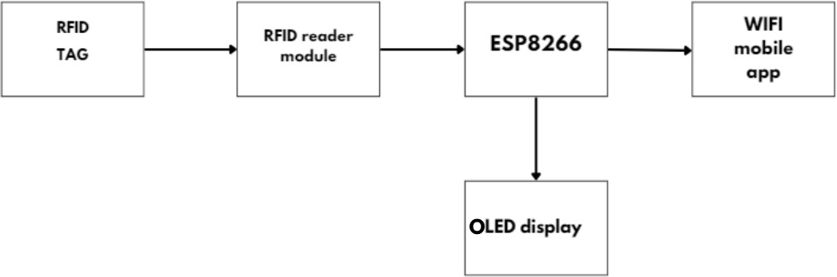

Figure 3.1: Block Diagram of the Smart Shopping cart
Department of Electronics Engineering 7

The Smart Shopping Cart with Automatic Billing System integrates multiple components to create a seamless and efficient shopping experience. The system begins when a product with an RFID tag is placed into the cart. The RC522 RFID reader scans the RFID tag, which contains vital product information such as the product's name, price and a unique identifier. This data is sent to the ESP8266 Wi-Fi module, which acts as the central controller for the system. The ESP8266 processes the information, calculates the total price and updates the cart’s contents in real time. The processed data is transmitted to the Blynk IoT app on the customer's smartphone, where they can track their shopping list, see product details and monitor the total price as they add or remove items. Simultaneously, the OLED display on the cart shows real-time information, including the list of products in the cart and the total price, giving customers instant visual feedback. When the shopping is complete, the customer can proceed to checkout through the Blynk app, where the payment is processed securely. The ESP8266 ensures communication between the RFID reader, Blynk app and OLED display, coordinating all actions and providing an automated, smooth and user-friendly shopping and billing experience. This system not only improves the efficiency of the checkout process but also enhances customer convenience by eliminating the need for traditional barcode scanning and manual entry.

DESIGN

Designing the Smart Shopping cart with an automatic billing system requires a systematic approach that involves both hardware and software design. The process begins with selecting the appropriate hardware components and creating the layout for their integration, followed by the development of the software that will control and manage these components.

HARDWARE DESIGN

- RC522 RFID Reader

  - The RC522 RFID reader is a widely used module to read and write data from RFID tags. In this system, it scans the RFID tags attached to products in the shopping cart. The tags contain essential product information such as the product name, price and a unique identifier. When a product is added or removed from the cart, the RFID reader detects the tag and sends the data to the ESP8266 Wi-Fi module for processing. It enables contactless identification and ensures that the cart’s contents are updated automatically.

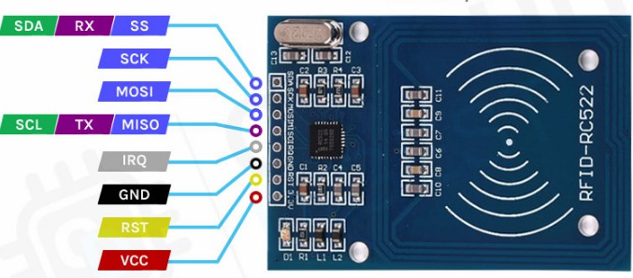

Figure 3.2: RC522 Pinout
Department of Electronics Engineering 9

- RFID Tags

  - RFID tags are small devices that store data about the product to which they are attached. Each tag has a unique identifier (UID) and additional data, such as the product's name, price and other relevant information. These tags allow the RC522 RFID reader to capture the product details without needing manual barcode scanning, speeding up the checkout process.

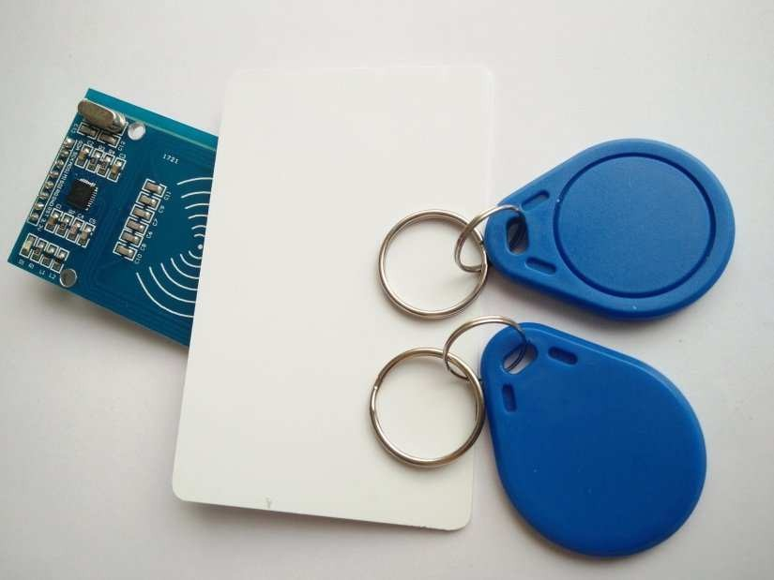

Figure 3.3: RC522 RFID Module

- ESP8266 Wi-Fi Module

  - The ESP8266 is a low-cost, low-power Wi-Fi module that serves as the central processing unit for the system. It receives data from the RC522 RFID reader, processes it and updates the shopping cart’s contents and total price. The ESP8266 also communicates with the Blynk IoT app to send real-time updates about the cart's status and with the OLED display to show the product details and total price. It acts as the bridge between the hardware components and the software (app), enabling communication over the Internet.

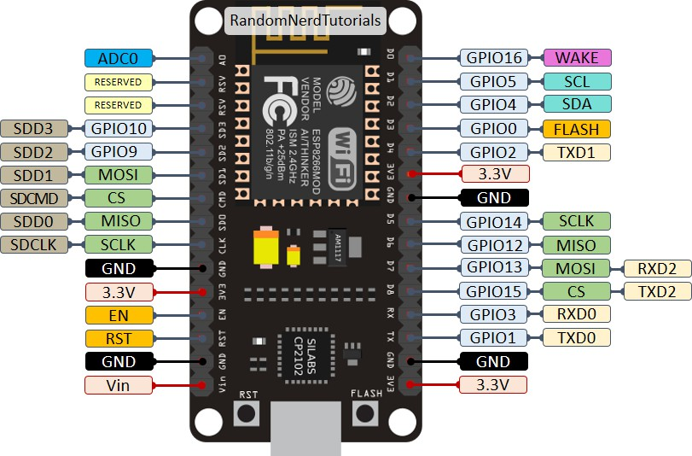

Figure 3.4: ESP8266 Pinout

- OLED Display

- The OLED display is used to provide real-time information about the cart to the customer. It shows the list of products in the cart, the individual price of each item and the total price. The display updates automatically as products are added or removed from the cart, giving the customer instant feedback on their shopping progress. The OLED display makes it easy for the customer to keep track of their purchases without needing to check their mobile app continuously.
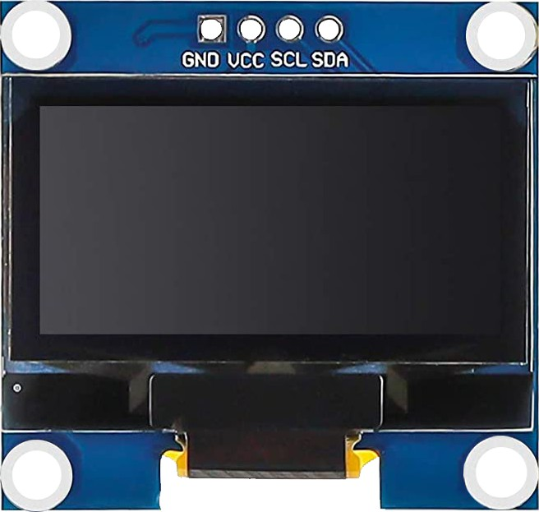

Figure 3.5 OLED

SOFTWARE DESIGN

Real time display in Blynk IoT- The Blynk IoT app is a mobile application that acts as the user interface for the system. It connects with the ESP8266 through Wi-Fi, allowing customers to monitor their shopping cart in real-time. The app displays product details, prices and the total cost of the items in the cart. The app also enables the customer to complete the checkout process, view promotions or discounts, and make secure payments. It is a critical part of the system for enhancing customer interaction and convenience.

Department of Electronics Engineering 11

CIRCUIT DIAGRAM

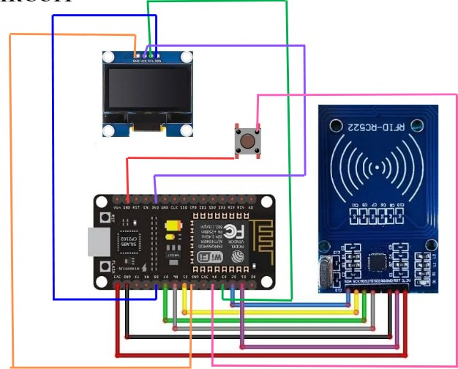
Figure 3.6 :Circuit Diagram

In essence, the circuit diagram illustrates how the RC522 RFID reader, ESP8266 Wi-Fi module, OLED display and Blynk IoT app are interconnected to create a smart, automated shopping experience. The diagram shows how the system collects data from RFID tags, processes it, displays it locally on the OLED screen and sends real-time updates to the mobile app, providing customers with an efficient and seamless shopping experience.

ALGORITHM
Step 1:Initialize System

- Start ESP8266, RFID Reader (MFRC522), OLED Display, and Wi-Fi.
- Connect to Blynk App.
- Set totalAmount=0.0 and walletBalance=predefined amount.

Step 2:Scan RFID Tag:

- Detect RFID tag and read UID.
- Match UID with stored product list to fetch item name & price.

Step 3:Update Billing:

- If item added: Add price to totalAmount, deduct from walletBalance, update OLED & Blynk.
- If item removed: Subtract price from totalAmount, refund to walletBalance, update OLED & Blynk.
Step 4:Display Updates:

- Show scanned item, total bill, and wallet balance on Blynk.
- Show Total bill on OLED display.

Step 5: End/Repeat

- Continuously monitor and repeat the process.

FEASIBILITY STUDY

The Smart Shopping Cart with Automatic Billing System is technically, economically, operationally and legally feasible. The technology required for the system is readily available and affordable. The system provides significant potential for cost savings and enhanced customer satisfaction, making it a good investment for modern retailers. The primary challenges are ensuring reliable Internet connectivity and addressing privacy concerns, but these are manageable with proper planning. Overall, this system has the potential to revolutionize the retail industry by streamlining the shopping experience and reducing operational costs.

IMPLEMENTATION AND RESULTS
This section illustrates the implementation, snapshots and results of the final project. System implementation can be expressed in terms of hardware and software implementation.

SYSTEM IMPLEMENTATION

HARDWARE IMPLEMENTATION:

The Smart Shopping Cart System integrates ESP8266, RC522 RFID reader, OLED display, push button and the Blynk app for an automated shopping experience. The ESP8266 controls communication between components and updates the Blynk app for remote monitoring. The RC522 RFID reader scans tagged items, displaying the item name and price on the OLED screen. A push button allows user interactions, such as confirming purchases or removing items. The Blynk app tracks purchased items and updates the wallet balance in real time. Powered by a portable battery, the system ensures efficient, compact and scalable operation for smart retail applications.

ESP8266 Board

The ESP8266 Wi-Fi module serves as the core microcontroller in the Smart Shopping Cart System, enabling seamless communication between hardware components and the Blynk app. It processes data from the RC522 RFID reader, updates the OLED display and transmits shopping details to the Blynk cloud for real-time monitoring. Its built-in Wi-Fi capability allows users to track purchased items, prices and wallet balance remotely. Additionally, ESP8266 ensures low power consumption, compact design and efficient processing, making it ideal for IoT-based smart retail applications.

RFID RC522 Module

The RC522 RFID reader is used to detect and identify RFID-tagged items in the Smart Shopping Cart System. When a product with an RFID tag is placed in the cart, the RC522 module reads its unique ID and sends the data to the ESP8266 microcontroller for processing. The system then retrieves the item name and price and displays them on the OLED screen. The RC522 operates at 13.56 MHz and uses SPI communication, ensuring fast and accurate scanning. Its compact design, low power consumption and high-speed operation make it ideal for automated retail solutions.

OLED Display

The OLED display is used to provide real-time visual feedback in the Smart Shopping Cart System. It displays essential details such as the item name, price, total bill and wallet balance, ensuring a seamless shopping experience. The display is energy-efficient, compact and offers high contrast, making it easily readable in various lighting conditions. Controlled by the ESP8266, the OLED screen updates dynamically whenever an item is added or removed from the cart. Its fast response time and clear visibility enhance user interaction, making it an ideal choice for smart retail applications.

SOFTWARE IMPLEMENTATION

Blynk integration

Fig 4.1 shows how the details are displayed in the Blynk app
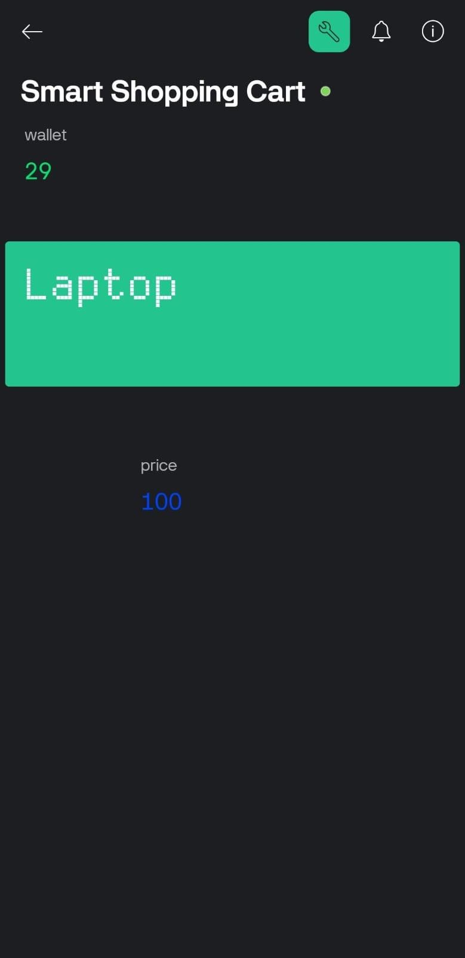
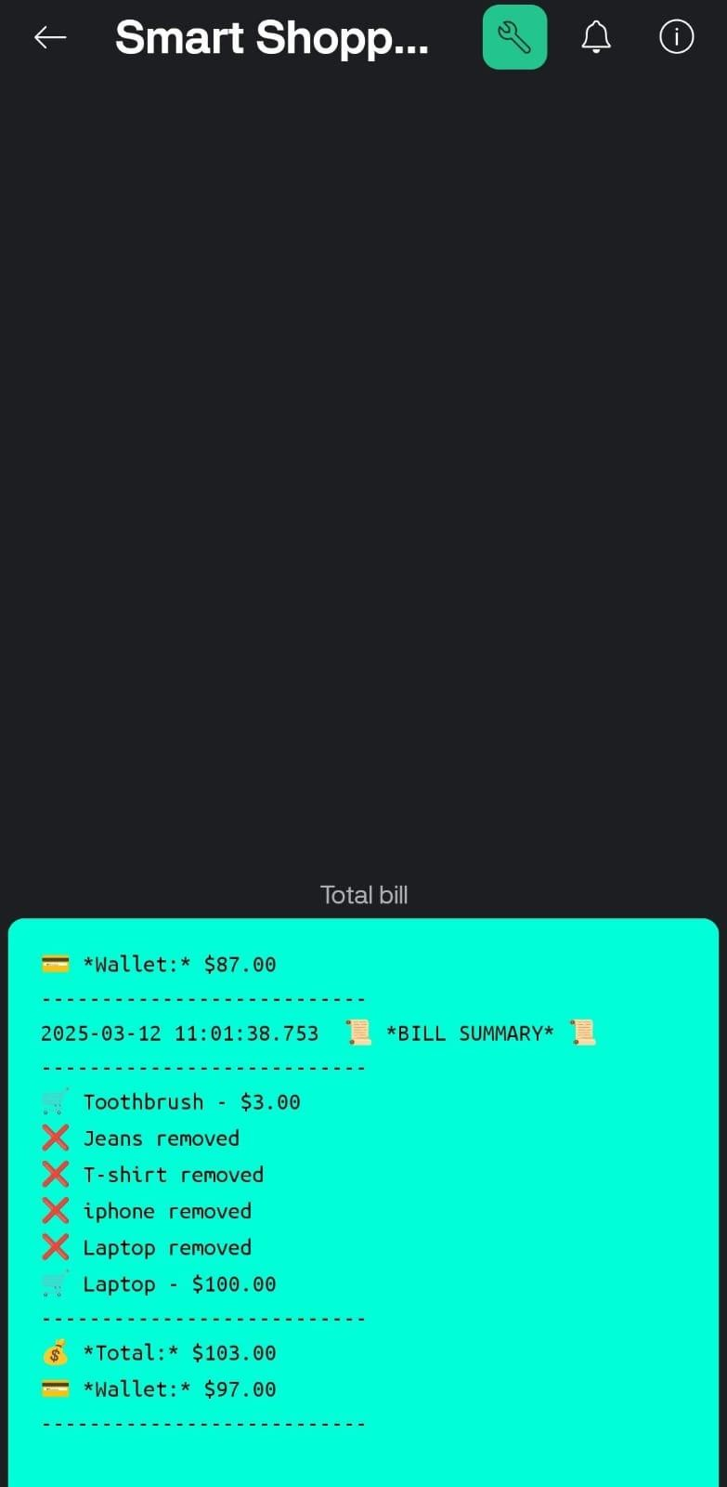
Figure 4.1: Blynk App

CHAPTER 5

CONCLUSION
The Smart Shopping Cart System is a step towards modernizing the retail shopping experience by integrating automation, real-time tracking and cashless transactions. Traditional shopping methods often involve manual barcode scanning, long checkout queues and human errors in billing, leading to inefficiencies and delays. This system addresses these challenges by using ESP8266, RC522 RFID reader, OLED display and the Blynk app to create a seamless and intelligent shopping experience. By utilizing RFID technology, items are automatically detected when added to the cart, eliminating the need for manual barcode scanning. The OLED display provides real-time information about each item's name, price, total bill and wallet balance, allowing users to track their expenses conveniently. The Blynk app integration further enhances usability by enabling remote access to shopping details, ensuring customers have full control over their purchases. Additionally, the push button allows users to confirm or remove items from the cart, providing flexibility and ease of use.
The cashless transaction feature not only makes the payment process more efficient but also reduces dependency on physical cash, aligning with modern digital payment trends. This system significantly reduces human effort, minimizes billing errors and enhances inventory management by automatically updating store records based on items scanned in the cart. Retailers can also benefit from improved stock management, enhanced customer satisfaction and reduced operational costs. Looking ahead, the Smart Shopping Cart System has the potential for further advancements, including AI-based recommendations, automated discount application, barcode integration and advanced payment methods such as NFC or UPI-based transactions. The system can also be expanded to support self-checkout stations, smart retail stores and warehouse inventory tracking, making it a scalable solution for the evolving retail industry.
In conclusion, this project provides a faster, smarter and more efficient shopping experience, benefiting both customers and retailers. It represents a significant step towards the future of smart retail, improving convenience, accuracy and automation in shopping environments.

FUTURE SCOPE
The Smart Shopping Cart System has immense potential for future advancements, making it a scalable and adaptable solution for the evolving retail industry. Some key areas of future development include:
    - Advanced Payment Systems
    - Self-Checkout Implementation
    - Inventory Management & Analytics
    - Smart Navigation System
    - Security Features

ADVANTAGES AND APPLICATION
- Cashless Transactions – Supports digital payments, reducing dependency on physical cash.
- Reduces Manpower Requirements – Minimizes the need for cashier and billing staff, cutting operational costs.
- Supermarkets & Retail Stores – Automates the shopping and checkout process, reducing long queues.
- Self-Service Shopping – Allows customers to independently scan and pay for items.

DRAWBACKS

The Smart Shopping Cart System has drawbacks, including RFID interference in crowded stores, and reliance on internet connectivity, which may cause disruptions. Customer adaptation can be challenging, and security risks like unauthorized RFID scanning require safeguards. However, advancements in technology can help mitigate these issues.

REFERENCES

International Journal of Applied Engineering Research Vol. 13, No. 23,pp. 16545 – 16547 Development of Automatic Shopping Trolley in Supermarkets.

- Design & Implementation of Automated Trolley by Using Mobile Frequency V.B. Vaidya, Pranjal S, Yash G, S. Mohite,S. Zode, R. Singh.

- Smart shopping trolley using RFIDP. T. Sivagurunathan, P. Seema, M. Shalini,R. Sindhu

- RFID Based Intelligent Trolley System using ZigbeeP. Sudha, R. Basri, Shobha, Shajahan,T.Babu.

- RFID Based Automatic Shopping Cart Deepa Saibannavar, Yogesh Naik.

CHAPTER 6

APPENDIX
  - SYSTEM SPECIFICATIONS
Operating Voltage = 3.3V in built Wi-Fi =2.4 GHz

CODE
#include <Wire.h> #include <Adafruit_GFX.h>
#include <Adafruit_SSD1306.h>
#include <SPI.h> #include <MFRC522.h>
#define BLYNK_TEMPLATE_ID "TMPL3de9Q8UHz"
#define BLYNK_TEMPLATE_NAME "Quickstart Template" #include <ESP8266WiFi.h>
#include <BlynkSimpleEsp8266.h>

#define SCREEN_WIDTH 128
#define SCREEN_HEIGHT 64
#define OLED_RESET -1
Adafruit_SSD1306 display(SCREEN_WIDTH, SCREEN_HEIGHT, &Wire, OLED_RESET);

#define SS_PIN D8 #define RST_PIN D3
MFRC522 rfid(SS_PIN, RST_PIN);

// WiFi & Blynk Credentials
char auth[] = "TBQ0cT6E0ZEFLpUDNtezQckvD2eswiGV"; char ssid[] = "OnePlus Nord CE 2 Lite 5G";
char pass[] = "get lost";

struct Item { byte uid[4];
const char* name; float price;
};
Item items[] = {
{{0xFB, 0x5D, 0xE8, 0x3B}, "Jeans", 10},
{{0xEB, 0xBB, 0x9C, 0x3B}, "T-shirt", 8},
{{0xEB, 0x7D, 0x62, 0x3B}, "iphone", 50},
{{0xFB, 0x06, 0x88, 0x3B}, "Toothbrush", 3},
{{0xEB, 0x3F, 0xBE, 0x3B}, "Laptop", 100},
{{0x13, 0x1C, 0x79, 0x22}, "PANJAMI", 0}
};

const int numItems = sizeof(items) / sizeof(items[0]); bool itemState[numItems];

#define BUTTON_PIN 2

float totalAmount = 0.0; float walletBalance = 200.0;

bool lastButtonState = HIGH; bool buttonPressed = false; bool scanningEnabled = true;
unsigned long lastDebounceTime = 0; unsigned long debounceDelay = 50;

BlynkTimer timer; String billDetails = "";

bool compareUID(byte *uid, byte *storedUID) { for (byte i = 0; i < 4; i++) {
if (uid[i] != storedUID[i]) return false;
}
return true;
}
void updateBlynkBill() {
String bill = "📜 *BILL SUMMARY* 📜\n"; bill += " \n";
bill += billDetails; // Add scanned items bill += " \n";
bill += "💰 *Total:* $" + String(totalAmount, 2) + "\n";
bill += "💳 *Wallet:* $" + String(walletBalance, 2) + "\n"; bill += " \n";
Blynk.virtualWrite(V10, bill); // Send to Blynk Terminal
}

void setup() { Serial.begin(115200);

// Reset item states
for (int i = 0; i < numItems; i++) { itemState[i] = false;
}

// Reset total amount and wallet balance totalAmount = 0.0;
walletBalance = 200.0; // Reset to initial wallet balance billDetails = ""; // Clear bill details

Blynk.begin(auth, ssid, pass);

if (!display.begin(SSD1306_SWITCHCAPVCC, 0x3C)) { Serial.println("SSD1306 allocation failed");
while (1);
}

SPI.begin(); rfid.PCD_Init();
pinMode(BUTTON_PIN, INPUT_PULLUP);

display.clearDisplay(); display.setTextSize(1); display.setTextColor(WHITE); display.setCursor(10, 20); display.println("RFID Ready!"); display.display();
Serial.println("RFID & OLED Initialized");

// ✅ *Clear Blynk LCD Display (if using Virtual Pin V9)* Blynk.virtualWrite(V9, " ");

// ✅ *Clear Blynk Terminal (if using Virtual Pin V10 for bill details)* Blynk.virtualWrite(V10, " ");

// ✅ *Reset Wallet Balance in Blynk (Virtual Pin V8)* Blynk.virtualWrite(V8, walletBalance);

// ✅ *Clear Last Scanned Item Price (Virtual Pin V5)* Blynk.virtualWrite(V5, " ");

// ✅ *Reset Total Amount in Blynk (Optional)* Blynk.virtualWrite(V6, totalAmount);
}

void loop() { Blynk.run();
timer.run();

int buttonState = digitalRead(BUTTON_PIN);
if (buttonState == HIGH && lastButtonState == LOW && (millis() - lastDebounceTime) > debounceDelay) {
buttonPressed = true; scanningEnabled = false; lastDebounceTime = millis();
} else if (buttonState == LOW && lastButtonState == HIGH) { buttonPressed = false;
scanningEnabled = true;
}
lastButtonState = buttonState;

if (scanningEnabled) {
if (!rfid.PICC_IsNewCardPresent() || !rfid.PICC_ReadCardSerial()) return;

Serial.print("RFID Tag UID: ");
for (byte i = 0; i < rfid.uid.size; i++) { Serial.print(rfid.uid.uidByte[i], HEX); Serial.print(" ");
}
Serial.println();

const char* itemName = "Unknown Item"; float itemPrice = 0.0;
bool itemFound = false; int foundIndex = -1;

for (int i = 0; i < numItems; i++) {
if (compareUID(rfid.uid.uidByte, items[i].uid)) { itemName = items[i].name;
itemPrice = items[i].price; itemFound = true; foundIndex = i;
break;
}
}

if (itemFound && foundIndex != -1) { if (!itemState[foundIndex]) { totalAmount += itemPrice; walletBalance -= itemPrice; itemState[foundIndex] = true;

billDetails += "🛒 " + String(itemName) + " - $" + String(itemPrice, 2) + "\n";

display.clearDisplay(); display.setTextSize(2); display.setCursor(10, 10); display.println("Added:");

display.setCursor(10, 35); display.print(itemName); display.display();

Serial.print("Added Item: "); Serial.println(itemName);
} else {
totalAmount -= itemPrice; walletBalance += itemPrice; itemState[foundIndex] = false;

billDetails.replace("🛒 " + String(itemName) + " - $" + String(itemPrice, 2) + "\n", "❌ "
+ String(itemName) + " removed\n");

display.clearDisplay(); display.setTextSize(2); display.setCursor(10, 10); display.println("Removed:"); display.setCursor(10, 35); display.print(itemName); display.display();

Serial.print("Removed Item: "); Serial.println(itemName);
}

Blynk.virtualWrite(V9, itemName); Blynk.virtualWrite(V5, itemPrice); Blynk.virtualWrite(V8, walletBalance); updateBlynkBill(); // Send bill update to Blynk
}

rfid.PICC_HaltA();
}

if (buttonPressed) { display.clearDisplay(); display.setTextSize(2); display.setCursor(10, 10); display.println("Total Amount"); display.setTextSize(3); display.setCursor(10, 40); display.print("$"); display.println(totalAmount, 2); display.display();

updateBlynkBill(); // Show the bill in Blynk Terminal delay(2000);
}

delay(500);
}

