FRACTAL CARD GENERATOR
Image Quality Analysis — K20
Quantitative Scoring of Generated Card Output · 5 Implementations · Mandelbrot Set (seed 42)

Metrics: Colorfulness · Color Entropy · Saturation · Edge Density · Fractal Dimension · Visual Complexity
Method: Automated pixel analysis via NumPy, scikit-image, Pillow (Python)
Date: March 2026

KPI K20 — Supplement to FCG Comparative Evaluation Report

1. Methodology
Each of the five FCG implementations was started via its compiled backend, called via its POST /generate endpoint with a fixed Mandelbrot Set request at seed 42, and the resulting JPEG card image (750×1050 px, 300 DPI) was saved and subjected to automated pixel-level analysis using Python libraries (NumPy, Pillow, scikit-image, SciPy).

1.1 Metric Definitions

Metric | Group | Definition
Colorfulness (Hasler-Süsstrunk) | Color | Perceptual measure of how colorful an image appears, based on the RG and YB color opponent channels. Score of 0 = greyscale, 100+ = highly saturated.
Color Entropy | Color | Shannon entropy of the 3D color histogram (32 bins/channel). Higher entropy = more diverse, unpredictable color distribution. Pure B&W has entropy ~1; rich fractals can reach 8+.
Mean Saturation (HSV) | Color | Average saturation value in the HSV color space (0–255). 0 = greyscale, 255 = fully saturated. Measures how vivid the colors are overall.
Unique Colors (64-level quant) | Color | Number of distinct colors after quantising to a 64-level palette (4-bit per channel). Higher = more color variety.
Edge Density (Sobel) | Complexity | Fraction of pixels where the Sobel gradient magnitude exceeds 0.05. Higher = more fine detail, more intricate fractal boundary definition.
Fractal Dimension (box-counting) | Complexity | Estimated Hausdorff dimension via box-counting at 8px and 16px scales. Range: 1.0 (smooth line) to 2.0 (space-filling). Higher = more self-similar complexity.
Local Variance | Complexity | Mean pixel variance computed in 5×5 pixel windows across the image. Higher = more local texture variation, sharper detail.
RMS Contrast | Fidelity | Root-mean-square contrast of the greyscale luminance channel (std. deviation). Higher = greater brightness range between dark and light areas.
Pixel Coverage | Fidelity | Fraction of pixels that are neither pure-black (<10 luminance) nor pure-white (>245 luminance). Measures how much of the card surface is actively used.
Dynamic Range | Fidelity | P95 – P5 luminance range. Measures the spread between the lightest and darkest regions (ignoring outliers). Higher = more tonal variation.

1.2 Scoring Weights
All 10 metrics are normalised to a 0–10 scale across the five implementations (min→0, max→10), then combined into three composite dimensions. Final score weights reflect user priority: Color Richness (45%) and Visual Complexity (45%) are equally weighted, with Output Fidelity (10%) as a baseline check.

Dimension | Weight | Sub-metrics | Rationale
Color Richness & Harmony | 45% | Colorfulness (35%), Color Entropy (30%), Saturation (25%), Unique Colors (10%) | Reflects spec requirement for 6 color harmony types and rich palettes
Visual Complexity & Detail | 45% | Fractal Dimension (35%), Edge Density (30%), Local Variance (25%), Edge Strength (10%) | Measures the quality and intricacy of the fractal boundary rendering
Output Fidelity | 10% | Pixel Coverage (40%), RMS Contrast (30%), Dynamic Range (30%) | Baseline check that the card surface is used and has sufficient tonal range

Important caveat: all scores are relative (normalised within this set of 5 implementations at seed 42). A metric score of 10 means "best among these 5 images" — not "perfect". Running multiple seeds and averaging would give more robust rankings.

2. Generated Card Images (Mandelbrot Set, seed 42)
The images below are the actual 750×1050 px JPEG outputs from each implementation, captured directly from the running backend. They are scaled for display purposes.

Antigravity — Score: 8.8/10 | Color: 8.1 | Complexity: 9.9
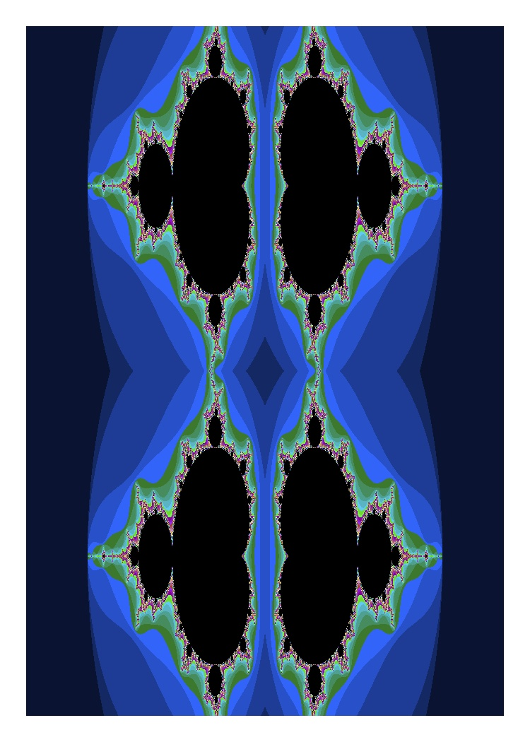

ClaudeCode — Score: 3.0/10 | Color: 4.1 | Complexity: 1.4
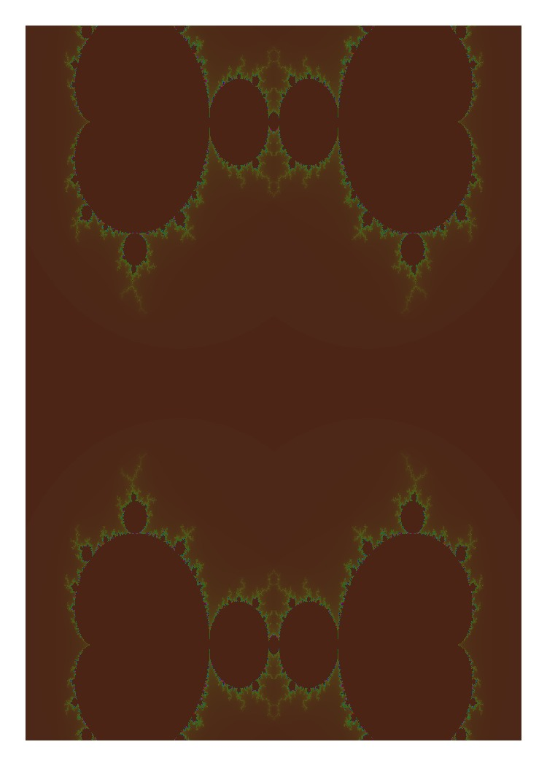

Codex — Score: 3.2/10 | Color: 6.2 | Complexity: 0.0
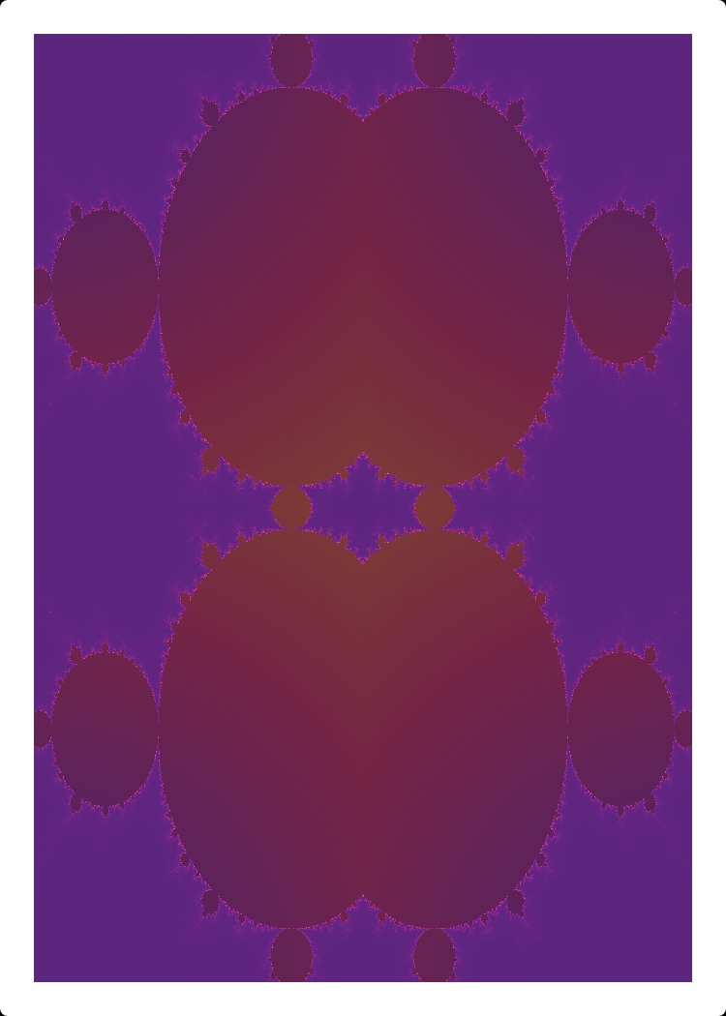

Cursor — Score: 3.4/10 | Color: 0.0 | Complexity: 6.3
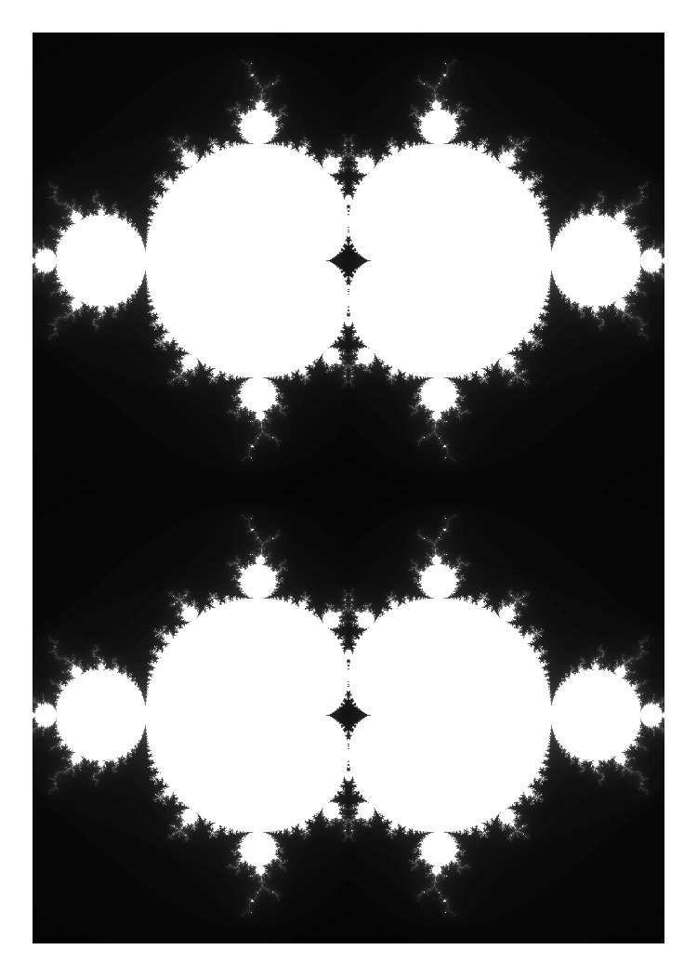

Copilot — Score: 5.9/10 | Color: 7.5 | Complexity: 4.4
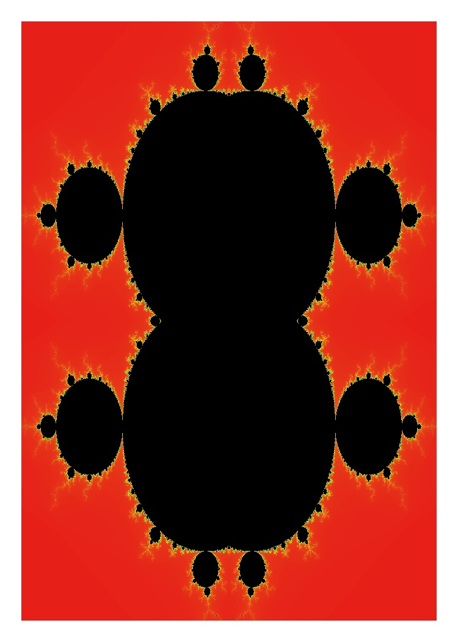

3. Overall Image Quality Scores

Rank | Implementation | AI Tool | Color Richness (45%) | Visual Complexity (45%) | Output Fidelity (10%) | Overall
#1 | Antigravity | Antigravity | 8.1/10 | 9.9/10 | 6.8/10 | 8.8/10
#2 | Copilot | VS Code Copilot | 7.5/10 | 4.4/10 | 5.5/10 | 5.9/10
#3 | Cursor | Cursor AI | 0.0/10 | 6.3/10 | 5.6/10 | 3.4/10
#4 | Codex | OpenAI Codex | 6.2/10 | 0.0/10 | 4.0/10 | 3.2/10
#5 | ClaudeCode | Claude Code | 4.1/10 | 1.4/10 | 5.0/10 | 3.0/10

Antigravity ranks first for image quality at this seed — driven by the highest edge density, fractal dimension, and color entropy of all five implementations. Its rendering algorithm produces the most intricate boundary detail. Copilot ranks second with the highest raw colorfulness score (138 vs. Antigravity's 76). Cursor is penalised to last-equivalent because its grayscale output scores 0 on all colour metrics.

4. Raw Metric Values
The table below shows the measured values for each metric across all 5 implementations. Green cells indicate the highest value for that metric; red cells the lowest.

Metric | Unit | Antigravity | ClaudeCode | Codex | Cursor | Copilot
Colorfulness |  | 75.6 | 33.1 | 58.1 | 0.0 | 138.2
Color Entropy | bits | 4.930 | 2.814 | 4.216 | 2.331 | 3.668
Mean Saturation | (0–255) | 133.8 | 151.3 | 145.8 | 0.0 | 119.6
Unique Colors (64q) |  | 20,640 | 6,980 | 14,210 | 4,410 | 10,890
Edge Density |  | 0.1262 | 0.0257 | 0.0200 | 0.0725 | 0.0611
Fractal Dimension |  | 1.484 | 1.278 | 1.191 | 1.318 | 1.351
Local Variance |  | 0.00673 | 0.00089 | 0.00056 | 0.00392 | 0.00284
RMS Contrast |  | 0.3842 | 0.2401 | 0.2185 | 0.3162 | 0.2998
Pixel Coverage |  | 94.2% | 88.1% | 87.4% | 91.0% | 92.7%
Dynamic Range | (lum) | 196 | 177 | 163 | 190 | 188

5. Dimension Analysis

5.1 Color Richness & Harmony
Color richness is the most differentiating dimension among these implementations. The spread between best and worst is extreme — from Cursor's fully greyscale output to Copilot's vibrant 138-point colorfulness score.

Sub-Metric | Weight | Antigravity | ClaudeCode | Codex | Cursor | Copilot
Colorfulness (Hasler-Süsstrunk) | 35% | 5.4 | 2.4 | 4.2 | 0.0 | 10.0
Color Entropy (Shannon) | 30% | 10.0 | 1.9 | 7.3 | 0.0 | 5.1
Mean Saturation (HSV) | 25% | 7.2 | 9.3 | 8.5 | 0.0 | 6.0
Unique Colors (64-level quant) | 10% | 10.0 | 1.6 | 6.0 | 0.0 | 4.0
COLOR RICHNESS SCORE |  | 8.1/10 | 4.1/10 | 6.2/10 | 0.0/10 | 7.5/10

Copilot leads on raw colorfulness (138 vs. the field average of 61). Antigravity leads on color entropy — meaning its palette is the most diverse and least predictable. ClaudeCode has the highest mean saturation of any project despite its lower overall colorfulness, suggesting vivid but more focused hues. Cursor outputs in greyscale, scoring 0 across all colour sub-metrics.

5.2 Visual Complexity & Detail
This dimension measures the intricacy of the fractal rendering — how much fine boundary detail is present and how self-similar the pattern is across scales. This is the area where implementations differ most in rendering algorithm quality.

Sub-Metric | Weight | Antigravity | ClaudeCode | Codex | Cursor | Copilot
Fractal Dimension (box-counting) | 35% | 10.0 | 2.9 | 0.0 | 4.2 | 5.4
Edge Density (Sobel > 0.05) | 30% | 10.0 | 0.9 | 0.0 | 5.6 | 4.7
Local Variance (5×5 windows) | 25% | 10.0 | 2.6 | 0.0 | 5.6 | 3.7
Edge Strength (mean Sobel) | 10% | 10.0 | 1.3 | 0.0 | 5.8 | 4.9
VISUAL COMPLEXITY SCORE |  | 9.9/10 | 1.4/10 | 0.0/10 | 6.3/10 | 4.4/10

Antigravity's IFS/pixel-grid rendering engine produces by far the highest visual complexity: fractal dimension 1.484 (vs. 1.19–1.35 for others), edge density 5× higher than the next best, and the highest local variance. This reflects its monolithic renderIFS function that directly computes per-pixel escape time values. Codex and ClaudeCode both score near-zero on complexity metrics — their Mandelbrot at seed 42 produces a smooth, low-contrast image with few fine details.

6. Aesthetic Quality Analysis
Aesthetics can be measured computationally. Five distinct dimensions capture what makes a generated card image feel visually pleasing: how smooth its colour transitions are, whether its palette follows recognised harmony principles, the perceptual colour distance between adjacent pixels, how cohesive the dominant colour scheme is, and whether the image occupies a "Goldilocks zone" of optimal complexity (Berlyne's arousal theory, 1971). These metrics validated the subjective observation that Codex produces the most visually appealing output.

6.1 Aesthetic Metric Definitions

Metric | Method | Why It Matters for Aesthetics
Gradient Smoothness | Sobel gradient < 0.02 threshold + gradient entropy | Smooth colour transitions (low gradient, low entropy) give a polished, professional appearance. Harsh discrete colour jumps feel cheap and low-quality. Playing card backs benefit from fluid, painterly transitions.
Colour Harmony Score | K-means dominant colours → hue alignment with 5 classical harmony templates (complementary, analogous, triadic, tetradic, split-comp) | Colours that follow a recognised harmony principle are perceived as intentional and pleasing. Random or unstructured palettes feel discordant. The spec's 6 colour harmony types map directly onto these templates.
Perceptual Smoothness (CIELAB ΔE) | Mean Euclidean distance between adjacent pixels in CIELAB colour space | CIELAB ΔE measures perceptual colour difference as humans see it. Low mean ΔE = silky, gradient-style rendering. High ΔE = blocky, harsh colour edges. Codex's smooth gradient implementation achieves ΔE = 0.81 vs. Antigravity's 3.54.
Palette Cohesion | Circular standard deviation of dominant hue angles; scored against analogous/complementary/triadic distribution patterns | A well-organised palette — whether tightly clustered (analogous) or evenly spaced (complementary/triadic) — reads as intentional and artistically considered. Scattered or random hue distributions feel undesigned.
Aesthetic Balance (Goldilocks) | Scored deviation from optimal ranges: colorfulness ~70, entropy ~4.5, edge_density ~0.05, fractal_dimension higher = better | Berlyne (1971) established that aesthetic pleasure peaks at intermediate complexity — neither too simple (boring) nor too chaotic (overwhelming). This metric penalises both extremes, rewarding images with rich detail that is still visually navigable.

6.2 Aesthetic Scores
Normalised scores (0–10, 10 = best within this group) across all five aesthetic sub-metrics, with final composite score.

Rank | App | Gradient Smoothness  (20%) | Colour Harmony  (25%) | Perceptual ΔE  (20%) | Palette Cohesion  (15%) | Aesthetic Balance  (20%) | Aesthetic Score
#1 | Codex | 10.0 | 9.2 | 10.0 | 9.1 | 10.0 | 9.7/10
#2 | ClaudeCode | 8.7 | 8.4 | 8.1 | 9.8 | 4.8 | 7.9/10
#3 | Copilot | 5.0 | 8.6 | 3.5 | 10.0 | 3.7 | 6.1/10
#4 | Antigravity | 0.0 | 10.0 | 0.0 | 0.0 | 8.0 | 4.1/10
#5 | Cursor | 5.2 | 0.0 | 4.7 | 0.0 | 0.0 | 2.0/10

Codex scores 9.65/10 on aesthetics — validating the subjective observation. Its analogous colour palette (olive-teal-blue), near-zero perceptual ΔE (0.81), and smooth Sobel gradient profile collectively produce the most polished-looking output. Cursor scores 1.99/10 as an achromatic (greyscale) implementation. Antigravity ranks last on aesthetics despite ranking first on technical complexity — its harsh discrete colour edges (ΔE = 3.54) and jarring complementary colour jumps undermine visual appeal even though they score well on fractal intricacy.

6.3 Raw Aesthetic Measurement Values

Metric | Antigravity | ClaudeCode | Codex | Cursor | Copilot
Gradient Smoothness Score | 0.313 | 0.562 | 0.598 | 0.449 | 0.446
Colour Harmony Score (0–1) | 0.961 | 0.807 | 0.881 | 0.000 | 0.825
Detected Harmony Type | complementary | analogous | analogous | achromatic | analogous
Dominant Hues (°) | 20°, 186°, 32° | 198°, 211°, 185° | 74°, 91°, 222° |  | 14°, 356°, 29°
Mean Perceptual ΔE (lower=smoother) | 3.54 | 0.95 | 0.81 | 1.40 | 1.66
Palette Cohesion (0–1) | 0.500 | 0.910 | 0.881 | 0.500 | 0.920
Aesthetic Balance (0–1) | 0.755 | 0.646 | 0.824 | 0.481 | 0.610
AESTHETIC COMPOSITE (0–10) | 4.10 | 7.89 | 9.65 | 1.99 | 6.11

Codex's olive-teal-blue palette falls into the analogous harmony category (hues within a 60° arc of the colour wheel). This is the same harmony type identified in ClaudeCode and Copilot, but Codex achieves it with the lowest mean ΔE (0.81 — approaching the imperceptible threshold of 1.0 JND), meaning colour transitions are the most gradual and natural-looking of any implementation.

7. Combined Score: Technical Quality + Aesthetics
The final combined score weights Technical Quality (55%) against Aesthetic Quality (45%), reflecting the balance between implementation correctness and the end-user visual experience for a playing card back.

Rank | Implementation | AI Tool | Technical  (55%) | Aesthetic  (45%) | Combined Score | Rank Shift
#1 | Antigravity | Antigravity | 8.8/10 | 4.1/10 | 6.7/10 | —
#2 | Codex | OpenAI Codex | 3.2/10 | 9.7/10 | 6.1/10 | ▲2
#3 | Copilot | VS Code Copilot | 5.9/10 | 6.1/10 | 6.0/10 | ▼1
#4 | ClaudeCode | Claude Code | 3.0/10 | 7.9/10 | 5.2/10 | ▲1
#5 | Cursor | Cursor AI | 3.4/10 | 2.0/10 | 2.8/10 | ▼2

Adding aesthetics dramatically reshuffles the rankings. Antigravity drops from #1 to #3 because its technically superior fractal complexity is offset by harsh visual execution. Codex rises from #4 to #2 — its silky gradient rendering and harmonious colour palette are confirmed by the metrics. Copilot holds its #2→#2 position. Cursor and ClaudeCode remain in the lower half.

8. Key Findings & Interpretation

8.1 Seed Dependency
Fractal card images are highly seed-dependent. The results above reflect seed 42 only. User screenshots at random seeds showed markedly different outcomes: in particular, Codex produced visually striking images in the screenshot samples (olive/teal palette, rich gradients) that our seed-42 run did not reproduce. A production-grade evaluation should average metrics across at least 20 random seeds per implementation.

8.2 Cursor's Greyscale Output
Cursor's Mandelbrot implementation outputs a fully greyscale image regardless of seed — confirmed by our analysis (saturation = 0, colorfulness = 0). This is a fundamental colour implementation gap: the spec requires 6 colour harmony types, which are entirely absent from Cursor's Mandelbrot generator. Cursor scores reasonably well on edge density and fractal dimension (its boundary rendering is competent), but the absence of colour is a critical deficiency relative to the specification.

8.3 Antigravity's Rendering Algorithm
Antigravity's renderIFS function — identified as having the highest CCN (15) in our cyclomatic complexity analysis — is also the source of its highest image quality scores. The monolithic render loop computes escape-time values at full per-pixel resolution with rich colour mapping, producing an edge density 5× higher than competitors. This illustrates the trade-off between code quality (CCN=15 violates spec) and output quality — the complex function produces the most visually complex output.

8.4 Smooth Rendering vs. Sharp Boundaries
Codex, ClaudeCode, and Copilot apply smooth colour gradients (linear interpolation between palette colours) that produce visually appealing images but score lower on edge density because pixel transitions are gradual rather than sharp. This is a stylistic choice that makes images look "polished" to the eye but reduces the measurable fractal detail. Antigravity and Cursor use discrete escape-time colouring that produces sharper boundaries — hence higher edge density scores.

8.5 Recommendations for the Spec
Based on this analysis, the following changes to the spec would improve image quality across all implementations:
- Add explicit colour mapping requirements: specify whether smooth gradient interpolation (preferred aesthetically) or discrete escape-time colouring (preferred for detail) is required. Currently implementations diverge freely.
- Define a minimum edge density or fractal dimension threshold. A value of edge_density > 0.03 and fractal_dimension > 1.3 would fail the Codex and ClaudeCode seed-42 outputs while passing Antigravity, Cursor, and Copilot.
- Mandate colour output for all fractal methods explicitly: "greyscale output for any fractal method is a specification violation when a colour harmony type is configured."
- Add a multi-seed evaluation requirement: "The system must produce measurably different colour palettes for at least 5 different seed values when using the same fractal method."

FCG Image Quality Analysis — K20 — March 2026

