**Service 1 : Fetch Zipcode based on city name**

**code**

**From browser localhost: http://localhost:5000/zipcode?city=Chicago**

**from browser localhost :** [**http://localhost:5000/zipcode?city=New**](http://localhost:5000/zipcode?city=New) **York**

**From curl command line :**

1. curl <http://127.0.0.1:5000> & 2. curl <http://10.0.0.192:5000>

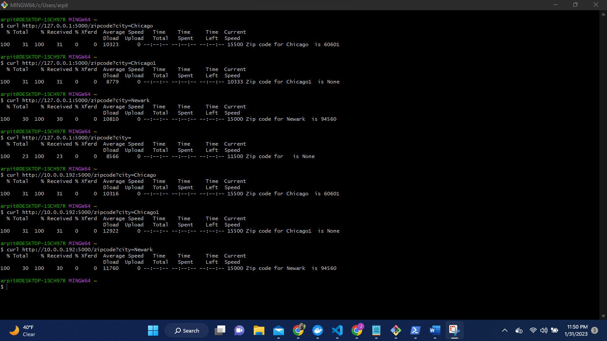

**Running the code inside a Docker container**

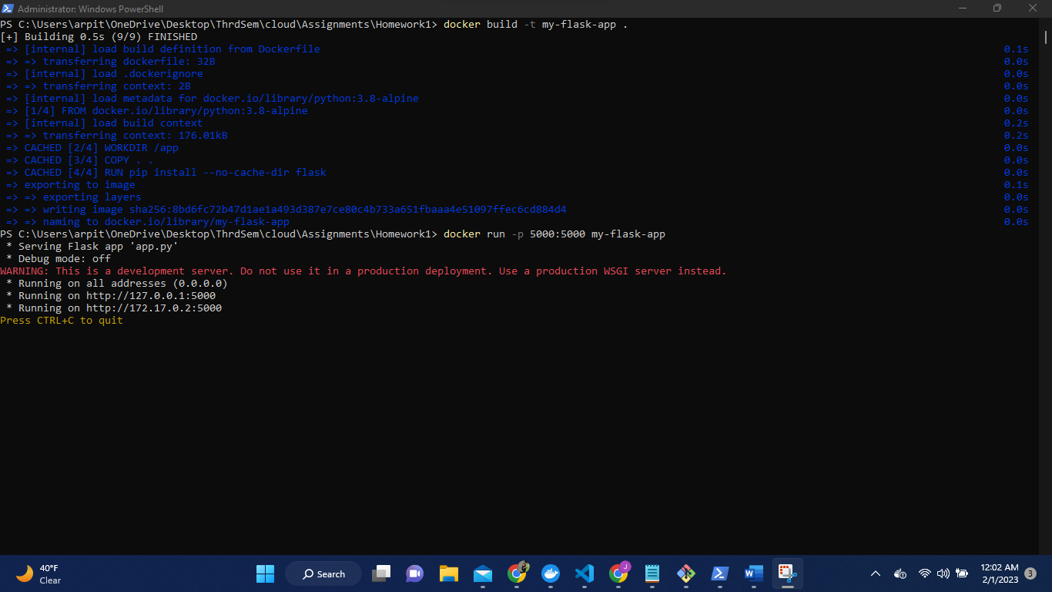

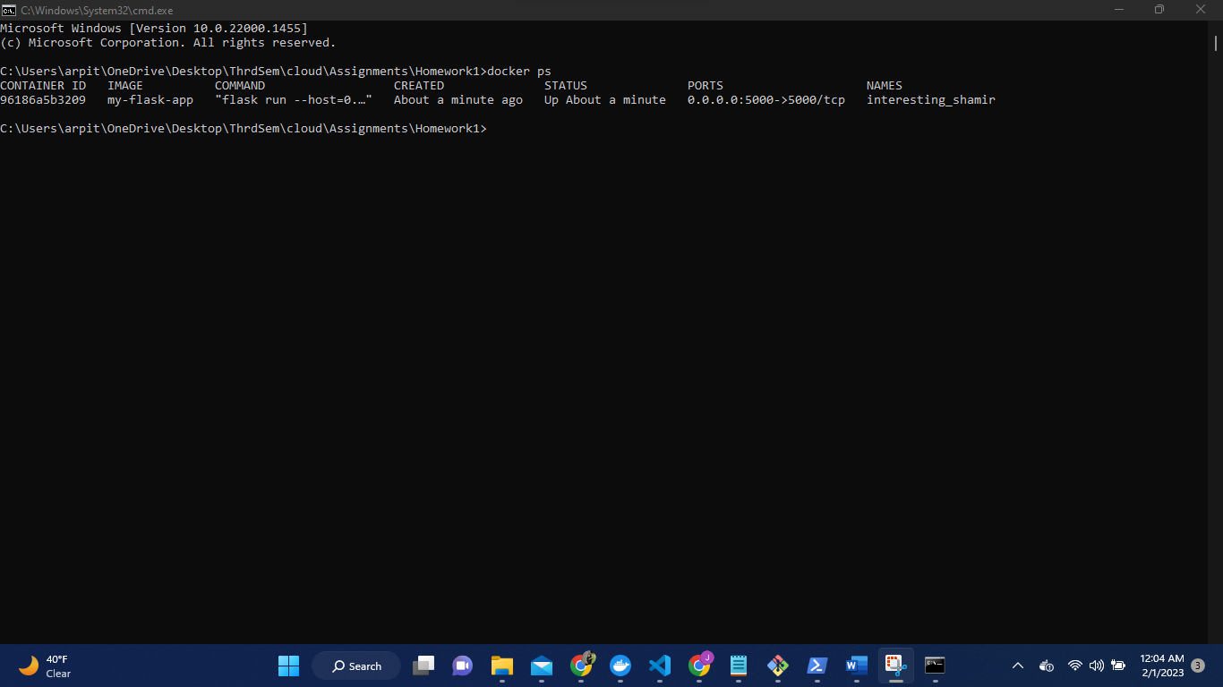

From browser

**From curl**

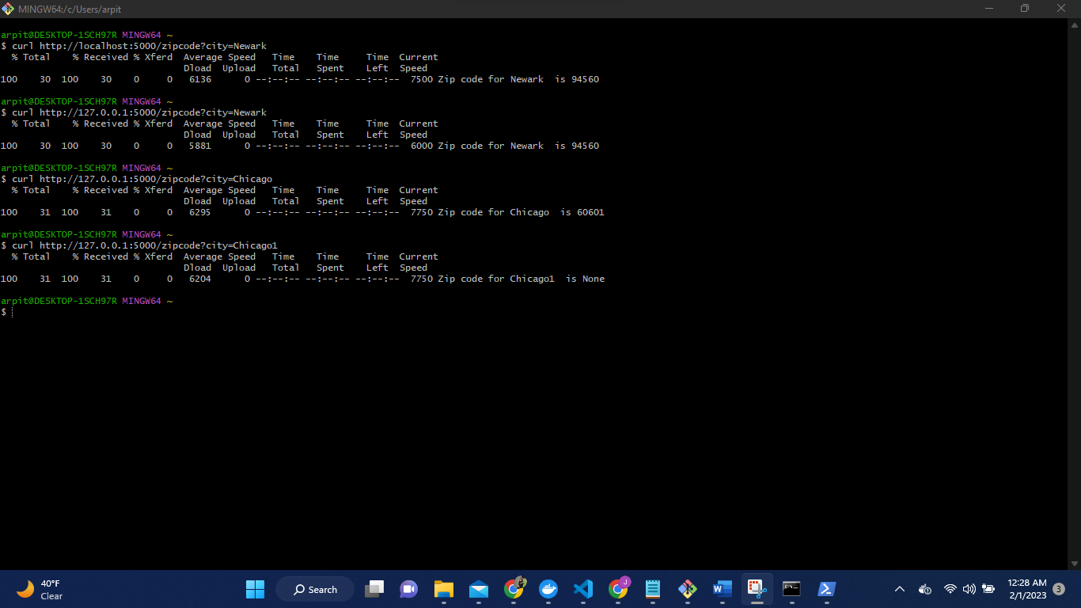

To cross check.

**Service 2 : Fetch weather information based on zip code**

**code**

From browser http://localhost:5001/weather?zip=94560

http://127.0.0.1:5001/weather?zip=94550

From curl

curl http://127.0.0.1:5000/weather?zip=10001

Curl http://localhost:5001/weather?zip=94560

**Running the code inside a Docker container**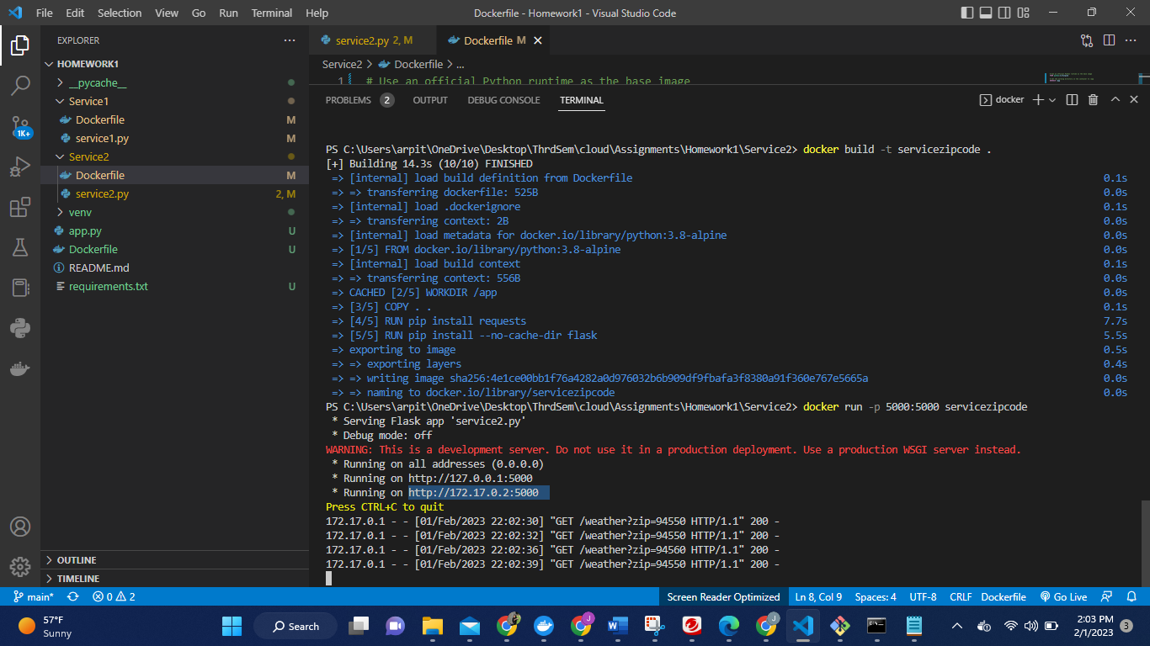

From browser

From curl

Both the service up and running together

