**Service 1 : Fetch Zipcode based on city name**

code

From browser localhost: http://localhost:5000/zipcode?city=Chicago

from browser localhost : <http://localhost:5000/zipcode?city=New> York

From curl command line :

1. curl <http://127.0.0.1:5000> & 2. curl <http://10.0.0.192:5000>

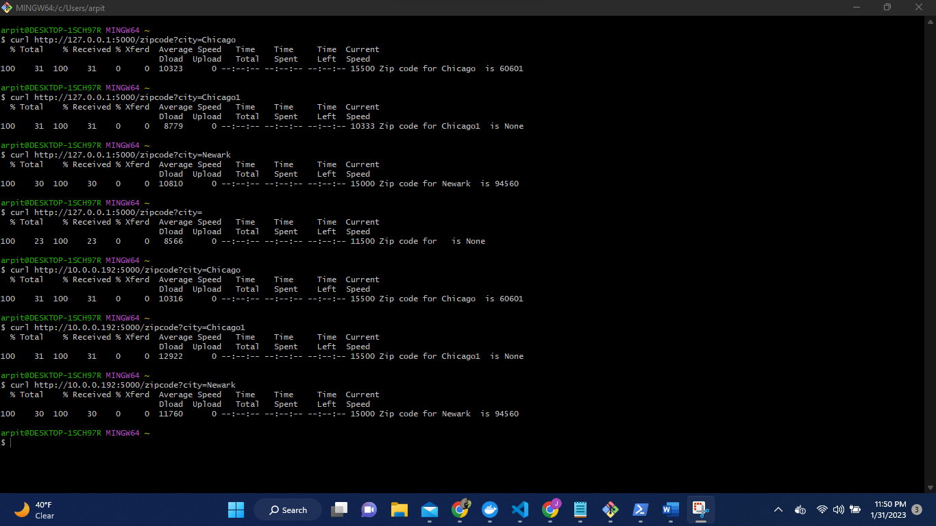

**Running the code inside a Docker container**

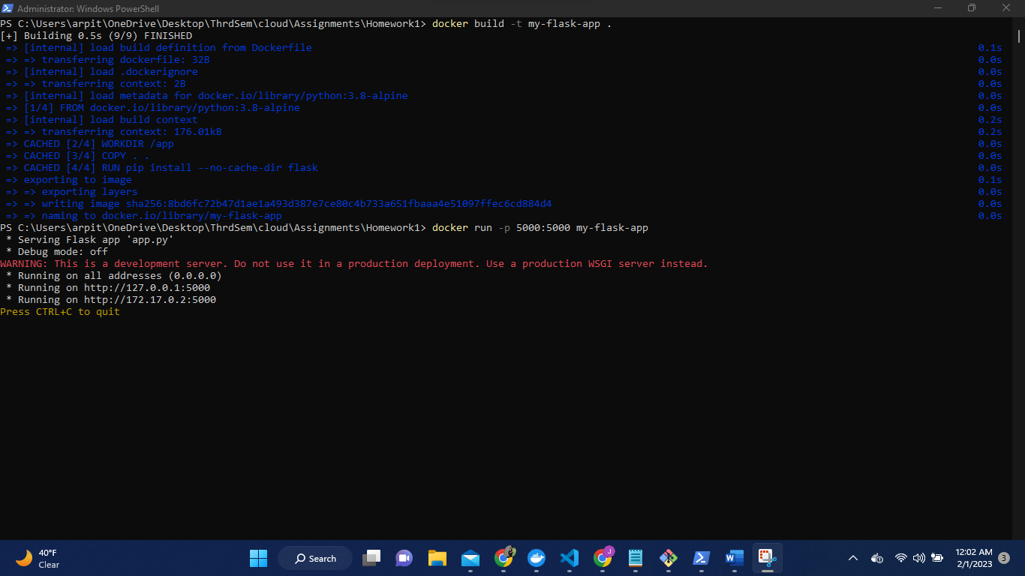

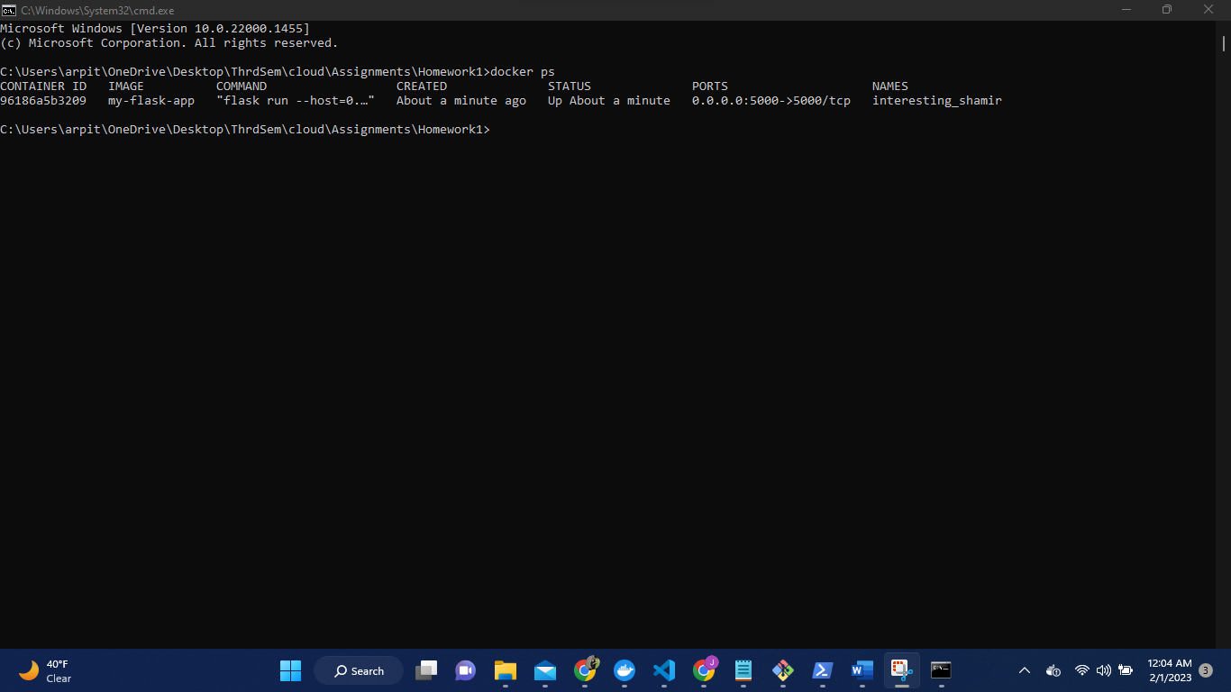

From browser: <http://localhost:5000/zipcode?city=Los> Angeles

<http://localhost:5000/zipcode?city=Newark>

1. From curl <http://127.0.0.1:5000>

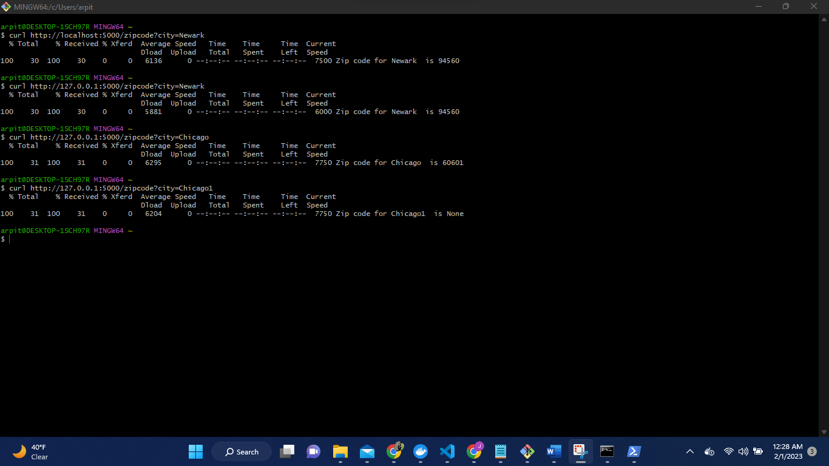

To cross check.

**Service 2 : Fetch weather information based on zip code**

code

From browser http://localhost:5000/weather?zip=94560

http://127.0.0.1:5001/weather?zip=1001

From curl

1. curl <http://127.0.0.1:5000/weather?zip=10001> 2. curl http://localhost:5001/weather?zip=94560

From browser http://localhost:5001/weather?zip=10001

http://localhost:5001/weather?zip=94560

From curl

1. curl <http://127.0.0.1:5000/weather?zip=10001>
2. curl http://localhost:5001/weather?zip=94560

Both the service are up and running together

