PAYROLL & BENEFITS

System Workflow &
Operational Flowcharts
Priority Handling Logistics, Inc.
Implementation-aligned process guide

Document purpose
A client-ready explanation of how users, attendance, leave, compensation, benefits, claims, payroll, reports and AI-assisted attendance analytics move through the implemented system.

Version 1.0 | 19 September 2026
Prepared from the current Next.js, Supabase and PostgreSQL implementation

Document control
Item | Value
Document | Payroll & Benefits System Workflow & Operational Flowcharts
Organization | Priority Handling Logistics, Inc.
Audience | Super administrators, HR administrators, payroll managers, HR managers, reviewers and implementation teams
Source of truth | Current application routes, server actions and ordered Supabase migrations through 202609190001
Status | Implementation-aligned working document; statutory and company policy values require owner approval before production payroll

Contents
- Executive overview and system boundaries
- Roles, access and security workflow
- Employee, attendance and leave workflow
- Payroll calculation and approval workflow
- Compensation, benefits and claims workflow
- Automatic HR Analytics workflow
- Reports, exports, payslips and auditability
- Recommended operating procedure and exception handling
- Deployment and acceptance checklist
Reading guide
Green paths represent completed, payroll-ready outputs. Amber paths require review. Red controls represent security, validation or exception gates. Dashed external boundaries are described in text because they require a configured third-party service.

1. Executive overview
The Payroll & Benefits system centralizes employee records, attendance, paid leave, compensation, benefits, claims, payroll calculation, payslips and analytics. PostgreSQL is the authoritative operational store. Next.js supplies the responsive user interface and server actions, while Supabase provides authentication, MFA, database access and row-level security.
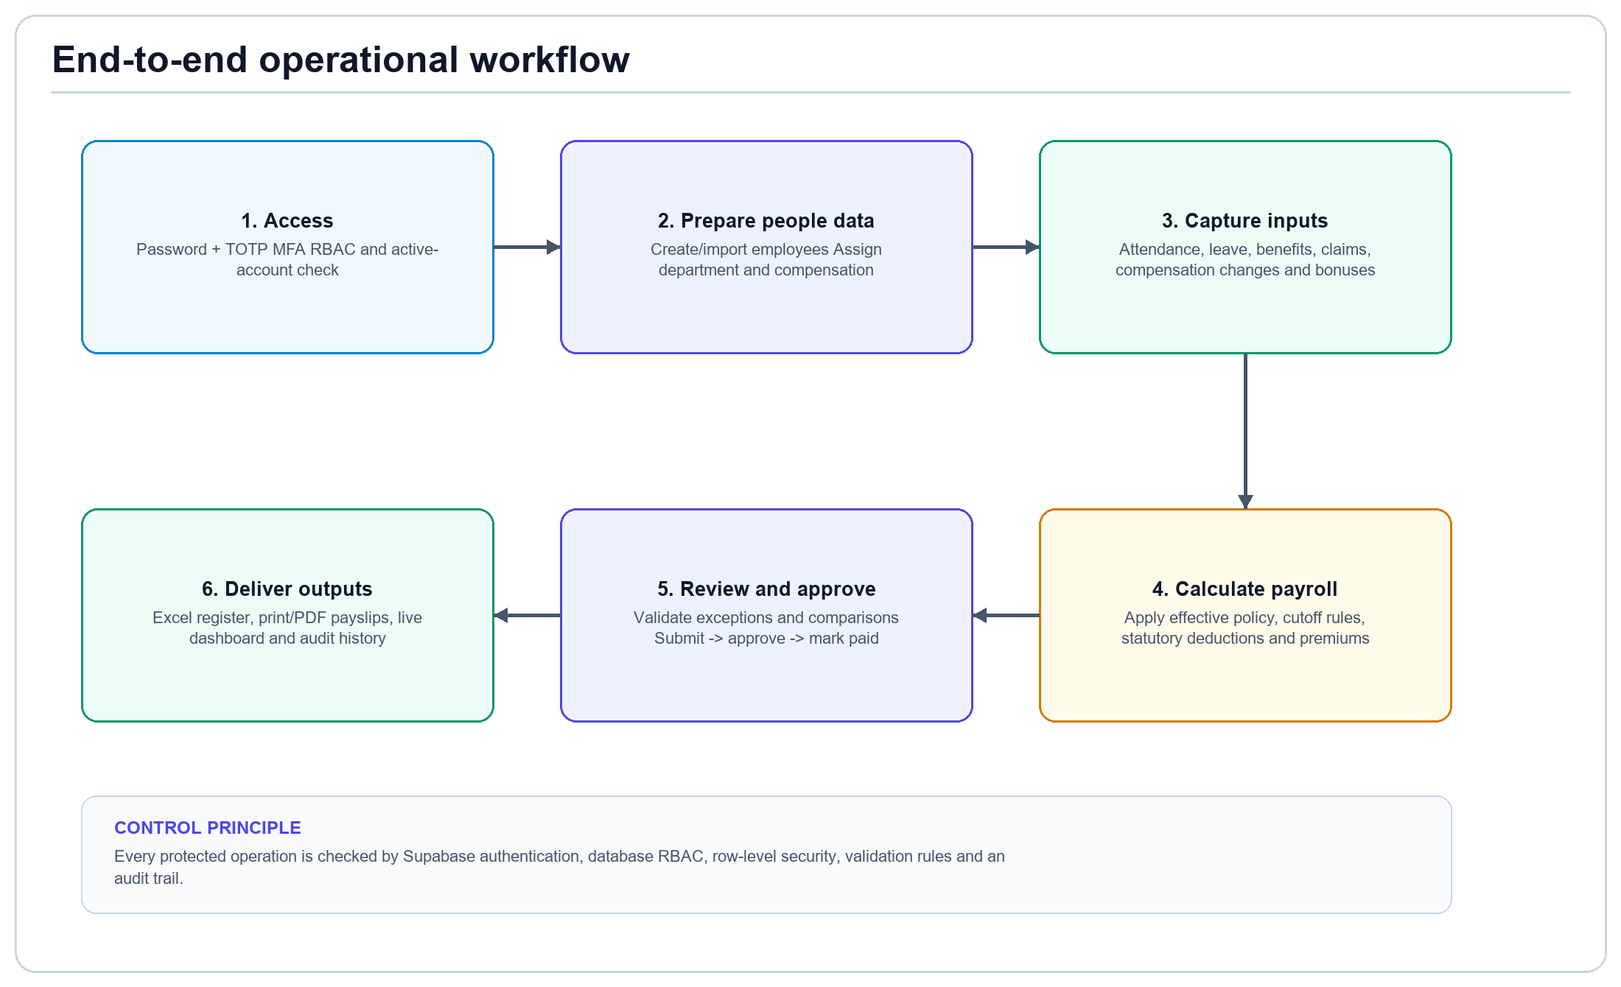
Figure 1. End-to-end operational workflow from secure access to auditable outputs.

1.1 Implemented automation
- Validated CRUD, search, pagination, confirmed deletion and audit history for operational records.
- Effective-dated employee compensation and effective-dated payroll policy selection.
- 1st cutoff (1-15), 2nd cutoff (16-month end) and full-month payroll schedules.
- Late, undertime, absence, overtime, night differential, approved paid leave, bonuses and reimbursements.
- Itemized SSS, PhilHealth, Pag-IBIG and BIR withholding deductions through a versioned policy.
- Payroll validation, controlled state transitions, immutable approved payroll, Excel registers and print/PDF payslips.
- Live Overview and HR Analytics snapshots; automatic on-visit XGBoost scoring when configured.

1.2 External or policy-dependent boundaries
- ESS synchronization needs a configured server-side ESS integration endpoint.
- XGBoost scoring needs XGBOOST_SERVICE_URL and XGBOOST_SERVICE_TOKEN plus the documented prediction contract.
- Bank disbursement, file uploads, loan deductions, 13th-month pay and automatic government holiday synchronization are separate integrations.
- Government rates, taxable benefits, cutoff allocation, schedules and rounding must be approved and updated through reviewed policy versions.

2. Roles, access and security workflow
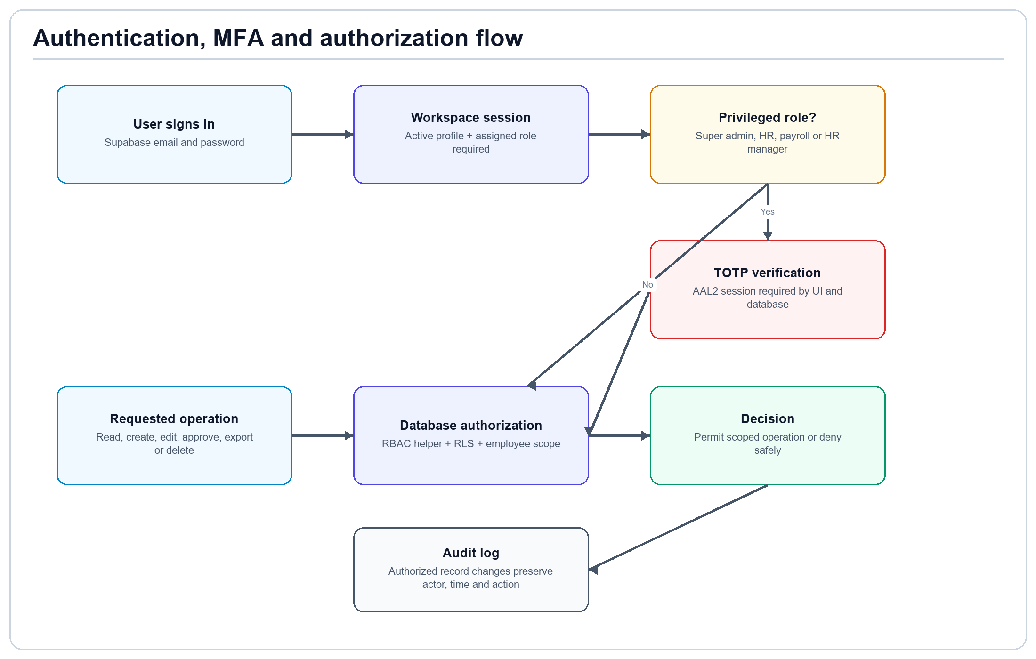
Figure 2. Authentication, MFA, RBAC, row-level security and audit controls.
Role | Primary responsibility | Typical access
super_admin | System ownership and governance | All modules; invitations; RBAC; payroll policy; protected owner safeguards
hr_admin | People and HR operations | Employees, attendance, leave, compensation, benefits, claims and analytics
payroll_manager | Payroll preparation and processing | Attendance inputs, payroll calculation, validation, approval workflow and outputs
hr_manager | HR review | Compensation and claims review; permitted analytics
manager | Department oversight | Read only within assigned department scope
employee | Self-service visibility | Own permitted records; no administrative CRUD

2.1 Security controls
- Privileged roles require TOTP MFA and an AAL2 token. Database role checks enforce MFA, not only the interface.
- The system owner remains active, cannot lose the super-admin role and is excluded from payroll employee records.
- Inactive or terminated profiles are denied workspace access immediately.
- Self-approval is blocked for governed leave, claims and compensation decisions.
- Direct authenticated writes to sensitive role and workflow tables are revoked; validated RPCs perform atomic changes.

3. Employee, attendance and leave workflow
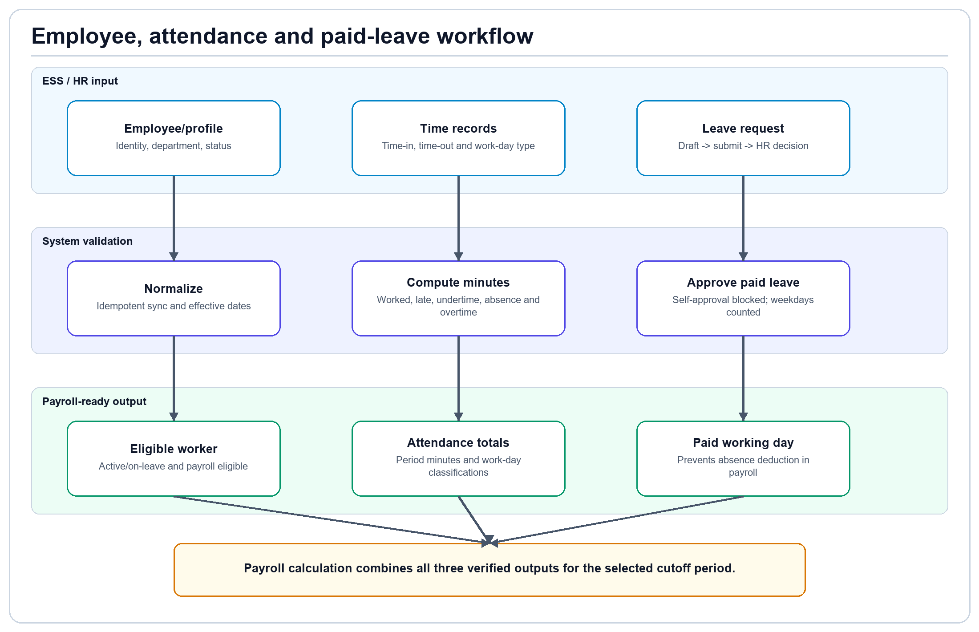
Figure 3. Employee identity, attendance minutes and approved paid leave converge into payroll-ready inputs.

3.1 Employee preparation
- Create or invite the Supabase Authentication account.
- Create the employee profile, employee number, department, job title, location and employment status.
- Mark the person as payroll eligible; system identities remain excluded.
- Create an effective compensation history record with salary amount and frequency.
- Assign the appropriate workspace role and optional manager department scope.

3.2 Attendance inputs
Input | System treatment | Payroll effect
Time-in / time-out | Stored as timestamps and validated for logical order | Determines worked minutes
Late minutes | Summed within the payroll period | Hourly rate x late minutes / 60
Undertime minutes | Summed independently; does not offset overtime | Hourly rate x undertime minutes / 60
Absence | Recorded classification and absence minutes | Fixed-salary absence deduction unless covered by paid leave
Overtime minutes | Uses reviewed work-day type | Policy multiplier by ordinary/rest/special/holiday category
Night minutes | Stored for eligible hours | Policy night differential

3.3 Paid-leave process
- Employee/HR creates a draft leave request and submits it.
- An authorized HR reviewer approves or rejects the submitted request; the requester cannot approve their own request.
- Approved paid weekdays overlapping the payroll period are counted as paid leave days.
- Paid leave is included as a paid working day and prevents the related absence deduction.
- Decided requests are protected from casual edits or deletion.

4. Payroll calculation and approval workflow
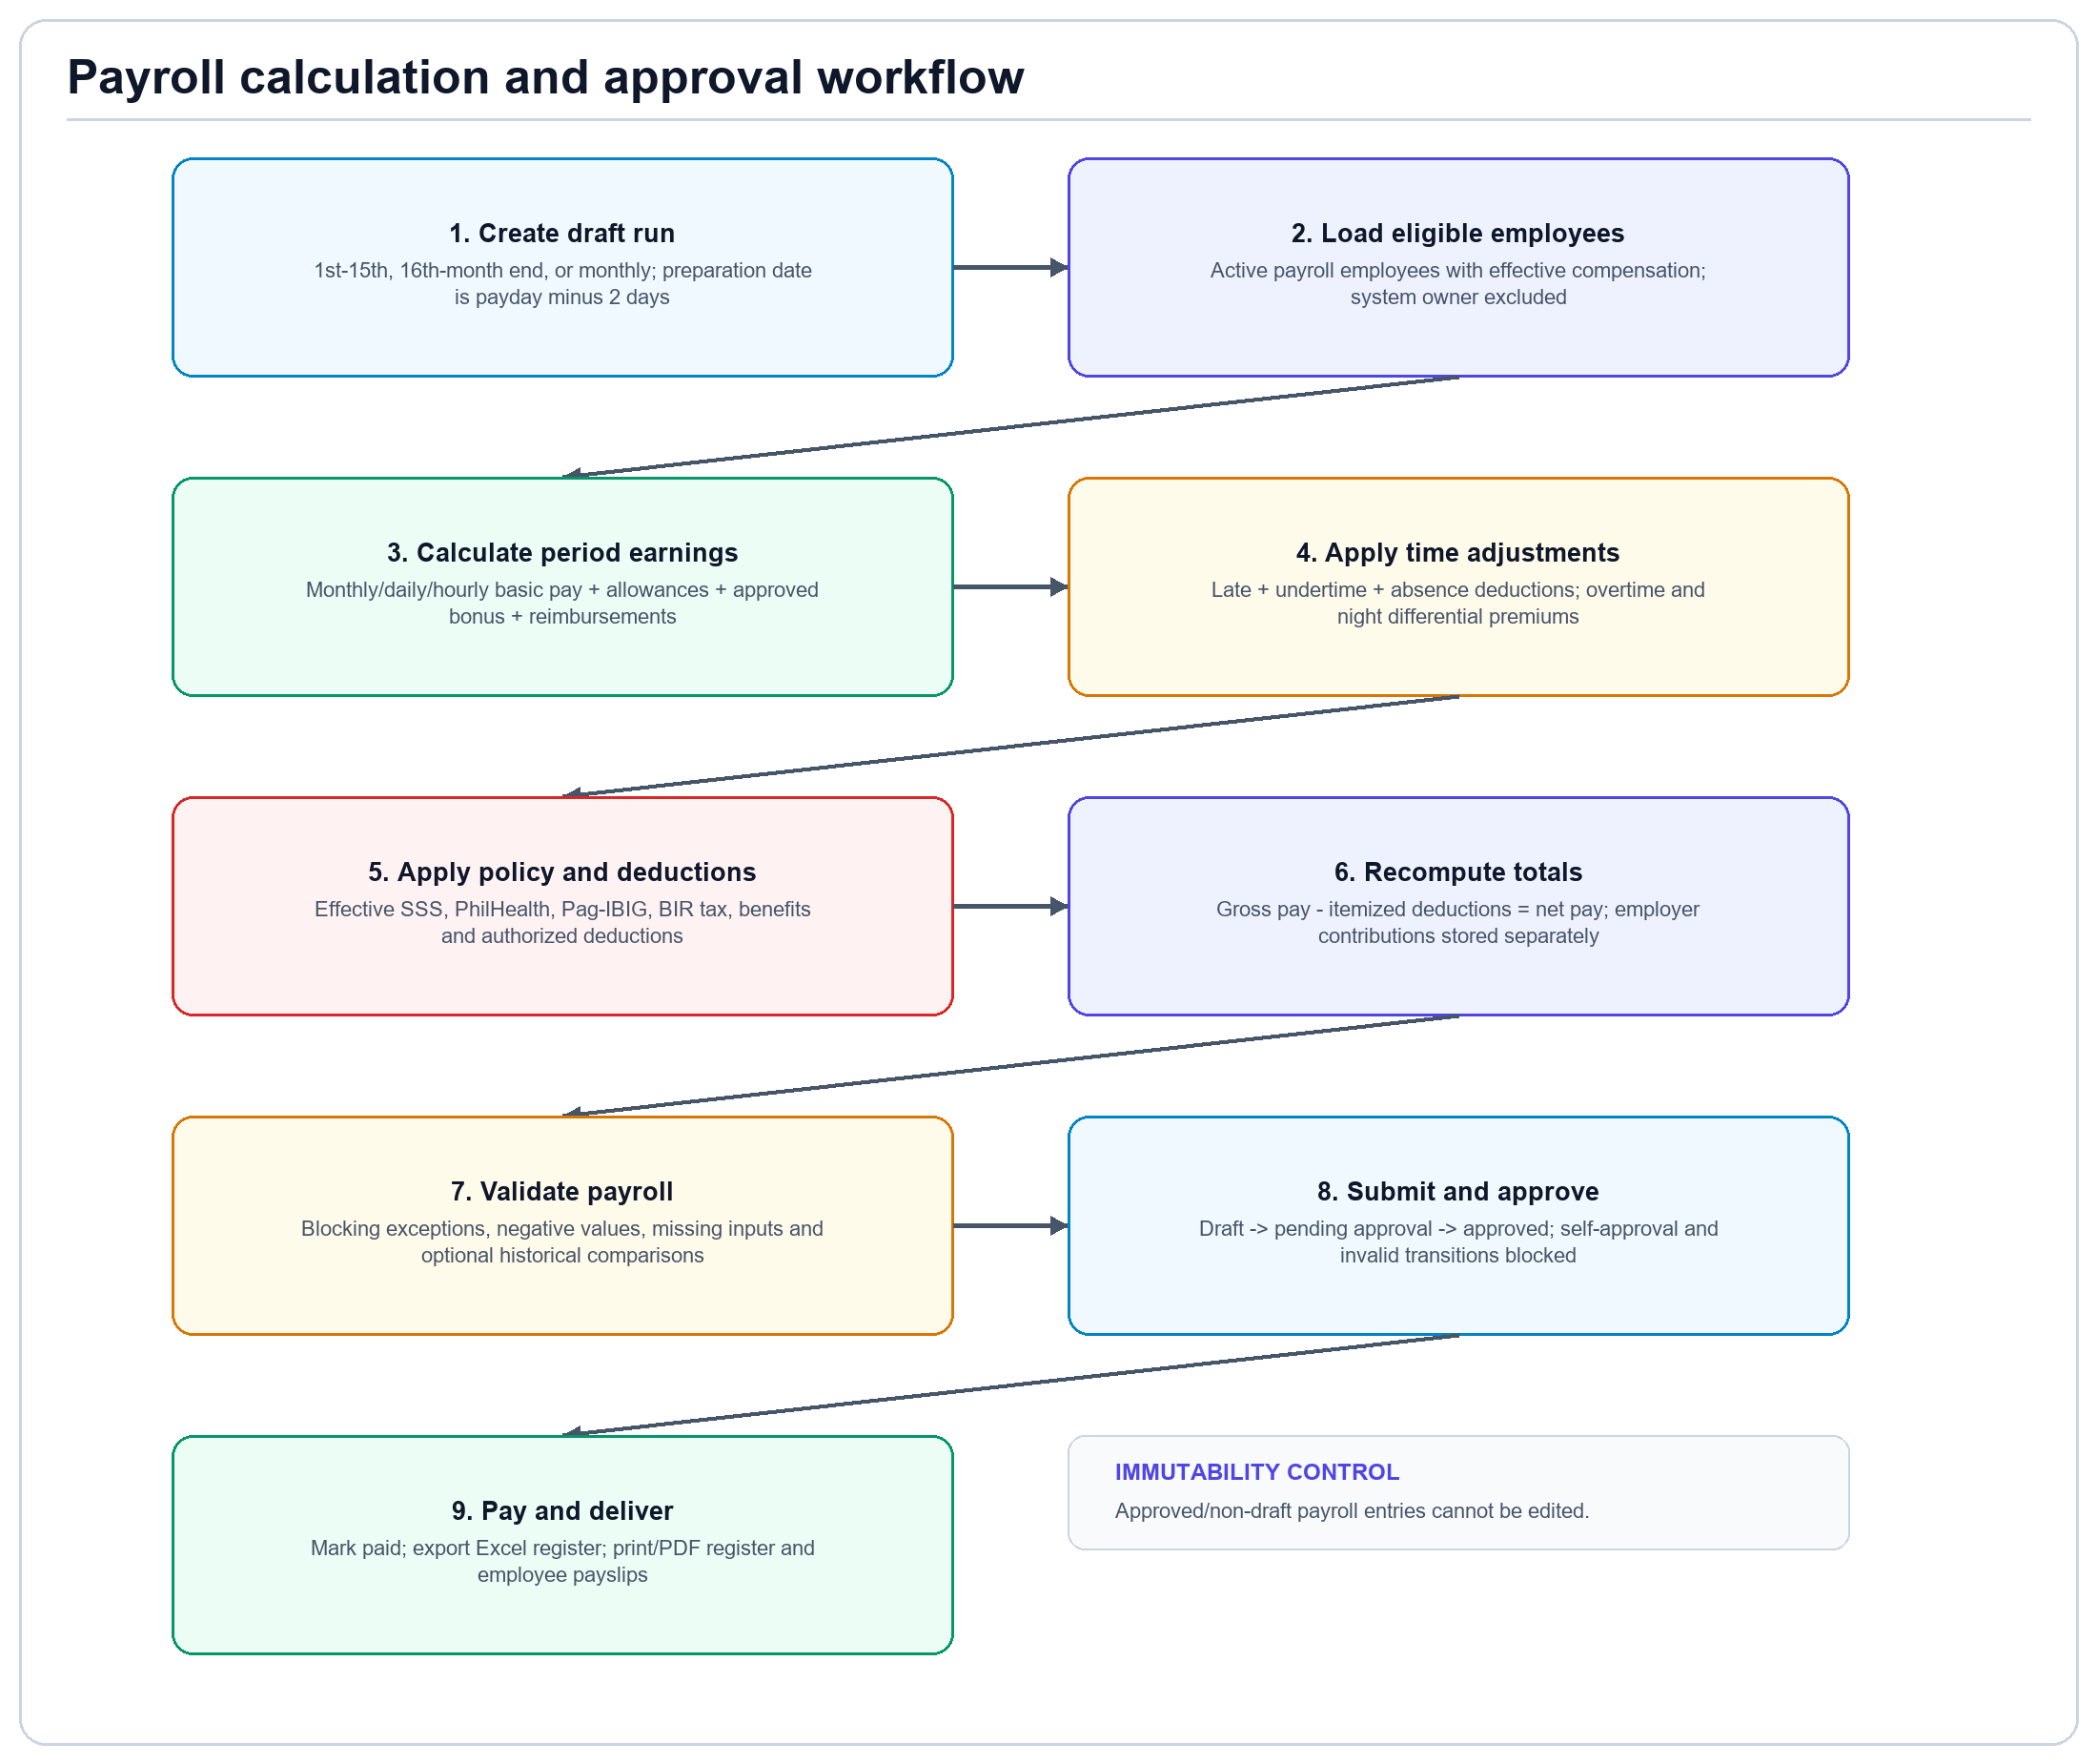
Figure 4. Calculation, validation, approval, payment and output lifecycle.

4.1 Core computation
Component | Implemented calculation
Monthly / semi-monthly basic | Applicable period share based on the selected cutoff schedule
Daily-paid basic | Daily rate x (worked days + approved paid-leave days)
Hourly-paid basic | Hourly rate x (worked hours + approved paid-leave hours)
Late / undertime | Hourly rate x minutes / 60
Fixed-salary absence | Daily rate x absence minutes / configured workday minutes
Overtime | Hourly rate x eligible hours x effective day-type multiplier
Night differential | Hourly rate x night hours x configured differential
Gross pay | Basic + allowances + overtime + night differential + bonus + benefits + reimbursements
Net pay | Gross pay - itemized employee deductions

4.2 Statutory and other deductions
The effective payroll policy controls statutory rates, contribution caps, cutoff allocation, premium multipliers and rounding. The seeded policy reflects the configured 2025/2023 rule references but must be reviewed by the company before live payroll.
- SSS employee and employer contributions, including employer EC treatment.
- PhilHealth employee and employer shares with configured salary floor and ceiling.
- Pag-IBIG employee and employer shares with configured compensation cap.
- BIR withholding tax for semi-monthly and monthly schedules.
- Benefit employee cost, authorized other deductions and non-taxable approved expense reimbursements.

4.3 Payroll state controls
State | Allowed activity | Control
Draft | Edit inputs, calculate, recalculate, validate | Only draft entries may change
Processing / needs review | Resolve calculation exceptions | Blocking validation issues must be cleared
Pending approval | Authorized approver reviews totals | Invalid/self approval is blocked
Approved | Generate final outputs and prepare payment | Lock timestamp; entries immutable
Paid | Historical reporting and employee payslip access | Final state retained in audit history

5. Compensation, benefits and claims workflow

5.1 Compensation changes
- Create a compensation cycle and a draft proposal containing current salary, proposed salary, bonus and justification.
- Submit the proposal for review. A different authorized reviewer approves or rejects it.
- Approval creates the effective salary-history change transactionally and preserves compensation history.
- Payroll loads the salary record effective for the payroll period; an approved bonus is applied idempotently.

5.2 Benefits
- Maintain providers and plans for HMO, allowances, insurance/group, leave and government categories.
- Enroll eligible employees with effective/expiration dates and membership details.
- During calculation, active eligible plans contribute the configured employee cost and employer cost.
- Benefit history, record exports and audit events remain available to permitted roles.

5.3 Claims and reimbursements
- Create a draft claim with category, amount, description and HTTPS supporting-document link.
- Submit the claim; verify document status; approve or reject with the required reason.
- Approved claims not already linked to a payroll are included as reimbursements during calculation.
- The claim is linked to the payroll run to prevent duplicate reimbursement.
Review boundary
The system records a document URL and verification decision. It does not currently upload or virus-scan files; production document storage requires a separate secure integration.

6. Automatic HR Analytics workflow
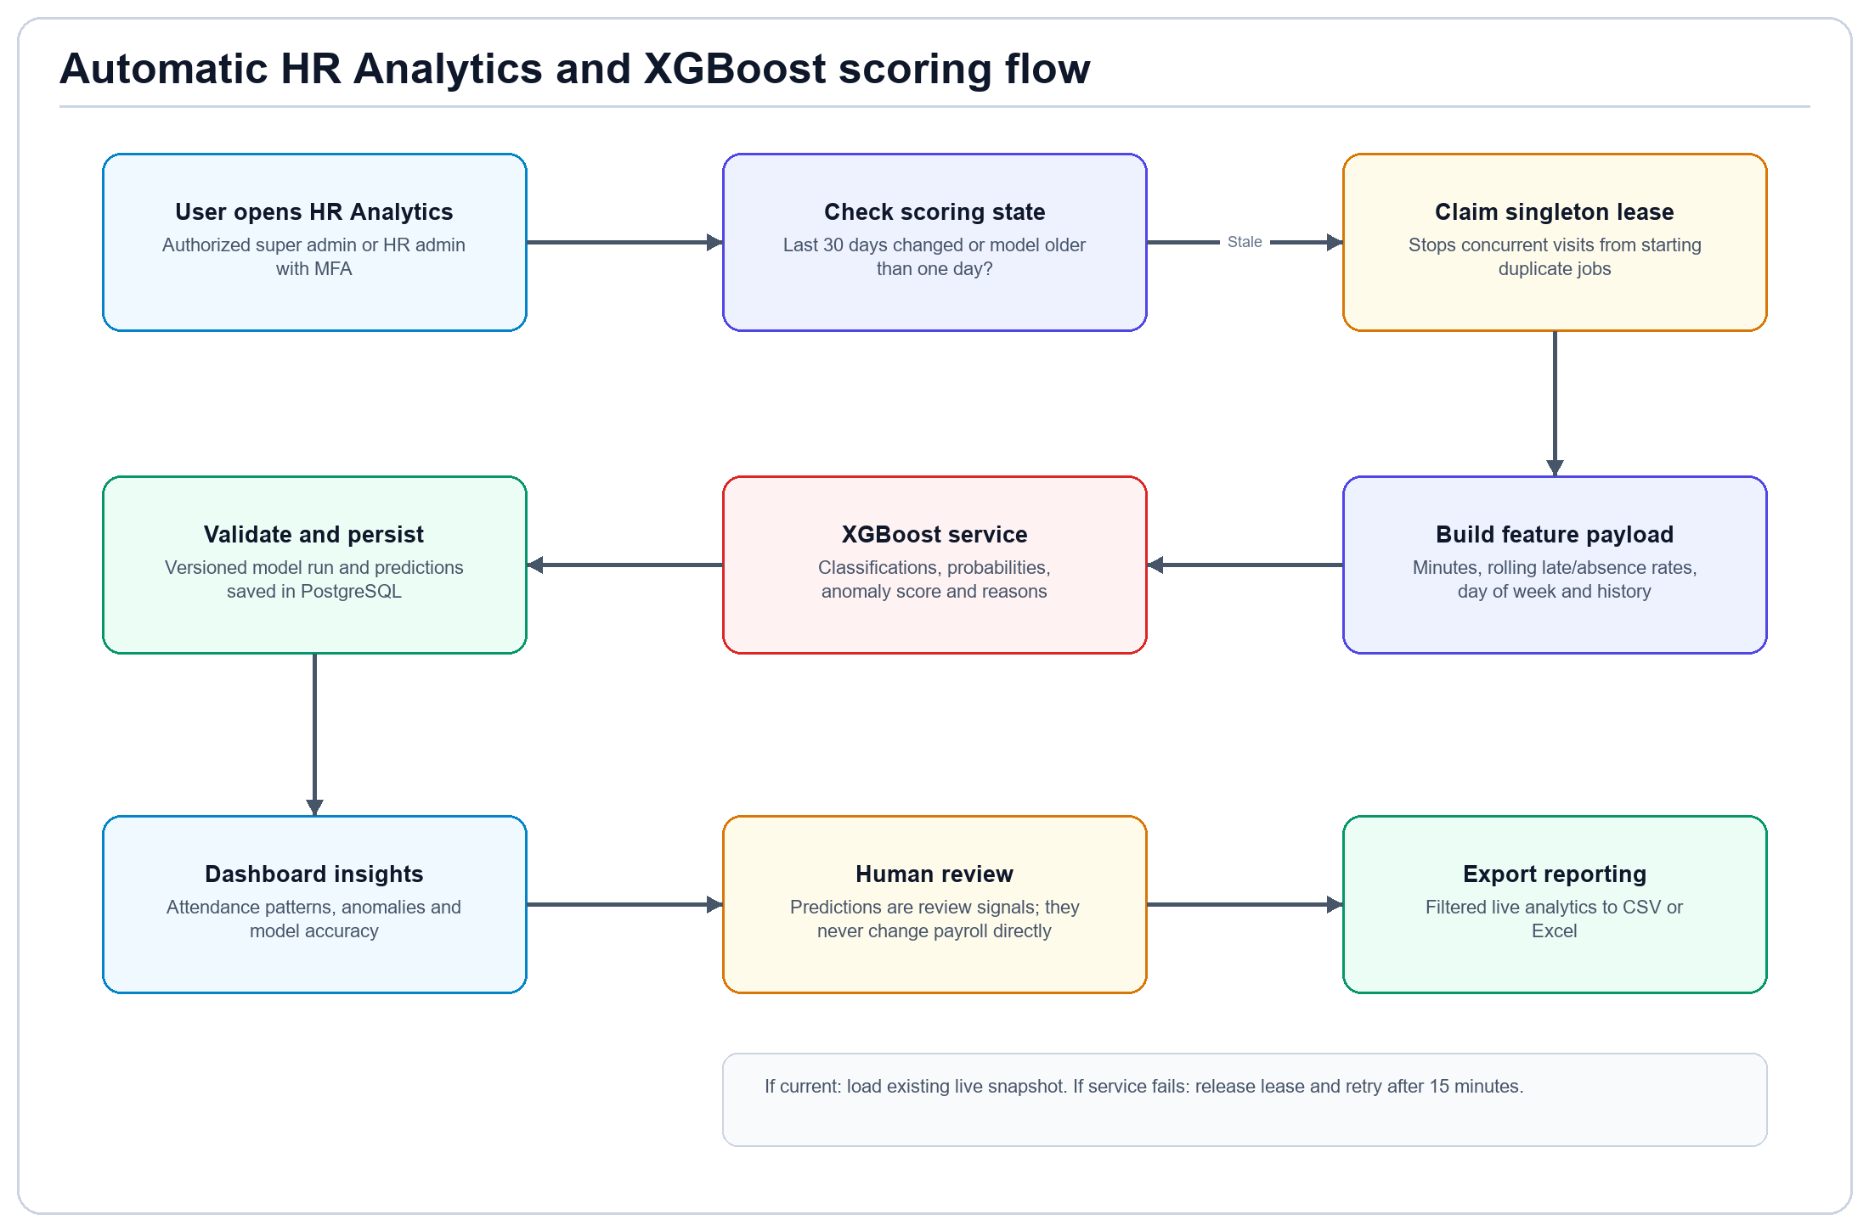
Figure 5. Automatic, on-visit XGBoost attendance scoring with concurrency and retry controls.

6.1 Automatic behavior
- An authorized user opens HR Analytics; no separate Run AI button is required.
- The database checks whether the last 30 days of attendance changed or the completed score is older than one day.
- A singleton lease prevents concurrent users from starting duplicate scoring jobs.
- The server sends a versioned feature payload to the configured XGBoost endpoint.
- Validated classifications, probabilities, anomaly scores and reasons are persisted as a versioned model run.
- The live dashboard refreshes, animates charts and makes the current filtered results exportable.

6.2 Safety and operation
- Model output is advisory and cannot directly alter attendance or payroll.
- Failures release the lease and set a 15-minute retry window.
- This is on-visit automation, not an unattended scheduler. A scheduled worker can be added later if required.
- The XGBoost URL and token remain server-only environment values.

7. Reports, exports, payslips and auditability
Output | Format | Content / use
Operational records | CSV and Excel | Filtered employee, attendance, compensation, benefit, claim and payroll records
Payroll register | Excel | Employee-level earnings, minutes, statutory deductions, contributions and net pay
Payroll print package | Print / PDF | A4 payroll register followed by an individual payslip for each employee
Analytics report | CSV and Excel | Current filtered live snapshot, classifications, anomalies and model metrics
Audit history | Application view / database | Actor, action, entity, record, timestamp and retained deletion history

7.1 Payslip contents
- Payroll period, cutoff schedule, pay date, employee number and employee name.
- Basic pay, allowances, categorized overtime, night differential, bonus, benefits and reimbursements.
- Late/undertime/absence minutes with their deductions.
- SSS, PhilHealth, Pag-IBIG, BIR withholding, benefit and other deductions.
- Gross pay, total deductions, employer contributions and final net pay.
Privacy control
Employees may only view their own payroll items through database row-level security. Administrative exports are limited to authorized payroll/HR roles.

8. Recommended operating procedure
Timing | Owner | Activity | Completion evidence
Ongoing | HR admin | Maintain employee status, salary history, benefits and approved leave | Validated current records
Daily / sync | HR or integration | Capture time-in/out, minutes and reviewed work-day type | Attendance exceptions resolved
Before cutoff | HR/payroll | Complete claims, bonuses and compensation approvals | Approved inputs available
Payday - 2 days | Payroll manager | Create/recalculate draft payroll and run validation | No blocking issues
Review window | Authorized approver | Compare totals, exceptions and sampled payslips | Payroll approved and locked
Payday | Payroll/finance | Mark paid after external disbursement; issue payslips | Paid status and outputs retained
Post-payroll | HR/payroll | Review analytics, audit changes and resolve anomalies | Actions documented

8.1 Exception handling
Exception | Required response
Missing compensation | Create a non-overlapping effective salary record, then recalculate.
Attendance conflict | Correct source record or reviewed classification; do not hide the exception with a manual net-pay edit.
Unapproved leave | Complete the leave decision before calculation or treat the absence according to policy.
Failed payroll validation | Resolve all blocking issues and failed historical comparisons before submission.
Statutory rule changed | Create and approve a new effective-dated payroll policy; never rewrite a policy used by locked payroll.
AI service unavailable | Use existing live records; investigate service configuration; automatic scoring retries after the cooldown.
Unauthorized action | Confirm role, employment status, MFA assurance and department scope; never bypass RLS.

9. Deployment and acceptance checklist

9.1 Database and authentication
- Apply migrations in documented order through 202609190001; never rerun already applied migrations.
- Configure Supabase URL, anonymous key and server-only service role key where needed.
- Create the protected first administrator, remove the one-time setup token and enroll two TOTP authenticators.
- Verify role assignment, manager scope, owner protection, inactive-account denial and employee self-access.

9.2 Payroll policy acceptance
- Obtain written approval for salary frequencies, cutoff allocation, workday hours and rounding.
- Confirm SSS, PhilHealth, Pag-IBIG and BIR configuration for the effective period.
- Confirm regular, rest-day, special-day, holiday, double-holiday and night premium treatment.
- Load anonymized historical comparison cases and reconcile representative payslips before live use.

9.3 Functional acceptance
- Create, edit, export and safely delete permitted draft records; confirm audit history remains.
- Test monthly-, daily- and hourly-paid workers across both cutoffs and a monthly run.
- Test late, undertime, absence, overtime, paid leave, benefit cost, claim reimbursement and bonus cases.
- Submit, approve, lock, print and export payroll; confirm locked entries cannot be changed.
- Run npm test, npm run typecheck, npm run lint and npm run build, followed by authenticated hosted-Supabase smoke checks.
Production sign-off
Technical completion does not replace payroll/legal review. A Philippine payroll professional and the client's authorized finance/HR owners should approve the effective policy and reconciled results before the first live payroll.

